Table 2 CMT Results for 2012 Palu Earthquake.
Event | Mw  (GFZ) (GCMT) (BMKG) (This Study) | MT GFZ | MT GCMT | MT BMKG | MT This Study | 1st S/D/R (°)  (GFZ)  (GCMT)  (BMKG)  (This Study) | 2nd S/D/R (°)  (GFZ)  (GCMT)  (BMKG)  (This Study) | DC% (GFZ) (GCMT) (BMKG) (This Study) | VR% This Study | CN This Study
2012  Main  shock | 6.35 | 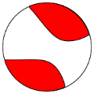 | 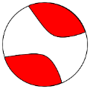 | 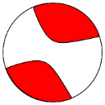 | 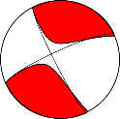 | 338.28/78.99/-12.52 | 70.71/77.71/-168.72 | 63.86% | 63% | 4
2012  Main  shock | 6.37 |  |  |  |  | 339/83/-5 | 70/85/-173 | 68.23% | 63% | 4
2012  Main  shock | 6.24 |  |  |  |  | 158.94/85.74/-3.28 | 249.18/86.73/-175.73 | 75.81% | 63% | 4
2012  Main  shock | 6.5 |  |  |  |  | 153/82/-13 | 245/77/-171 | 83% | 63% | 4

Table 3 CMT Results for 2012 Palu Earthquake.
Event |  |  |  | CMT Solution from This Study |  |  | Event |  |  |  | CMT Solution from This Study
No. | ID BMKG | Mw | Date & Time (UTC+8) |  |  |  | No. | ID  BMKG | Mw | Date & Time (UTC+8)
1 | Bmg  2012  qevb | 4.7 | 20120818  074501 | 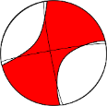 | 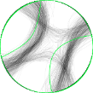 | DC = 56 %  M_{w} = 4.3 | 9 | Bmg  2012  qgdg | 4.2 | 20120819  010219 | 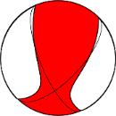 |  | DC = 73 %  M_{w} = 4.1
2 | Bmg  2012  qevh | 3.9 | 20120818  075231 | 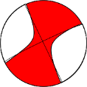 | 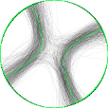 | DC = 77 %  M_{w} = 4.0 | 10 | Bmg  2012  qhse | 4.0 | 20120819  214256 | 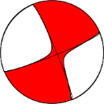 | 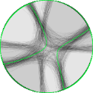 | DC = 92 %  M_{w} = 3.9
3 | Bmg  2012  qeyx | 6.2 | 20120818  094154 | 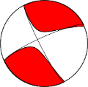 |  | DC = 83 %  M_{w} = 6.5 | 11 | Bmg  2012  qptw | 4.4 | 20120824  074234 | 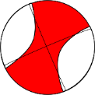 |  | DC = 56 %  M_{w} = 4.4
4 | Bmg  2012  qfct | 4.0 | 20120818  113905 | 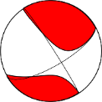 | 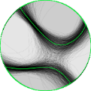 | DC = 70 %  M_{w} = 4.1 | 12 | Bmg  2012  rfwq | 4.0 | 20120902  031344 | 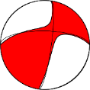 |  | DC = 89 %  M_{w} = 4.3
5 | Bmg  2012  qffi | 4.0 | 20120818  125643 | 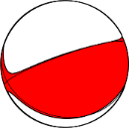 | 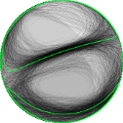 | DC = 93 %  M_{w} = 3.9 | 13 | Bmg  2012  rkdn | 4.0 | 20120904  111453 | 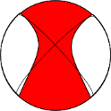 | 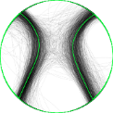 | DC = 60 %  M_{w} = 3.9
6 | Bmg  2012  qfha | 4.7 | 20120818  134751 | 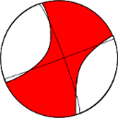 |  | DC = 54 %  M_{w} = 4.8 | 14 | Bmg  2012  rzpx | 4.3 | 20120912  223304 | 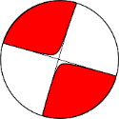 |  | DC = 95 %  M_{w} = 4.1
7 | Bmg  2012  qfjl | 3.8 | 20120818  150104 | 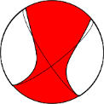 |  | DC = 62 %  M_{w} = 3.8 | 15 | Bmg  2012  yxpw | 4.2 | 20121220  105945 | 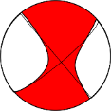 |  | DC = 74 %  M_{w} = 4.2
8 | Bmg  2012  qfjz | 4.9 | 20120819  151911 | 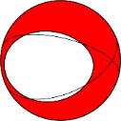 | 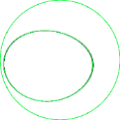 | DC = 54 %  M_{w} = 4.8 | 16 | Bmg  2012  zmij | 4.0 | 20121228  121513 | 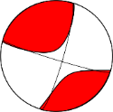 |  | DC = 71 %  M_{w} = 4.0

Table 4 Decomposed major and minor DC MTs of the CMT solution for the Mw 6.3 Palu 2012 mainshock.
Name | Mechanism | 1st S/D/R (°) | 2nd S/D/R (°) | DC Component (%) | M0 (Nm) | $\frac{M_{0}}{M_{0}^{sum}} . 100\%$ (%)
Original non-DC MT | Left Strike-Slip | 153.2/81.5/-13.4 | 245.2/76.8/-171.3 | 83.6 | 6.60E+18 | 100
MT major | Left Strike-Slip | 301.3/71.4/7.2 | 208.9/83.2/161.2 | 100 | 6.06E+18 | 91.79
MT minor | Normal | 6.5/40/-61.2 | 150.8/55.7/-112.1 | 100 | 5.42E+17 | 8.20
MT sum | Left Strike-Slip | 153.2/81.5/-13.4 | 245.2/76.8/-171.3 | 83.6 | 6.60E+18 | 100

Table 5 Parameter values for each event from the selected fault plane.
No | ID BMKG | Latitude | Longitude | Strike | Dip | Slip | No | ID BMKG | Latitude | Longitude | Strike | Dip | Slip
1 | bmg2012qevb | -1.21 | 119.975 | 170 | 85 | -5 | 9 | bmg2012qgdg | -1.213 | 119.957 | 158 | 62 | 42
2 | bmg2012qevh | -1.387 | 120.295 | 334 | 90 | 5 | 10 | bmg2012qhse | -1.289 | 119.976 | 337 | 83 | -7
3 | bmg2012qeyx | -1.353 | 120.037 | 153 | 82 | -13 | 11 | bmg2012qptw | -1.191 | 119.97 | 157 | 89 | -3
4 | bmg2012qfct | -1.157 | 120.057 | 327 | 85 | -27 | 12 | bmg2012rfwq | -1.323 | 119.826 | 8 | 77 | 29
5 | bmg2012qffi | -1.362 | 119.98 | 250 | 77 | 81 | 13 | bmg2012rkdn | -0.503 | 119.794 | 317 | 79 | 13
6 | bmg2012qfha | -1.297 | 119.947 | 340 | 82 | -1 | 14 | bmg2012rzpx | -1.376 | 120.198 | 107 | 90 | -2
7 | bmg2012qfjl | -1.233 | 120.026 | 147 | 75 | 20 | 15 | bmg2012yxpw | -1.333 | 119.966 | 320 | 90 | -14
8 | bmg2012qfjz | -1.23 | 119.976 | 284 | 56 | -67 | 16 | bmg2012zmij | -1.497 | 120.113 | 107 | 84 | 11

Table 6 Fault model of this study used for Coulomb Stress calculation. The fault model is used as the receiver fault of Coulomb stress calculation. The orange highlights are the updated parameter from our CMT analysis
No. | Segment | Strike (º) | Dip (º) | Rake (º) | Length (km) | Width (km) | Number of Sub Fault
1 | PaluKoro-Saluki | 349.7⁰ | 82.5⁰ | 0⁰ | 44 | 25 | 40
2 | PaluKoro-Palu | 343.7⁰ | 82.5⁰ | 0⁰ | 31 | 25 | 40
3 | Palolo B | 316.6⁰ | 60⁰ | -90⁰ | 24 | 25 | 25
4 | Palolo A | 316.6⁰ | 60⁰ | -90⁰ | 29 | 25 | 25
5 | PaluKoro-Makassar Strait | 345⁰ | 90⁰ | 0⁰ | 130 | 25 | 60

