Supplementary Materials for

Bayesian Moment Tensor Analysis of The 2012 Mw 6.3 Palu Earthquake Sequence for Updating The Palu-Saluki Segments and Its Impact on Coulomb Stress Distribution

Table Supplementary Materials
Table S1 Moment Tensors Solution for the Palu Earthquake Sequence of August 18, 2012. Delta here is the distance of the farthest station used in inversion and the nearest.
Sequence Type | No. | ID BMKG | Lat/Lon/Depth  (^{O}/ ^{O}/km) | Delta (Km) | Mw | MT | Uncertainty | Strike/ Dip/ Slip 1 (^{O}) | Strike/ Dip/ Slip 2 (^{O}) | VR% | DC% | CN
Foreshock | 1 | bmg2012qevb | 119.975/  -1.21/14.3 | 172-268 | 4.3 |  | 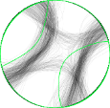 | 260/85/-175 | 170/85/-5 | 73 | 56 | 8
Foreshock | 2 | bmg2012qevh | 120.295/  -1.387/13.7 | 169-196 | 4.2 |  | 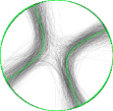 | 244/85/180 | 334/90/5 | 46 | 77 | 5
Mainshock | 3 | bmg2012qeyx | 120.047/  -1.380/18.7 | 176-328 | 6.5 | 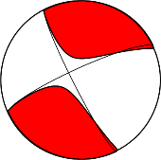 | 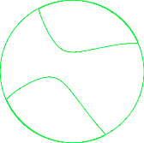 | 153/82/-13 | 245/77/-171 | 63 | 83 | 4
Aftershock | 4 | bmg2012qfct | 120.057/  -1.157/8.2 | 165-213 | 4.1 | 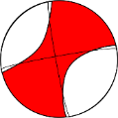  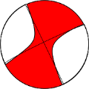  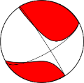 | 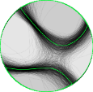 | 327/85/-27 | 60/63/-175 | 45 | 70 | 4
Aftershock | 5 | bmg2012qffi | 119.98/  -1.362/12.3 | 181-194 | 3.9 | 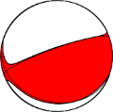  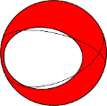  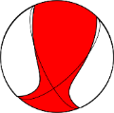 | 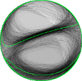 | 250/77/81 | 106/15/124 | 47 | 93 | 6
Aftershock | 6 | bmg2012qfha | 119.947/  -1.297/13.7 | 190-322 | 4.8 |  |  | 70/89/-172 | 340/82/-1 | 52 | 54 | 3
Aftershock | 7 | bmg2012qfjl | 120.026/  -1.233/8.2 | 170-205 | 3.8 | 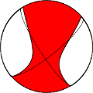  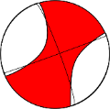 | 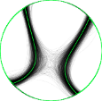 | 52/71/164 | 147/75/20 | 51 | 62 | 4
Aftershock | 8 | bmg2012qfjz | 119.976/  -1.23/6.3 | 173-314 | 4.8 |  | 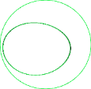 | 67/40/-120 | 284/56/-67 | 41 | 54 | 2
Aftershock | 9 | bmg2012qgdg | 119.957/  -1.213/11.8 | 174-273 | 4.1 |  | 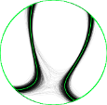 | 158/62/42 | 44/54/144 | 41 | 73 | 9
Aftershock | 10 | bmg2012qhse | 119.976/  -1.289/4.6 | 175-201 | 3.9 | 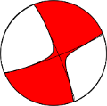 | 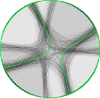 | 337/83/-7 | 68/83/-173 | 57 | 92 | 3
Aftershock | 11 | bmg2012qptw | 119.97/  -1.191/12.7 | 175-341 | 4.4 | 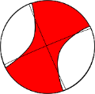 |  | 247/87/-179 | 157/89/-3 | 59 | 56 | 3
Aftershock | 12 | bmg2012rfwq | 119.826/  -1.323/15.8 | 180-209 | 4.3 | 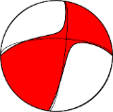 | 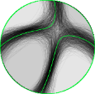 | 271/62/166 | 8/77/29 | 43 | 89 | 6
Aftershock | 13 | bmg2012rkdn | 119.794/  -0.503/8.2 | 90-210 | 3.9 | 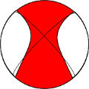 | 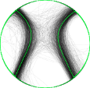 | 225/77/168 | 317/79/13 | 41 | 60 | 8
Aftershock | 14 | bmg2012rzpx | 120.198/  -1.376/10 | 175-288 | 4.1 | 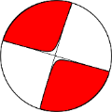 | 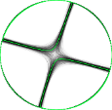 | 107/90/-2 | 197/88/-180 | 52 | 95 | 3
Aftershock | 15 | bmg2012yxpw | 119.966/  -1.333/10 | 181-319 | 4.2 | 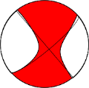 |  | 320/90/-14 | 50/76/-180 | 53 | 74 | 4
Aftershock | 16 | bmg2012zmij | 120.113/  -1.497/10 | 175-202 | 4 | 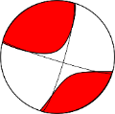 | 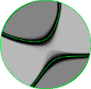 | 107/84/11 | 16/79/174 | 41 | 71 | 3

Table S2 Moment Tensor Inversion Result Parameters and Their Uncertainty
No | ID BMKG | VR% | DC% | DC Unc% | CN | Long (deg) | Long Unc (Km) | Lat (deg) | Lat Unc (Km) | Centroid depth (km) | Depth Unc (km) | Mw ISOLA | Mw Unc | M0 (Newton-Meter) | Time Shift (s) | Time Unc (s) | P azimuth | P plunge | T azimuth | T plunge | Type | Quality
1 | bmg2012qevb | 73 | 56 | 21 | 8 | 119.975 | 7.74 | -1.21 | 4.39 | 14.3 | 3.49 | 4.3 | 0.21 | 3.17E+15 | 1.8 | 2.2 | 305.22 | -7.07 | 215.22 | -0.01 | L | A
2 | bmg2012qevh | 46 | 77 | 16 | 5 | 120.295 | 2.17 | -1.387 | 2.36 | 13.7 | 0 | 4.2 | 0.17 | 1.10E+15 | 0.1 | 0.46 | 108.89 | 3.53 | 19.11 | -3.53 | L | B
3 | bmg2012qeyx | 62 | 81 | 0 | 3 | 120.037 | 0 | -1.353 | 0 | 20.3 | 0 | 6.5 | 0 | 6.14E+18 | 6.5 | 0 | 109 | 0.71 | 19 | -0.71 | L | A
4 | bmg2012qfct | 45 | 70 | 19 | 4 | 120.057 | 1.35 | -1.157 | 0.75 | 8.2 | 0.91 | 4.1 | 0.22 | 1.84E+15 | 4.65 | 0.28 | 99.97 | -22.42 | 16.3 | 14.96 | SS-N | B
5 | bmg2012qffi | 47 | 93 | 22 | 6 | 119.98 | 2.88 | -1.362 | 0.79 | 12.3 | 1.61 | 3.9 | 0.27 | 9.15E+14 | 6.45 | 1.34 | 347.45 | 31.43 | 328.25 | -57.09 | Reverse | B
6 | bmg2012qfha | 52 | 54 | 2 | 3 | 119.947 | 0 | -1.297 | 0 | 13.7 | 0 | 4.8 | 0.01 | 1.66E+16 | 4.6 | 0 | 115.35 | -6.35 | 24.79 | -4.94 | L | B
7 | bmg2012qfjl | 51 | 62 | 14 | 4 | 120.026 | 1.3 | -1.233 | 1.14 | 8.2 | 0.77 | 3.8 | 0.18 | 5.61E+14 | -4.05 | 0.36 | 278.71 | 2.9 | 190.04 | -24.62 | L | B
8 | bmg2012qfjz | 41 | 54 | 1 | 2 | 119.976 | 0 | -1.23 | 0 | 6.3 | 0 | 4.8 | 0.01 | 1.56E+16 | 0.9 | 0 | 65.19 | -69.23 | 357.79 | 8.29 | SS-N | B
9 | bmg2012qgdg | 41 | 73 | 8 | 9 | 119.957 | 0.24 | -1.213 | 0.24 | 11.8 | 0 | 4.1 | 0.13 | 1.65E+15 | 3.2 | 0.08 | 279.83 | 4.92 | 195.43 | -48.57 | SS-R | B
10 | bmg2012qhse | 57 | 92 | 15 | 3 | 119.976 | 4.43 | -1.289 | 1.43 | 4.6 | 4.94 | 3.9 | 0.34 | 6.75E+14 | 1.8 | 0.39 | 112.43 | -9.89 | 22.43 | -0.04 | L | B
11 | bmg2012qptw | 59 | 56 | 6 | 3 | 119.97 | 0 | -1.191 | 0 | 12.7 | 0.85 | 4.4 | 0.08 | 4.78E+15 | 2.9 | 0.01 | 291.99 | -2.83 | 202.06 | 1.41 | L | B
12 | bmg2012rfwq | 43 | 89 | 15 | 6 | 119.826 | 0 | -1.323 | 0.63 | 15.8 | 1.09 | 4.3 | 0.15 | 2.91E+15 | 3.15 | 0.22 | 136.91 | 10.08 | 52.69 | -29.54 | L | B
13 | bmg2012rkdn | 41 | 60 | 18 | 8 | 119.794 | 1.67 | -0.503 | 1.99 | 8.2 | 0.3 | 3.9 | 0.48 | 7.95E+14 | 1.2 | 1.24 | 90.56 | 1.22 | 0.93 | -16.92 | L | B
14 | bmg2012rzpx | 52 | 95 | 5 | 3 | 120.198 | 0 | -1.376 | 0 | 10 | 0.23 | 4.1 | 0.05 | 1.71E+15 | 2.5 | 0.07 | 241.98 | -1.41 | 152.02 | 1.41 | L | B
15 | bmg2012yxpw | 53 | 74 | 6 | 4 | 119.966 | 0.69 | -1.333 | 0.69 | 10 | 0 | 4.2 | 0.07 | 2.13E+15 | 2.1 | 0.25 | 94.14 | -9.85 | 5.86 | 9.85 | L | B
16 | bmg2012zmij | 41 | 71 | 10 | 3 | 120.113 | 0 | -1.497 | 0 | 10 | 0.32 | 4 | 0.08 | 1.08E+15 | 3.45 | 0.07 | 241.06 | 3.46 | 151.79 | -12.01 | L | B

Figure Supplementary Materials

Fig. S1-S16 shows inversion solution for all event No. 1-16. Every Figure have same additional note: a. Map of stations (red triangles) used for the search; b. Depth of solution. The red-circled beach ball is the solution with the highest VR (the solution that will be selected); c. Waveform fitting; d. Beach ball representation of the best-fit CMT; e. CMT uncertainty by 10000 possible random solutions drawn from a ten-dimensional posterior PDF; f. Histogram of DC components
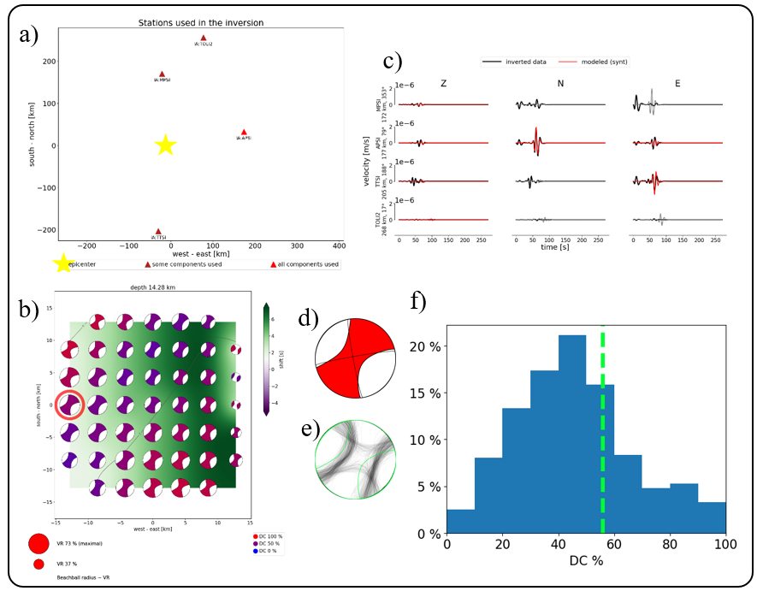
Fig. B1 Event No. 1, ID: bmg2012qevb

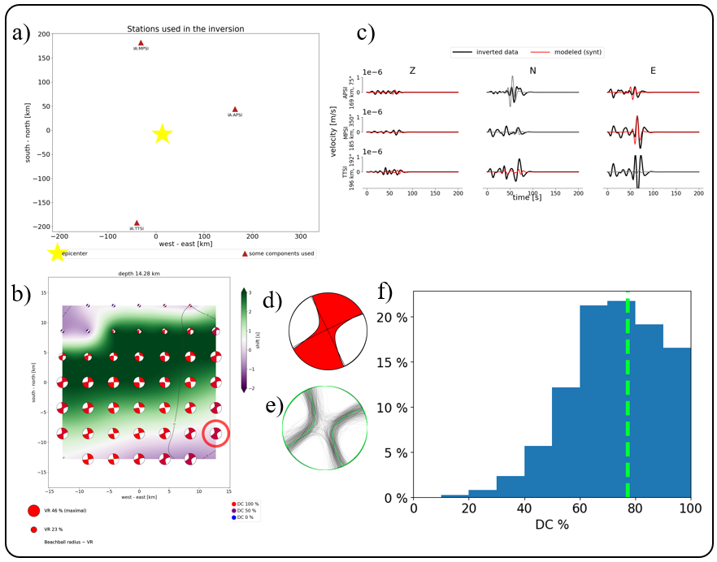
Fig. B2 Event No. 2, ID: bmg2012qevh

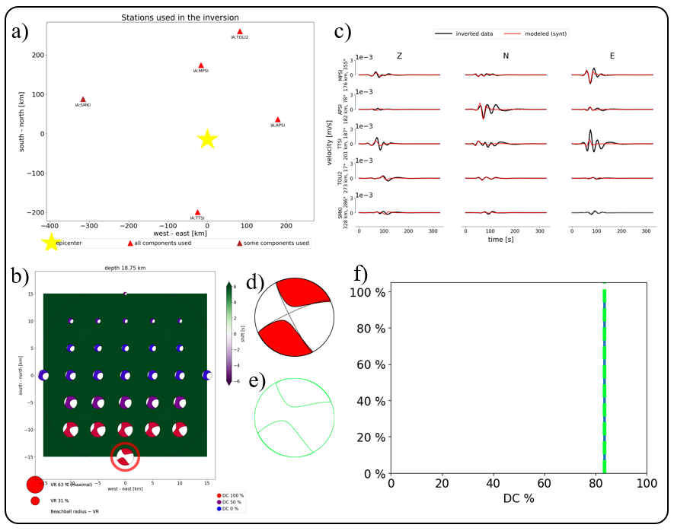
Fig. B3 Event No. 3, ID: bmg2012qeyx

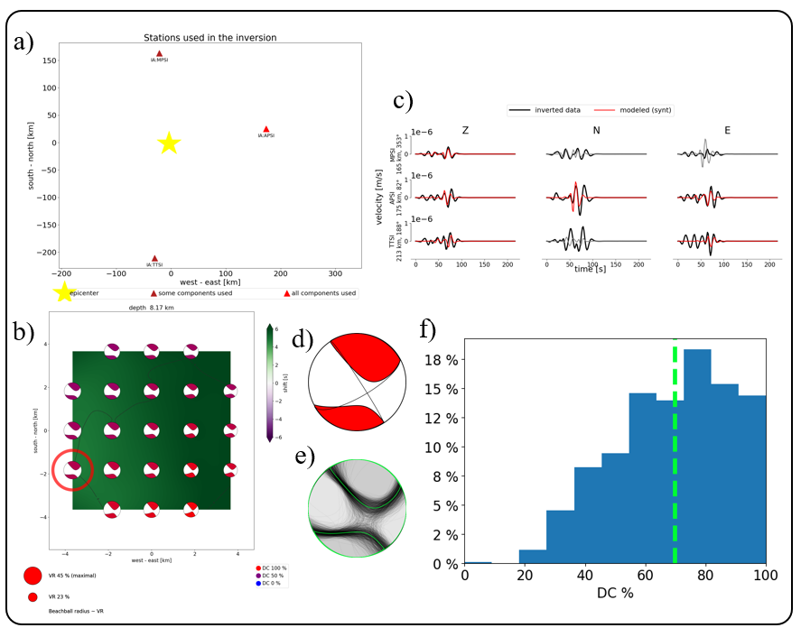
Fig. B4 Event No. 4, ID: bmg2012qfct

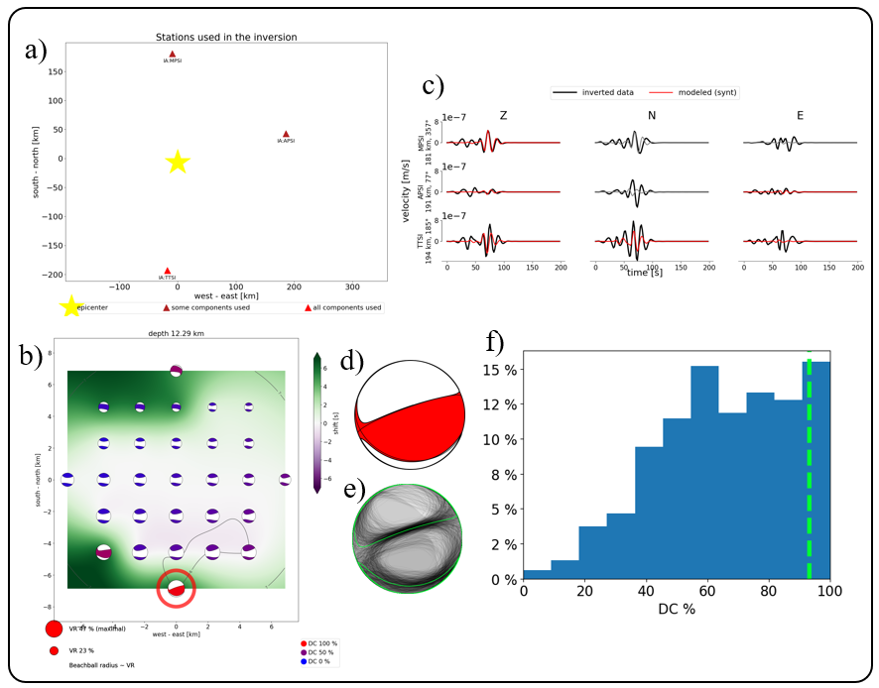
Fig. B5 Event No. 5, ID: bmg2012qffi

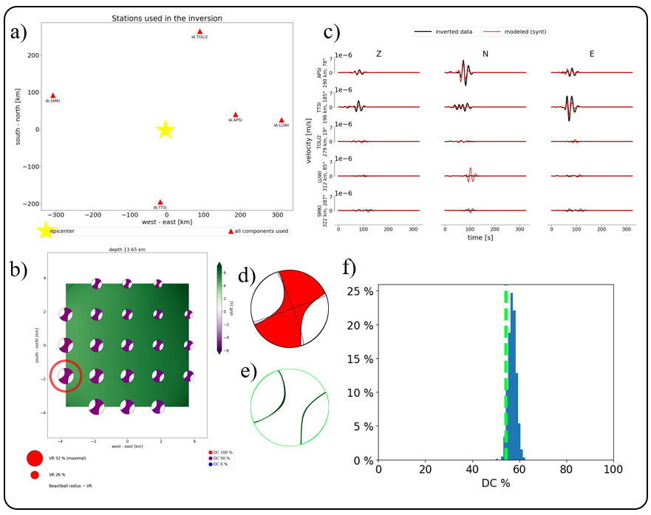
Fig. B6 Event No. 6, ID: bmg2012qfha

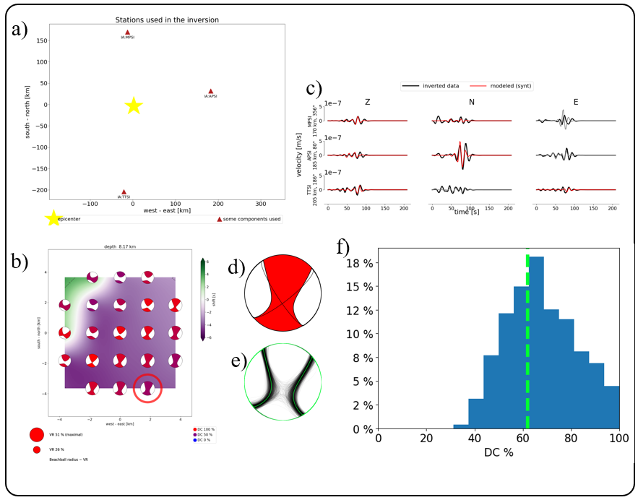
Fig. B7 Event No. 7, ID: bmg2012qfjl

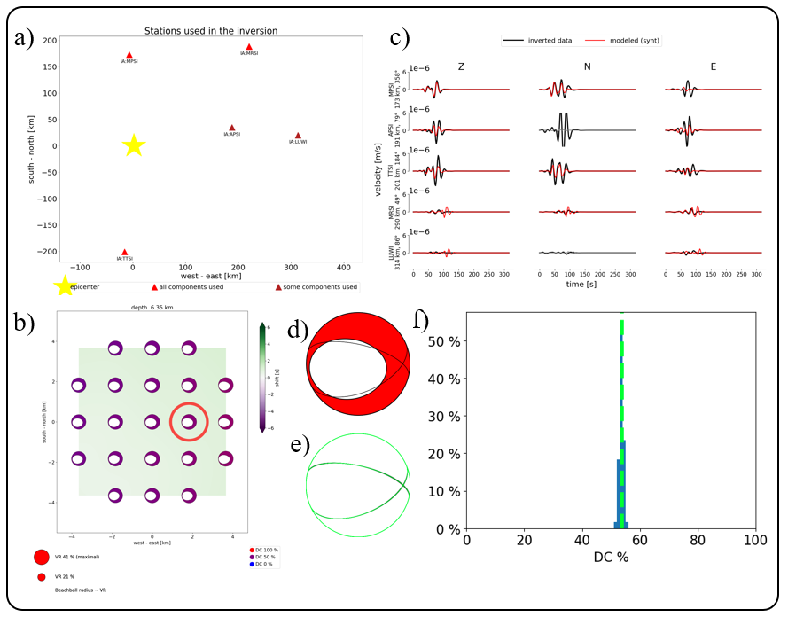
Fig. B8 Event No. 8, ID: bmg2012qfjz

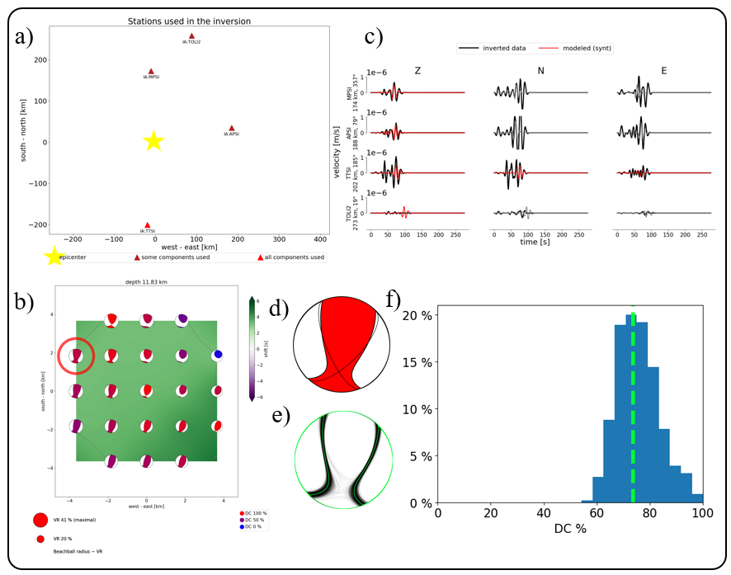
Fig. B9 Event No. 9, ID: bmg2012qgdg

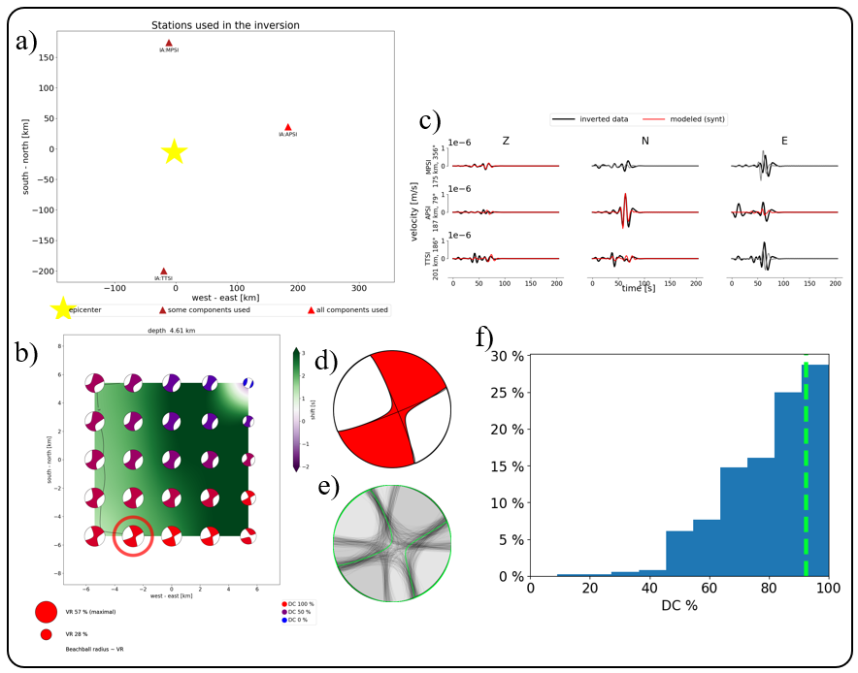
Fig. B10 Event No. 10, ID: bmg2012qhse

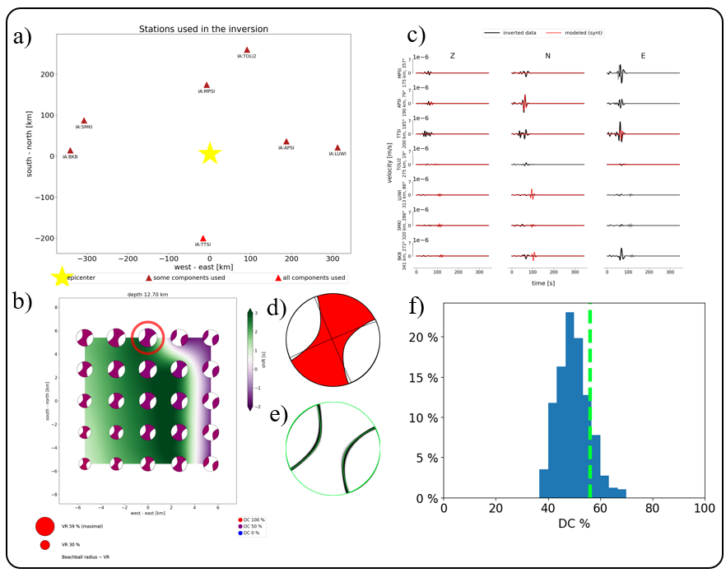
Fig. B11 Event No. 11, ID: bmg2012qptw

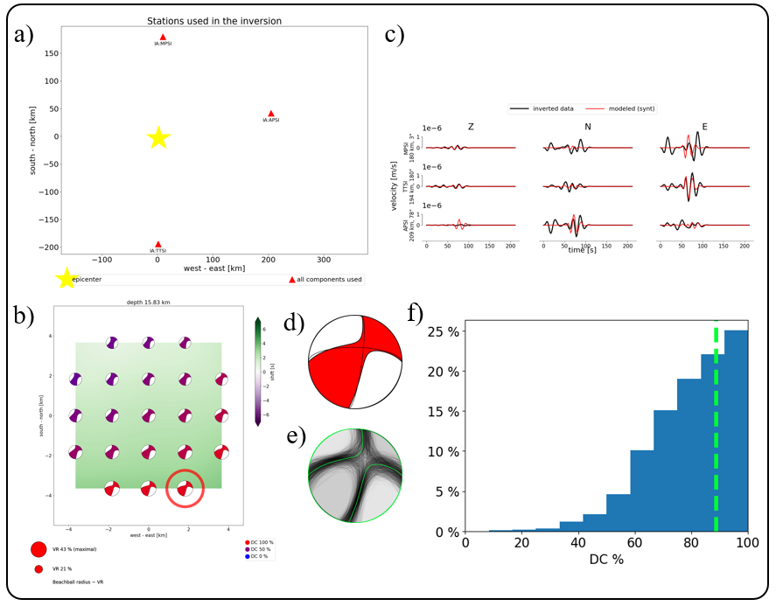
Fig. B12 Event No. 12, ID: bmg2012rfwq

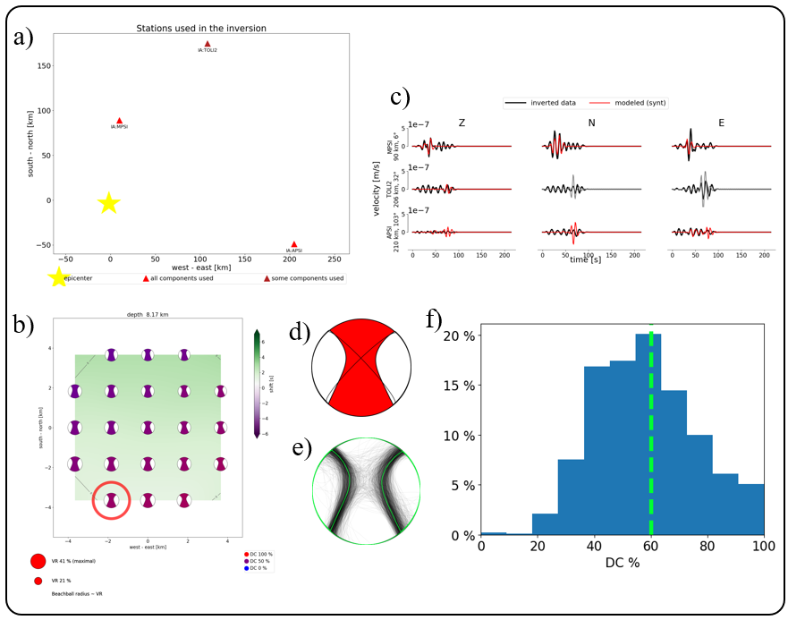
Fig. B13 Event No. 13, ID: bmg2012rkdn

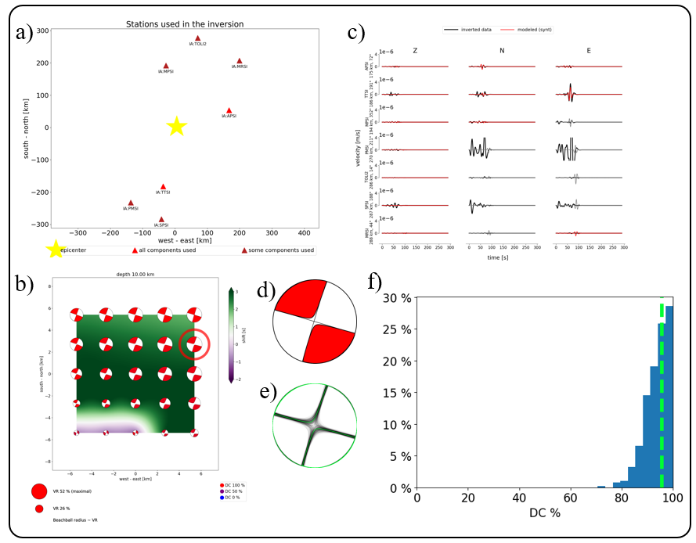
Fig. B14 Event No. 14, ID: bmg2012rzpx

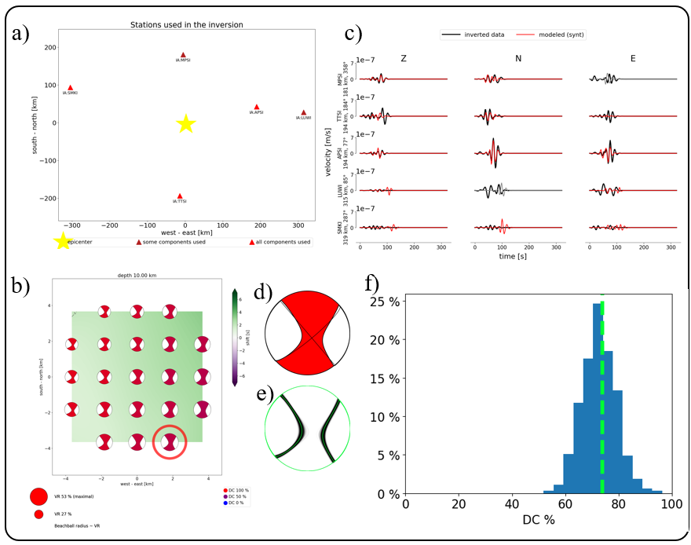
Fig. B15 Event No. 15, ID: bmg2012yxpw

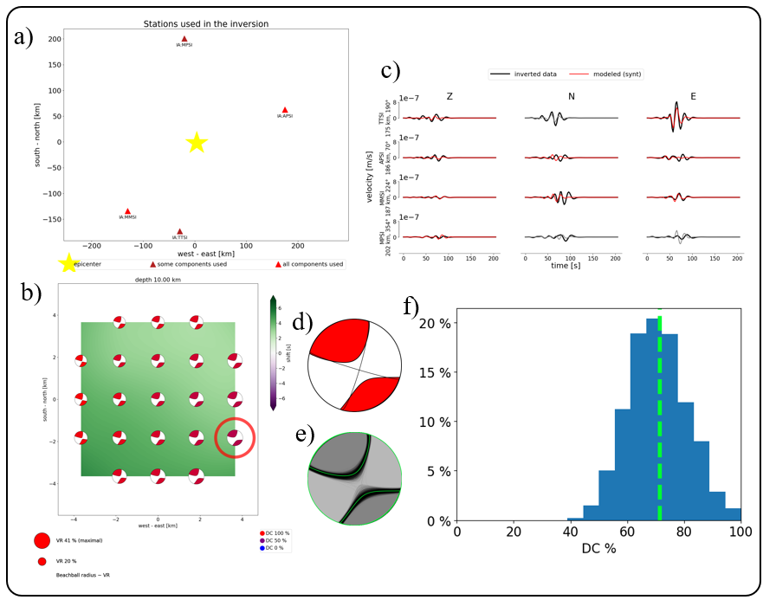
Fig. B16 Event No. 16, ID: bmg2012zmij

