Appendices

Appendix A – Violin Plot of Continuous Variables Measured in the in vivo Testing.
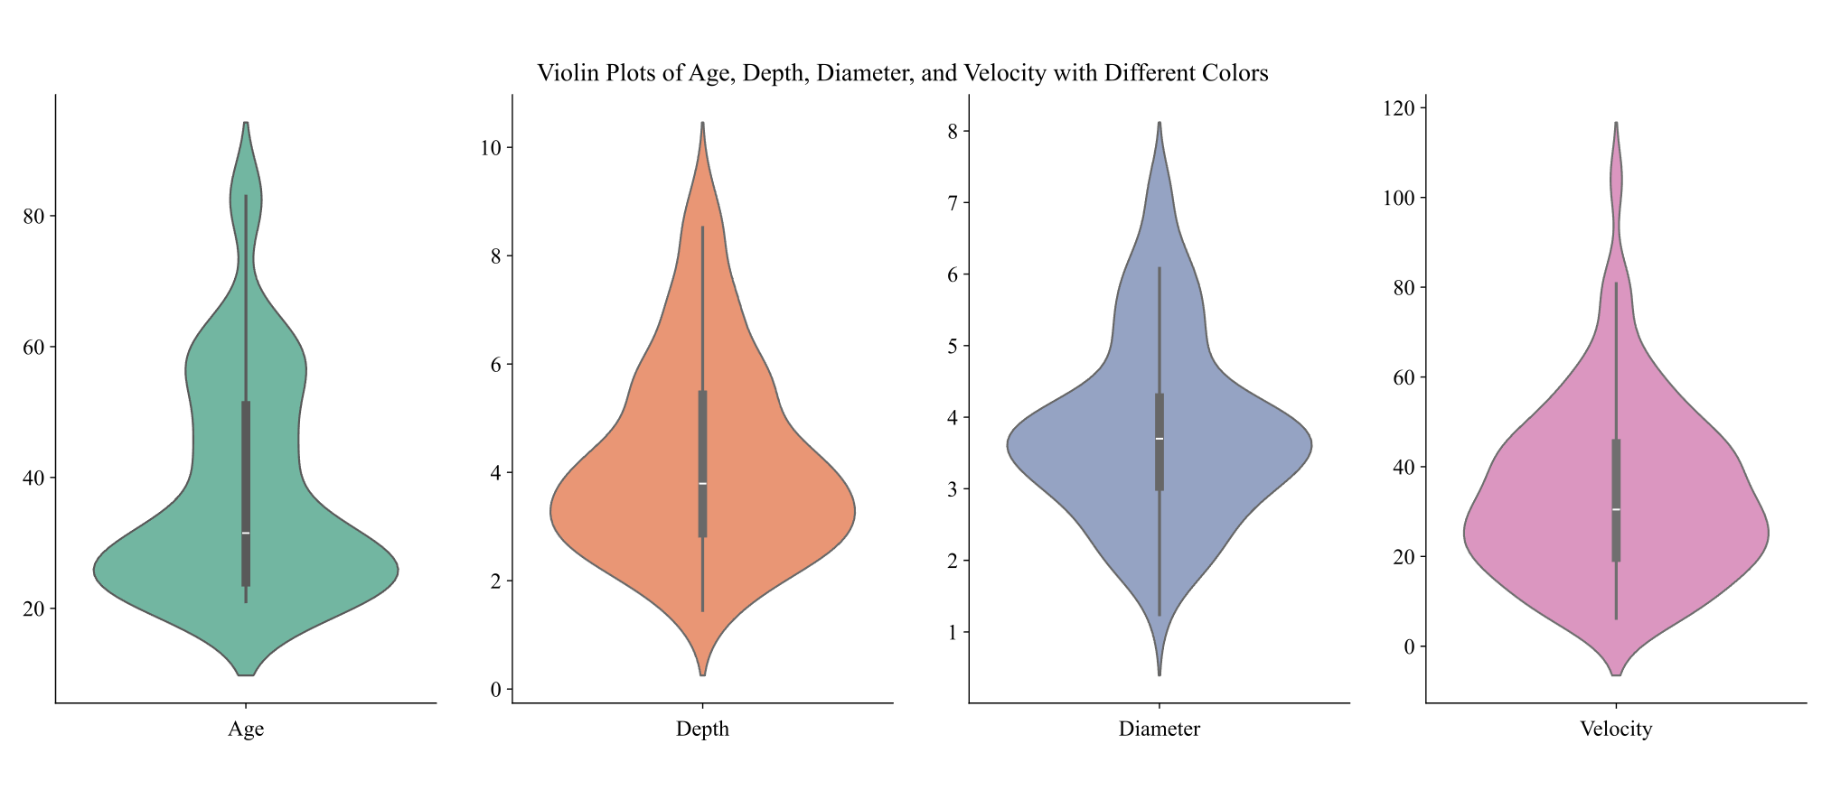
Figure A.1: Continuous variable distribution of age, depth, diameter, and velocity. Across 40 arms (80 vessels), the mean participant age was 38.2 (ranging 21 - 83), vessel depth was 4.24mm (ranging 1.45 – 9.26mm), vessel velocity was 19.02mm/s (ranging 6.20 – 104.00 mm/s), and vessel diameter was 3.80mm (ranging 1.24 – 7.27 mm).

Appendix B – Gelatin Phantom Manufacturing Process
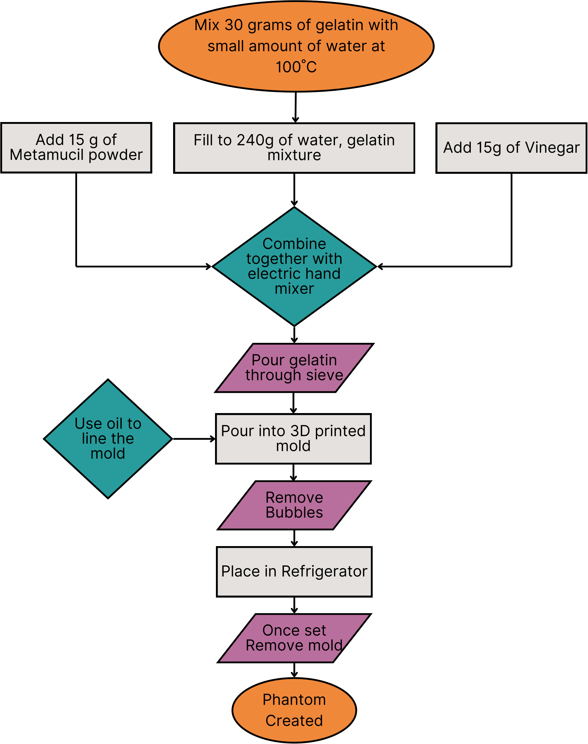

Figure B.1. : Flowchart describing gelatin phantom manufacturing process.

Appendix C –Vessel Characteristic Validation

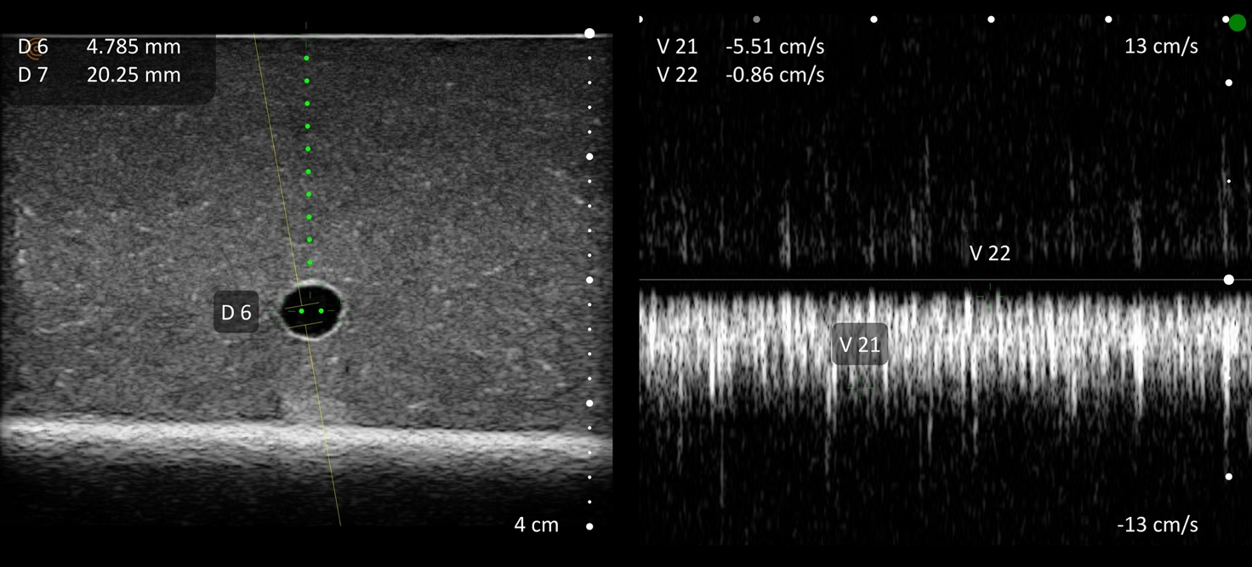
Figure C.1. : Example vessel characteristic validation measurement using ultrasound probe. The image shows a vessel with 4.79mm diameter, 20.25mm depth, and 55.1mm/s, as measured by the ultrasound scanner [Clarius L15 HD3 High Frequency Linear Ultrasound Scanner, Vancouver, Canada]. This phantom was used to represent a vein with 5mm diameter, 20mm depth and 50mm/s flow rate.

Appendix D – Usability
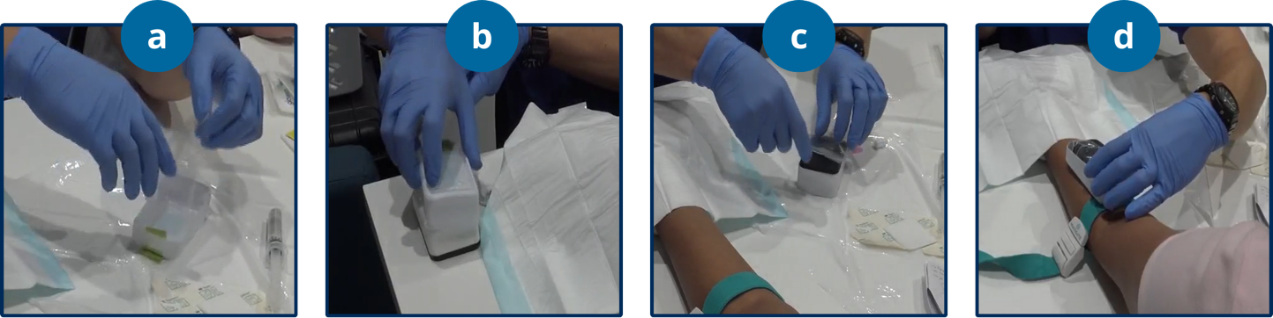
Table D.1. Key tasks and acceptance criteria assessed during the usability study. Participating clinicians were asked to complete each of the listed tasks while maintaining their sterile field. A breach of sterility was assessed whenever contact was made between a non-sterile component and sterile component. A task was deemed successful when the acceptance criteria was completed.
Tasks | Acceptance Criteria
Deploying Sheath
Prepare sterile field | All materials (cannula, dressing, flush, gloves, cleaning swab) required for cannulation unpackaged in a sterile manner and placed on the sterile field.
Unpackage sheath | The clinician removes the contents of a sheath package onto the sterile field while maintaining sterility of the field.
Peel internal layer (device-sheath) to expose gel (a) | The sterile clinician removes the internal peelable layer and maintains sterility of themselves and the field.
Attach sheath to device (b) | The sterile clinician attaches the sheath to the device and maintains sterility of themselves and the field.
Secure sheath across screen  (c) | The sterile clinician secures the sheath across the entire surface of the device and maintains sterility of themselves and the field.
Peel external layer (sheath-patient) to expose gel | The sterile clinician removes the external peelable layer and maintains sterility of themselves and the field.
Performing mock cannulation
Place device on arm (d) | The sterile clinician places the device on the patients arm in the correct orientation (screen is facing the clinician).
Use cannula to mock cannulate | The sterile clinician places the cannula at the centre of the device and performs a mock cannulation with the device still on the patient.
Removing sheath
Take device out of sheath | The clinician successfully removes the device out of the sheath.
Clean device | The clinician successfully cleans the device with provided wipes.
Dispose of sheath | The clinician disposes of the sheath with the other material waste.

