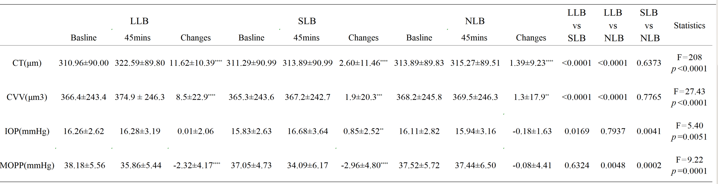
Table 1 . Parameter at baseline, affter 45minutes’ lunch break and their changes (Mean ± SD)

IOP: Intraocular pressure; MOPP: Mean ocular perfusion pressure; CVV: Choroidal vascular volume; CT: Choroidal thickness;
LLB: Lying lunch break；SLB : Sitting head-on-arms lunch break NLB: Sitting no lunch break.
Basline: mean value before lunch break; 45mins: mean value after 45 minutes’ lunch break;
Changes: D-value before and after lunch break.
*Statistically significant difference between basline and 45mins’ lunch break (paired t-tests, ** p＜0.01; *** p＜0.001; **** p＜0.0001.).
Comparing mean changes in pairs by repeated measures ANOVA: LLB vs SLB、LLB vs NLB、SLB vs NLB ，p＜0.05 suggests significance.

