Supplementary Materials: Upregulation of KAT6A and KAT6B in invasive ductal breast carcinoma (IDC).

Β-actin
KAT6A
Figure S1. Original western blot images for KAT6A, KAT6B and b-actin; M – protein standard marker. (Figure 5)

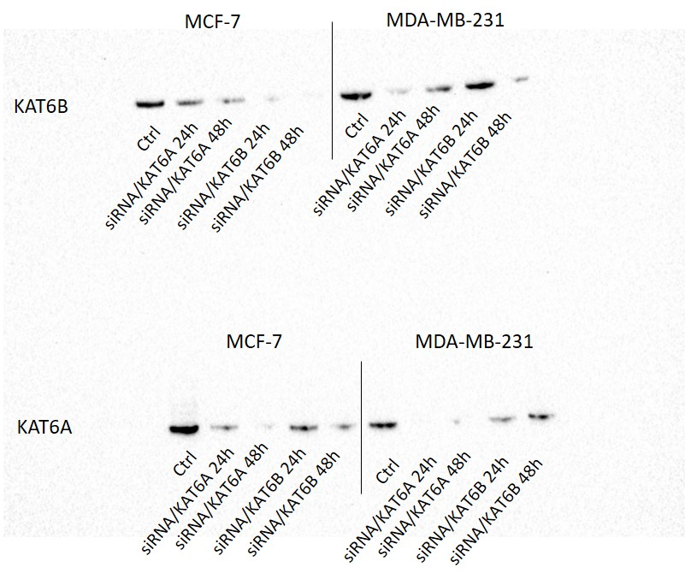
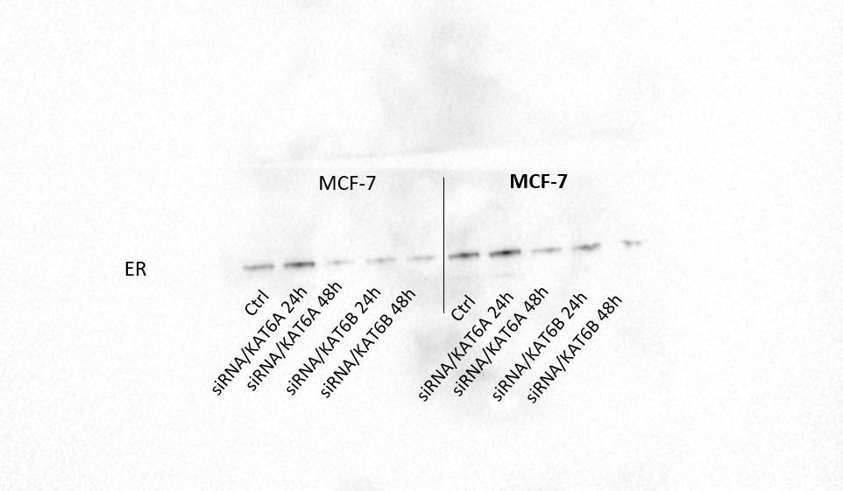
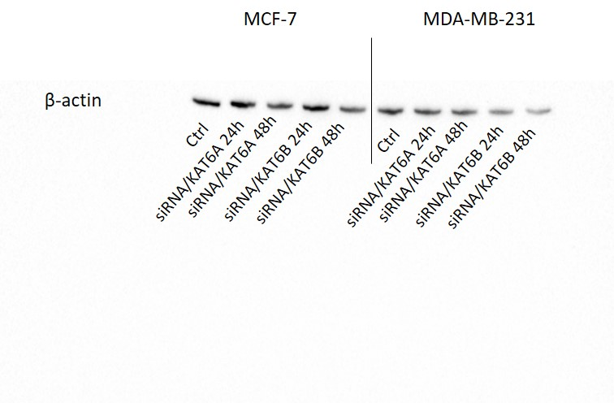

Figure S2. Original western blot images for KAT6A, KAT6B, ERα and b-actin. (Figure 6)

