Supplementary Information for
Direct observation of layer skyrmions in twisted WSe₂ bilayers

Fan Zhang^{1†}, Nicolás Morales-Durán^{1†}, Yanxing Li^{1†}, Wang Yao², Jung-Jung Su³, Yu-Chuan Lin^{4,5}, Chengye Dong⁴, Xiaohui Liu¹, Fu-Xiang Rikudo Chen¹, Hyunsue Kim¹, Kenji Watanabe⁶, Takashi Taniguchi⁶, Xiaoqin Li¹, Joshua A. Robinson⁴, Allan H. Macdonald^{1*}, and Chih-Kang Shih^{1*}

¹Department of Physics, University of Texas at Austin, Austin, TX, USA
²Department of Physics, The University of Hong Kong, Hong Kong, China
³Department of Electrophysics, National Yang Ming Chiao Tung University, Hsinchu, Taiwan
⁴Department of Materials Science and Engineering, Pennsylvania State University, University Park, PA, USA
⁵Department of Materials Science and Engineering, National Yang Ming Chiao Tung University, Hsinchu, Taiwan
⁶Research Center for Materials Nanoarchitectonics, National Institute for Materials Science, Tsukuba, Japan

†These authors contribute equally to this work.
*Corresponding authors’ email: macdpc@physics.utexas.edu; shih@physics.utexas.edu

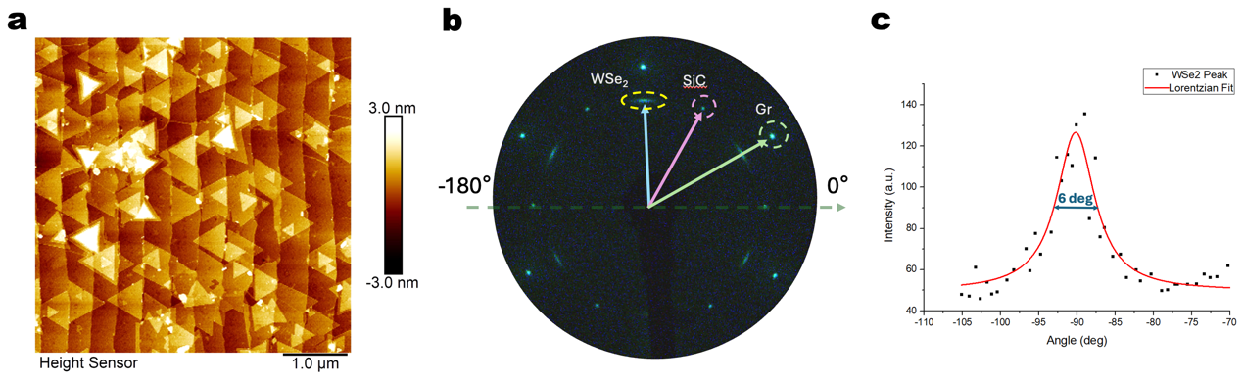
Figure S1 | Angle distribution of WSe₂ flakes in MOCVD grown WSe₂/Graphene sample. a, A typical AFM image of the MOCVD grown WSe₂/Graphene sample showing monolayer, bilayer and twisted bilayers WSe₂ flakes. b, LEED measurement of the sample. c, Dotted and fitted gaussian profile showing there is angle distribution indicating existence of twisted bilayers.

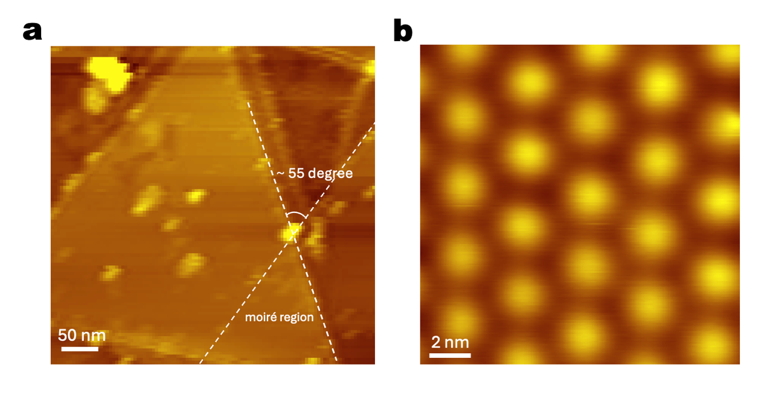
Figure S2 | Large scale STM images of 5.1-degree twist moiré region. a, Large scale STM image showing the ~5.1-degree twist between R stacked flakes with moiré region indicated. b, Zoom-in STM image showing the moiré pattern with a periodicity of 3.7 nm

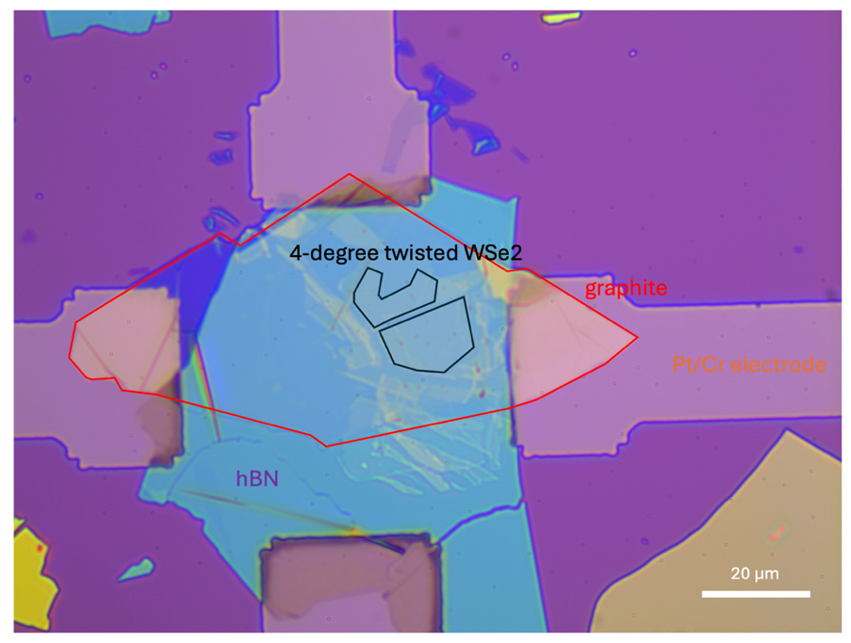
Figure S3 | Optical image of 4.2-degree twisted tear-and-stack WSe₂ sample. The twisted WSe₂ bilayer/graphite/hBN/Si structure is made using the exfoliation and stack method with each individual material flake marked with different colors in the image.
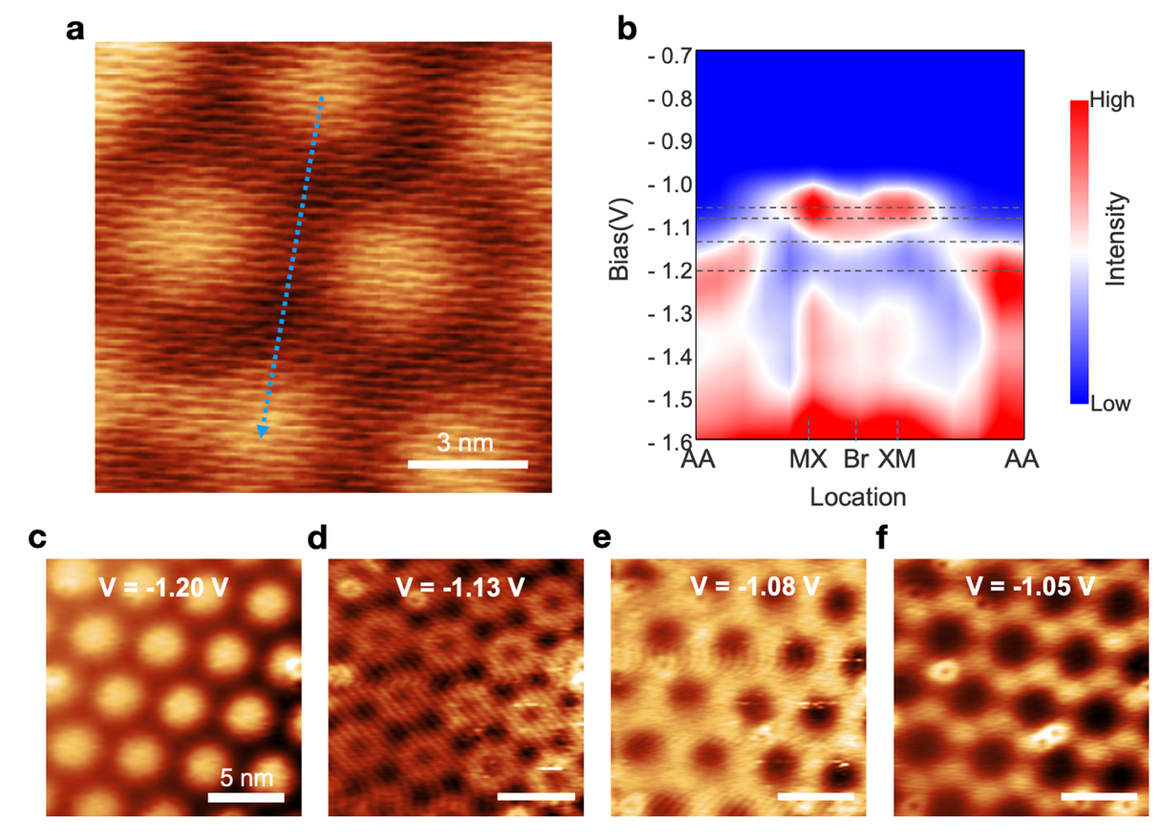
Figure S4 | Gamma valley moiré modulation in a 4.2-degree twisted tear-and-stack WSe₂ sample. a, Topography b, Constant-height STS color map along AA-MX-Br-XM-AA. c-f, dI/dV mappings obtained at different bias as labeled in each panel. (I = 100 pA). Scale bar: 5nm.
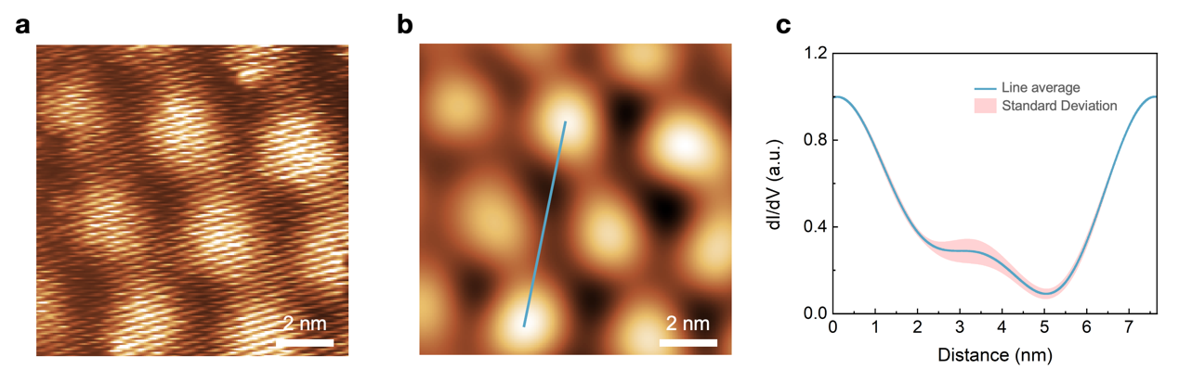
Figure S5 | Constant height conductivity image of 4.2-degree twisted WSe₂ at K valley. a, Constant height dI/dV images at (Vs= −0.85 V, I = −100 pA) b, Filtered dI/dV image by removing the Bragg peak in the FFT of a. Scale bar: 2nm. c, averaged line profile and standard deviation of 5 different lines along the AA-XM-Br-MX-AA symmetric sites. For line profiles with uneven AA site intensities, they were symmetrized by multiplying position dependent linear coefficient and then renormalized with the intensity of AA site set as 1.

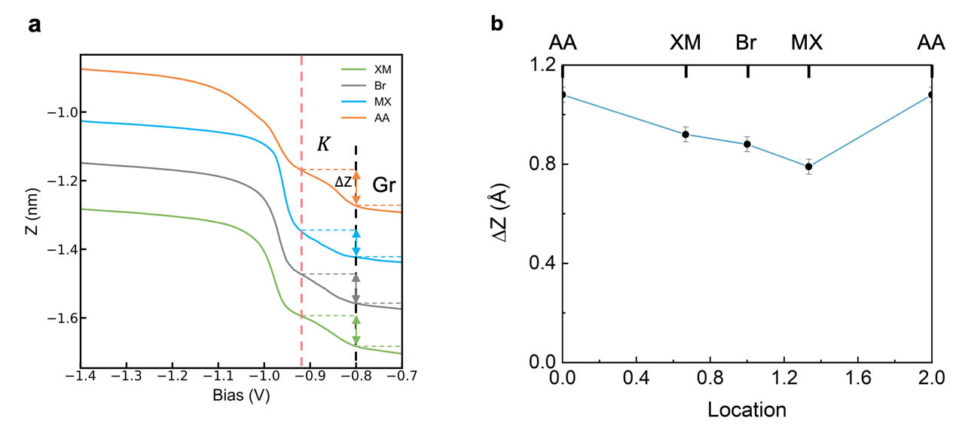
Figure S6 | The change of tip-to-sample-distance ($∆Z$) of 5.1-degree twisted WSe₂ at K valley. a, Z–V spectroscopies respectively from sites AA, MX, Br and XM. (I_{int} = −100 pA) b, The change of tip-to-sample-distance ($∆Z$) as marked by the colored arrows in a for sites AA, XM, Br, MX are estimated to be 1.08 $Å$, 0.79 $Å$, 0.88 $Å$ and 0.92 $Å$. This $∆Z$ difference among four sites directly reflect the K valley density of states difference, with highest density of state at AA site and lowest at MX site, which is consistent with the CC-STS measurements at K valley.
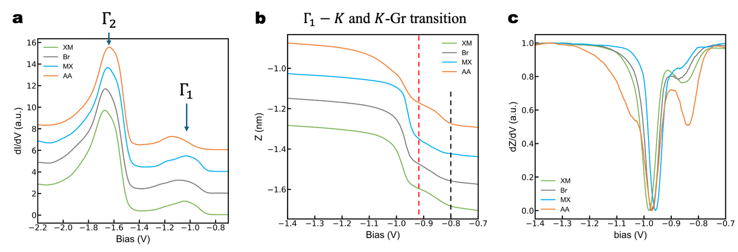
Figure S7 | Large-scale CHSTS and ZV spectra at high symmetry sites in the moiré superlattice of 5.1-degree twisted WSe₂. a, Large scale constant height STS (V_{int} = −2.2 V, I = −100 pA and V_{amp} = 30 mV) and b, Z–V and c, (∂Z/∂V)_{I} spectroscopies respectively from sites AA, MX, Br and XM. (I_{int} = −100 pA) The red dashed line in b marks the transition from Γ valley to K valley and the black dashed line marks the transition from K valley to graphene state.

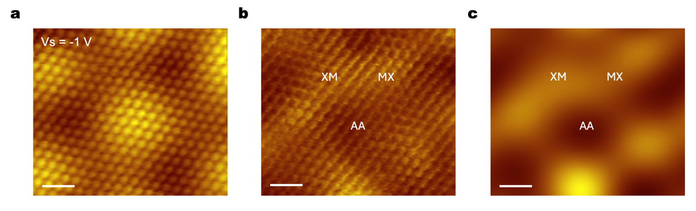
Figure S8 | dI/dV mapping of 5.1-degree twisted WSe₂ at the Γ valley. a-b, Topography and constant height dI/dV images at (Vs= −1 V, I = −40 pA), which is inside the Gamma valley. c, Filtered dI/dV image by removing the Bragg peak in the FFT of b. Scale bar: 1nm.

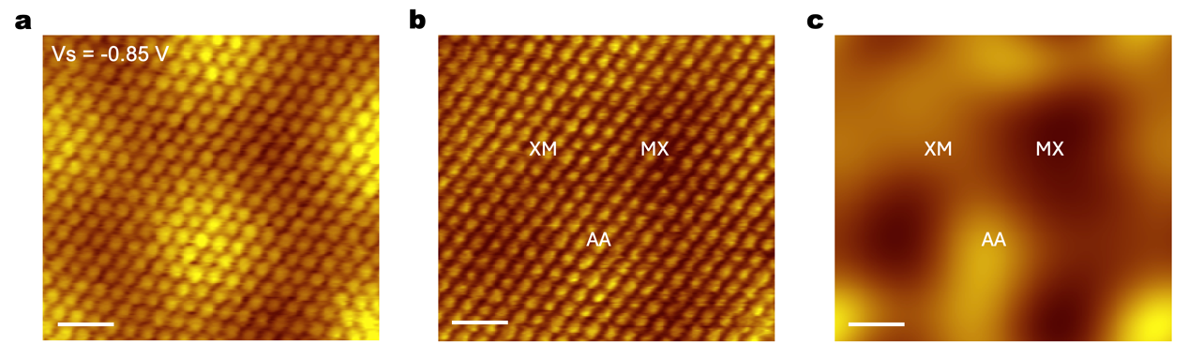
Figure S9 | Topography and constant current conductivity image of the same region of 5.1-degree twisted WSe₂ in Figure 3d-e. a-b, Topography and constant current dI/dV images at (Vs= −0.85 V, I = −40 pA) c, Filtered dI/dV image by removing the Bragg peak in the FFT of b. The relative intensity between different sites agrees well with constant height dI/dV shown in Fig. 3e. Scale bar: 1nm.

Supplementary Note 1

Azimuthal components of the layer pseudospin
For the layer pseudospin, the z-component is a physical observable carrying electrical polarization (therefore measurable using STS). The azimuthal component, which corresponds to the phase difference between electrons in different layers, is not directly measurable by STS. In our work, we map the measured LDOS texture to the full-layer pseudospin texture through the parameterized continuum model whose parameters are determined via fitting the experimentally determined LDOS texture.
Note that the layer pseudospin is fundamentally different from the valley pseudospin recently discussed by Liu et al (DOI: 10.1126/science.abm3770) concerning intervalley coherence in graphene at zero Landau Level (ZLL). There, the K-states exist in A-sublattice and K’- states in B-sublattice. Thus, the inter-valley pseudo-spin is directly reflected by atomic scale contrast in A-B sublattices. Intervalley coherence means that there is macroscopic coherence between valleys K and -K=K’ that gives rise to an interference pattern that varies in space like $Vexp(iφ)exp\left(i\left(K-K^{'}\right)∙r\right)$. Since K and K’ are on the valley corners this gives rise to a periodicity pattern that varies over a three sublattice unit cell. The length scale that depicts the spatial variation of the coherence order parameter is much larger, thus it can be measured locally at each point in space. Unfortunately, such a scenario does not exist for the layer pseudospin discussed in our case.

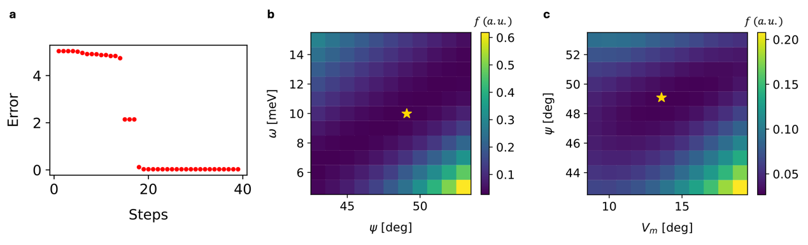
Figure S10 | The evolution of fitting error function $f= I_{expriment}-I_{theory}$ as a function of iterations and as a function of some of the continuum model parameters (V_{m}, ψ, ω). a, error evolves as a function of the number of iterations b, $f$ as a function of ψ, ω with a fixed $V_{m}=13.6$ meV, c, $f$ as a function of V_{m}, ψ with a fixed ω = 10.0 meV. The yellow star marks the position in the parameter space where $f$ is minimized.

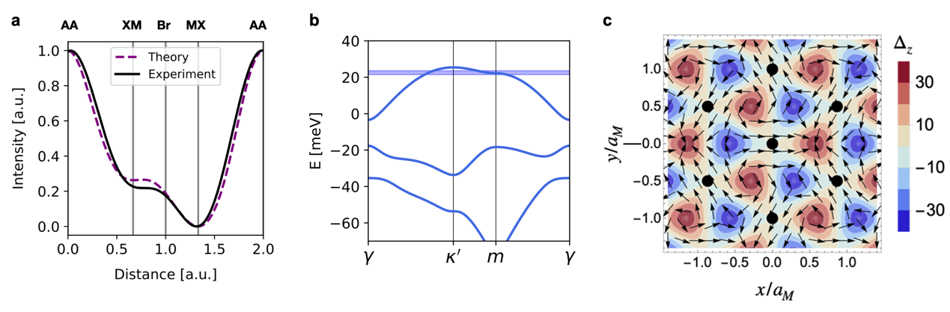
Figure S11 | Obtaining continuum model parameters from STS of 4.2-degree twisted WSe₂. a, Fit of the position-dependence of the layer-weighted LDOS near K_{VBM}. The black solid and purple dashed lines are respectively experiment and theoretical fit. The continuum parameters extracted from the fitting: $V_{m}=7.0$ meV, $ψ=90.1$degrees, $ω=24.4$meV and $m_{eff}=0.6m_{0}$. b, Moiré band-structure calculated with parameters obtained by fitting conductivity profile data along the high symmetry direction AA-XM-Br-MX-AA. The faint blue energy window marked where the theoretical LDOS curve in a is obtained. c, Layer-field $Δ$ with arrows corresponding to the x and y components and color-scale corresponding the z component. Black dots indicate moiré superlattice AA sites.

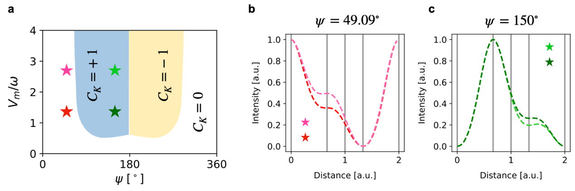
Figure S12 | Relationship between Chern number of the topmost moiré band and position-dependent LDOS. a, Topological phase diagram of the topmost moiré band. b-c, Position-dependent LDOS profiles (dashed lines) for different values of the continuum model parameter: red dashed line ($ψ=49.1$ degree, $V_{m}=13.6$ meV, $ω=10$ meV), pink dashed line ($ψ=49.1$ degree, $V_{m}=13.6$ meV, $ω=5$ meV); green dashed line ($ψ=150$ degree, $V_{m}=13.6$ meV, $ω=10$ meV), light green dashed line ($ψ=150$ degree, $V_{m}=13.6$ meV, $ω=5$ meV) as marked by colored stars in a.

