Contents

1 Introduction to intrinsic physics-adaptive learning 2
1.1 Advantages and challenges of fully analogue neuromorphic networks 2
1.2 Limitations of the BP algorithm for fully analogue neuromorphic networks 5
1.3 Intrinsic physics-adaptive learning 5
1.4 Mathematical proof of intrinsic physics-adaptive learning 8
1.5 Comparison between IPAL and BP 10
2 Experimental implementation of IPAL 12
2.1 Description of hardware system 12
2.1.1 PCB system 12
2.1.2 Analogue in-memory computing array and activation unit chips 13
2.1.3 Lego-like assembly of neuromorphic hardware 13
2.2 Implementation procedure of IPAL 14
3 Supplementary results 16
3.1 Training a single-layer analogue network for XOR classification 16
3.2 Supplementary results of Fig. 3 16
3.3 Supplementary results for demonstrating hardware-fault-tolerance 18
3.3.1 Restoration of synapse-defective neuromorphic networks 18
3.3.2 Restoration of neuron-defective neuromorphic networks 27
3.3.3 Restoration of hybrid-defective neuromorphic networks 30
4 Supplementary Video 33

Introduction to intrinsic physics-adaptive learning
In this section, we will first discuss the advantages of fully analogue neuromorphic networks and the challenges they pose in mathematical modelling (Section 1.1). One of the main challenges arises from the inconsistency between the actual behaviour of complex analogue hardware systems and their mathematical models. This inconsistency leads to incorrect gradients during the learning process when using the backpropagation (BP) algorithm, which ultimately impacts the training efficiency and accuracy of the neuromorphic networks. In some cases, it can even cause failure in the training process (Section 1.2). For this reason, how to effectively train the fully analogue neuromorphic networks is a challenging topic in the field of analogue AI. Subsequently, we use a hardware-based method (termed intrinsic physics-adaptive learning, IPAL) leveraging the intrinsic characteristics of physical systems to train analogue neuromorphic networks. This method can effectively train fully analogue neuromorphic networks without any mathematical model, overcoming the limitations of BP (Section 1.3). Moreover, we provide a mathematical proof of the IPAL algorithm (Section 1.4). We also compare the IPAL with the BP approach, showcasing their differences in methodology (Section 1.5).

Advantages and challenges of fully analogue neuromorphic networks
In conventional digital hardware, memory units and processing units are separated, resulting in frequent data movements between them, high energy consumption, and a performance bottleneck. Additionally, computations in traditional digital hardware are predominantly executed serially, consuming a significant amount of time and constraining system performance. As a result, the implementation of neural networks on digital hardware leads to high energy consumption, which limits the development of artificial intelligence.
Recent studies on implementing analogue neuromorphic networks in physical systems aim to enhance computing energy efficiency. Analogue hardware can perform in-memory computing by harnessing physical principles, eliminating data movements, and significantly improving the energy efficiency of the computing system. Notably, analogue in-memory computing (AIMC) arrays exhibit distinct advantages over digital systems in terms of area, energy, time, and parallelism, particularly in vector-by-matrix multiplication computations.
To implement a deep neuromorphic network, multiple AIMC arrays as well as activation units are required. Some neuromorphic networks still rely on digital hardware to implement activation functions, resulting in the need for A/D (Analogue-to-Digital) and D/A (Digital-to-Analogue) converters in the hidden layers, as shown in Fig. S1. This leads to frequent data conversion between analogue and digital systems, greatly increasing the system's energy consumption. Moreover, data obtained by A/D converters needs to be transmitted to the digital processor for computing and then sent back to D/A converters for analogue outputs, resulting in extensive data transmission and unnecessary energy consumption. On one hand, using multiple A/D converters to read data in parallel would occupy a large chip area, posing challenges to achieve large-scale integration. On the other hand, using a single A/D converter to read data in a serial manner would lead to frequent data movement between storage units and the A/D converter, further causing additional energy consumption and making it difficult to improve parallelism. Consequently, to unlock the full potential of analogue computing, it is imperative to construct fully analogue neuromorphic networks in physical systems, in which activation functions are realized using analogue hardware. This approach can eliminate data conversion in hidden layers and reduce the use of A/D and D/A converters.

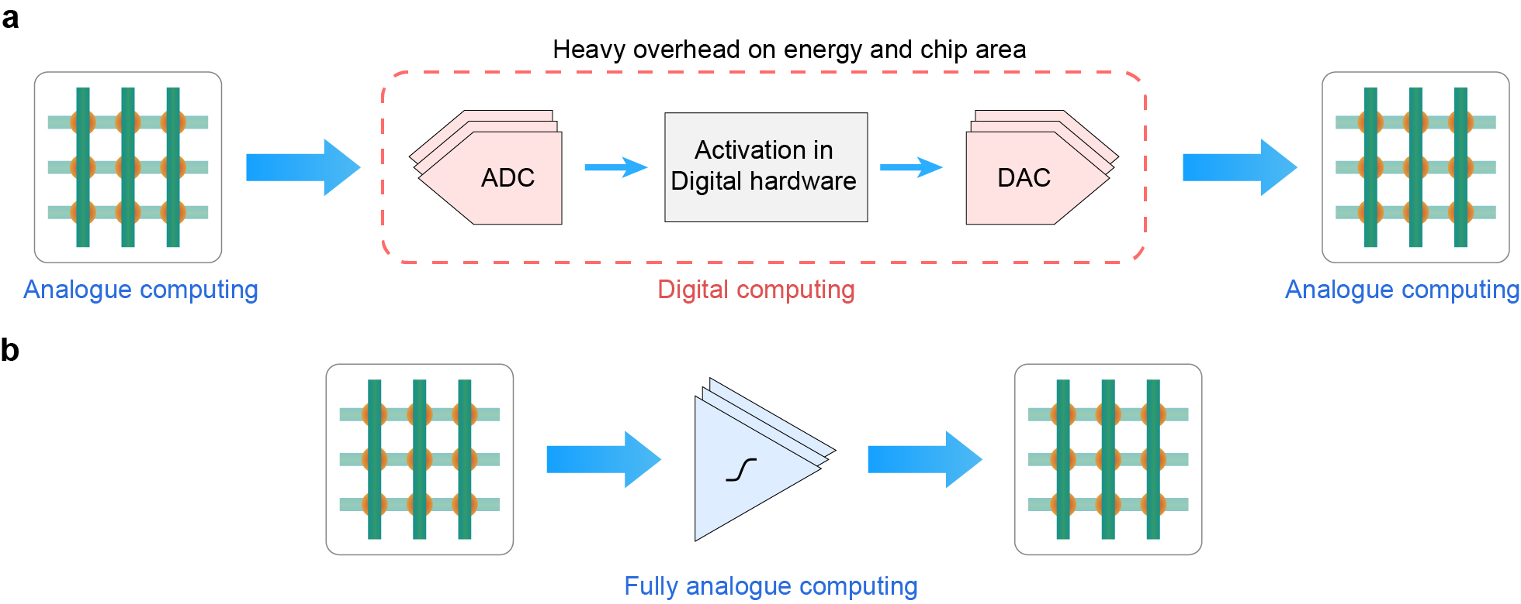
- | Fully analogue computing systems. a, Combining the analogue hardware with digital systems results in frequent data conversions, which cause a heavy overhead on energy and chip area. b, In fully analogue computing systems, analogue-to-digital conversion is unnecessary in the hidden layers.
The traditional BP algorithm is not suitable for fully analogue neuromorphic networks. The implementation of BP requires knowledge of the exact mathematical model to compute derivatives of loss with respect to parameters. Since digital systems executing explicit digital instructions can realize exact mathematical neural network models, BP has been a crucial algorithm for training deep neural networks in digital computing systems. In contrast, in fully analogue neuromorphic networks, the forward pass is determined by the physical processes. Implementing BP to train the fully analogue neuromorphic networks needs to build mathematical models of the physical systems first. However, it is almost impossible to obtain an exact mathematical model of the fully analogue neuromorphic network for the following reasons:
(1) Model complexity. When physical systems contain nonlinear behaviours, the model of the entire system becomes exceptionally complicated, making theoretical analysis challenging. For example, when we try to model the circuit shown in Extended Data Fig. 1d, the transfer function of the circuit involves the Lambert W function, which is difficult to calculate or solve. For more intricate circuits, their transfer functions will become even harder to express, making it challenging to construct a mathematical model. Especially in a deep analogue neuromorphic network involving multiple nonlinear layers, the modelling errors will accumulate and become unmanageable.
(2) Fabrication variations and defects. In analogue hardware, fabrication variation and defects refer to the inherent differences or unintended imperfections, which arise during the manufacturing process of analogue circuits. Fabrication variations and defects can lead to device mismatch, component parameter variations, and even functional failures, which further cause uncertain and uncontrollable differences in the physical characteristics among individual devices. These indicate that the real system will differ from its theoretical model, making the circuit models imprecise.
(3) Degradation and failure of components. In fact, the characteristics of electrical components are changing over time, due to some inevitable factors such as thermal diffusion, stress, materials aging. In particular, since the switching behaviours of the emerging non-volatile memory devices (e.g., RRAM, PCM, FLASH) involve dramatic changes in material states, component degradation is a common phenomenon. Therefore, the number of write-erase cycles in non-volatile memory cells is limited, causing the risk of failure after massive programming operations. The degradation and failure of components cause more variations in the system compared to the original hardware. These dynamic changes pose numerous obstacles to building a reliable mathematical model.
(4) Parasitic effects. Parasitic effects refer to unintended and undesirable electrical characteristics such as parasitic capacitance and resistance, which are inevitable as they stem from the inherent properties of the hardware. Parasitic effects are associated with multiple factors including manufacturing processes and hardware architectures, which are difficult to be predicted precisely and considered comprehensively during large-scale circuit modelling, further amplifying the discrepancies between the real system and the mathematical model.

Limitations of the BP algorithm for fully analogue neuromorphic networks
The BP algorithm uses the chain rule to compute gradients layer by layer, starting from the loss in the last layer of the neuromorphic network. This approach requires an accurate mathematical model that describes the forward pass of the network. Because the chain relationship is backpropagated and computed from the forward pass of the neuromorphic network, which is so called backpropagation. In general, it’s difficult to use fully analogue neuromorphic networks to directly implement backpropagation.
Section 1.1 has elaborated that modelling a forward pass of the fully analogue neuromorphic network is exceptionally difficult, and an exact mathematical model is even non-existent. Since the BP algorithm calculates the gradients of the loss with respect to parameters by backpropagating layer-by-layer, an inexact model can lead to error accumulating and propagating through the neuromorphic network, even resulting in the failure of training. Therefore, BP cannot be directly used to train fully analogue neuromorphic networks, as BP relies on mathematical models but constructing exact models of the physical systems is extremely challenging. The small inconsistencies between the real physical system and mathematical model will lead to imprecise backpropagation, decreasing the training efficiency and accuracy performance of the neuromorphic network. Moreover, the huge inconsistencies may even lead to the failure in training due to the excessive error in the backward pass.

Intrinsic physics-adaptive learning
To overcome the limitations of the traditional BP algorithm, in this section, we present a physical operation-based approach to effectively train fully analogue neuromorphic networks without exact mathematical models. The approach, called intrinsic physics-adaptive learning (IPAL), uses the intrinsic characteristics of physical systems to obtain the gradients of loss with respect to the parameters of the neuromorphic networks. As described in the main text, IPAL obtains the gradients of loss by applying perturbation signals in the physical system. A physical perturbation signal is injected into a node of the analogue neuromorphic network, propagates through the network, and causes a small change in the loss value, which is then used to compute the gradient of loss using the finite difference method. In contrast to BP, the implementation of IPAL is based on the intrinsic properties of the physical system, eliminating the requirement of mathematical modelling. A more detailed mathematical description of IPAL is provided in Section 1.4, which demonstrates the feasibility of the IPAL algorithm for training fully analogue neuromorphic networks. The implementation of IPAL is shown in Section 2.2, giving the practical operation procedure of IPAL on a dataset.
In this study, we demonstrate that IPAL exhibits distinctive features and unique advantages in training fully analogue networks, as follows:
(1) Physical operation-based training. As described in the main text, we apply a physical perturbation signal to the node of the neuromorphic network, causing a change in the loss value. By measuring the change in the loss value, the gradient of the loss with respect to the node can be obtained. During this process, intrinsic behaviours of the physical system are utilized, and there is no need to consider the mathematical model of the forward pass in the system. Since the same physical system is used for both the learning and inference processes, IPAL ensures the obtainment of the actual gradients of the analogue hardware system. Therefore, regardless of the underlying principles of the hardware and the mathematical models of the network, IPAL can effectively train neuromorphic networks by interacting with the physical system itself. So, IPAL is applicable to other physical systems, such as optical and mechanical systems.
(2) Adaptability. Since IPAL obtains the gradients of neuromorphic networks using their intrinsic behaviours, IPAL is capable of adapting to the intrinsic physical characteristics of analogue hardware. To demonstrate this adaptability, we used IPAL to train neuromorphic networks without any prior knowledge of the activation units and achieved impressive results shown in Fig. 3. These uncertain variations of the activation behaviours can thoroughly simulate the unpredictable variations in real hardware systems. In practice, IPAL can also adapt to the imperfect factors in hardware such as voltage offsets, varying component parameters, and parasitic effects, enhancing the robustness of the training process.
(3) Universality. IPAL can also adapt to different network architectures. In principle, IPAL just relies on the forward pass of the neuromorphic network, and therefore can be used to train any analogue neuromorphic network using continuous signals. To demonstrate the universality of IPAL, we designed and performed two experiments. In the first experiment shown in Fig. 2f, we implemented IPAL to train an analogue ResNet-like network, achieving high accuracy performance on the training set and test set. In this network, the first and last layers are interconnected via a shortcut connection. In the second experiment shown in Extended Data Fig. 4, we used IPAL to train a single-layer neuromorphic network for XOR classification, which utilizes a specially designed analogue activation unit. In this nonlinear hardware, the two input signals ($x_{1},x_{2}$) are first multiplied and then output to a sigmoid-like circuit, whose response function has the form $y=f\left(x_{1},x_{2}\right)$.
(4) Self-restoring capability. In further exploration of the adaptable nature, we discovered that IPAL allows us to dynamically train an analogue neuromorphic network even if the hardware structure is dynamically changing during training process. In other words, even if some hardware problems (e.g., degradation and failure of devices, hardware damages, and yield issue, which are especially common for non-volatile memory devices) happen to a fully analogue neuromorphic network, we can restore its failed functionality and attain comparably high accuracy performance by continuously training the analogue neuromorphic network with IPAL. The broken part of the hardware poses obstacles to the propagation of perturbation signal, resulting in a gradient of zero. While the remaining intact part of the hardware can still support implementing IPAL and updating the impaired neuromorphic network. Hence, the weights will adapt to the new structure of neuromorphic networks in the training process, and the impacts of hardware problems will be significantly reduced. In the similar principle, we can enhance the performance of a fully analogue neuromorphic network by extending its hardware scale and adaptively training it using IPAL.

Mathematical proof of intrinsic physics-adaptive learning
Although IPAL is based on physical systems to implement computations, they can be abstractly described by mathematical formulas. In this section, we will provide the proof to show that the basic perturbation method can obtain gradients of neuromorphic networks with respect to the physical parameters.
There are two approaches for implementing IPAL, including node perturbation and weight perturbation. The first thing to prove is node perturbation. A perturbation signal $Δz_{j}$ is applied to the given node j (in front of the activation). The perturbation signal propagates through the physical system, causing a small change of the loss in the last layer of the network. We can measure the change in MSE loss of the network using the formula:
$$ΔE=E\left(z_{j}+Δz_{j}\right)-E\left(z_{j}\right)$$
Here, $E$ denotes the MSE loss of the network, completely determined by the physical computing system; and $z_{j}$ denotes the input signal of node before applying the perturbation signal, which is a measurable and continuous physical quantity. We assume that the parameters of the neuromorphic network are continuous due to the continuous nature of the physical quantities in the real world. Hence, we can use the finite difference method to calculate the gradient of loss with respect to the node input, as follows:
$$δ_{j}=\frac{∂E}{∂z_{j}}=\frac{E\left(z_{j}+Δz_{j}\right)-E\left(z_{j}\right)}{Δz_{j}}+O\left(Δz_{j}^{ }\right) ≃ \frac{ΔE}{Δz_{j}}$$
$Δz_{j}$ denotes the amplitude of perturbation signal. The smaller $Δz_{j}$ is, the more precise $δ$. The central difference method is a second-order difference method, requiring that a positive perturbation and a negative perturbation with the same amplitude (absolute value) are sequentially applied to the given node. The precision of $δ$ can be further improved by the central difference method using both positive and negative perturbation signals, as follows:
$$\frac{∂E}{∂z_{j}}=\frac{E\left(z_{j}+\frac{Δz_{j}}{2}\right)-E\left(z_{j}-\frac{Δz_{j}}{2}\right)}{Δz_{j}}+O\left(Δz_{j}^{2}\right)$$
To train the neuromorphic networks, we also need to obtain the gradient of loss with respect to the weights and biases. For the input $z_{j}$ of node j, it satisfies the following relationship (assuming a linear weight computation process):
$$\begin{aligned}z_{j}=\sum{W_{jk}x_{k}+b_{j}}\end{aligned}$$
Here, $W_{jk}$ is the weight of connection from k^{th} neuron’s output to j^{th} neuron’s input, $x_{k}$ is the k^{th} neuron’s output, $b_{j}$ is the bias of neuron j, and $z_{j}$ is the j^{th} neuron’s input. So, the gradient of loss with respect to $W_{jk}$ is:
$$\begin{aligned}\frac{∂E}{∂W_{jk}}=\frac{∂E}{∂z_{j}}\frac{∂z_{j}}{∂W_{jk}}=\frac{∂E}{∂z_{j}}x_{k}\end{aligned}$$
And the gradient of loss with respect to $b_{j}$ is:
$$\begin{aligned}\frac{∂E}{∂b_{j}}=\frac{∂E}{∂z_{j}}\end{aligned}$$
Then we can update weights and biases of the neuromorphic network by:
$$ΔW_{jk}=-η\frac{∂E}{∂W_{jk}}=-η\frac{∂E}{∂z_{j}}x_{k}=-ηδ_{j}x_{k}$$
$$Δb_{j}=-η\frac{∂E}{∂z_{j}}=-ηδ_{j}$$
Another approach is weight perturbation, adding a perturbation directly onto the weight connection and calculating the gradient of the loss function with respect to weight by the finite difference method. Consequently, the gradient of loss with respect to weight is obtained without backpropagation. The gradient of MSE loss with respect to the weight can be calculated by the forward difference method:
$$\frac{∂E}{∂W_{ij}}≃\frac{∆E}{ΔW_{ij}}=\frac{E\left(W_{ij}+{ΔW}_{ij}\right)-E\left(W_{ij}\right)}{{ΔW}_{ij}}$$
The weight update formula with a learning rate $η$ is:
$$\begin{aligned}ΔW_{ij}=-η\frac{ΔE}{{ΔW}_{ij}}\end{aligned}$$
In addition, bias is considered the same as weight, so the update formula for bias is identical to the update formula of weight.
By the way, the precision of weight perturbation can also be further improved by the central difference method:
$$\begin{aligned}\frac{∂E}{∂W_{ij}}=\frac{E\left(W_{ij}+\frac{ΔW_{ij}}{2}\right)-E\left(W_{ij}-\frac{ΔW_{ij}}{2}\right)}{ΔW_{ij}}+O\left(ΔW_{ij}^{2}\right)\end{aligned}$$
To summarize, the node perturbation method applies perturbation traversing all nodes (activation units) in the network, whereas the weight perturbation method applies perturbation to each weight in the network. The node perturbation method is suitable for neuromorphic networks using linear AIMC arrays, while weight perturbation can be used for any analogue neuromorphic networks including nonlinear connections. This is because weight perturbation directly obtains the gradient of the loss with respect to the weights regardless of the computational process of the hardware. However, weight perturbation needs to traverse all weight connections of the neuromorphic networks, which requires more operations than node perturbation. For the experiments in this study, we used node perturbation for the implementation of IPAL, and the central difference method for the computation of the gradients.

Comparison between IPAL and BP
Due to the success of the gradient optimization method in deep neural networks, both BP and IPAL essentially aim to obtain gradients, and further obtain partial derivatives of the loss with respect to weights and biases. Their effectiveness stems from gradient descent, which can efficiently minimize a cost or loss function, reducing the difference between the predicted target and the actual output. In principle, the generalization ability of a fully analogue neuromorphic network should be equivalent to that of a mathematical neural network model. From this perspective, an effective learning approach can enable a fully analogue neuromorphic network to achieve accuracy performance equivalent to that in a BP-trained mathematical model. Our results shown in Extended Data Fig. 3 illustrate that the IPAL-trained neuromorphic network indeed achieves the better accuracy performance on the test set than a BP-trained mathematical model.
The fundamental difference between BP and IPAL lies in that IPAL is a hardware-based and model-free approach, whereas BP heavily relies on mathematical modelling. This leads to that IPAL is effective in training analogue neuromorphic networks, while BP is not suitable for analogue neuromorphic networks as discussed in Section 1.2. As shown in Fig. S2, we summarize how to implement two different training approaches, in which we can see the implementation of IPAL is completely different from that of BP. IPAL utilizes perturbation propagation based on intrinsic physical characteristics of the system, allowing for the calculation of gradients for any physical system without any mathematical model. In summary, BP calculates the partial derivatives layer by layer through backward pass, while IPAL measures the perturbation propagating through the forward pass. For a hardware-based neuromorphic network, the backward pass is an imaginary pathway given by its mathematical model, but the forward pass corresponds to its real physical entity. Therefore, our IPAL can fully utilize the physical characteristics of the hardware while the backpropagation is performed on the mathematical model in software. This can explain why IPAL is more suitable for fully analogue neuromorphic networks.

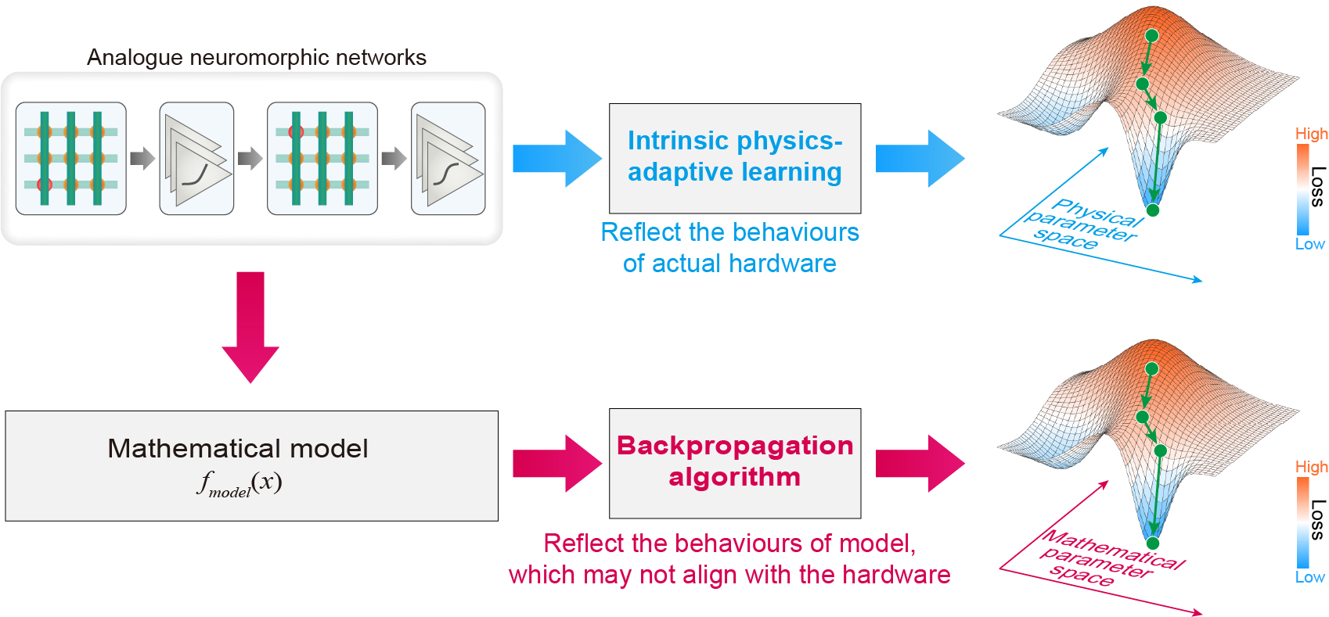
- | Difference between IPAL and BP.

Experimental implementation of IPAL
In this section, we describe the hardware system and implementation procedure of IPAL.

Description of hardware system
To demonstrate IPAL, we built a printed circuit board (PCB) system (Fig. S3), consisting of the DACs, input drivers, AIMC arrays (×7), activation modules (×3), ADCs, a sub-board for shortcut connection, and an auxiliary controller.

PCB system
Description of the PCB system is provided in Methods section ‘Hardware system for IPAL demonstration’.

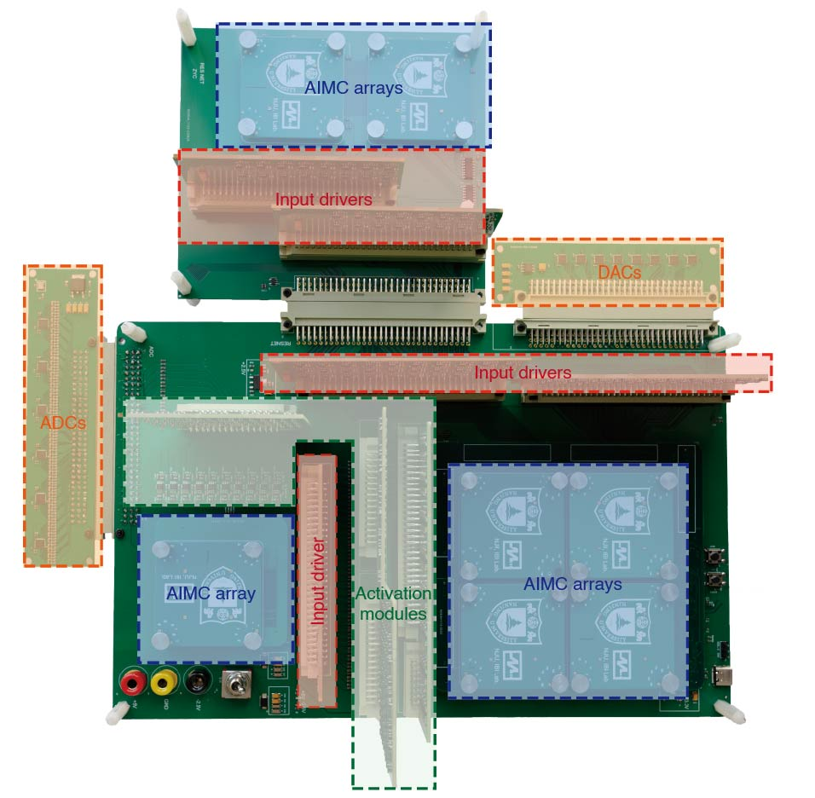
- | Photo of the PCB system for the fully analogue neuromorphic network.

Analogue in-memory computing array and activation unit chips
More information about the analogue chips used in this work is provided in Extended Data Fig. 1, as well as Methods sections ‘Analogue in-memory computing array chip’, ‘Analogue activation module’, and ‘Fabrication and integration of 1T1R memristor chips’.

Lego-like assembly of neuromorphic hardware
Due to the hardware-adaptability, we can use IPAL to build analogue AI in a manner of Lego-like assembly, as shown in Fig. S4. IPAL can adapt to the analogue hardware in real time and unlock its full potential even if the hardware is incomplete or damaged. This allows us to repair or enhance the analogue AI flexibly by replacing or adding the building blocks of neuromorphic hardware.

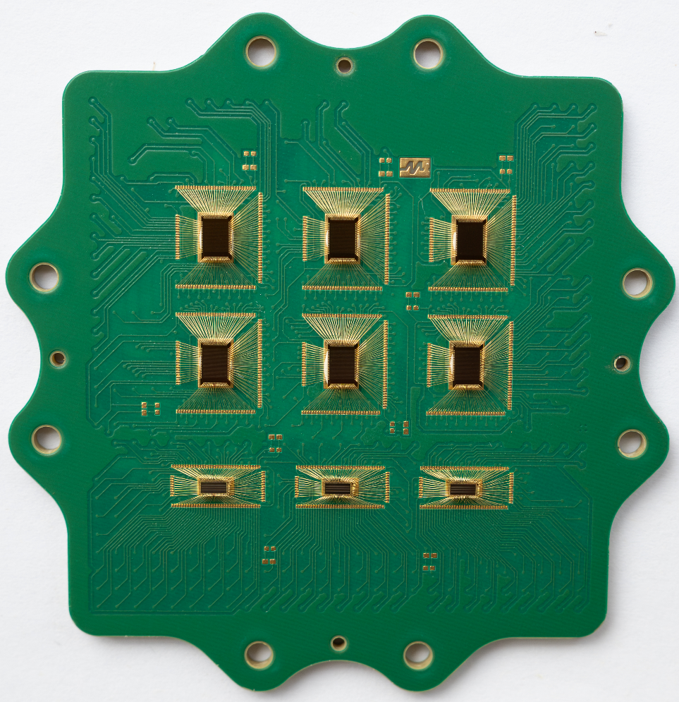
- | Lego-like assembly of neuromorphic hardware.

Implementation procedure of IPAL
In this subsection, we present the implementation procedure of IPAL for training a neuromorphic network on a dataset. The pseudocode presents the basic flow of training a fully analogue neuromorphic network using IPAL. It's worth emphasizing that perturbation propagation is always realized on the analogue hardware, not software. The digital system is only used for controlling the components (e.g., AIMC arrays, activation modules, ADCs, DACs, MUXs) in the system, as well as simple auxiliary digital computation. Major computation processes (including forward propagation and perturbation propagation) are conducted entirely in the fully analogue domain.
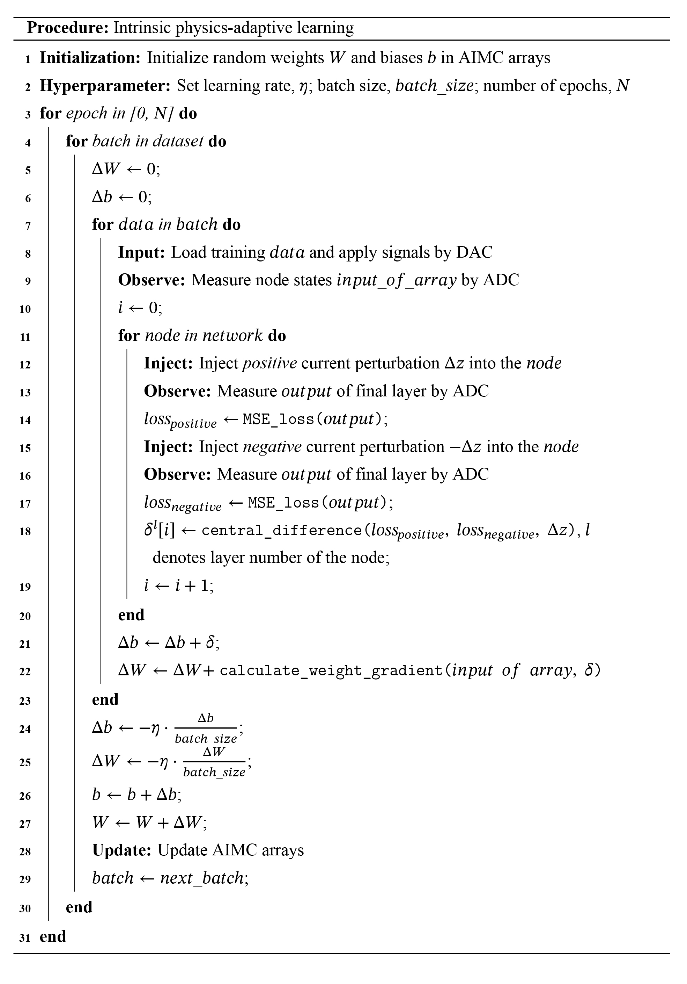

Supplementary results
Only a portion of the experimental results are presented in the main text due to space limitations. In this section, we supplement more experimental results to further support our conclusion.

Training a single-layer analogue network for XOR classification
In the experiment shown in Extended Data Fig. 4, we used IPAL to train a single-layer neuromorphic network for XOR classification. We achieved desirable classification performance with the analogue neuromorphic network, which consists of only a single AIMC array with 3×2 weights and a novel AU. The special AU is constructed using an analogue multiplier (AD835 produced by ADI) connected to a non-linear amplification circuit that exhibits Sigmoid-like behaviour. We input the 3 analogue signals (2 signals representing inputs, and 1 signal providing bias) into an AIMC array with 3×2 weights (implemented using 3×4 AIMC cells with the differential scheme), producing two output signals. The AU multiplies these two analogue signals and then carries out non-linear amplification, generating an output signal that represents the classification result. Regardless of the internal structure of the neuromorphic network, we trained this analogue neuromorphic network as usual, by perturbing the output signals of the AIMC array and measuring the resulting response at the output nodes of the network. The final result in Extended Data Fig. 4d demonstrates that IPAL can successfully train the single-layer analogue neuromorphic network for XOR classification, highlighting the versatility of IPAL.

Supplementary results of Fig. 3
The data given in Fig. S5 supplement the results in Fig. 3 in the main text, showing the self-adaptive capability of IPAL. To further demonstrate this adaptability, we conducted another experiment shown in Fig. S5 by using 4 AUs with Sigmoid-like behaviours (instead of 2 Sigmoid-like and 2 ReLU-like AUs). All AUs in the analogue neuromorphic network are randomly reconfigured into the 4 types. During the training process, IPAL did not have any prior knowledge of the AU types. We demonstrate IPAL can still train the analogue neuromorphic network with unknown behaviours, achieving a high recognition rate and demonstrating its excellent self-adaptive capability.
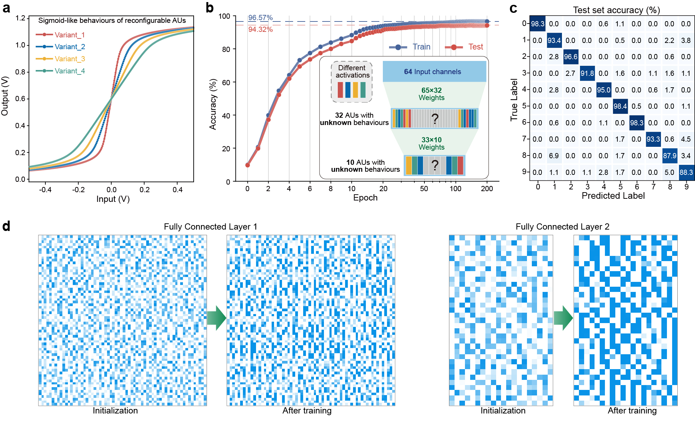
- | Additional experiment to Fig. 3. a, The AUs can be reconfigured into diverse variants with different behaviours. Different to the experiment shown in Fig. 3 of the main text, here the AUs are reconfigured into 4 variants with different Sigmoid-like behaviours. b, Improvement of classification accuracy during the implementation of IPAL. IPAL allows training an analogue neuromorphic network with unknown hardware variations. In the experimental demonstration, the types of the AUs are randomly set and these behaviours are unknown throughout the training process. c, Confusion matrix for the test set. d, Evolution of the weight distributions in AIMC arrays.

Supplementary results for demonstrating hardware-fault-tolerance
In the main text, we demonstrate the prominent capability of IPAL to restore the functionality of hardware-damaged analogue neuromorphic networks. We supplement our findings with additional experimental results in this subsection.

Restoration of synapse-defective neuromorphic networks
In Fig. 4b of the main text, we have shown that analogue neuromorphic networks can be trained to correctly classify digit images even when 60% of AIMC cells fail to function. We have also carried out more experiments with respect to different impairment rates. In Fig. S6–14, we show the related supplementary results associated with the training process, the final confusion matrix, as well as the evolution of weight distributions in AIMC arrays.
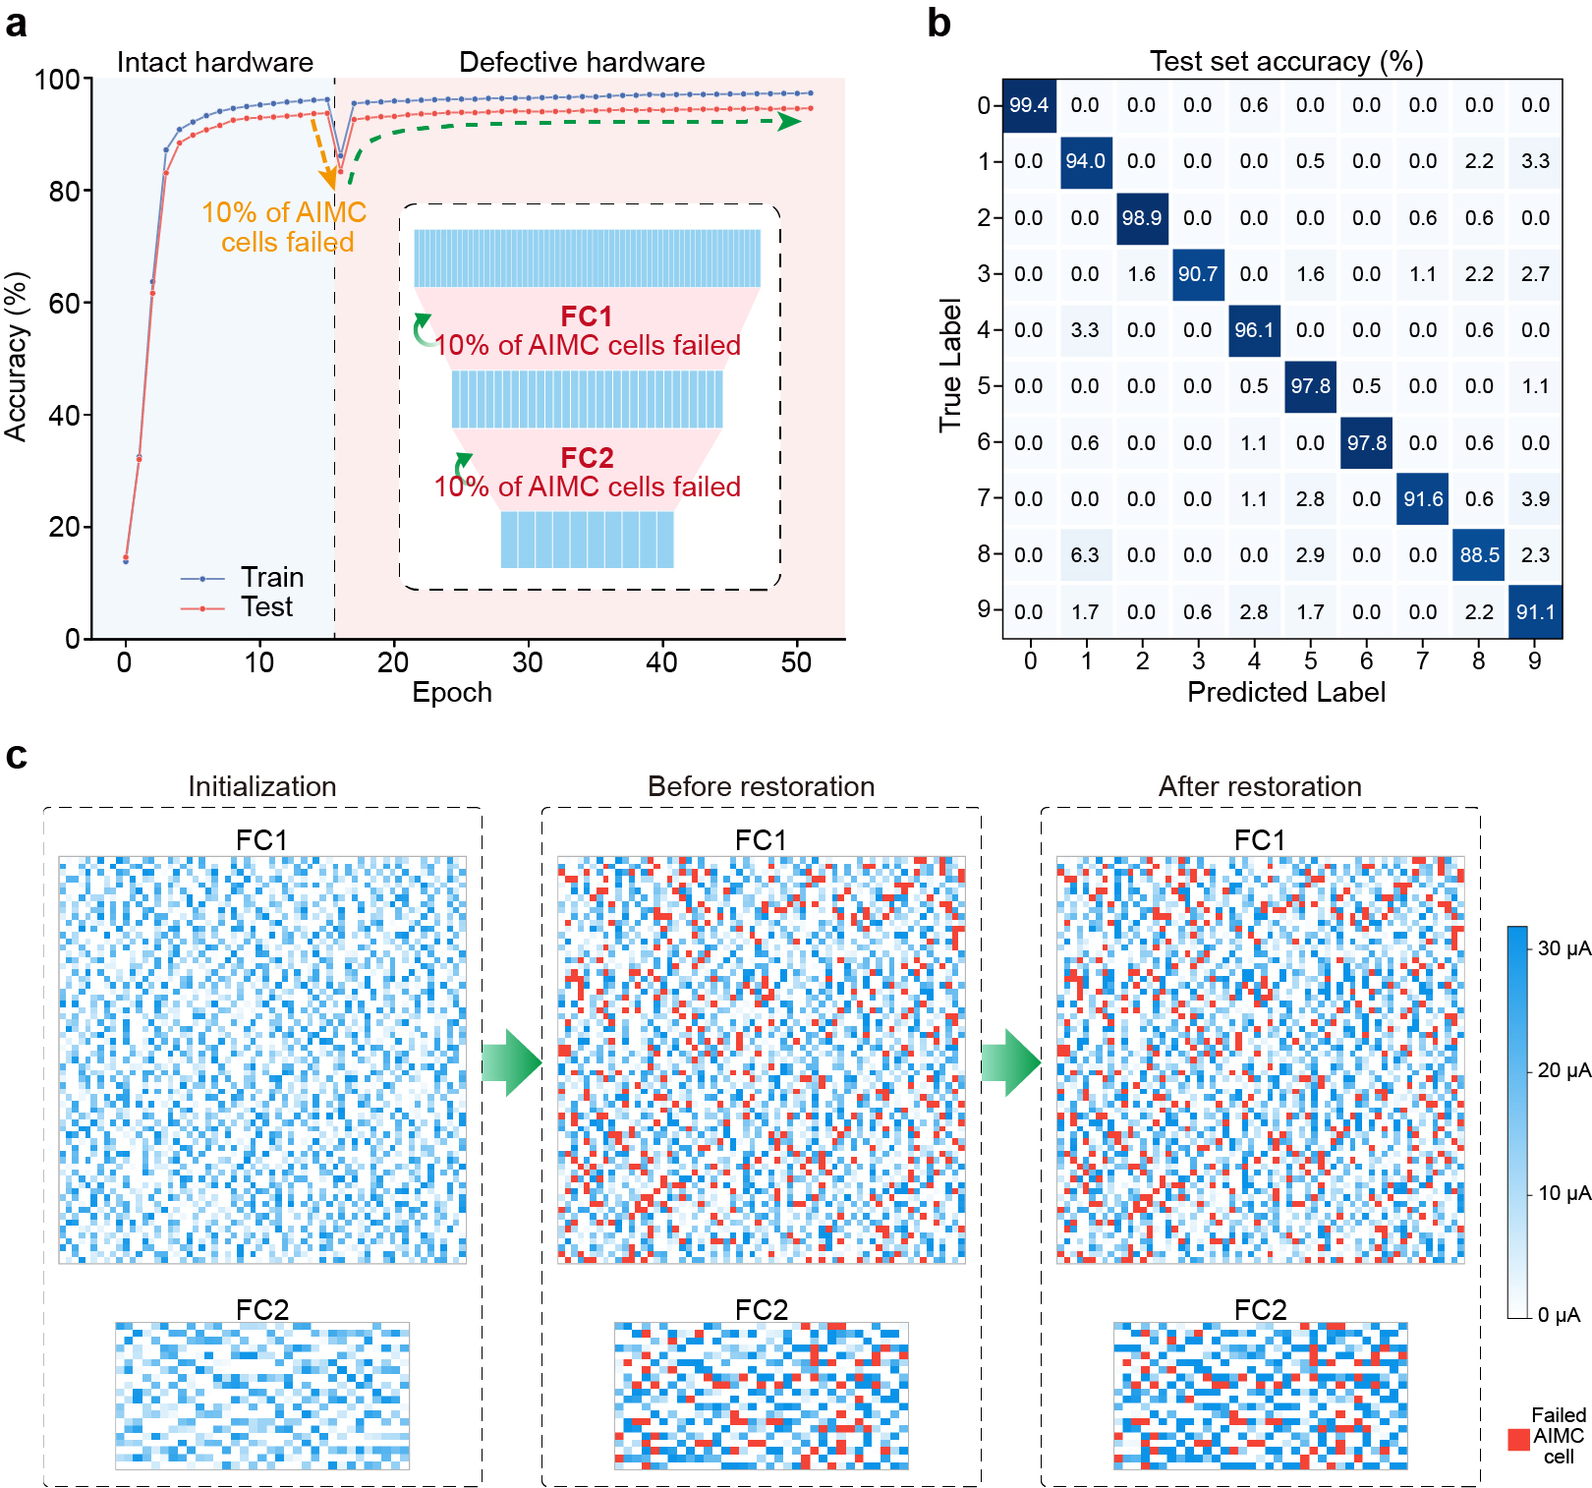
- | Experimental demonstration for training a defective neuromorphic network. IPAL restores the functionality of the analogue neuromorphic network after 10% of AIMC cells fail to function. a, Accuracy performance of the analogue neuromorphic network increases again after the 16th epoch. The inset shows the diagram of the hardware-defective analogue neuromorphic network. b, Final confusion matrix for the test set. c, Evolution of the weight distributions in AIMC arrays.
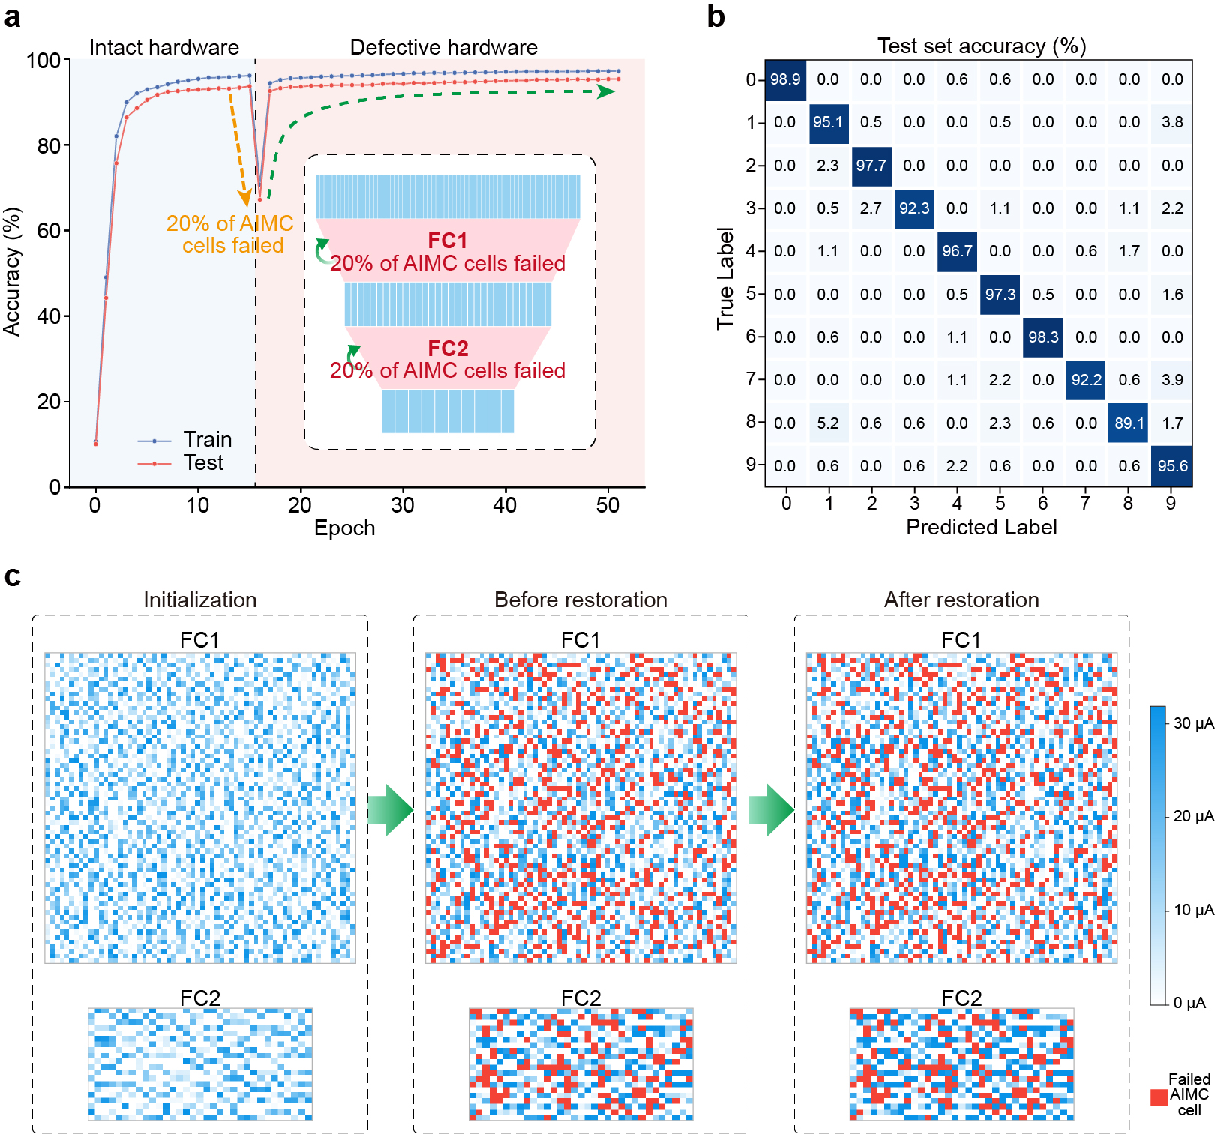
- | Experimental demonstration for training a defective neuromorphic network. IPAL restores the functionality of the analogue neuromorphic network after 20% of AIMC cells fail to function. a, Accuracy performance of the analogue neuromorphic network increases again after the 16th epoch. The inset shows the diagram of the hardware-defective analogue neuromorphic network. b, Final confusion matrix for the test set. c, Evolution of the weight distributions in AIMC arrays.

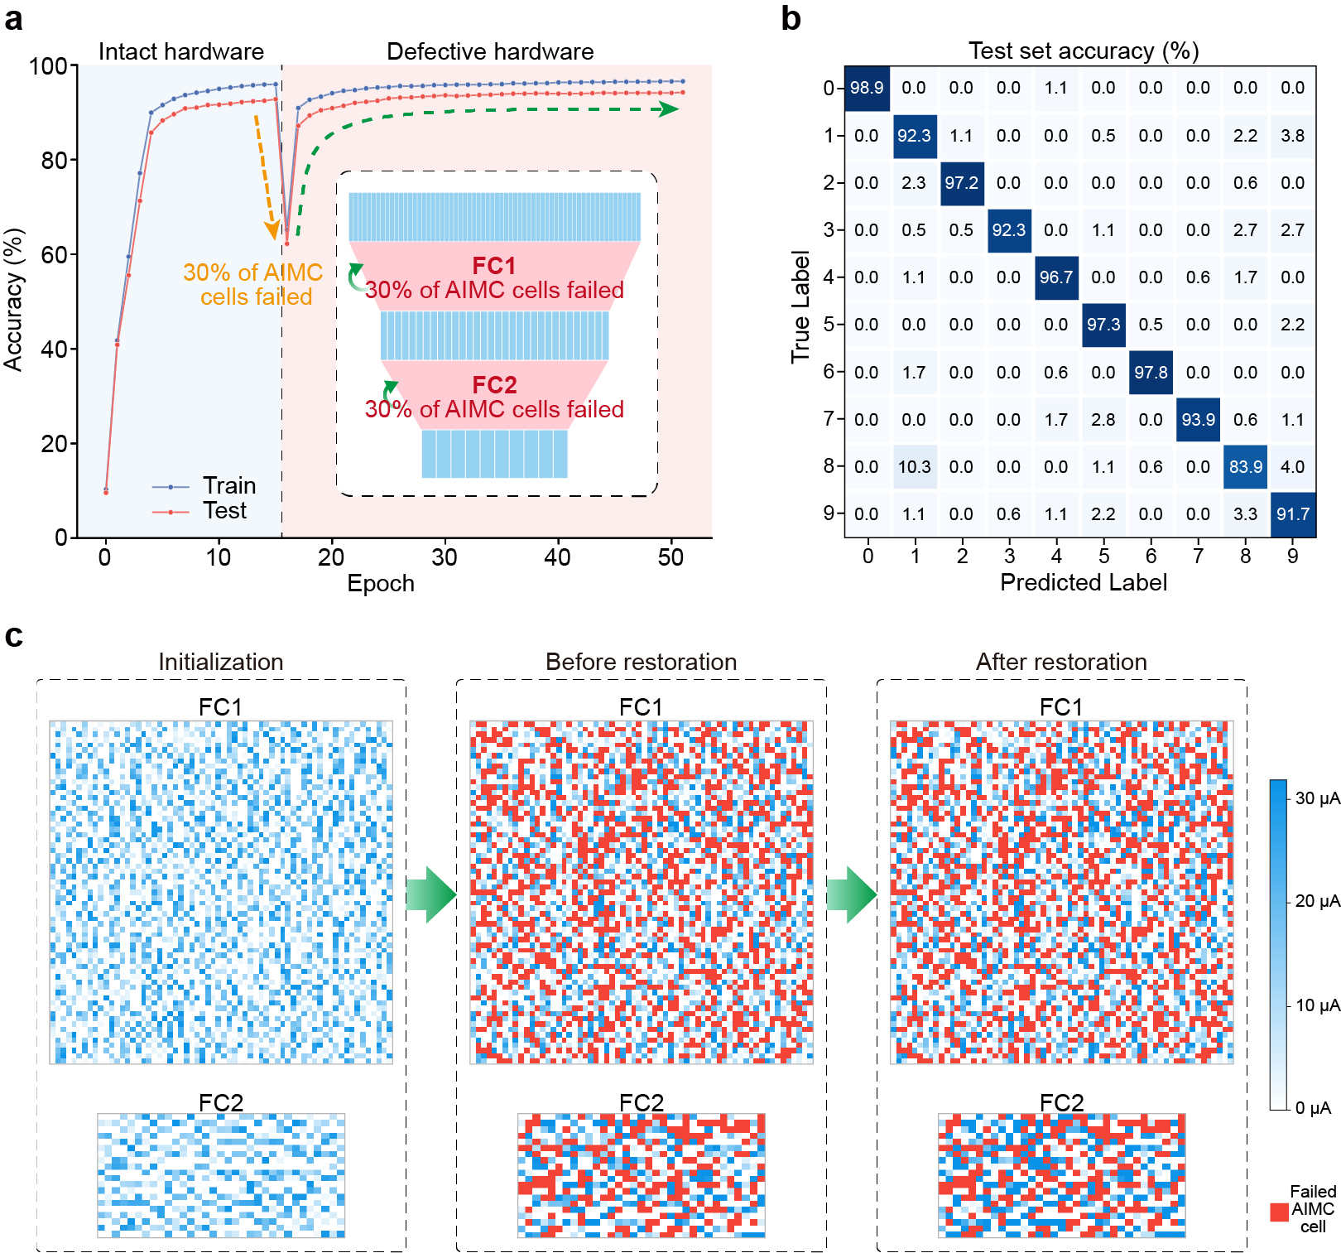
- | Experimental demonstration for training a defective neuromorphic network. IPAL restores the functionality of the analogue neuromorphic network after 30% of AIMC cells fail to function. a, Accuracy performance of the analogue neuromorphic network increases again after the 16th epoch. The inset shows the diagram of the hardware-defective analogue neuromorphic network. b, Final confusion matrix for the test set. c, Evolution of the weight distributions in AIMC arrays.

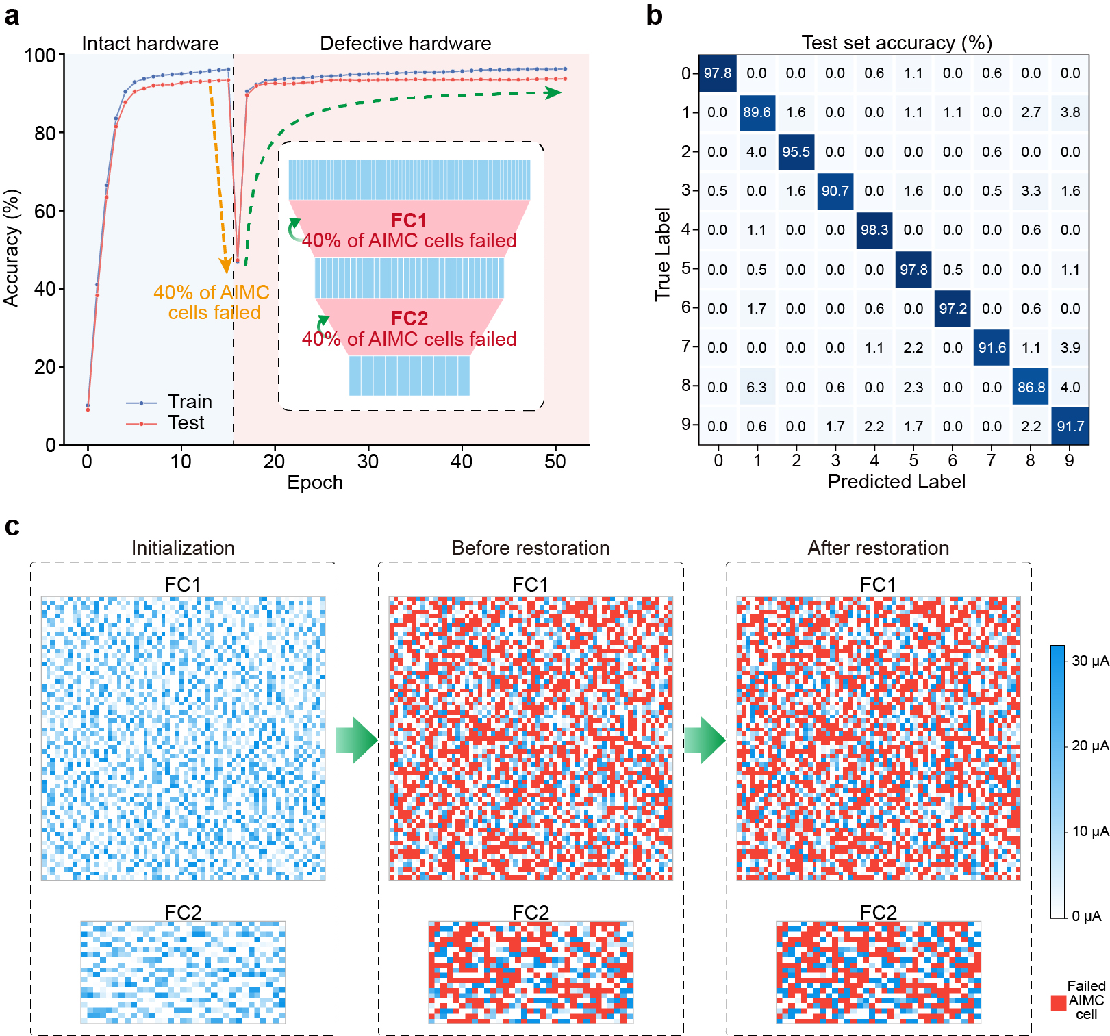
- | Experimental demonstration for training a defective neuromorphic network. IPAL restores the functionality of the analogue neuromorphic network after 40% of AIMC cells fail to function. a, Accuracy performance of the analogue neuromorphic network increases again after the 16th epoch. The inset shows the diagram of the hardware-defective analogue neuromorphic network. b, Final confusion matrix for the test set. c, Evolution of the weight distributions in AIMC arrays.
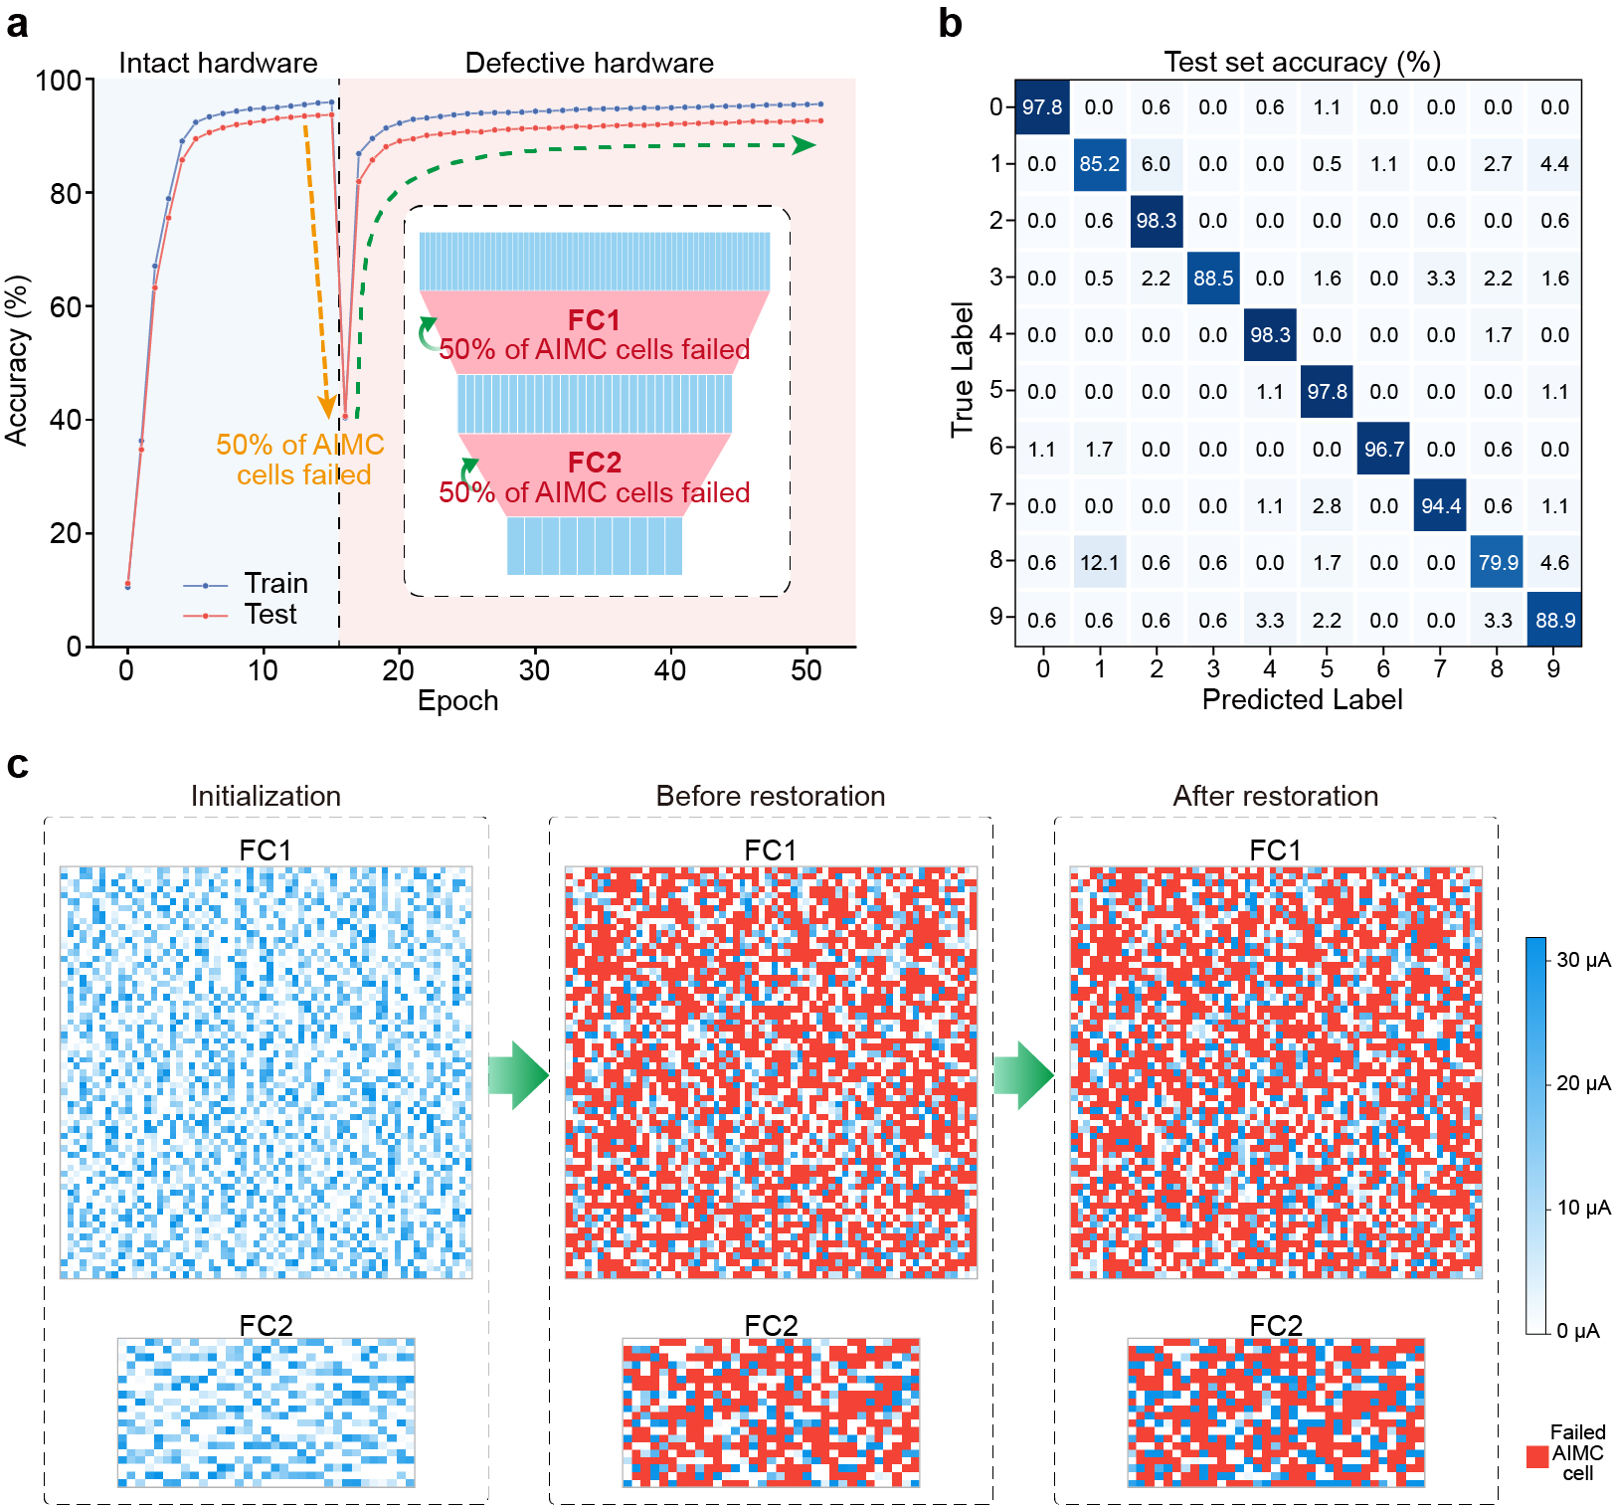
- | Experimental demonstration for training a defective neuromorphic network. IPAL restores the functionality of the analogue neuromorphic network after 50% of AIMC cells fail to function. a, Accuracy performance of the analogue neuromorphic network increases again after the 16th epoch. The inset shows the diagram of the hardware-defective analogue neuromorphic network. b, Final confusion matrix for the test set. c, Evolution of the weight distributions in AIMC arrays.

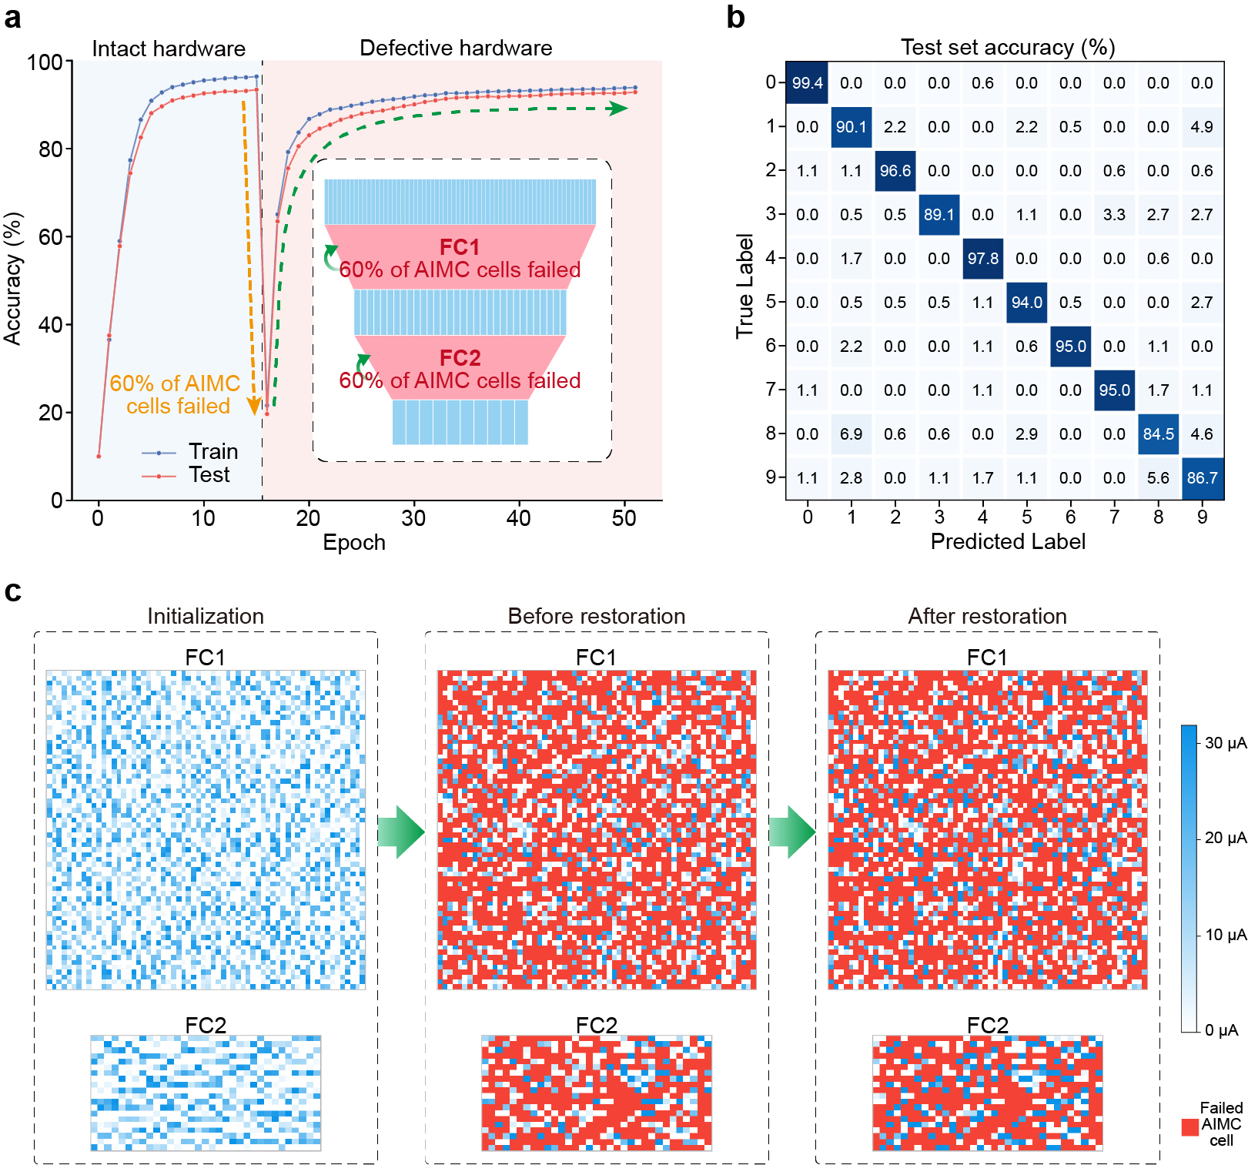
- | Experimental demonstration for training a defective neuromorphic network. IPAL restores the functionality of the analogue neuromorphic network after 60% of AIMC cells fail to function. a, Accuracy performance of the analogue neuromorphic network increases again after the 16th epoch. The inset shows the diagram of the hardware-defective analogue neuromorphic network. b, Final confusion matrix for the test set. c, Evolution of the weight distributions in AIMC arrays.

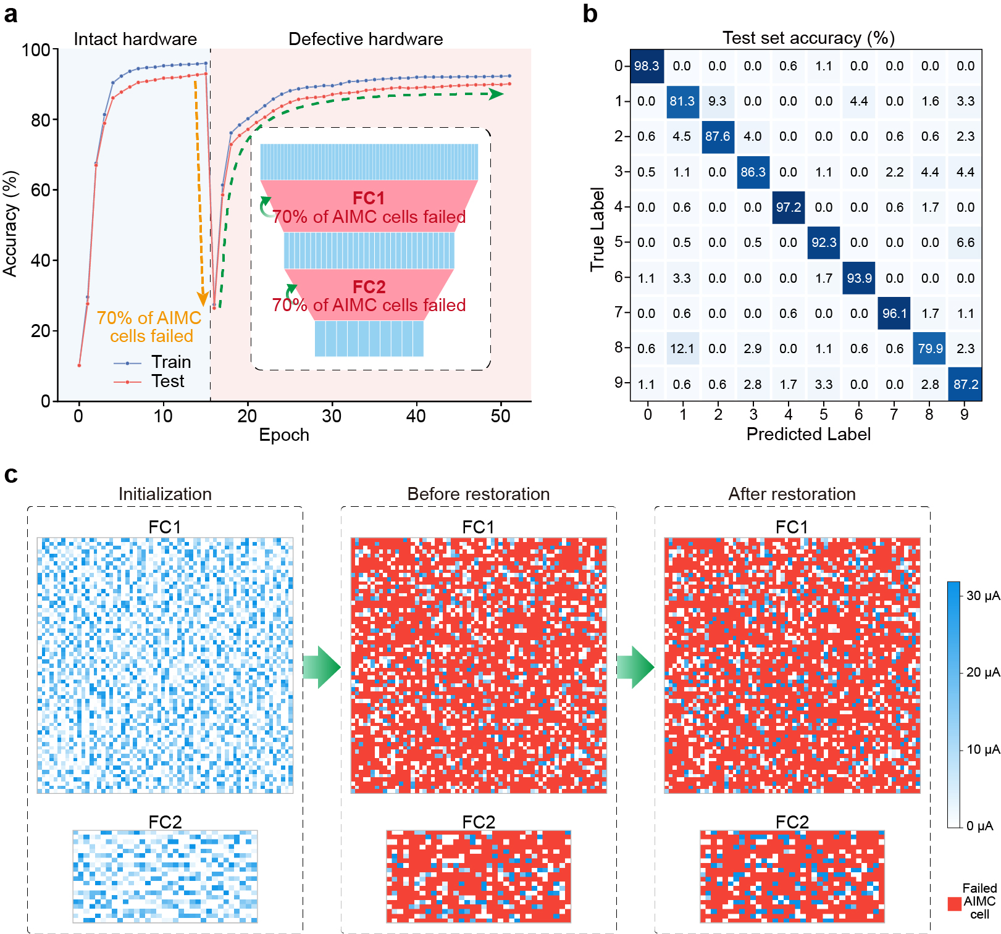
- | Experimental demonstration for training a defective neuromorphic network. IPAL restores the functionality of the analogue neuromorphic network after 70% of AIMC cells fail to function. a, Accuracy performance of the analogue neuromorphic network increases again after the 16th epoch. The inset shows the diagram of the hardware-defective analogue neuromorphic network. b, Final confusion matrix for the test set. c, Evolution of the weight distributions in AIMC arrays.
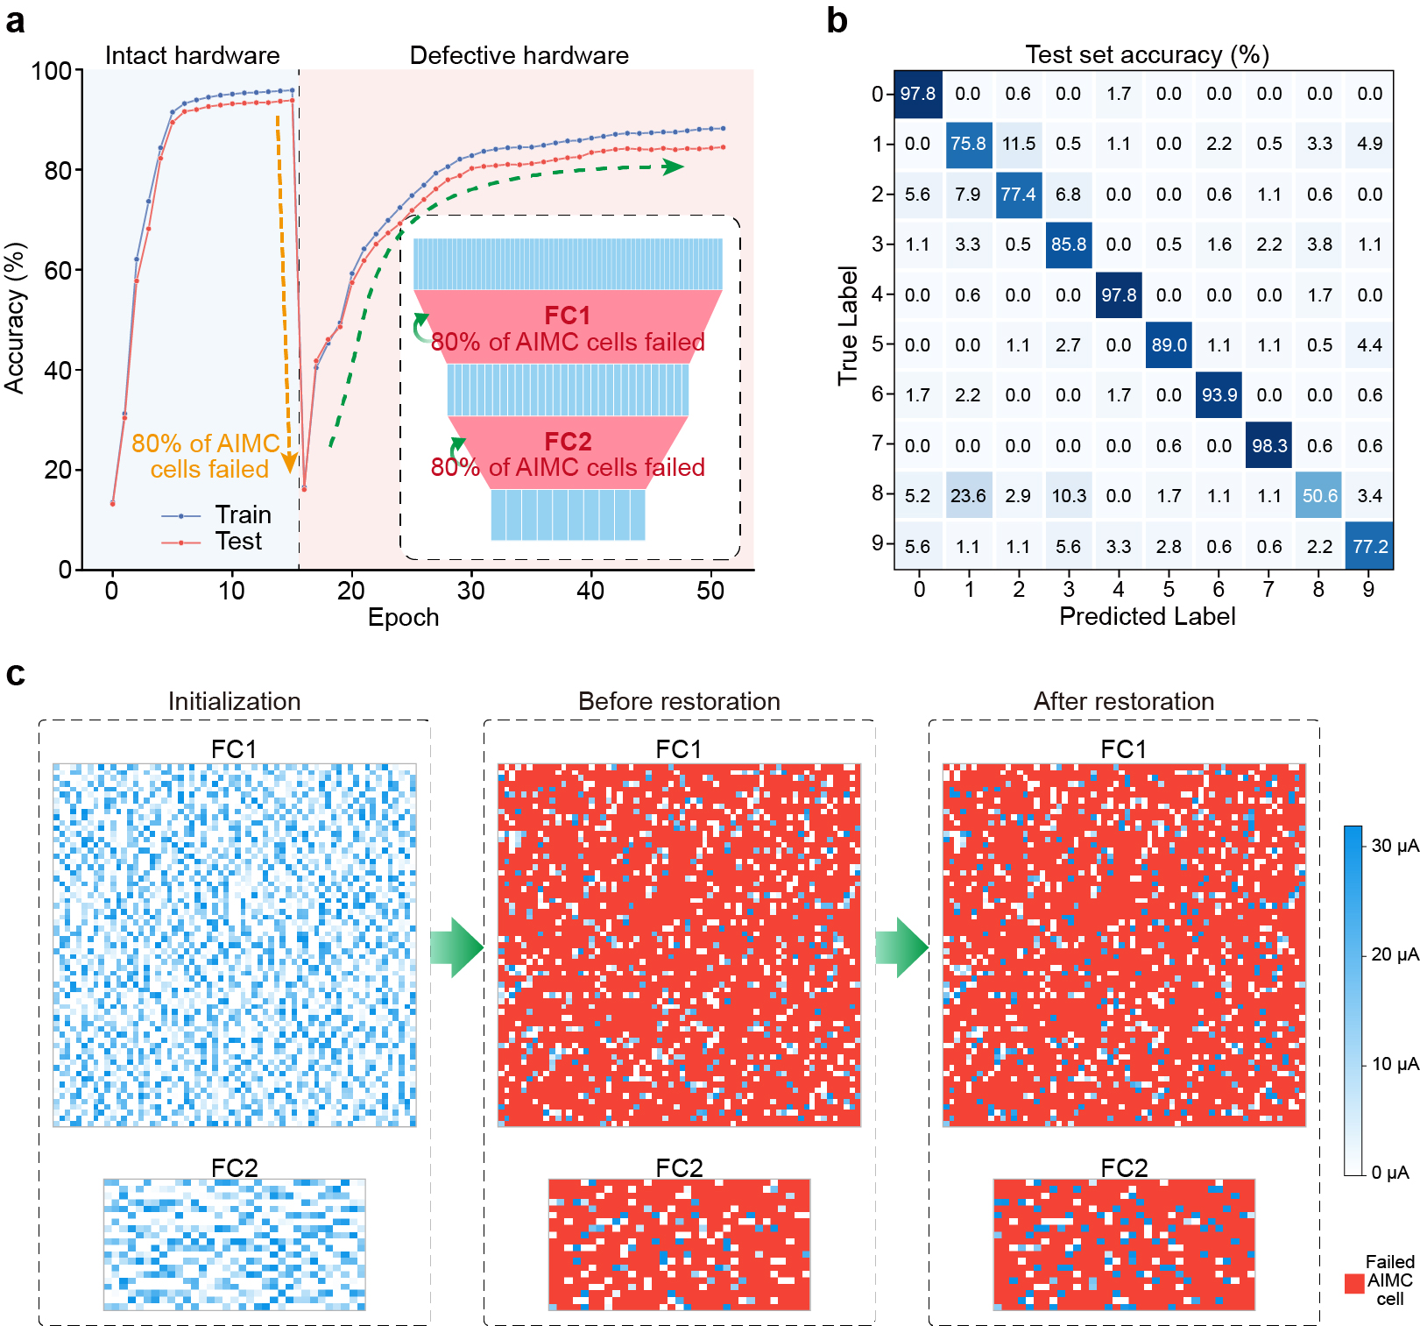
- | Experimental demonstration for training a defective neuromorphic network. IPAL restores the functionality of the analogue neuromorphic network after 80% of AIMC cells fail to function. a, Accuracy performance of the analogue neuromorphic network increases again after the 16th epoch. The inset shows the diagram of the hardware-defective analogue neuromorphic network. b, Final confusion matrix for the test set. c, Evolution of the weight distributions in AIMC arrays.

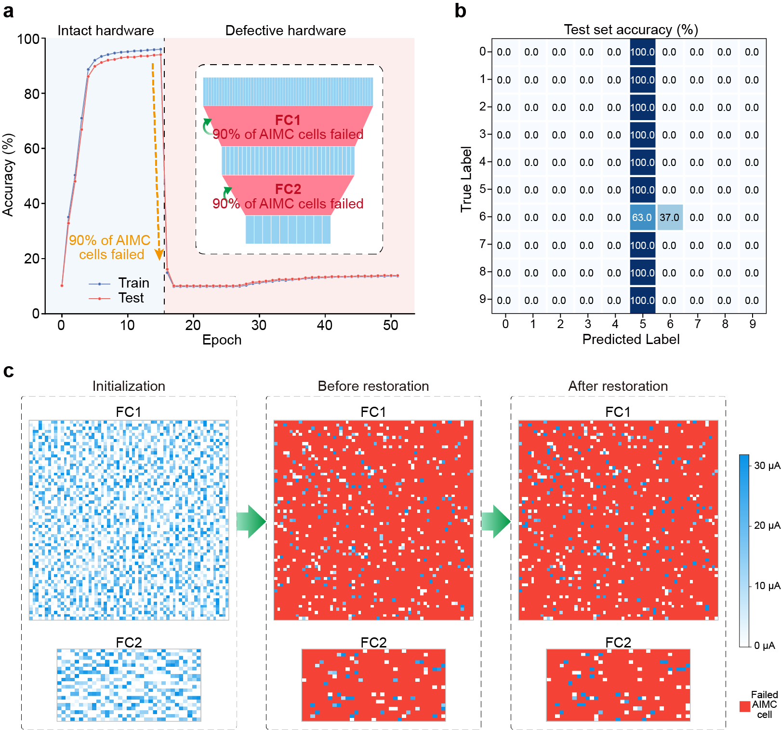
- | Experimental demonstration for training a defective neuromorphic network. IPAL restores the functionality of the analogue neuromorphic network after 90% of AIMC cells fail to function. a, Accuracy performance of the analogue neuromorphic network increases again after the 16th epoch. The inset shows the diagram of the hardware-defective analogue neuromorphic network. b, Final confusion matrix for the test set. c, Evolution of the weight distributions in AIMC arrays.

Restoration of neuron-defective neuromorphic networks
In Fig. 4c of the main text, we have shown that analogue neuromorphic networks can be trained to correctly classify handwritten digit images even if 60% of AUs break down. We have also carried out more experiments with respect to different impairment rates. In Fig. S15-17, we show the related supplementary results associated with the training process, the final confusion matrix, as well as the evolution of weight distributions in AIMC arrays.

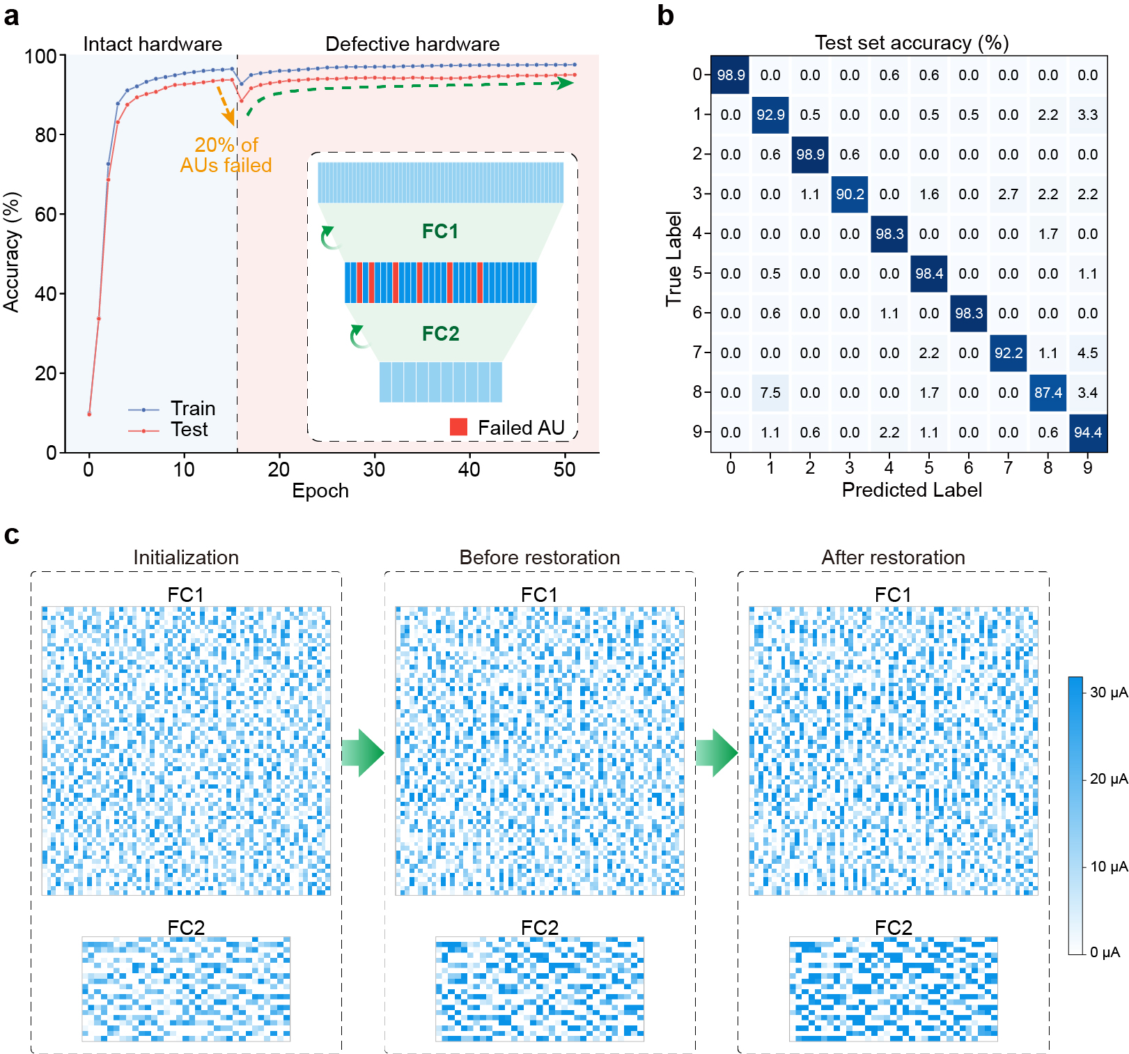
- | Experimental demonstration for training a defective neuromorphic network. IPAL restores the functionality of the analogue neuromorphic network after 20% of hidden-layer AUs fail to function. a, Accuracy performance of the analogue neuromorphic network increases again after the 16th epoch. The inset shows the diagram of the hardware-defective analogue neuromorphic network. b, Final confusion matrix for the test set. c, Evolution of the weight distributions in AIMC arrays.

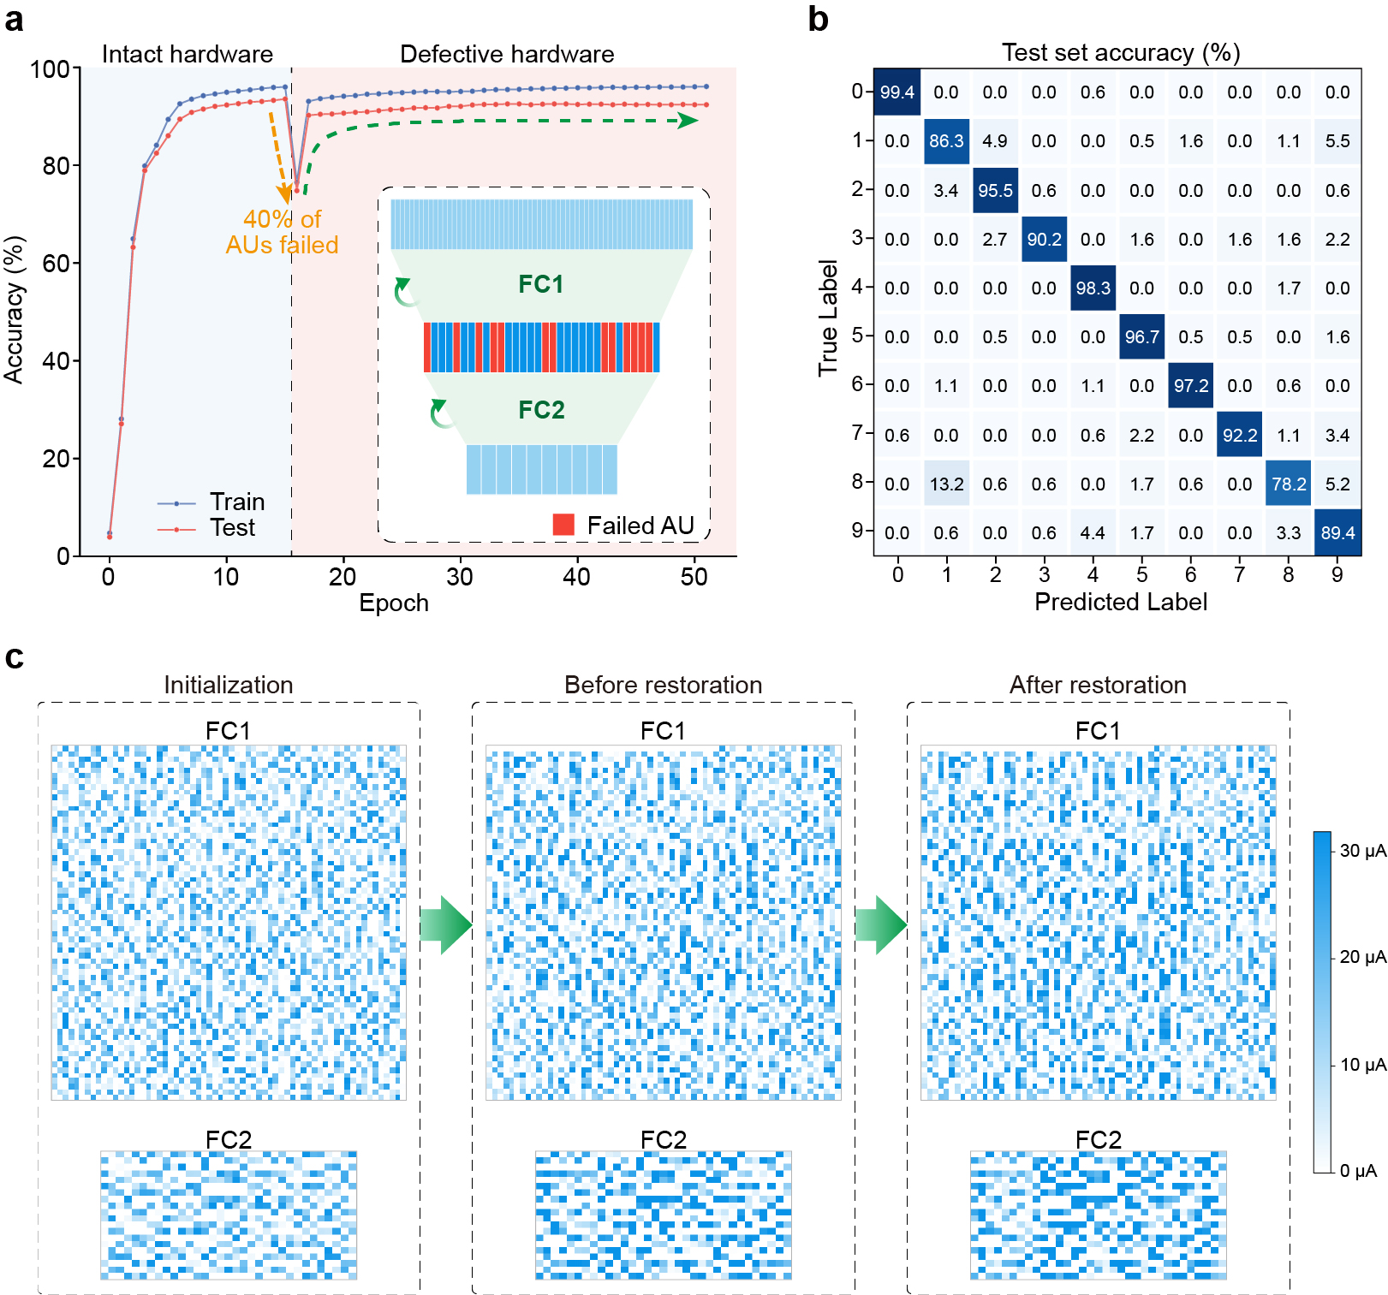
- | Experimental demonstration for training a defective neuromorphic network. IPAL restores the functionality of the analogue neuromorphic network after 40% of hidden-layer AUs fail to function. a, Accuracy performance of the analogue neuromorphic network increases again after the 16th epoch. The inset shows the diagram of the hardware-defective analogue neuromorphic network. b, Final confusion matrix for the test set. c, Evolution of the weight distributions in AIMC arrays.

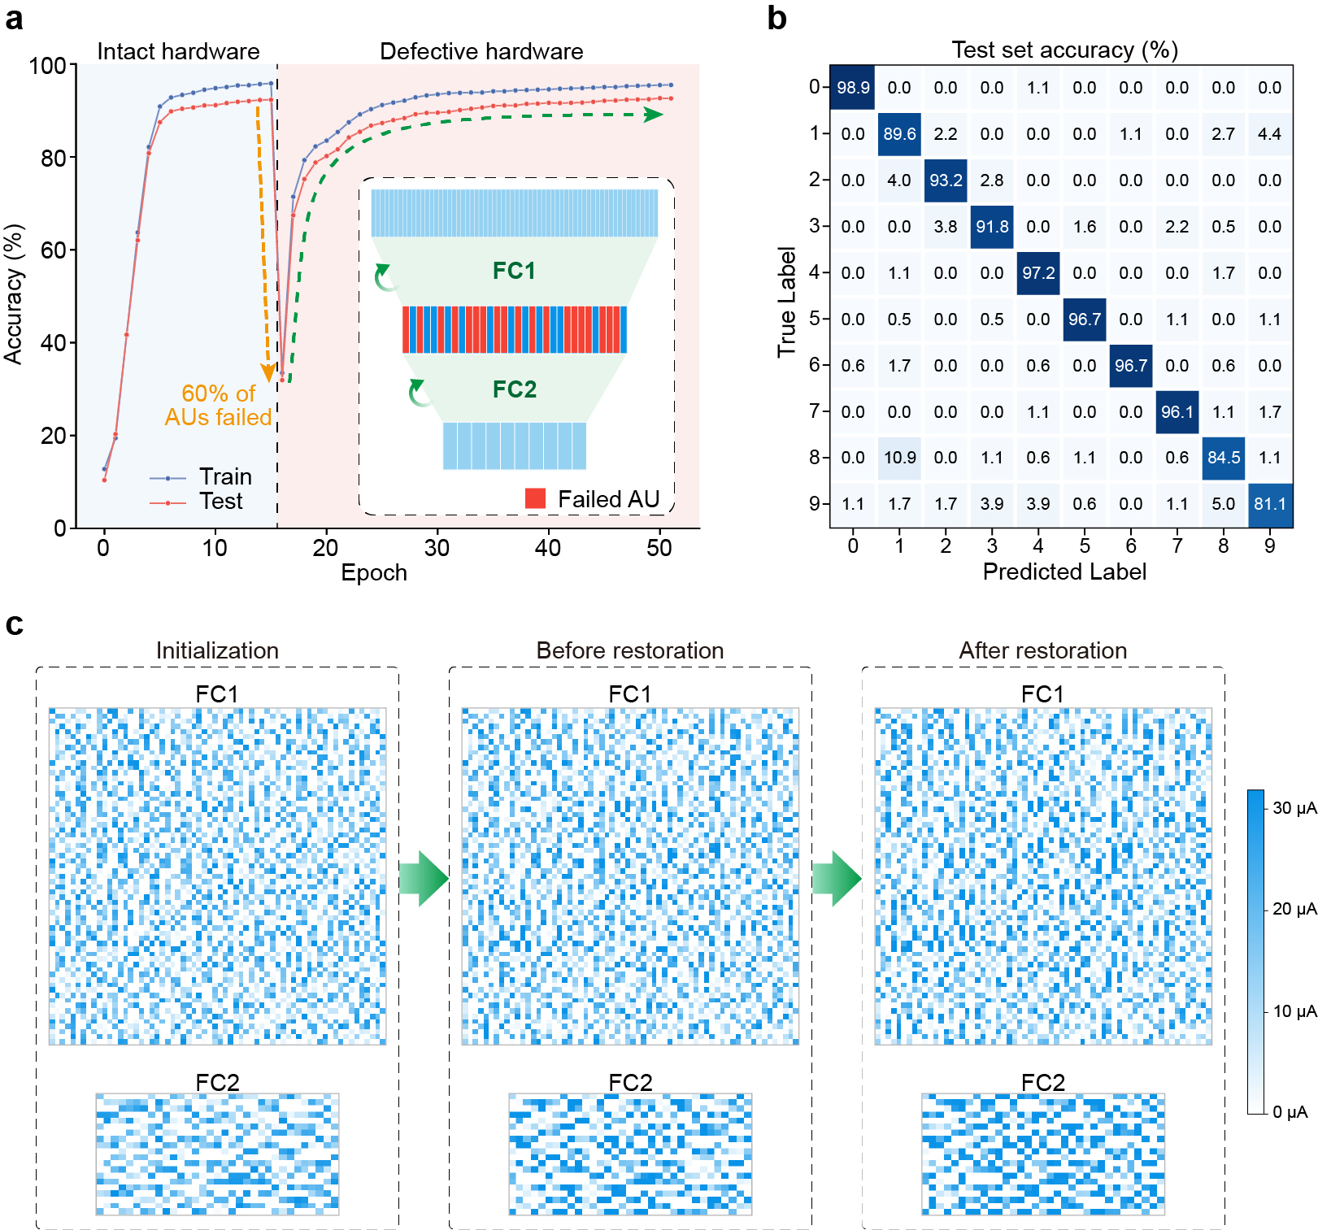
- | Experimental demonstration for training a defective neuromorphic network. IPAL restores the functionality of the analogue neuromorphic network after 60% of hidden-layer AUs fail to function. a, Accuracy performance of the analogue neuromorphic network increases again after the 16th epoch. The inset shows the diagram of the hardware-defective analogue neuromorphic network. b, Final confusion matrix for the test set. c, Evolution of the weight distributions in AIMC arrays.

Restoration of hybrid-defective neuromorphic networks
In Fig. 4d of the main text, we have shown that analogue neuromorphic networks can be trained to correctly classify digit images even if 60% of AIMC cells and 60% of AUs break down. We have also carried out more experiments with respect to different impairment rates. In Fig. S18-20, we show the related supplementary results associated with the training process, the final confusion matrix, as well as the evolution of weight distributions in AIMC arrays.

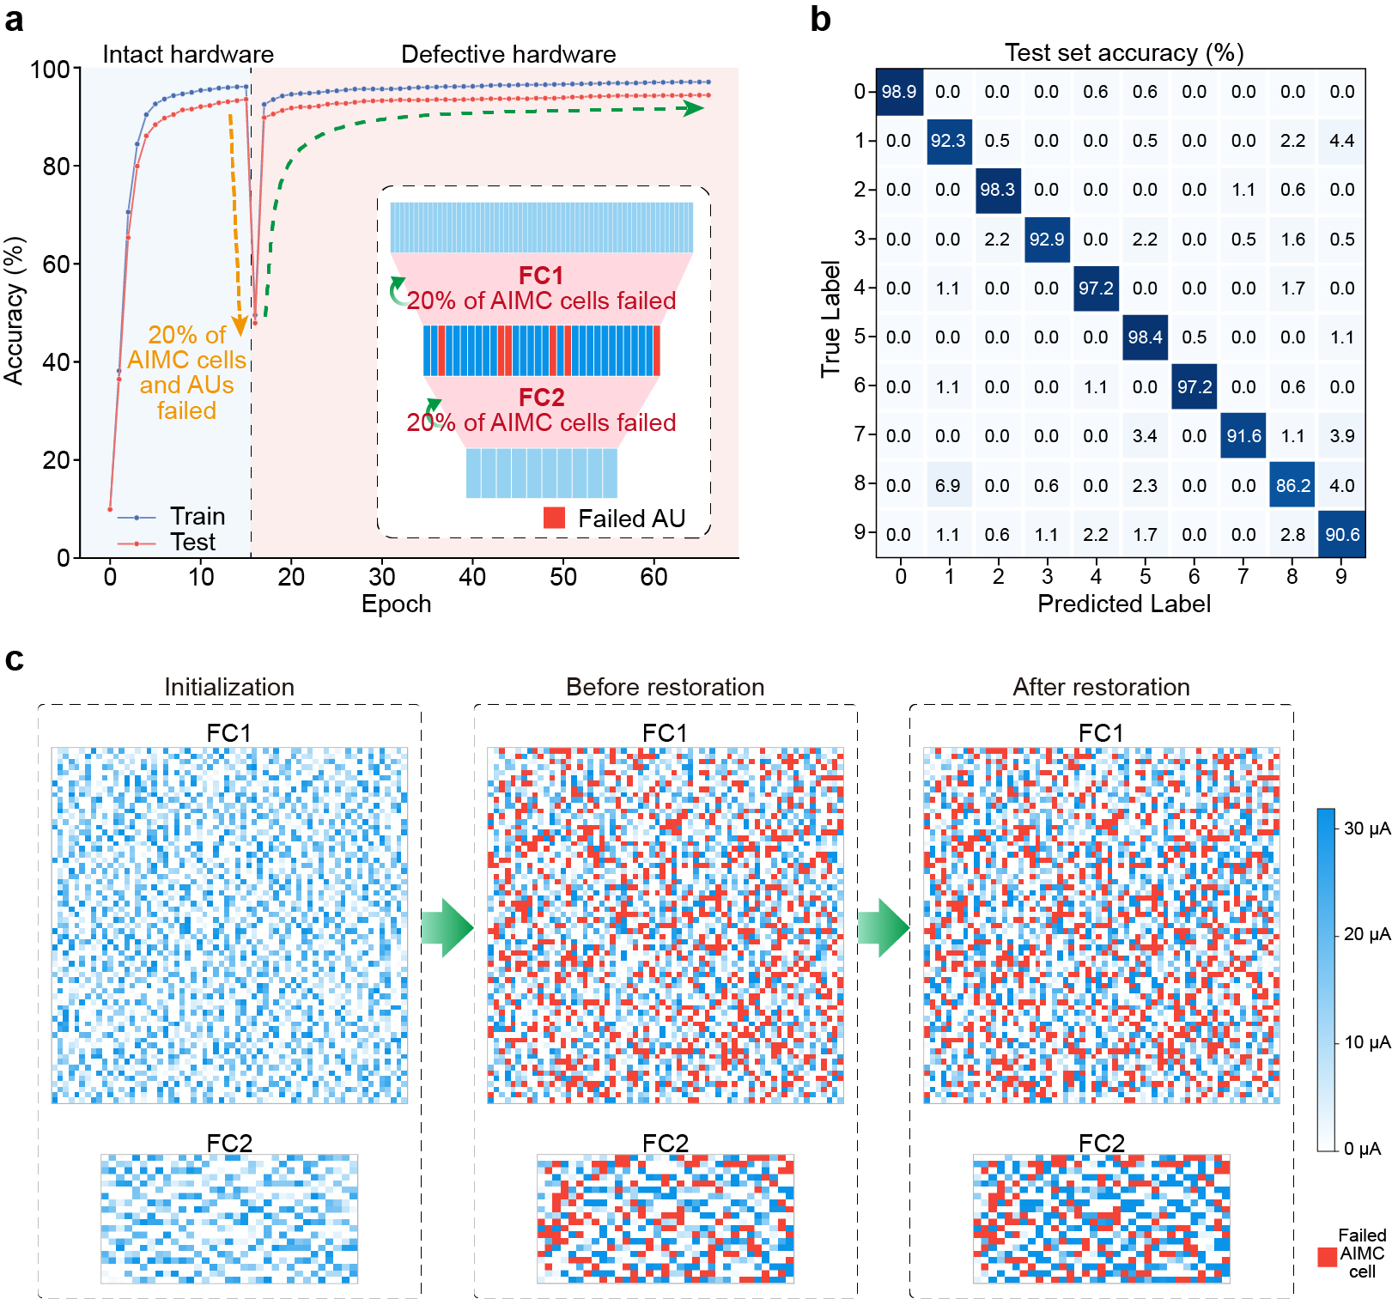
- | Experimental demonstration for training a defective neuromorphic network. IPAL restores the functionality of the analogue neuromorphic network after 20% of AIMC cells and hidden-layer AUs fail to function. a, Accuracy performance of the analogue neuromorphic network increases again after the 16th epoch. The inset shows the diagram of the hardware-defective analogue neuromorphic network. b, Final confusion matrix for the test set. c, Evolution of the weight distributions in AIMC arrays.

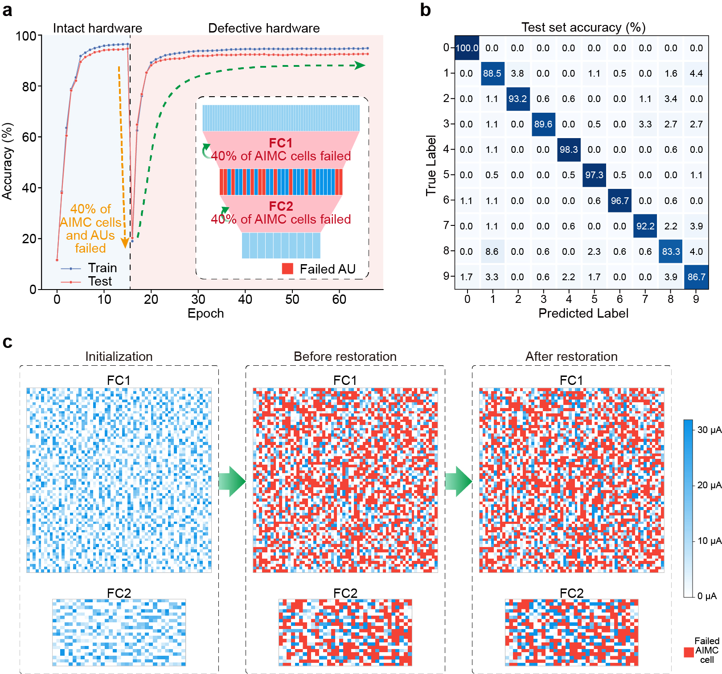
- | Experimental demonstration for training a defective neuromorphic network. IPAL restores the functionality of the analogue neuromorphic network after 40% of AIMC cells and hidden-layer AUs fail to function. a, Accuracy performance of the analogue neuromorphic network increases again after the 16th epoch. The inset shows the diagram of the hardware-defective analogue neuromorphic network. b, Final confusion matrix for the test set. c, Evolution of the weight distributions in AIMC arrays.
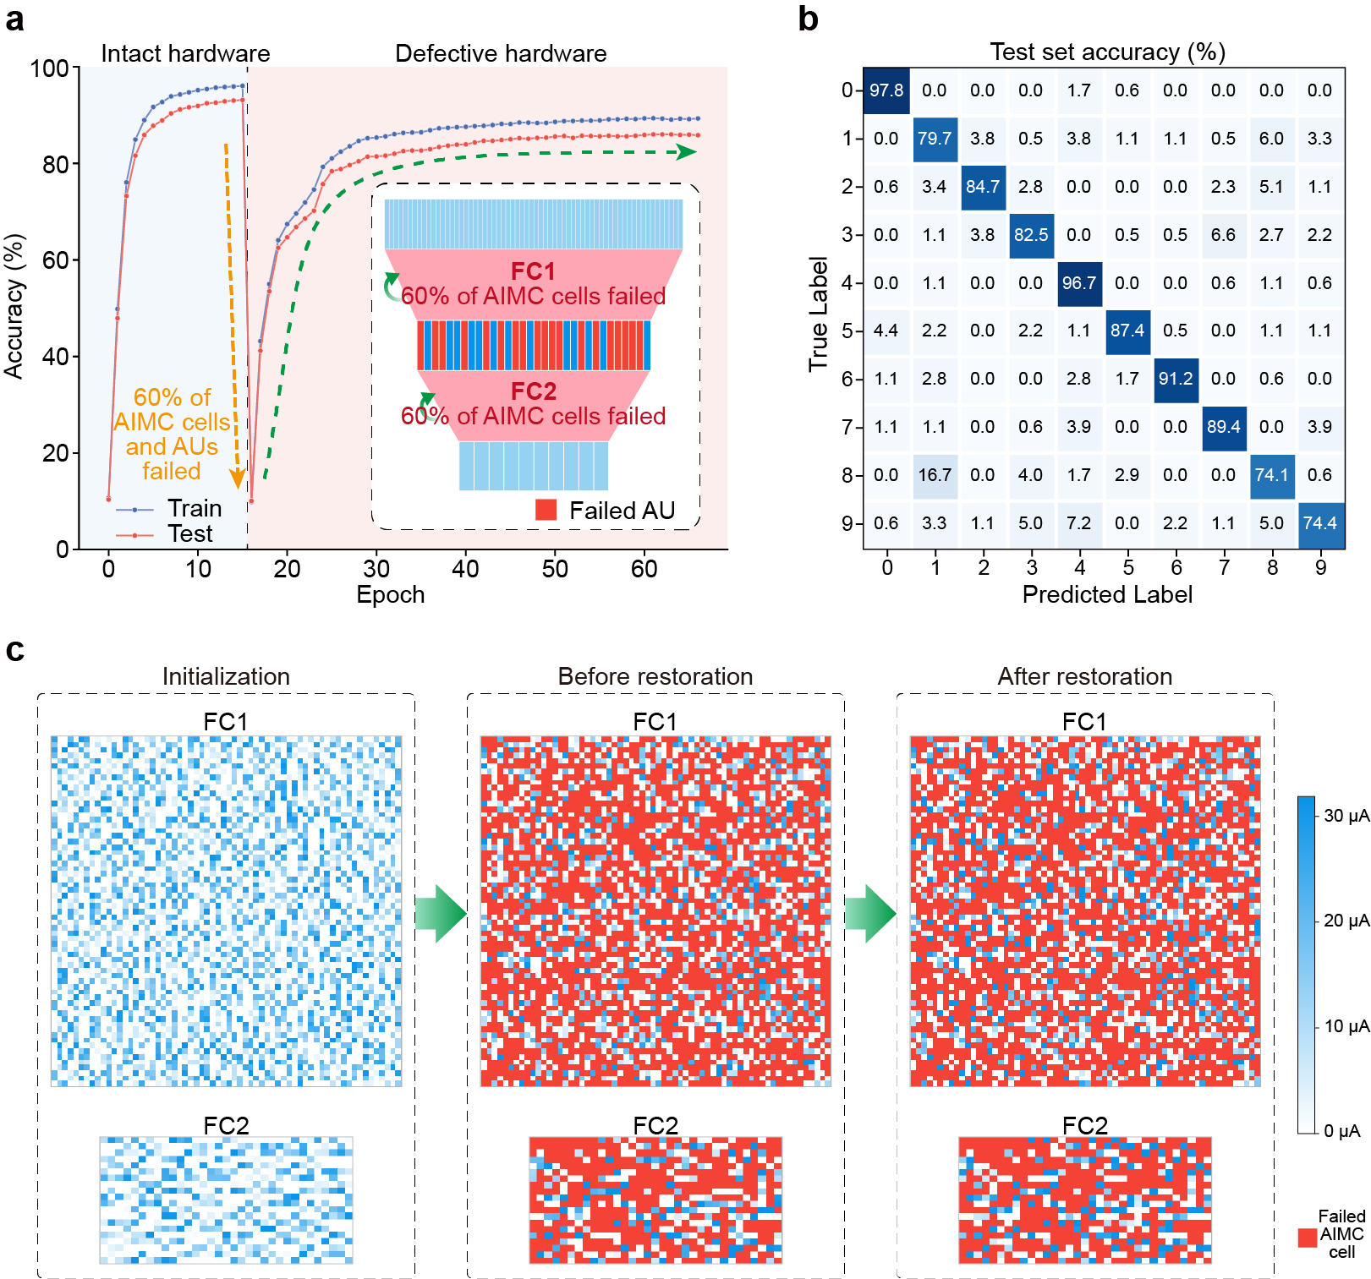
- | Experimental demonstration for training a defective neuromorphic network. IPAL restores the functionality of the analogue neuromorphic network after 60% of AIMC cells and hidden-layer AUs fail to function. a, Accuracy performance of the analogue neuromorphic network increases again after the 16th epoch. The inset shows the diagram of the hardware-defective analogue neuromorphic network. b, Final confusion matrix for the test set. c, Evolution of the weight distributions in AIMC arrays.

Supplementary Video
Supplementary Video 1 The movie shows the real-time recognition process before the intrinsic physics-adaptive learning. The entire Optdigits dataset including the training and test sets was fed into our end-to-end fully analogue neuromorphic hardware networks. Few handwritten digits (~10%) were correctly recognized.

Supplementary Video 2 The movie shows the real-time recognition process after the intrinsic physics-adaptive learning. The entire Optdigits dataset including the training and test sets was fed into our end-to-end fully analogue neuromorphic hardware networks. Almost all of the handwritten digits were correctly recognized, demonstrating the effectiveness of IPAL.

