Extended Data
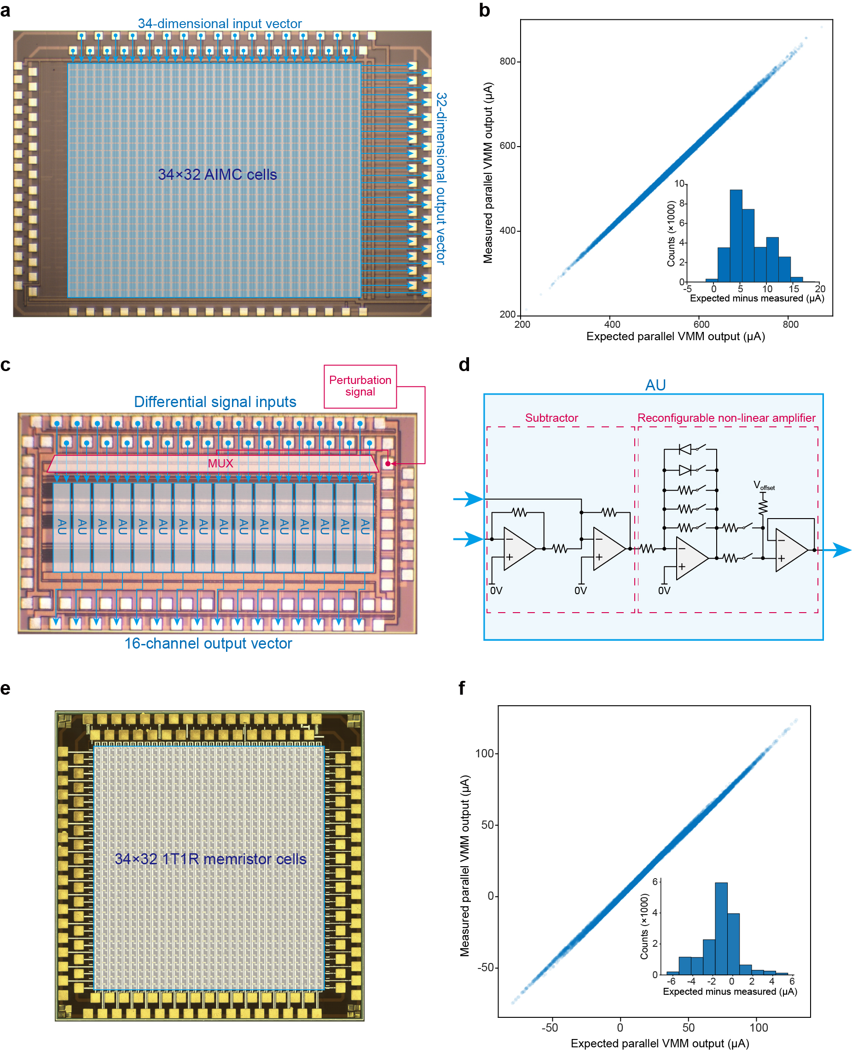
Extended Data Fig. 1 | Analogue in-memory computing array chip and analogue activation chip. a, Photo of the SRAM-based AIMC array. b, Results of parallel analogue VMM test using the AIMC array. c, Photo of the customized activation chip, which contains 16 AUs. d, Schematic of each AU, containing a subtractor and a reconfigurable nonlinear amplification circuit. By turning on/off the switches in an AU, the AU can be reconfigured into different activation behaviours. e, Photo of the fabricated 1T1R memristor crossbar array. f, Results of parallel analogue VMM test using the 1T1R memristor crossbar array.
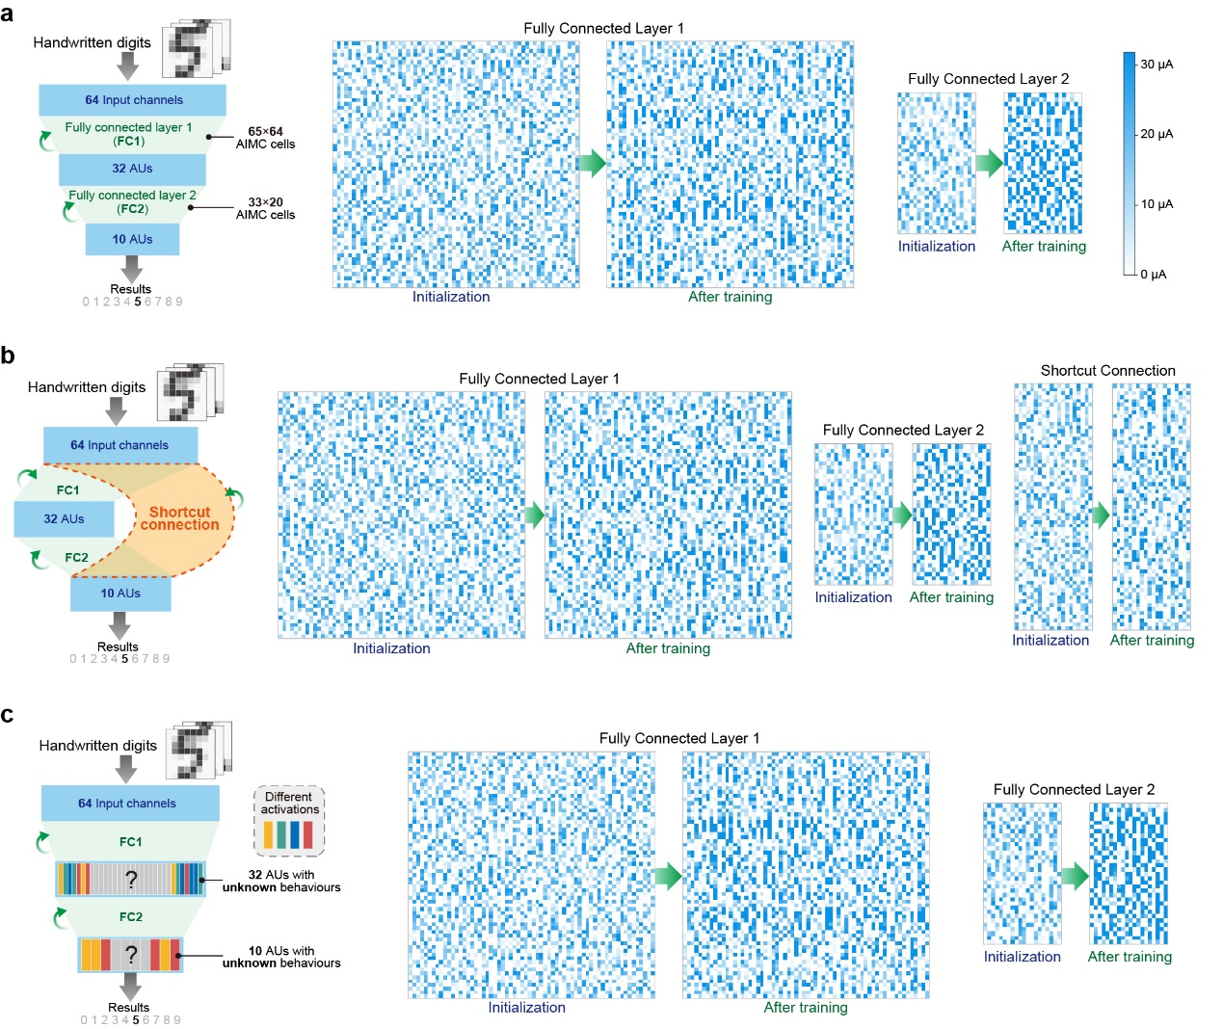
Extended Data Fig. 2 | Evolution of the weight distributions during the training experiments shown in Fig. 2 and 3. a, Evolution of the weight distributions in AIMC arrays in the training experiment shown in Fig. 2d. b, Evolution of the weight distributions in AIMC arrays in the training experiment shown in Fig. 2g. c, Evolution of the weight distributions in AIMC arrays in the training experiment shown in Fig. 3c.

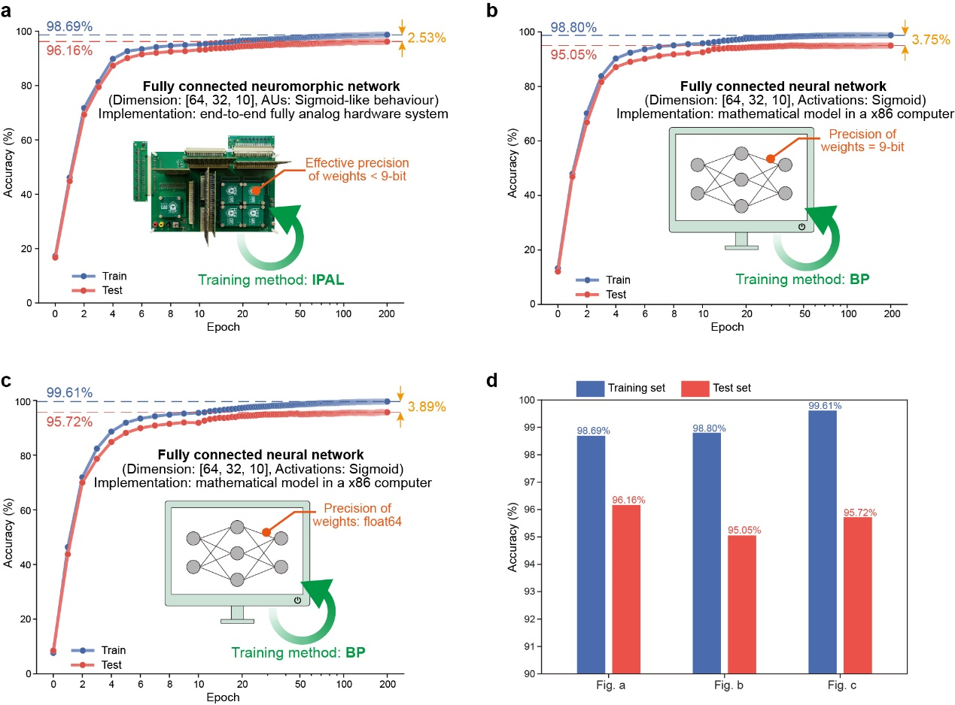
Extended Data Fig. 3 | IPAL-trained fully analogue neuromorphic network versus BP-trained mathematical neural network model. Both networks have the same fully connected structure, consisting of 64 input neurons, 32 hidden neurons (Sigmoid), and 10 output neurons (Sigmoid). The mathematical neural network models are realized by Python scripts performed on a x86 computer, in which weights are limited to 9-bit precision in b, and float64 precision in c, respectively. The scripts are provided at https://github.com/MiaoGroup/standard_bp_optdigits. The neuromorphic network is implemented by our fully analogue hardware system, in which the effective precision of weights is lower than 9-bit. a-c, The training curves illustrate similar learning efficiency. d, Comparison of recognition accuracies. The IPAL-trained analogue neuromorphic network achieves the highest accuracy on the test set. This is because the IPAL-trained analogue neuromorphic network exhibits a closer alignment in accuracy performance between the training set and test set (2.53%), compared to that of the BP-trained mathematical model (>3.5%). This indicates that our approach can mitigate the overfitting issue.

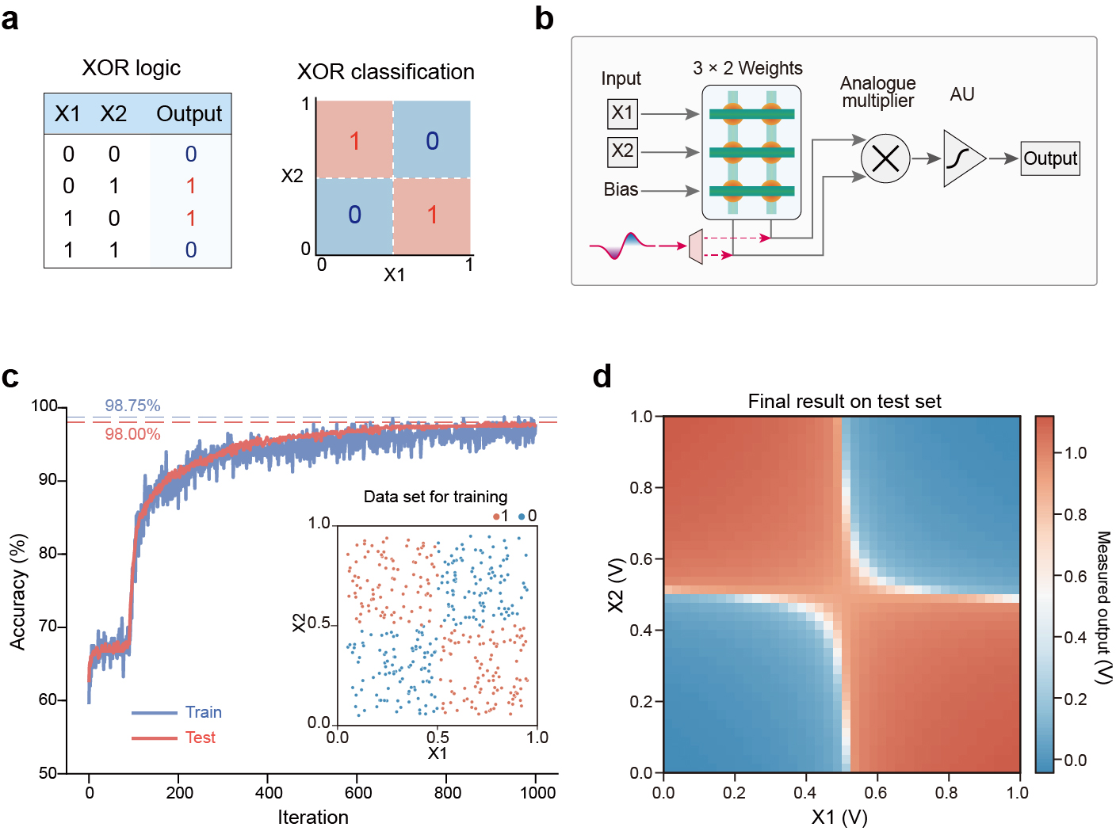
Extended Data Fig. 4 | Training a single-layer neuromorphic network for XOR classification. a, XOR logic and XOR classification problem, in which two classes of data cannot be linearly separated. b, Schematic of testing circuits. Note that we combine an analogue multiplier (AD835) and a Sigmoid-like AU for nonlinear transformation. The outputs exceeding the threshold are classified as ‘1’, and the others are classified as ‘0’. c, XOR classification task is successfully trained using IPAL. The training dataset is randomly generated in each iteration. d, Measured output result on the test set (equidistant two-dimensional grids).

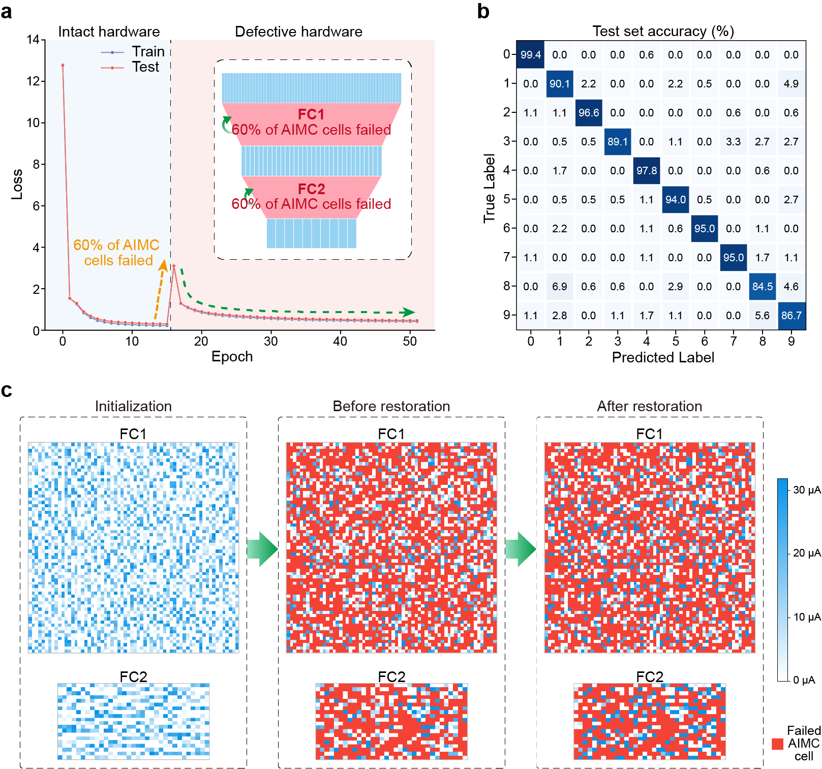
Extended Data Fig. 5 | Training an electrical synapse-impaired neuromorphic network. This figure supplements the result shown in Fig. 4b. a, The loss value decreases after the failure of 60% of the electrical synapses at the 16th epoch. b, Confusion matrix of measured recognition results on the test set. c, Evolution of the weight distributions in AIMC arrays.

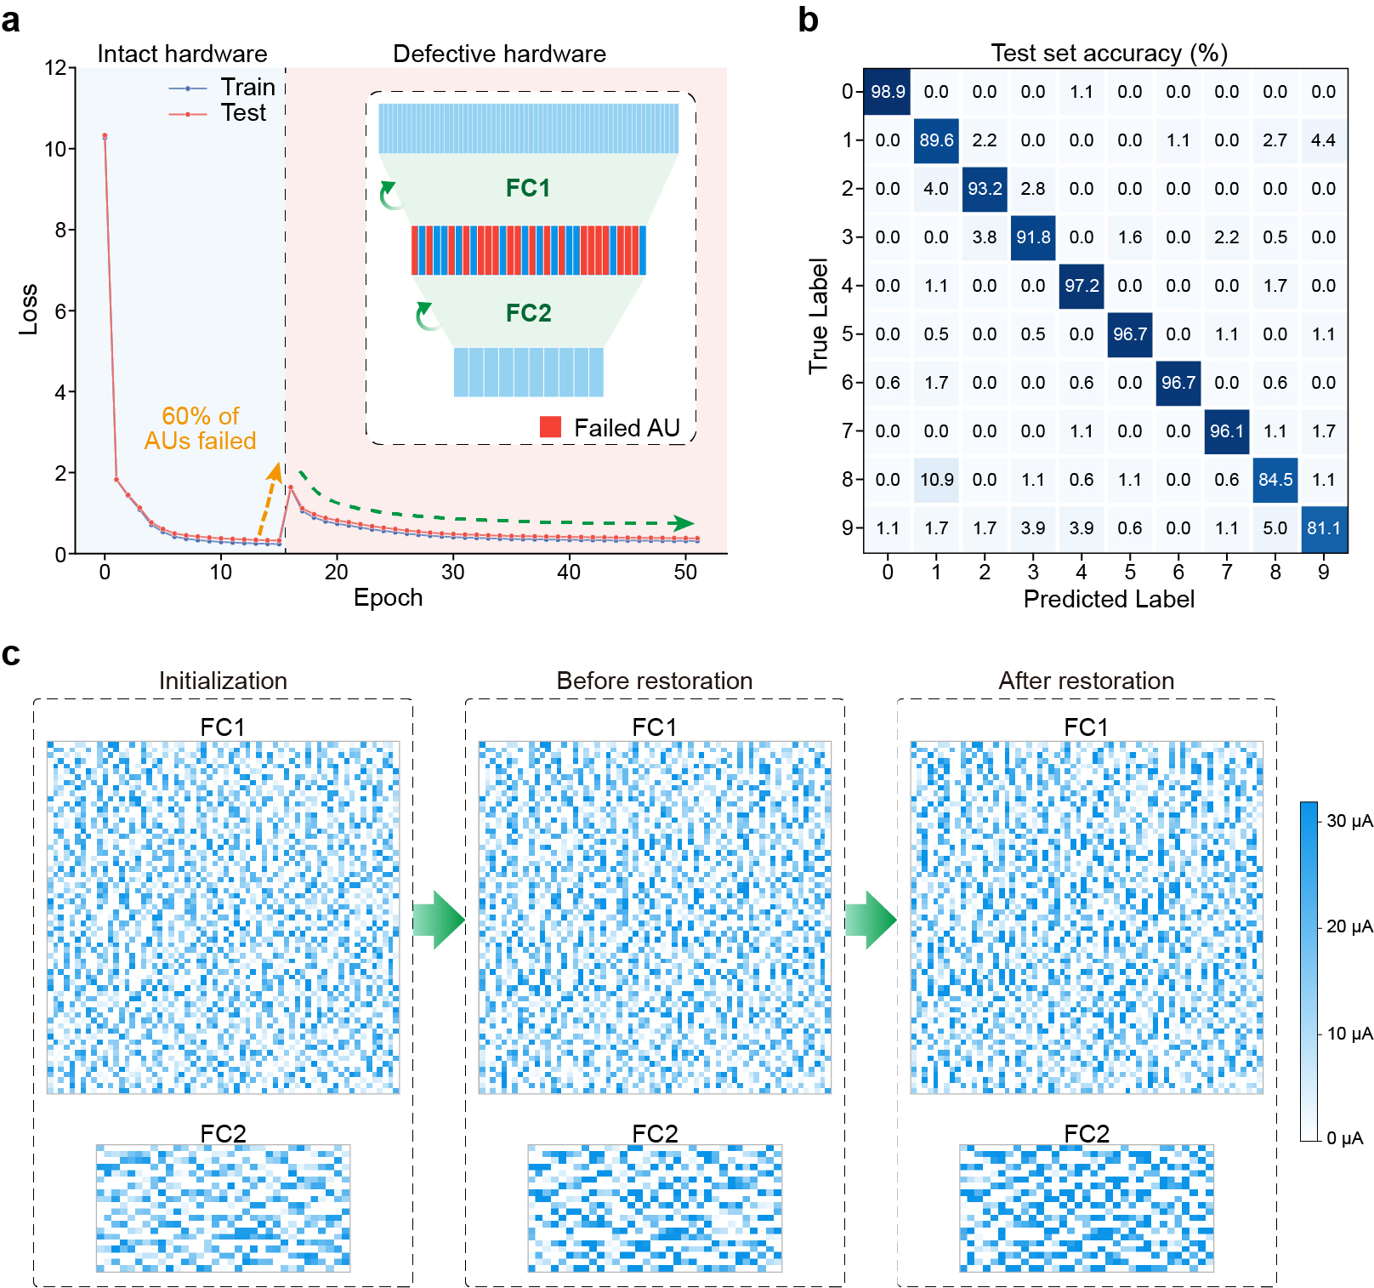
Extended Data Fig. 6 | Training an electrical neuron-impaired neuromorphic network. This figure supplements the result shown in Fig. 4c. a, The loss value decreases after the failure of 60% of the electrical neurons in the hidden layer. b, Confusion matrix of the measured recognition accuracy on the test set. c, Evolution of the weight distributions in AIMC arrays.

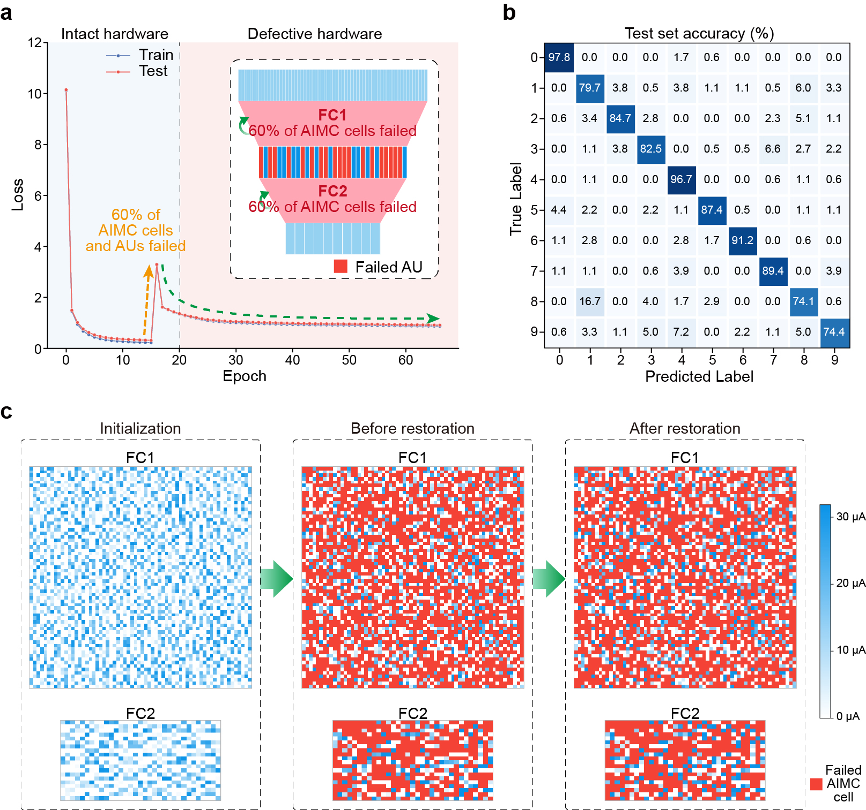
Extended Data Fig. 7 | Training a defective neuromorphic network. This figure supplements the result shown in Fig. 4d. a, The loss value decreases after the failure of 60% of the electrical synapses and neurons at the 16th epoch. b, Confusion matrix of the measured recognition accuracy on the test set. c, Evolution of the weight distributions in AIMC arrays.

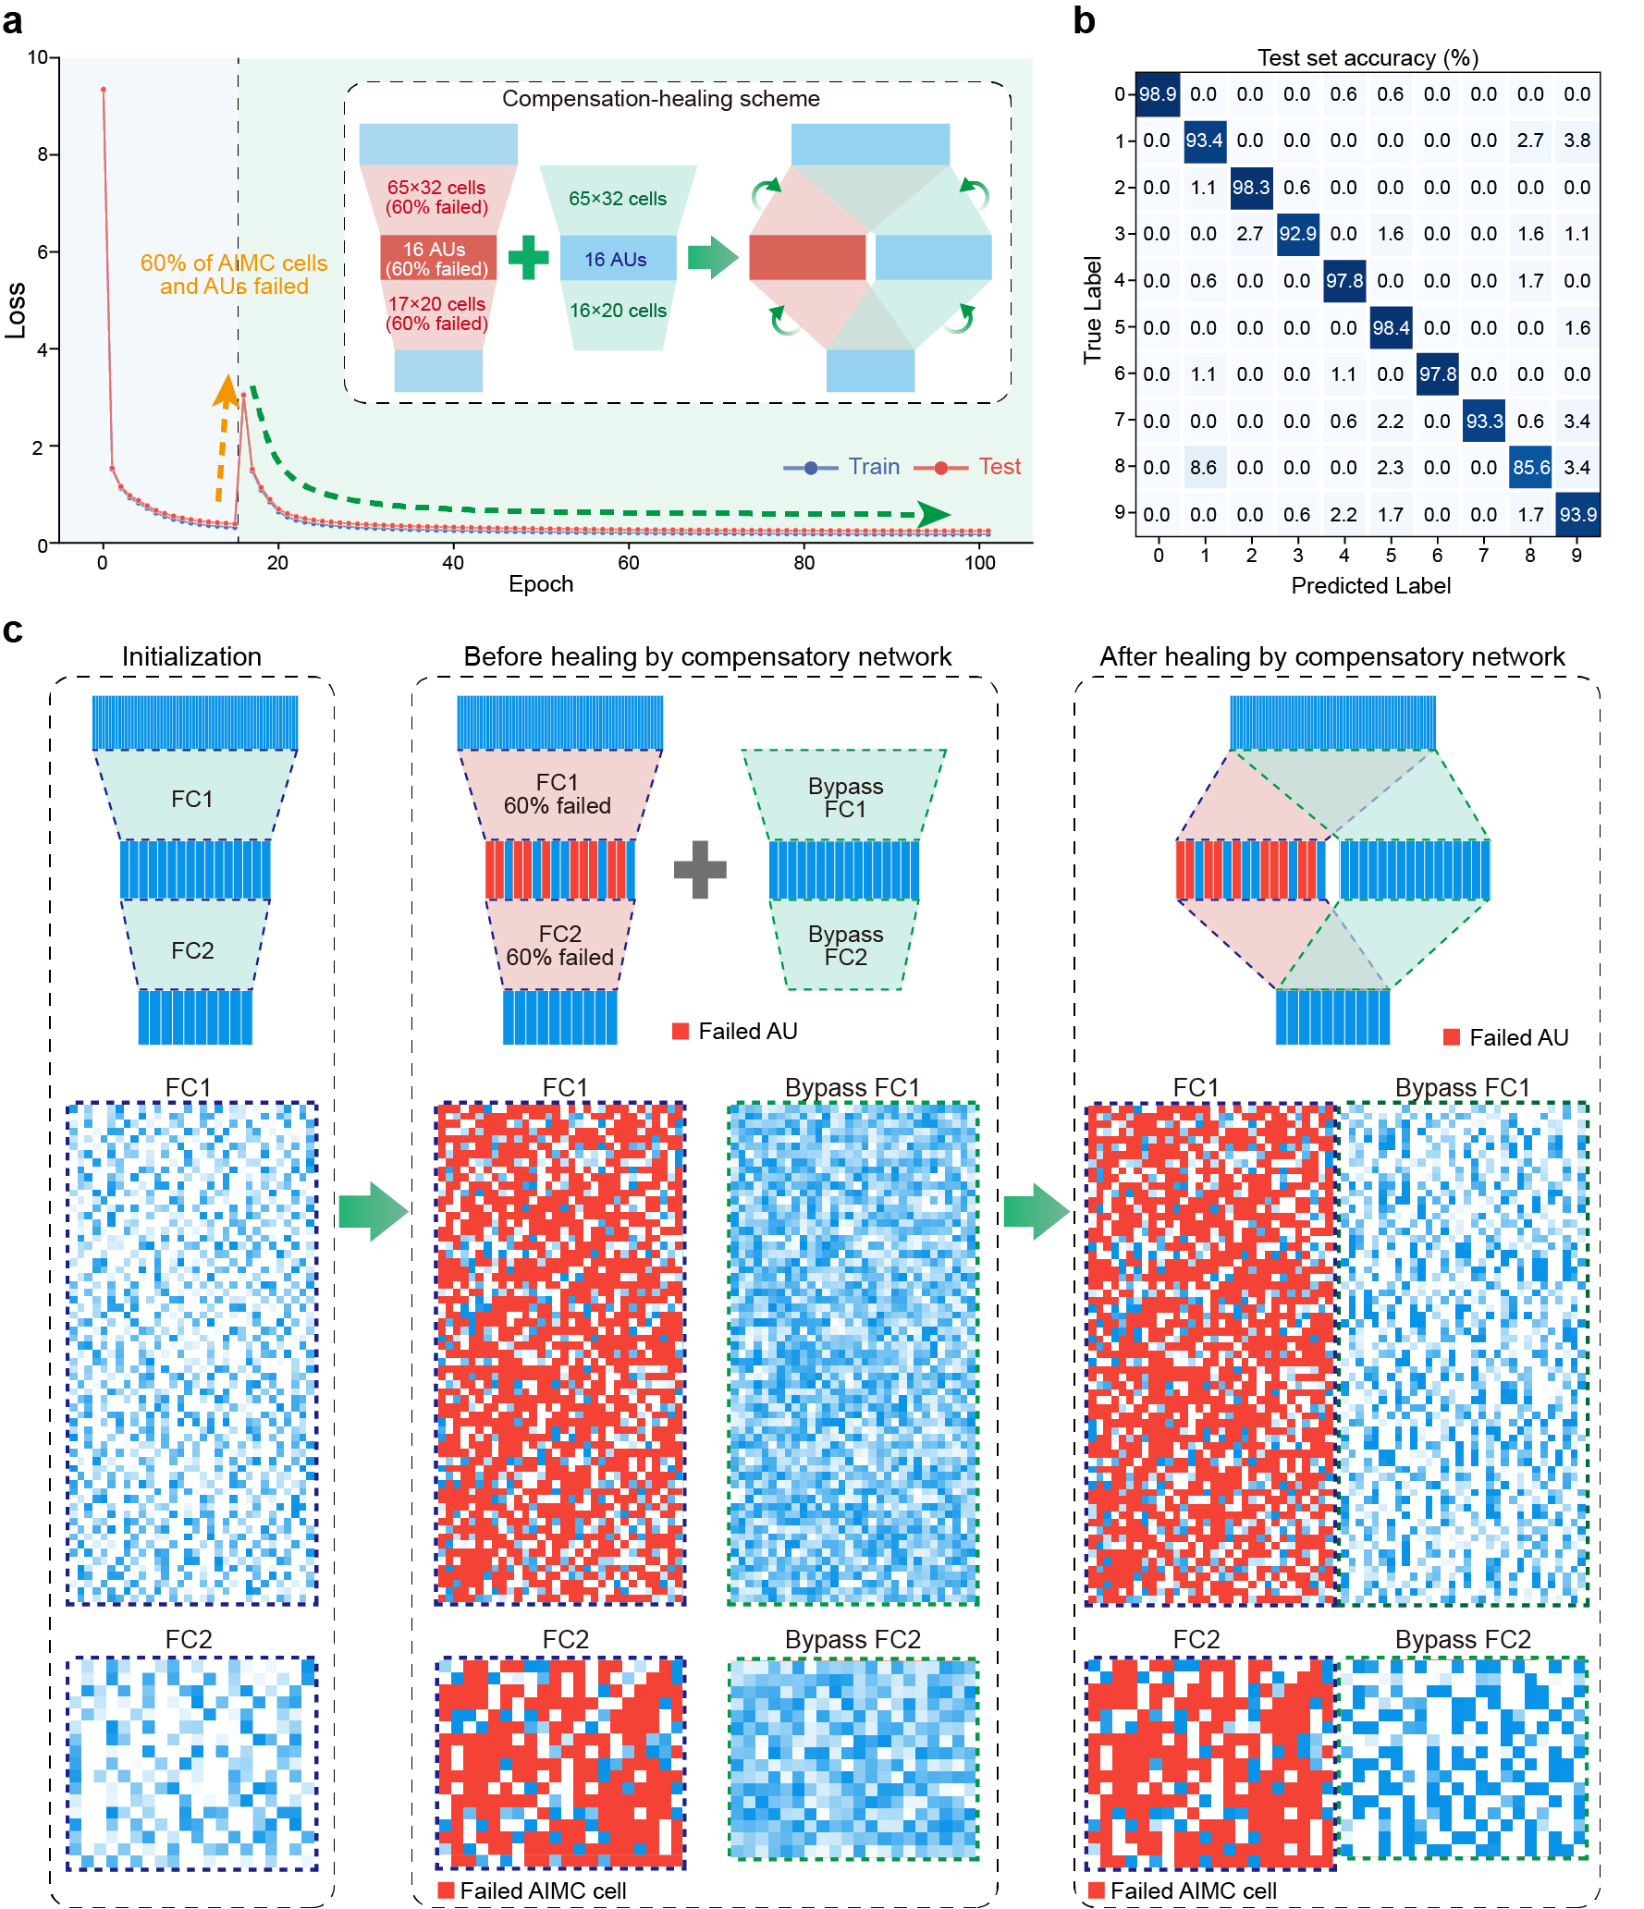
Extended Data Fig. 8 | Compensation-healing scheme. This figure supplements the result shown in Fig. 4f. a, The loss value decreases again after the breakdown and compensation at the 16th epoch. The final loss value is lower than the accuracy before the breakdown. b, Measured confusion matrix of recognition accuracy on the test set. c, Evolution of the network structure and the weight distributions in AIMC arrays.

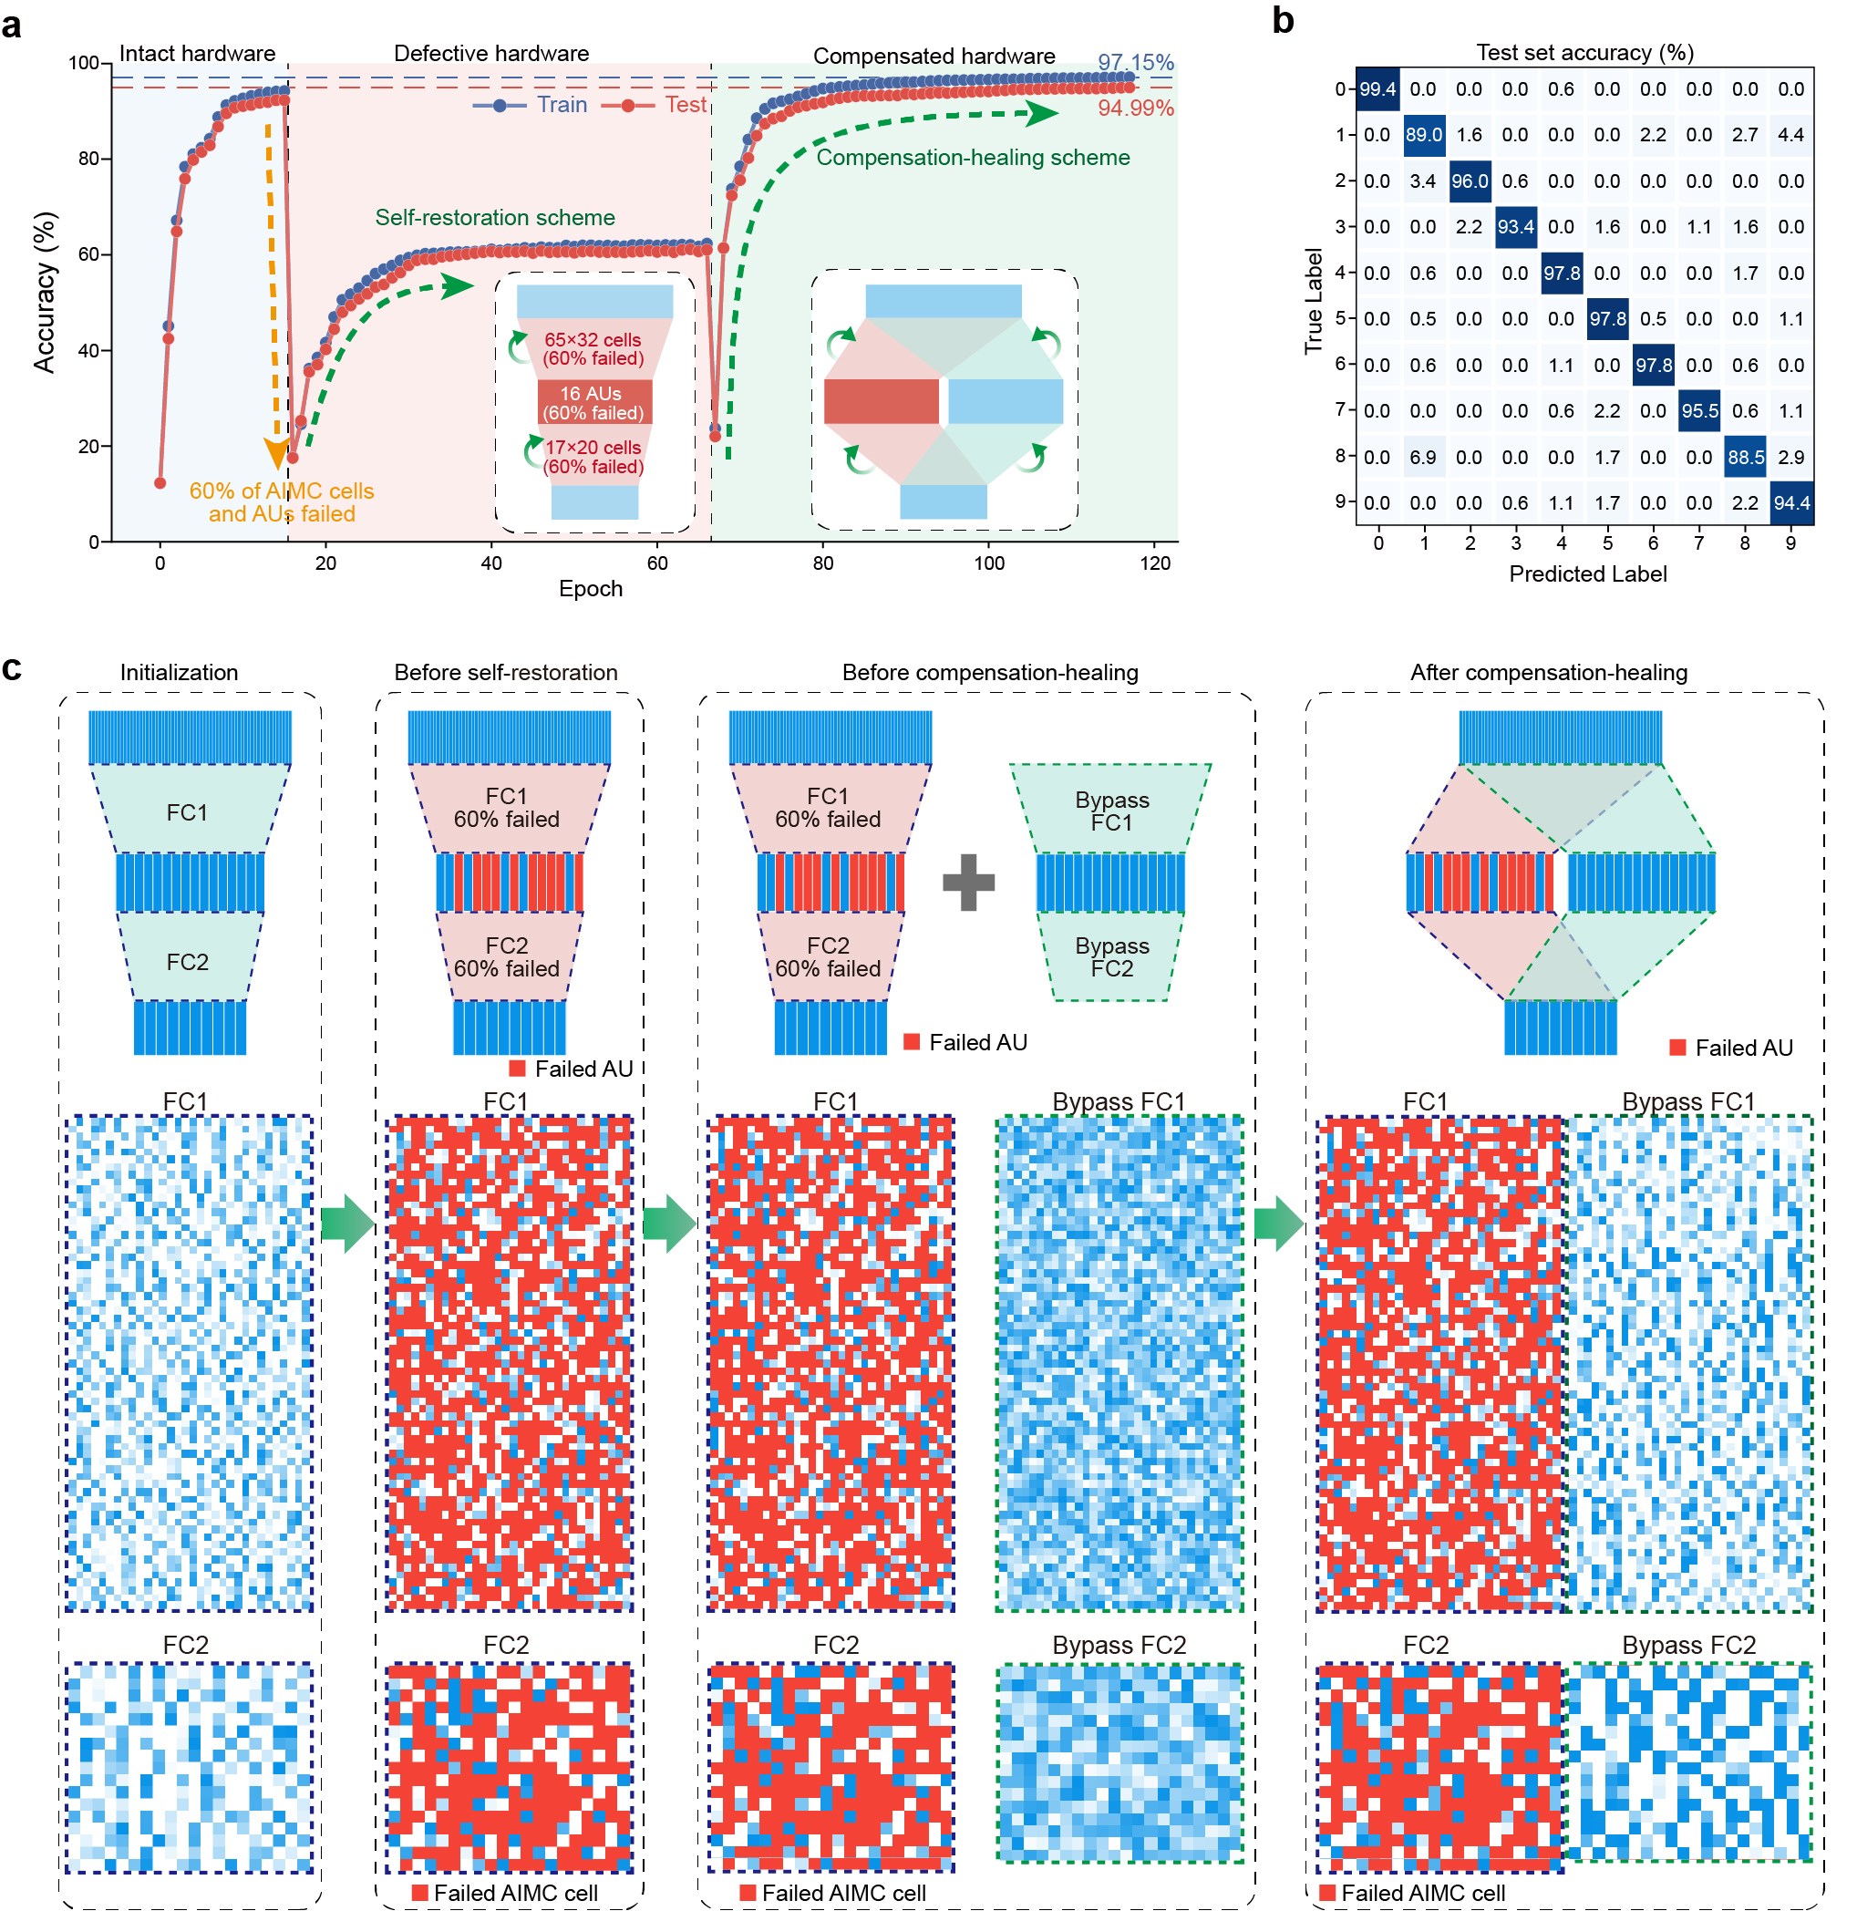
Extended Data Fig. 9 | Enhancement of a defective analogue neuromorphic network via a compensation-healing scheme. a, The experimental demonstration shows that the accuracy performance of the analogue neuromorphic network is slightly improved after the breakdown at the 16th epoch. After the hardware compensation at the 66th epoch, the classification accuracy significantly increases over that of the original intact neuromorphic network. b, Measured confusion matrix of recognition accuracy on the test set. c, Evolution of the network structure and the weight distributions in AIMC arrays.

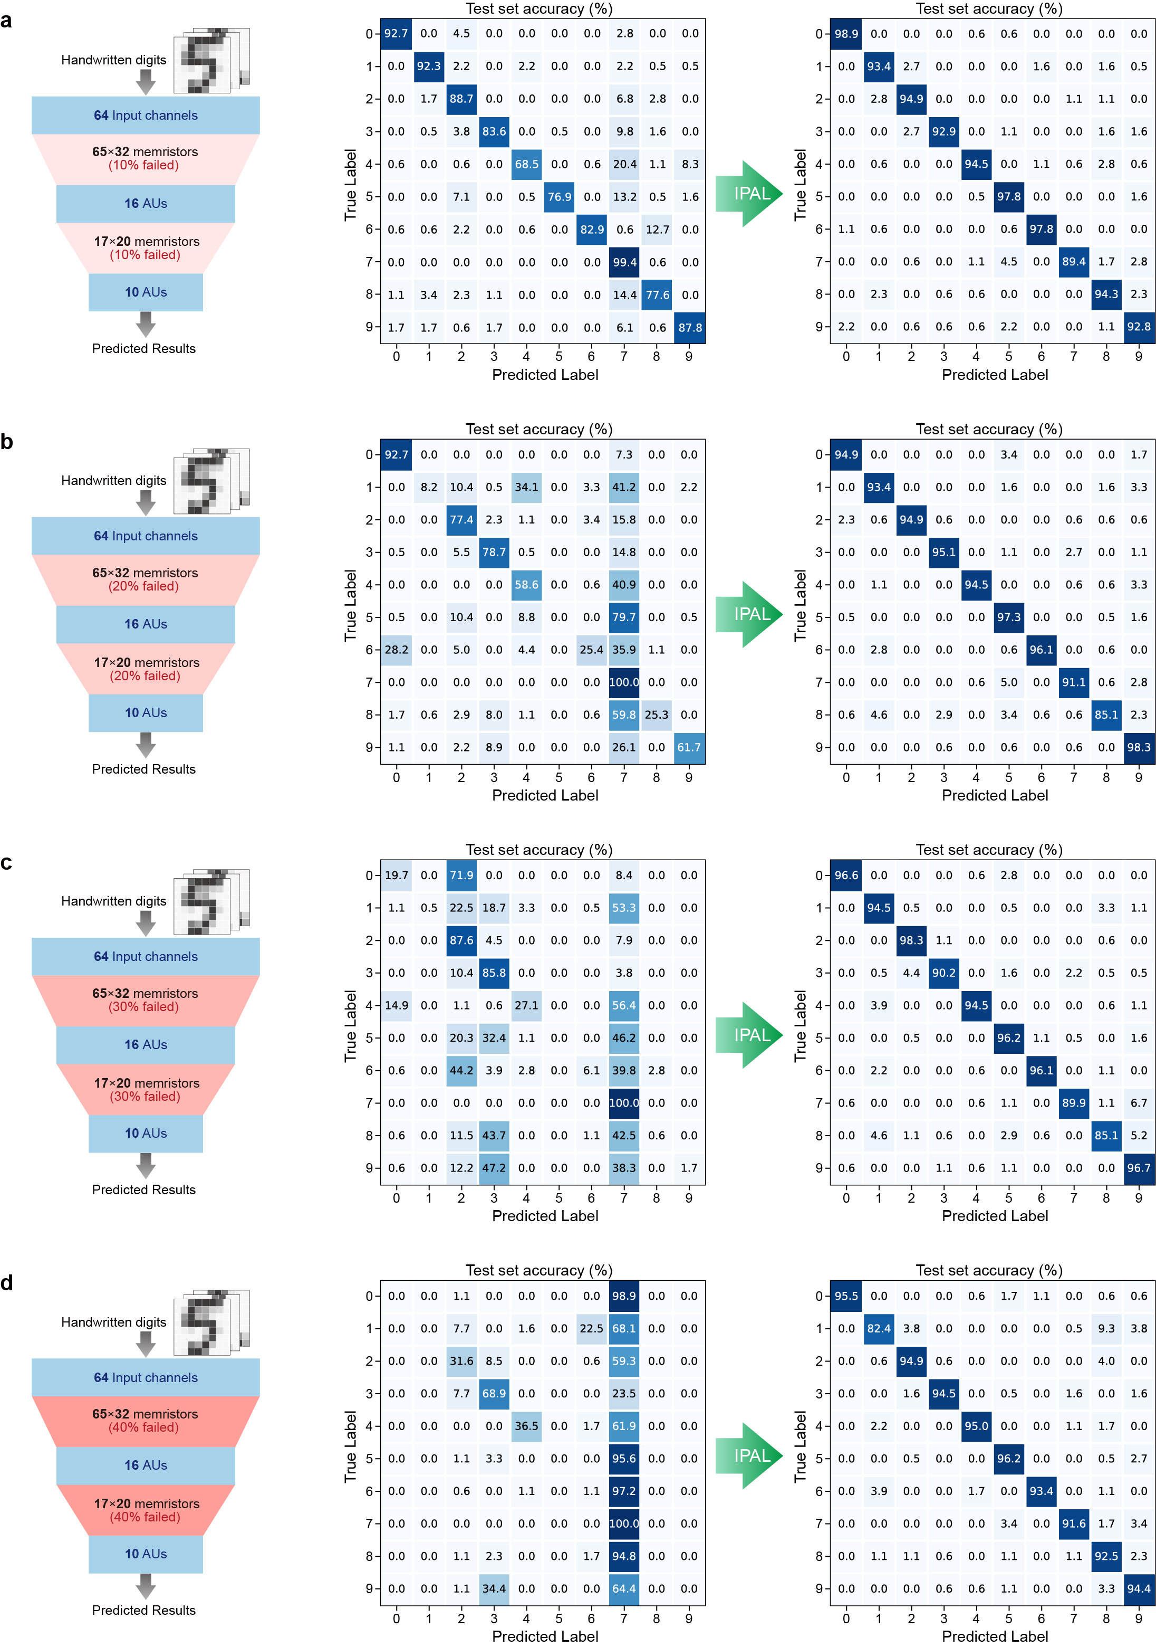
Extended Data Fig. 10 | Experimental demonstration of training analogue neuromorphic networks based on defective memristive crossbar arrays. Evolution of the confusion matrices of the measured recognition accuracy on the test set. These supplement the results shown in Fig. 5c.

