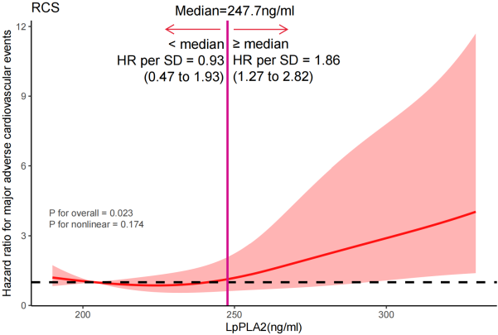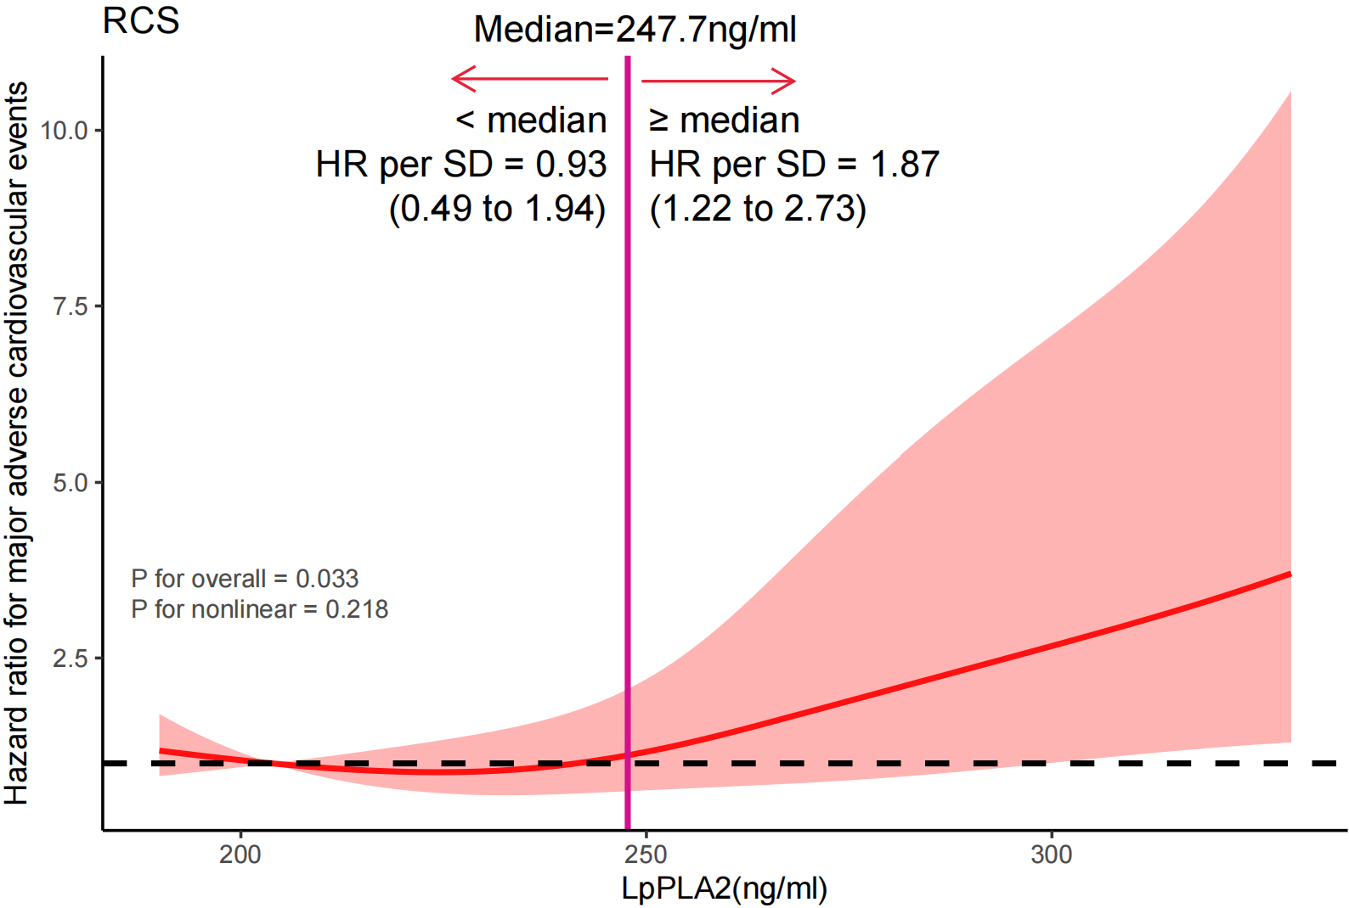

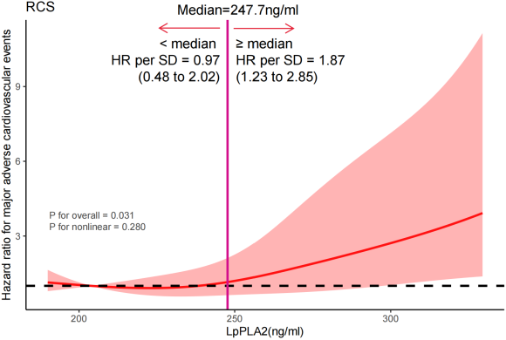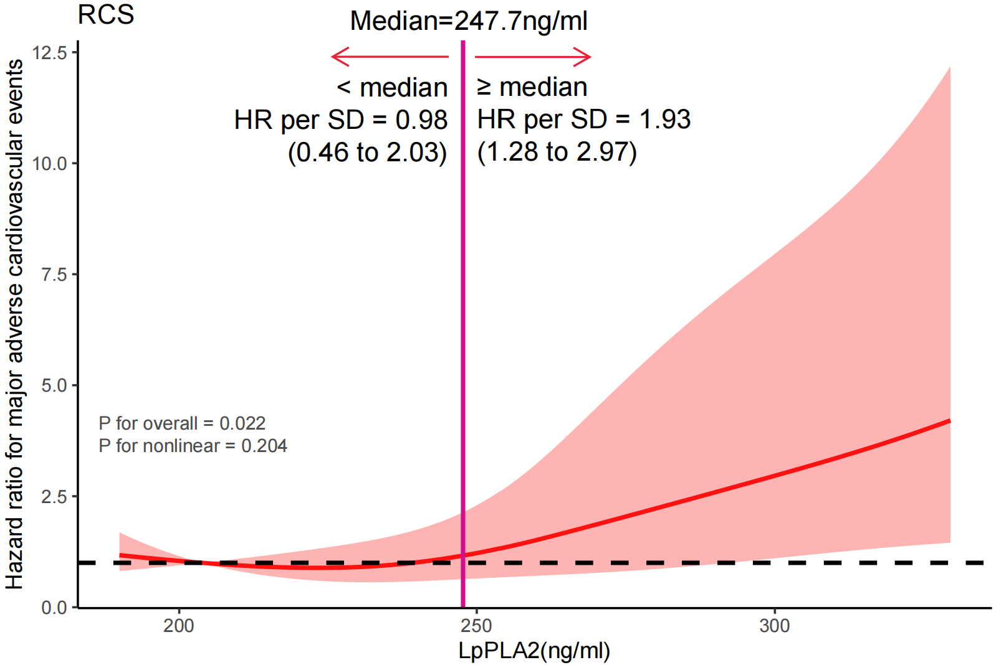
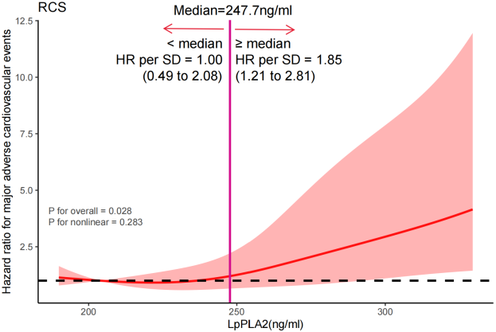

eFigure 1. Association of predicted LpPLA2 levels with incident MACE in 285 CSF patients on data following multiple imputation with 5 replications through 4-knotted RCS curve adjusted for covariates in model 3. Hazard ratio is indicated by solid line and 95% CI by shaded area. Reference point was set at tenth percentiles while knots corresponded to 5th, 35th, 65th, and 95th percentiles. Standard deviation for LpPLA2 levels was 38.83 ng/ml.

