Supplementary appendix

Supplementary appendix 18
Supplementary methods 20
Comparator Classification by ICD10 Codes 20
Traditional Classification Methods 20
BERT Classifier 20
Few-Shot and finetuned LLM Classifier 20
Appendix S1 Code and LUTs Repository 21
Appendix S2 Regex Rule Builder 22
Appendix S3 GPT4 Prediction Prompt (API) 23
Appendix S4 GPT4 Token Limits 24
Appendix S5 Prescribed Drugs 25
Appendix S6 Prescribing Specialities 26
Appendix S7 Labelling Coverage 27
Appendix S8 Uncommon Indications 28
Appendix S9 Class Distributions 29
Appendix S 10 Per Class Prediction Scores 30
Appendix S11 Training Set Size Effects 32

Supplementary methods

Comparator Classification by ICD10 Codes
We first summarised all ICD10 codes into broader concepts using the CCSR classification tool, grouping >70,000 ICD10 codes into 544 categories. Two independent clinical researchers then developed a custom lookup table mapping CCSR categories to our 11 infection source groups (Appendix S1), with a third clinician resolving discrepancies.

Traditional Classification Methods

Regex Rules
The regex patterns for each category were built using the 50 most common indications for that infection source in the training data, with individually assigned error-rate thresholds for inexact matching and specified word boundaries for each string. This allowed for strict exact matching on abbreviations while permitting spelling mistakes for longer words. Word boundaries ensured that abbreviations were not matched when part of a longer word (e. g. avoiding finding UTI in roUTIne post-op, cUTIbacterium). Our tool, designed to automate the creation of complex regex queries based on a given reference set and user specifications, can be found in Appendix S2. The assisted regex builder simplified creating complex matching rules for infection sources, extracting the most common indications for each category and exporting them into a pre-populated table with parsing options for additional user input. Users can then modify these rules: adding word boundaries for precise matches, setting error rates (e.g., zero for abbreviations), and excluding redundant words. The edited table is then read back and converted into complex regex-matching strings for each category. This allows for medical experts to build and modify complex matching rules without needing to understand and debug error-prone regular expressions.

BERT Classifier
We evaluated the performance of the original generic “uncased base BERT” model, pre-trained on the BooksCorpus and English Wikipedia and a domain-specific “Bio+Clinical BERT”, pre-trained on biomedical and clinical text sourced from PubMed, PubMed Central and MIMIC-III v1.4 notes^{22,23}. Both pre-trained models were fetched from the HuggingFace model hub (uploaded on the 18-June-2019 and 28-February-2020), and finetuned using the HuggingFace “transformers” library with indications as input and the source categories as output ²¹.

Few-Shot and finetuned LLM Classifier
We developed prompts for GPT4, comprised of instructions and the target categories, asking the model to complete the categories (specific prompt in Appendix S3)²⁴. We made several iterations to the prompt on a subset of the training data, aiming to increase the model’s understanding of the task. Given the model’s generative nature, we accessed GPT4 through the API and supplied inputs to create more structured, deterministic and less creative answers. Specifying a rigid output format is crucial for a multi-label task. We therefore instructed the model to present its prediction output in JSON format, using the original indication as the key and the categories as a list of values. To prevent the model from creating new categories, we penalised it for returning new tokens not seen in the text (i.e. the prompt) by setting a higher `presence penalty’. A fixed `seed’ and lower `temperature’ were chosen to coerce the model into returning more deterministic and reproducible answers³². The same hyperparameters were used for prediction with the fine-tuned GPT3.5 model, aiming to increase determinism and reproducibility.

Appendix S1 Code and LUTs Repository
ICD10 to Infection Source Mapping Table
https://github.com/kevihiiin/EHR-Indication-Processing/blob/main/00_Data/LUTs/icd10_ccsr_mapping.csv

Appendix S2 Regex Rule Builder
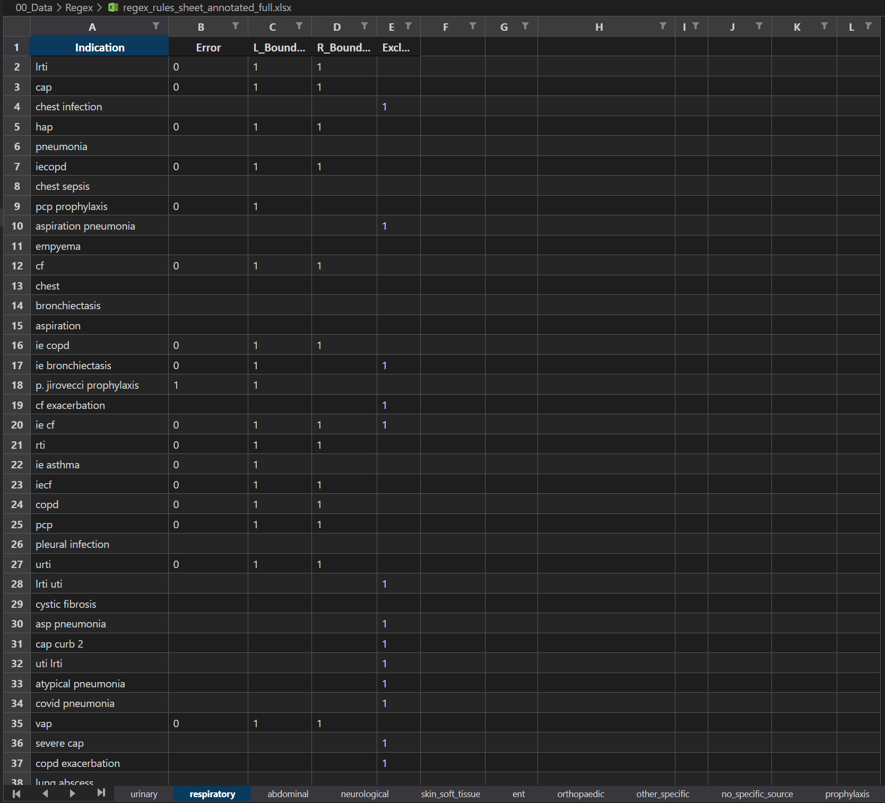
Figure S2: Regex Rule Builder user specifications. Specify a non-default error rate for abbreviations, set left and right word boundaries and exclude duplicated words. One sheet per category.

Appendix S3 GPT4 Prediction Prompt (API)
System prompt:
You are a helpful and precise UK medical expert; you have been given a list of indications describing why antibiotics were prescribed to patients in a hospital. You have been asked to **label** these indications into categories.
You can only choose from these categories which are: Urinary, Respiratory, Abdominal, Neurological, Skin Soft Tissue, Ent, Orthopaedic, Other Specific, No Specific Source, Prophylaxis, Uncertainty, Not Informative
Multiple categories are allowed.
When returning your answer, please return a json
User prompt:
This is the list of indications, return a json with the categories (multiple allowed) for each indication.
“abdo pathology”,
“sepsis ?hap”,
“artholin abscess”,
[…]
The results are then parsed from the JSON-formatted response.

Appendix S4 GPT4 Token Limits
The number of supplied indications per request is limited by the number of output tokens. We determined that 300 input indications result in ~3800 return tokens, leaving a 10% safety margin for the 4k return limit.
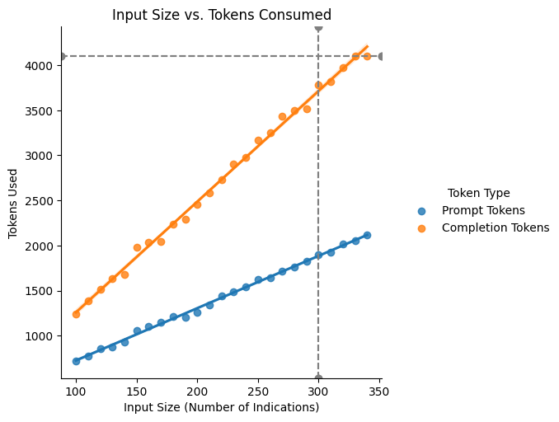
Figure S4: Token consumption (prompt and model output) depending on input size (number of indications.) Providing a higher number of supplied indications (input to classify) per round is more cost-effective, as the system and user instruction prompts are only submitted once. However, the number of output tokens is limited to 4k or 16k (depending on the model).

Appendix S5 Prescribed Drugs
Table S5: Ten most commonly prescribed drugs.
Drug [Oxford] | Number | Percentage
Co-amoxiclav | 269945 | 33%
Gentamicin | 70002 | 8%
Metronidazole | 65094 | 8%
Ceftriaxone | 58763 | 7%
Flucloxacillin | 47537 | 6%
Amoxicillin | 32151 | 4%
Ciprofloxacin | 25145 | 3%
Vancomycin | 23250 | 3%
Piperacillin + Tazobactam (Tazocin equivalent) | 21666 | 3%
Clarithromycin | 18607 | 2%

Drug [Banbury] | Number | Percentage
Co-amoxiclav | 39114 | 35%
Ceftriaxone | 11369 | 10%
Gentamicin | 10251 | 9%
Amoxicillin | 7297 | 7%
Clarithromycin | 6525 | 6%
Flucloxacillin | 5630 | 5%
Metronidazole | 4851 | 4%
Doxycycline | 4416 | 4%
Nitrofurantoin | 3204 | 3%
Piperacillin + Tazobactam (Tazocin equivalent) | 2862 | 3%

Appendix S6 Prescribing Specialities
Table S6: Specialties of the prescribing clinicians, ordered to show the ten most active specialties.
Clinician Main Specialty [Oxford] | Number | Percentage
General Surgery | 146719 | 18%
Acute General Medicine | 98687 | 12%
Trauma and Orthopaedics | 90719 | 11%
Acute Geratology | 72371 | 9%
Clinical Haematology | 46928 | 6%
Obstetrics | 36431 | 4%
Neurosurgery | 34666 | 4%
Infectious Diseases | 30584 | 4%
Plastic Surgery | 29334 | 4%
Urology | 29258 | 4%

Clinician Main Specialty [Banbury] | Number | Percentage
Acute General Medicine | 41312 | 37%
Acute Geratology | 14912 | 13%
Gastroenterology | 9128 | 8%
Cardiology | 8682 | 8%
Infectious Diseases | 7870 | 7%
Trauma and Orthopaedics | 7642 | 7%
General Surgery | 6803 | 6%
Emergency Medicine | 4924 | 4%
Urology | 2885 | 3%
Gynaecology | 2287 | 2%

Appendix S7 Labelling Coverage
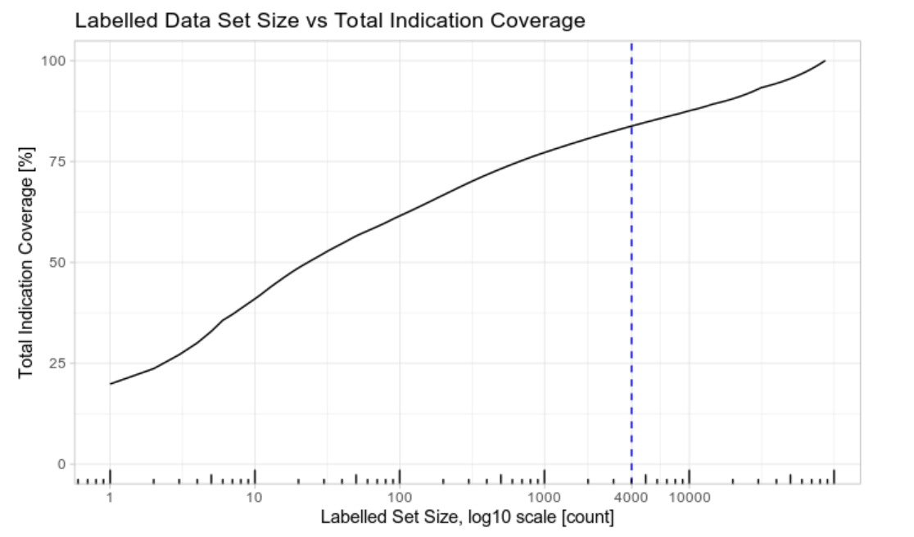
Figure S7: Total coverage of data given a set of labelled data. Labelling the most common 4000 samples covers 84% of the entire data set.

Appendix S8 Uncommon Indications
Table S8: Example list of uncommon indications. Randomly sampled from all indications occurring more than 5 and less than 100 times. Occurrences less than 10 are truncated to <10 for statistical disclosure control.
Uncommon Indication | Occurrence | Percentage
septic left knee | <10 | <1%
abdo contamination | <10 | <1%
infected femur | 10 | <1%
flu prophylaxis | 63 | <1%
forearm cellulitis | <10 | <1%
mesenteric panniculitis | <10 | <1%
intra-abdo inf | 14 | <1%
?dental infection | 14 | <1%
cap curb1 | 41 | <1%
septic unknown source | <10 | <1%

Appendix S9 Class Distributions
Table S9: Distributions of the classes within the different data sets.
 | Urinary | Respiratory | Abdominal | Neurological | Skin & Soft Tissue | ENT | Orthopaedic | Other Specific | No Specific Source | Prophylaxis | Not Informative
Training | 6.26% (n=54882) | 12.91% (n=113211) | 6.33% (n=55486) | 0.76% (n=6641) | 4.43% (n=38843) | 1.47% (n=12902) | 1.66% (n=14522) | 2.30% (n=20177) | 35.40% (n=310479) | 27.50% (n=241201) | 0.98% (n=8598)
Oxford Test | 5.79% (n=160) | 13.53% (n=374) | 8.64% (n=239) | 0.83% (n=23) | 4.74% (n=131) | 1.84% (n=51) | 1.99% (n=55) | 3.18% (n=88) | 32.77% (n=906) | 25.46% (n=704) | 1.23% (n=34)
Banbury Test | 12.51% (n=305) | 28.95% (n=706) | 4.84% (n=118) | 0.74% (n=18) | 7.59% (n=185) | 0.57% (n=14) | 0.98% (n=24) | 1.03% (n=25) | 26.65% (n=650) | 14.72% (n=359) | 1.44% (n=35)

Appendix S 10 Per Class Prediction Scores
Table S10.1: Per class prediction scores on the internal Oxford test set. Values are reported in F1 score, Precision Recall AUC and ROC AUC where applicable.
Model | Metric | Urinary | Respiratory | Abdominal | Neurological | Skin & Soft Tissue | ENT | Orthopaedic | Other Specific | No Specific Source | Prophylaxis | Uncertainty | Not Informative
Regex | F1 | 0.87 | 0.63 | 0.63 | 0.68 | 0.76 | 0.54 | 0.3 | 0.11 | 0.78 | 0.93 | 0.20 | 0.00
XGBoost | F1 | 0.64 | 0.81 | 0.9 | 0.76 | 0.83 | 0.83 | 0.7 | 0.71 | 0.91 | 0.96 | 0.66 | 0.9
Base_BERT | F1 | 0.97 | 0.98 | 0.94 | 0.23 | 0.94 | 0.27 | 0.59 | 0.63 | 0.98 | 0.98 | 0.95 | 0.67
Bio_ClinicalBERT | F1 | 0.98 | 0.98 | 0.96 | 0.88 | 0.93 | 0.91 | 0.93 | 0.84 | 0.98 | 0.98 | 0.96 | 0.85
Fine-Tuned GPT3.5 | F1 | 0.98 | 0.97 | 0.95 | 0.93 | 0.83 | 0.8 | 0.95 | 0.77 | 0.97 | 0.97 | 0.92 | 0.99
Few-Shot GPT4 | F1 | 0.98 | 0.96 | 0.83 | 0.88 | 0.87 | 0.79 | 0.87 | 0.30 | 0.34 | 0.94 | 0.78 | 0.30
Regex | PR | - | - | - | - | - | - | - | - | - | - | - | -
XGBoost | PR | 0.62 | 0.87 | 0.91 | 0.68 | 0.89 | 0.82 | 0.65 | 0.72 | 0.97 | 0.99 | 0.69 | 0.83
Base_BERT | PR | 0.98 | 0.99 | 0.97 | 0.69 | 0.95 | 0.85 | 0.94 | 0.77 | 0.99 | 0.99 | 0.97 | 0.92
Bio_ClinicalBERT | PR | 0.99 | 1.00 | 0.97 | 0.91 | 0.98 | 0.93 | 0.96 | 0.88 | 0.99 | 1.00 | 0.99 | 0.94
Fine-Tuned GPT3.5 | PR | - | - | - | - | - | - | - | - | - | - | - | -
Few-Shot GPT4 | PR | - | - | - | - | - | - | - | - | - | - | - | -
Regex | ROC | - | - | - | - | - | - | - | - | - | - | - | -
XGBoost | ROC | 0.9 | 0.96 | 0.97 | 0.92 | 0.98 | 0.96 | 0.91 | 0.92 | 0.97 | 0.99 | 0.87 | 0.94
Base_BERT | ROC | 0.98 | 1.00 | 0.98 | 0.97 | 0.99 | 0.96 | 0.99 | 0.91 | 0.99 | 0.99 | 1.00 | 0.98
Bio_ClinicalBERT | ROC | 0.99 | 1.00 | 0.98 | 1.00 | 0.99 | 0.98 | 0.99 | 0.96 | 0.99 | 1.00 | 1.00 | 0.99
Fine-Tuned GPT3.5 | ROC | - | - | - | - | - | - | - | - | - | - | - | -
Few-Shot GPT4 | ROC | - | - | - | - | - | - | - | - | - | - | - | -
Regex | Accuracy | 0.98 | 0.79 | 0.89 | 0.99 | 0.97 | 0.96 | 0.89 | 0.36 | 0.76 | 0.96 | 0.32 | 0.97
XGBoost | Accuracy | 0.96 | 0.94 | 0.98 | 1.00 | 0.98 | 0.99 | 0.99 | 0.98 | 0.92 | 0.97 | 0.95 | 1.00
Base_BERT | Accuracy | 0.99 | 0.99 | 0.99 | 0.99 | 0.99 | 0.98 | 0.98 | 0.97 | 0.98 | 0.98 | 0.99 | 0.99
Bio_ClinicalBERT | Accuracy | 1.00 | 0.99 | 0.99 | 1.00 | 0.99 | 1.00 | 1.00 | 0.99 | 0.98 | 0.98 | 0.99 | 1.00
Fine-Tuned GPT3.5 | Accuracy | 1.00 | 0.99 | 0.99 | 1.00 | 0.97 | 0.99 | 1.00 | 0.98 | 0.97 | 0.98 | 0.99 | 1.00
Few-Shot GPT4 | Accuracy | 1.00 | 0.98 | 0.96 | 1.00 | 0.98 | 0.99 | 0.99 | 0.94 | 0.64 | 0.96 | 0.97 | 0.96
Table S10.2: Per class prediction scores on the external Banbury test set. Values are reported in F1 score, Precision Recall AUC and ROC AUC where applicable.
Model | Metric | Urinary | Respiratory | Abdominal | Neurological | Skin & Soft Tissue | ENT | Orthopaedic | Other Specific | No Specific Source | Prophylaxis | Uncertainty | Not Informative
Regex | F1 | 0.96 | 0.73 | 0.35 | 0.78 | 0.90 | 0.30 | 0.25 | 0.03 | 0.81 | 0.95 | 0.30 | 0.00
XGBoost | F1 | 0.67 | 0.8 | 0.86 | 1.00 | 0.91 | 0.87 | 0.76 | 0.63 | 0.92 | 0.98 | 0.72 | 0.87
Base_BERT | F1 | 0.99 | 0.99 | 0.92 | 0.76 | 0.96 | 0.73 | 0.63 | 0.65 | 0.98 | 0.98 | 0.99 | 0.79
Bio_ClinicalBERT | F1 | 0.99 | 0.99 | 0.95 | 1.00 | 0.96 | 0.92 | 0.91 | 0.92 | 0.99 | 0.97 | 0.99 | 0.87
Fine-Tuned GPT3.5 | F1 | 0.98 | 0.98 | 0.95 | 1.00 | 0.91 | 0.81 | 0.90 | 0.70 | 0.98 | 0.96 | 0.95 | 1.00
Few-Shot GPT4 | F1 | 0.99 | 1.00 | 0.85 | 1.00 | 0.96 | 0.88 | 0.91 | 0.25 | 0.6 | 0.96 | 0.88 | 0.59
Regex | PR | - | - | - | - | - | - | - | - | - | - | - | -
XGBoost | PR | 0.67 | 0.87 | 0.83 | 1.00 | 0.91 | 0.91 | 0.77 | 0.57 | 0.95 | 0.98 | 0.73 | 0.83
Base_BERT | PR | 1.00 | 1.00 | 0.96 | 1.00 | 0.98 | 0.9 | 0.88 | 0.75 | 0.98 | 0.99 | 0.99 | 0.92
Bio_ClinicalBERT | PR | 1.00 | 1.00 | 0.95 | 1.00 | 0.98 | 1.00 | 0.96 | 0.87 | 0.98 | 0.98 | 0.99 | 0.94
Fine-Tuned GPT3.5 | PR | - | - | - | - | - | - | - | - | - | - | - | -
Few-Shot GPT4 | PR | - | - | - | - | - | - | - | - | - | - | - | -
Regex | ROC | - | - | - | - | - | - | - | - | - | - | - | -
XGBoost | ROC | 0.86 | 0.93 | 0.94 | 1.00 | 0.96 | 0.96 | 0.90 | 0.93 | 0.97 | 0.99 | 0.87 | 0.94
Base_BERT | ROC | 1.00 | 1.00 | 0.98 | 1.00 | 0.99 | 0.99 | 1.00 | 0.95 | 1.00 | 0.99 | 1.00 | 0.98
Bio_ClinicalBERT | ROC | 1.00 | 1.00 | 0.98 | 1.00 | 0.99 | 1.00 | 0.98 | 0.97 | 0.99 | 0.99 | 1.00 | 0.99
Fine-Tuned GPT3.5 | ROC | - | - | - | - | - | - | - | - | - | - | - | -
Few-Shot GPT4 | ROC | - | - | - | - | - | - | - | - | - | - | - | -
Regex | Accuracy | 0.99 | 0.75 | 0.84 | 0.99 | 0.98 | 0.97 | 0.95 | 0.41 | 0.85 | 0.98 | 0.41 | 0.97
XGBoost | Accuracy | 0.92 | 0.88 | 0.98 | 1.00 | 0.98 | 1.00 | 0.99 | 0.99 | 0.95 | 0.99 | 0.94 | 1.00
Base_BERT | Accuracy | 1.00 | 0.99 | 0.99 | 1.00 | 0.99 | 1.00 | 0.99 | 0.99 | 0.99 | 0.99 | 1.00 | 0.99
Bio_ClinicalBERT | Accuracy | 1.00 | 0.99 | 0.99 | 1.00 | 0.99 | 1.00 | 1.00 | 1.00 | 0.99 | 0.99 | 1.00 | 1.00
Fine-Tuned GPT3.5 | Accuracy | 0.99 | 0.99 | 0.99 | 1.00 | 0.98 | 1.00 | 1.00 | 0.99 | 0.99 | 0.99 | 0.99 | 1.00
Few-Shot GPT4 | Accuracy | 1.00 | 0.98 | 0.96 | 1.00 | 0.98 | 0.99 | 0.99 | 0.94 | 0.64 | 0.96 | 0.97 | 0.96

Appendix S11 Training Set Size Effects
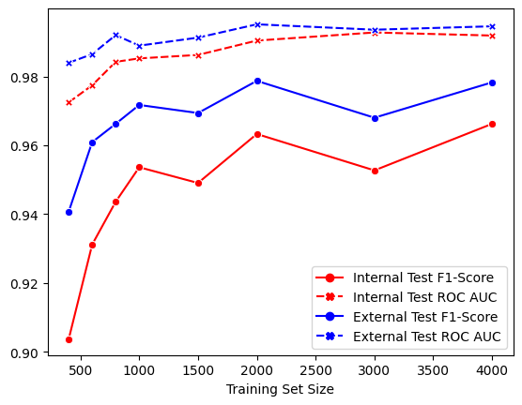
Figure S11: Training set size effect on the performance of Bio+Clinical BERT, evaluated on both F1-Score and ROC AUC. The training was run on randomly sampled subsets of the training dataset of size [500, 1000, 1500, 2000, 3000, 4000] and evaluated on the same internal and external test sets (2000 samples each).

