Supplementary Table S1 Date of detector plants placement and removal from the field in Lambsburg (2014), weather variables, maximum accumulated blight risk index values for the boxwood blight infection risk model using leaf wetness estimated by leaf wetness sensor (SENSOR and SENSOR-ADJ) and algorithms based on energy principles (ESTIM-LW), and infected leaf count recorded during each week. Boxwood blight was predicted for weeks in which the continuously accumulated blight index reached 56, 160 or 250 degree-hours (°F) before the infection process stopped. Between row treatment was only included in 2024.
Year | Week | Date  in | Date  out | Exposure period  (days) | Weekly  total  rain  (mm) | Rain  per  day  (mm) | Rain  duration  per  day  (hours) | Weekly† mean  wind  speed  (m/s) | Weekly†† mean relative humidity  (%) | Weekly  total  leaf  wetness duration (hours) | Mean  leaf  wetness  duration  per  day  (hours) | Weekly§ mean  temperature (°C) | Maximum accumulated  blight index value |  |  |  | Infected leaf count
 |  |  |  |  |  |  |  |  |  |  |  |  | SENSOR | ESTIM-  LW | SENSOR-  ADJ |  | Infected  canopies | Leaf  debris | Between  row
2014 | 1 | 5-26 | 6-2 | 7 | 6.2 | 0.89 | 0.46 | 0.26 | 80.14 | 42.98 | 6.14 | 20.59 | 747 | 801 | 762 |  | 0 | NA | NA
2014 | 2 | 6-9 | 6-16 | 7 | 6.6 | 0.94 | 0.46 | 0.28 | 79.89 | 57.58 | 8.23 | 20.78 | 457 | 1787 | 438 |  | 0 | 0 | 3
2014 | 3 | 6-16 | 6-23 | 7 | 6 | 0.86 | 0.21 | 0.4 | 77.92 | 33.83 | 4.83 | 22.23 | 411 | 491 | 402 |  | 0 | 4 | 0
2014 | 4 | 6-23 | 6-30 | 7 | 54 | 7.71 | 1.11 | 0.26 | 91.19 | 69.38 | 9.91 | 19.71 | 940 | 1994 | 897 |  | 3 | 13 | 4
2014 | 5 | 6-30 | 7-7 | 7 | 0.6 | 0.09 | 0.04 | 0.4 | 77.35 | 1.87 | 0.27 | 26.2 | 21 | 1153 | 27 |  | 0 | 0 | 0
2014 | 6 | 7-7 | 7-14 | 7 | 27 | 3.86 | 0.54 | 0.19 | 86.95 | 93.13 | 13.3 | 20.49 | 1323 | 1523 | 1298 |  | 16 | 17 | 1
2014 | 7 | 7-14 | 7-21 | 7 | 3 | 0.43 | 0.39 | 0.11 | 80.31 | 67.03 | 9.58 | 18.87 | 788 | 1813 | 791 |  | 0 | 0 | 0
2014 | 8 | 7-21 | 7-28 | 7 | 29.8 | 4.26 | 0.71 | 0.31 | 89.26 | 109.03 | 15.58 | 21.85 | 856 | 1543 | 868 |  | 7 | 31 | 7
2014 | 9 | 7-28 | 8-4 | 7 | 38.2 | 5.46 | 2 | 0.11 | 82.11 | 67.52 | 9.65 | 17.11 | 1165 | 1329 | 1155 |  | 3 | 30 | 0
2014 | 10 | 8-4 | 8-11 | 7 | 114.6 | 16.4 | 5.11 | 0.23 | 89.3 | 95.98 | 13.71 | 18.82 | 1553 | 1912 | 1547 |  | 83 | 215 | 7
2014 | 11 | 8-11 | 8-18 | 7 | 51.2 | 7.31 | 2.43 | 0.09 | 88.44 | 54.92 | 7.85 | 19.76 | 757 | 2184 | 738 |  | 31 | 50 | 10
2014 | 12 | 9-8 | 9-15 | 7 | 46.4 | 6.63 | 1.54 | 0.14 | 94.59 | 160.38 | 22.91 | 18.88 | 3692 | 3672 | 3559 |  | 276 | 120 | 9
2014 | 13 | 9-15 | 9-22 | 7 | 0.6 | 0.09 | 0.07 | 0.2 | 89.87 | 127.93 | 18.28 | 18.4 | 1982 | 2158 | 1906 |  | 0 | 0 | 0
2014 | 14 | 9-22 | 9-29 | 7 | 2.8 | 0.4 | 0.43 | 0.07 | 87.44 | 139.8 | 19.97 | 16.12 | 2299 | 1533 | 2257 |  | 0 | 0 | 0
2014 | 15 | 9-29 | 10-6 | 7 | 14 | 2 | 0.75 | 0.14 | 85.67 | 137.05 | 19.58 | 18.26 | 1392 | 729 | 1891 |  | 0 | 7 | 0
2014 | 16 | 10-6 | 10-13 | 7 | 49.2 | 7.03 | 3.57 | 0.16 | 95.62 | 154.52 | 22.07 | 14.14 | 2373 | 1393 | 2253 |  | 48 | 44 | 48
2014 | 17 | 10-13 | 10-20 | 7 | 46.6 | 6.66 | 1.36 | 0.52 | 87.97 | 148.83 | 21.26 | 16.82 | 1989 | 1415 | 1974 |  | 247 | 134 | 17
2014 | 18 | 10-20 | 10-27 | 7 | 0 | 0 | 0 | 0.82 | 65 | 13 | 1.86 | 12.73 | 120 | 153 | 95 |  | 0 | 0 | 0
2014 | 19 | 10-27 | 11-3 | 7 | 12.2 | 1.74 | 1.43 | 0.94 | 67.92 | 85.38 | 12.2 | 4.72 | 233 | 200 | 228 |  | 0 | 0 | 0
2014 | 20 | 11-3 | 11-10 | 7 | 1.8 | 0.26 | 0.18 | 0.5 | 64.9 | 55.88 | 7.98 | 11.66 | 207 | 112 | 247 |  | 0 | 0 | 0
2015 | 1 | 5-19 | 5-26 | 7 | 1 | 0.14 | 0.18 | 0.02 | 66.07 | 13.02 | 1.86 | 16.3 | 84 | 263 | 75 |  | 2 | 2
2015 | 2 | 5-26 | 6-2 | 7 | 27 | 3.86 | 0.89 | 0.18 | 85.33 | 80.72 | 11.53 | 20.16 | 654 | 715 | 598 |  | 18 | 362
2015 | 3 | 6-2 | 6-9 | 7 | 43.4 | 6.2 | 1.68 | 0.09 | 91.85 | 66.92 | 9.56 | 19.85 | 419 | 1837 | 400 |  | 135 | 684
2015 | 4 | 6-9 | 6-16 | 7 | 0 | 0 | 0 | 0.25 | 76.61 | 98.08 | 14.01 | 25.45 | 177 | 391 | 174 |  | 34 | 123
2015 | 5 | 6-16 | 6-23 | 7 | 8.2 | 1.17 | 0.5 | 0.46 | 82.28 | 74.22 | 10.6 | 24.32 | 721 | 1406 | 720 |  | 21 | 6
2015 | 6 | 6-23 | 6-30 | 7 | 2 | 0.29 | 0.25 | 0.07 | 76.82 | 9.68 | 1.38 | 22.21 | 252 | 745 | 239 |  | 1 | 3
2015 | 7 | 6-30 | 7-7 | 7 | 10 | 1.43 | 0.86 | 0.09 | 89.15 | 90.62 | 12.95 | 21.83 | 845 | 1510 | 817 |  | 156 | 52
2015 | 8 | 7-7 | 7-14 | 7 | 6.4 | 0.91 | 0.71 | 0.72 | 78.89 | 27.95 | 3.99 | 19.99 | 184 | 697 | 169 |  | 1 | 0
2015 | 9 | 7-14 | 7-21 | 7 | 0.8 | 0.11 | 0.11 | 0.64 | 77.02 | 12.73 | 1.82 | 26.07 | 156 | 375 | 171 |  | 0 | 0
2015 | 10 | 7-21 | 7-28 | 7 | 18.6 | 2.66 | 0.32 | 0.37 | 83.3 | 43.67 | 6.24 | 23.21 | 306 | 848 | 273 |  | 0 | 0
2015 | 11 | 7-28 | 8-4 | 7 | 0.4 | 0.06 | 0.07 | 0.1 | 72.98 | 28.67 | 4.1 | 27.3 | 408 | 901 | 388 |  | 0 | 0
2015 | 12 | 8-4 | 8-11 | 7 | 11.8 | 1.69 | 0.5 | 0.14 | 84.9 | 57.37 | 8.2 | 22.34 | 462 | 1517 | 783 |  | 0 | 0
2015 | 13 | 8-11 | 8-17 | 6 | 1.4 | 0.23 | 0.21 | 0.08 | 80.67 | 42.82 | 7.14 | 20.88 | 296 | 786 | 263 |  | 2 | 5
2015 | 14 | 8-17 | 8-25 | 8 | 52.2 | 6.53 | 1.19 | 0.07 | 83.08 | 61.87 | 7.73 | 22.08 | 889 | 2030 | 847 |  | 25 | 0
2015 | 15 | 8-25 | 9-1 | 7 | 0 | 0 | 0 | 0.17 | 75.15 | 16.45 | 2.35 | 20.98 | 130 | 336 | 127 |  | 2 | 1
2015 | 16 | 9-1 | 9-8 | 7 | 13.8 | 1.97 | 0.32 | 0.27 | 81.08 | 49.92 | 7.13 | 20.5 | 311 | 435 | 317 |  | 33 | 8
2015 | 17 | 9-8 | 9-15 | 7 | 5.8 | 0.83 | 0.5 | 0.05 | 79.25 | 50.47 | 7.21 | 19.61 | 403 | 775 | 395 |  | 12 | 10
2015 | 18 | 9-15 | 9-23 | 8 | 18.2 | 2.28 | 0.91 | 0.09 | 80.07 | 77.83 | 9.73 | 16.4 | 628 | 1151 | 641 |  | 7 | 5
2015 | 19 | 9-23 | 9-30 | 7 | 94.4 | 13.5 | 4.54 | 0.05 | 91.74 | 141.15 | 20.16 | 17.37 | 2541 | 2696 | 2538 |  | 650 | 321
2015 | 20 | 9-30 | 10-7 | 7 | 48.4 | 6.91 | 1.96 | 0.07 | 89.34 | 99.43 | 14.2 | 12.43 | 612 | 1698 | 599 |  | 67 | 35
2015 | 21 | 10-7 | 10-14 | 7 | 0.4 | 0.06 | 0.04 | 0.3 | 85.89 | 84.8 | 12.11 | 14.5 | 337 | 1247 | 343 |  | 11 | 2
2015 | 22 | 10-14 | 10-21 | 7 | 0 | 0 | 0 | 0.37 | 69.15 | 19.4 | 2.77 | 8.55 | 4 | 55 | 7 |  | 11 | 7
2015 | 23 | 10-21 | 10-29 | 8 | 135.4 | 16.9 | 3.97 | 0.11 | 80.3 | 80.72 | 10.09 | 11.1 | 600 | 630 | 589 |  | 40 | 77
2015 | 24 | 10-29 | 11-4 | 6 | 37.6 | 6.27 | 5.75 | 0.01 | 88.36 | 93.87 | 15.65 | 13.7 | 770 | 1132 | 958 |  | 15 | 3
2015 | 25 | 11-4 | 11-11 | 7 | 61.8 | 8.83 | 3.5 | 0.11 | 82.13 | 59.5 | 8.5 | 10.21 | 373 | 1432 | 376 |  | 126 | 6
2015 | 26 | 11-11 | 11-17 | 6 | 0 | 0 | 0 | 0.42 | 56.14 | 2.16 | 0.36 | 8.95 | 29 | 17 | 27 |  | 18 | 27
2016 | 1 | 6-29 | 7-6 | 7 | 55.2 | 7.89 | 1.14 | 0.13 | 84.26 | 78.68 | 11.24 | 20.92 | 720 | 2318 | 687 |  | 4 | 2
2016 | 2 | 7-6 | 7-13 | 7 | 12.6 | 1.8 | 0.5 | 0.95 | 78.64 | 71.95 | 10.28 | 21.89 | 721 | 837 | 752 |  | 6 | 6
2016 | 3 | 7-13 | 7-21 | 8 | 52.2 | 6.53 | 0.63 | 0.28 | 79.95 | 96.35 | 12.04 | 21.48 | 433 | 888 | 518 |  | 11 | 1
2016 | 4 | 7-21 | 7-28 | 7 | 4.6 | 0.66 | 0.14 | 0.91 | 77.77 | 72.63 | 10.38 | 25.82 | 543 | 737 | 516 |  | 12 | 0
2016 | 5 | 7-28 | 8-4 | 7 | 105.6 | 15.1 | 3.5 | 0.11 | 80.12 | 83.7 | 11.96 | 21.06 | 908 | 1463 | 943 |  | 1 | 2
2016 | 6 | 8-4 | 8-11 | 7 | 36.8 | 5.26 | 1.46 | 0.05 | 89.19 | 95.92 | 13.7 | 21.12 | 748 | 2620 | 1068 |  | 5 | 7
2016 | 7 | 8-11 | 8-16 | 5 | 5 | 1 | 0.25 | 0.04 | 84.69 | 69.53 | 13.91 | 25.34 | 378 | 795 | 373 |  | 5 | 0
2016 | 8 | 8-16 | 8-24 | 8 | 17.8 | 2.23 | 0.84 | 0.32 | 83.89 | 115.45 | 14.43 | 23.76 | 817 | 954 | 756 |  | 15 | 4
2016 | 9 | 8-24 | 8-31 | 7 | 5.2 | 0.74 | 0.21 | 0.08 | 82.86 | 90.45 | 12.92 | 22.23 | 394 | 441 | 384 |  | 10 | 3
2016 | 10 | 8-31 | 9-7 | 7 | 28.8 | 4.11 | 0.25 | 0.39 | 77.86 | 51.08 | 7.3 | 20.56 | 314 | 711 | 351 |  | 140 | 1
2016 | 11 | 9-7 | 9-14 | 7 | 0 | 0 | 0 | 0.21 | 78.37 | 81.56 | 11.65 | 22.88 | 294 | 355 | 294 |  | 1 | 0
2016 | 12 | 9-14 | 9-21 | 7 | 5 | 0.71 | 0.5 | 0.01 | 82.45 | 88.03 | 12.58 | 19.09 | 351 | 983 | 342 |  | 9 | 7
2016 | 13 | 9-21 | 9-28 | 7 | 14.6 | 2.09 | 1.14 | 0.01 | 85.9 | 107.27 | 15.32 | 19.25 | 777 | 1914 | 770 |  | 166 | 35
2016 | 14 | 9-28 | 10-5 | 7 | 44.4 | 6.34 | 0.57 | 0.12 | 86.75 | 108.83 | 15.55 | 18.12 | 747 | 1231 | 744 |  | 567 | 91
2016 | 15 | 10-5 | 10-12 | 7 | 49.4 | 7.06 | 3.04 | 0.06 | 78.7 | 89.83 | 12.83 | 17.55 | 867 | 1198 | 833 |  | 158 | 80
2016 | 16 | 10-12 | 10-19 | 7 | 0.8 | 0.11 | 0.14 | 0.28 | 84.64 | 89.62 | 12.8 | 15.45 | 214 | 527 | 188 |  | 0 | 0
2016 | 17 | 10-19 | 10-26 | 7 | 0.2 | 0.03 | 0.04 | 0.01 | 69.48 | 50.07 | 7.15 | 11.9 | 227 | 271 | 228 |  | 0 | 2
2016 | 18 | 10-26 | 11-2 | 7 | 1 | 0.14 | 0.14 | 0.05 | 81.89 | 82.12 | 11.73 | 13.18 | 156 | 637 | 153 |  | 0 | 0
2016 | 19 | 11-2 | 11-9 | 7 | 1 | 0.14 | 0.14 | 0.83 | 70.57 | 59.77 | 8.54 | 11.52 | 110 | 127 | 104 |  | 0 | 7
2016 | 20 | 11-9 | 11-17 | 8 | 0.2 | 0.03 | 0.03 | 0.01 | 64.59 | 33.65 | 4.21 | 5 | 9 | 9 | 4 |  | 0 | 1
2016 | 21 | 11-17 | 11-23 | 6 | 0 | 0 | 0 | 0.93 | 57.68 | 25.18 | 4.2 | 5.42 | 9 | 37 | 17 |  | 1 | 0
2016 | 22 | 11-23 | 12-1 | 8 | 72.6 | 9.08 | 1.91 | 0.21 | 73.61 | 57.33 | 7.17 | 12.99 | 525 | 678 | 519 |  | 2 | 2
2016 | 23 | 12-1 | 12-7 | 6 | 37.2 | 6.2 | 3.33 | 0.04 | 74.37 | 53.38 | 8.9 | 4.66 | 28 | 47 | 26 |  | 46 | 9
2016 | 24 | 12-7 | 12-14 | 7 | 3.6 | 0.51 | 0.43 | 0.03 | 69.7 | 38.35 | 5.48 | 4.5 | 9 | 28 | 4 |  | 4 | 0
2017 | 1 | 3-8 | 4-5 | 28 | 30.0¶ | 4.29 | 1.37 | 0.2 | 63.02 | 38.61¶ | 4.12 | 10.31 | 317 | 755 | 282 |  | 0 | 0
2017 | 2 | 4-5 | 4-26 | 21 | 66.0¶¶ | 9.43 | 2.27 | 0.07 | 72.24 | 64.47¶¶ | 6.96 | 11.35 | 459 | 1175 | 884 |  | 0 | 0
2017 | 3 | 4-26 | 5-17 | 21 | 33.5¶¶ | 4.76 | 1.61 | 0.18 | 74.07 | 72.58¶¶ | 8.78 | 14.05 | 520 | 676 | 483 |  | 0 | 0
2017 | 4 | 5-17 | 5-24 | 7 | 133.6 | 19.1 | 4.64 | 0.05 | 82.27 | 99.63 | 14.23 | 15.96 | 616 | 776 | 624 |  | 0 | 11
2017 | 5 | 5-24 | 5-31 | 7 | 33.2 | 4.74 | 1.54 | 0.08 | 75.23 | 80.83 | 11.55 | 16.73 | 318 | 335 | 325 |  | 0 | 0
2017 | 6 | 5-31 | 6-7 | 7 | 8.2 | 1.17 | 0.57 | 0.19 | 72.42 | 69.63 | 9.95 | 20.25 | 321 | 829 | 564 |  | 0 | 0
2017 | 7 | 6-7 | 6-14 | 7 | 4.6 | 0.66 | 0.32 | 0.33 | 75.49 | 79.95 | 11.42 | 19.46 | 253 | 311 | 235 |  | 0 | 0
2017 | 8 | 6-14 | 6-21 | 7 | 52.6 | 7.51 | 0.93 | 0.22 | 84.01 | 86.6 | 12.37 | 21.98 | 362 | 1396 | 581 |  | 0 | 0
2017 | 9 | 6-21 | 6-28 | 7 | 10 | 1.43 | 0.71 | 0.21 | 75.81 | 66.35 | 9.48 | 21.72 | 383 | 1217 | 669 |  | 0 | 0
2017 | 10 | 6-28 | 7-5 | 7 | 35.8 | 5.11 | 1.04 | 0.03 | 78.94 | 79.17 | 11.31 | 21.6 | 738 | 906 | 994 |  | 0 | 0
2017 | 11 | 7-5 | 7-12 | 7 | 3.8 | 0.54 | 0.29 | 0.04 | 75.39 | 83.13 | 11.88 | 20.76 | 341 | 421 | 334 |  | 0 | 0
2017 | 12 | 7-12 | 7-19 | 7 | 19.6 | 2.8 | 0.57 | 0.29 | 81.99 | 97 | 13.86 | 24.22 | 569 | 1314 | 745 |  | 87 | 0
2017 | 13 | 7-19 | 7-26 | 7 | 28 | 4 | 0.46 | 0.17 | 75.43 | 62.38 | 8.91 | 22.08 | 386 | 467 | 383 |  | 20 | 0
2017 | 14 | 7-26 | 8-2 | 7 | 18 | 2.57 | 0.5 | 0.04 | 80.84 | 86.4 | 12.34 | 24.22 | 1252 | 1376 | 1202 |  | 17 | 0
2017 | 15 | 8-2 | 8-9 | 7 | 23 | 3.29 | 1.5 | 0.02 | 77.74 | 85.93 | 12.28 | 20.73 | 868 | 951 | 828 |  | 0 | 0
2017 | 16 | 8-9 | 8-16 | 7 | 41 | 5.86 | 2.04 | 0.02 | 86.88 | 99.27 | 14.18 | 21.96 | 1210 | 2008 | 1163 |  | 160 | 0
NA = detector plants were not placed in the field.
† = wind speed values during rainy periods.
†† = relative humidity values outside rainy periods.
§ = temperature during wet periods.
¶ = values represent totals per week rather than summed over four weeks.
¶ ¶ = values represent total per week rather than summed over three weeks.

Supplementary Table S2 Mean temperature during hours when relative humidity exceeded 90% in (A) outside and inside rainy periods, and (B) outside rainy periods.
 |  |  |  |  | A. Values inside and outside rainy periods |  |  |  | B. Values outside rainy periods
Year | Location | Week | Exposure period  (days) | Infected  leaf  count | Mean  temperature  (°C) | Hours per  week  RH > 90% | Mean hours  per day  RH > 90% |  | Mean  temperature (°C) | Hours per  week  RH > 90% | Mean hours  per day  RH > 90%
2014 | Lambsburg | 1 | 7 | 0 | 17.58 | 56.00 | 8.00 |  | 17.50 | 53.75 | 7.68
2014 | Lambsburg | 2 | 7 | 3 | 18.70 | 56.25 | 8.04 |  | 18.62 | 54.00 | 7.71
2014 | Lambsburg | 3 | 7 | 4 | 20.19 | 37.75 | 5.39 |  | 20.18 | 37.00 | 5.29
2014 | Lambsburg | 4 | 7 | 20 | 20.32 | 108.50 | 15.50 |  | 20.40 | 102.00 | 14.57
2014 | Lambsburg | 5 | 7 | 0 | 21.50 | 34.00 | 4.86 |  | 21.47 | 33.75 | 4.82
2014 | Lambsburg | 6 | 7 | 34 | 20.19 | 91.50 | 13.07 |  | 20.20 | 88.75 | 12.68
2014 | Lambsburg | 7 | 7 | 0 | 18.82 | 53.75 | 7.68 |  | 18.83 | 51.50 | 7.36
2014 | Lambsburg | 8 | 7 | 45 | 20.54 | 94.25 | 13.46 |  | 20.53 | 91.25 | 13.04
2014 | Lambsburg | 9 | 7 | 33 | 17.61 | 66.50 | 9.50 |  | 17.74 | 52.50 | 7.50
2014 | Lambsburg | 10 | 7 | 305 | 18.51 | 113.75 | 16.25 |  | 18.39 | 78.25 | 11.18
2014 | Lambsburg | 11 | 7 | 91 | 19.34 | 93.75 | 13.39 |  | 19.24 | 76.75 | 10.96
2014 | Lambsburg | 12 | 7 | 405 | 19.16 | 132.50 | 18.93 |  | 19.19 | 122.00 | 17.43
2014 | Lambsburg | 13 | 7 | 0 | 16.45 | 108.00 | 15.43 |  | 16.44 | 107.50 | 15.36
2014 | Lambsburg | 14 | 7 | 0 | 14.88 | 87.75 | 12.54 |  | 14.83 | 84.75 | 12.11
2014 | Lambsburg | 15 | 7 | 7 | 14.51 | 98.75 | 14.11 |  | 14.30 | 93.50 | 13.36
2014 | Lambsburg | 16 | 7 | 140 | 14.22 | 140.00 | 20.00 |  | 14.25 | 115.50 | 16.50
2014 | Lambsburg | 17 | 7 | 398 | 13.77 | 97.50 | 13.93 |  | 13.43 | 88.50 | 12.64
2014 | Lambsburg | 18 | 7 | 0 | 10.50 | 18.25 | 2.61 |  | 10.50 | 18.25 | 2.61
2014 | Lambsburg | 19 | 7 | 0 | 5.17 | 22.00 | 3.14 |  | 5.80 | 12.75 | 1.82
2014 | Lambsburg | 20 | 7 | 0 | 5.56 | 15.25 | 2.18 |  | 5.38 | 14.75 | 2.11
2015 | Lowgap | 1 | 7 | 4 | 12.40 | 34.50 | 4.93 |  | 12.25 | 33.25 | 4.75
2015 | Lowgap | 2 | 7 | 380 | 17.35 | 91.50 | 13.07 |  | 17.24 | 86.75 | 12.39
2015 | Lowgap | 3 | 7 | 819 | 17.55 | 114.50 | 16.36 |  | 17.38 | 104.25 | 14.89
2015 | Lowgap | 4 | 7 | 157 | 18.54 | 46.75 | 6.68 |  | 18.54 | 46.75 | 6.68
2015 | Lowgap | 5 | 7 | 27 | 20.94 | 72.50 | 10.36 |  | 20.92 | 71.00 | 10.14
2015 | Lowgap | 6 | 7 | 4 | 18.65 | 63.00 | 9.00 |  | 18.54 | 61.25 | 8.75
2015 | Lowgap | 7 | 7 | 208 | 19.82 | 102.50 | 14.64 |  | 19.77 | 98.00 | 14.00
2015 | Lowgap | 8 | 7 | 1 | 19.61 | 75.50 | 10.79 |  | 19.62 | 71.50 | 10.21
2015 | Lowgap | 9 | 7 | 0 | 20.15 | 28.25 | 4.04 |  | 20.15 | 28.25 | 4.04
2015 | Lowgap | 10 | 7 | 0 | 20.11 | 77.25 | 11.04 |  | 20.10 | 76.00 | 10.86
2015 | Lowgap | 11 | 7 | 0 | 18.86 | 50.25 | 7.18 |  | 18.86 | 50.25 | 7.18
2015 | Lowgap | 12 | 7 | 0 | 20.15 | 95.50 | 13.64 |  | 20.12 | 93.00 | 13.29
2015 | Lowgap | 13 | 6 | 7 | 17.39 | 67.25 | 11.21 |  | 17.36 | 66.50 | 11.08
2015 | Lowgap | 14 | 8 | 25 | 20.41 | 83.25 | 10.41 |  | 20.28 | 75.00 | 9.38
2015 | Lowgap | 15 | 7 | 3 | 16.40 | 48.00 | 6.86 |  | 16.40 | 48.00 | 6.86
2015 | Lowgap | 16 | 7 | 41 | 18.16 | 67.00 | 9.57 |  | 18.15 | 66.00 | 9.43
2015 | Lowgap | 17 | 7 | 22 | 14.83 | 63.25 | 9.04 |  | 14.64 | 60.25 | 8.61
2015 | Lowgap | 18 | 8 | 12 | 13.24 | 99.25 | 12.41 |  | 13.01 | 92.25 | 11.53
2015 | Lowgap | 19 | 7 | 971 | 17.15 | 141.75 | 20.25 |  | 17.08 | 110.50 | 15.79
2015 | Lowgap | 20 | 7 | 102 | 12.93 | 110.75 | 15.82 |  | 13.01 | 97.00 | 13.86
2015 | Lowgap | 21 | 7 | 13 | 12.53 | 106.75 | 15.25 |  | 12.53 | 106.75 | 15.25
2015 | Lowgap | 22 | 7 | 18 | 2.35 | 54.00 | 7.71 |  | 2.35 | 54.00 | 7.71
2015 | Lowgap | 23 | 8 | 117 | 11.22 | 101.75 | 12.72 |  | 11.29 | 70.50 | 8.81
2015 | Lowgap | 24 | 6 | 18 | 11.31 | 113.25 | 18.88 |  | 10.27 | 78.75 | 13.13
2015 | Lowgap | 25 | 7 | 132 | 13.61 | 80.50 | 11.50 |  | 15.12 | 58.00 | 8.29
2015 | Lowgap | 26 | 6 | 45 | 1.82 | 18.25 | 3.04 |  | 1.82 | 18.25 | 3.04
2016 | Lowgap | 1 | 7 | 6 | 19.65 | 80.25 | 11.46 |  | 19.61 | 73.75 | 10.54
2016 | Lowgap | 2 | 7 | 12 | 18.63 | 53.50 | 7.64 |  | 18.64 | 53.00 | 7.57
2016 | Lowgap | 3 | 8 | 12 | 19.34 | 79.75 | 9.97 |  | 19.33 | 77.00 | 9.63
2016 | Lowgap | 4 | 7 | 12 | 20.55 | 61.50 | 8.79 |  | 20.55 | 61.50 | 8.79
2016 | Lowgap | 5 | 7 | 3 | 20.87 | 69.75 | 9.96 |  | 20.97 | 47.75 | 6.82
2016 | Lowgap | 6 | 7 | 12 | 21.19 | 103.75 | 14.82 |  | 21.24 | 95.00 | 13.57
2016 | Lowgap | 7 | 5 | 5 | 21.23 | 63.25 | 12.65 |  | 21.24 | 62.75 | 12.55
2016 | Lowgap | 8 | 8 | 19 | 19.06 | 91.75 | 11.47 |  | 19.03 | 90.00 | 11.25
2016 | Lowgap | 9 | 7 | 13 | 19.24 | 84.00 | 12.00 |  | 19.22 | 83.00 | 11.86
2016 | Lowgap | 10 | 7 | 141 | 16.38 | 50.75 | 7.25 |  | 16.26 | 49.25 | 7.04
2016 | Lowgap | 11 | 7 | 1 | 17.23 | 73.75 | 10.54 |  | 17.23 | 73.75 | 10.54
2016 | Lowgap | 12 | 7 | 16 | 18.09 | 76.00 | 10.86 |  | 18.04 | 72.50 | 10.36
2016 | Lowgap | 13 | 7 | 201 | 17.85 | 101.50 | 14.50 |  | 17.75 | 93.75 | 13.39
2016 | Lowgap | 14 | 7 | 658 | 14.54 | 101.75 | 14.54 |  | 14.43 | 98.25 | 14.04
2016 | Lowgap | 15 | 7 | 238 | 12.04 | 85.00 | 12.14 |  | 10.24 | 64.25 | 9.18
2016 | Lowgap | 16 | 7 | 0 | 11.25 | 93.00 | 13.29 |  | 11.27 | 92.50 | 13.21
2016 | Lowgap | 17 | 7 | 2 | 9.27 | 46.00 | 6.57 |  | 9.26 | 45.75 | 6.54
2016 | Lowgap | 18 | 7 | 0 | 9.10 | 78.25 | 11.18 |  | 9.08 | 77.50 | 11.07
2016 | Lowgap | 19 | 7 | 7 | 3.60 | 51.25 | 7.32 |  | 3.53 | 50.75 | 7.25
2016 | Lowgap | 20 | 8 | 1 | -1.20 | 36.50 | 4.56 |  | -1.20 | 36.50 | 4.56
2016 | Lowgap | 21 | 6 | 1 | 2.67 | 22.00 | 3.67 |  | 2.67 | 22.00 | 3.67
2016 | Lowgap | 22 | 8 | 4 | 8.98 | 61.00 | 7.63 |  | 7.73 | 47.00 | 5.88
2016 | Lowgap | 23 | 6 | 55 | 4.48 | 51.00 | 8.50 |  | 4.35 | 31.50 | 5.25
2016 | Lowgap | 24 | 7 | 4 | 2.83 | 43.50 | 6.21 |  | 2.74 | 41.00 | 5.86
2017 | Lowgap | 1 | 28 | 0 | 9.37 | 39.31¶ | 5.61 |  | 9.10 | 30.75¶ | 4.39
2017 | Lowgap | 2 | 21 | 0 | 11.84 | 65.50¶¶ | 9.35 |  | 12.08 | 50.50¶¶ | 7.21
2017 | Lowgap | 3 | 21 | 0 | 12.83 | 69.08¶¶ | 9.86 |  | 12.67 | 59.00¶¶ | 8.42
2017 | Lowgap | 4 | 7 | 11 | 16.38 | 102.00 | 14.57 |  | 16.64 | 70.50 | 10.07
2017 | Lowgap | 5 | 7 | 0 | 15.34 | 62.25 | 8.89 |  | 15.18 | 53.00 | 7.57
2017 | Lowgap | 6 | 7 | 0 | 14.41 | 50.50 | 7.21 |  | 14.25 | 48.50 | 6.93
2017 | Lowgap | 7 | 7 | 0 | 14.74 | 58.75 | 8.39 |  | 14.68 | 57.75 | 8.25
2017 | Lowgap | 8 | 7 | 0 | 19.19 | 79.25 | 11.32 |  | 19.13 | 75.75 | 10.82
2017 | Lowgap | 9 | 7 | 0 | 15.35 | 52.75 | 7.54 |  | 15.01 | 49.25 | 7.04
2017 | Lowgap | 10 | 7 | 0 | 19.29 | 66.50 | 9.50 |  | 19.11 | 60.50 | 8.64
2017 | Lowgap | 11 | 7 | 0 | 18.27 | 64.50 | 9.21 |  | 18.22 | 63.00 | 9.00
2017 | Lowgap | 12 | 7 | 87 | 19.10 | 81.25 | 11.61 |  | 19.10 | 80.75 | 11.54
2017 | Lowgap | 13 | 7 | 20 | 20.67 | 47.00 | 6.71 |  | 20.63 | 44.25 | 6.32
2017 | Lowgap | 14 | 7 | 17 | 18.50 | 79.00 | 11.29 |  | 18.36 | 76.75 | 10.96
2017 | Lowgap | 15 | 7 | 0 | 17.70 | 79.50 | 11.36 |  | 17.37 | 70.25 | 10.04
2017 | Lowgap | 16 | 7 | 160 | 20.20 | 99.50 | 14.21 |  | 20.07 | 87.50 | 12.50
¶ = values represent totals per week rather than summed over four weeks.
¶ ¶ = values represent total per week rather than summed over three weeks.

Supplementary Table S3 Monthly weather summaries during boxwood blight monitoring in Lambsburg, VA (2014) and Lowgap, NC (2015–2017).
Location | Year | Weather variable | Month
Location | Year | Weather variable | March | April | May | June | July | August | September | October | November | December
Lambsburg | 2014 | Total rain (mm) | NA | NA | 6.2 | 66.6 | 60.4 | 204.0 | 50.8 | 114.0 | 8.8 | NA
 |  | Mean wind speed during rainy periods (m/s) | NA | NA | 0.26 | 0.28 | 0.23 | 0.17 | 0.14 | 0.24 | 1.13 | NA
 |  | Rain duration (h) | NA | NA | 3.25 | 12.50 | 11.75 | 66.75 | 14.50 | 42.50 | 8.25 | NA
 |  | Mean wind direction during rainy periods (°) | NA | NA | 110.16 | 141.73 | 31.55 | 26.66 | 265.27 | 227.58 | 76 | NA
 |  | Mean temperature (°C) during wet periods | NA | NA | 20.59 | 20.29 | 20.81 | 18.70 | 18.29 | 14.78 | 4.63 | NA
 |  | Mean relative humidity (%) outside rainy periods | NA | NA | 79.64 | 82.85 | 82.26 | 89.61 | 90.60 | 81.00 | 63.95 | NA
 |  | Leaf wetness duration (h) | NA | NA | 43.00 | 160.88 | 274.63 | 215.00 | 452.78 | 482.48 | 126.18 | NA
 |  | Number of hours relative humidity exceeded 90% outside rainy periods | NA | NA | 41.25 | 209.25 | 266 | 203 | 339.5 | 297.75 | 20.25 | NA
 |  | Mean temperature (°C) when relative humidity exceeded 90% outside rainy periods | NA | NA | 18.51 | 19.55 | 20.13 | 18.58 | 17.04 | 13.42 | 4.95 | NA
 |  | Number of hours relative humidity exceeded 90% both inside and outside rainy periods | NA | NA | 43.50 | 218.75 | 274.25 | 269.50 | 353.75 | 338.75 | 27.50 | NA
 |  | Mean temperature (°C) when relative humidity exceeded 90% both inside and outside rainy periods | NA | NA | 18.56 | 19.55 | 20.13 | 18.61 | 17.09 | 13.59 | 4.63 | NA
Lowgap | 2015
 |  | Total rain (mm) | NA | NA | 22.4 | 60.8 | 34.6 | 65.4 | 133.8 | 182.6 | 99.4 | NA
 |  | Mean wind speed during rainy periods (m/s) | NA | NA | 0.14 | 0.17 | 0.39 | 0.09 | 0.07 | 0.10 | 0.05 | NA
 |  | Rain duration (h) | NA | NA | 5.25 | 20.00 | 13.75 | 14.25 | 45.75 | 44.75 | 59 | NA
 |  | Mean wind direction during rainy periods (°) | NA | NA | 337.90 | 342.79 | 286.61 | 327.49 | 1.62 | 3.52 | 316.34 | NA
 |  | Mean temperature (°C) during wet periods | NA | NA | 19.82 | 20.86 | 21.73 | 22.04 | 17.58 | 11.35 | 12.25 | NA
 |  | Mean relative humidity (%) outside rainy periods | NA | NA | 73.79 | 82.18 | 81.39 | 79.57 | 82.54 | 81.18 | 73.04 | NA
 |  | Leaf wetness duration (h) | NA | NA | 75.10 | 202.93 | 192.63 | 175.00 | 354.23 | 300.88 | 134.5 | NA
 |  | Number of hours relative humidity exceeded 90% outside rainy periods | NA | NA | 96.00 | 313.75 | 296.25 | 296.50 | 339.50 | 354.75 | 125.25 | NA
 |  | Mean temperature (°C) when relative humidity exceeded 90% outside rainy periods | NA | NA | 15.42 | 18.69 | 19.98 | 18.67 | 15.77 | 10.12 | 12.68 | NA
 |  | Number of hours relative humidity exceeded 90% both inside and outside rainy periods | NA | NA | 100.00 | 329.25 | 306.00 | 308.00 | 382.75 | 398.75 | 182.25 | NA
 |  | Mean temperature (°C) when relative humidity exceeded 90% both inside and outside rainy periods | NA | NA | 15.56 | 18.74 | 19.99 | 18.78 | 15.95 | 10.25 | 12.51 | NA
Lowgap | 2016
 |  | Total rain (mm) | NA | NA | NA | 0.6 | 127.0 | 195.0 | 65.0 | 51.4 | 73.8 | 41
 |  | Mean wind speed during rainy periods (m/s) | NA | NA | NA | 0.20 | 0.40 | 0.12 | 0.04 | 0.07 | 0.24 | 0.03
 |  | Rain duration (h) | NA | NA | NA | 0.50 | 18.50 | 43.50 | 16.50 | 23.50 | 16.50 | 23.00
 |  | Mean wind direction during rainy periods (°) | NA | NA | NA | 235.50 | 90.21 | 342.43 | 359.39 | 25.63 | 106.00 | 353.87
 |  | Mean temperature (°C) during wet periods | NA | NA | NA | 26.35 | 21.73 | 21.51 | 18.97 | 17.21 | 12.78 | 4.64
 |  | Mean relative humidity (%) outside rainy periods | NA | NA | NA | 78.16 | 79.96 | 84.62 | 81.95 | 79.19 | 67.96 | 71.72
 |  | Leaf wetness duration (h) | NA | NA | NA | 13.02 | 337.22 | 427.15 | 366.02 | 373.30 | 185.25 | 92.20
 |  | Number of hours relative humidity exceeded 90% outside rainy periods | NA | NA | NA | 10.50 | 277.50 | 357.00 | 324.75 | 327.50 | 170.25 | 72.50
 |  | Mean temperature (°C) when relative humidity exceeded 90% outside rainy periods | NA | NA | NA | 17.02 | 19.75 | 20.21 | 17.45 | 10.37 | 4.44 | 3.44
 |  | Number of hours relative humidity exceeded 90% both inside and outside rainy periods | NA | NA | NA | 10.50 | 287.50 | 391.25 | 340.50 | 349.75 | 184.75 | 94.50
 |  | Mean temperature (°C) when relative humidity exceeded 90% both inside and outside rainy periods | NA | NA | NA | 17.02 | 19.76 | 20.24 | 17.52 | 10.79 | 5.12 | 3.72
Lowgap | 2017
 |  | Total rain (mm) | 96.0 | 230.0 | 260.0 | 79.8 | 101.0 | 64.0 | NA | NA | NA | NA
 |  | Mean wind speed during rainy periods (m/s) | 0.20 | 0.08 | 0.12 | 0.19 | 0.12 | 0.02 | NA | NA | NA | NA
 |  | Rain duration (h) | 34.00 | 55.00 | 74.00 | 20.25 | 17.00 | 24.75 | NA | NA | NA | NA
 |  | Mean wind direction during rainy periods (°) | 40.43 | 64.79 | 355.00 | 54.10 | 46.38 | 30.64 | NA | NA | NA | NA
 |  | Mean temperature (°C) during wet periods | 10.09 | 11.67 | 15.19 | 21.38 | 22.66 | 21.44 | NA | NA | NA | NA
 |  | Mean relative humidity (%) outside rainy periods | 61.27 | 73.51 | 74.00 | 77.00 | 78.37 | 82.47 | NA | NA | NA | NA
 |  | Leaf wetness duration (h) | 118.07 | 281.38 | 377.83 | 330.20 | 357.63 | 207.98 | NA | NA | NA | NA
 |  | Number of hours relative humidity exceeded 90% outside rainy periods | 88.00 | 232.75 | 254.25 | 251.00 | 283.75 | 179.50 | NA | NA | NA | NA
 |  | Mean temperature (°C) when relative humidity exceeded 90% outside rainy periods | 8.80 | 12.39 | 13.81 | 16.16 | 19.31 | 18.59 | NA | NA | NA | NA
 |  | Number of hours relative humidity exceeded 90% both inside and outside rainy periods | 118.00 | 284.25 | 323.00 | 263.25 | 294.50 | 200.75 | NA | NA | NA | NA
 |  | Mean temperature (°C) when relative humidity exceeded 90% both inside and outside rainy periods | 9.13 | 12.20 | 14.05 | 16.34 | 19.38 | 18.82 | NA | NA | NA | NA
*NA = months when detector plants were not deployed in the field.
Supplementary Table S4 Confusion matrices for the boxwood blight infection risk model using leaf wetness estimated by leaf wetness sensor (SENSOR and SENSOR-ADJ) and algorithms based on energy principles (ESTIM-LW). The criterion for disease prediction was the continuous accumulation of 56, 160 and 250 degree-hours (°F) before the infection process stopped. True negative or specificity represent the accurate prediction of disease-free weeks. False positive represents disease-free weeks incorrectly predicted as having disease. False negative represents weeks during which boxwood blight was recorded but not predicted by the model. True positive or sensitivity represents the correct prediction of weeks during which boxwood blight was recorded on detector plants.
Model | Degree hours for disease prediction | True negative | False positive | False negative | True positive
SENSOR | 56 | 1 | 24 | 6 | 55
ESTIM-LW | 56 | 0 | 25 | 5 | 56
SENSOR-ADJ | 56 | 1 | 24 | 6 | 55
SENSOR | 160 | 4 | 21 | 9 | 52
ESTIM-LW | 160 | 2 | 23 | 6 | 55
SENSOR-ADJ | 160 | 3 | 22 | 9 | 52
SENSOR | 250 | 7 | 18 | 10 | 51
ESTIM-LW | 250 | 3 | 22 | 6 | 55
SENSOR-ADJ | 250 | 8 | 17 | 13 | 48

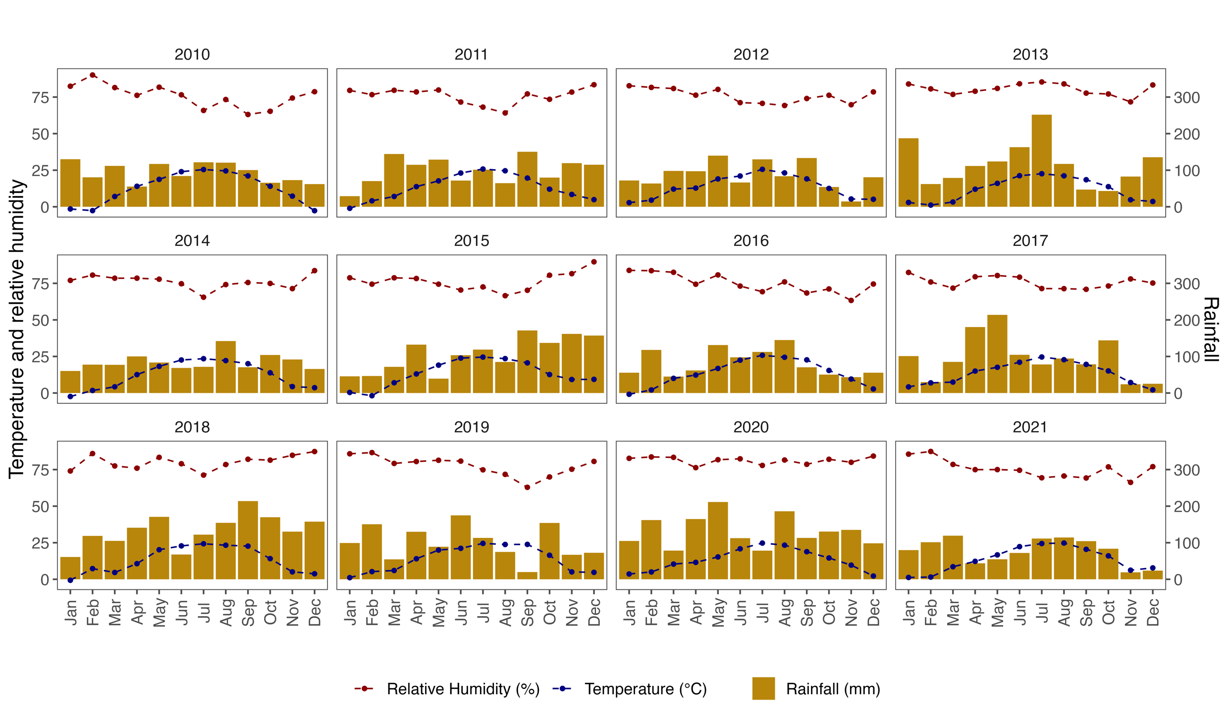
Supplementary Figure S1 Monthly mean relative humidity, temperature, and total rainfall for the Lambsburg and Lowgap trial sites for 12 years.
Supplementary Figure S2 A heatmap showing infected leaf count recorded on two-year-old potted detector plants (cv. `Suffruticosa` in Lambsburg and cv. `Justin Brouwers` in Lowgap) for each combination of hours relative humidity exceeding 90% outside rainy periods and coinciding mean temperature during this period. The increasing intensity of red colour represents a higher infected leaf count for each temperature and relative humidity category.
Supplementary Figure S3 A heatmap showing infected leaf count recorded on two-year-old potted detector plants (cv. `Suffruticosa` in Lambsburg and cv. `Justin Brouwers` in Lowgap) for each combination of temperature during wet periods and relative humidity outside rainy periods category. The increasing intensity of red colour represents a higher infected leaf count for each temperature and relative humidity category.
Supplementary Figure S4 A heatmap showing infected leaf count recorded on two-year-old potted detector plants (cv. `Suffruticosa` in Lambsburg and cv. `Justin Brouwers` in Lowgap) for each combination of hours when relative humidity exceeded 90% both inside and outside rainy periods and coinciding mean temperature during this period. The increasing intensity of red colour represents a higher infected leaf count for each temperature and relative humidity category.
Supplementary Figure S5 A heatmap showing infected leaf count recorded on two-year-old potted detector plants (cv. `Suffruticosa` in Lambsburg and cv. `Justin Brouwers` in Lowgap) for each combination of temperature during wet periods and leaf wetness duration category. The increasing intensity of red colour represents a higher infected leaf count for each temperature and leaf wetness duration category.
Supplementary Figure S6 A heatmap showing infected leaf count recorded on two-year-old potted detector plants (cv. `Suffruticosa` in Lambsburg and cv. `Justin Brouwers` in Lowgap) for each combination of temperature during rainy periods and rainfall category. The increasing intensity of red colour represents a higher infected leaf count recorded for each temperature and rainfall category.
Supplementary Figure S7 A calendar heatmap showing daily mean temperature during rainy periods when boxwood blight epidemics were monitored using detector plants in Lambsburg in 2014, and in Lowgap from 2015 to 2017.

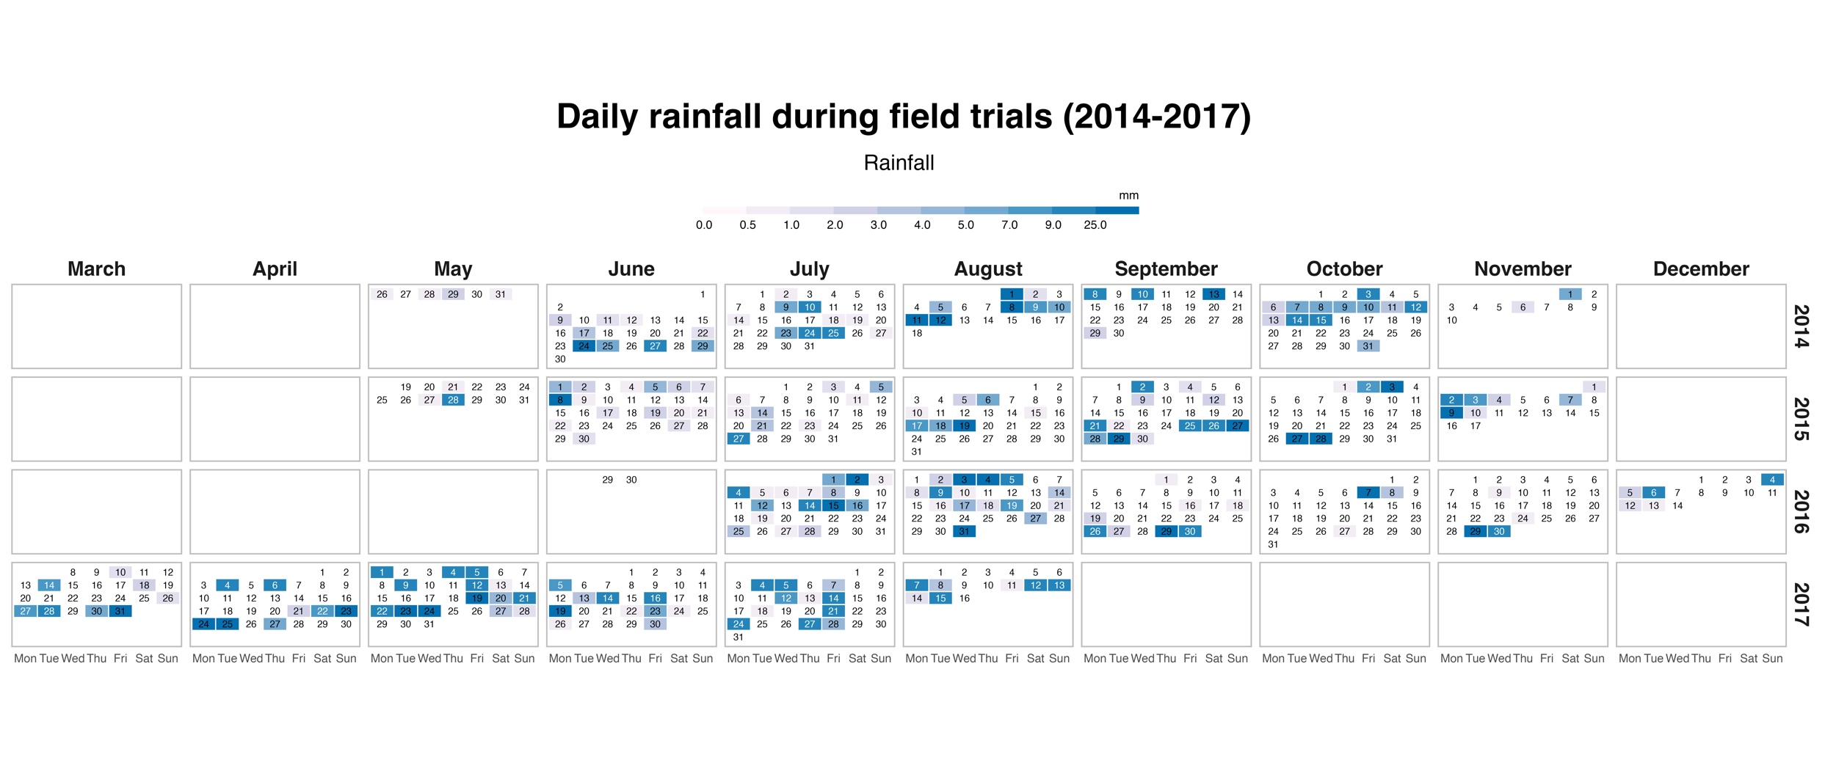
Supplementary Figure S8 A calendar heatmap showing daily rainfall recorded when boxwood blight epidemics were monitored using detector plants in Lambsburg in 2014, and in Lowgap from 2015 to 2017. The daily rainfall data corresponds to the period when the detector plants were placed in the field.
. 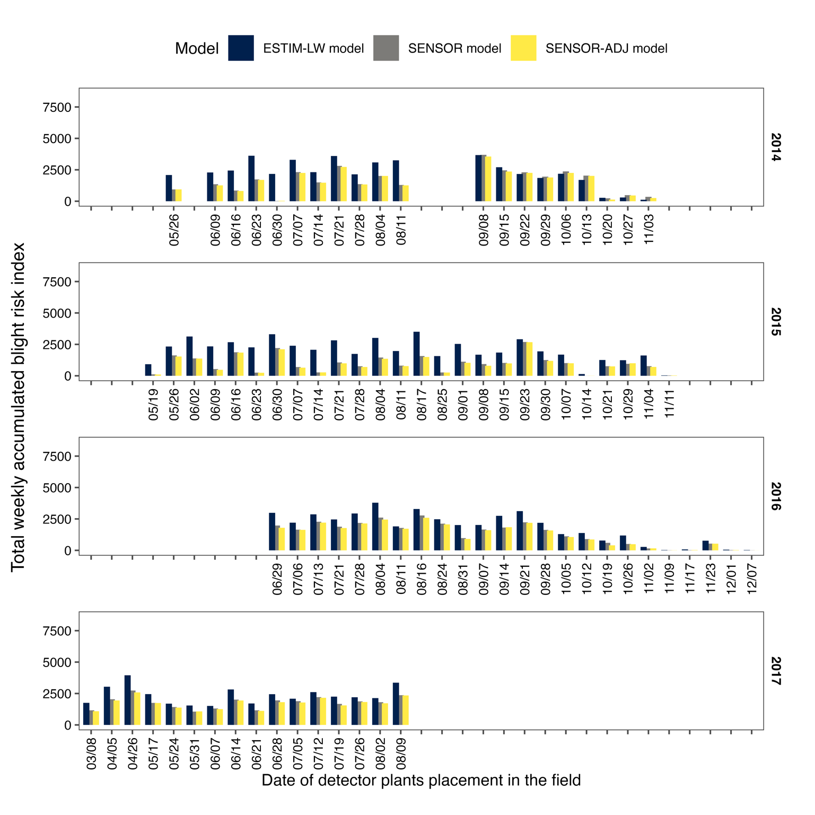
Supplementary Figure S9 Weekly total accumulated blight infection risk index of the boxwood blight infection risk model using leaf wetness estimated by leaf wetness sensor (SENSOR and SENSOR-ADJ) and algorithms based on energy principles (ESTIM-LW).

Supplementary Figure S10 Generalised linear models fit for infected leaf count on detector plants during each monitoring week and the boxwood blight infection risk model using leaf wetness estimated by leaf wetness sensor (SENSOR and SENSOR-ADJ) and algorithms based on energy principles.

