BMAL1-HIF2α heterodimers contribute to ccRCC

Supplementary Information

Rebecca M. Mello^{1,2}, Diego Gomez Ceballos^{1,2}, Colby R. Sandate³, Daniel Agudelo⁴, Celine Jouffe^{4,5}, Nina Henriette Uhlenhaut^{4,6}, Nicolas H. Thomä³, M. Celeste Simon^{7,8}, Katja A. Lamia^{1,2*}
¹Department of Molecular and Cellular Biology, Scripps Research Institute, La Jolla, CA, 92037, USA.
²Department of Molecular Medicine, Scripps Research Institute, La Jolla, CA, 92037, USA.
³Friedrich Miescher Institute for Biomedical Research, Basel, Switzerland.
⁴Institute for Diabetes and Endocrinology (IDE), Helmholtz Munich, Ingolstaedter Landstr. 1, 85764, Neuherberg, Germany.
⁵Institute for Diabetes and Cancer (IDC), Helmholtz Munich, Ingolstaedter Landstr. 1, 85764, Neuherberg, Germany.
⁶Metabolic Programming, TUM School of Life Sciences & ZIEL Institute for Food and Health, Gregor-Mendel-Str. 2, 85354, Freising, Germany.
⁷Abramson Family Cancer Research Institute, Perelman School of Medicine; Philadelphia, Pennsylvania 19104, USA.
⁸Department of Cell and Developmental Biology, University of Pennsylvania, Philadelphia, Pennsylvania 19104, USA.
*Corresponding author. Email: klamia@scripps.edu

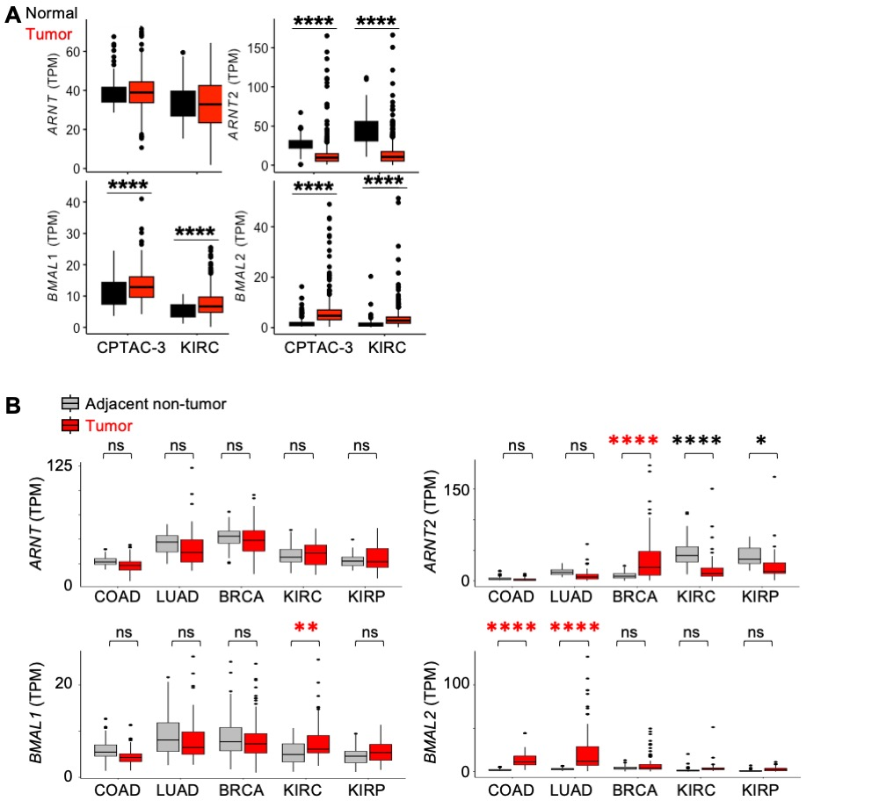Figure S1 BMAL1 mRNA is elevated in ccRCC. (A,B) Detection of ARNT, ARNT2, BMAL1, and BMAL2 (transcripts per million, TPM) calculated from RNA sequencing data from ccRCC tumors and normal kidney samples (A) or tumors and adjacent normal tissues from the same patients (B) in clinical proteomic tumor analysis consortium (CPTAC-3) and cancer genome atlas projects: colorectal adenocarcinoma (COAD), lung adenocarcinoma (LUAD), breast cancer (BRCA), kidney clear cell renal cell carcinoma (KIRC), and renal papillary cancinoma (KIRP). * Padj < 0.05, ** Padj < 0.01, **** Padj < 0.0001 by two-way ANOVA with Tukey’s posthoc correction. In all boxplots, the box depicts the median and interquartile range (IQR), whiskers extend either to the minimum or maximum data point or 1.5*IQR beyond the box, whichever is shorter. Outliers (values beyond the whisker) are shown as dots.

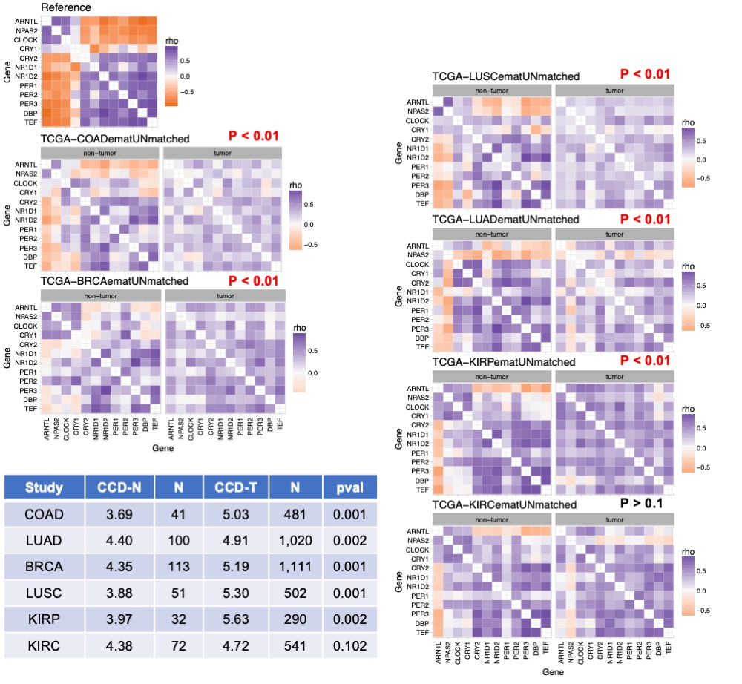Figure S2. Circadian rhythms are maintained in ccRCC in contrast to other tumor types. Clock correlation distance (CCD) heatmaps calculated from RNA sequencing data from normal human tissues (GTEX, reference) or from tumors and non-tumor samples from the same tissues in cancer genome atlas (TCGA) projects: colorectal adenocarcinoma (COAD), lung adenocarcinoma (LUAD), small cell lung cancer (LUSC), breast cancer (BRCA), kidney clear cell renal cell carcinoma (KIRC), and renal papillary cancinoma (KIRP). The table shows the number of samples in each group (N), calculated CCD values for non-tumor (CCD-N) or tumor (CCD-T) samples, and adjusted p values (pval).

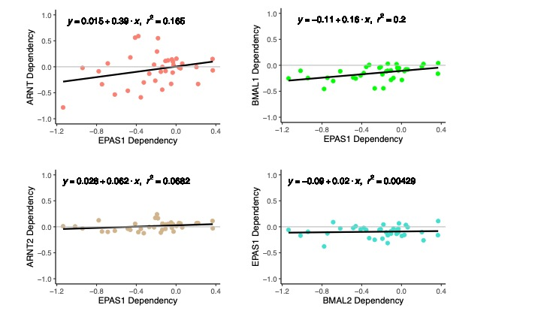Figure S3. In RCC cell lines, HIF2A (a.k.a. EPAS1) dependency is correlated with dependencies for ARNT and BMAL1. Correlation of dependency (CHRONOS) scores for ARNT, ARNT2, BMAL1, and BMAL2 with those for EPAS1 in RCC cell lines from DepMap ^{1,2}.

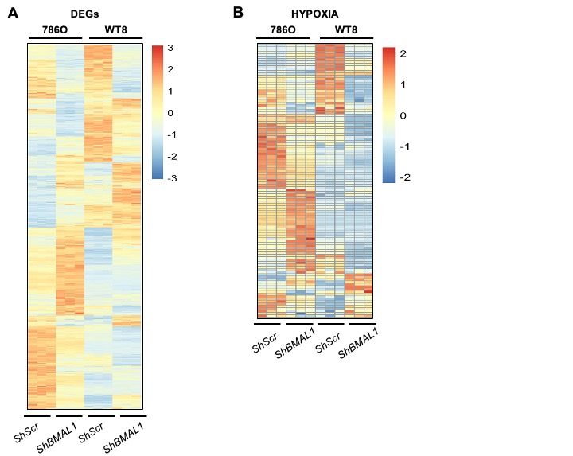Figure S4: Depletion of BMAL1 alters many of the same genes that are affected by rescuing VHL function in 786O cells. (A,B) Heatmaps depicting all differentially expressed genes (DEGs) (A), or DEGs in the Hallmark HYPOXIA gene set (B) in786O cells and WT8 cells expressing the indicated shRNAs. DEGs were identified using DESeq2 with a false discovery rate (FDR) cutoff of 0.1. (Note: WT8 cells are 786O cells engineered to express WT VHL).

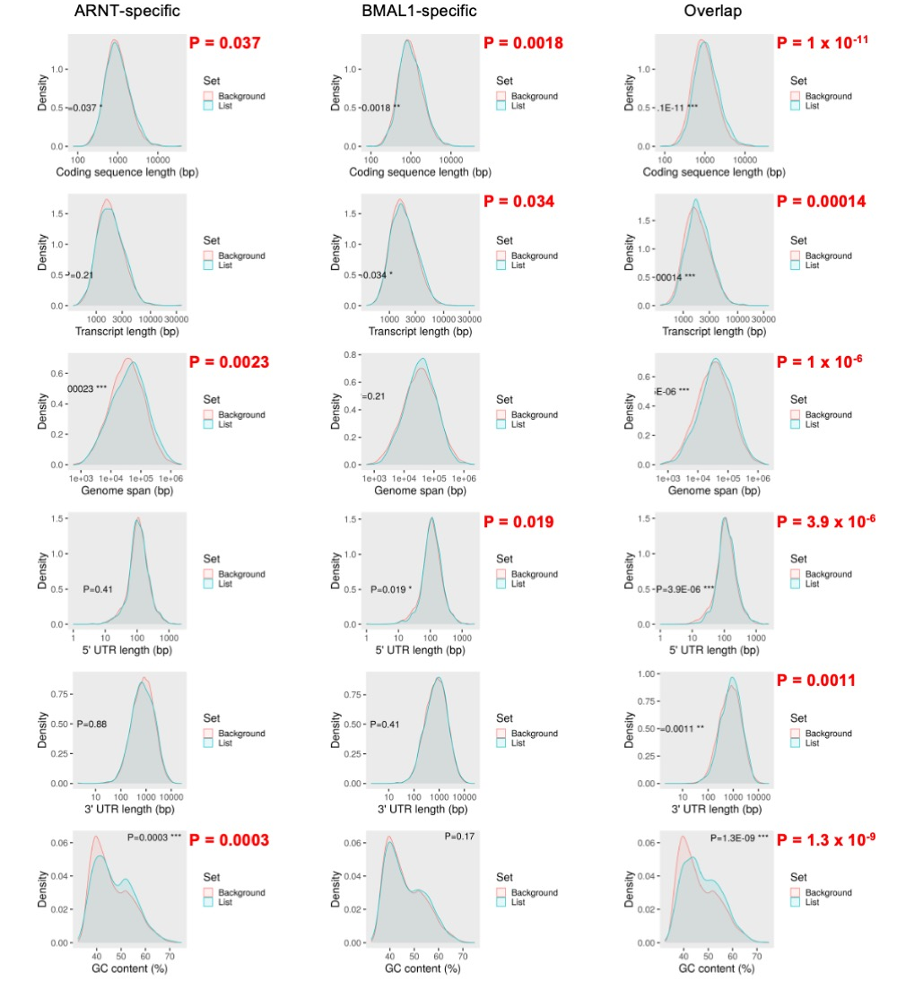Figure S5 Characterization of ARNT- and BMAL1-dependent transcripts in 786O cells. Distribution of coding sequence length, transcript length, genome span, 5’UTR length, 3’UTR length, and GC content for transcripts that exhibit reduced expression exclusively in 786O cells expressing shARNT, exclusively in 786O cells expressing shBMAL1, or in both compared to 786O cells expressing shControl. Each “List” of DEGs so defined (depicted in blue) is compared to the “background” of all transcripts detected in RNA prepared from 786O cells expressing shControl (depicted in red). Analysis performed using ShinyGO ³.

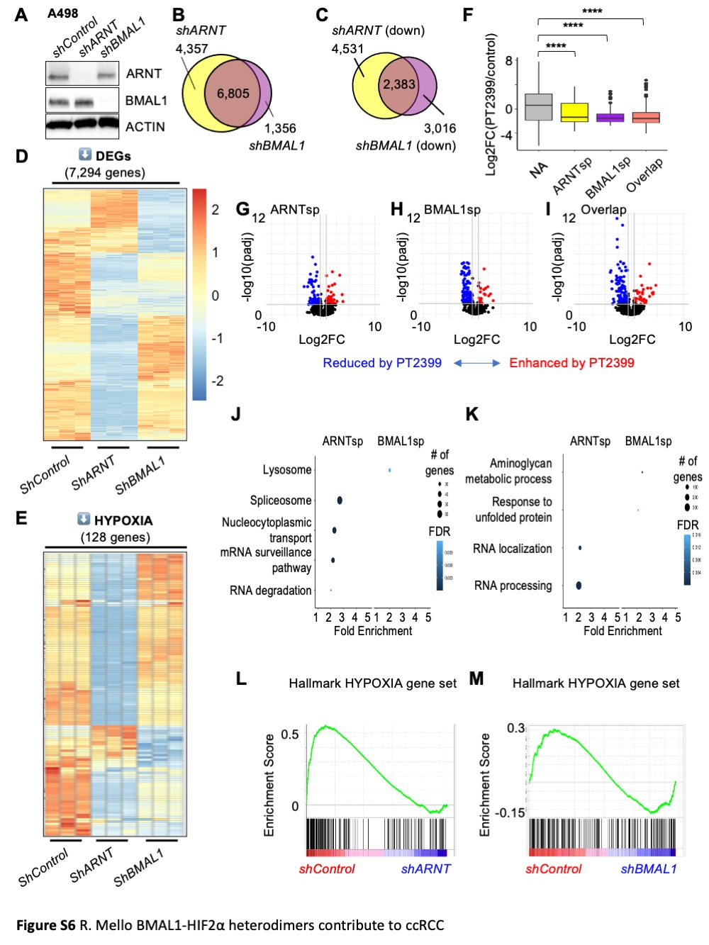Figure S6 Endogenous BMAL1 contributes to HIF2α target gene expression in A498 cells. (A) Detection of ARNT, BMAL1, and ACTIN by immunoblot in A498 cells expressing the indicated shRNAs. (B-E) Venn diagrams (B,C) and heatmaps (D,E) depicting all differentially expressed genes (DEGs) (B), significantly downregulated genes (C,D) or downregulated genes in the Hallmark HYPOXIA gene set (E) in A498 cells expressing the indicated shRNAs. DEGs were identified using DESeq2 with a false discovery rate (FDR) cutoff of 0.1. (F) Boxplot depicting changes in gene expression in patient-derived xenografts (PDXs) treated with PT2399 (data from ⁴ including sensitive PDXs only) for genes grouped by whether their expression in A498 cells is decreased by shARNT and not by shBMAL1 (ARNTsp, yellow), by shBMAL1 and not by shARNT (BMAL1sp, purple), by either shARNT or shBMAL1 (Overlap, salmon), or neither (NA, gray). **** P < 0.0001 by two-way ANOVA with Tukey’s correction. Boxes depict the median and interquartile range (IQR), whiskers extend either to the minimum or maximum data point or 1.5*IQR beyond the box, whichever is shorter. Outliers (values beyond the whisker) are shown as dots. (G-I) Volcano plots depicting the expression changes for individual genes in the groups depicted in (F). Genes with padj < 0.05 are colored in red (fold change > 1.5) or blue (fold change < 0.67) . (J,K) GOBP (J) or KEGG (K) pathways enriched among ARNT-specific or BMAL1-specific target genes in A498 cells. (L,M) Enrichment plots showing the impact of shARNT (F) or shBMAL1 (G) on genes in the Hallmark HYPOXIA gene set.

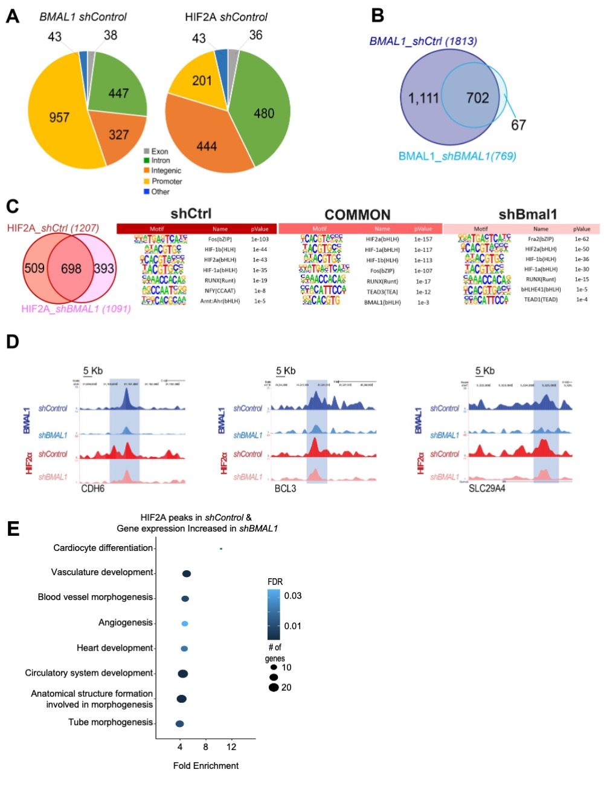

Figure S7: Impact of shBMAL1 on HIF2α chromatin interactions. (A) Pie chart distribution of HOMER peak annotation for BMAL1 and HIF2α peaks in 786O cells expressing shControl.

(B) Venn diagram depicting the numbers of genomic sites identified in CUT&RUN samples prepared using BMAL1-specific antibodies from 786O cells expressing shControl or shBMAL1. (C) Left: Venn diagram depicting numbers of genomic sites identified in CUT&RUN samples prepared using HIF2α-specific antibodies from 786O cells expressing shControl or shBMAL1. Right: Top motifs enriched in chromatin associated with HIF2α in 786O cells expressing shControl, shBMAL1, or both (common) (D) Representative genome browser tracks for BMAL1 and HIF2α CUT&RUN signatures, showing CDH6, BCL3, and SLC29A4 loci. (E) Data integration of RNA-seq and CUT&RUN HIF2α peaks. The x-axis represents the Enrichment Ratio, and the y-axis represents enriched GOBP pathways for genes associated with HIF2α peaks identified in CUT&RUN data from 786O cells expressing shControl with at least 5 genes, FDR < 0.05, and fold enrichment > 2. Expression of these genes was increased in 786O cells expressing shBMAL1 compared to 786O cells expressing shControl. There were no significant KEGG pathway enrichments detected for genes with associated with HIF2α peaks identified in CUT&RUN data from 786O cells expressing shControl and no significant enrichment for either KEGG or GOBP databases for genes associated with HIF2α peaks identified in CUT&RUN data from 786O cells expressing shBMAL1 with either increased or decreased expression in 786O cells expression in BMAL1-depleted 786O cells.

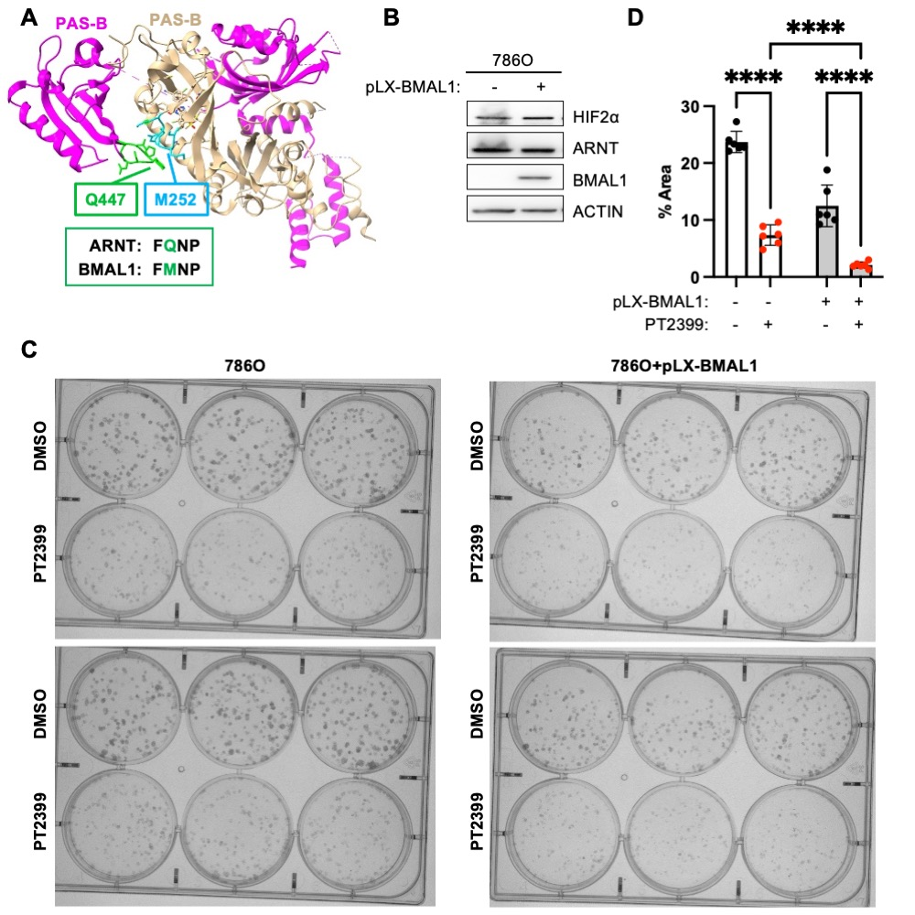Figure S8. BMAL1-HIF2α heterodimers are sensitive to disruption by PT2399. (A) Three dimensional structure (PDB ID: 7W80) containing the bHLH and PAS domains of ARNT (magenta) and HIF2α (beige) bound to PT2399. Ligand binding to the PAS-B domain of HIF2α leads to structural reorganization of HIF2α loop (shown in blue), which thereby clashes with a loop in ARNT (shown in green). (B) Detection of HIF2α, ARNT, BMAL1, and ACTIN by immunoblot in 786O cells with (+) or without (-) lentivirus-mediated overexpression of BMAL1. (C,D) Representative images (C) and quantification (D) of colonies stained with crystal violet 10-16 days after plating 250 cells expressing the indicated plasmids per well in media containing vehicle (DMSO) or PT2399. Data in (D) represent the mean ± s.d. for six wells per condition from one experiment representative of at least three replicates. **** P < 0.0001 by two-way ANOVA with Tukey’s correction for multiple hypothesis testing.

Supplementary References

1 Meyers, R. M. et al. Computational correction of copy number effect improves specificity of CRISPR-Cas9 essentiality screens in cancer cells. Nat Genet 49, 1779-1784 (2017). https://doi.org/10.1038/ng.3984
2 Tsherniak, A. et al. Defining a Cancer Dependency Map. Cell 170, 564-576 e516 (2017). https://doi.org/10.1016/j.cell.2017.06.010
3 Ge, S. X., Jung, D. & Yao, R. ShinyGO: a graphical gene-set enrichment tool for animals and plants. Bioinformatics 36, 2628-2629 (2020). https://doi.org/10.1093/bioinformatics/btz931
4 Chen, W. et al. Targeting renal cell carcinoma with a HIF-2 antagonist. Nature 539, 112-117 (2016). https://doi.org/10.1038/nature19796

