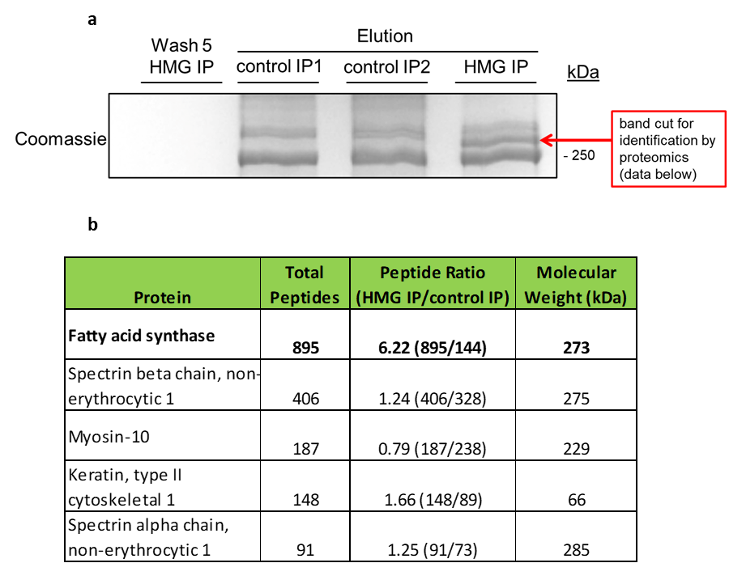
Extended Data Fig. 1: Immunoprecipitation of HMGylated protein in statin-treated cells
The HMGylated protein from statin-treated HepG2 cells was identified as fatty acid synthase via an IP followed by mass spectrometry. (a) Coomassie gel showing the proteins separated from the HMG IP versus the control IPs utilizing a pre-immune serum. The unique band occurring above 250 kDa was cut out of the gel for subsequent mass spectrometry. The corresponding area in the control IP was cut out as a baseline for mass spectrometry results. (b) A table showing the proteins detected in each band. FAS was present in a higher ratio in the HMG IP indicating it is the HMGylated protein.

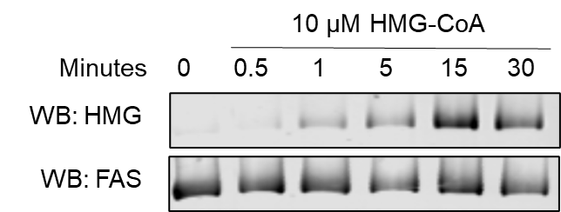
Extended Data Fig. 2: Purified FAS becomes HMGylated in the presence of HMG-CoA
Purified porcine FAS was incubated with 10 µM HMG-CoA for up to 30 minutes at 37 °C. Western blotting shows HMGylation is strongly present following 15 minutes of incubation.

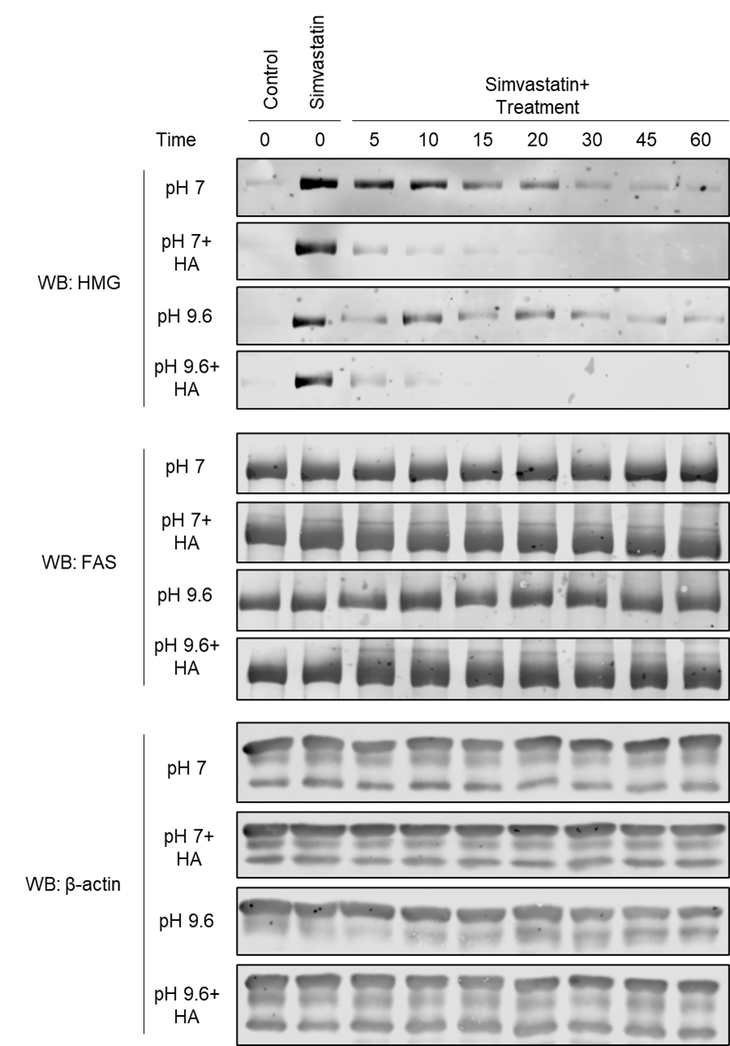
Extended Data Fig. 3: Loading controls for HMGylated FAS treated with hydroxylamine
Treatment of lysates containing HMGylated FAS with hydroxylamine at pH 7 or 9.6 show the HMG modification is labile and therefore a thioester or ester bond. Expanded image of Figure 3F including the loading controls that show FAS levels remain constant while the HMGylation signal diminishes with treatment.

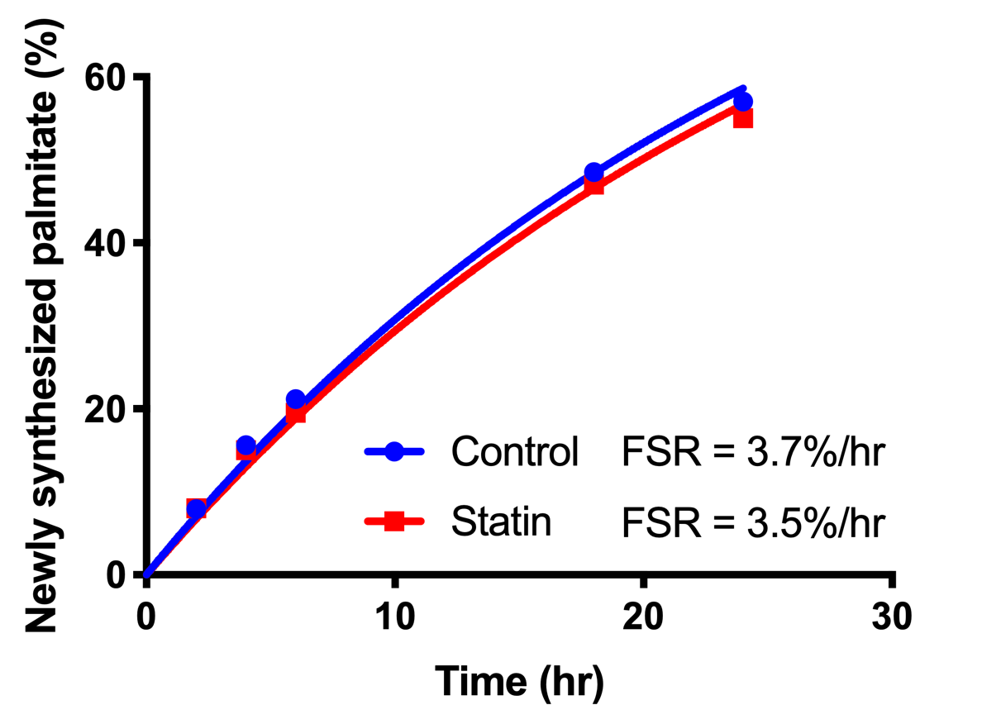
Extended Data Fig. 4: Fractional Synthesis Rate of Palmitate in control and statin-treated cells HepG2
The fraction of newly synthesized palmitate was fitted vs time to determine the fractional synthesis rate (%/hr). The fractional synthesis rates between control and statin-treated HepG2 cells were not significantly different.

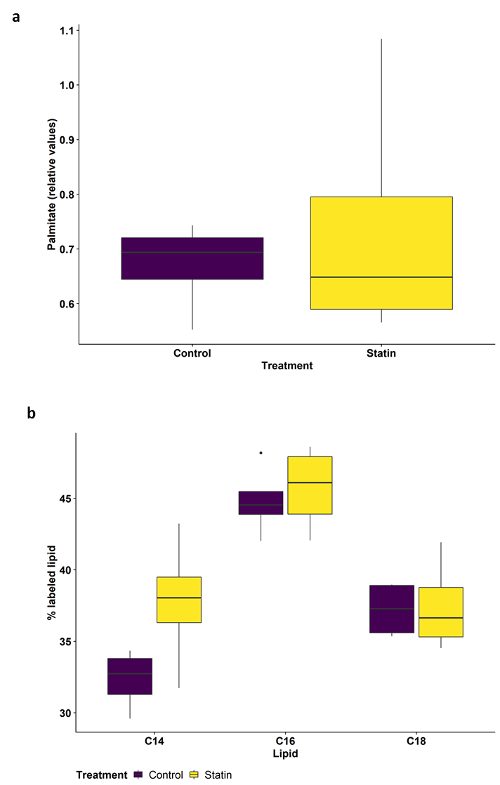
Extended Data Fig. 5: Measurement of lipid in control and statin-treated mice
Analysis of hepatic lipids from control and statin-treated mice. (a) Total palmitate levels in the liver were determined by normalization to an added control lipid (C17). No change in total palmitate levels was detected between treatment groups (p = 0.6, n = 4, ANOVA). (b) Levels of less common FAS products, myrisate (C14) and sterate (C18), were analyzed using the same labeled tissues. No changes were detected in newly synthesized myristate (p = 0.8, n = 4, ANOVA) or sterate (p = 0.9, n = 4, ANOVA). Data is shown as a boxplot where the box represents the first to third quartiles and “whiskers” represent the data extending beyond this range. Outliers were determined by being more than 1.5 IQR from the 25 percentile.
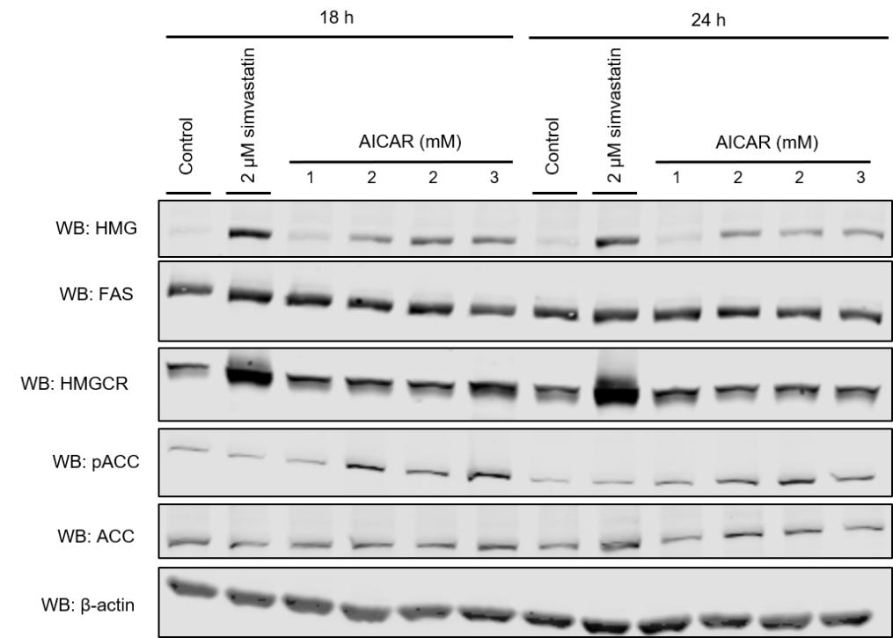
Extended Data Fig. 6: AMPK activation with AICAR results in HMGylation of FAS
HepG2 cells were treated with the AMPK activator AICAR for 18 or 24 hours. Western blotting reveals a singular HMGylation band consistent with the results observed in metformin- or statin-treated cells. Phosphorylated ACC shows AMPK is activated during HMGylation of FAS.

