Supplemental Figure 1: (Top left panel) Hourly PM_{2.5} data from the Hawthorne monitoring station in Salt Lake City, UT from 1/1/2022-12/31/2022. The red box highlights the dust event modeled in Figure 1 and in Additional File 1. The top right panel shows PM_{2.5} data for all state monitoring stations (averaged) from April 1-30, 2022, with Hawthorne station data highlighted in red. The red box highlights the dust event modeled in Figure 1 and in Additional File 1. The bottom panel shows hourly PM_{2.5} data for the April 21, 2022, event for all state monitoring stations individually, with Hawthorne shown in red and the average in blue.

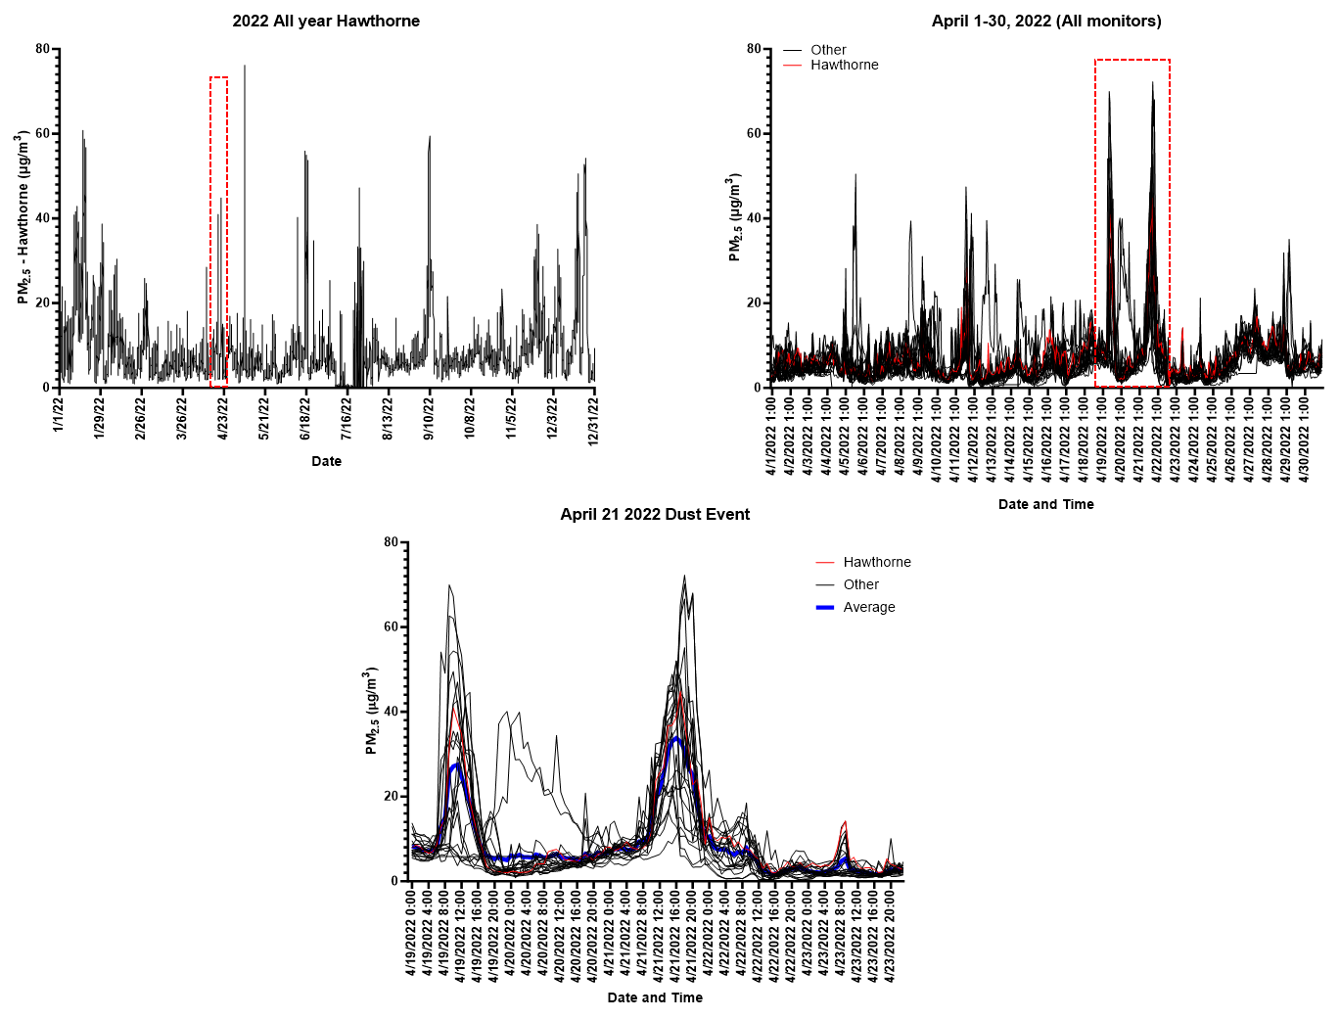

Supplemental Figure 2: A table showing results from the analysis of Great Salt Lake (GSL) and GSL dust (GSLD) PM_{2.5} using inductively-coupled plasma mass spectrometry (ICP-MS), and the fold enrichment and/or reduction of specific elements in PM_{2.5}.
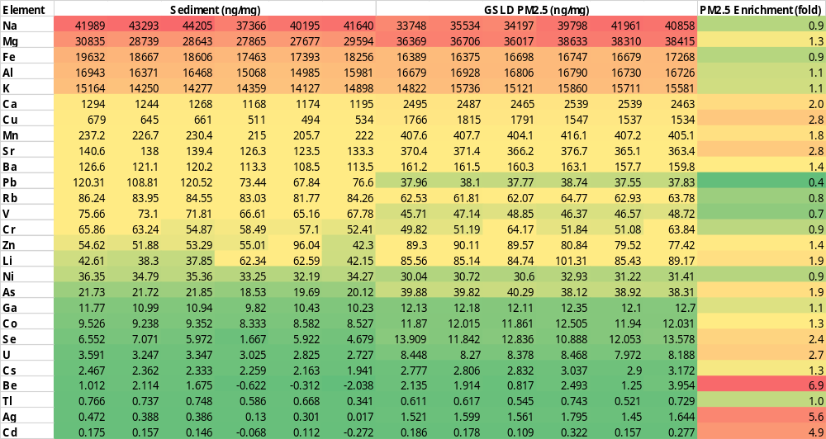
Supplemental Figure 3: Elemental analysis of GSL sediment determined using scanning electron microscopy and energy-dispersive X-ray spectroscopy (SEM-EDS).
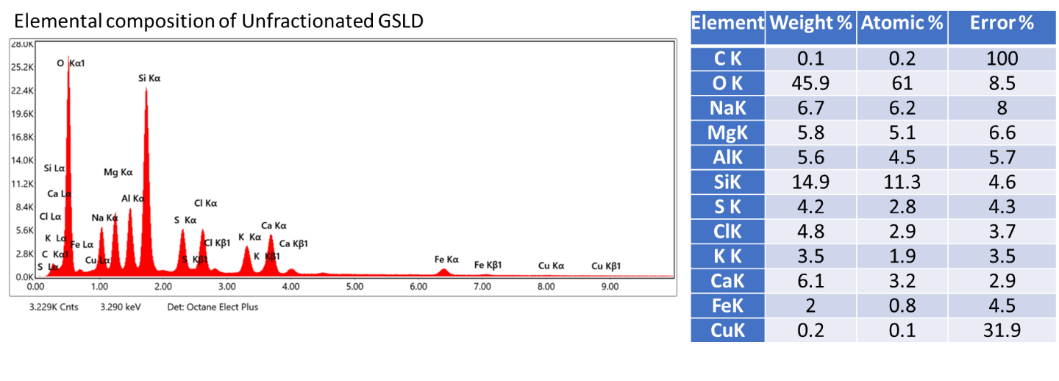

Supplemental Figure 4: Elemental analysis of GSLD PM_{2.5} determined using scanning electron microscopy and energy-dispersive X-ray spectroscopy (SEM-EDS).
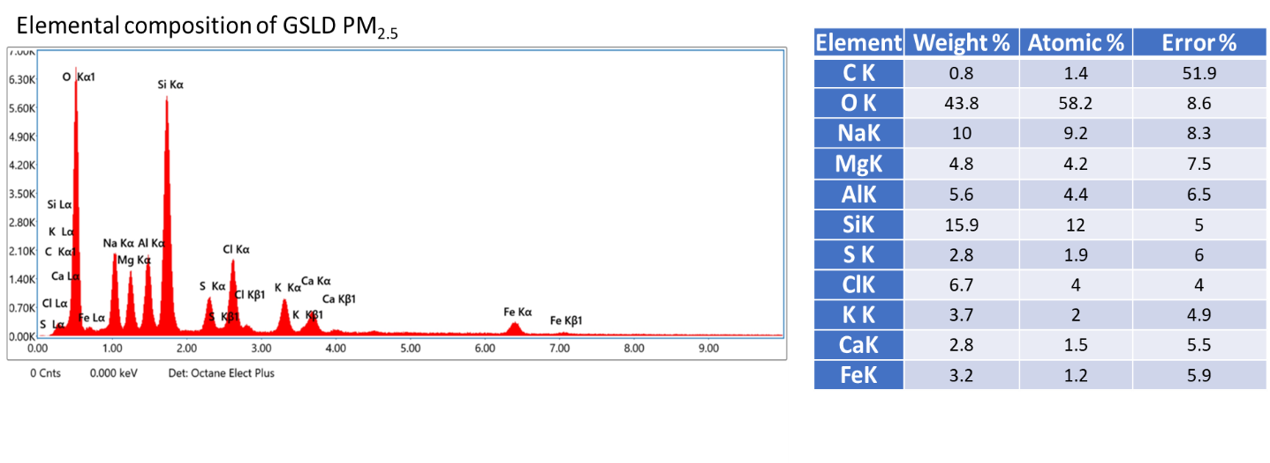

Supplemental Figure 5: Representative images of cells recovered in bronchoalveolar lavage (BAL) obtained from mice expsosed to filtered air or GSLD PM_{2.5} via inhalation (50 μg/m³) for 2X 15 min and 6X 15 min over two days.
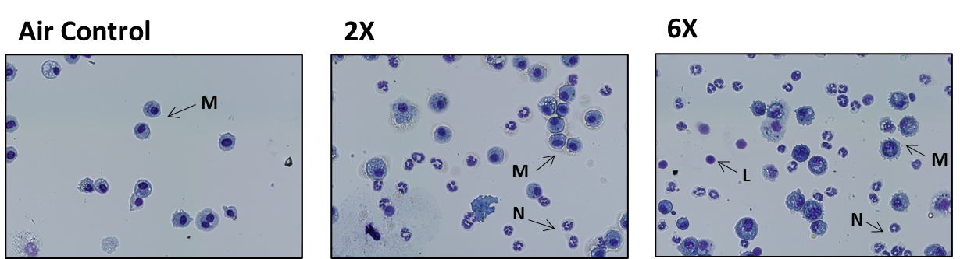

Supplemental Figure 6: Quantification of (a) BAL cells and (b) percentage of neutrophils in BAL in mice treated via oropharyngeal aspiration (OPA) with GSLD PM_{2.5}. (c-f) Representative images of lung tissue from mice treated with saline (25 μL) or a suspension of GSLD PM_{2.5} in saline (2.5 mg/kg). Effects of GSLD PM2.5 treatment were compared to saline treated mice using 1-way ANOVA and A dunnett post-test. **p<0.01 and ***p<0.001.

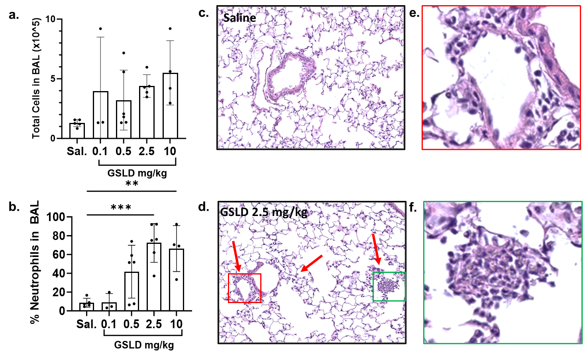

Supplemental Figure 7: Qquantification of multiple cell types in BAL and tissue of mice exposed to GSLD PM_{2.5} (50 μg/m³; 3x 15 min) using flow cytometry. ª=p<0.05 vs. air control, ^{b}=compared to 3x, and ^{c}=compared to C57Bl/6 using 1-way ANOVA and a Tukey post test.
 | C57Bl/6 Air (n=3) | C57Bl/6 GSLD 3x (n=3) | C57Bl/6 GSLD 6x (n=4) | Trpv1^{N606D} Air (n=3) | Trpv1^{N606D} GSLD 3x (n=4)
 | Myeloid Cells
Neutrophils (Ly6G⁺) | 9.2 ± 2.3 | 29.7 ± 4.8ª | 31.9 ± 4.7ª | 10.9 ± 4.1 | 35.8 ± 4.5ª
Eosinophils (CD11b⁺SigF⁺CD11c⁻) | 3.9 ± 0.6 | 3.1 ± 0.6 | 2.4 ± 0.6 ª | 4.3 ± 0.8 | 3.0 ± 0.5
Alveolar Macrophages (CD11b⁻SigF⁺CD11c⁺) | 16.9 ± 3.6 | 11.2 ± 2.6 | 13.9 ± 1.5 | 27.7 ± 2.1^{c} | 7.7 ± 2.6ª
Interstitial Macrophages (CD43⁺CD11c⁺) | 5.9 ± 0.7 | 4.7 ± 0.6 | 4.0 ± 0.9 | 6.1 ± 0.2 | 6.2 ± 1.3
Total Monocyte-derived Macs (MoDMs, CD43⁻CD11c⁺) | 0.7 ± 0.06 | 1.3 ± 0.2ª | 1.3 ± 0.2ª | 0.9 ± 0.2 | 1.0 ± 0.2
Classical Monocytes (CD11b⁺CD43⁻CD11c⁻) | 2.4 ± 0.2 | 3.0 ± 0.3 | 5.1 ± 1.2 | 4.4 ± 1.5 | 6.2 ± 0.7
 | Lymphoid Cells
Total CD3⁺ Lymphocytes | 17.3 ± 1.3 | 10.9 ± 1.1ª | 9.7 ± 0.6ª | 10.6 ± 0.5^{c} | 9.4 ± 1.4
Helper T cells (CD3⁺CD4⁺) | 9.7 ± 0.8 | 5.8 ± 0.9ª | 5.2 ± 0.5ª | 5.1 ± 0.2^{c} | 4.9 ± 0.5
Cytotoxic T cells (CD3⁺CD8⁺) | 1.5 ± 0.2 | 0.9 ± 0.08ª | 0.7 ± 0.08ª | 1.3 ± 0.2 | 0.9 ± 0.1ª
CD4⁺CD103⁺ Dendritic cells | 0.2 ± 0.0001 | 0.2 ± 0.0001 | 0.2 ± 0.0001 | 0.13 ± 0.06 | 0.2 ± 0.06
CD8⁺CD103⁺ Dendritic cells | 4.3 ± 0.4 | 2.2 ± 0.1ª | 1.2 ± 0.1^{a,b} | 2.3 ± 0.3^{c} | 1.5 ± 0.2^{a,c}
Total B cells (B220⁺) | 22.8 ± 2.5 | 14.6 ± 2.1ª | 12.3 ± 1.9ª | 16.1 ± 1.1^{c} | 13.5 ± 2.8
CX₃CR1⁻ B cells | 7.3 ± 2.4 | 2.5 ± 0.2ª | 9.6 ± 1.8^{b} | 4.4 ± 0.4 | 2.9 ± 0.8
CX₃CR1⁺ B cells | 15.5 ± 1.1 | 12.0 ± 1.9ª | 2.7 ± 0.3^{a,b} | 11.8 ± 0.8 | 10.6 ± 2.1

Supplemental Figure 8: Relative expression of (a) Il6 (b) Cxcl1 (c) Cxcl2 and (d) Muc5ac mRNA in mouse lung tissue as a function of GSLD PM_{2.5} treatment via OPA. Abundance was compared to the vaues for saline treated mice (n≥3/group) using 1-way ANOVA and a Dunnett post-test. *p<0.05, **p<0.01, ***p<0.001, ****p<0.0001.

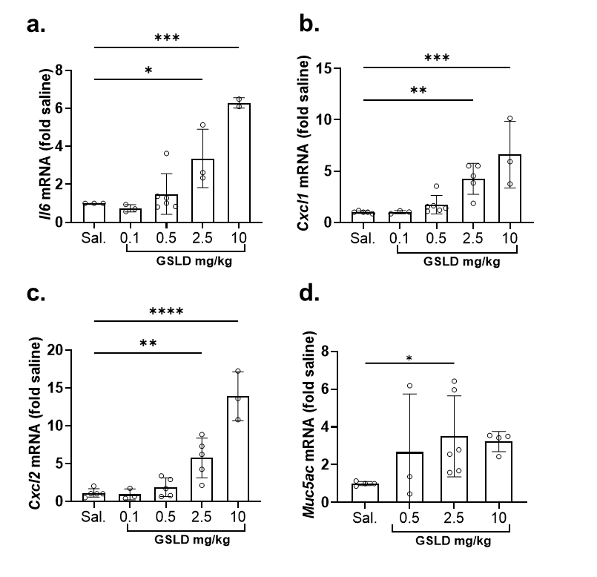

Supplemental Figure 9: (a) Percentage of BAL neutrophils and relative expression of (b) Il6 (c) Cxcl1 (d) Cxcl2 and (e) Muc5ac mRNA in mouse lung tissue after expsoure to inhaled GSLD PM_{2.5} or CFA PM_{2.5} (50 μg/m³) using the 3x exposure paradigm. Abundance was compared to the air control group (n≥4/group) using 1-way ANOVA and either a Tukey post-test (neutrophils) or a Dunnett post-test (mRNAs). *p<0.05, **p<0.01, ****p<0.0001. ####p<0.001 comparing GSLD and CFA PM_{2.5} effects on neutrophils.
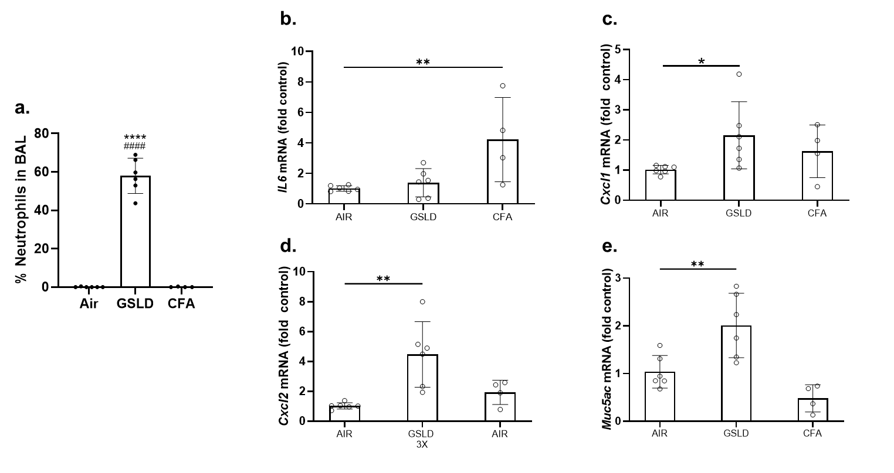

Supplemental Figure 10: Activation of TRP ion channels by Salton Sea PM_{2.5} dust (SSD). (a-c) Normalized (to ionomycin, 10 μM) calcium flux in HEK-293 cells transiently transfected with a control (empty) or human and mouse TRP expression plasmids for TRPA1, M8 and V1. Known agonists of each channel are shown on the left side of each panel and included TRPA1 (AITC; 150 µM), TRPM8 and ΔM801 (menthol; 500 µM), TRPV1 (nonivamide; 20 µM. Effects of LHC9 (negative control) are on the right side of each panel. Results were compared to the control vector for each treatment using 2-way ANOVA and a Dunnett post-test. ****p<0.0001.

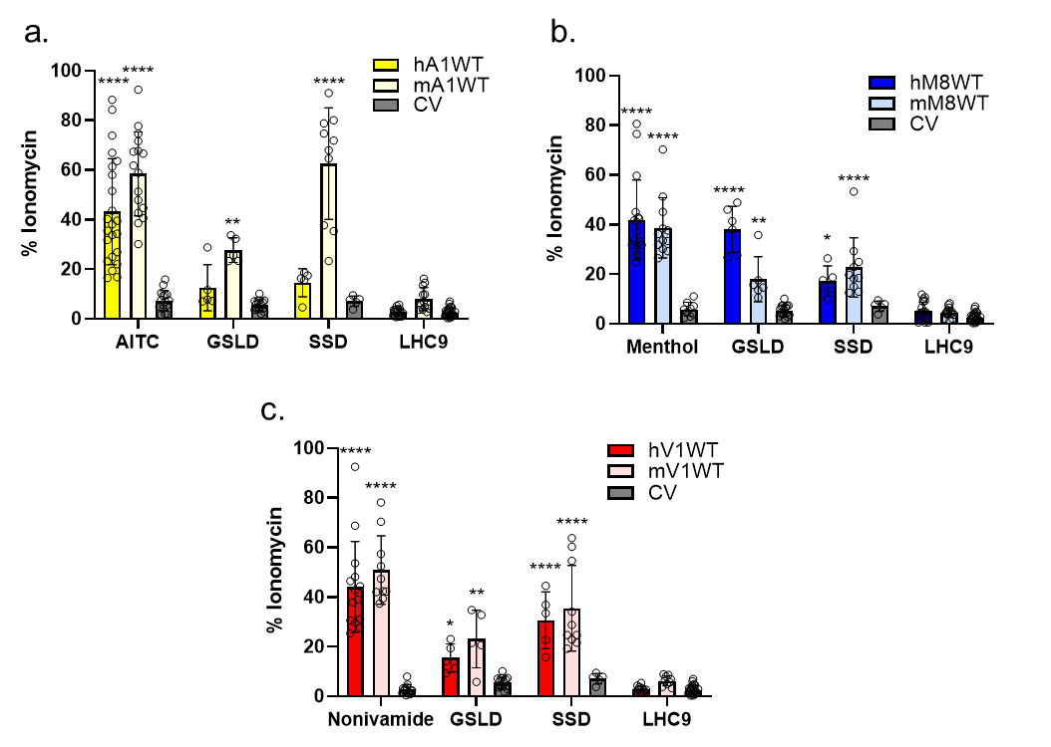

Supplemental Figure 11: Effects of TRP channel inhibitors on IL6/8 mRNA induction in HBEC3-KT cells. Expression of (a) IL6 and (b) IL8 mRNA by HBEC3-KT cells treated for 24h with GSLD PM_{2.5} (66 μg/cm²) and inhibitors for TRPA1 (A967076; 5 μM), TRPM8/ΔM801 (AMTB; 2 μM), TRPV1 (LJO-328; 20 μM), TRPV3 (007; 50 μM); TRPV4 (HC030031; 50 nM). Results were corrected for control values and normalized to GSLD PM_{2.5} treatment using 1-way ANOVA and a Dunnett post-test. ***p<0.001 and ****p<0.0001. (c) effects of TAK-242 (1 μM) on IL6 induction by LPS (2.5 μg/mL), GSLD (12 μg/cm²), and SSD (12 μg/cm²). Results for all treatments were normalized to the GSLD PM2.5 response and analyzed using multiple t-tests to compare the effects of TAK-242 on the response of each agent and correcting for multiple comparisons using the Holm-Šίdάk method with an adjusted p-value threshold of α=0.05 (*).

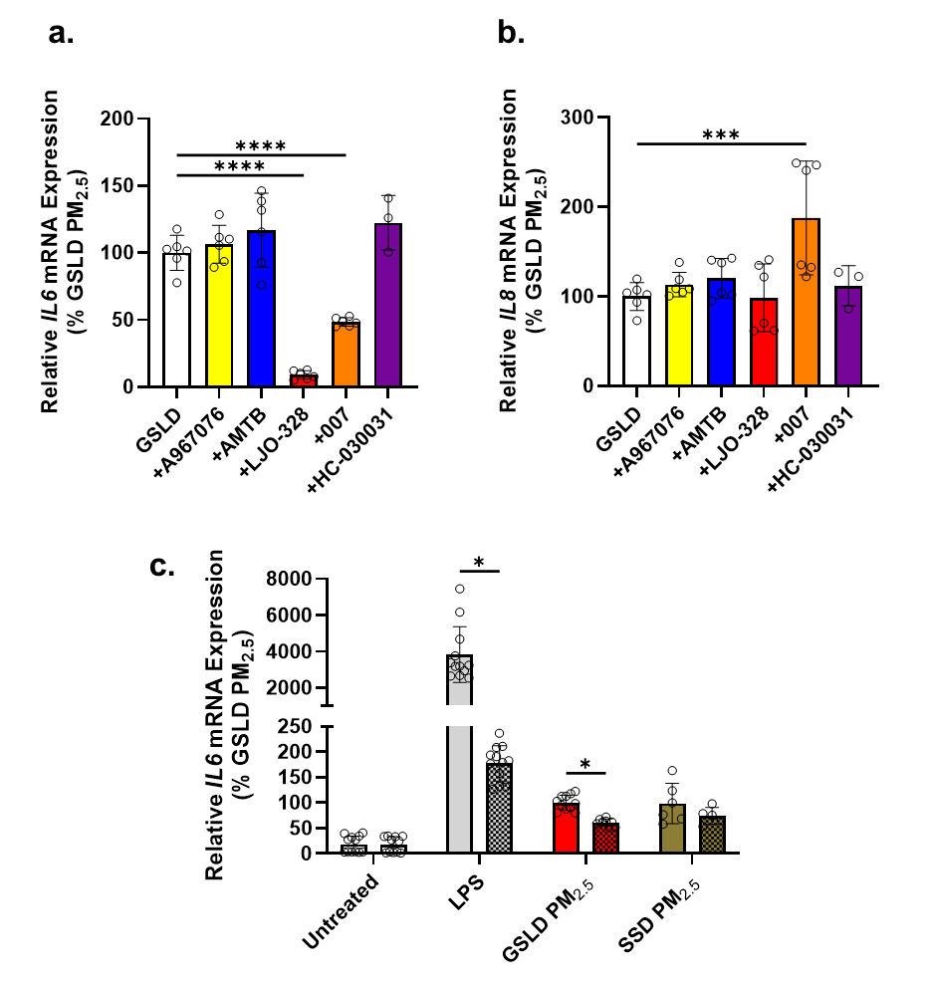

Supplemental Figure 12: Comparison of IL6/8 mRNA induction by GSLD and SSD PM_{2.5} and the effects of TRPV1, V3 and TLR4 inhibitors on responses to SSD treatment of HBEC3-KT cells. Expression of (a) IL6 and (b) IL8 mRNA by HBEC3-KT cells treated for 24h with GSLD (white) or SSD (brown) PM_{2.5} (66 μg/cm²). The effects of co-treatment with the TRPV1 inhibitor LJO-328 (20 μM; red), the TRPV3 inhibitor 007 (50 μM; orange), a combination of LJO-328 and 007 (20+50µM; red/orange checkered), and the TLR4 inhibitor TAK-242 are shown. All treatment groups were corrected for the respective controls and normalized to SSD PM_{2.5} treated cells. Data were analyzed using 1-way ANOVA and Dunnett post-test. ****p< 0.0001.

