Supplementary material for

Iron’s role in soil organic carbon (de)stabilization in mangroves under land use change

Francisco Ruiz ^{a*}, Cornelia Rumpel ^{b}, Xosé Luis Otero ^{c,d}, Angelo Fraga Bernardino ^{e}, Hermano Melo Queiroz^{f} Tiago Osório Ferreira ^{a,g*}

ª Department of Soil Science, “Luiz de Queiroz” College of Agriculture/University of São Paulo (ESALQ/USP), Av. Pádua Dias 11, Piracicaba, São Paulo 13418-900, Brazil
^{b} CNRS, Institute for Ecology and Ecological Sciences, (iEES Paris, UMR Sorbonne Université, CNRS, INRAE, UPEC, IRD), Paris, France
^{c} CRETUS, Department of Edaphology and Agricultural Chemistry, Faculty of Biology, University of Santiago de Compostela – USC, Rúa Lope Gómez de Marzoa, s/n. Campus sur, 15782, Santiago de Compostela, Spain
^{d} REBUSC Network of Biological Stations of the University of Santiago de Compostela, A Graña Marine Biology Station, Ferrol, Spain
^{e} Department of Oceanography, Federal University of Espírito Santo, Vitória, Espírito Santo, Brazil
^{f} Department of Geography, University of São Paulo, Av. Prof. Lineu Prestes, 338, Cidade Universitária, 05508-900, São Paulo, SP, Brazil
^{g} Center for Carbon Research in Tropical Agriculture (CCARBON) - University of São Paulo, Piracicaba, São Paulo, Brazil

* Corresponding authors: francisco.ruiz@usp.br; toferreira@usp.br

Table S1 Parameters obtained after the sequential wet-chemical experiment using the MAOC fraction of a pristine mangrove.
Depth | Treatment | Fe | OC:Fe ratio | ED |  | DSC-T₅₀ |  | CH:COO⁻ ratio
cm |  | g kg ⁻¹ | mol mol⁻¹ | J mgC⁻¹ |  | ºC
0-10 | Before extraction |  |  |  | 3.3 |  | 329.8 |  | 1.7
0-10 | cit | 4.3 ± 0.1 | 4.0 ± 0.1 |  | 3.7 |  | 343.6 |  | 2.5
0-10 | asc | 1.1 ± 0.02 | 12.5 ± 0.0 |  | 4.0 |  | 352.3 |  | 4.0
0-10 | cbd | 1.2 ± 0.08 | 4.7 ± 1.8 |  | 3.7 |  | 347.9 |  | 3.0
40-50 | Before extraction |  |  |  | 3.3 |  | 330.8 |  | 1.7
40-50 | cit | 5.1 ± 0.1 | 1.5 ± 0.5 |  | 3.9 |  | 344.5 |  | 3.6
40-50 | asc | 1.4 ± 0.03 | 13.4 ± 2.2 |  | 4.2 |  | 352.5 |  | 5.3
40-50 | cbd | 0.5 ± 0.05 | 4.6 ± 7.1 |  | 4.0 |  | 340.0 |  | 2.8
80-100 | Before extraction |  |  |  | 3.9 |  | 337.6 |  | 1.7
80-100 | cit | 3.8 ± 0.04 | 2.9 ± 0.3 |  | 4.6 |  | 348.8 |  | 3.2
80-100 | asc | 0.6 ± 0.01 | 10.4 ± 0.3 |  | 4.5 |  | 354.1 |  | 4.5
80-100 | cbd | 2.0 ± 0.2 | 4.0 ± 0.5 |  | 4.1 |  | 338.2 |  | 1.1
ED: Energy density; DSC-T50: the temperature at which half of the exothermic energy is released; cit: Na-citrate pH 6; asc: Citrate-ascorbate pH 6; cbd: citrate bicarbonate dithionite.

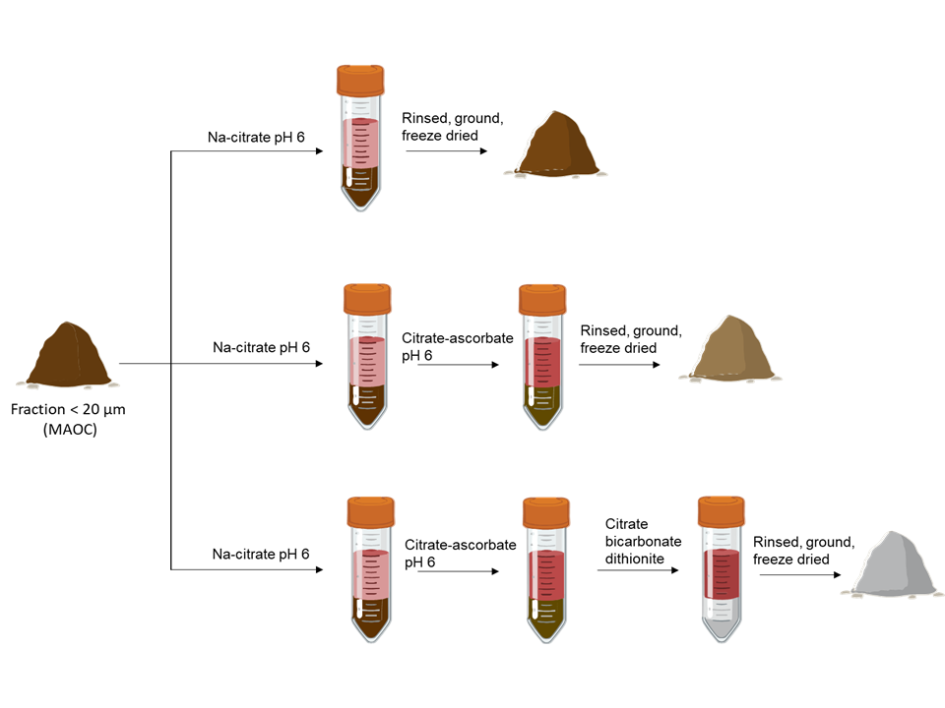
Fig S1. Illustration of the experimental scheme involving wet-chemical extractions. Subsamples from the MAOC fraction of a pristine mangrove, at depths of 0-10, 40-50 and 80-100 cm, in duplicate, underwent distinct sequences of chemical extractions. Following these chemical treatments, the subsamples were then analyzed for Total Organic Carbon (TOC), as well as through infrared and thermal analysis.

Fig S2 PCA biplot showing the relationship among FTIR and TG-DSC parameters of pristine mangrove samples after the sequential wet-chemical extractions.
Fig .S3 FTIR spectra obtained from the MAOC of the studied soils. Peaks at 3695, 3648, 3620, 1100, 1030, 1008 and 912 cm⁻¹ are typical of kaolinite (Chukanov, 2013).

References
Chukanov, N. V, 2013. Infrared spectra of mineral species: extended library. Springer Science & Business Media.

