Supplementary tables and figures

Longitudinal latent class analysis to understand trajectory of breast density and breast cancer risk.

Jiang S, Bennett DL, Wang Y, and Colditz GA.
Author Affiliations: Division of Public Health Sciences, Department of Surgery (S.J., Y.W., G.A.C.), Department of Radiology (D.L.B.), Washington University School of Medicine in St. Louis, St. Louis, MO
Email jiang.shu@wustl.edu ; colditzg@wustl.edu

Table S1.
The association table for the longitudinal model of mammographic breast density – logistic regression of class membership increasing density vs decreasing density over time (box cox scale)
Risk factors | Dense |  |  | Non-dense
Model | Estimate | P-value | 95% confidence interval | Estimate | P-value | 95% confidence interval
Intercept class (decreasing density) | -0.695 | 0.024 | (-1.300, -0.090) | -0.890 | 0.002 | (-1.447, -0.332)
Intercept class (increasing density) | -0.527 | 0.055 | (-1.067, 0.012) | -0.721 | 0.004 | (-1.215, -0.228)
Age | -0.004 | 0.457 | (-0.013, 0.006) | 0.0004 | 0.924 | (-0.008, 0.009)
BMI | -0.036 | <0.001 | (-0.045, -0.026) | -0.034 | <0.001 | (-0.043, -0.025)
Menopause | -0.068 | 0.445 | (-0.244, 0.107) | -0.280 | <0.001 | (-0.446, -0.114)
Alcohol | 0.050 | 0.420 | (-0.071, 0.171) | -0.069 | 0.176 | (-0.169, 0.031)
History benign breast | 0.025 | 0.675 | (-0.093, 0.143) | 0.160 | 0.007 | (0.044, 0.275)
Family history | -0.045 | 0.543 | (-0.188, 0.099) | 0.105 | 0.068 | (-0.008, 0.219)
Parity | -0.006 | 0.932 | (-0.134, 0.123) | 0.043 | 0.452 | (-0.070, 0.157)
Time decreasing density class | -0.098 | <0.001 | (-0.116, -0.081) | -0.085 | <0.001 | (-0.102, -0.068)
Time increasing density class | 0.056 | <0.001 | (0.031, 0.081) | 0.062 | <0.001 | (0.036, 0.088)

Figure S1A plot of class mean change in absolute dense area over repeated examinations among women with dense breasts at entry. Fitted line for decreasing density (Class 1) and women with increasing density (Class 2). Figure A represents 374 women with dense breasts at entry and Figure B represents 558 women with non-dense breasts at entry.

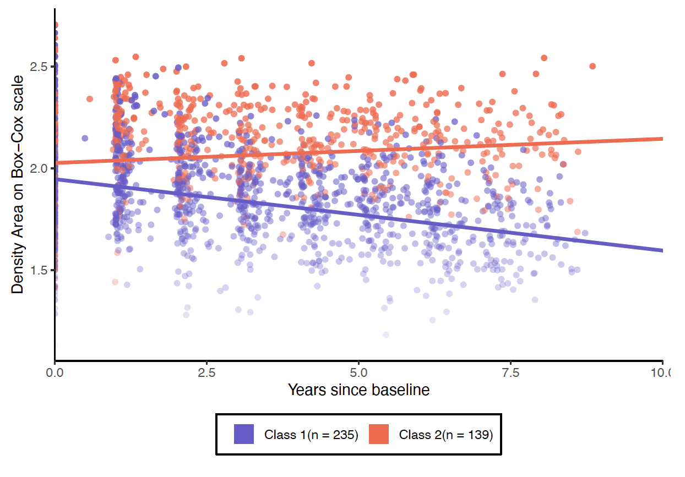
Figure S1B
Plot of class mean change in absolute dense area over repeated examinations among women with non-dense breasts at entry. Fitted line for decreasing density (Class 1) and women with increasing density (Class 2).
