Supporting information
Preparing flake nanocelluloses with hydrophobic surface from the spent liquor of cellulose nanocrystals
Jiebai Li^{1,2}, Dongyan Liu³, Xilin Jia^{1,2}, Guangguang Guan^{1,2}, Wenbo Zhang⁴, Jingyuan Wei⁵, Yangtao Zhou^{1,*}
¹ Shenyang National Laboratory for Materials Science, Institute of Metal Research, Chinese Academy of Sciences, Shenyang 110016, China
² School of Materials Science and Engineering, University of Science and Technology of China, Shenyang 110016, China
³Shi-Changxu Innovation Center for Advanced Materials, Institute of Metal Research, Chinese Academy of Sciences, Shenyang 110016, China
⁴ Yingkou Science and Technology Innovation Service Center, Yingkou 115004, China
⁵ Liaoning Academy of Analytical Sciences, Shenyang 110015, China
* Corresponding author: Y. Zhou, e-mail: ytzhou@imr.ac.cn

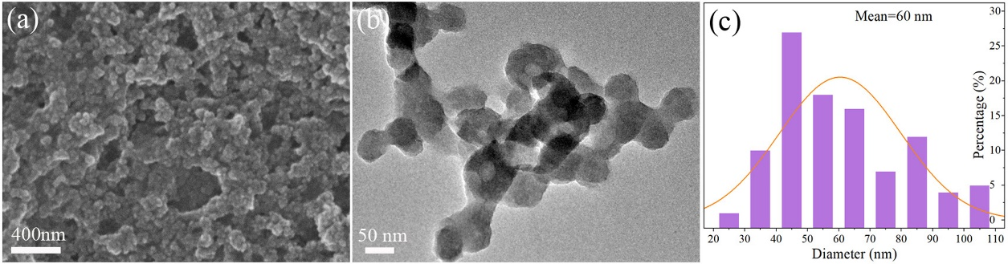
Fig. S1 SEM images (a), TEM images (b), and sizes distribution diagrams (c) of SCNCs
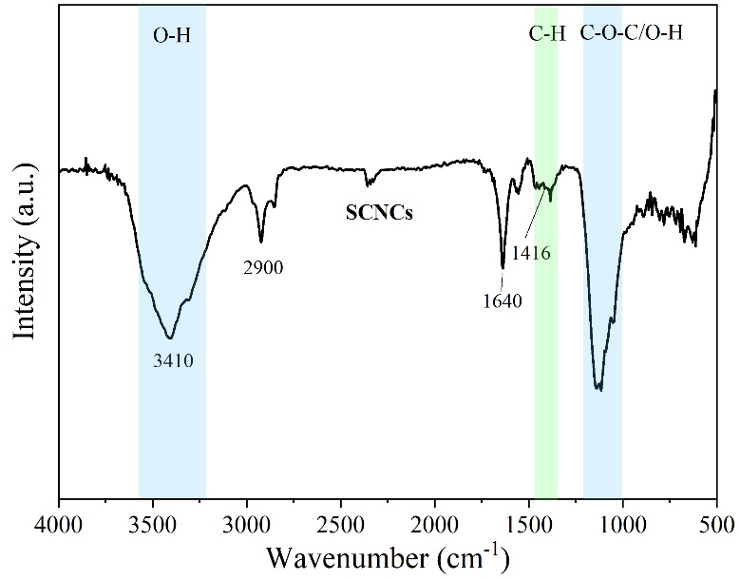
Fig. S2 FTIR spectra for SCNCs
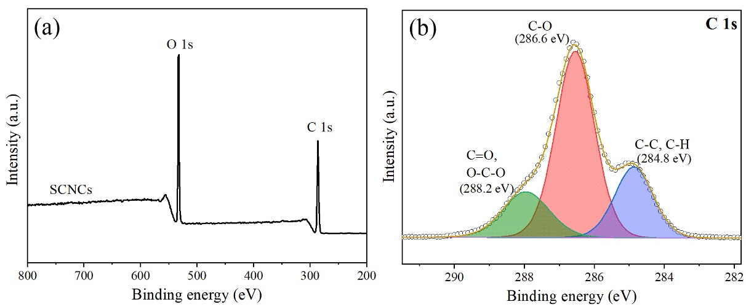
Fig. S3 (a) XPS survey spectrum and (b) high resolutions C 1s spectra for SCNCs
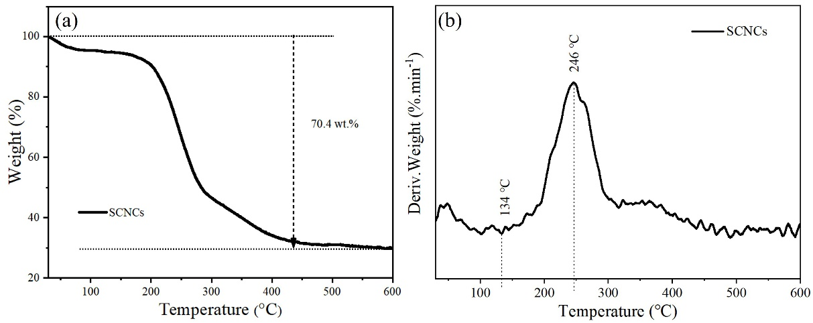
Fig. S4 (a) TGA and (b) DTGA for SCNCs
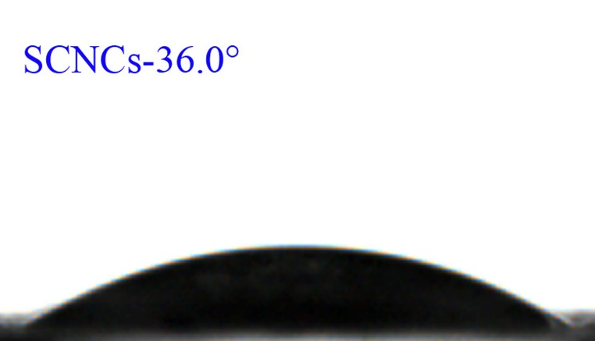
Fig. S5 Contact angle of SCNCs

