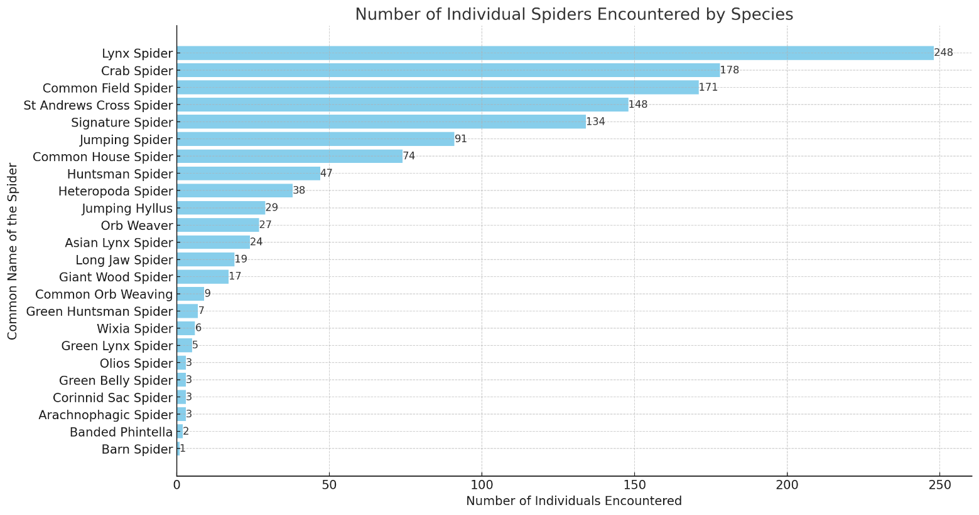

Graph 1 Individual Share of Different Spiders

Graph 2.0 Per Cent Share of Different Families in Total Population of Spiders

