Supporting information

An electrochemical biosensor for sensitive detection of live Salmonella in food via MXene amplified methylene blue signals and electrostatic immobilization of bacteriophages

Jingjing Zhouª, Tingliu Deng^{b}, Qin Zeng^{b}, Heye Wang*^{c}, Chunyan Deng*^{b}

ªBeijing Key Laboratory of Maternal-FetalMedicine and Fetal Heart Disease&Echocardiography Department, Beijing Anzhen Hospital, Capital Medical University, Beijing 100069, China
^{b}Hunan Provincial Key Laboratory of Micro & Nano Materials Interface Science, College of Chemistry and Chemical Engineering, Central South University, Changsha, 410083, P. R. China
^{c}Key Laboratory of Food Quality and Safety of Jiangsu Province-State Key Laboratory Breeding Base, Institute of Food Safety and Nutrition, Jiangsu Academy of Agricultural Sciences, Nanjing, 210000, China

＃:Jingjing Zhou and Tingliu Deng contribute equally to this work.

*Corresponding Author: Chunyan Deng
Phone: +86-731-88876490. Fax: +86-731-88879616.
E-mail: dengchunyan@csu.edu.cn
Table of Contents

- Table S1. Comparison of bacteria detection performances with the proposed sensor and other methods.
- Figure S1. Cyclic voltammograms responses of the different electrodes.

Table S1. Comparison of bacteria detection performances with the proposed sensor and other methods.
Ref | analytical method | LOD  (CFU mL⁻¹) | Linearity region  (CFU mL⁻¹) | Live/dead cells discrimination
Biosens. Bioelectron. 2015, 74, 872-877 | SERS | 15 | 102-107 | NO
ACS Appl. Mater. Interfaces. 2020, 12 (8), 8989-8999 | Colorimetric | 24 | 10²-10⁷ | NO
Anal. Chem. 2020, 92 (4), 3340-3345 | Flow cytometry | 40 | 1.5 × 10²-1.5 × 10⁶ | NO
Anal. Chem. 2019, 91 (22), 14681-14690 | Fluorescent | 8 | 50-10⁷ | NO
Anal. Chem. 2021, 93, 24,8544-8552 | Electrochemical | 6 | 10-7.5 × 10⁵ | NO
this work | Electrochemical | 5 | 2.4×10¹-2.4×10⁷ | YES

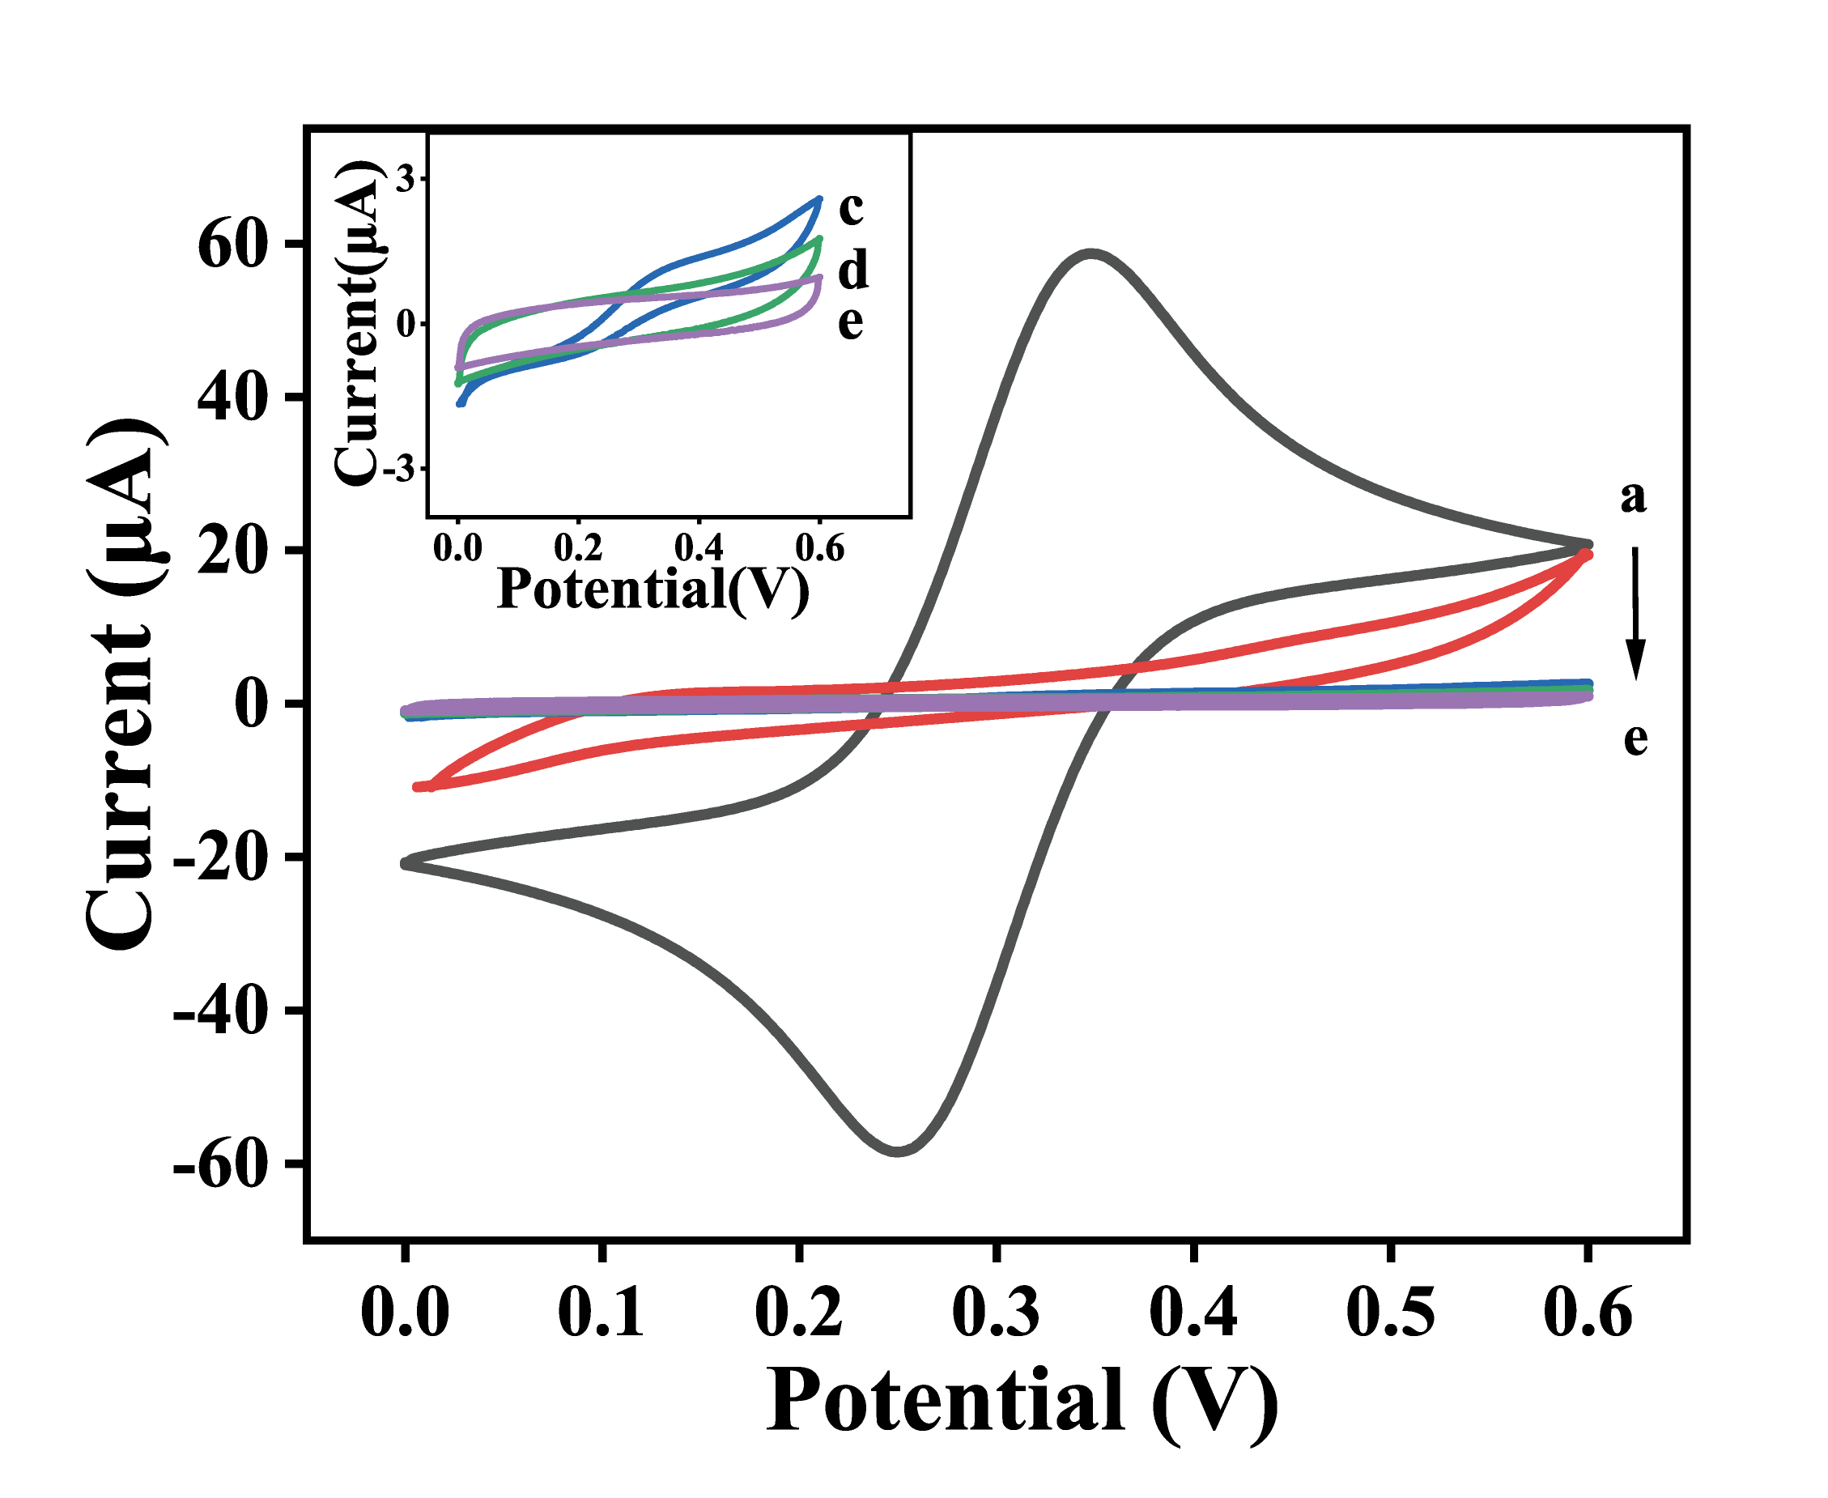
Figure S1. Cyclic voltammograms responses of the bare GC (curve a), Mxene@MB/GCE (curve b), PDDA/Mxene@MB/GCE (curve c), Phage/PDDA/Mxene@MB/GCE (line d), bacteria/Phage/PDDA/Mxene@MB/GCE (line e) of 2.4 × 10⁵ CFU mL⁻¹. The current density measurements at 0-0.6 V in 5.0 mM [Fe (CN)₆]³⁻ / [Fe (CN)₆]⁴⁻ (1:1) containing 0.1 M KCl, scan rate: 100 mV s⁻¹ (Ag/AgCl electrode as the reference electrode).

