OPEN Feasibility study paper Supplementary materials
S1: List of recruiting sites and number of participants consented. Trusts who participated but did not recruit participants are not listed. Date recruitment started: 01/06/2022; date recruitment ended: 31/05/2023; date follow up ended: 31/11/2023.
Sites | Consented (N)
SLAM (South London and Maudsley NHS Foundation Trust) | 5
SWLSTG (South West London and St George’s Mental Health NHS Trust) | 5
CNWL (Central and North West London NHS Foundation Trust) | 7
Solent | 1
Dorset | 1
Sussex | 1
East London NHS Foundation Trust | 1
Total | 20

S2: Complete baseline demographics and clinical characteristics.
Baseline demographics/scales | Available data | n (%) / Mean (SD)
Self-reported gender | 20 (100%)
Male |  | 0 (0%)
Female |  | 19 (95%)
Non-binary |  | 1 (5%)
Ethnicity | 20 (100%)
Black |  | 0 (0%)
White |  | 15 (75%)
Asian/Asian British |  | 2 (10%)
Mixed/Multiple ethnic groups |  | 3 (15%)
Other |  | 0 (0%)
Primary diagnosis | 20 (100%)
Anorexia Nervosa |  | 18 (90%)
Atypical Anorexia Nervosa |  | 2 (10%)
Setting at time of recruitment | 20 (100%)
Outpatient |  | 18 (90%)
Inpatient |  | 1 (5%)
Day care |  | 1 (5%)
Age | 20 (100%) | 16.3 (3.1)
Adolescents (12-17) |  | 15 (75%)
Adults (18-24) |  | 5 (25%)
Height (m) | 20 (100%) | 1.6 (.082)
Weight (Kg) | 20 (100%) | 46 (7.2)
STANDING Systolic blood pressure (mmHg) | 18 (90%) | 106 (11)
STANDING Diastolic blood pressure (mmHg) | 18 (90%) | 72 (9.7)
STANDING Pulse rate (bpm) | 17 (85%) | 83 (17)
Body Temperature (degrees Celsius) | 10 (50%) | 37 (0.52)
BMI (kg/m²) | 20 (100%) | 17 (1.8)
EDE-Q Restraint subscore | 19 (95%) | 4.8 (0.92)
EDE-Q Eating subscore | 20 (100%) | 3.9 (0.94)
EDE-Q Shape subscore | 20 (100%) | 5.4 (0.77)
EDE-Q Weight subscore | 20 (100%) | 5 (0.88)
EDE-Q Global score | 20 (100%) | 4.8 (0.68)
BAVQ-R Malevolence¹ | 14 (100%) | 14 (4.0)
BAVQ-R Benevolence¹ | 14 (100%) | 13 (4.0)
BAVQ-R Omnipotence1 | 14 (100%) | 16 (3.8)
BAVQ-R Resistance -Emotion¹ | 14 (100%) | 11 (3.8)
BAVQ-R Resistance - Behaviour ¹ | 14 (100%) | 11 (4.3)
BAVQ-R Engagement - Emotion¹ | 14 (100%) | 8.4 (3.0)
BAVQ-R Engagement - Behaviour ¹ | 14 (100%) | 8.8 (3.1)
SREBQ – Total mean score | 20 (100%) | 2.9 (0.5)
DASS – Depression score² | 17 (100%) | 29 (11)
DASS – Anxiety score² | 17 (100%) | 21 (9.4)
DASS – Stress score² | 17 (100%) | 31 (7.3)
RCADS – Social phobia score³ | 3 (100%) | 22 (2.9)
RCADS – Panic disorder score³ | 3 (100%) | 20 (0)
RCADS – Major depression score³ | 3 (100%) | 27 (5.5)
RCADS – Separation anxiety score³ | 3 (100%) | 16 (1.7)
RCADS – Generalized anxiety score³ | 3 (100%) | 17 (2.3)
RCADS – Obsessive compulsive score³ | 3 (100%) | 13 (2.6)
Y-BOCS/ CY-BOCS Total score | 16 (80%) | 20 (8.1)
ESS / ESS-CHAD Total Score | 20 100%) | 5.5 (4.2)
EDSIS Social Isolation score⁴ | 11 (85%) | 8.1 (3)
EDSIS Guilt score⁴ | 11 (85%) | 14 (5.1)
EDSIS Nutrition score⁴ | 10 (77%) | 24 (5.6)
EDSIS Dysregulation score⁴ | 10 (77%) | 4.8 (5.1)

¹Only required for those age 15 years or over, n=14. Any extraneous data completed by those under 15 years was removed.
²Only required for those age 14 years or over, n=17. Any extraneous data completed by those under 14 years was removed.
³Only required for those under 14 years, n=3. Any extraneous data completed by those 14 years or over was removed.
⁴Completed by a parent/caregiver only if they agreed to have data collected about themselves, n=13

S3: Feasibility parameters with confidence intervals
Parameter | N | Proportion | 95% Confidence Interval
Potential eligibility in overall number considered (Number eligible/Number considered) | 37/52 | 0.71 | 0.57,0.83
Potential eligibility in those approached (Number eligible/Number approached) | 35/39 | 0.90 | 0.76,0.97
Consented participants of those approached.  (Number consented/number approached) | 20/39 | 0.51 | 0.35,0.68
Consented participants of those approached and eligible (Number consented /number approached and eligible) | 20/35 | 0.57 | 0.39,0.74
Commenced olanzapine (number started olanzapine/number consented) | 20/20 | 1.00 | 0.83,1.00
Adhered to treatment per prescribed dose¹ (Number adhered to Olanzapine/number consented) | 15/20 | 0.75 | 0.50,0.91
Completed follow up to Month 6 or Month 12 depending on when recruited (Number completed follow up/Number consented) | 13/20 | 0.65 | 0.41,0.85
¹Adherence here uses the amount prescribed rather than pill count returns (which was definition in the SAP) because of the missing data in pill counts (see Adherence section).

S4: Summary statistics for follow up measures
Descriptives for each of the measures are presented here by visit. As Month 12 was completed by only two participants, and most participants only had 6 months follow up (as trial was stopped), Month 12 descriptives have been omitted. As per the baseline section, some scales are only collected in a subset of participants; see footnotes at the end of this section for expected numbers who should have completed these measures.

Week 8 Scales | Available data  (% of recruited or relevant N) | Mean (SD)
EDE-Q Restraint subscore | 11 (55%) | 3 (1.4)
EDE-Q Eating subscore | 10 (50%) | 3 (1.5)
EDE-Q Shape subscore | 11 (55%) | 5 (.98)
EDE-Q Weight subscore | 11 (55%) | 4.1 (1.4)
EDE-Q Global score | 11 (55%) | 3.8 (1.1)
BAVQ-R Malevolence¹ | 7 (50%) | 11 (4.8)
BAVQ-R Benevolence¹ | 7 (50%) | 12 (4.5)
BAVQ-R Omnipotence¹ | 7 (50%) | 14 (5.1)
BAVQ-R Resistance -Emotion¹ | 8 (57%) | 10 (3.9)
BAVQ-R Resistance - Behaviour ¹ | 5 (36%) | 9.4 (4.4)
BAVQ-R Engagement - Emotion¹ | 8 (57%) | 9.6 (4.4)
BAVQ-R Engagement - Behaviour ¹ | 6 (43%) | 8.3 (1.6)
SREBQ – Total mean score | 10 (50%) | 2.6 (.44)
DASS – Depression score² | 9 (53%) | 23 (11)
DASS – Anxiety score² | 9 (53%) | 13 (7.4)
DASS – Stress score² | 9 (53%) | 23 (8.7)
RCADS – Social phobia score³ | 0 (0%) | N/A
RCADS – Panic disorder score³ | 0 (0%) | N/A
RCADS – Major depression score³ | 0 (0%) | N/A
RCADS – Separation anxiety score³ | 0 (0%) | N/A
RCADS – Generalized anxiety score³ | 0 (0%) | N/A
RCADS – Obsessive compulsive score³ | 0 (0%) | N/A
Y-BOCS/ CY-BOCS Total score | 10 (50%) | 13 (11)
ESS / ESS-CHAD Total Score | 10 (50%) | 5.9 (6.2)
Weight (Kg) | 10 (50%) | 51 (8.6)
BMI (kg/m²) | 10 (50%) | 18 (2.5)

¹Only required for those age 15 or over, n=14. Any extraneous data completed by those under 15 was removed.
²Only required for those age 14 or over, n=17. Any extraneous data completed by those under 14 was removed.
³Only required for those under 14, n=3. Any extraneous data completed by those 14 or over was removed.
⁴Completed by parent/caregiver only if they have agreed to have data collected about themselves, n=13

Week 16 scales | Available data  (% of recruited or relevant N) | Mean (SD)
EDE-Q Restraint subscore | 9 (45%) | 3.1 (1.5)
EDE-Q Eating subscore | 9 (45%) | 3.2 (1.3)
EDE-Q Shape subscore | 9 (45%) | 5 (1.2)
EDE-Q Weight subscore | 9 (45%) | 4.3 (1.7)
EDE-Q Global score | 9 (45%) | 3.9 (1.3)
BAVQ-R Malevolence¹ | 6 (43%) | 14 (2.1)
BAVQ-R Benevolence¹ | 6 (43%) | 13 (2.1)
BAVQ-R Omnipotence¹ | 6 (43%) | 16 (4.5)
BAVQ-R Resistance -Emotion¹ | 6 (43%) | 12 (3.3)
BAVQ-R Resistance - Behaviour ¹ | 6 (43%) | 12 (5.3)
BAVQ-R Engagement - Emotion¹ | 6 (43%) | 8.8 (4.3)
BAVQ-R Engagement - Behaviour ¹ | 6 (43%) | 7.7 (2.8)
SREBQ – Total mean score | 9 (45%) | 2.6 (.49)
DASS – Depression score² | 8 (47%) | 23 (9.2)
DASS – Anxiety score² | 8 (47%) | 11 (8.1)
DASS – Stress score² | 8 (47%) | 24 (9.2)
RCADS – Social phobia score³ | 1 (33%) | 25 (-)
RCADS – Panic disorder score³ | 1 (33%) | 15 (-)
RCADS – Major depression score³ | 1 (33%) | 31 (-)
RCADS – Separation anxiety score³ | 1 (33%) | 21 (-)
RCADS – Generalized anxiety score³ | 1 (33%) | 13 (-)
RCADS – Obsessive compulsive score³ | 1 (33%) | 9 (-)
Y-BOCS/ CY-BOCS Total score | 7 (35%) | 14 (11)
ESS / ESS-CHAD Total Score | 9 (45%) | 6.4 (3)
Weight (Kg) | 10 (50%) | 50 (7.2)
BMI (kg/m²) | 10 (50%) | 18 (2.1)

Month 6 scales | Available data  (% of recruited or relevant N) | Mean (SD)
EDE-Q Restraint subscore | 7 (35%) | 2.2 (1.8)
EDE-Q Eating subscore | 7 (35%) | 2.4 (.93)
EDE-Q Shape subscore | 7 (35%) | 3.9 (1.8)
EDE-Q Weight subscore | 7 (35%) | 3.1 (1.6)
EDE-Q Global score | 7 (35%) | 2.9 (1.4)
BAVQ-R Malevolence¹ | 5 (36%) | 12 (5.4)
BAVQ-R Benevolence¹ | 5 (36%) | 9.8 (3.6)
BAVQ-R Omnipotence¹ | 5 (36%) | 11 (5.7)
BAVQ-R Resistance -Emotion¹ | 5 (36%) | 9 (5.2)
BAVQ-R Resistance - Behaviour ¹ | 5 (36%) | 11 (5.4)
BAVQ-R Engagement - Emotion¹ | 5 (36%) | 6.6 (4.2)
BAVQ-R Engagement - Behaviour ¹ | 6 (43%) | 6 (1.9)
SREBQ – Total mean score | 7 (35%) | 2.7 (.25)
DASS – Depression score² | 6 (35%) | 21 (12)
DASS – Anxiety score² | 6 (35%) | 13 (9.6)
DASS – Stress score² | 6 (35%) | 22 (13)
RCADS – Social phobia score³ | 0 (0%) | N/A
RCADS – Panic disorder score³ | 0 (0%) | N/A
RCADS – Major depression score³ | 0 (0%) | N/A
RCADS – Separation anxiety score³ | 0 (0%) | N/A
RCADS – Generalized anxiety score³ | 0 (0%) | N/A
RCADS – Obsessive compulsive score³ | 0 (0%) | N/A
Y-BOCS/ CY-BOCS Total score | 7 (35%) | 17 (10)
ESS / ESS-CHAD Total Score | 7 (35%) | 4 (4.2)
EDSIS Social Isolation score⁴ | 3 (23%) | 4.7 (1.5)
EDSIS Guilt score⁴ | 3 (23%) | 5.7 (.58)
EDSIS Nutrition score⁴ | 3 (23%) | 13 (3.2)
EDSIS Dysregulation score⁴ | 3 (23%) | 3.7 (4.7)
Weight (Kg) | 11 (55%) | 52 (7.4)
BMI (kg/m²) | 11 (55%) | 19 (2.2)
¹Only required for those age 15 or over, n=14. Any extraneous data completed by those under 15 was removed.
²Only required for those age 14 or over, n=17. Any extraneous data completed by those under 14 was removed.
³Only required for those under 14, n=3. Any extraneous data completed by those 14 or over was removed.
⁴ Note EDSIS not collected at Week 8 and Week 16.Completed by parent/caregiver only if they have agreed to have data collected about themselves, n=13

Month 6 EQ5D-Y scores are presented below.
Month 6 Scale | Available data | Mean (SD)
MOBILITY | 7 (35%) | 1 (0)
LOOKING AFTER MYSELF | 7 (35%) | 1 (0)
DOING USUAL ACTIVITIES | 7 (35%) | 1.4 (.53)
HAVING PAIN OR DISCOMFORT | 7 (35%) | 1.1 (.38)
FEELING WORRIED, SAD OR UNHAPPY | 7 (35%) | 2.3 (.49)
YOUR HEALTH TODAY | 7 (35%) | 80 (13)

Month 6 CAA-SUS data is presented in table below restricted to data on hospital stays/appointments only.
N=7 | N response (%) / Mean (SD)
Overnight stay in hospital in last 3 months because of an eating disorder
0. No | 6 (85.7%)
1. Yes | 1 (14.3%)
If stayed overnight because of eating disorder, total number of nights (N=1) | 100 (-)
Overnight stay in hospital in last 3 months because of any other mental health reason
0. No | 7 (100.0%)
Overnight stay in hospital for anything else (this could include accidents, injuries, physical health conditions or illnesses)
0. No | 7 (100.0%)
Hospital appointments because of an eating disorder (DID NOT stay overnight) in last 3 months
0. No | 4 (57.1%)
1. Yes | 3 (42.9%)
Number of hospital appointments (N=3 with data) | 4.3 (2.5)

The table below gives summary data for the CSSRS at Week 8, 16 and Month 6. In this case the summary is the question on the most severe suicidal ideation.
Visit | N (%)
Week 8 Most Severe Ideation:
None | 6 (60.0%)
Wish to be Dead | 1 (10.0%)
Non-Specific Active Suicidal Thoughts | 2 (20.0%)
Active Suicidal Ideation with Any Methods without Intent to Act | 1 (10.0%)
Week 16 Most Severe Ideation:
None | 5 (62.5%)
Wish to be Dead | 2 (25.0%)
Active Suicidal Ideation with Any Methods without Intent to Act | 1 (12.5%)
Month 6 Most Severe Ideation:
None | 6 (75.0%)
Non-Specific Active Suicidal Thoughts | 1 (12.5%)
Active Suicidal Ideation with Any Methods without Intent to Act | 1 (12.5%)

S5: List of all adverse events
The table below gives a full listing of all adverse events reported during the trial. Dummy ID indicates AEs for the same participant.
Dummy ID* | Description | Body System | Status | Relatedness | Serious? | AE timing relative to visit
1 | Foot pain (muscular) | Musculoskeletal and connective tissue disorders | Recovered | Not related | Not serious | Unknown timing as missing data
1 | Hospitalization for Anorexia Nervosa | Psychiatric disorders | Recovered with sequelae | Not related | Not serious | Between baseline and week 8
2 | Bacterial infection | Infections and infestations | Recovered | Not related | Not serious | Between week 16 and month 6
3 | Inpatient admission for AN | Social circumstances | Ongoing at end of study | Not related | Not serious | Between week 16 and month 6
4 | Bradycardia, dehydration and hypoglycemia | Metabolism and nutrition disorders | Recovered | Not related | Not serious | Between baseline and week 8
4 | COVID-19 positive test | Infections and infestations | Recovered | Not related | Not serious | Between baseline and week 8
5 | Overdose of 15 tabs of promethazine 25 mgs, presented to A&E | Injury, poisoning and procedural complications | Recovered | Not related | Not serious | Between baseline and week 8
5 | Anorexia nervosa | Psychiatric disorders | Recovered with sequelae | Not related | Not serious | Between week 16 and month 6
6 | Self harm by cutting arm | Injury, poisoning, and procedural complications | Recovered | Remote | Not serious | Between week 16 and month 6
6 | Diarrhoea, incontinence under investigation by GP | Gastrointestinal disorders | Ongoing at end of study | Possibly | Not serious | Unknown timing as missing data
6 | Self harm by cutting arm | Injury, poisoning, and procedural complications | Recovered | Remote | Not serious | Between week 8 and week 16
6 | Autism | 7. Psychiatric disorders | Ongoing at end of study | Not related | Not serious | Between week 16 and month 6
7 | elevated ALT to 180u/l | 15. Hepatobiliary disorders | Recovered | Definitely | Not serious | Between baseline and week 8

S6: Exploratory change over time results
Measure/Visit | N | Mean (SD) | Estimated mean (SE) change from baseline | 95% CI for mean change from baseline
EDE-Q Global score
Baseline | 20 | 4.8 (0.68) | - | -
Week 8 | 11 | 3.8 (1.1) | -0.95 (0.27) | (-1.47, -0.42)
Week 16 | 9 | 3.9 (1.3) | -0.96 (0.34) | (-1.61, -0.29)
Month 6 | 7 | 2.9 (1.4) | -1.87 (0.52) | (-2.90, -0.85)
Weight (kg)
Baseline | 20 | 46.0 (7.2) | - | -
Week 8 | 10 | 50.7 (8.6) | 2.7 (1.1) | (0.5, 4.9)
Week 16 | 10 | 50.0 (7.2) | 3.8 (1.0) | (1.8, 5.8)
Month 6 | 11 | 52.3 (7.4) | 6.2 (1.2) | (3.8, 8.5)
BMI (kg/m²)
Baseline | 20 | 16.9 (1.8) | - | -
Week 8 | 10 | 18.2 (2.5) | 0.9 (0.4) | (0.1, 1.6)
Week 16 | 10 | 18.1 (2.1) | 1.3 (0.4) | (0.5, 2.0)
Month 6 | 11 | 19.1 (2.2) | 2.2 (0.4) | (1.4, 3.0)

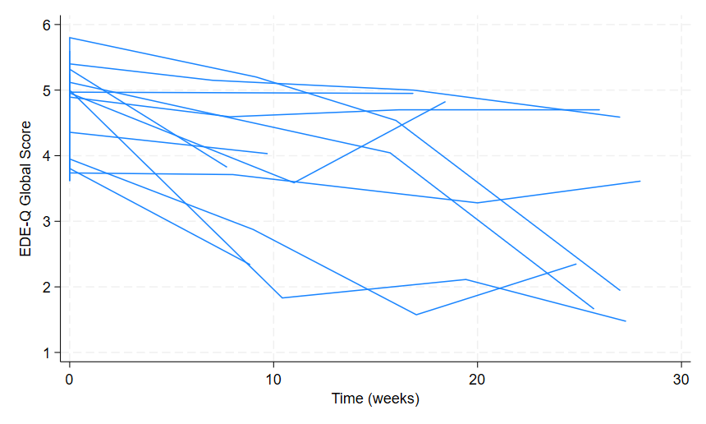
Supplemental Figure S1 - EDE Q Global score over time trajectories
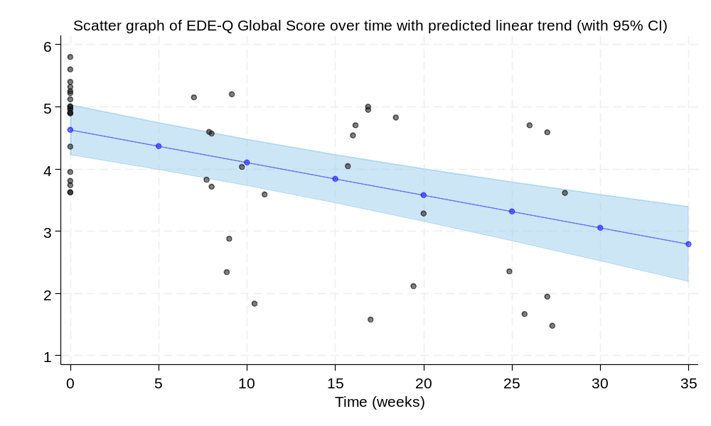
Supplemental Figure S2 - EDE Q Global score over time
This graph corresponds to a mean decrease of 0.07 EDE Q Global score (0.04, 0.09 95% CI) per week.

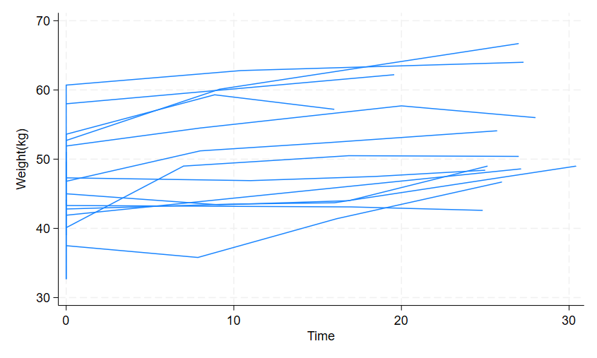
Supplemental Figure S3 - Weight over time - individual trajectories

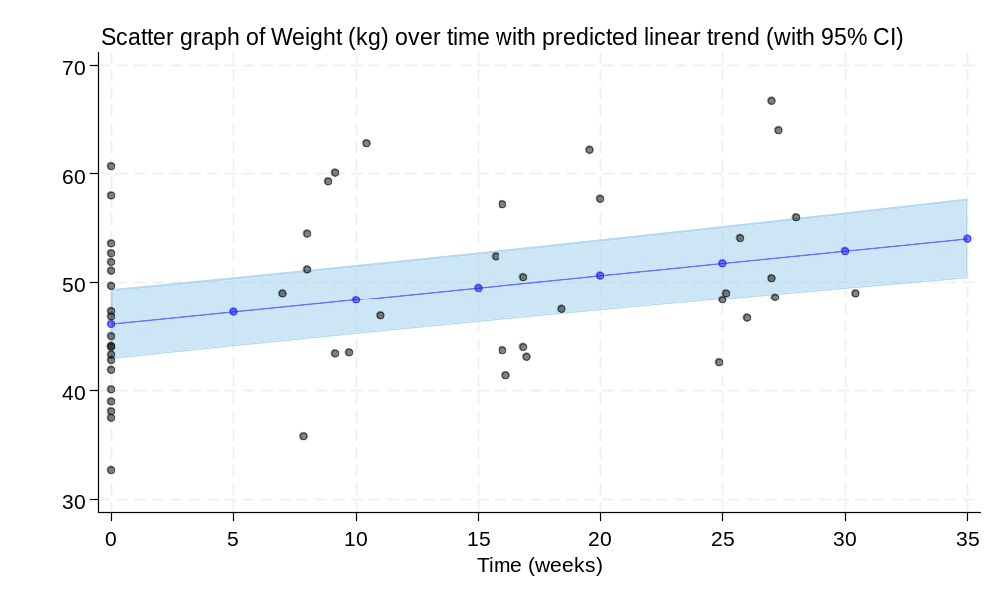

Supplemental Figure S4 - Weight over time scatter graph
This graph corresponds to a mean increase of 0.22 kg (0.16, 0.29 95% CI) per week.

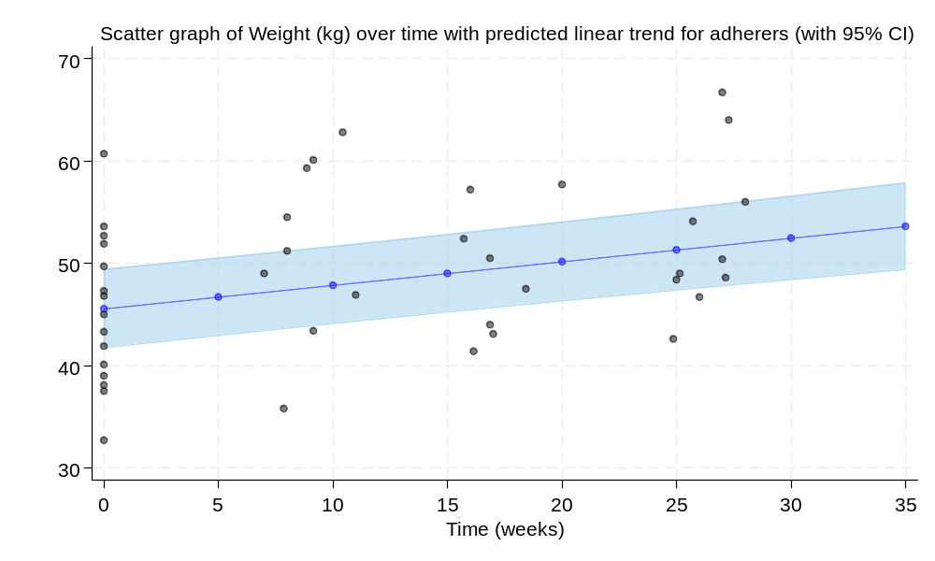
Supplemental Figure S5 - Weight over time in those adhered to Olanzapine
This graph corresponds to a mean increase of 0.23 kg (0.15, 0.30 95% CI) per week in those who adhered.

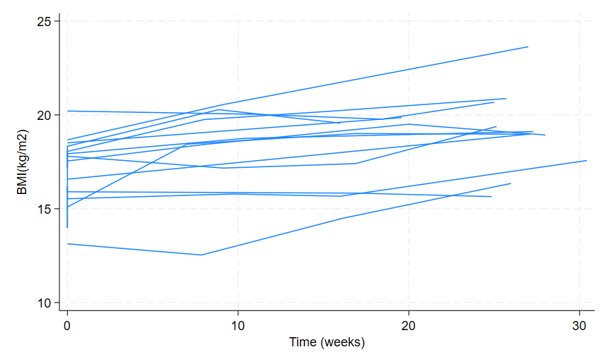
Supplemental Figure S6 – BMI (kg/m2) over time - individual trajectories
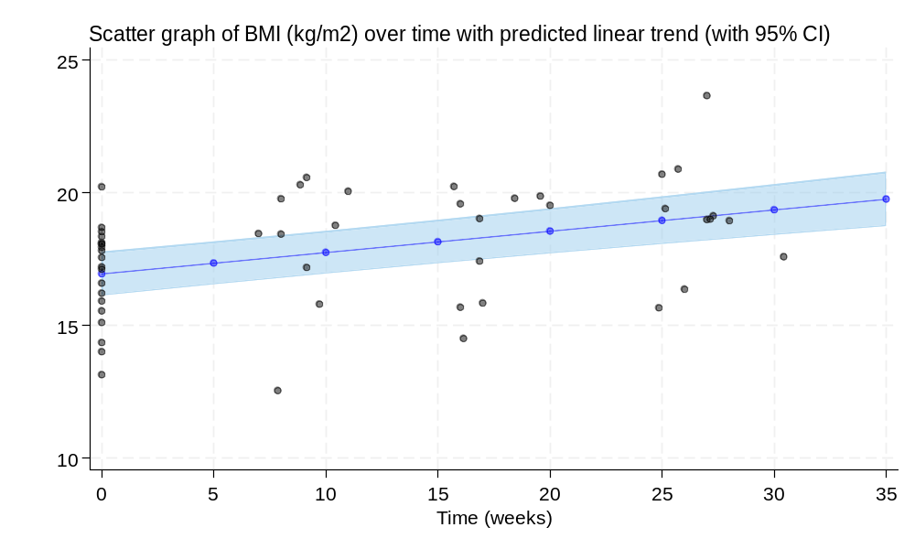
Supplemental Figure S7 - BMI over time scatter graph
This graph corresponds to a mean increase of 0.08 kg/m² (0.06, 0.10 95% CI) per week.

