Supplementary Information

Deviatoric Stress-Induced Transition of Self-Trapped Exciton Emissions

Chaofan Lv,^{1, 2, 3} Xigui Yang,^{3,✉} Yanran Wu,³ Yachuan Liang,³ Jinxu Qin,³ Shoulong Lai,³ Hang Liu,³ Jinhao Zang,³ Shaobo Cheng,³ Kaikai Liu,^{3,✉} Chongxin Shan^{3,✉}
¹State Key Laboratory of Luminescence and Applications, Changchun Institute of Optics, Fine Mechanics and Physics, Chinese Academy of Sciences, No. 3888 Dongnanhu Road, Changchun 130033, China
²Center of Materials Science and Optoelectronics Engineering, University of Chinese Academy of Sciences, Beijing 100049, China
³Henan Key Laboratory of Diamond Optoelectronic Materials and Devices, Key Laboratory of Material Physics, Ministry of Education, School of Physics and Microelectronics, Zhengzhou University, Zhengzhou 450052, China
✉e-mail: yangxg@zzu.edu.cn; liukaikai@zzu.edu.cn; cxshan@zzu.edu.cn

Figure S1. Deviatoric stress distribution and deformation evaluation of specimens under compression from FEM simulations for various high-pressure experimental configurations. The simulations capture the 3D shape and numerically determined stress distribution of samples with various deviatoric stress components: (a) a single prism ZnO wire under hydrostatic compression of 1.5 and 11 GPa; (b) pyramidal ZnO nanocrystals at pressures of 0.18 and 1.15 GPa under hydrostatic compression combined with a deviatoric stress component; (c) pyramidal ZnO nanocrystals at pressures less than 0.01 GPa and 0.45 GPa with the absence of isotropic compression and the maximum level of deviatoric stress.

Figure S2. Comparison of yielding deformation behaviors between various level deviatoric stress extracted from FEM simulations. (a) Selected nodes (red dots) in the contact surface of the model of pyramidal ZnO nanocrystal to export derivative curve of average stress data under compression combined with deviatoric squeezing, the yielding deformation points are marked by dash ellipses and drop lines. (b) Selected nodes (red dots) in the bottom of pyramidal ZnO nanocrystal to export stress data (dash lines) and average stress data (green dots) under compression combined with deviatoric squeezing, the yielding deformation points were marked with dash ellipses and drop lines, and corresponding stress data, marked with horizontal lines, were used as the reference of environmental pressure. (c) Selected nodes (red dots) in the contact surface of the model of pyramidal ZnO nanocrystal to export derivative curve of average stress data with the absence of isotropic compression and the maximum level of deviatoric stress, the yielding deformation points are marked by dash ellipses and drop lines. (d) Selected nodes (red dots) in the bottom of pyramidal ZnO nanocrystal to export stress data (dash lines) and average stress data (green dots) with the absence of isotropic compression and the maximum level of deviatoric stress, the yielding deformation points were marked with dash ellipses and drop lines, and corresponding stress data, marked with horizontal lines, were used as reference of environmental pressure.
Figure S3. Detail and analysis of stress extracted from FEM of experimental configurations with the absence of isotropic compression and the maximum level of deviatoric stress. (a) Selected nodes (gray dots) and 4 typical nodes (polychrome dots) in the contact surface of the model of pyramidal ZnO nanocrystal to export stress and its derivative curve with the absence of isotropic compression and the maximum level of deviatoric stress. (b) Average stress (blue) and corresponding derivative curve (red) extracted from selected nodes in contact surface under compression combined with a deviatoric stress component, the yielding deformation points are marked by a dash ellipse and drop line. (c) Evolution of stress under compression of typical 4 nodes, the corresponding yielding deformation points are marked by a dash ellipse and drop line.

Figure S4. TEM graph and fitted grain size distribution before (a, b) and after (c, d) 11.0 GPa pressure treatment.

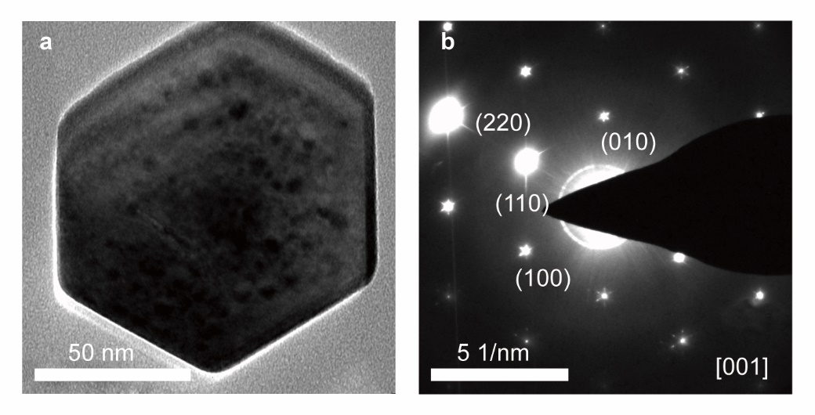
Figure S5. TEM graph (a) and corresponding SAED pattern (b) of pyramidal ZnO nanocrystal from the bottom view before pressure treatment.

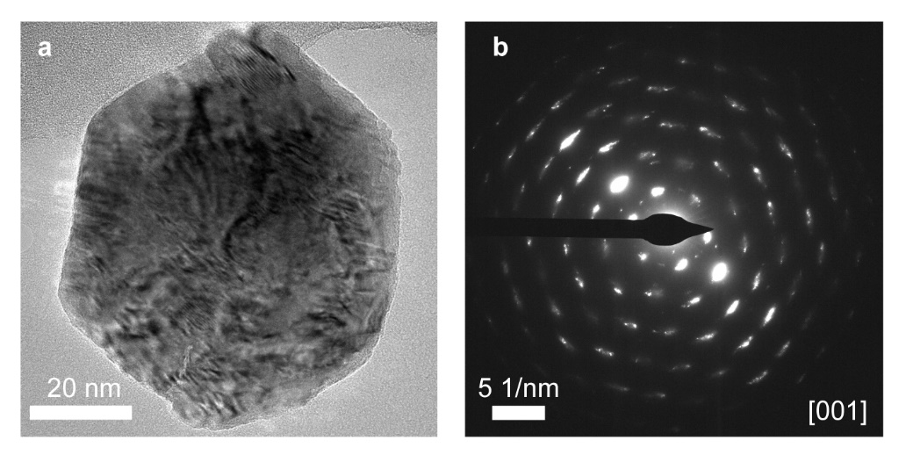
Figure S6. TEM graph (a) and corresponding SAED pattern (b) of pyramidal ZnO nanocrystal from the bottom view after pressure treatment.

Figure S7. In-situ PL spectra (a) and evolution of PL intensity (b) under pressure as isopropanol serves as PTM.
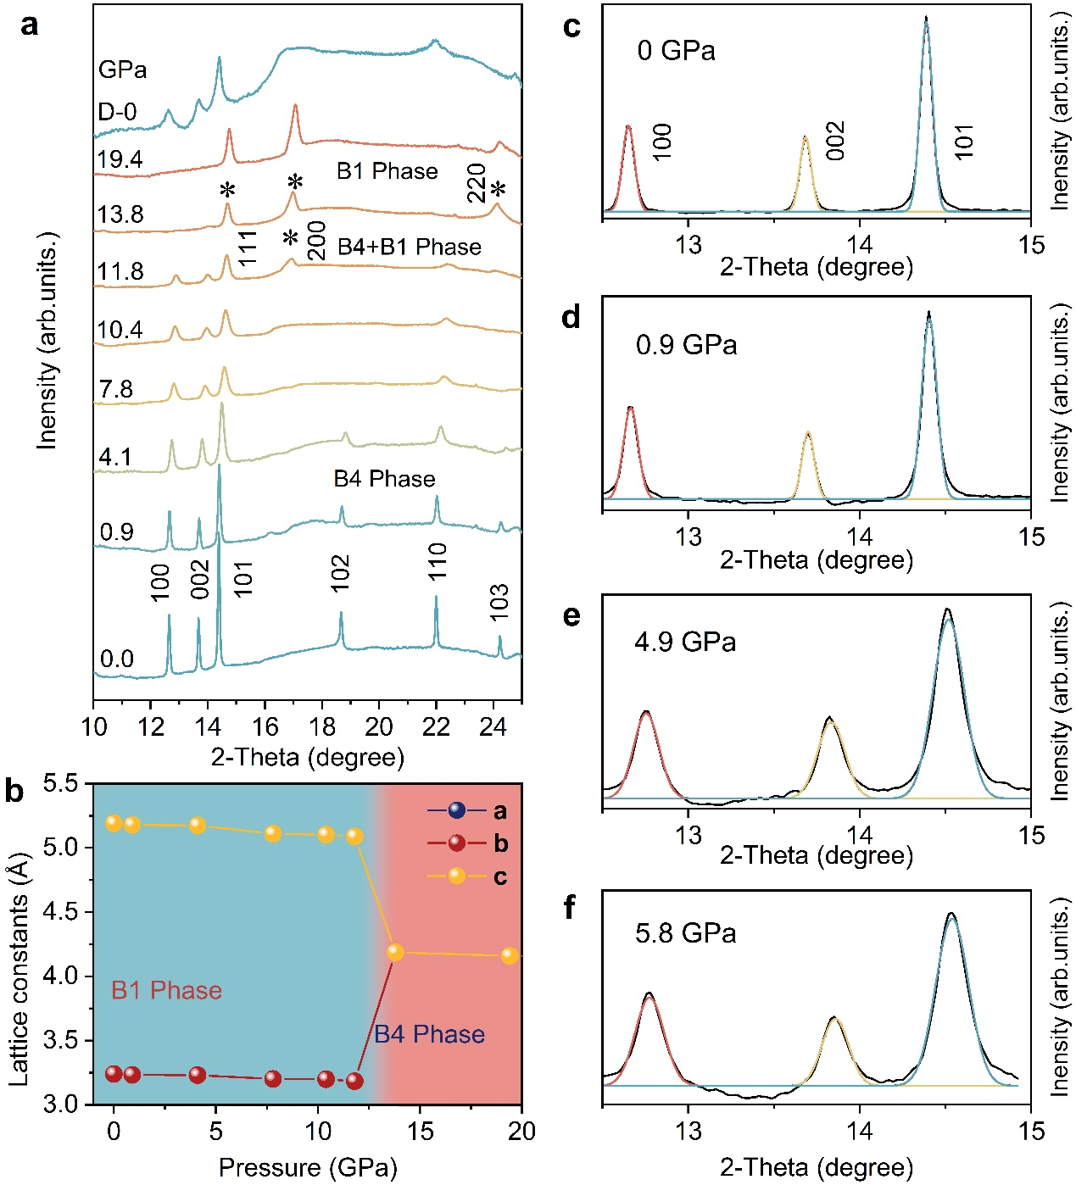
Figure S8. (a) In-situ high-pressure ADXRD patterns under selected pressure. (b) Lattice constants under selected pressure. (c-f) Fitted details curve of ADXRD patterns under selected pressures.

To establish a correlation between the optical properties and structural phases, we conducted a comprehensive characterization of structural variations under pressure using ADXRD spectroscopy. The complete ADXRD patterns are shown in Fig. S6a. At ambient conditions, the ZnO crystal possessed a hexagonal symmetry with the P63mc space group, referred to as the B4 phase.¹ As pressure increased, all Bragg diffraction peaks shifted to larger degrees, indicating the stabilization and sustained contraction of the B4 phase. A significant change in the diffraction pattern occurred at 11.8 GPa, where a new peak abruptly appeared around 17 ̊, providing direct evidence of a phase transition. This new phase, designated as B1, was assigned to a cubic phase with the Fm3m space group.² At 13.8 GPa, the diffraction peaks associated with the B4 Phase disappeared, and the dominance of the B1 phase suggested the completion of the phase transition to the cubic B1 phase. Variations of lattice parameters are summarized in Fig. S6b. Importantly, the observed phase transition proved to be reversible upon complete pressure release, as evidenced by the return of the diffraction pattern to its initial states, despite broadened line widths and increased background.

Figure S9. The strain evolution of the (101) and the (002) plane and the PL intensity of the ex-STE band under pressure.

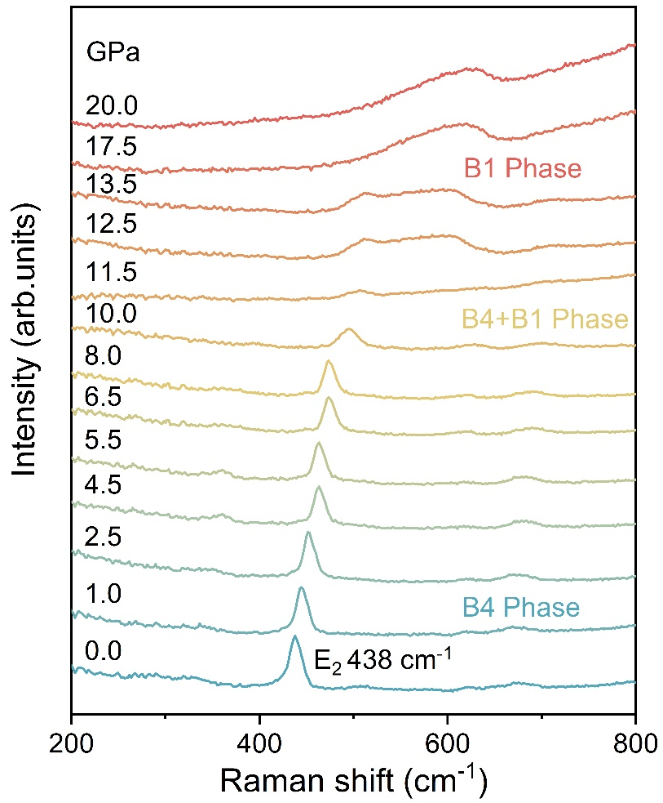
Figure S10. In-situ high-pressure Raman spectra under selected pressure.

Under ambient pressure, only a low-frequency E₂ phonon mode at 438 cm⁻¹ was apparent. With the increasing pressure, the E₂ mode moved continuously along the high-frequency direction, gradually becoming asymmetric and broadening above 10.0 GPa, indicating structural distortion of the B4 phase. Eventually, the E₂ mode disappeared after 13.5 GPa, suggesting the transition to the B1 phase.^{3–5}
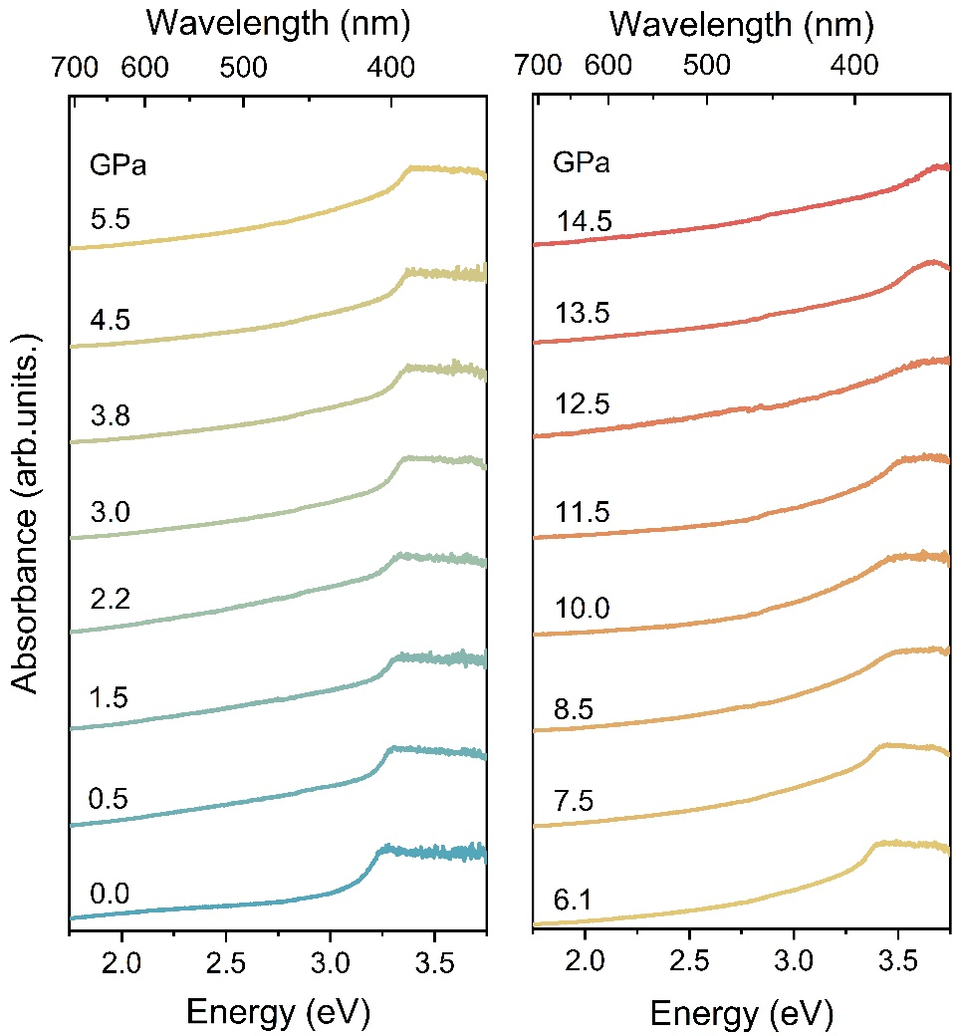
Figure S11. In-situ high-pressure UV–Visible absorption spectra under selected pressure.

To elucidate the origin of the ex-STE in pyramidal ZnO nanocrystals, we conducted in-situ pressure-dependent UV-vis absorption spectra. Under ambient conditions, the absorption spectra exhibited a sharp edge at 3.47 eV, corresponding to the band edge position.⁶ Upon increasing pressure to 11.5 GPa, the absorption edge underwent a persistent blue shift, which may be related to the bond length contraction and band gap expansion.⁷ The phase transition to the B1 phase, determined from the absorption spectra, occurred above 11.5 GPa, marked by a sudden change in the absorption edge.⁸ This change transitioned from the step-like shape typical of the wurtzite phase, with its exciton-related maximum, to a structureless absorption tail. This tail could be assigned to an indirect transition with a band gap of ~2.47 eV at 12.5 GPa.⁸

Figure S12. Fluence-dependent PL intensity of pyramidal nanocrystals under 8.0 GPa.

Figure S13. In-situ pressure-dependent PL spectra of pyramidal ZnO nanocrystals after annealing. (a) FTIR spectrum of pyramidal ZnO nanocrystals after annealing. (b) SEM graph of ZnO nanocrystals after annealing for 250 ℃ and 30min. (c) In-situ high-pressure PL spectra of ZnO nanocrystals after annealing for 250 ℃ and 30min. (d) Evolution of PL intensity of ZnO nanocrystals after annealing for 250 ℃ and 30min, open cycles represent pressure released to 0.0 GPa.

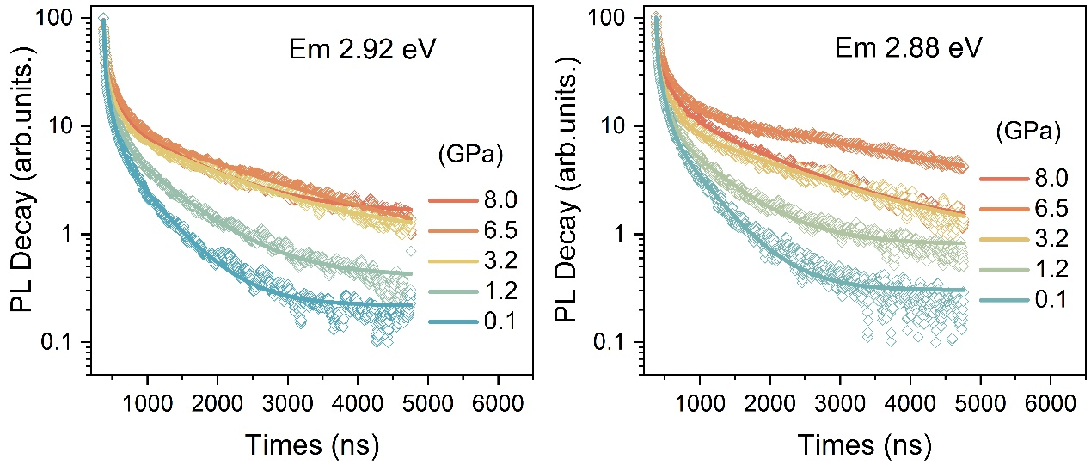
Figure S14. In-situ high-pressure PL decay curve and fitted details monitored around ex-STE band under selected pressure.

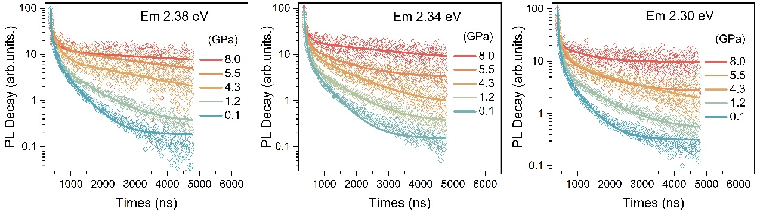
Figure S15. In-situ high-pressure PL decay curve and fitted details monitored around in-STE band under selected pressure.

Table S1. Yielding pressure points of various high-pressure experimental configurations extracted from FEM simulation.
Yielding Pressure (GPa) | 1 st | 2 nd | 3 rd | 4 th
Prism ZnO wire with PTM | None
Pyramidal ZnO nanocrystals with PTM | 0.18 GPa | 0.45 GPa | 0.72 GPa | 1.15 GPa
Pyramidal ZnO nanocrystals without PTM | < 0.01 GPa | 0.22 GPa | 0.35 GPa | 0.45 GPa

References:
1. Molepo, M. et al. Computational study of the structural phases of ZnO. Phys. Rev. B 84, 094110 (2011).
2. Wu, X. et al. Pressure-induced phase transformation in controlled shape ZnO nanorods. Solid State Communications 135, 780–784 (2005).
3. Bushiri, M. J. et al. Pressure-induced phase transition in hydrothermally grown ZnO nanoflowers investigated by Raman and photoluminescence spectroscopy. J. Phys.: Condens. Matter 27, 385401 (2015).
4. Jaffe, J. E. et al. Hartree-Fock study of phase changes in ZnO at high pressure. Phys. Rev. B 48, 7903–7909 (1993).
5. Decremps, F. et al. High-pressure Raman spectroscopy study of wurtzite ZnO. Phys. Rev. B 65, 092101 (2002).
6. Segura, A. et al. Optical properties and electronic structure of rock-salt ZnO under pressure. Appl. Phys. Lett. 83, 278–280 (2003).
7. Sun, J. et al. Ab initio investigations of optical properties of the high-pressure phases of ZnO. Phys. Rev. B 71, 125132 (2005).
8. Sans, J. A. et al. Optical properties of wurtzite and rock-salt ZnO under pressure. Microelectronics Journal 36, 928–932 (2005).

