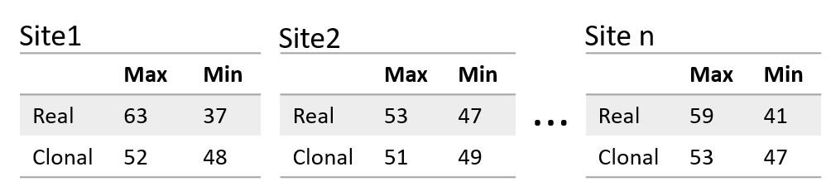

Supplementary_Figure1: Contingency tables for the CMH test using heterozygous SNP data. Each box represents a different SNP position from Site 1 to Site n, and the numbers represent the read depth in each allele in the position. Real: Data from real isolate. Clonal: Data from the simulated clonal isolate. Max: Allele with the largest read depth in that position; Min: Allele with the lowest read depth in the position.

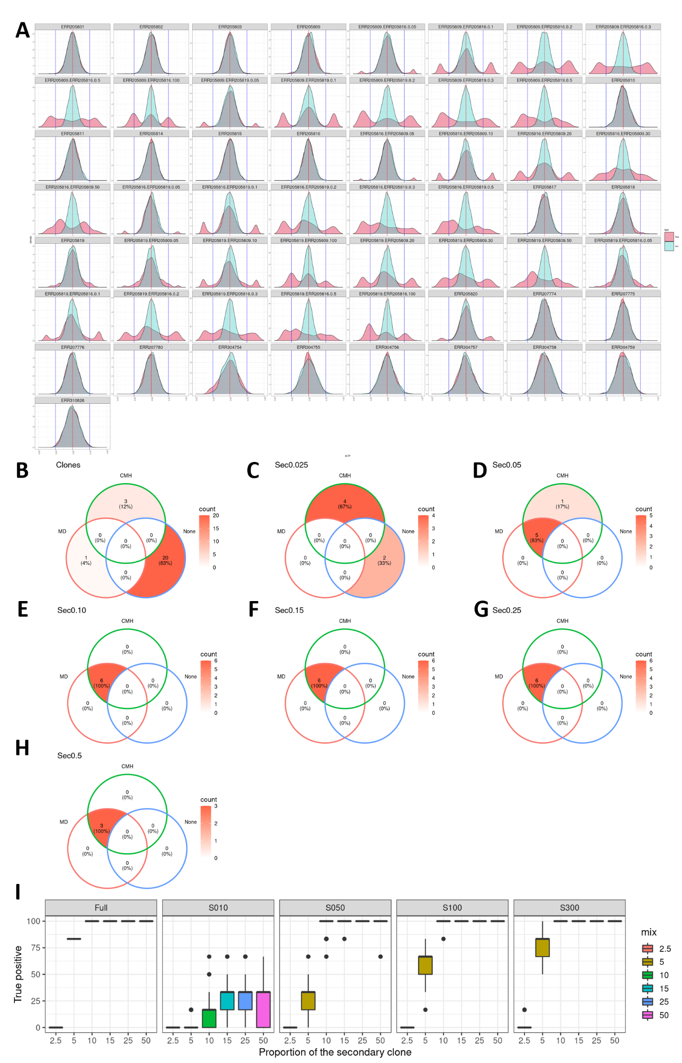
Supplementary_Figure 2: Assessing the impact of the proportion if the secondary clone and heterozygous SNP counts in the CI estimations. A) Density distributions of the AARD proportion in heterozygous positions for all combinations of the secondary clone, varying from 2.5-50%, as well as for the diploid clones. Each panel corresponds to a different isolate. The red distribution corresponds to the isolate data, while the cyan distribution represents the simulated clone, with the same number of SNPs and read depth as the real sample. B - I) Venn diagrams assessing the MD and CMH test accuracy to classify 24 clonal isolates (Clones), and 33 mixed infections (mix). Results that were below the cutoff for both are in the “None” quadrant. Each panel corresponds to the complexity estimation with a different proportion of the secondary clone, B) Clones; C) 2.5%; D) 5%; E) 10%; F) 15%; G) 25% and H) 50%. I) Impact of the number of SNPs in complexity estimations. Boxplot representing the percentage of MIX samples that were classified as complex. Each panel corresponds to downsampling to a different SNP count, where “S010”, “S050”, “S100”, “S300” and “Full” correspond, respectively, to 10, 50, 100, 300 and the Full SNP dataset. The X axis corresponds to the proportion of the secondary clone, from 2.5%-50% and the Y axis to the proportion of samples from each dataset that were correctly estimated as complex, in 100 iterations.

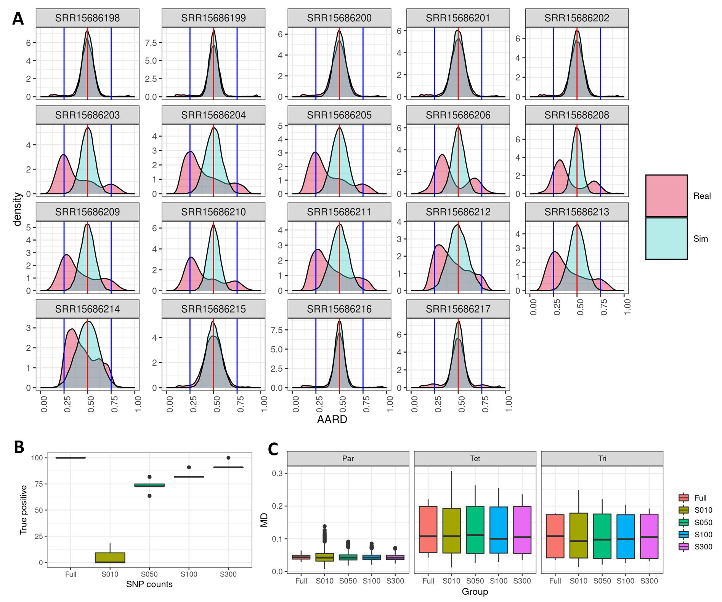

Supplementary_Figure 3: The impact of ploidy variation in complexity. A) Density distributions of the AARD proportion in heterozygous positions for all triploid ("SRR15686206","SRR15686208") and tetraploid ("SRR15686203", "SRR15686204", "SRR15686205", "SRR15686207", "SRR15686209", "SRR15686210", "SRR15686211", "SRR15686212", "SRR15686213", "SRR15686213", "SRR15686214") samples, as well as for the dissomic clones (“SRR15686198”, “SRR15686199”, “SRR15686200”, “SRR15686201”, “SRR15686202”, “SRR15686215”, “SRR15686216”, “SRR15686217”). The red distribution corresponds to the isolate data, while the cyan distribution represents the simulated clone, with the same number of SNPs and read depth as the real sample. B) Boxplots representing the impact of SNP counts in the accuracy of classifying polyploid isolates as complex, using 100 replicate interactions. C) Boxplots representing the impact of SNP counts in the complexity values. Each panel corresponds to a group: Parental Diploid (Par), Tetraploid (Tet) and Triploid (Tri) samples.

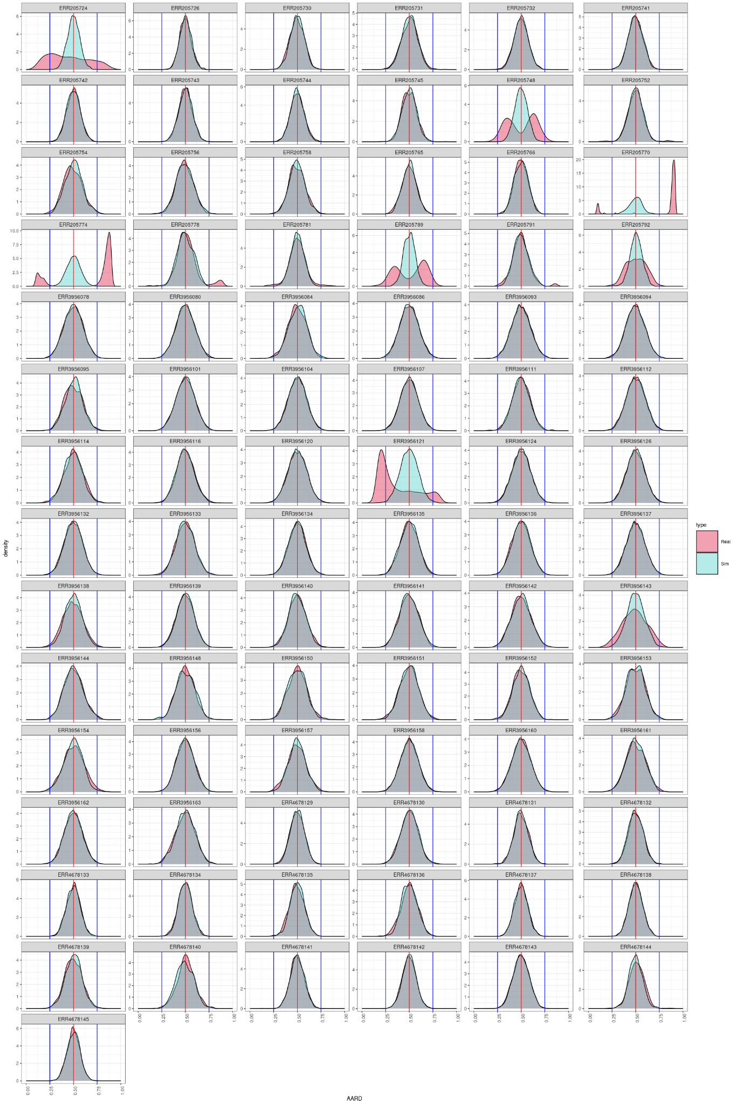
Supplementary Figure 4: AARD density plot for the 85 L. donovani samples.
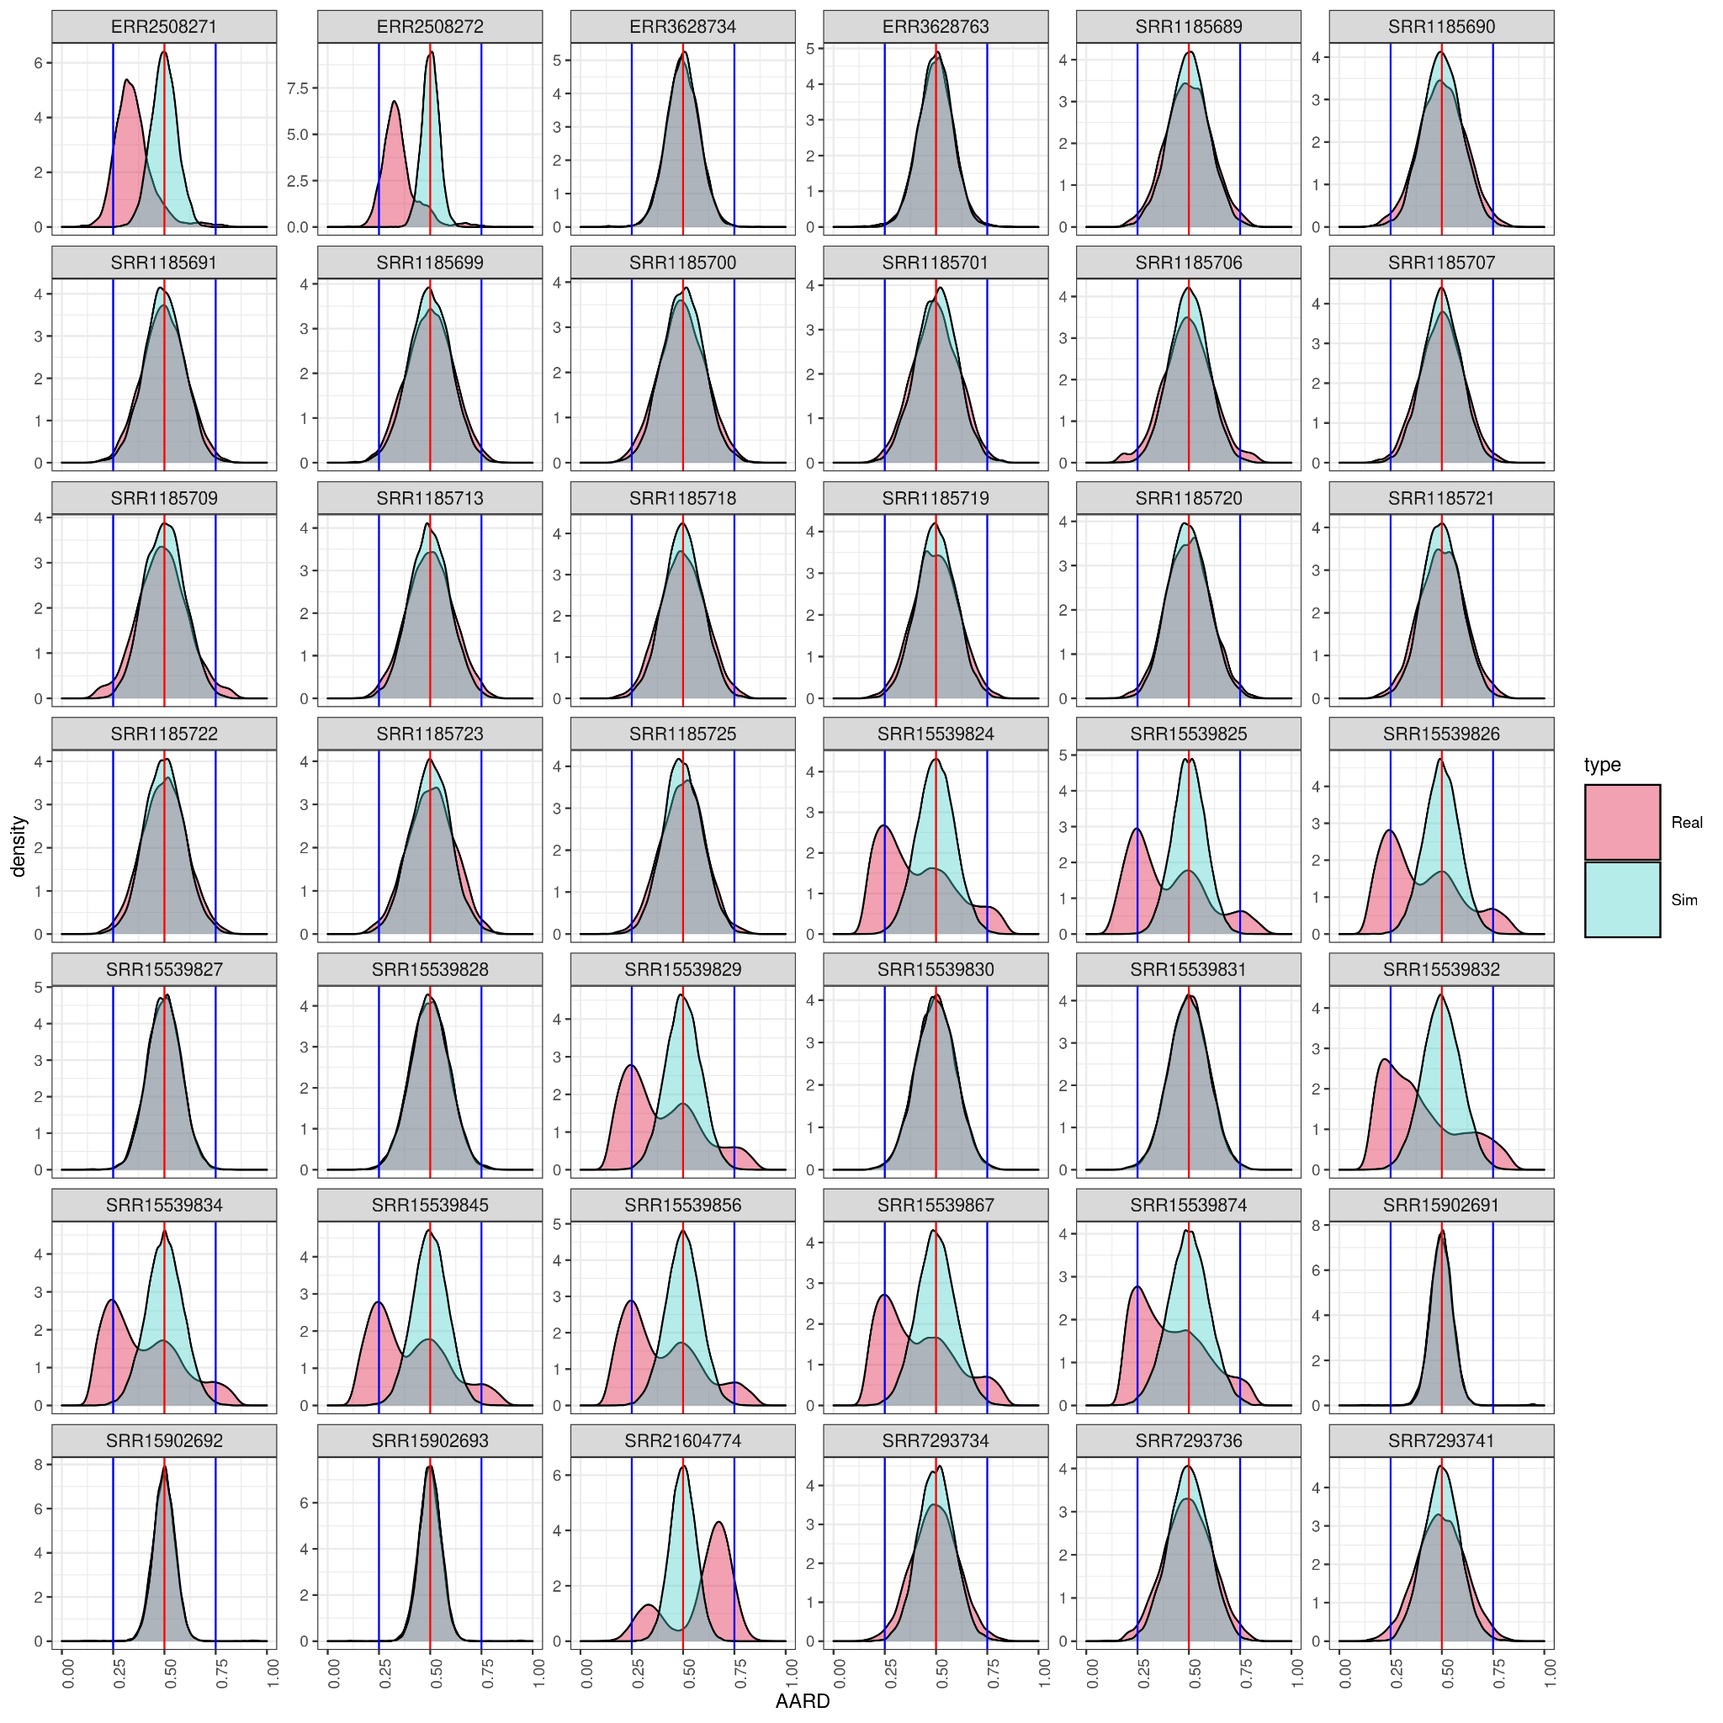
Supplementary Figure 5: AARD density plot for the 42 L. braziliensis samples.

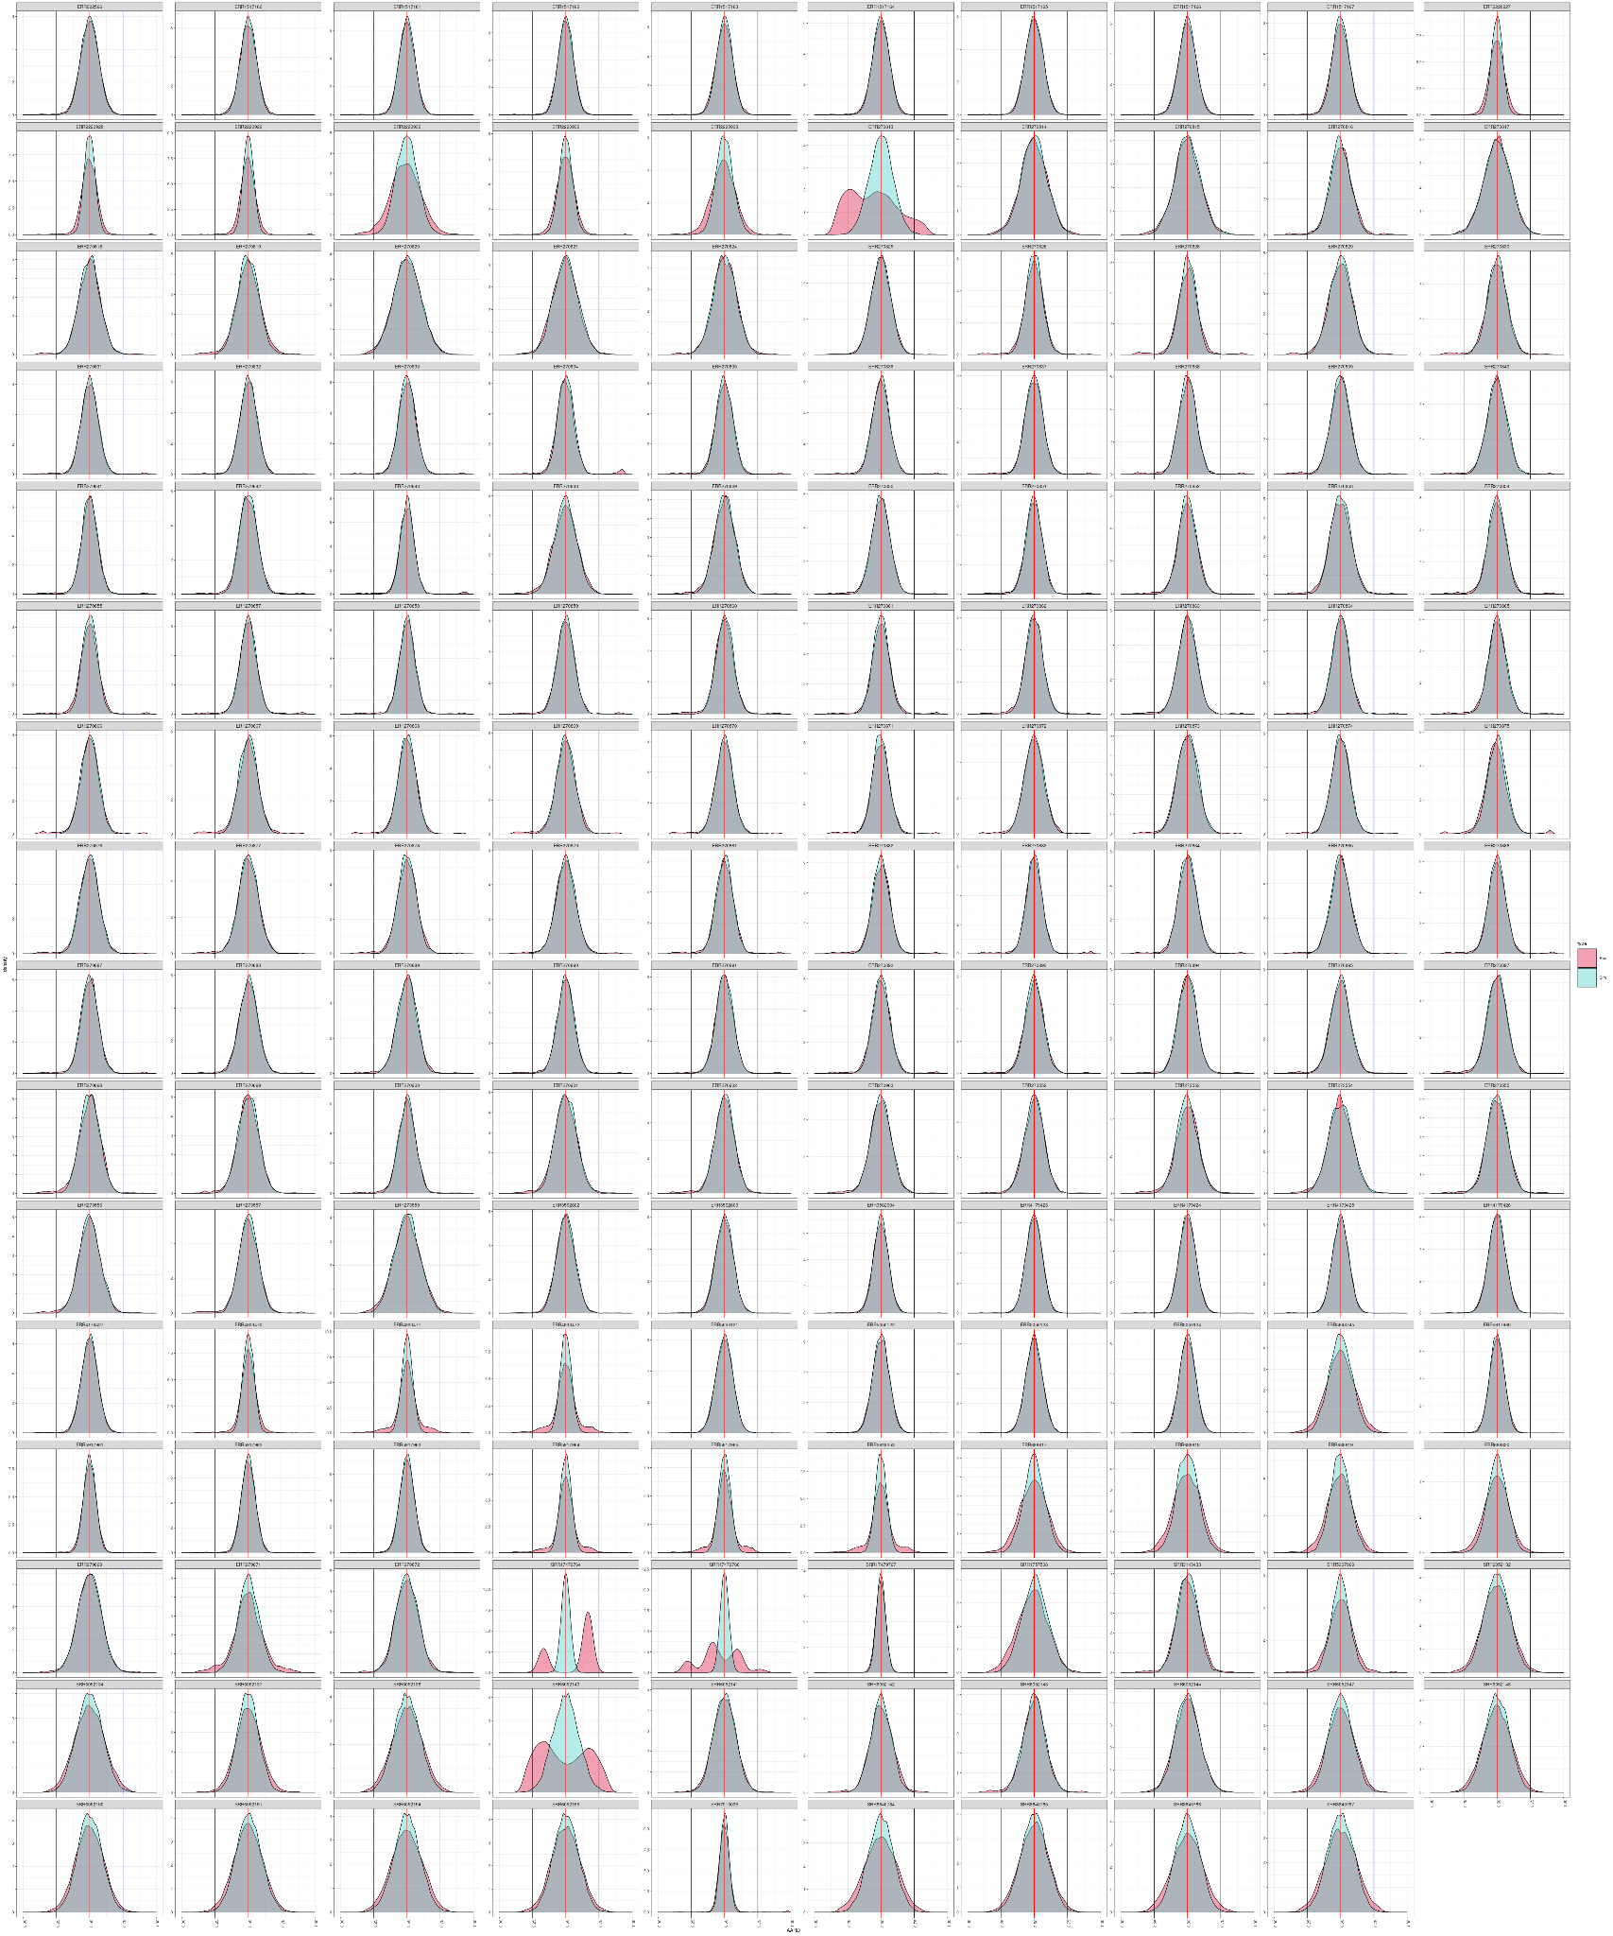
Supplementary Figure 6: AARD density plot for the 159 T. brucei samples.
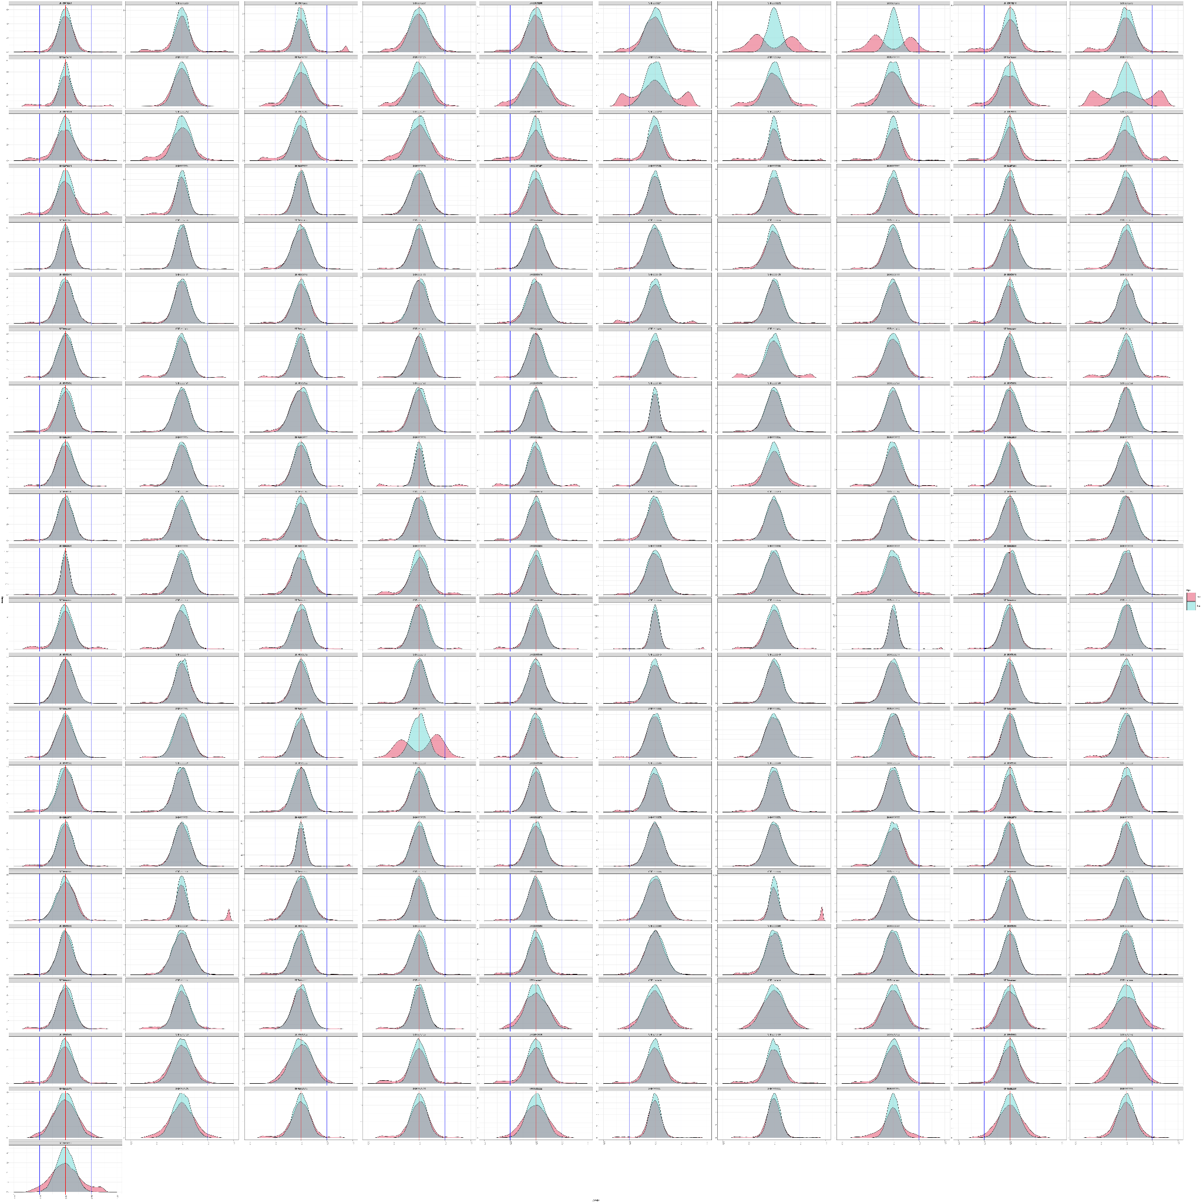
Supplementary Figure 7: AARD density plot for the 211T. cruzi samples.

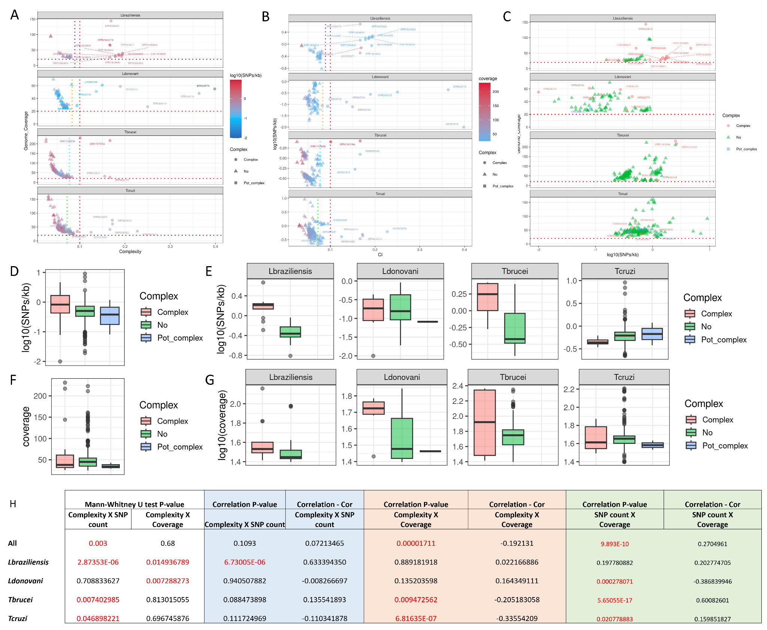
Supplementary_Figure 8: Evaluation of genome coverage, SNP count on complexity estimations in field and lab trypanosomatid isolates. A-C) Genome coverage and mean complexity in each sample; B) log10(SNPs/kb) counts and mean complexity in each sample; C) Genome coverage and log10(SNPs/kb) in each sample. In these plots, each panel corresponds to a different species: from top to bottom L. braziliensis, L.donovani, T.brucei and T.cruzi, while each dot corresponds to a different isolate. The vertical red line in A and C corresponds to the 0.1 complexity cutoff, while the coloured lines correspond to the species population complexity cutoff. The horizontal red dotted lines in A and C correspond to the genome coverage value of 20. Boxplots representing the SNP counts, grouped by “Complex” (red), “Not complex” (green) and “Potential complex” (blue) for D) all samples; or E) separated by species. Boxplots representing the genome coverage for F) all samples; or G) separated by species. H) Table with the Mann-Whitney U test and Correlation between complexity, heterozygous SNP counts and genome coverage.

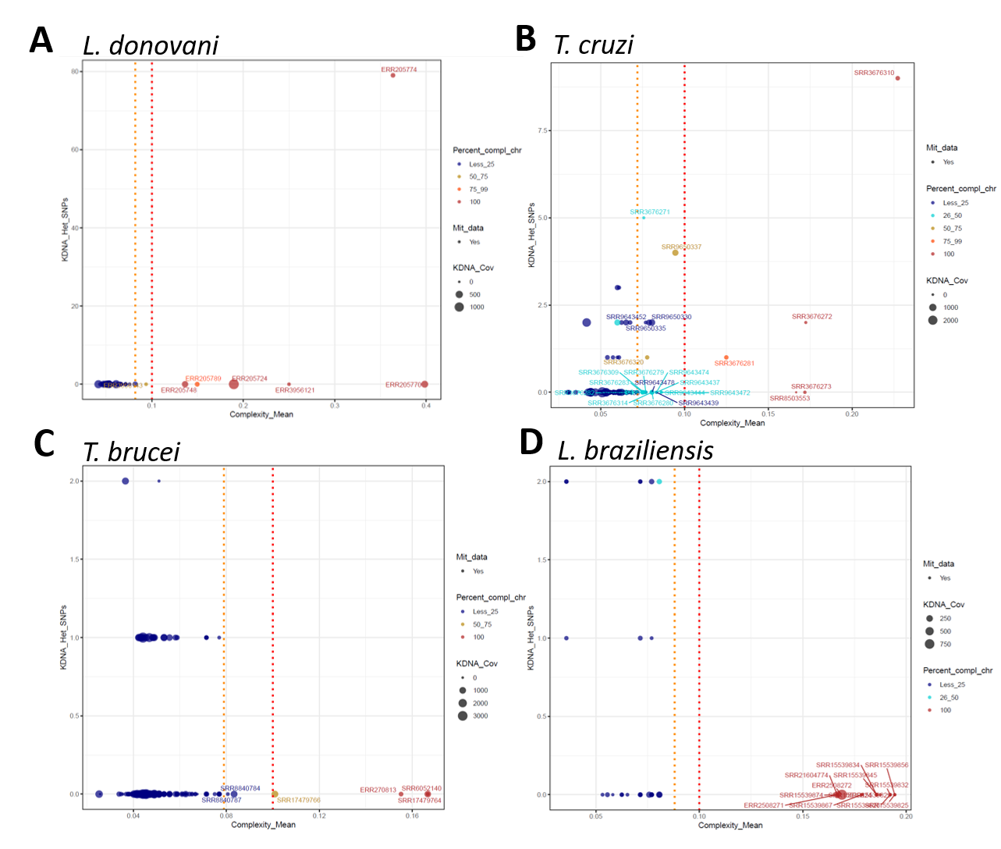
Supplementary_Figure 9: Maxicircle DNA heterozygous SNPs and the complexity estimated for the nuclear genome. In this figure, each dot corresponds to a parasite sample, the “Y” axis to the number of Heterozygous SNPs in the Maxicircle (mitochondrial) genome; and the “X” axis to the nuclear complexity of the isolate. The size of the dot represents the Maxicircle genome coverage, and the colours correspond to the proportion of nuclear chromosomes that had a mean complexity higher than 0.1.

