Supplementary material
Bismuth-gold nanohybrid conjugated with a HEX-bound oligonucleotide; a novel nano photosensitizer to combat antimicrobial resistance

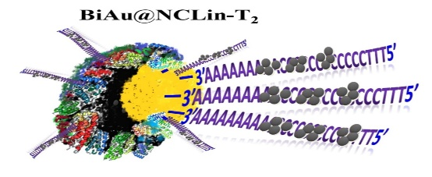
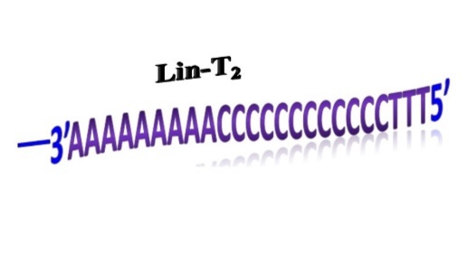
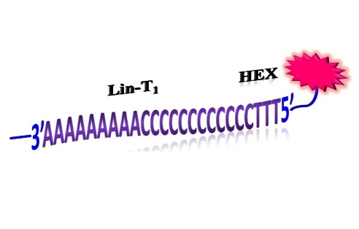
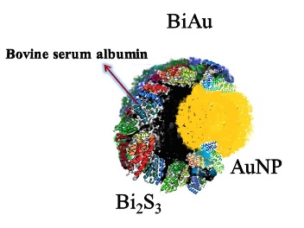
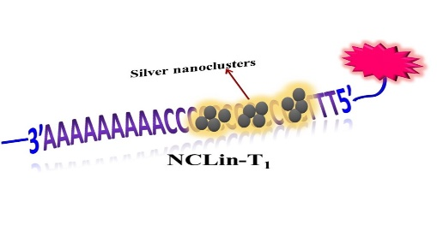
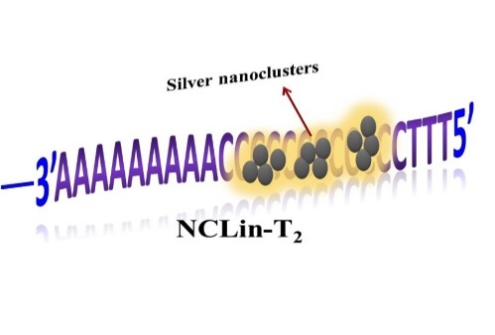

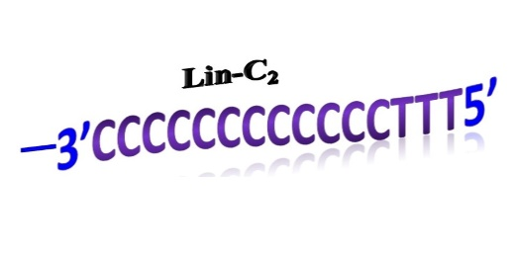
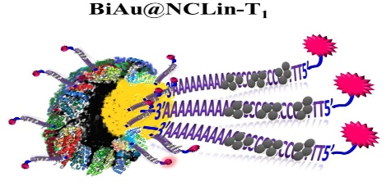
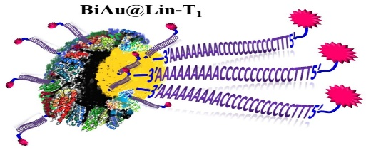
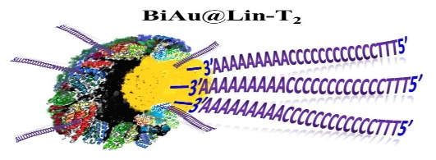
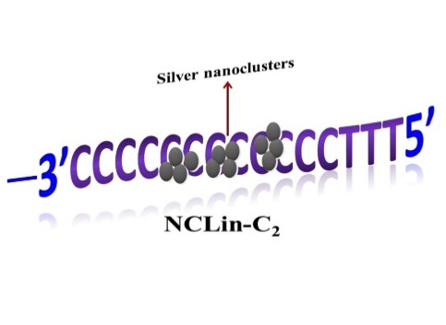
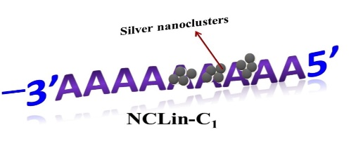
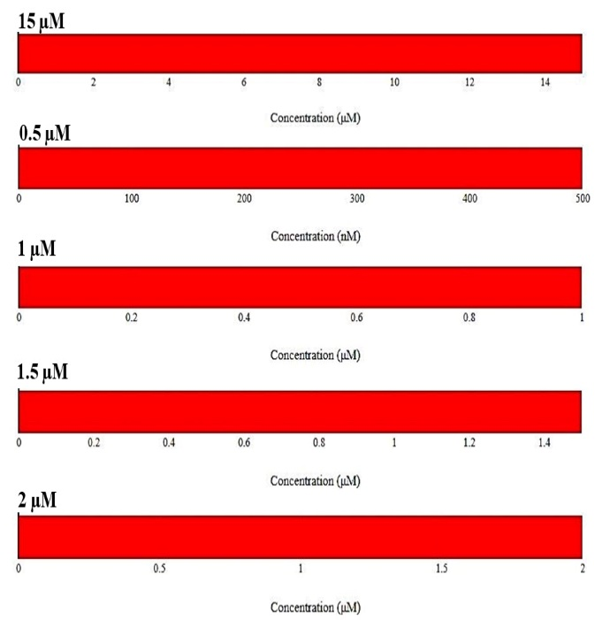
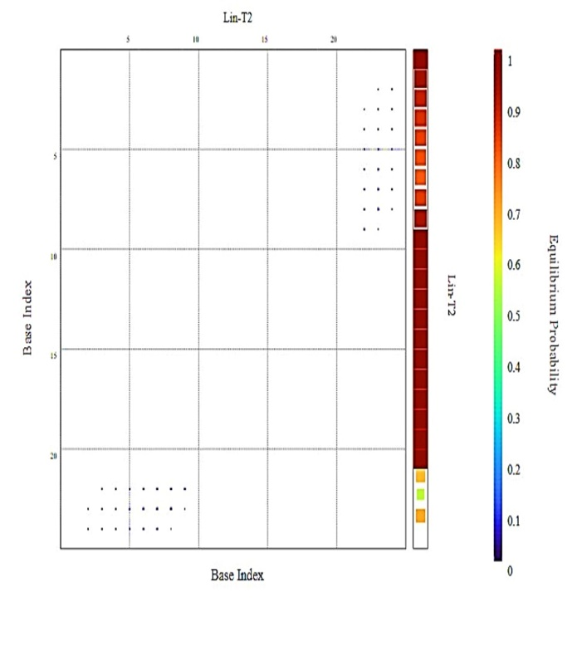
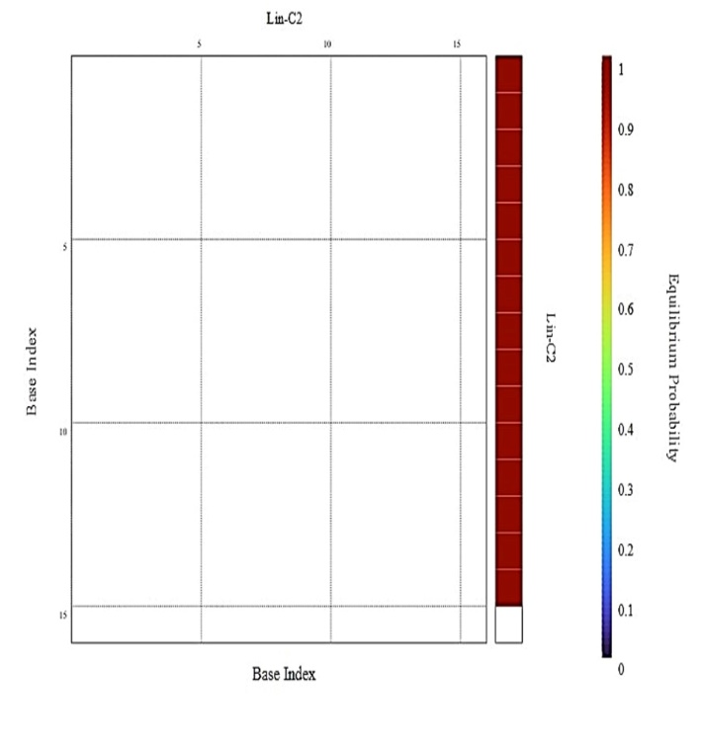
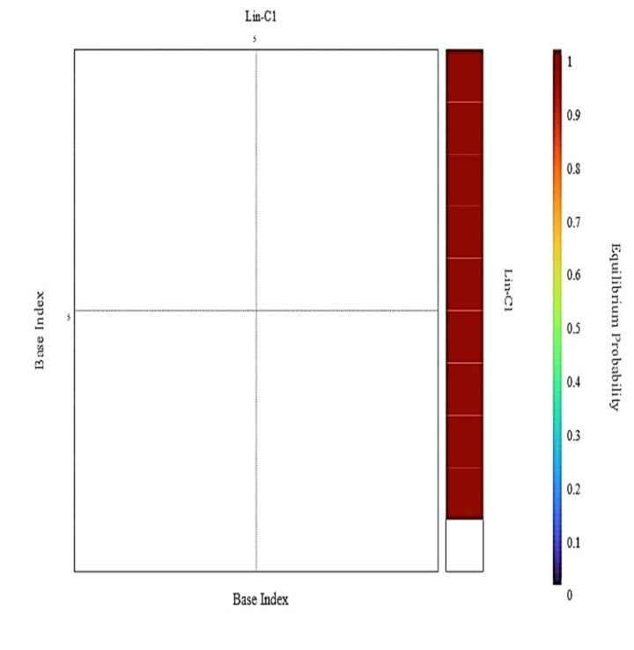
Figures of designed nanostructures

Supplementary Fig. S 1. the EBPP diagrams (based on concentration) Lin-T₂, Lin-C₂, and Lin-C₁ oligonucleotide sequences, and their corresponding equilibrium concentration histogram; a) the equilibrium concentration histogram of 3 stated oligonucleotide sequences at concentrations of 15, 0.5, 1, 1.5 and 2 μM; b) the EBPP graph of the Lin-T₂ at concentrations of 15, 0.5, 1, 1.5 and 2 μM; c) the EBPP diagram of the Lin-C₂ at concentrations of 15, 0.5, 1, 1.5 and 2 μM; d) the EBPP diagram of the Lin-C₁ at concentrations of 15, 0.5, 1, 1.5 and 2 μM.
a)
b)
c)
d)
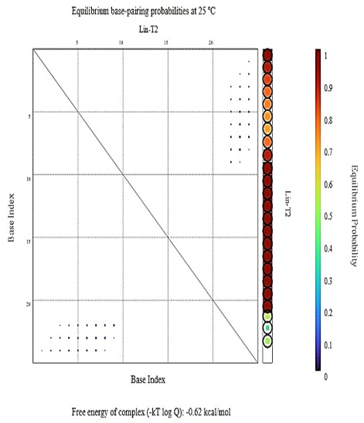
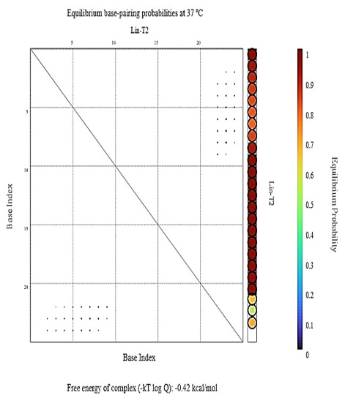
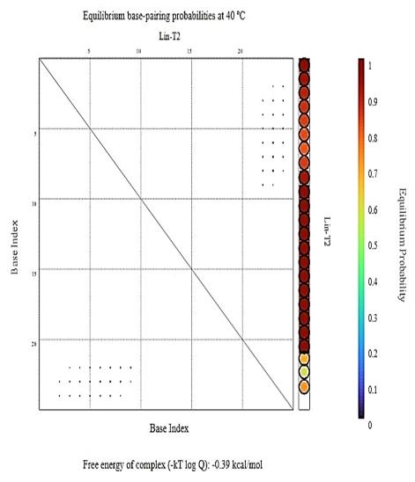
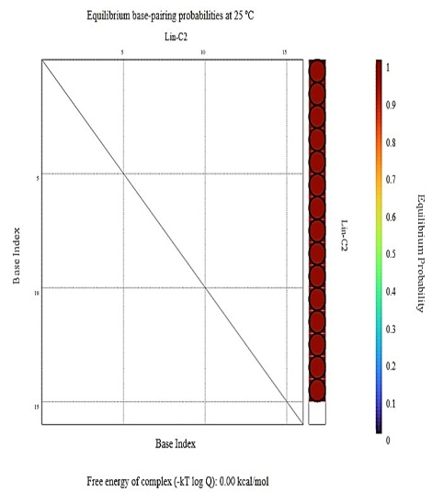
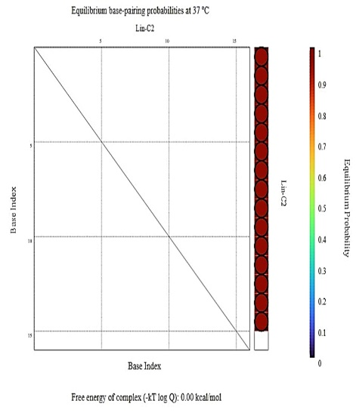
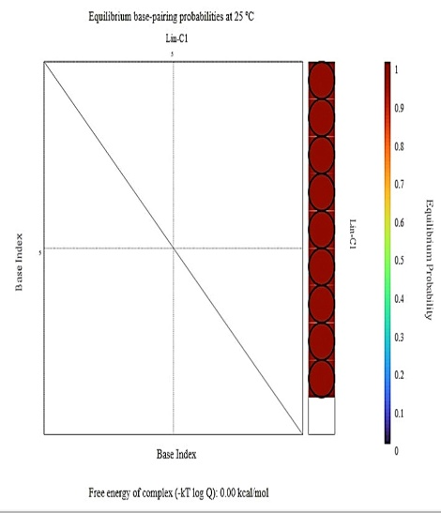
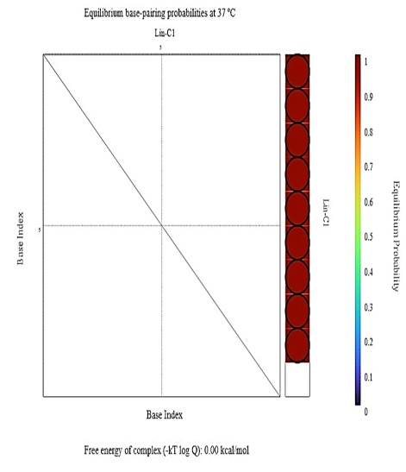

Supplementary Fig. S 2: EBPP diagram (independent of concentration) of oligonucleotide sequences at temperatures of 25, 37 and 40°C and their free energy values: a), b) and c) EBPP diagram of Lin-T₂ sequence and its corresponding free energy at temperatures of 25, 37 and 40°C respectively; d) and e) EBPP diagram of Lin-C₂ sequence and its corresponding free energy at temperatures of 25 and 37°C, respectively; f) and g) EBPP diagram of Lin-C₁ sequence and its corresponding free energy at temperatures of 25 and 37°C, respectively.
a)
b)
c)
d)
e)
f)
g)

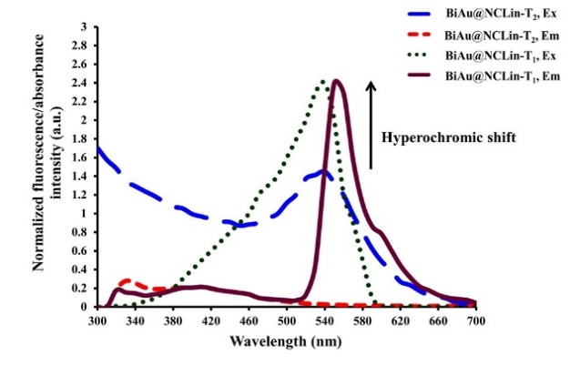
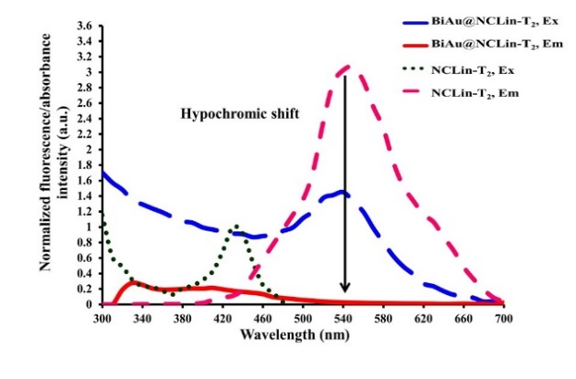
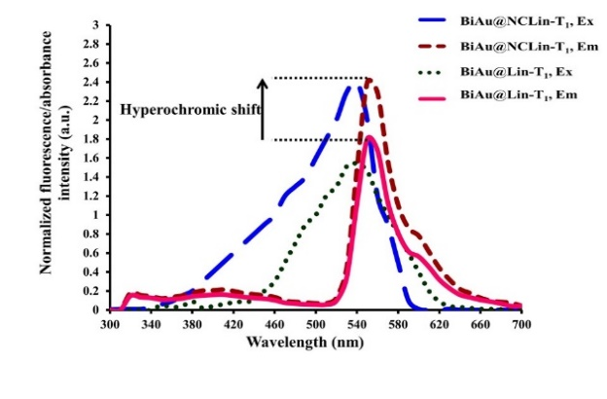
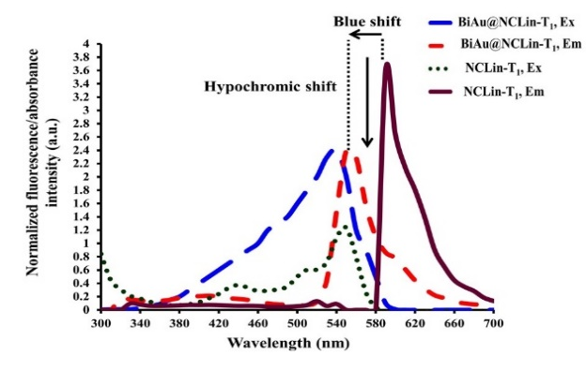
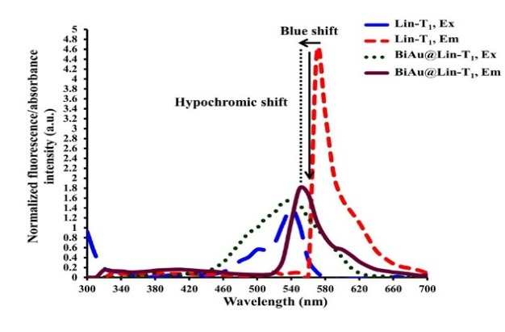
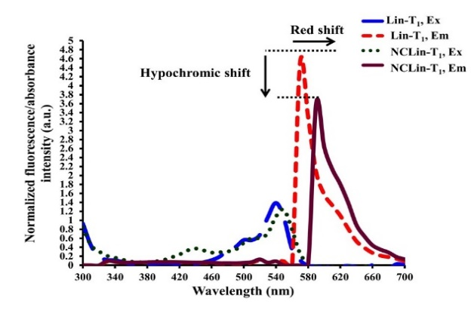
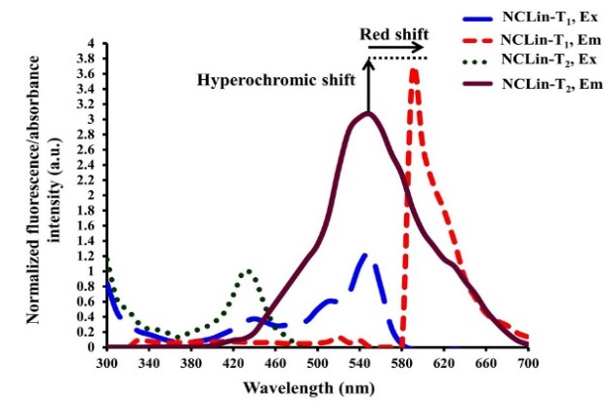
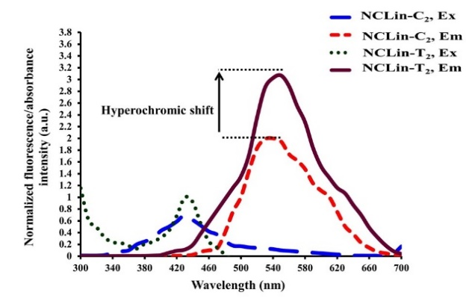
Supplementary Fig. S 3. comparison of excitation and emission spectra of synthesized fluorophores. The vertical axis is the normalized fluorescence/absorbance intensity, based on arbitrary units (a.u.) and the horizontal axis is wavelength in nanometers (nm).
c)
f)
b)
g)
h)
e)
a)
d)
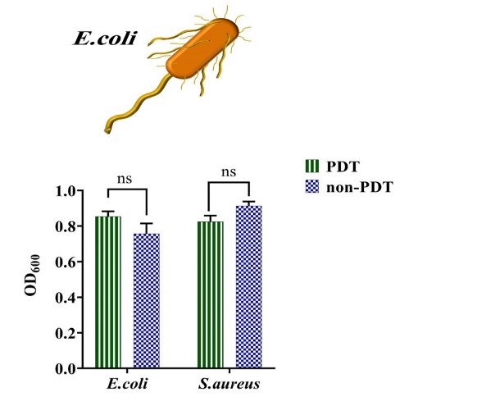
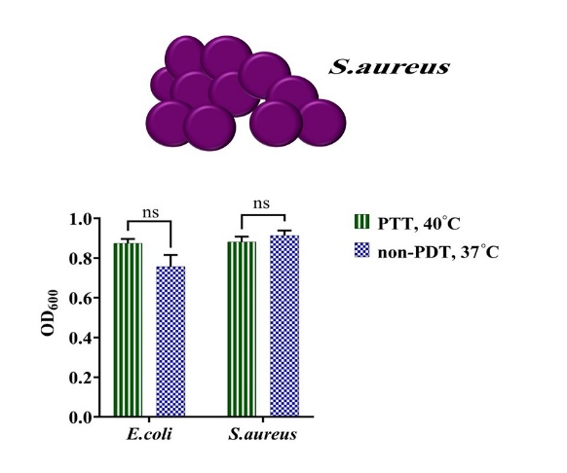
Supplementary Fig. S 4. investigating the effect of light and temperature of 40°C on the growth of untreated bacteria; a) E.coli and S.aureus bacteria under photostimulation and non-photostimulation conditions; b) E.coli and S.aureus bacteria under PTT conditions, non-photostimulation and 37°C temperature. The error bar in the results indicates standard deviation.
a)
b)

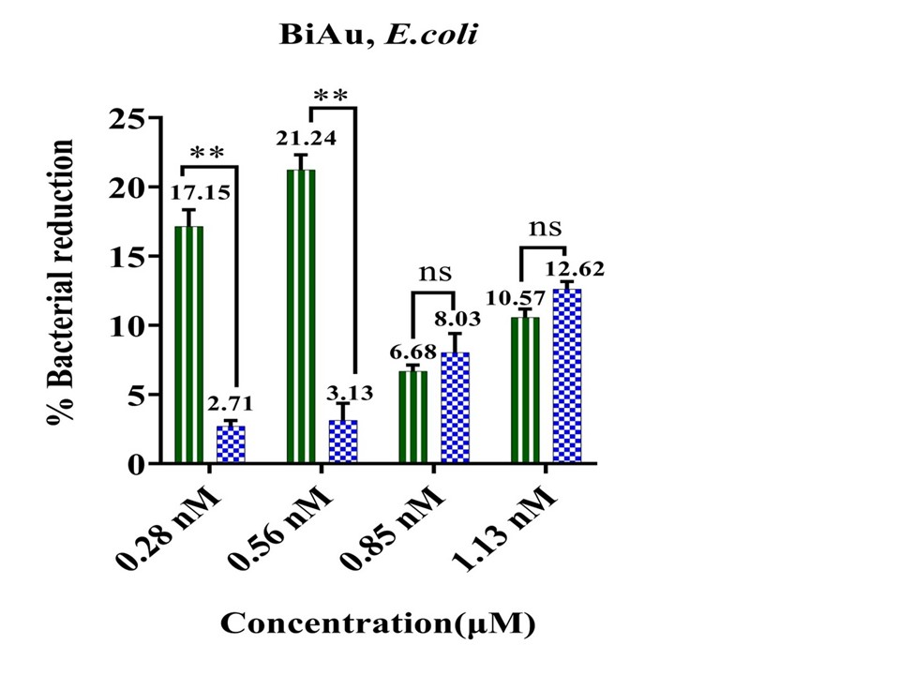
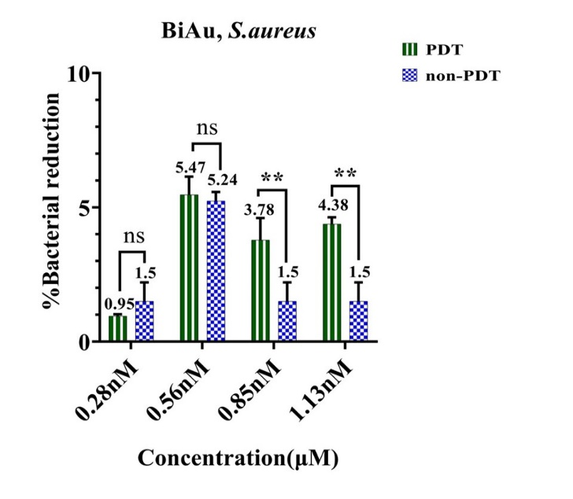
Supplementary Fig. S 5. BiAu performance under PDT and non-PDT conditions; a) antibacterial activity of BiAu against E.coli; b) antibacterial activity of BiAu against S.aureus. Error bar in both cases indicates standard deviation.
a)
b)

Supplementary Fig. S 6: concentrations with PDT effect in Lin-T₁ and Lin-T₂ sequences. E.coli: Lin-T₁ sequence at 1.5 μM and Lin-T₂ at 3 concentrations of 0.5, 1 and 1.5 μM.
S.aureus: Lin-T₁ sequence at 3 concentrations of 0.5, 1 and 1.5 μM and Lin-T₂ didn't have PDT effect at any concentration.
.
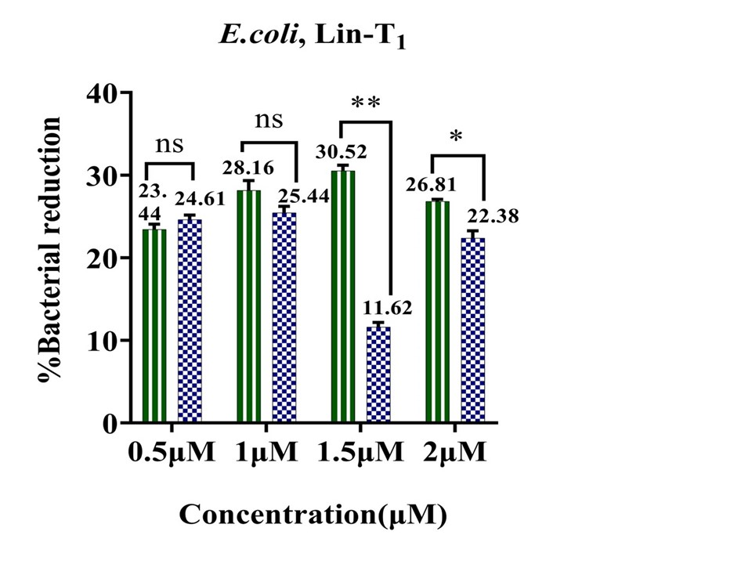
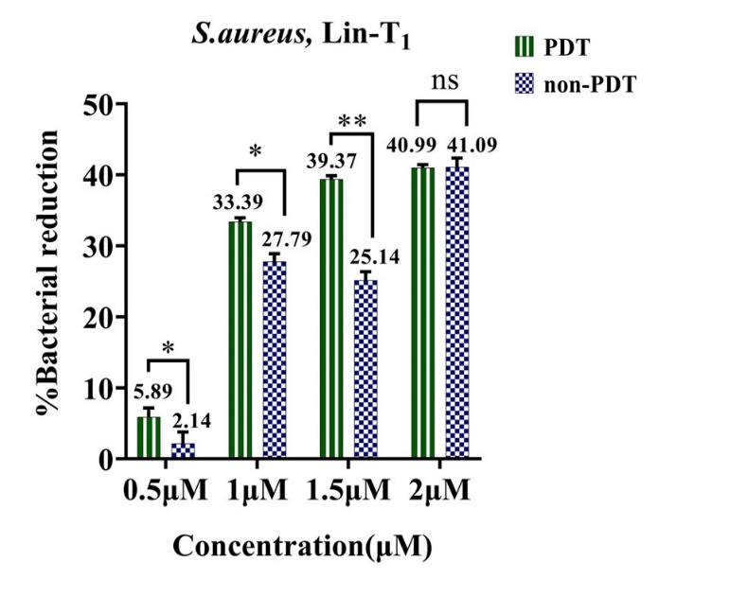
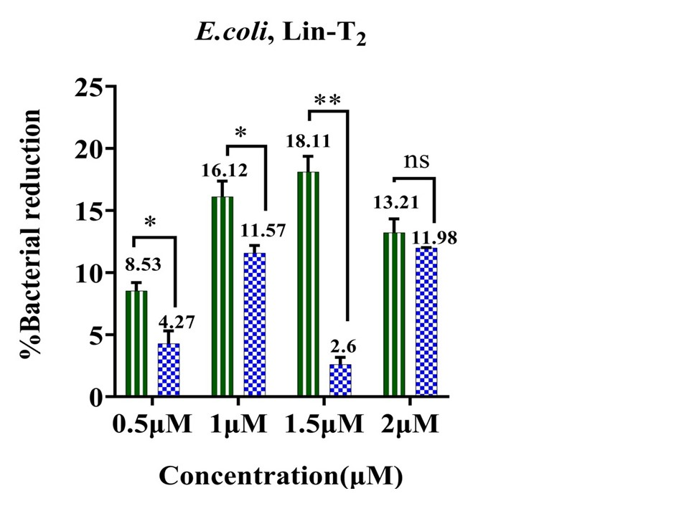
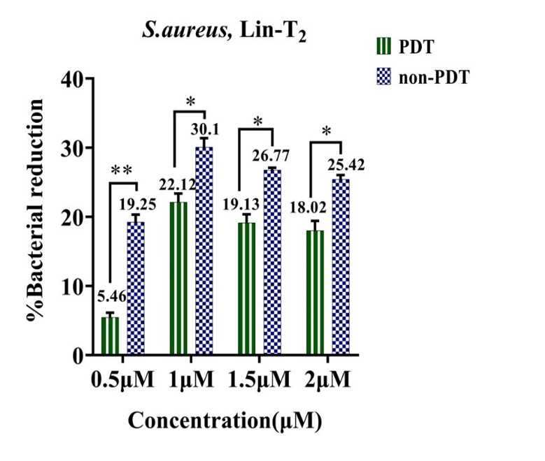
a)
b)
Supplementary Fig. S 6. antibacterial performance of Lin-T₁ and Lin-T₂ under PDT and non-PDT conditions; a) antibacterial activity of Lin-T₁ against E.coli; b) antibacterial activity of Lin-T₁ against S.aureus; c) antibacterial performance of Lin-T₂ against E.coli; d) antibacterial performance of Lin-T₂ against S.aureus. Error bar indicates standard deviation.
c)
d)

Supplementary Fig. S 7 presents the antibacterial performance of NCLin-T₁ and NCLin-T₂. The both NCs exhibited antibacterial activity against both gram-positive and gram-negative strains in all mentioned concentrations under PDT and non-PDT conditions. In non-PDT conditions, the antibacterial effect against gram-positive strain is more than gram-negative strain. NCLin-T₁ has shown considerable PDT effect against E.coli at 1.5 μM.
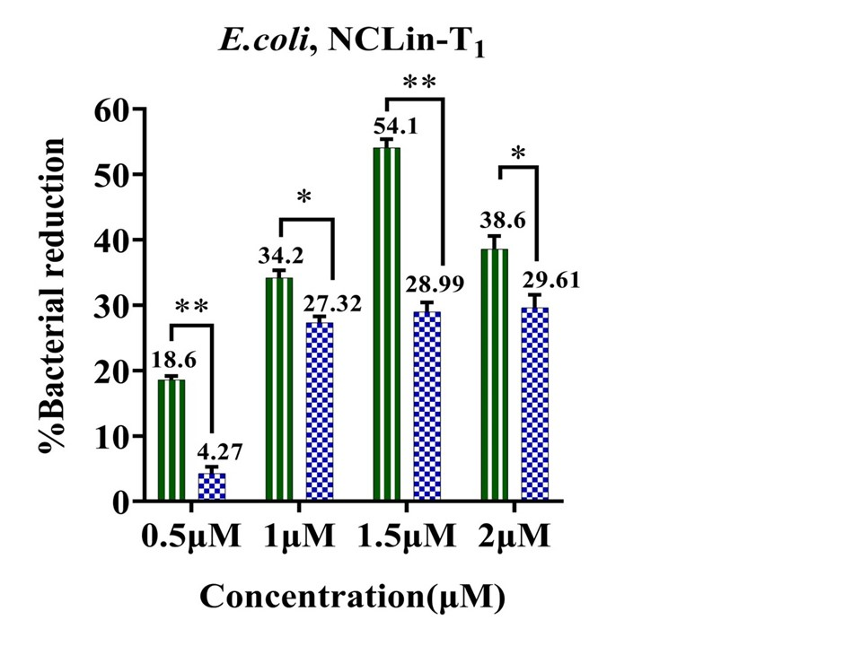
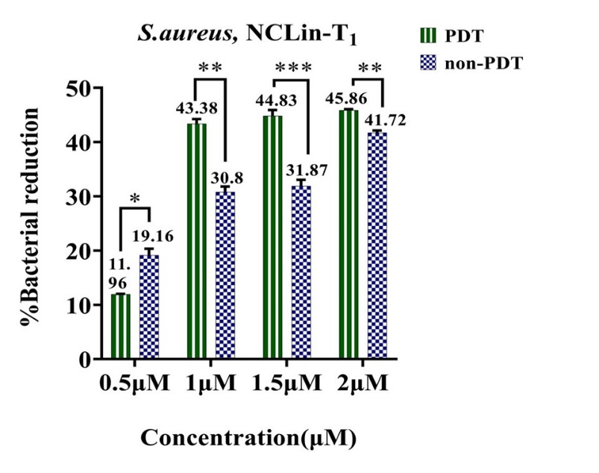
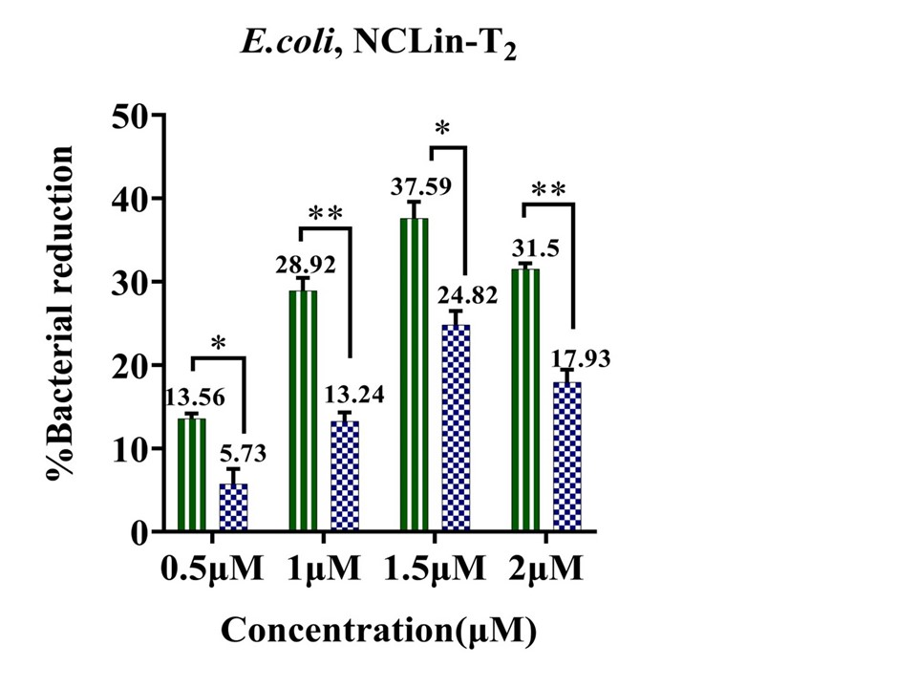
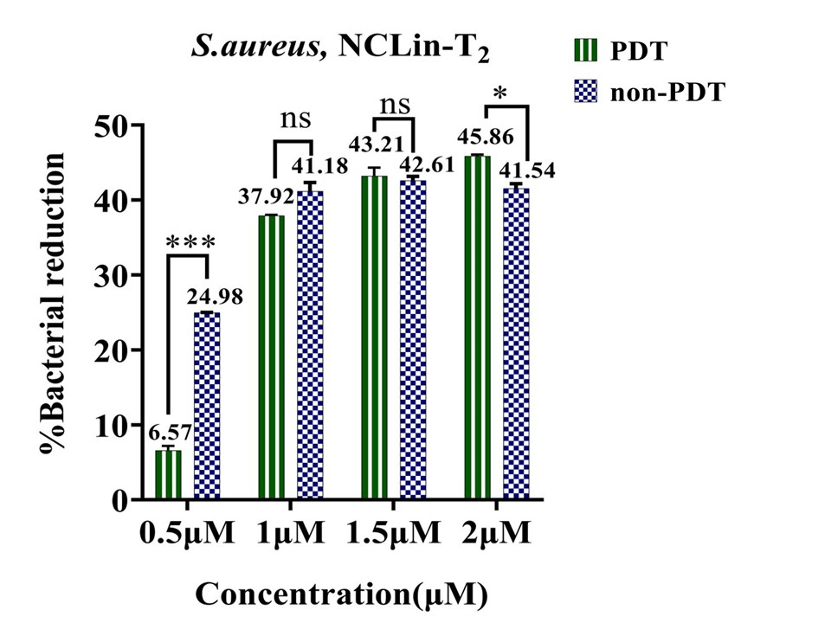
Supplementary Fig. S 7. antibacterial performance of NCLin-T₁ and NCLin-T₂ under PDT and non-PDT conditions; a) antibacterial activity of NCLin-T₁ against E.coli; b) antibacterial activity of NCLin-T₁ against S.aureus; c) antibacterial activity of NCLin-T₂ against E.coli; d) antibacterial activity of NCLin-T₂ against S.aureus. Error bar indicates standard deviation.
a)
b)
c)
d)
Supplementary Fig. S 8: PDT effective concentrations of NCLin-C₁ and NCLin-C₂ nanostructures.
E.coli: NCLin-C₁ and NCLin-C₂ at concentrations of 1.5 and 1 μM, respectively.
S.aureus: NCLin-C₁ at 3 concentrations of 1, 1.5 and 2 μM. NCLin-C₂ didn't have PDT effect at any concentration.

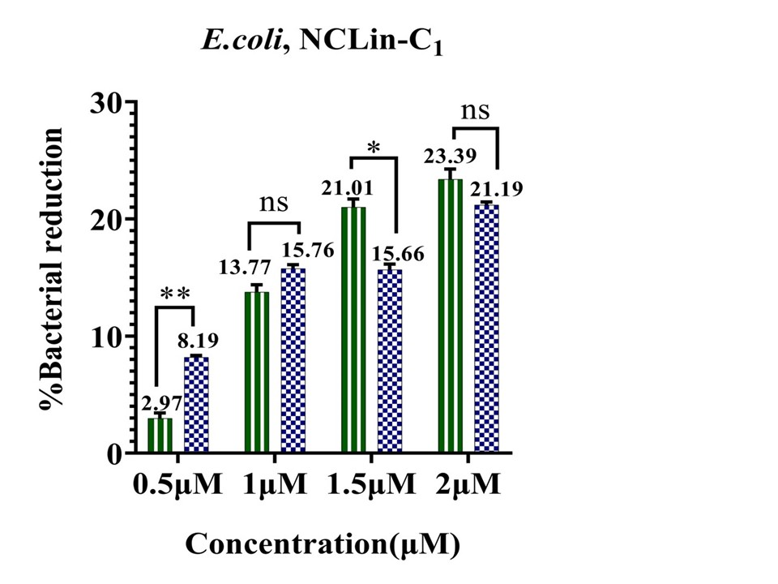
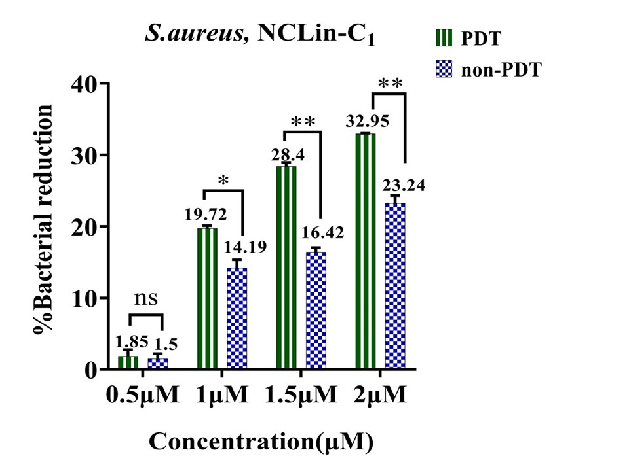
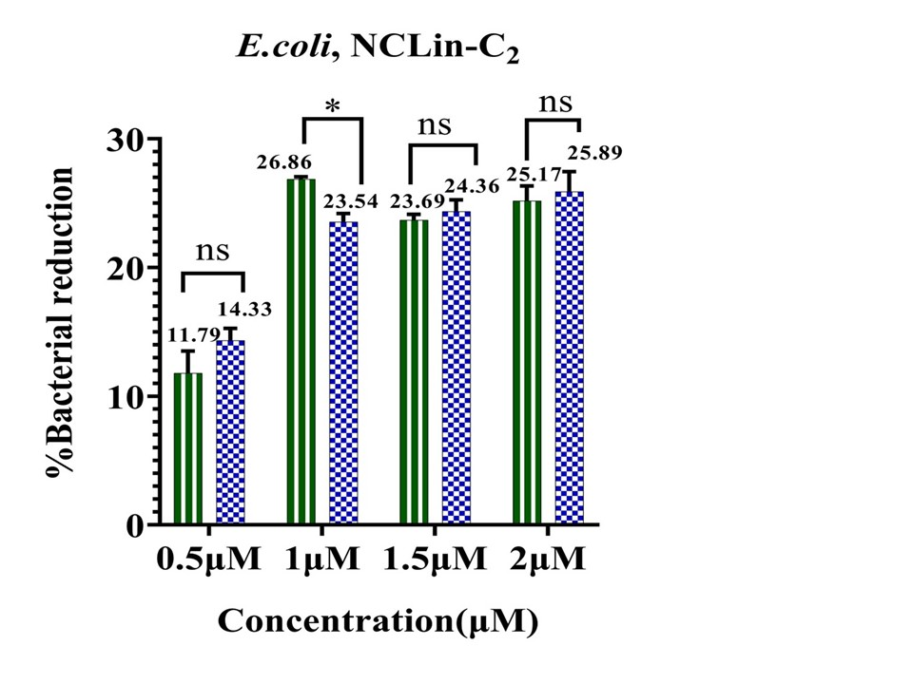
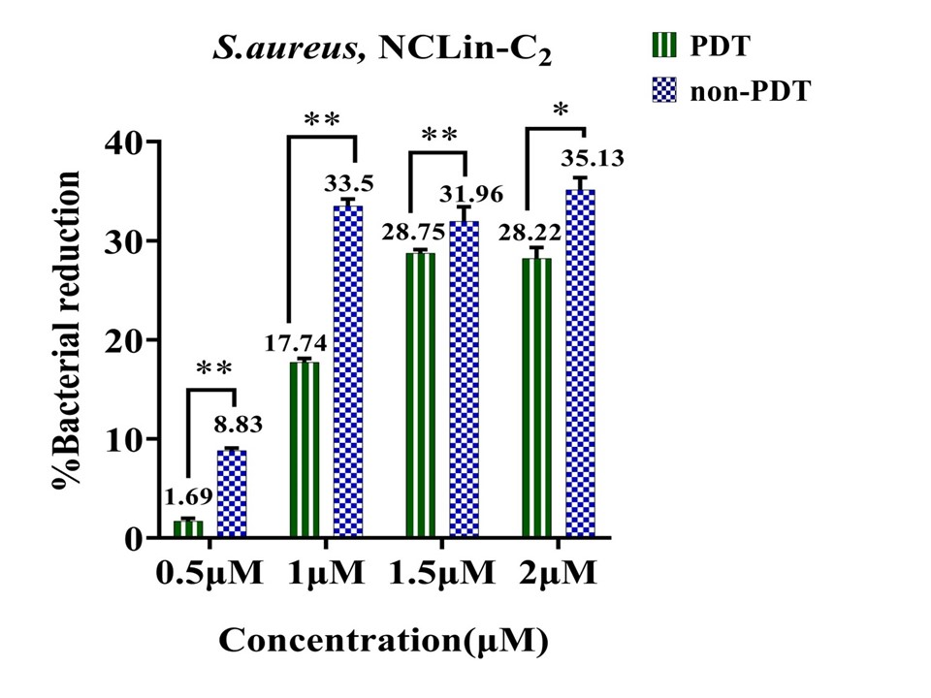
Supplementary Fig. S 8. Antibacterial performance of NCLin-C₁ and NCLin-C₂ under PDT and non-PDT conditions; a) antibacterial activity of NCLin-C₁ against E.coli; b) antibacterial activity of NCLin-C₁ against S.aureus; c) antibacterial activity of NCLin-C₂ against E.coli; d) antibacterial activity of NCLin-C₂ against S.aureus. Error bar indicates standard deviation.

a)
b)
c)
d)
Supplementary Fig. S 9: PDT effective concentrations of Lin-C₁ and Lin-C₂ nanostructures.
E.coli: Lin-C₁ and Lin-C₂ sequences at concentrations of 2 and 1.5 μM, respectively.
S.aureus: Lin-C₁ and Lin-C₂ sequences at concentration of 2 μM.
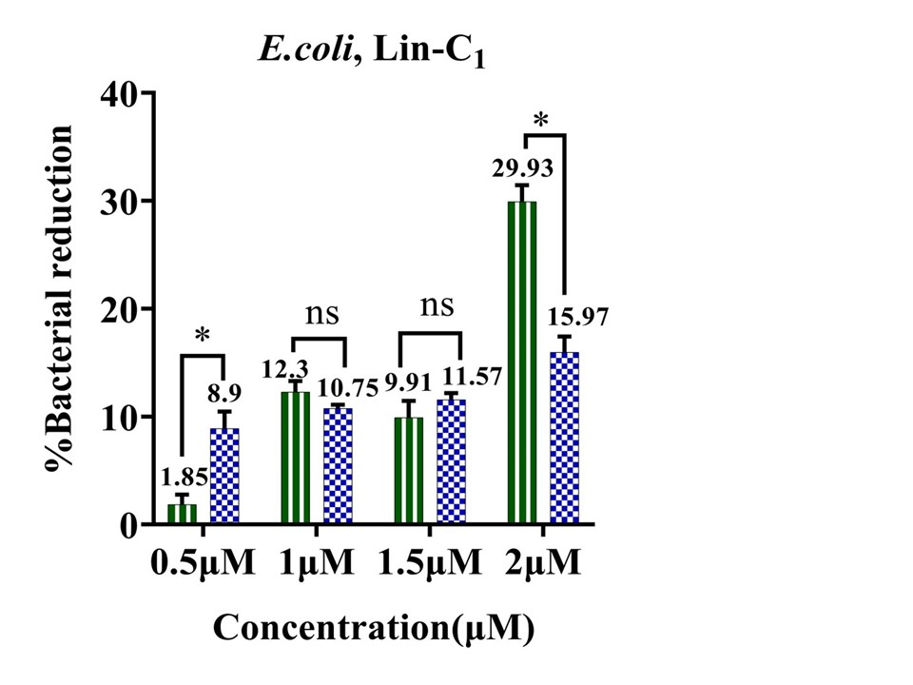
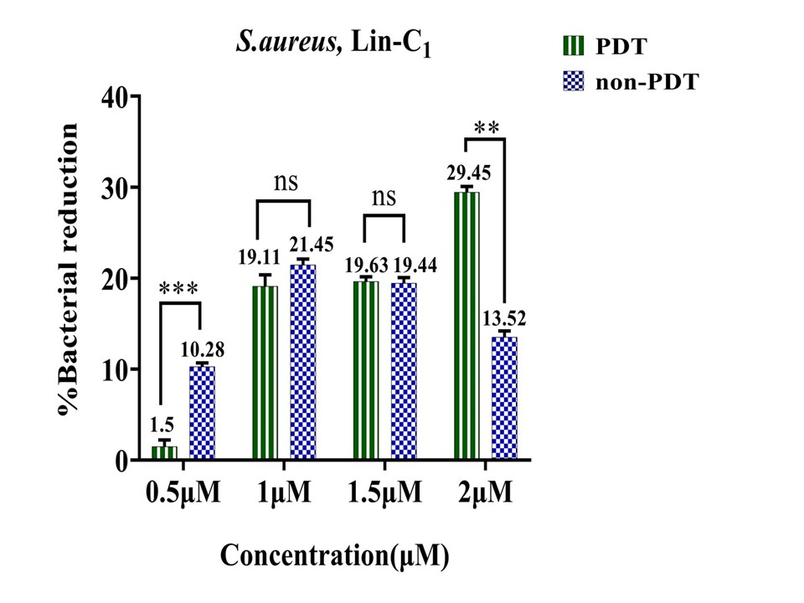
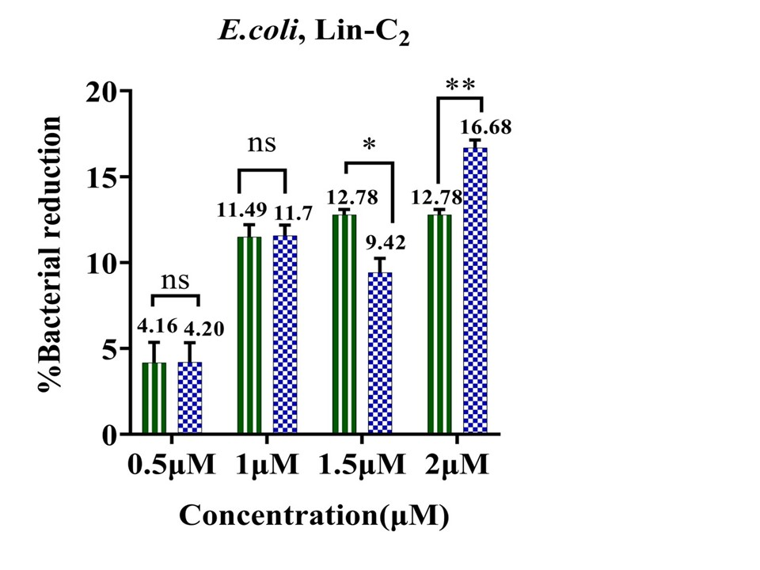
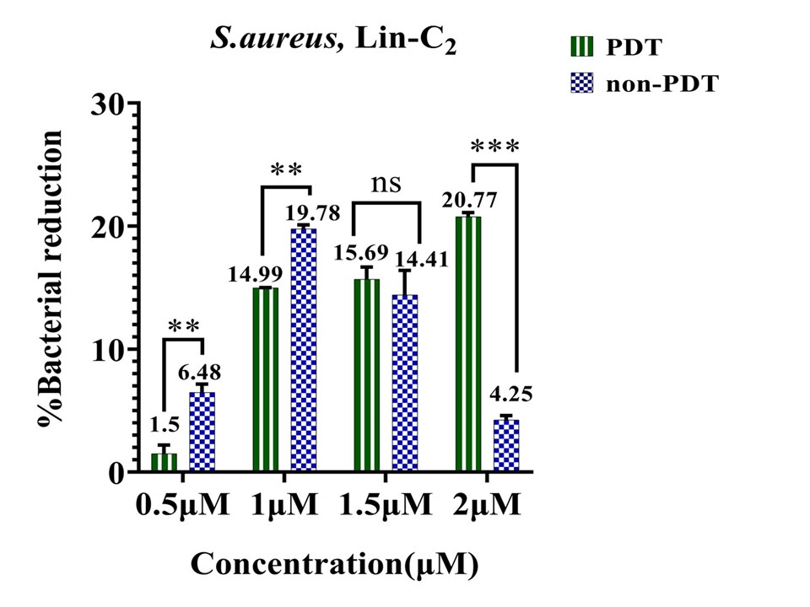
Supplementary Fig. S 9. antibacterial performance of Lin-C₁ and Lin-C₂ under PDT and non-PDT conditions; a) antibacterial activity of Lin-C₁ against E.coli; b) antibacterial activity of Lin-C₁ against S.aureus; c) antibacterial activity of Lin-C₂ against E.coli; d) antibacterial activity of Lin-C₂ against S.aureus. Error bar indicates standard deviation.
a)
b)
c) 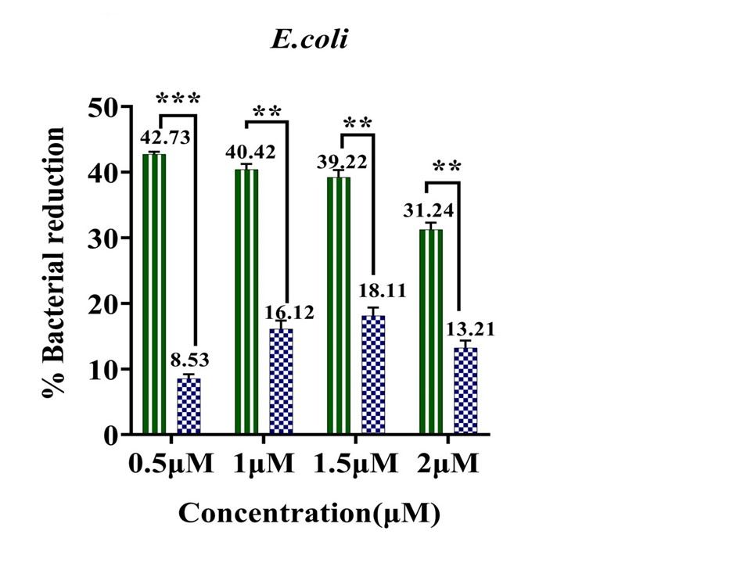
d)

Supplementary Fig. S 10 compares the antibacterial performance of BiAu@Lin-T₁ with Lin-T₁ and BiAu@Lin-T₂ with Lin-T₂. In the case of E.coli, the PDT efficacy of BiAu@Lin-T₁ and BiAu@Lin-T₂ nanostructures has been increased across all concentrations compared to Lin-T₁ and Lin-T₂, respectively. In S.aureus bacteria, a substantial increase in the antibacterial efficacy of Lin-T₁ compared to BiAu@Lin-T₁ was observed at all 4 concentrations. While BiAu@LinT₂ exhibited enhanced antibacterial activity in the three concentrations of 1, 1.5, and 2 μM compared to Lin-T₂.
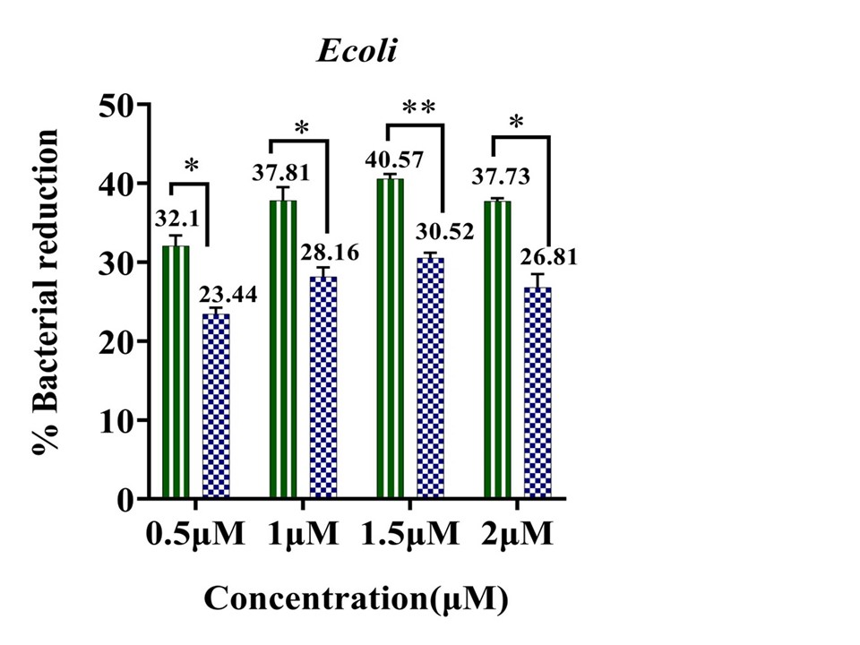
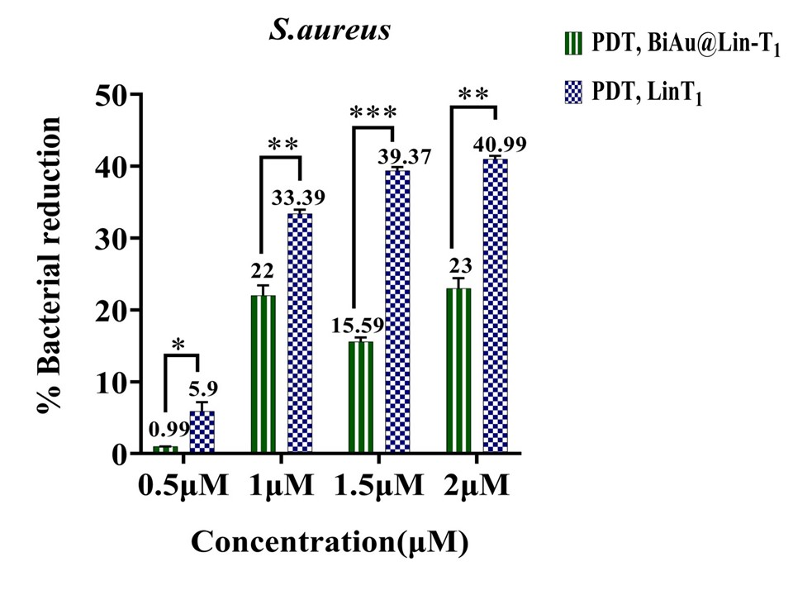
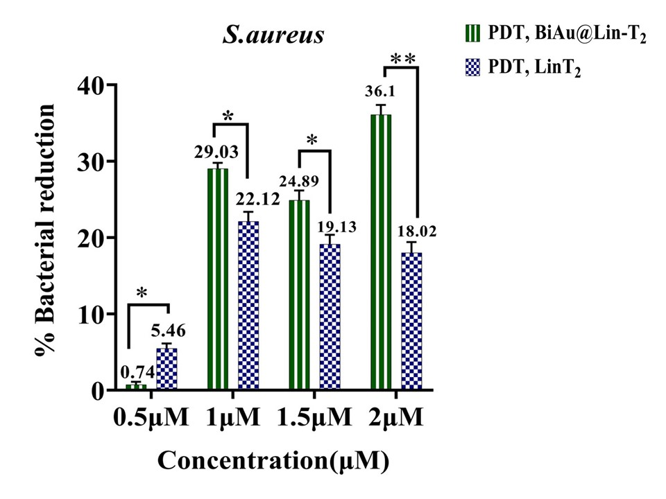
Supplementary Fig. S 10. antibacterial performance of BiAu@Lin-T₁ and BiAu@Lin-T₂, as well as their comparison with Lin-T₁ and Lin-T₂ respectively, under PDT conditions; a) antibacterial performance of BiAu@Lin-T₁ and Lin-T₁ in E.coli; b) antibacterial performance of BiAu@Lin-T₁ and Lin-T₁ in S.aureus; c) antibacterial performance of BiAu@ Lin-T₂ and Lin-T₂ in E.coli; d) antibacterial performance of BiAu@Lin-T₂ and Lin-T₂ in S.aureus. Error bar indicates standard deviation.
a)
b)
c)
d)

Supplementary Fig. S 11 presents a comparison of the antibacterial activity of BiAu@Lin-T₁ and BiAu@LinT₂ with BiAu. In E.coli, both nanostructures had higher PDT performance than BiAu in all 4 concentrations. In S.aureus, it has been determined that both nanostructures had more antibacterial activity than BiAu in 3 concentrations of 1, 1.5 and 2 μM.
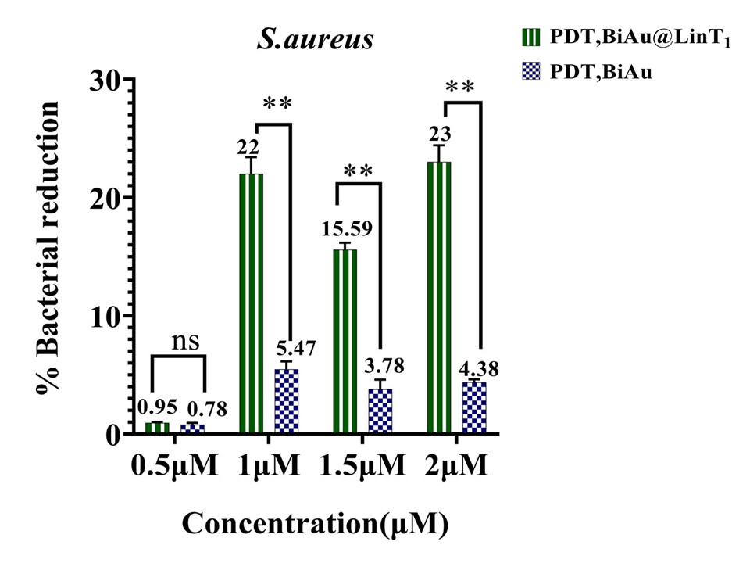
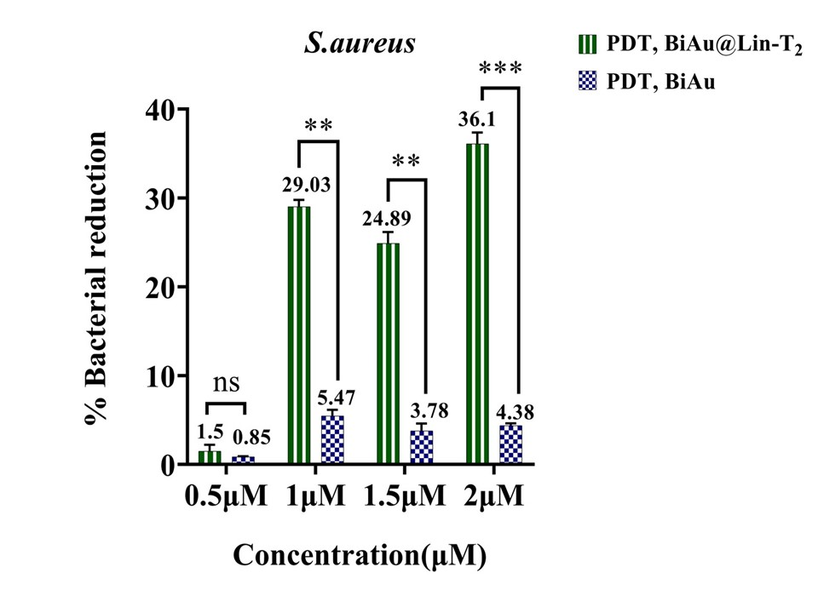
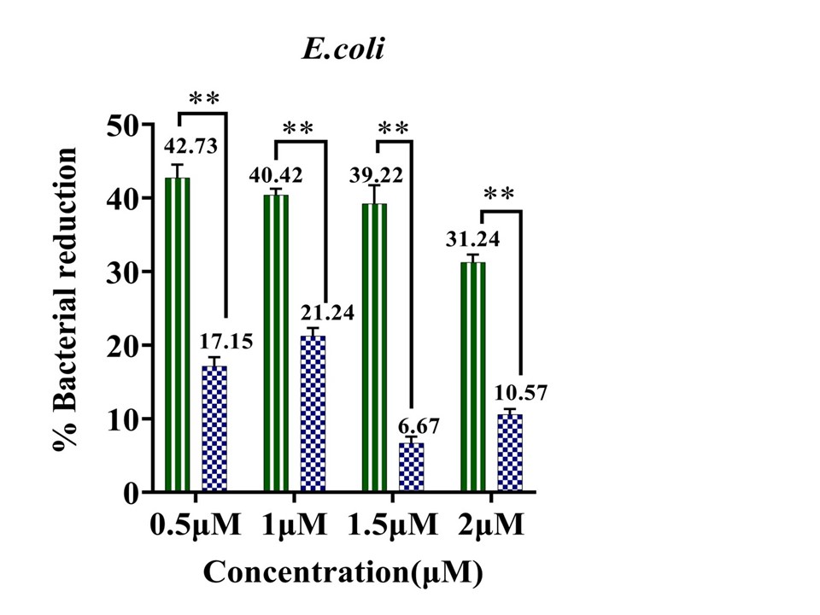
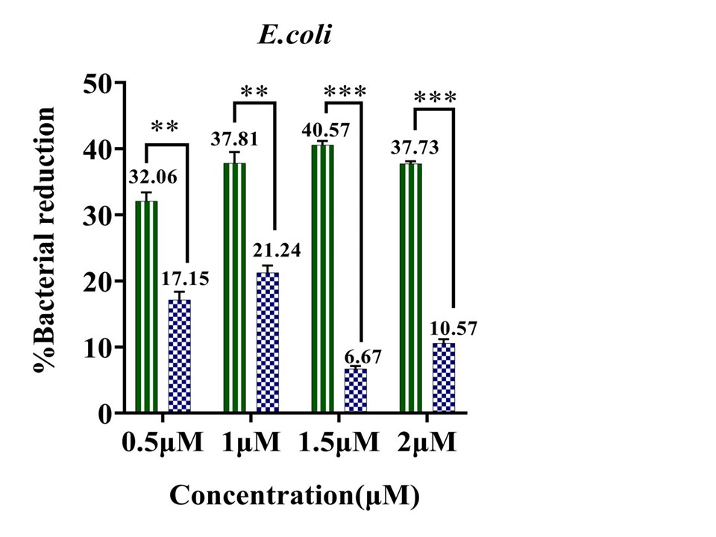
The antibacterial efficacy of NCLin-T₁ and NCLin-T₂ compared to the oligonucleotide sequences of Lin-T₁ and Lin-T₂, respectively, is presented in (Supplementary Fig. S 12). In E.coli, the NCLin-T₁ at concentrations of 1.5 μM compared to Lin-T₁ and NCLin-T₂ at 3 concentrations of 1, 1.5 and 2 μM compared to Lin-T₂ showed a considerable increase in PDT effect. In the S.aureus, the NCLin-T₁ showed greater antibacterial activity than Lin-T₁ at concentration of 1 μM and NCLin-T₂ compared to Lin-T₂ at concentrations of 1, 1.5 and 2 μM.
b)
d)
c)
a)
Supplementary Fig. S 11. the antibacterial performance of BiAu@Lin-T₁ and BiAu@Lin-T₂, as well as the comparison with BiAu, under PDT conditions; a) antibacterial performance of BiAu@Lin-T₁ and BiAu in E.coli; b) antibacterial performance of BiAu@Lin-T₁ and BiAu in S.aureus; c) antibacterial performance of BiAu@ Lin-T₂ and BiAu in E.coli; d) antibacterial performance of BiAu@ Lin-T₂ and BiAu on S.aureus. Error bar indicates standard deviation.
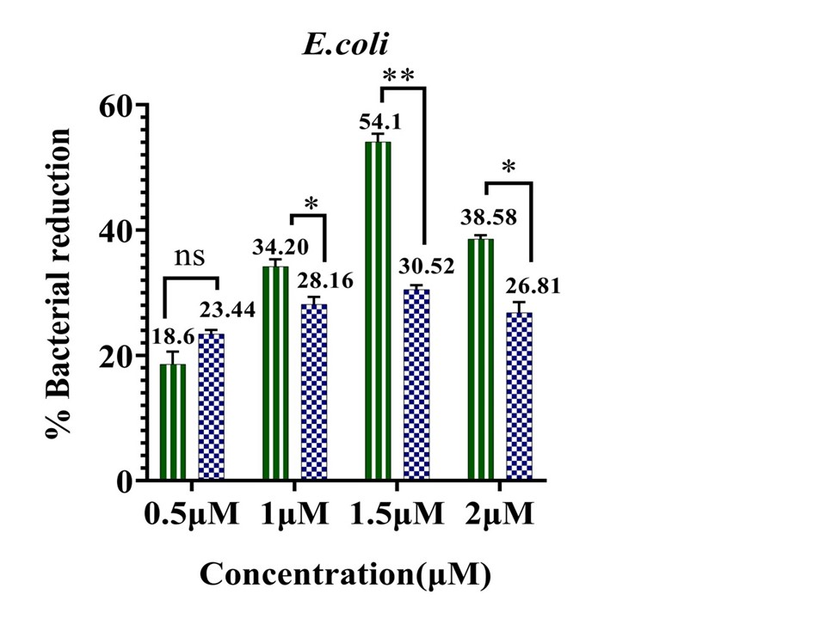
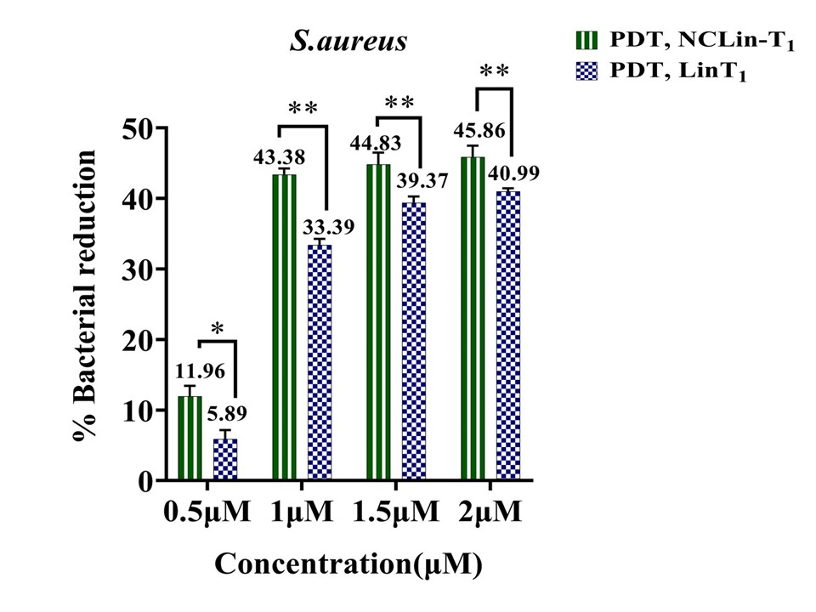
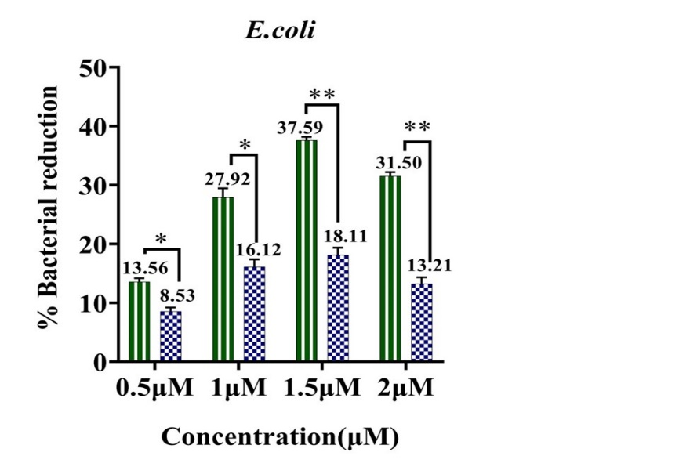
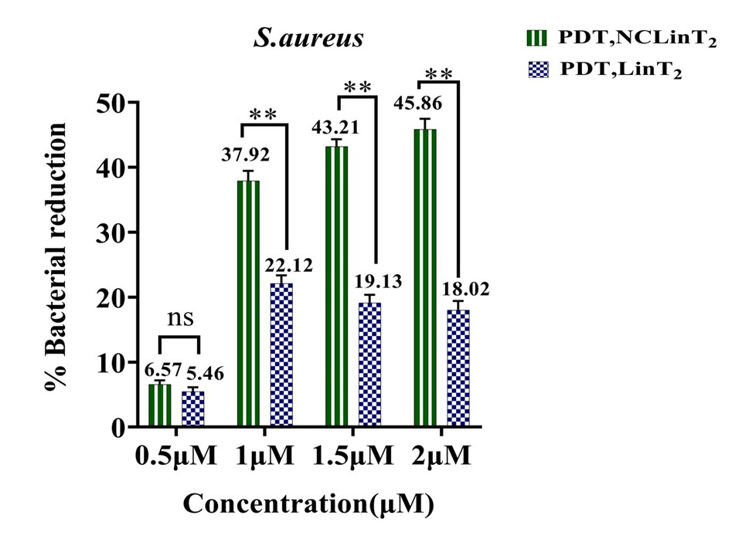
Supplementary Fig. S 12. the antibacterial performance of NCLin-T₁ and NCLin-T₂ and their comparison with Lin-T₁ and Lin-T₂ respectively under PDT conditions; a) antibacterial function of NCLin-T₁ and Lin-T₁ in E.coli; b) antibacterial function of NCLin-T₁ and Lin-T₁ in S.aureus; c) antibacterial function of NCLin-T₂ and Lin-T₂ in E.coli; d) antibacterial activity of NCLin-T₂ and Lin-T₂ in S.aureus. Error bar indicates standard deviation.
a)
b)
c)
d)
Supplementary Fig. S 13 depicts the antibacterial performance of NCLin-C₁ and NCLin-C₂, as well as their comparison with Lin-C₁ and Lin-C₂, respectively. In the case of E.coli, NCLin-C₁ compared to Lin-C₁ at concentration of 1.5 μM and NCLin-C₂ compared to Lin-C₂ at 3 concentrations of 1, 1.5 and 2 μM exhibited a substantial increase in PDT performance.
In S.aureus, the NCLin-C₂, compared to Lin-C₂ at concentrations of 1.5 and 2 μM, exhibited more antibacterial PDT performance. Furthermore, the NCLin-C₁ compared to Lin-C₁ at concentration of 1.5 μM had more antibacterial PDT performance.
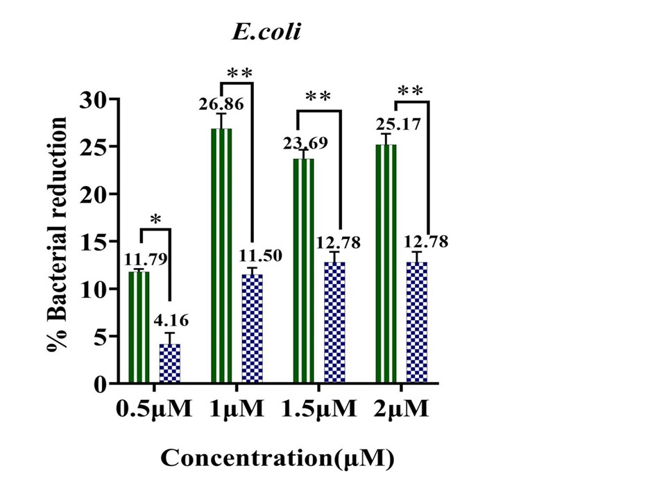
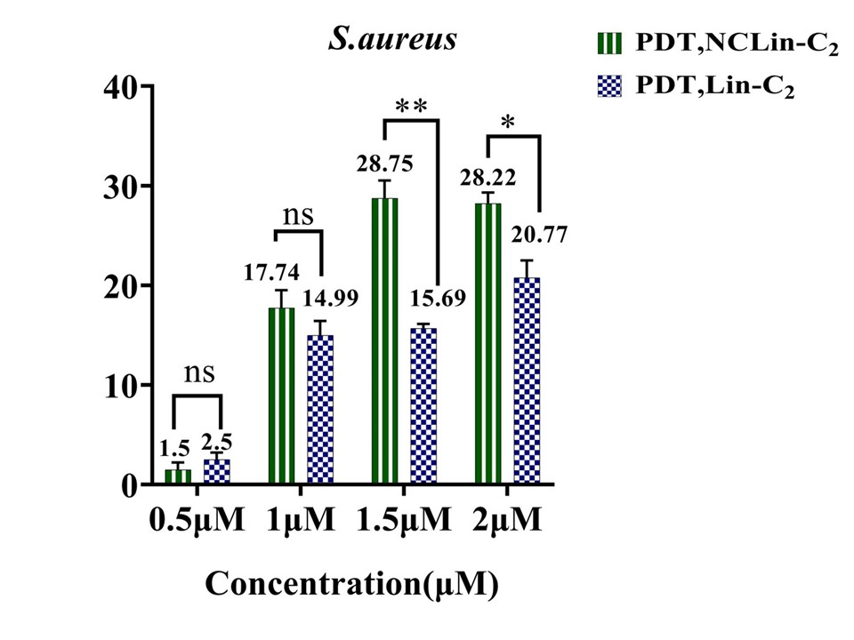
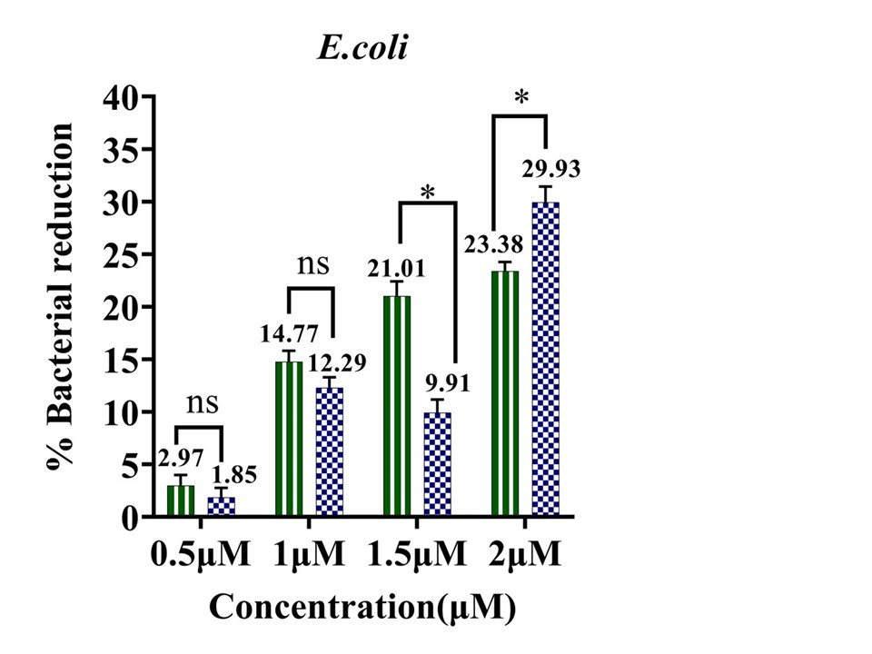
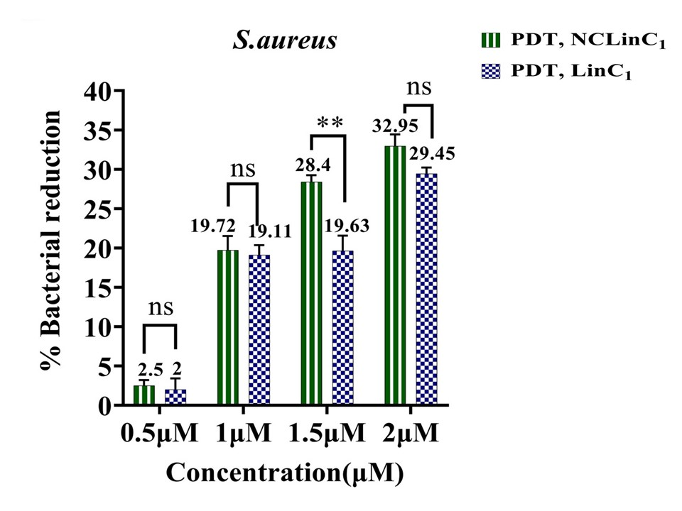
Antibacterial comparison under non-PDT conditions
Supplementary Fig. S 13. antibacterial performance of NCLin-C₁ and NCLin-C₂ and their comparison with Lin-C₁ and Lin-C₂ respectively under PDT conditions; a) antibacterial activity of NCLin-C₂ and Lin-C₂ against E.coli; b) antibacterial activity of NCLin-C₂ and Lin-C₂ in S.aureus; c) antibacterial activity of NCLin-C₁ and Lin-C₁ against E.coli; d) antibacterial activity of NCLin-C₁ and Lin-C₁ against S.aureus. Error bar indicates standard deviation.
a)
b)
c)
d)

Supplementary Fig. S 14 displays a comparative analysis of the antibacterial effect of BiAu@NCLin-T₁ with BiAu@Lin-T₁ and BiAu@NCLin-T₂ with BiAu@Lin-T₂ under non-PDT conditions.
E.coli: the BiAu@Lin-T₁ compared to BiAu@NCLin-T₁ at all 4 concentrations and BiAu@Lin-T₂ compared to BiAu@NCLin-T₂ at 3 concentrations of 0.5, 1.5 and 2 μM showed greater antibacterial effect. S.aureus: the BiAu@NCLin-T₁ nanostructure compared to BiAu@Lin-T₁ at all 4 concentrations and BiAu@NCLin-T₂ nanostructure compared to BiAu@Lin-T₂ at a concentration of 1.5 μM showed antibacterial performance.

Supplementary Fig. S 15 demonstrates the antibacterial effect of BiAu@Lin-T₁ with Lin-T₁ and BiAu@Lin-T₂ with Lin-T₂ under non-PDT conditions. E.coli: the BiAu@Lin-T₁ compared to Lin-T₁ illustrated a greater antibacterial activity at concentrations of 1.5 and 2 μM. The BiAu@Lin-T₂ showed more antibacterial effect than Lin-T₂ at 4 concentrations. S.aureus: the Lin-T₁ compared to BiAu@Lin-T₁ at 3 concentrations of 1, 1.5 and 2 μM. Lin-T₂ showed better antibacterial performance than BiAu@Lin-T₂ at all 4 concentrations.
Supplementary Fig.S 16 depicts a comparison of antibacterial activity of BiAu@Lin-T₁ and BiAu@LinT₂ nanostructures with BiAu in non-PDT mode. Both BiAu@Lin-T₁ and BiAu@Lin-T₂ demonstrated higher antibacterial performance in both gram-positive and gram-negative strains compared to BiAu.

Supplementary Fig. S17 illustrates the comparison of antibacterial performance of NCLin-T₁ and NCLin-T₂, respectively, compared to Lin-T₁ and Lin-T₂ in non-PDT mode. E. coli: the NCLin-T₁ and NCLin-T₂ showed more antibacterial effect than Lin-T₁ and Lin-T₂, respectively, at concentrations of 1.5 and 2 μM. While at the concentration of 0.5 μM. the antibacterial effect of Lin-T₁ was higher than NCLin-T₁. S.aureus: a considerable enhancement in antibacterial activity was sighted in the NCLin-T₁ compared to Lin-T₁ at concentrations of 0.5 and 1.5 μM. The NCLin-T₂ displayed a substantial augmentation in antibacterial effect compared to Lin-T₂ at all four concentrations.

Supplementary Fig. S 18 illustrates the antibacterial performance of NCLin-C₁ and NCLin-C₂ and their comparison with Lin-C₁ and Lin-C₂ respectively under non-PDT conditions.
E.coli: it was exhibited that NCLin-C₁ had a substantial increase in antibacterial effect compared to Lin-C₁ at 3 concentrations of 1, 1.5 and 2 μM. While NCLin-C₂ showed a considerable enhanced antibacterial activity compared to Lin-C₂ across all four concentrations.
S.aureus: the antibacterial effect of NCLin-C₁ surpassed of Lin-C₁ at a concentration of 2 μM. Moreover, NCLin-C₂ illustrated improved antibacterial performance compared to Lin-C₂ at concentrations of 1, 1.5 and 2 μM. While Lin-C₁ compared to NCLin-C₁ at 3 concentrations of 0.5, 1, and 1.5 μM has shown a substantial antibacterial increase.

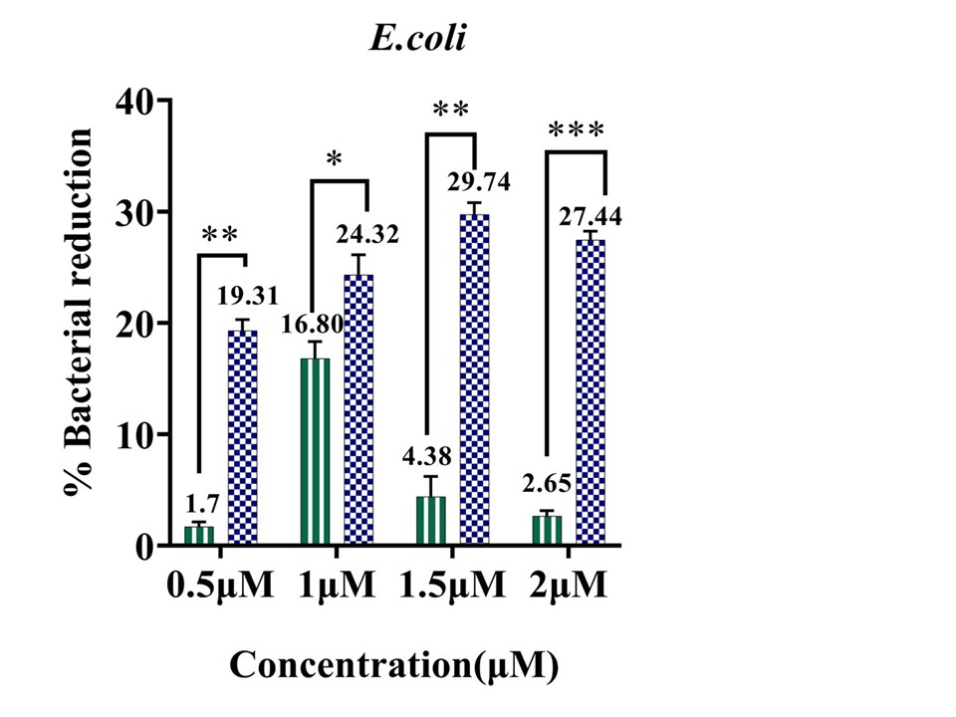
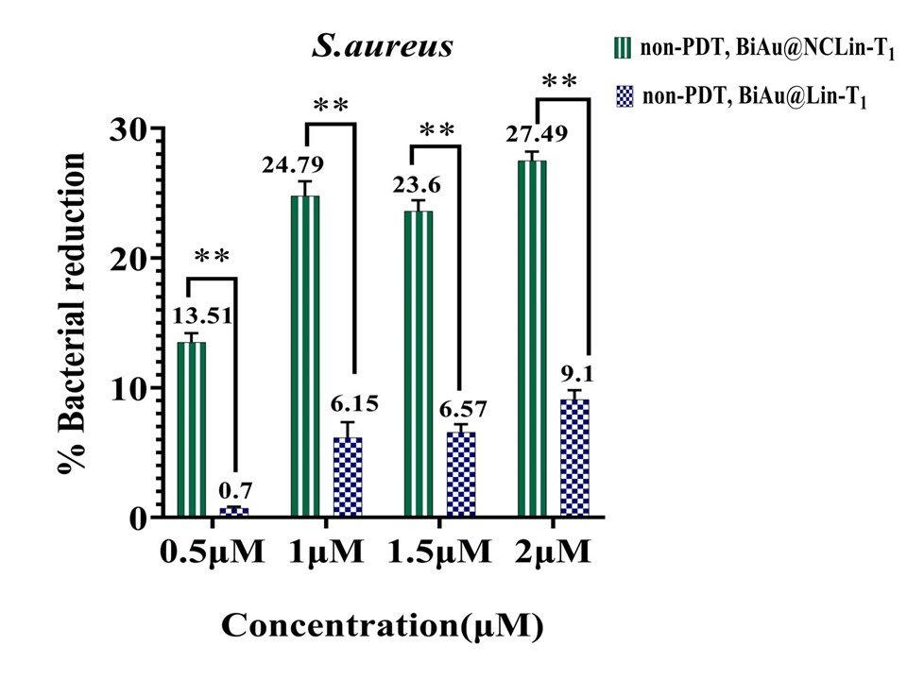
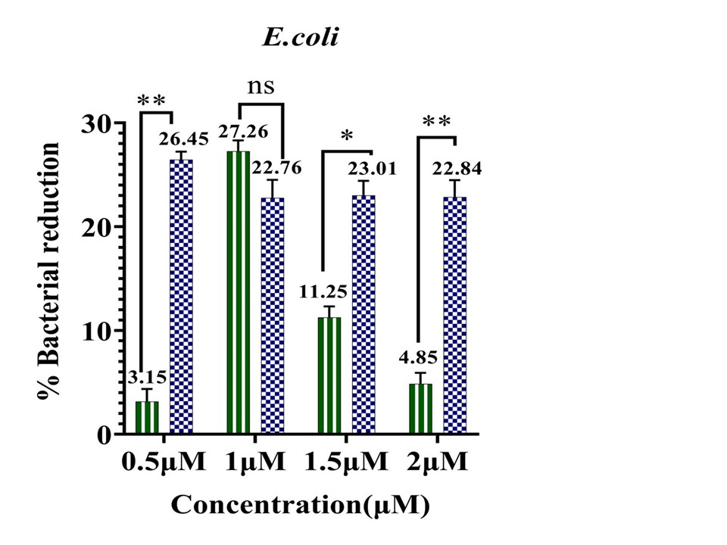
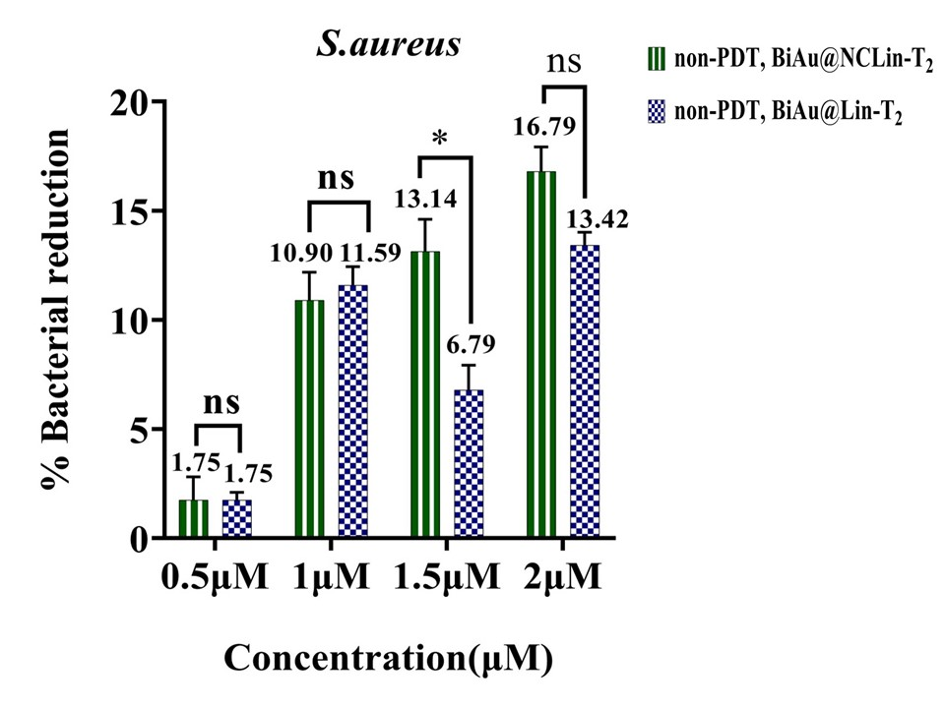
Supplementary Fig. S 14. antibacterial performance of BiAu@NCLin-T₁ and BiAu@NCLin-T₂, as well as their comparison with BiAu@Lin-T₁ and BiAu@Lin-T₂ respectively, under non-PDT conditions; a) antibacterial performance of BiAu@NCLin-T₁ and BiAu@Lin-T₁ against E.coli; b) antibacterial performance of BiAu@NCLin-T₁ and BiAu@Lin-T₁ against S.aureus; c) antibacterial performance of BiAu@NCLin-T₂ and BiAu@Lin-T₂ against E.coli; d) antibacterial performance of BiAu@NCLin-T₂ and BiAu@Lin-T₂ against S.aureus. Error bar indicates standard deviation.
a)
b)
c)
d)

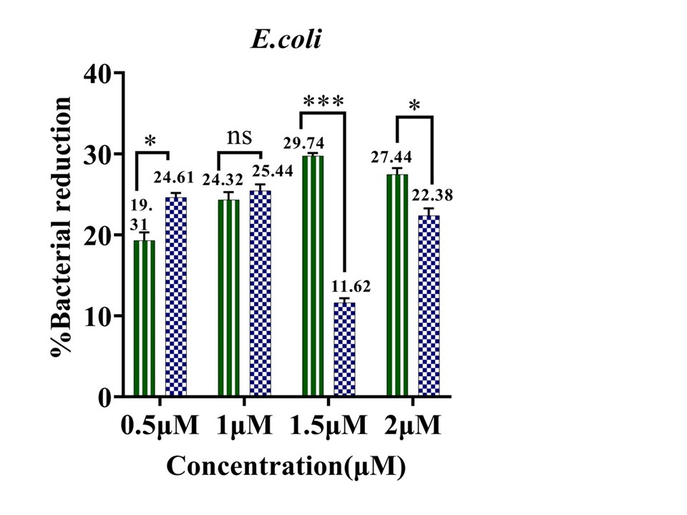
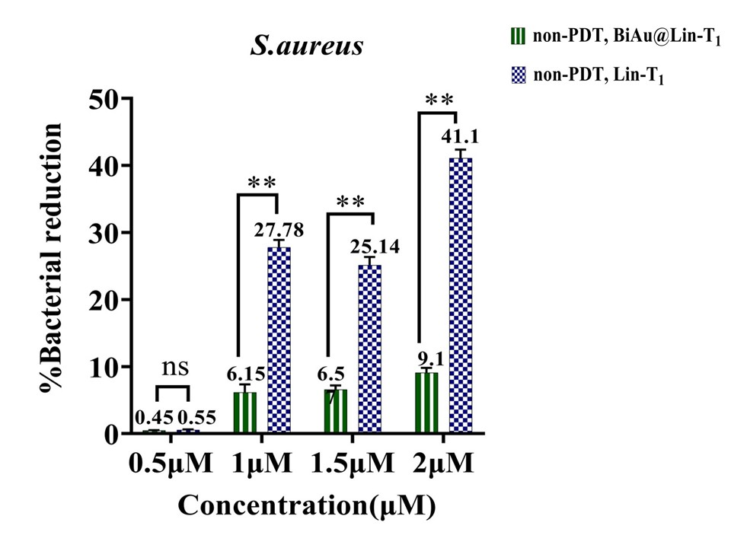
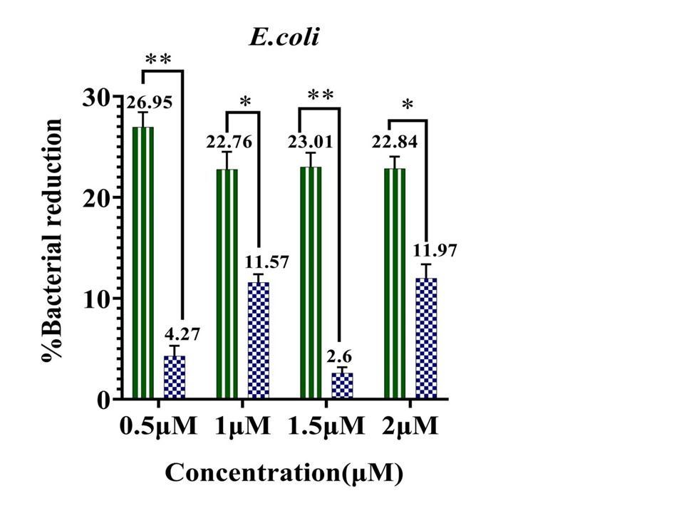
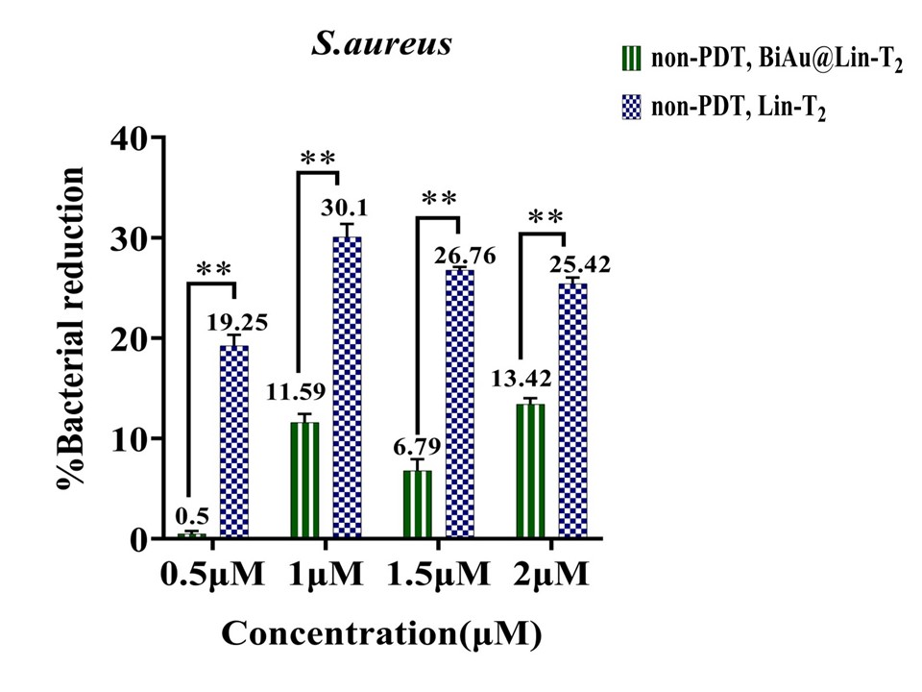
Supplementary Fig. S 15. antibacterial performance of BiAu@Lin-T₁ and BiAu@ Lin-T₂, as well as their comparison with Lin-T₁ and Lin-T₂ respectively under non-PDT conditions; a) antibacterial performance of BiAu@Lin-T₁ and Lin-T₁ against E.coli; b) antibacterial performance of BiAu@Lin-T₁ and Lin-T₁ against S.aureus; c) antibacterial performance of BiAu@Lin-T₂ and Lin-T₂ against E.coli; d) antibacterial performance of BiAu@Lin-T₂ and Lin-T₂ against S.aureus. Error bar indicates standard deviation.
a)
b)
c)
d)
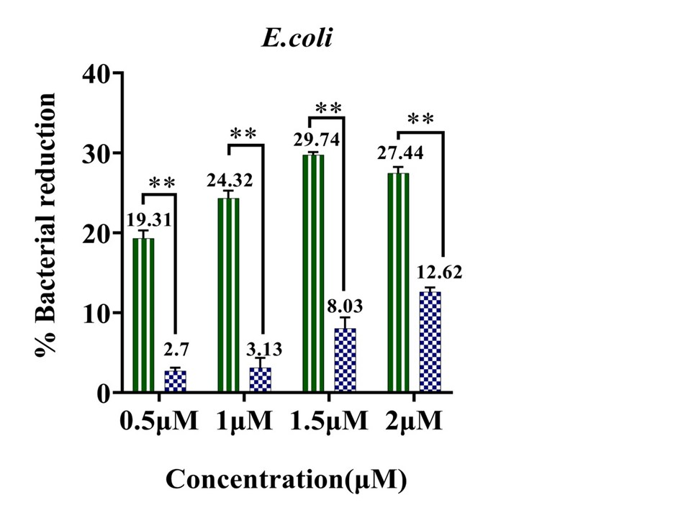
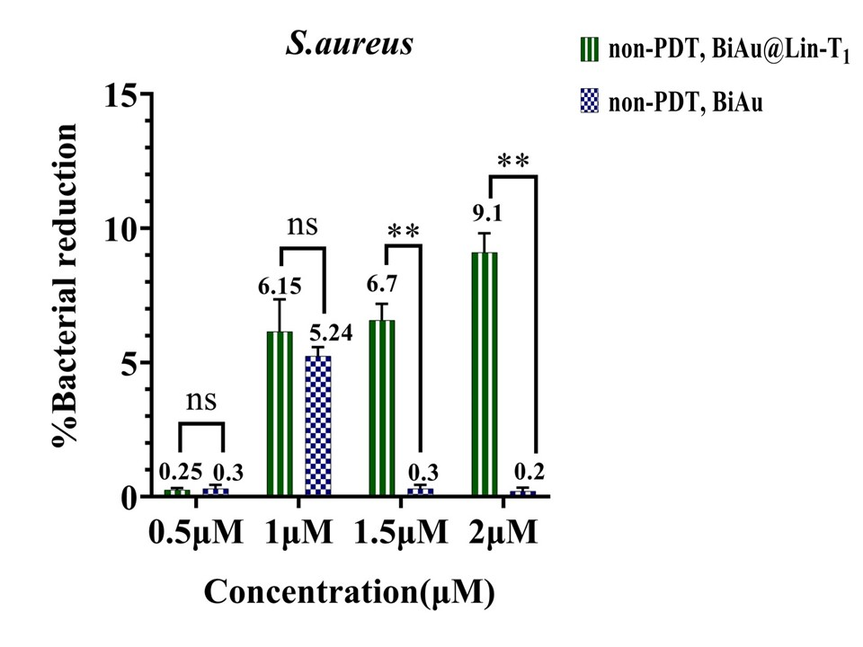
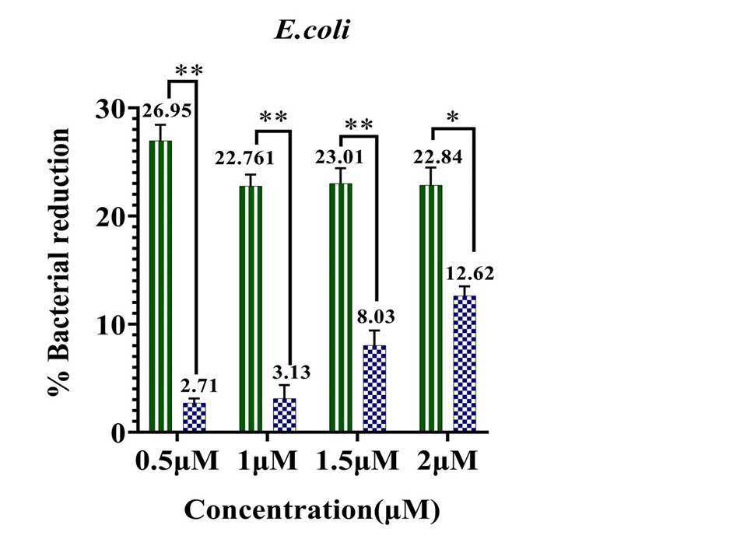
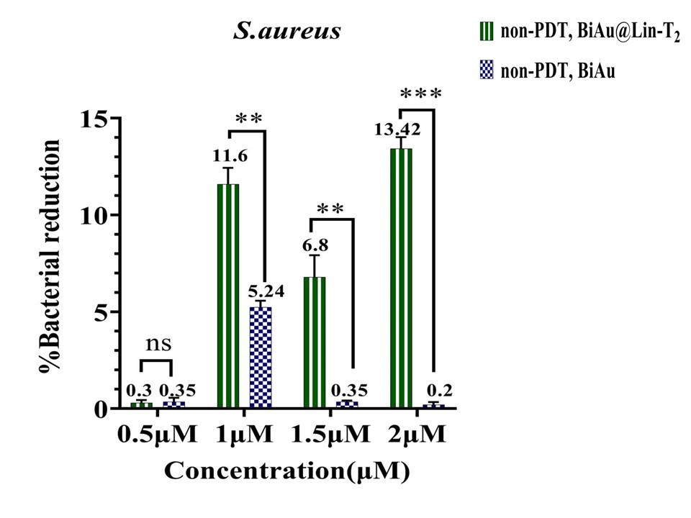
Supplementary Fig. S 16. antibacterial performance of BiAu@Lin-T₁ and BiAu@Lin-T₂ and their comparison with BiAu under non-PDT conditions; a) antibacterial performance of BiAu@Lin-T₁ and BiAu against E.coli; b) antibacterial performance of BiAu@Lin-T₁ and BiAu against S.aureus; c) antibacterial performance of BiAu@Lin-T₂ and BiAu against E.coli; d) antibacterial performance of BiAu@Lin-T₂ and BiAu against S.aureus. Error bar indicates standard deviation.

a)
b)
c)
d)
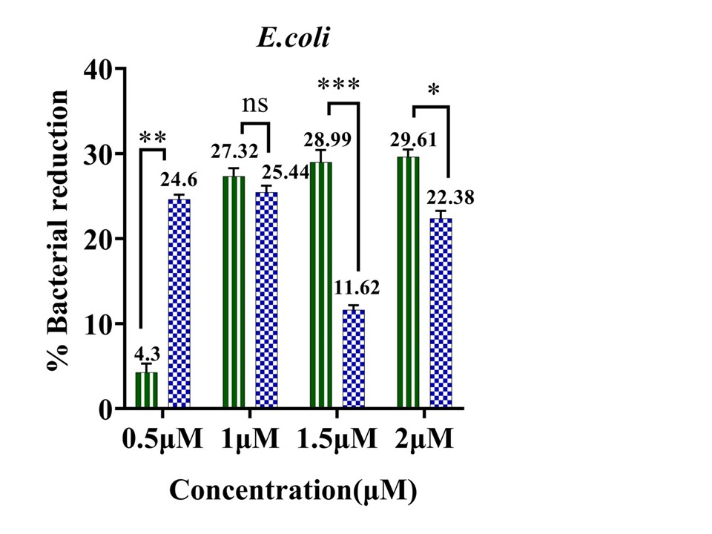
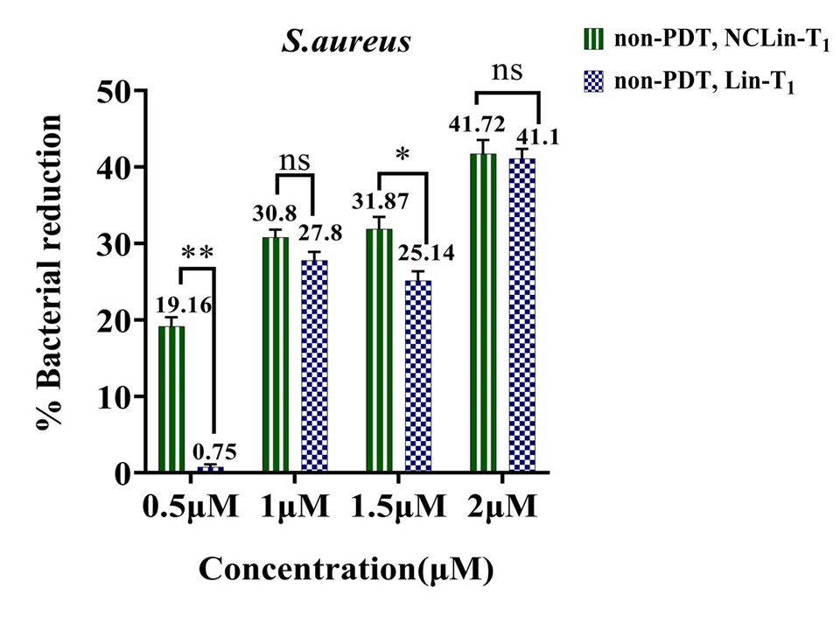
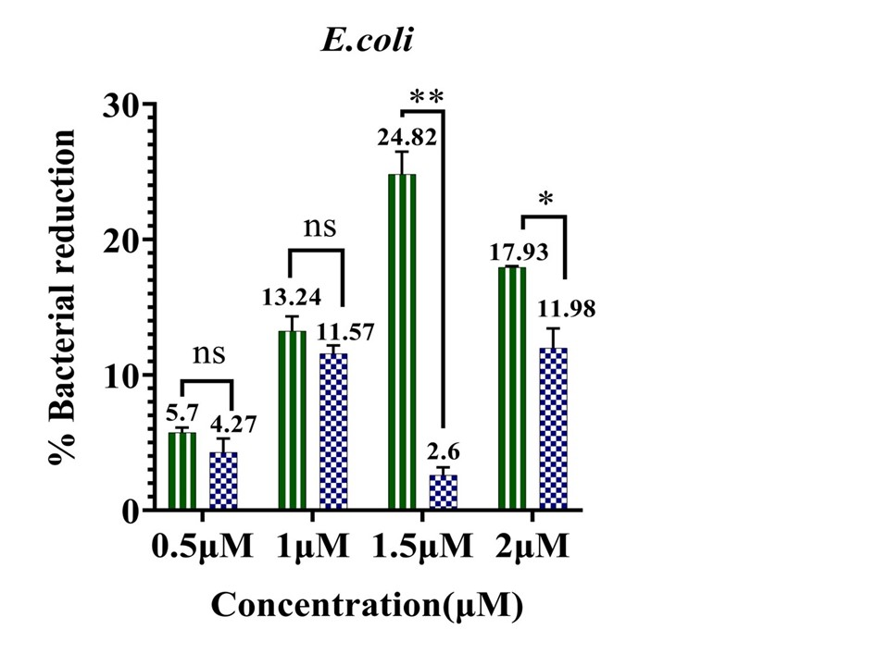
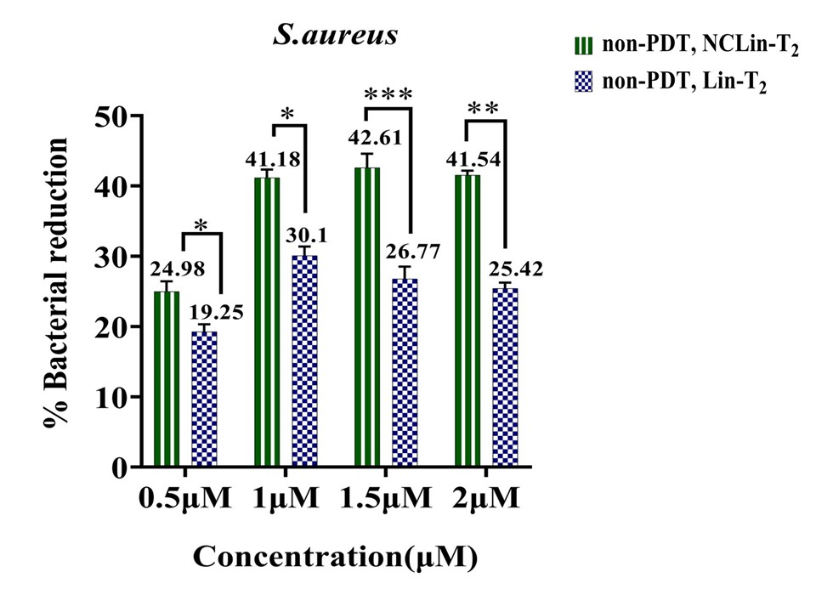
Supplementary Fig. S 17. antibacterial performance of NCLin-T₁ and NCLin-T₂ and their comparison with Lin-T₁ and Lin-T₂ respectively under non-PDT conditions; a) antibacterial activity of NCLin-T₁ and Lin-T₁ against E.coli; b) antibacterial activity of NCLin-T₁ and Lin-T₁ against S.aureus; c) antibacterial activity of NCLin-T₂ and Lin-T₂ against E.coli; d) antibacterial activity of NCLin-T₂ and Lin-T₂ against S.aureus. Error bar indicates standard deviation.
a)
b)
c)
d)
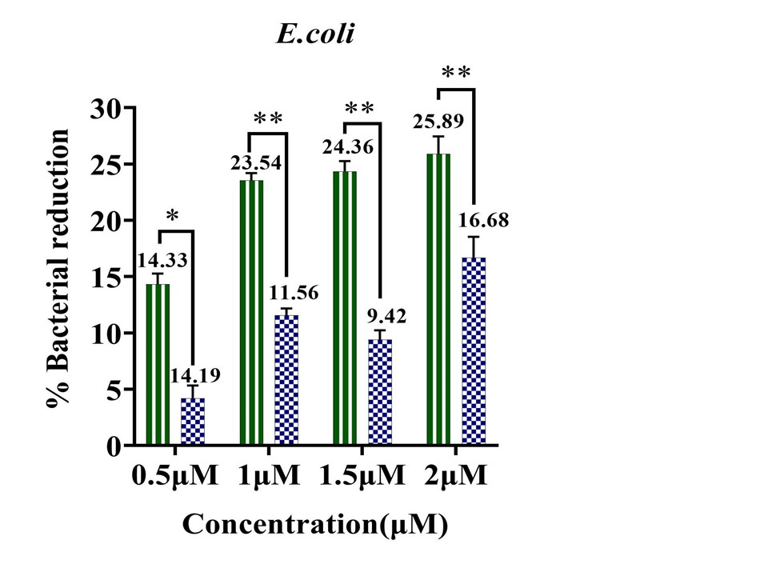
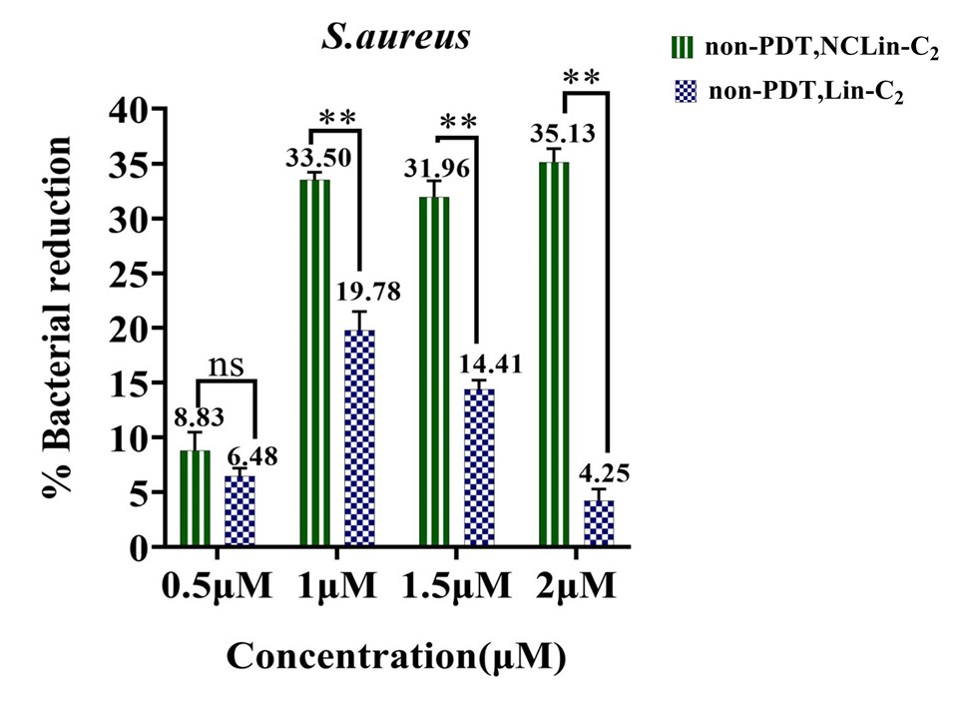
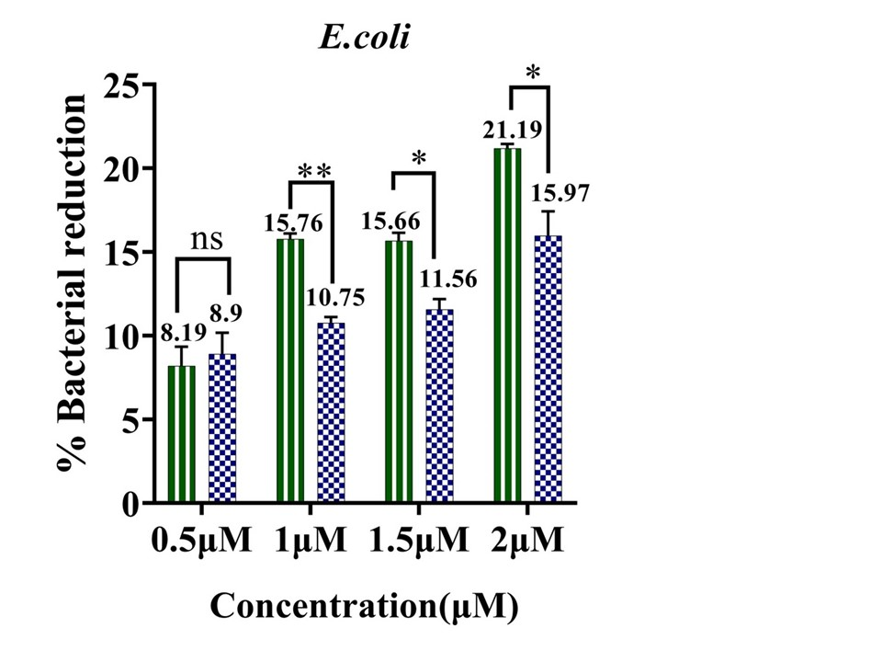
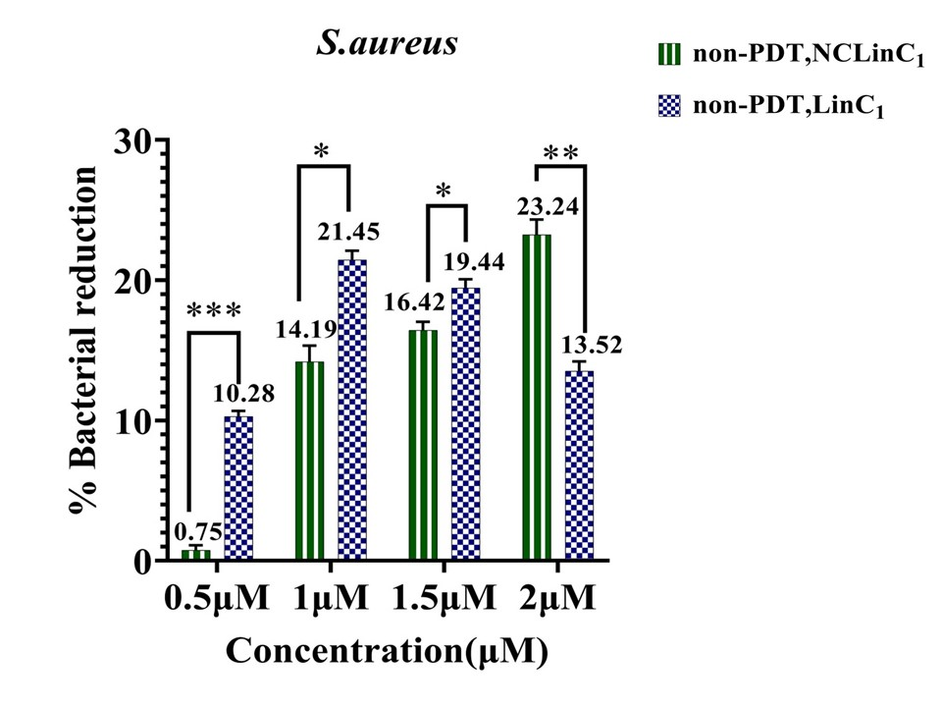
Supplementary Fig. S 18. antibacterial performance of NCLin-C₁ and NCLin-C₂ and their comparison with Lin-C₁ and Lin-C₂ respectively under non-PDT conditions; a) antibacterial activity of NCLin-C₂ and Lin-C₂ in E.coli; b) antibacterial function of NCLin-C₂ and Lin-C₂ in S.aureus; c) antibacterial function of NCLin-C₁ and Lin-C₁ in E.coli; d) antibacterial activity of NCLin-C₁ and Lin-C₁ in S.aureus. Error bar indicates standard deviation.
a)
b)
c)
d)

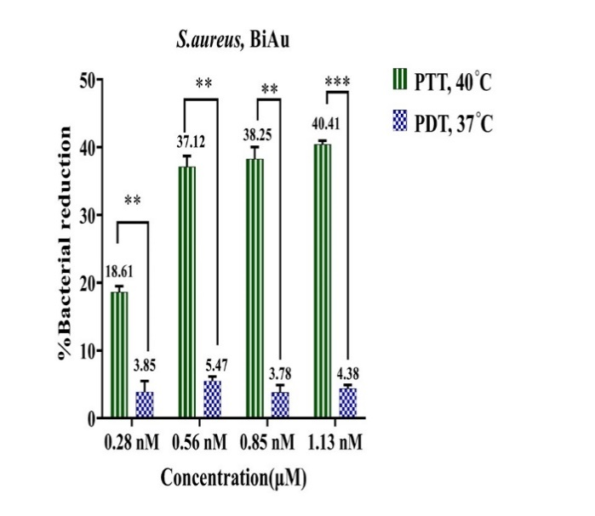
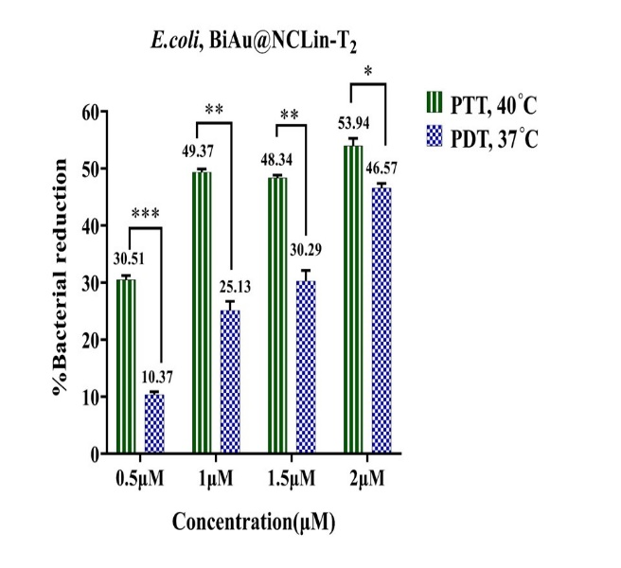
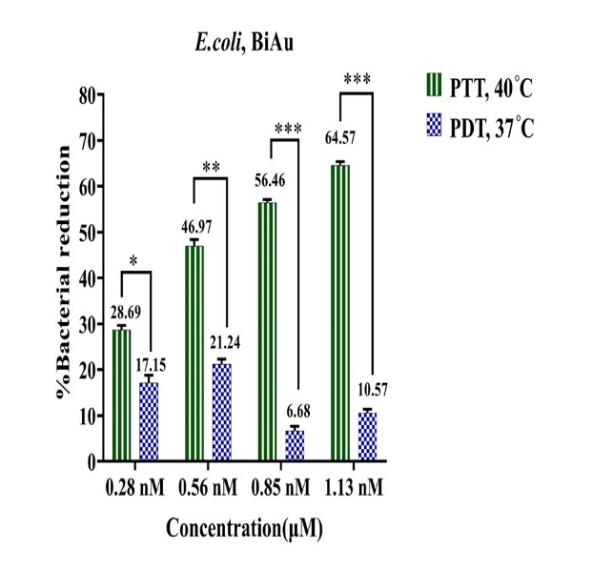
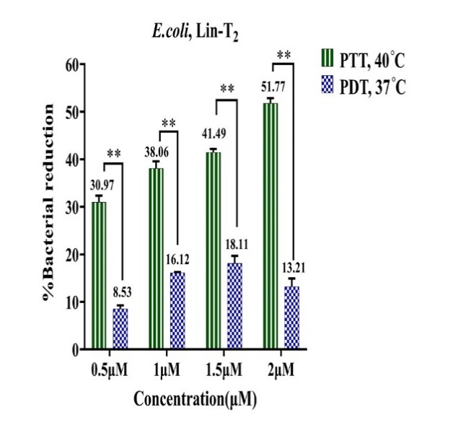
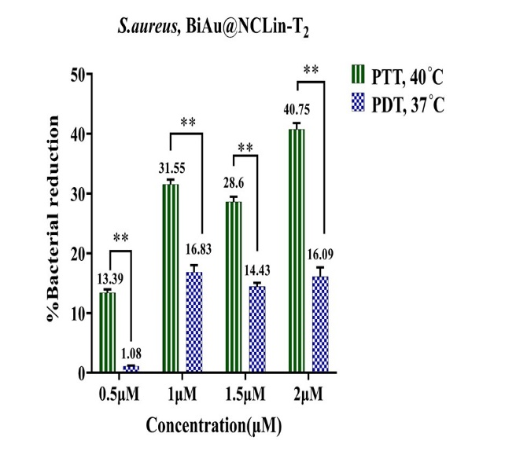
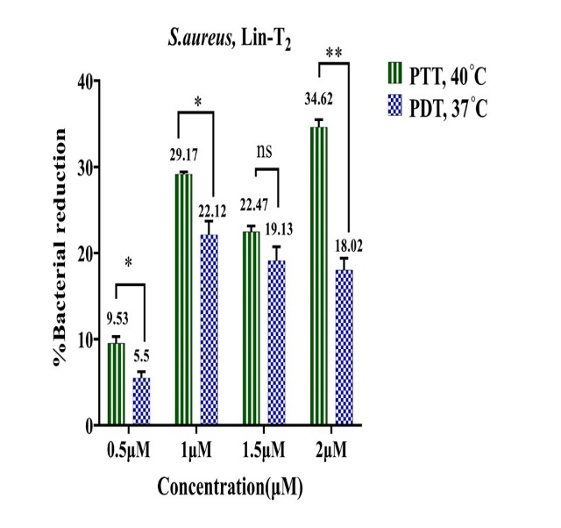
The PTT effect of BiAu@NCLin-T₂, BiAu, and Lin-T₂ was investigated under temperature conditions of 40°C. BiAu@NCLin-T₂ and BiAu exhibited increased antibacterial activity at 40°C compared to 37°C against both gram-positive and gram-negative bacterial strains in PDT conditions, (Supplementary Fig. S 19). Lin-T₂ exhibited more excellent antibacterial performance against gram-negative bacteria (at all 4 concentrations) and gram-positive bacteria (at the concentration of 2 μM) at 40°C compared to 37°C under PDT states. According to the stability analysis and computational analysis, this sequence maintains its stability with increasing temperature.
Supplementary Fig. S 19 comparison of antibacterial performance of BiAu@NCLin-T₂, BiAu and Lin-T₂ nanostructures under PTT and PDT conditions; a) antibacterial performance of BiAu@NCLin-T₂ against E.coli; b) antibacterial activity of BiAu against E.coli; c) antibacterial activity of Lin-T₂ against E.coli; d) antibacterial performance of BiAu@NCLin-T₂ against S.aureus; e) antibacterial activity of BiAu against S.aureus; f) antibacterial activity of Lin-T₂ against S.aureus. Error bar indicates standard deviation.

e)
a)
b)
c)
d)
f)

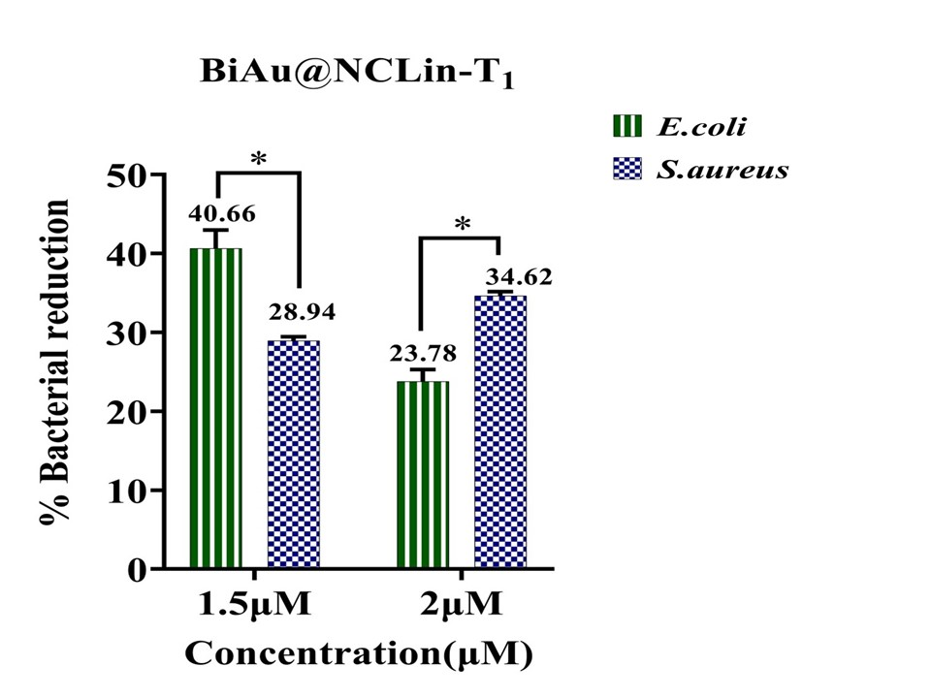
Supplementary Fig. S 20. The comparison of the antibacterial performance of BiAu@NCLin-T₁ in E.coli and S.aureus, under non-PDT conditions.. The error bar indicates the standard deviation.

The length of Lin-T₂
Considering that AgNC is synthesized with 12 C nucleobases, the space between 5ʹHEX and AgNC is filled with 3 T nucleobases. The length of each nucleobase is 0.676 nm (Its reference is mentioned below [Ref]). Consequently, the calculated length of the designed oligonucleotide sequence (Lin-T₂) with 24 nucleobases is 16.224 nm. The length of 3 nucleobase T, which is located between 5'HEX and AgNC, measures 2.028 nm, which falls below 10 nm.
[Ref] Roth, E., Glick Azaria, A., Girshevitz, O., Bitler, A. & Garini, Y. Measuring the Conformation and Persistence Length of Single-Stranded DNA Using a DNA Origami Structure. Nano Lett. 18(11):6703-6709. 10.1021/acs.nanolett.8b02093 (2018).

