Supplementary Information for:

Intercellular adhesion boots collective cell migration through elevated membrane tension

Description Of Additional Supplementary Files
- Supplementary Movies S1-S5
- Supplementary Figures S1-S4
- Supplementary Table S1
SUPPLEMENTARY MOVIES
Supplementary Movie 1: Cellular migration for wound-healing assay of MDA and MCF-7 cells. Frame rate (20 fps, with 20 frames per second). Scale-bar: 100 μm.
Supplementary Movie 2: Cellular migration for wound-healing assay of Cph1-PM-MDA cells under far-red and red light. Frame rate (20 fps, with 20 frames per second). Scale-bar: 100 μm.
Supplementary Movie 3: Single-cell tracking of individual cell nuclei of Cph1-PM-MDA cells under far-red or red light. Frame rate (20 fps, with 20 frames per second). Scale-bar: 100 μm.
Supplementary Movie 4: Cellular migration for wound-healing assay of Cph1-PM-MDA cells under far-red or red light in the presence of VU. Frame rate (20 fps, with 20 frames per second). Scale-bar: 100 μm.
Supplementary Movie 5: Cellular migration for wound-healing assay of Cph1-PM-MDA cells under far-red or red light in the presence of Oleic acid. Frame rate (20 fps, with 20 frames per second). Scale-bar: 100 μm.

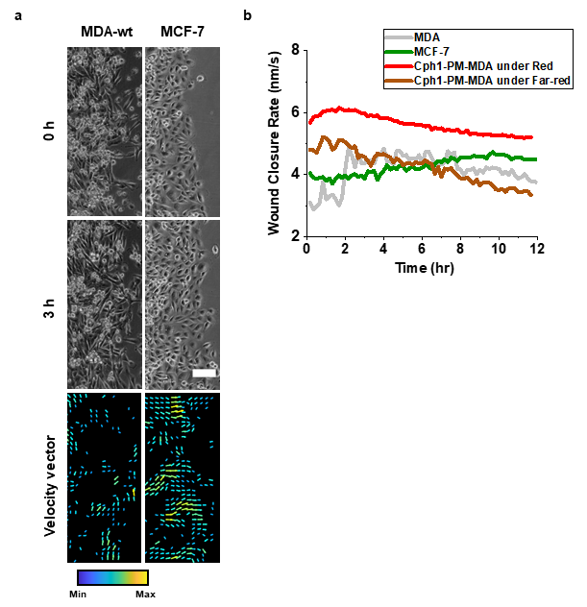
Supplementary Figure 1: Migration data for individual and collective migration. (a) Wound healing migration patterns for MDA-MB-231 (MDA) and MCF-7. (b) Velocity histograms depicting cellular migration patterns for MDA and MCF-7. Scale bar (a), 100 μm.

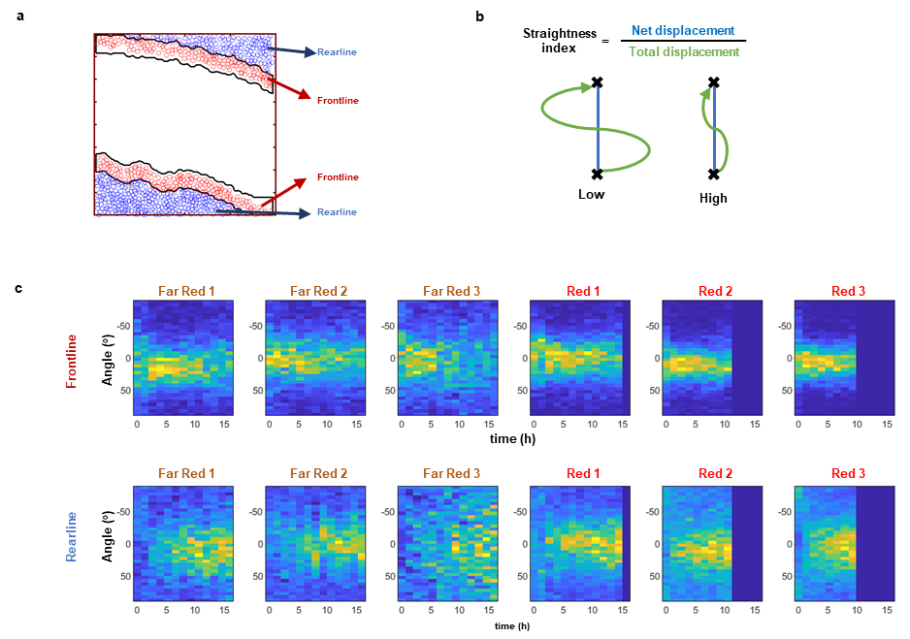
Supplementary Figure 2: Analysis of single-cell tracking data. (a) The regions were divided into frontline of around 3 lines and rearline of rest region. (b) The schematic of straightness index was presented. Straightness index values are calculated by dividing net displacement into total displacement. (c) The plots show the migration angle of individual Cph1-PM-MDA cells in the frontlines and rearlines under red and far-red light for 16 hours. The number indicates the technical replications.

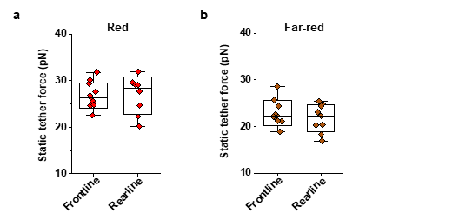
Supplementary Figure 3: Static tether force of Cph1-PM-MDA cells. Static tether forces were measured after exposures to either red or far-red light tension in the frontline and rearline in the wound direction both under red (a) and far-red light (b). Data source and statistic details are provided as a source data file.
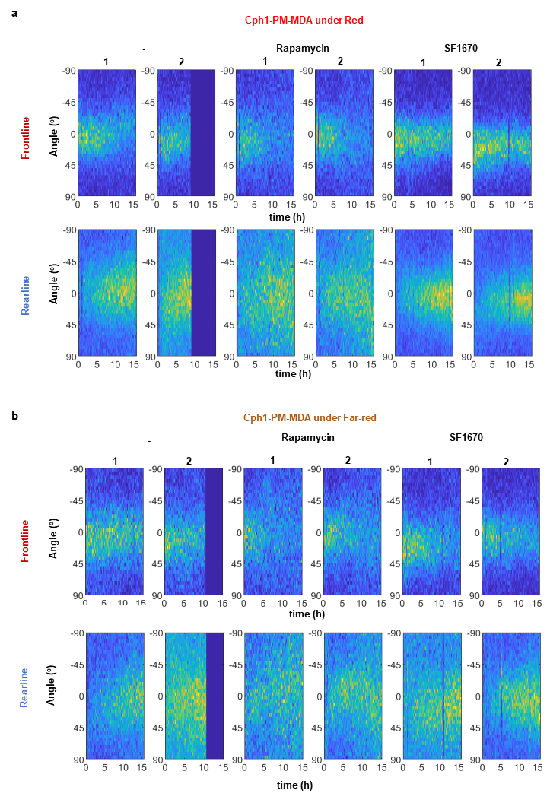
Supplementary Figure 4: Migration angles of Cph1-PM-MDA cells without or with rapamycin and SF1670. (a, b) The plots show the migration angle of individual Cph1-PM-MDA cells in the frontlines and rearlines under red and far-red light for 16 hours without treat or with treatment of rapamycin or SF1670. The number indicate the technical replications.
Target gene | Sequences | Tm (ºC) | Product size
ZEB1 | F: GCACAACCAAGTGCAGAAGA | 58.98 | 141 bp
ZEB1 | R: GCCTGGTTCAGGAGAAGATG | 57.96 | 141 bp
FN1 | F: GGAGCAAATGGCACCGAGATA | 60.48 | 132 bp
FN1 | R: AGCTGCACATGTCTTGGGAA | 59.89 | 132 bp
TEAD1 | F: GATTCAAACAGGGCAGCCAG | 59.47 | 185 bp
TEAD1 | R: AAAATTCCACCAGGCGAAGC | 59.40 | 185 bp
CTGF | F: GGCTTACCGACTGGAAGACA | 59.39 | 104 bp
CTGF | R: TCCCACAGGTCTTGGAACAG | 59.24 | 104 bp
GAPDH | F: CCTGCACCACCAACTGCTTA | 60.54 | 120 bp
GAPDH | R: GGCCATCCACAGTCTTCTGAG | 60.41 | 120 bp
Supplementary Table 1: Sequences and melting temperatures of primers used for gene expression analysis.

