Supplementary Material
Effects of glacier retreat on plant–soil relationships
Cécile Charles¹, Nora Khelidj¹, Lucia Mottet¹, Bao Ngan Tu^{1,2}, Thierry Adatte³, Brahimsamba Bomou³, Micaela Faria¹, Laetitia Monbaron¹, Olivier Reubi³, Natasha de Vere⁴, Stéphanie Grand¹⁼, Gianalberto Losapio^{1,2=}
¹Institute of Earth Surface Dynamics, Faculty of Geosciences and Environment, University of Lausanne, Lausanne, 1015, Switzerland
²Department of Biosciences, University of Milan, Milan, 20133, Italy
³Institute of Earth Sciences, University of Lausanne, Lausanne, 1015, Switzerland
⁴Natural History Museum of Denmark, University of Copenhagen, Copenhagen, Denmark

⁼Both authors contributed equally to the supervision of this work
Correspondence to: Gianalberto Losapio (Gianalberto.Losapio@unil.ch)

Element content, soil texture and plant richness after glacier retreat
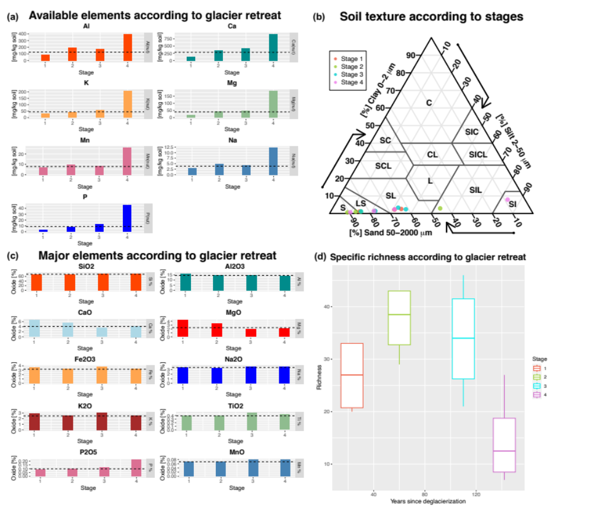
Figure A1: Additional soil and plant variables according to glacier retreat including plant available elements concentrations (a), soil texture (b), major element proportions (c) and plant species richness (d).

