Supporting Information

Enhancing Lithium-Ion Battery Performance: Nano Al₂O₃ Film Deposition on High Mass Loading LiFePO₄ Cathode Electrode Using Atomic Layer Deposition Technique

Pejman Salimi *#, Gloria Gottardi, William Gomes De Morais, Ruben Bartali, Nadhira Laidani, and Edoardo Gino Macchi *

Center for Sustainable Energy, Fondazione Bruno Kessler, via Sommarive 18, 38123.Trento, Italy

* Corresponding authors

# Current affiliation: Institute for Materials Research (imo-imomec), Hasselt University, Martelarenlaan 42, Hasselt BE3500, Belgium

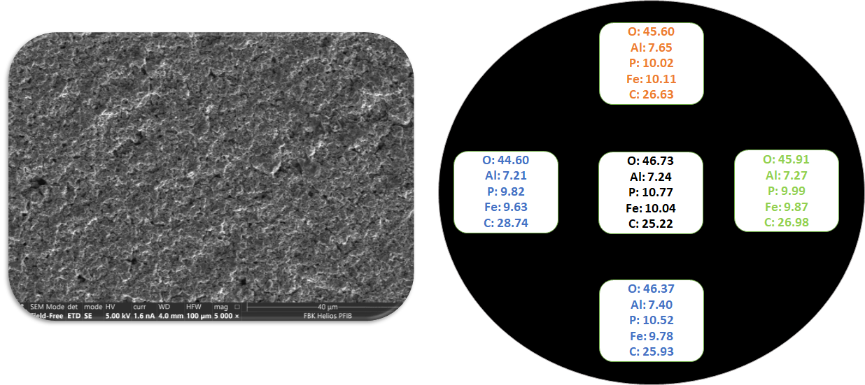
Fig. S1. FESEM-EDS analysis on 5nm Al₂O₃ LFP electrode to find out the uniform distribution of the elements (Al- O).

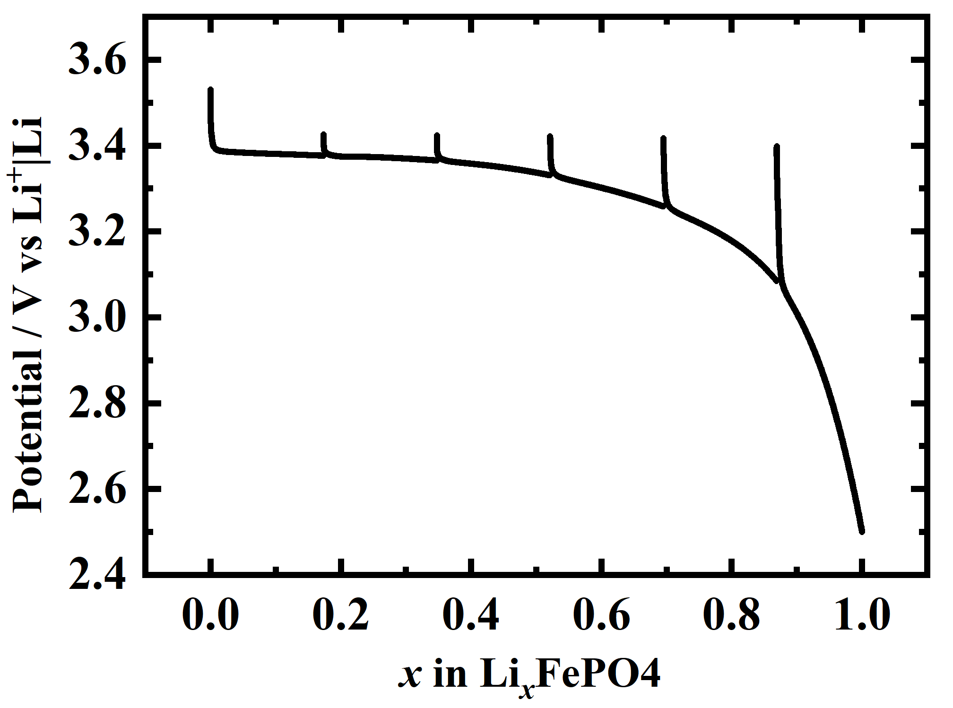
Fig. S2. Galvanostatic discharge curve of the Li/LFP half cell, employing a different discharge cut-off voltage after fully charging the cell.

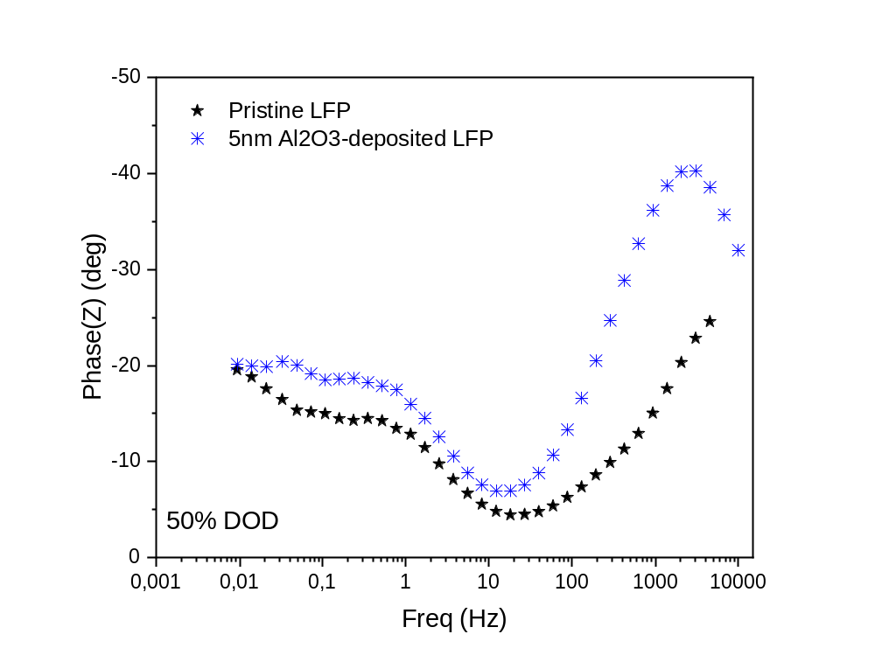
Fig S3. Bode plot of the cells with pristine and 5 nm Al₂O₃-coated LFP electrodes at DOD of 50%.

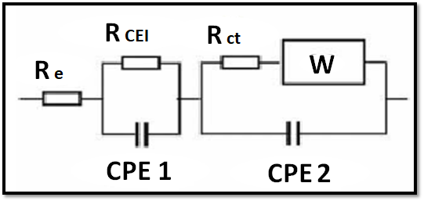

Fig S4. An equivalent circuit model used to fit and analyze the EIS data.

Samples | Pristine LFP electrode |  |  |  |  |  | 5nm Al₂O₃-coated LFP electrode
DOD (%) | 17% | 33% | 50% | 67% | 83% | 100% | 17% | 33% | 50% | 67% | 83% | 100%
R_{e} (Ω) | 5.2 | 8.9 | 8.3 | 13.8 | 16.8 | 11.4 | 7.8 | 5.3 | 5.4 | 5.6 | 5.7 | 5.8
R_{CEI} (Ω) | 66.2 | 60.5 | 64.1 | 59.8 | 53.2 | 63.1 | 58.6 | 56.6 | 55.8 | 56.9 | 57.9 | 58.5
R_{ct} (Ω) | 43.6 | 60.9 | 74.5 | 96.8 | 125.8 | 141.2 | 38.7 | 78.1 | 115.0 | 109.6 | 107.8 | 128.4
Overall Resistance (Ω) | 115 | 130.3 | 146.9 | 170.4 | 195.8 | 215.7 | 105.1 | 140 | 176.2 | 172.1 | 171.4 | 192.7
C_{CEI} (F) ×10⁻⁶ | 0.10 | 0.25 | 0.21 | 0.49 | 0.84 | 0.45 | 4.6 | 2.1 | 2.7 | 2.3 | 2.9 | 2.5
C_{dl}(F) ×10⁻³ | 1.4 | 2.0 | 2.6 | 3.0 | 3.1 | 2.9 | 3.2 | 1.7 | 1.7 | 2.7 | 2.4 | 1.9
w (Ohm.s^{-1/2}) | 7.5 | 9.5 | 17.2 | 30.1 | 35.6 | 184.2 | 8 | 10.4 | 19.7 | 31.4 | 53.5 | 195.4
Table 1. Numerical value of Resistance and capacitances obtained from the fitting of the EIS spectra at different states of lithiation for Pristine LFP electrode and 5nm Al₂O₃-coated LFP electrode.

Table S2. Lithium ions diffusion coefficient obtained from EIS spectra as function of the DoD for both pristine and coated LFP.
DoD (%) | Pristine LFP (cm² s⁻¹) | 5nm Al₂O₃-coated LFP electrode (cm² s⁻¹)
17 | 1.01638×10⁻¹¹ | 8.93302×10⁻¹²
33 | 7.57681×10⁻¹² | 6.32218×10⁻¹²
50 | 2.31035×10⁻¹¹ | 1.76117×10⁻¹¹
67 | 3.21312×10⁻¹¹ | 2.95257×10⁻¹¹
83 | 1.24364×10⁻¹⁰ | 5.50665×10⁻¹¹
100 | 1.01466E×10⁻¹⁰ | 9.01674×10⁻¹¹

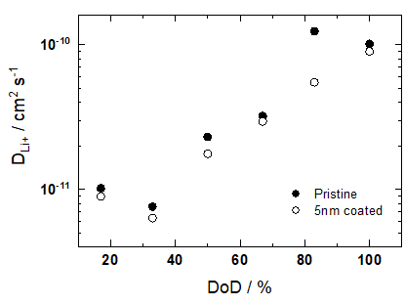
Fig. S5. Lithium ions diffusion coefficient obtained from EIS spectra as function of the DoD for both pristine and coated LFP.

