Supplementary Information
Fast-kinetics and high-compatibility aqueous cadmium-metal battery for next-generation energy storage infrastructures
Yang-feng Cui^{1,4}, Haobin Song^{1,4}, Jingjing Yao¹, Qi Hao², Xue Liang Li¹, Yifan Li¹, Binbin Guo,¹ Yun-hai Zhu,³ & Hui Ying Yang¹
¹Pillar of Engineering Product Development, Singapore University of Technology and Design, Singapore.
²School of Materials Science and Engineering, Zhejiang University, Hangzhou, China.
³State Key Laboratory of New Textile Materials and Advanced Processing Technologies, Wuhan Textile University, Wuhan, China.
⁴These authors contributed equally: Yang-feng Cui and Hao-bin Song.
e-mail: yanghuiying@sutd.edu; jingjing_yao@sutd.edu.sg

This file includes: Supplementary Figs. S1-S21
Table and Content
Fig. S1. Raman spectra of aqueous solutions.
Fig. S2. Weakening the hydrogen bond interaction among H₂O molecules.
Figs. S3. Schematic of two-electrode Swagelok-type cell.
Figs. S4−S6. Cycling stability of Cd//Cu and Zn// Cu cells.
Fig. S7. Morphologies of Zn and Cd anodes.
Fig. S8. Quantifying aging behaviors in Zn and Cd anodes.
Fig. S9. Ex-situ SEM images of Cd plating/stripping behaviors on Cu foil in 1M electrolyte.
Fig. S10. Ex-situ SEM images of Cd plating/stripping behaviors on Cu foil in 1M6M electrolyte.
Fig. S11. Ex-situ SEM images of Zn plating behavior on Cu foil in 2ZS electrolyte.
Fig. S12. FIB-SEM images of Cd deposits.
Fig. S13. Exchange current measurements in different aqueous electrolytes.
Fig. S14. Corrosion-resistant capability of Zn anode.
Fig. S15. Corrosion-resistant capability of Cd anode.
Fig. S16 and 17. Kinetics of Cd//PANI full cells
Fig. S18. Rechargeable capability of Cd//PANI full cells.
Fig. S19. Elctrochemistry of Cd//AC capacitors.
Fig. S20. Rechargeable capability of Cd//V₂O₅ full cell.
Fig. S21. Elctrochemistry of high-load Cd//PANI full cell.

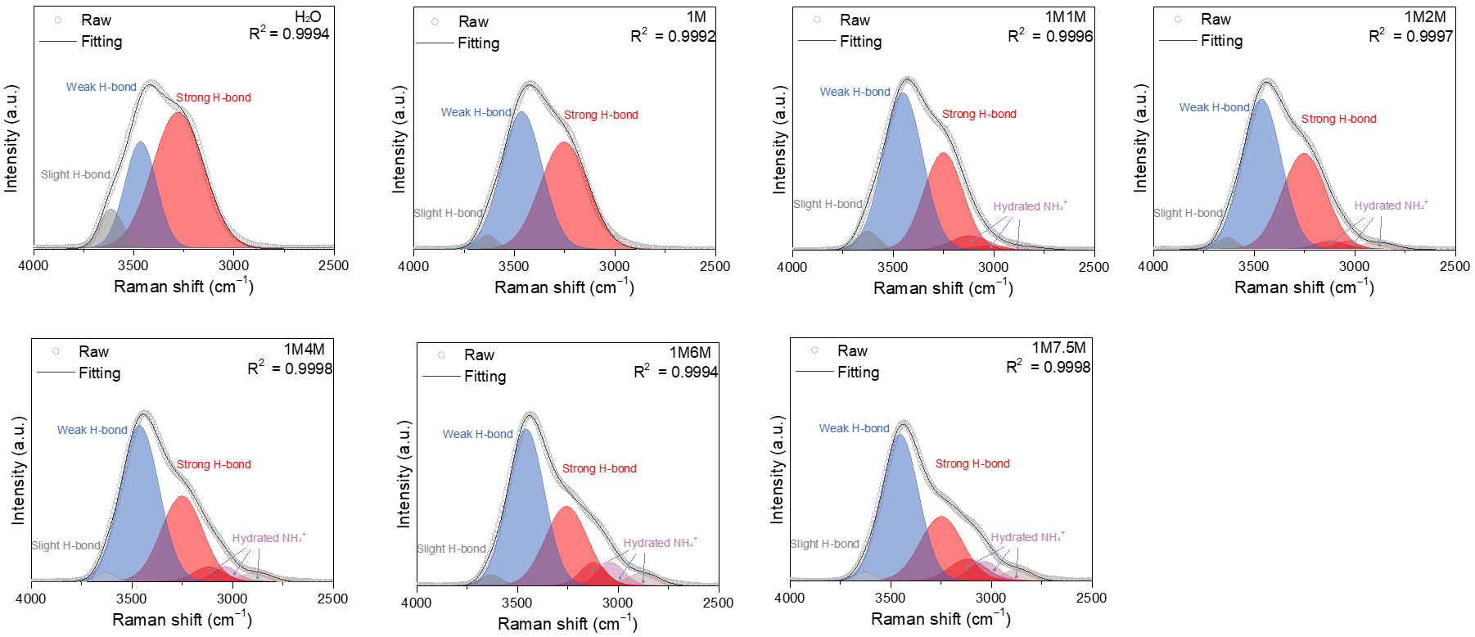
Supplementary Fig. 1 │ Raman spectra of aqueous solutions. Deconvolution fitting of Raman spectra of pure H₂O, 1M, 1M1M, 1M2M, 1M4M, 1M6M and 1M7.5M. It can be seen that the hydrogen bond interaction gradually decreased with the increased concentration of NH₄Cl, which demonstrated that the NH₄⁺ disrupt the hydrogen bond network among H₂O molecules and formed the NH₄⁺-involved hydrogen bond network, hydrate NH₄⁺.

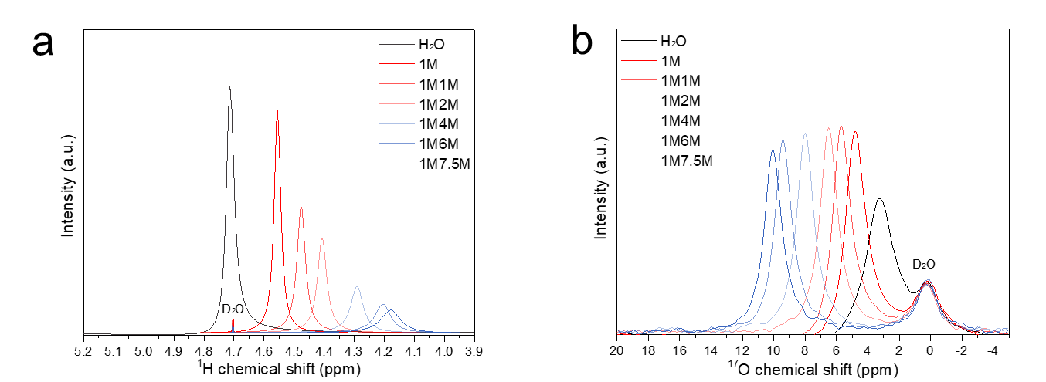
Supplementary Fig. 2 │ Weakening the hydrogen bond interaction among H₂O molecules. a, b, ¹H NMR spectra (a) and ¹⁷O NMR spectra (b) of pure H₂O, 1M, 1M1M, 1M2M, 1M4M, 1M6M and 1M7.5M. ¹H NMR signals and ¹⁷O NMR signals of H₂O moved to relatively lower and higher chemical shift, respectively, while increasing NH₄Cl concentration. They indicated the enhanced hydrogen bond interactions between H₂O and NH₄⁺ but decreased hydrogen bond interactions among H₂O molecules.

Supplementary Fig. 3 │ Schematic of two-electrode Swagelok-type cell.

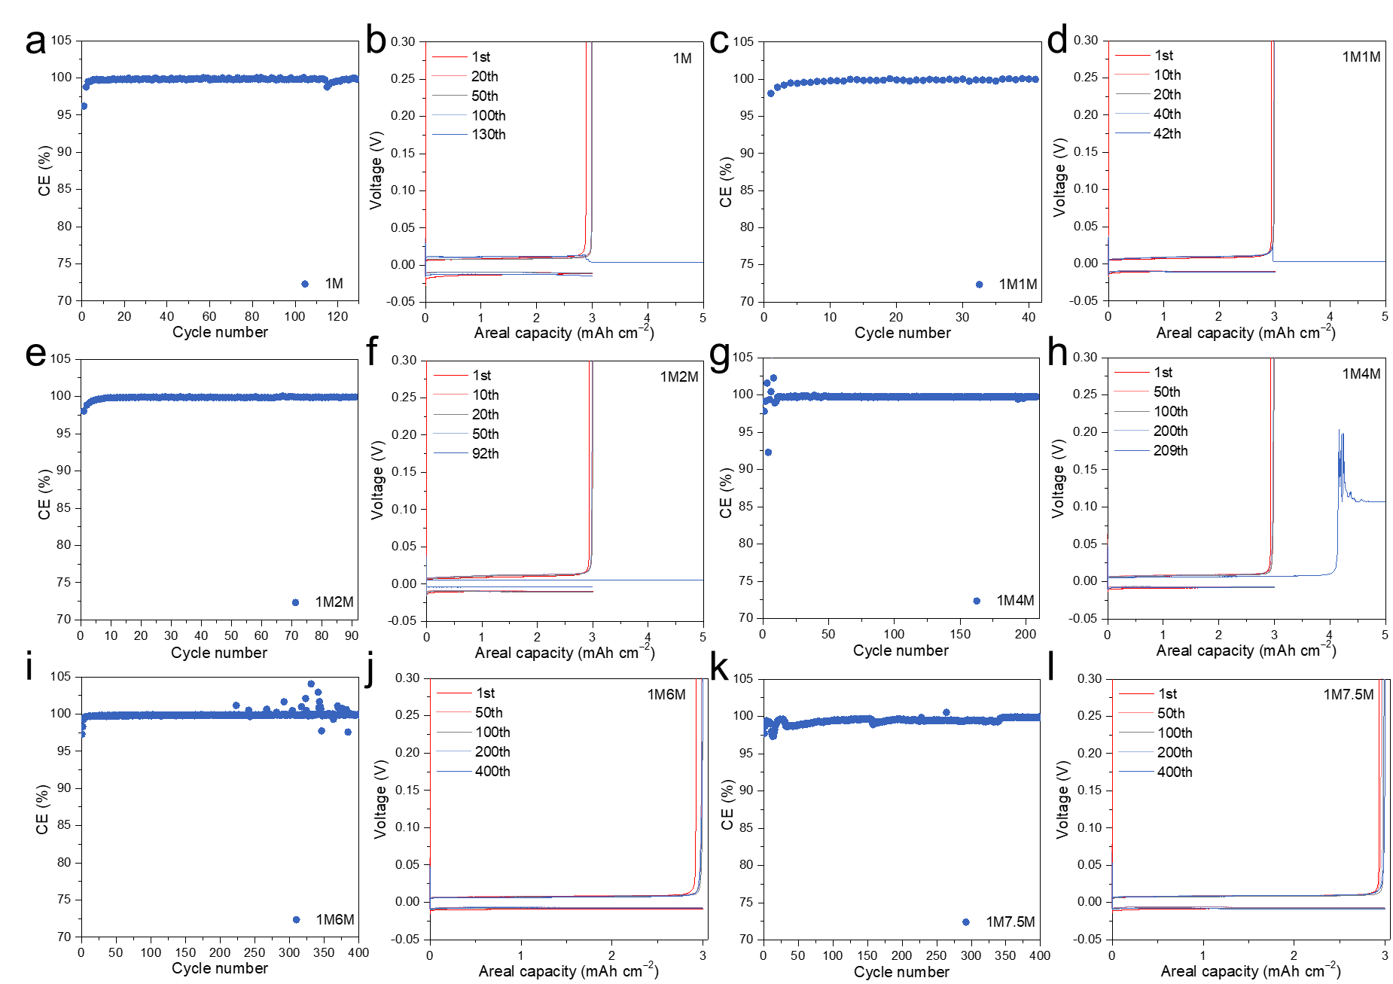
Supplementary Fig. 4 │ Cycling stability of Cd//Cu cells in different aqueous electrolytes. a-l, CEs of Cd plating/stripping measured at an areal capacity of 3 mAh cm⁻² and a current density of 2 mA cm⁻² in (a, b) 1M, (c, d) 1M1M, (e, f) 1M2M, (g, h) 1M4M, (i, j) 1M6M and (k, l) 1M7.5M electrolytes. CE vs. cycle index shown in a, c, e, g, i and k. Plating/stripping curves shown in b, d, f, h, j and l. The corresponding voltage polarization curves were shown in Supplementary Fig. 5.

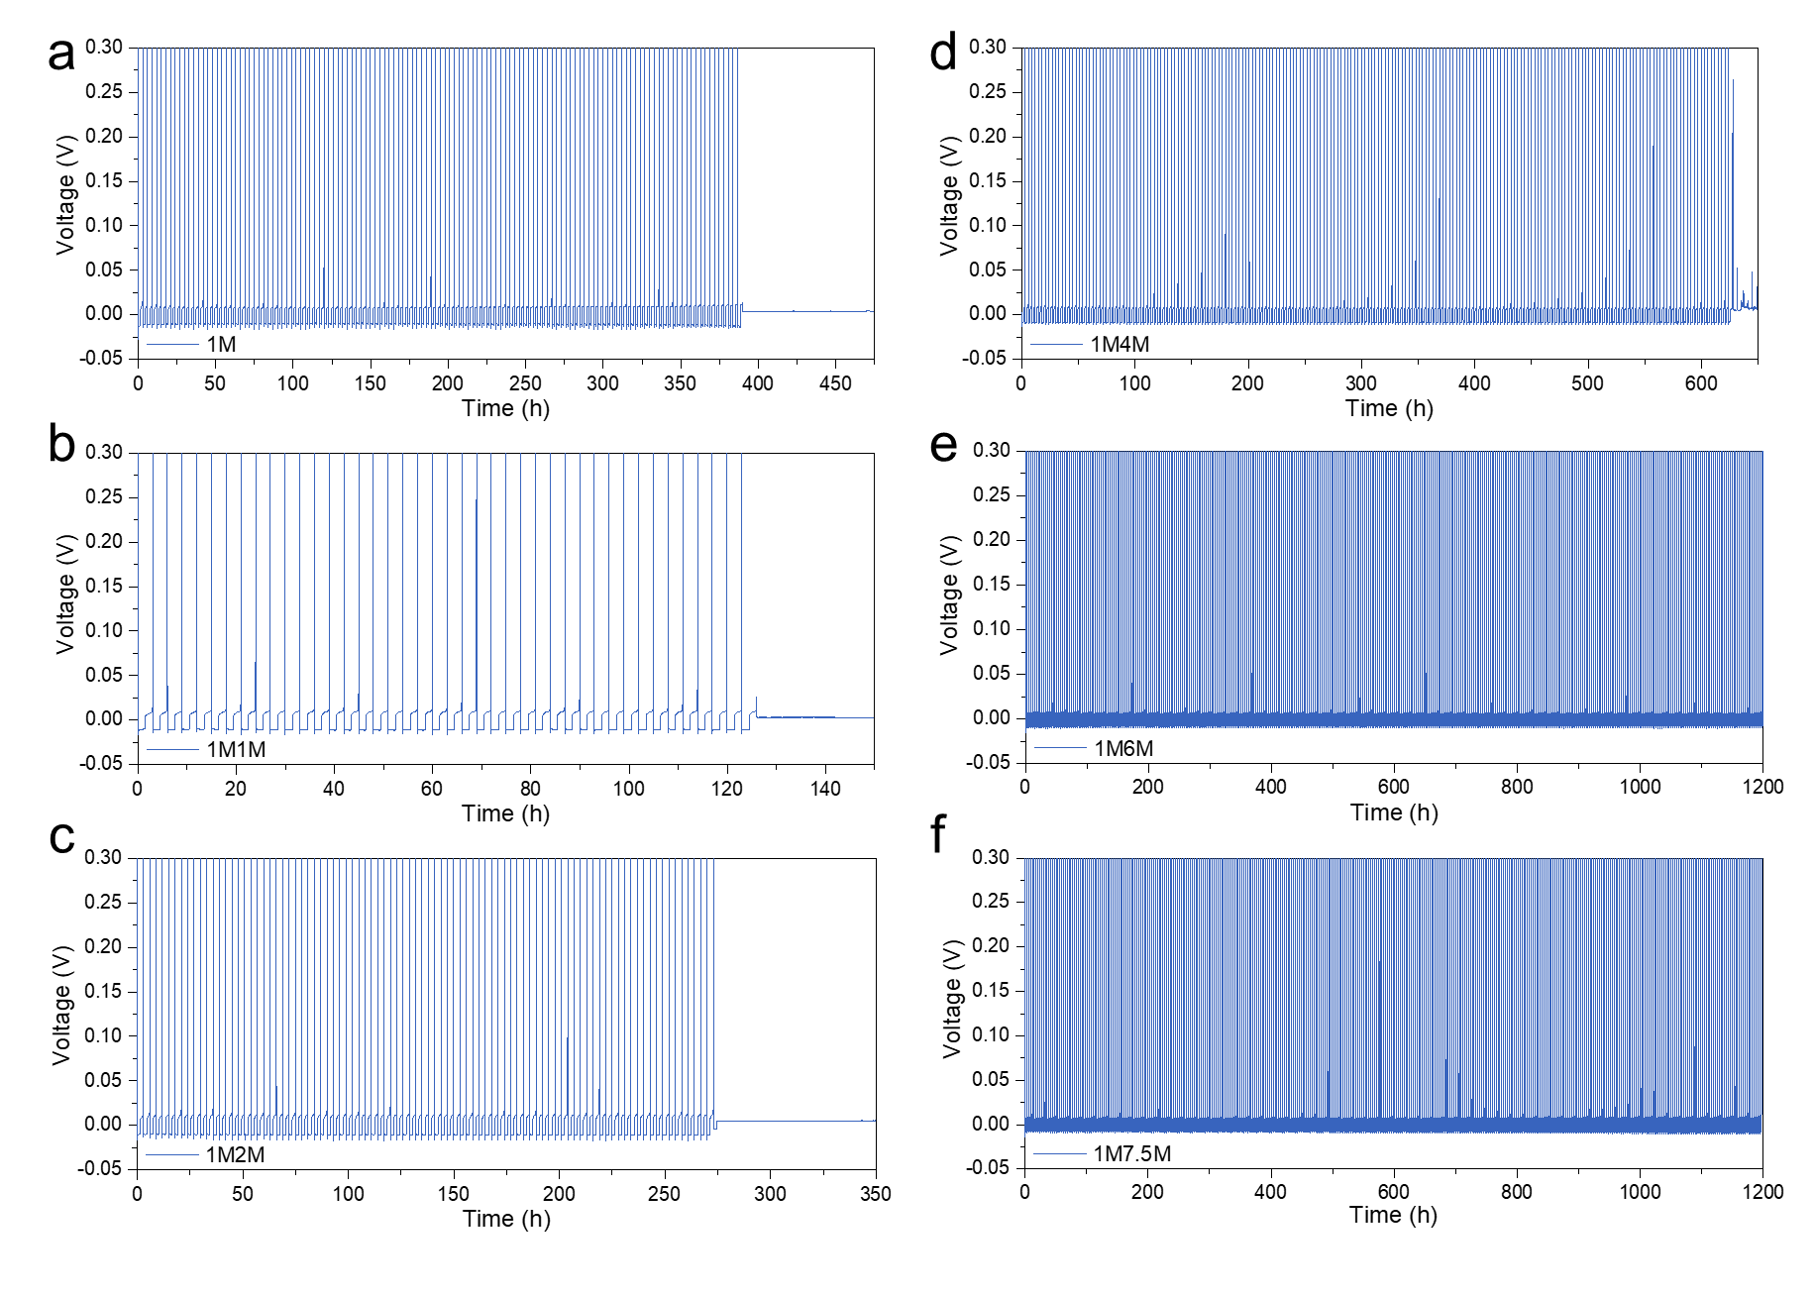
Supplementary Fig. 5 │ Voltage polarization curves of Cd//Cu cells in different aqueous electrolytes from Supplementary Fig. 4.
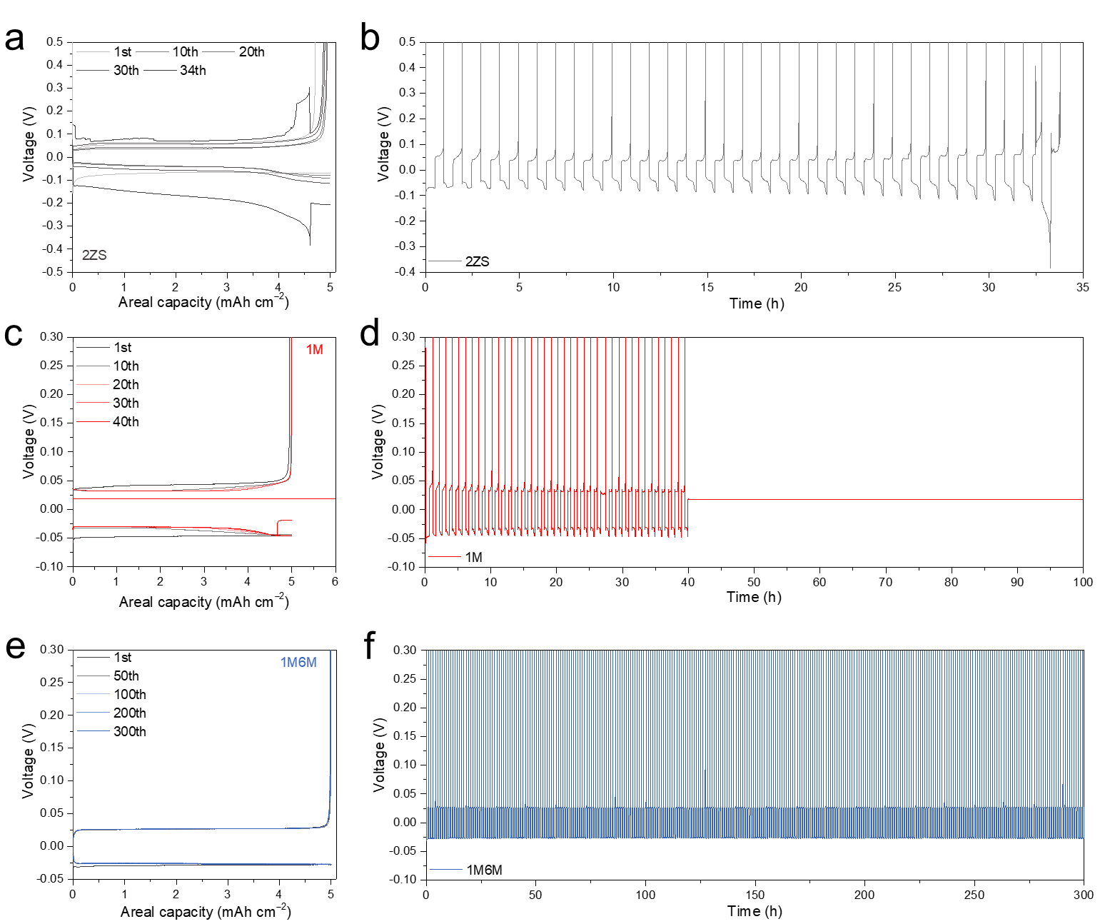
Supplementary Fig. 6 │ Cycling stability of Zn//Cu and Cd//Cu cells at AU of 55% in different aqueous electrolytes. a, b, Zn plating/stripping behaviors measured at an areal capacity of 5 mAh cm⁻² and a current density of 10 mA cm⁻² in 2ZS electrolyte (a, b). c-f, Cd plating/stripping behaviors measured at an areal capacity of 5 mAh cm⁻² and a current density of 10 mA cm⁻² in 1M electrolyte (c, d) and 1M6M electrolyte (e, f). Plating/stripping curves shown in a, c and e. Voltage polarization curves shown in b, d and f.

Supplementary Fig. 7 │ Morphologies of Zn and Cd anodes. a, b, SEM images of Cd anode (1M) in Cd//Cu cell (a) and Zn anode (2ZS) in Zn//Cu cell (b) after 10 cycles at AU of 55% obtained from Fig. 2f.

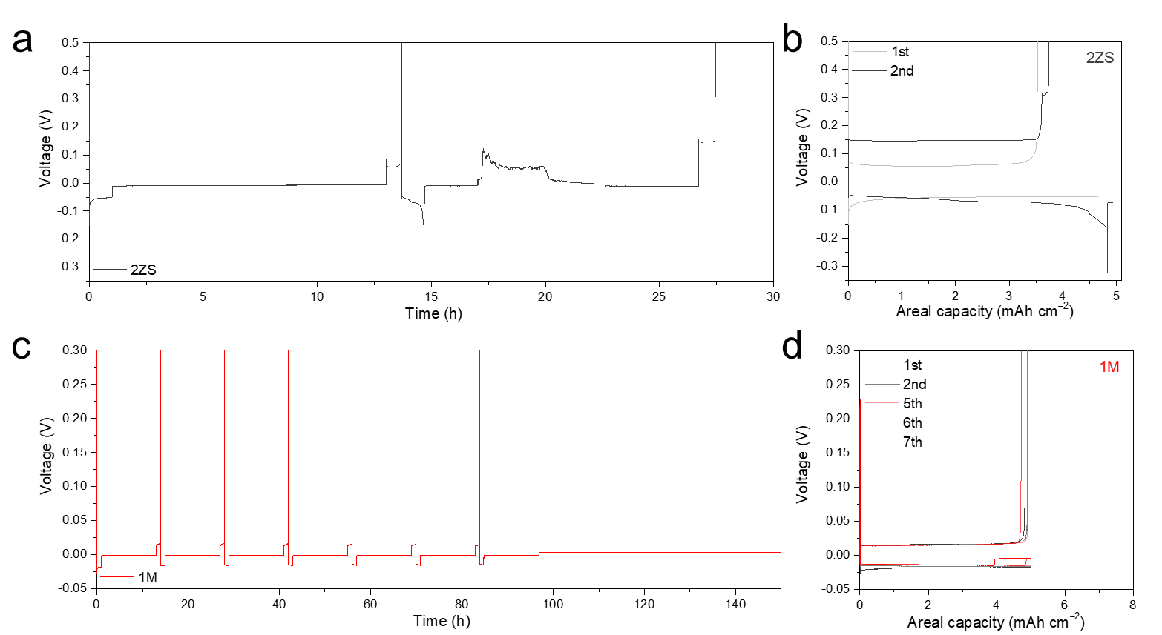
Supplementary Fig. 8 │ Quantifying aging behaviors in Zn and Cd anodes. a, b, Voltage polarization curve of Zn plating, aging and plating processes (a), and corresponding plating/stripping curves in 2ZS electrolyte (b). c, d, Voltage polarization curve of Cd plating, aging and plating processes (c), and corresponding plating/stripping curves in 1M electrolyte (d). Aging CEs measured at an areal capacity of 5 mAh cm⁻² and a current density of 5 mA cm⁻², aging 12 h, and then stripping at a current density of 5 mA cm⁻² for per cycle (a-d).
Supplementary Fig. 9 │Ex-situ SEM images of Cd plating/stripping behaviors on Cu foil in 1M electrolyte. P0.1, P0.5, P1, P2, P3, and P5 correspond to the plated areal capacities of 0.1, 0.5, 1, 2, 3, and 5 mAh cm⁻², respectively. S0.5, S1, S2, S3, S4.5, and S5 correspond to the stripped areal capacities of 0.5, 0.1, 2, 3, 4.5, and 5 mAh cm⁻², respectively.

Supplementary Fig. 10 │Ex-situ SEM images of Cd plating/stripping behaviors on Cu foil in 1M6M electrolyte. P0.1, P0.5, P1, P2, P3, and P5 correspond to the plated areal capacities of 0.1, 0.5, 1, 2, 3, and 5 mAh⁻², respectively. S0.5, S1, S2, S3, S4.5, and S5 correspond to stripped areal capacities of 0.5, 0.1, 2, 3, 4.5, and 5 mAh cm⁻², respectively.

Supplementary Fig. 11 │ Ex-situ SEM images of Zn plating behavior on Cu foil in 2ZS electrolyte. a-c, P1, P3, and P5 correspond to plating areal capacities of 1 (a), 3 (b), and 5 mAh cm⁻² (c), respectively.
Supplementary Fig. 12 │ FIB-SEM images of Cd deposits. a, b, FIB areas of Cd deposits in 1M electrolyte (a) and 1M6M electrolyte (b).

Supplementary Fig. 13 │ Exchange current measurements in different aqueous electrolytes. a, b, Cyclic voltammetry for symmetric Cd//Cd cells at a scan rate of 10 mV s⁻¹ in a voltage range from 0 mV to ±40 mV vs. open circuit voltage (OCV) in 1M electrolyte (a) and 1M6M electrolyte (b).

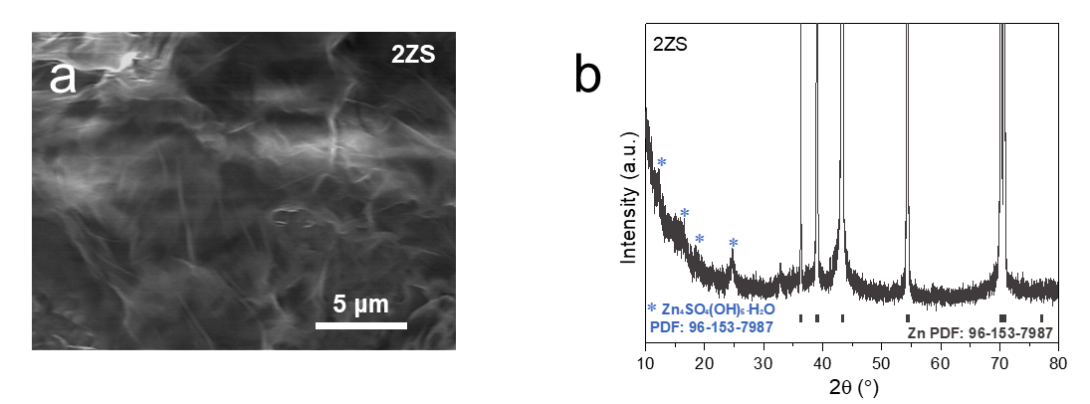
Supplementary Fig. 14 │ Corrosion-resistant capability of Zn anode. a, b, SEM image (a) and XRD pattern (b) of Zn anode obtained from the failed Zn//Zn symmetric cell in Fig. 4c.

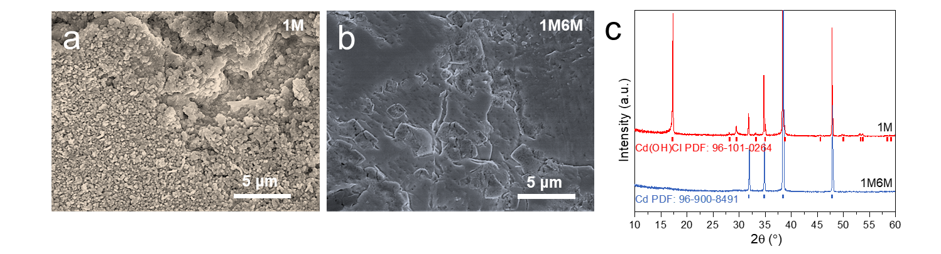
Supplementary Fig. 15 │ Corrosion-resistant capability of Cd anode. a-c, SEM images of Cd anodes in 1M electrolyte (a) and 1M6M electrolyte (b), and the corresponding XRD patterns (c). Cd anodes obtained from the Cd//Cd symmetric cells after cycling 229 h in Fig. 4c.
Supplementary Fig. 16 │ Kinetics of Cd//PANI full cells. a, b, EIS of Cd//PANI full cells in 1M electrolyte (a) and 1M6M electrolyte (b) obtained from the CVs after different cycles in Fig. 5a. The EIS of after different cycles of CV demonstrated that the full cell using 1M6M electrolyte has the better reaction kinetics and electrochemical interface with smaller charge transfer impedance, compared to the full cell using 1M electrolyte.
Supplementary Fig. 17 │ Kinetics of Cd//PANI full cells. a, b, CV curves of Cd//PANI full cells at a scan rate of 10 mV s⁻¹ in a voltage range from 0 mV to ±40 mV vs. OCV in 1M electrolyte (a) and 1M6M electrolyte (b). c, Corresponding exchange current density.

Supplementary Fig. 18 │Rechargeable capability of Cd//PANI full cells. a, b, Long cycling performance of full cells in 1M electrolyte at 1.12 C (a) and 50.34 C (b). The Cd//PANI full cell in 1M electrolyte performed the poor rechargeability at a low rate of 1.12 C and the rapid capacity decay at a high rate of 50.34 C limited by their slow kinetics and potential side reactions in 1M electrolyte.

Supplementary Fig. 19│Elctrochemistry of Cd//AC capacitors. a, b, CV curves of Cd//AC capacitors at different scan rates between voltage of 0 V and 1.3 V in 1M electrolyte (a) and 1M6M electrolyte (b). c, d, Cyclic CV curves of Cd//AC capacitors at a fixed scan rate of 50 mV s⁻¹ between voltage of 0 V and 1.3 V in 1M electrolyte (c) and 1M6M electrolyte (d). e, Cycling stability of Cd//AC capacitor in 1M6M electrolyte at a fixed discharge/charge current density of 10 mA cm⁻² in 1M6M electrolyte. Supplemental Fig. 19a, b showed that the CV curves of the Cd//AC capacitor in 1M6M electrolyte at different scan rates from 20 to 100 mV s⁻¹ maintain regular rectangle shape with larger response currents than that of the cell in 1M electrolyte, indicating the characteristic of electronic double layer capacitors. In addition, the more effective capacitive behaviors with well overlapped CV curves within 10,000 cycles at a scan rate of 50 mV s⁻¹ were observed in Cd//AC capacitor in 1M6M electrolyte compared to the Cd//AC capacitor in 1M electrolyte (Supplemental Fig. 19c, d).
Supplementary Fig. 20 │ Rechargeable capability of Cd//V₂O₅ full cell. a, b, Cycling performance of Cd//V₂O₅ cell in 1M6M electrolyte at a current density of 5 mA cm⁻² (a) and the corresponding discharge/charge curves (b).

Supplementary Fig. 21 │ Elctrochemistry of high-load Cd//PANI full cell. a, Rechargeable capability of Cd//PANI full cell in 1M electrolyte at a current density of 10 mA cm⁻². b, Voltage curves of intermittent usage of a full cell in 1M electrolyte with a high-load cathode (38.22 mg cm⁻²) and low N/P rate (1.91) at 5 mA cm⁻² and interval 12 h (g)

