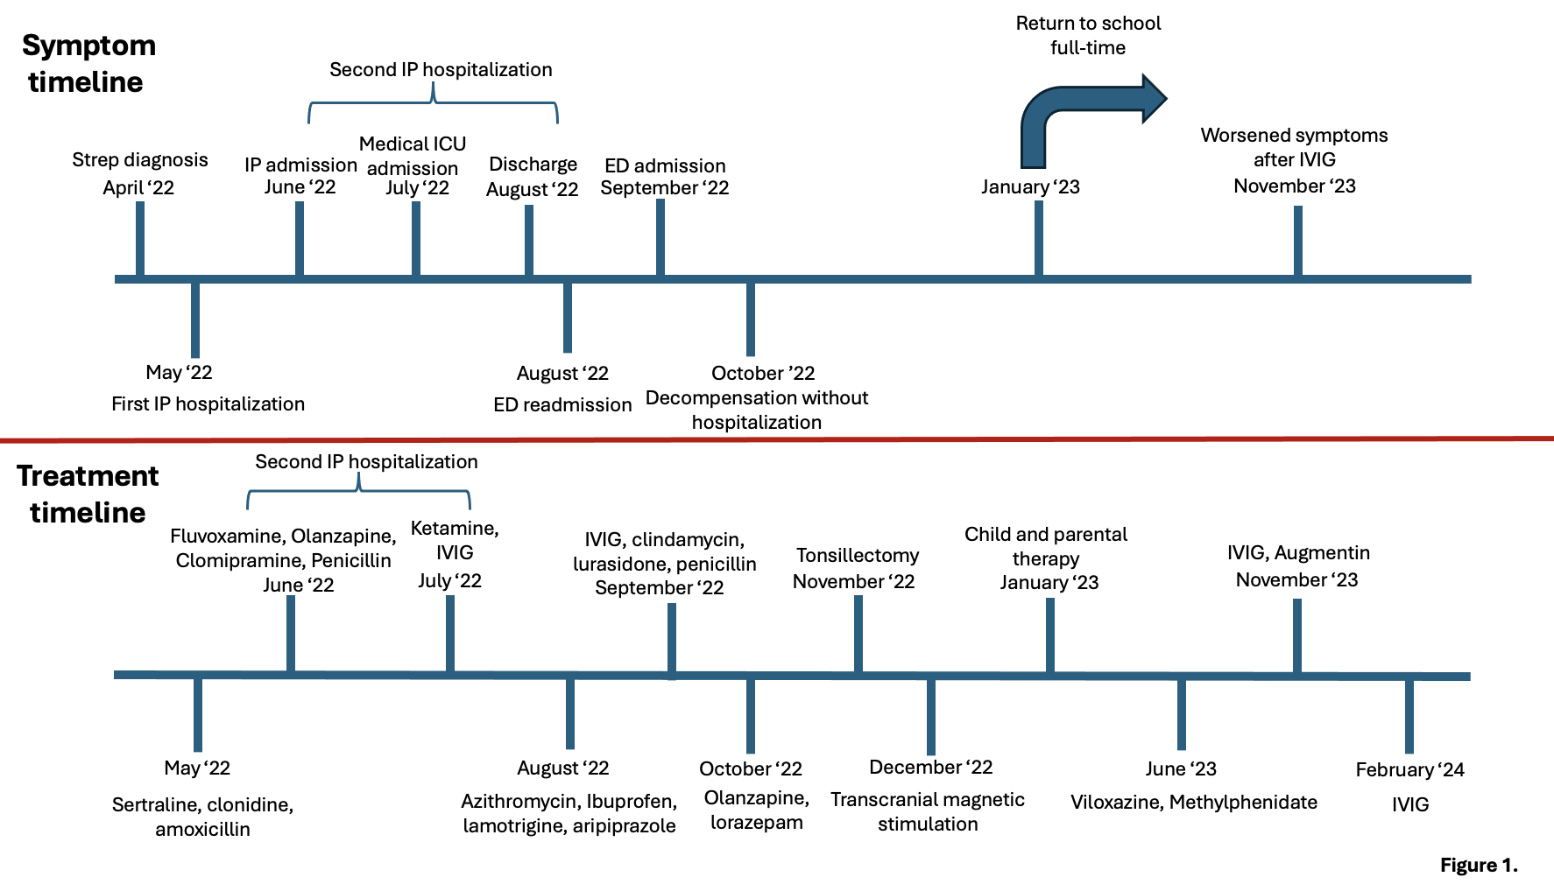
Figure 1. Timeline of symptoms (top) and treatments(bottom). Symptom timeline includes first streptococcus diagnosis, inpatient psychiatric hospitalizations, medical ICU admission, ED admissions, decompensation without hospitalization, and return to school as a marker of functionality. Treatment timeline includes both pharmacological and non-pharmacological therapies for OCD, PANDAS, and ADHD. Abbreviations from top left to bottom right: (Strep- Group A b-hemolytic Streptococcus pyogenes; IP- Inpatient psychiatric unit; ICU- intensive care unit; ED- Emergency Department; IVIG- Intravenous Immunoglobulin)

