Age specific neuroprotection of curcumin through differential modulation of dopamine metabolism: Insights from Drosophila model of Parkinson’s disease

Mohamad Ayajuddin^{1,2}, Abhik Das¹, and Sarat Chandra Yenisetti¹*

¹ Drosophila Neurobiology Laboratory, Department of Zoology, Nagaland University (Central), Lumami 798 627 Nagaland state, India
² Department of Zoology, Lilong Haoreibi College, Usoipokpi 795130, Manipur, India
*Corresponding author: Drosophila Neurobiology Laboratory, Department of Zoology, Nagaland University (Central), Lumami 798 627 Nagaland state, India; Phone: +91 9402908988; Email: sarat@nagalanduniversity.ac.in; yschandrays@rediffmail.com

Supplementary figures:

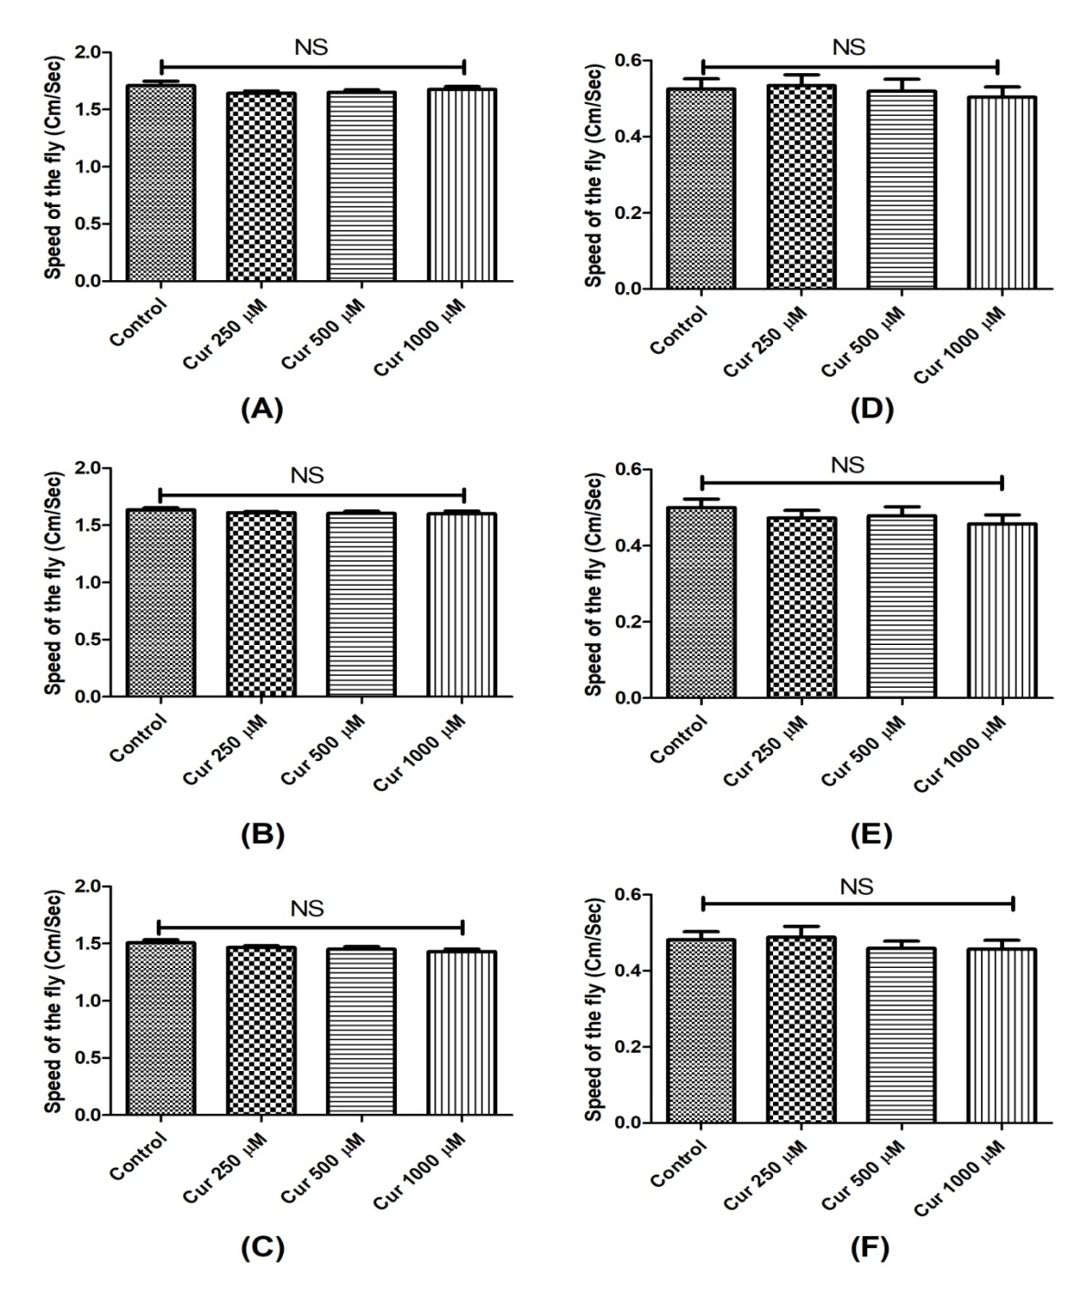

Figure S1: CUR does not cause perturbations in mobility of Drosophila during early health and transition phase: Feeding with CUR concentrations of 250 µM, 500 µM and 1000 µM for 3 days (A), 5 days (B) and 7 days (C) of the early health phase flies resulted in no mobility perturbations. Feeding the flies of the transition phase with the same concentrations of CUR for 1 day (D), 3 days (E) and 5 days (F) resulted in no mobility defects too. There was no mortality at these time points. (One-way ANOVA followed by the Newman-Keuls Multiple Comparison Test showed no significant difference in mobility. NS- Not Significant)

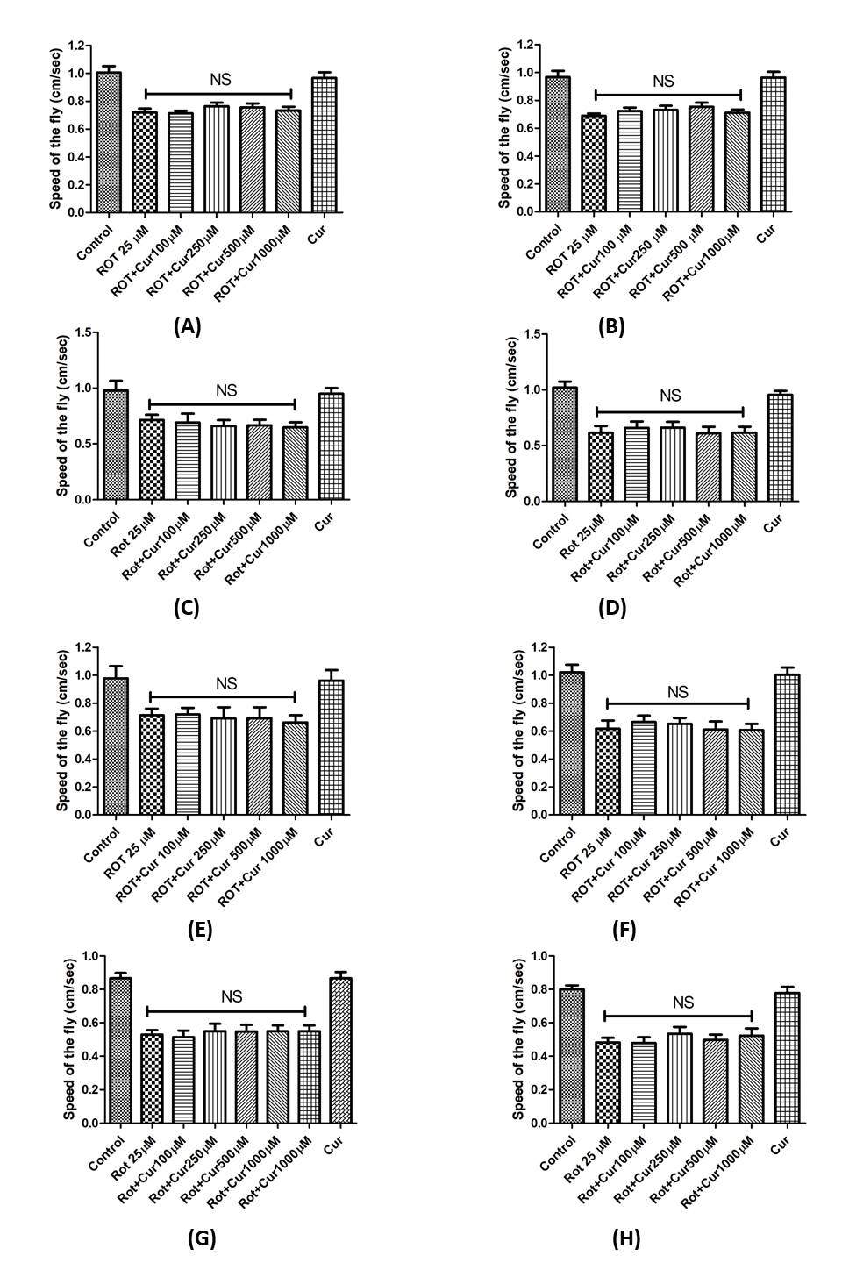

Figure S2: Curcumin fails to rescue rotenone induced mobility defects during the late health phase of adult life in Drosophila model of PD: Negative geo-taxis assay of the late health phase fly in co-feeding regime (A & B) and pre-feeding regimens (C – H): In the co-feeding regimen, fly was fed with ROT alone or ROT along with CUR for 2 days and the mobility defect was assessed on 1st day (24 Hr) (A) and 2nd day (48 Hr) (B). In the Pre-feeding regimen, fly was pre-fed with CUR alone for 2 days (C & D), 3 days (E & F) and 5 days (G & H) and exposed to ROT for 2 days and the mobility defects were assessed on 1st day (24 Hr) (C, E & G) and 2nd day (48 Hr) (D, F and H). CUR fails to rescues mobility defects during the late health phase in both the co-feeding and pre-feeding regimens in fly model of ROT-mediated sporadic PD. (One way ANOVA followed by Newman-Keuls Multiple Comparison Test showed no significant difference in mobility. NS- Not significant)
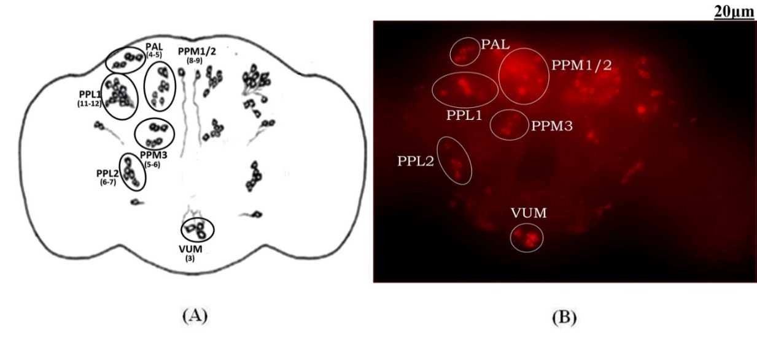

Figure S3: Quantifiable dopaminergic neuronal clusters in whole brain of Drosophila: Cartoon of Drosophila brain depicting the position of quantifiable dopaminergic neurons (A); and image of whole-brain mount of Drosophila captured by ZEN software of Carl Zeiss Fluorescence Microscope using fluorescently labelled secondary antibody targeted against the primary anti-TH antibody (B). The scale bar of the image in the panel is 20 µm. There are around 141 dopaminergic neurons (including ~ 100 neurons of PAM cluster which could not be counted using this method) arranged in different clusters in each hemisphere. (PAL- Protocerebral Anterior Lateral; PAM- Protocerebral Anterior Medial; PPL- Protocerebral Posterior Lateral; PPM- Protocerebral Posterior Medial; VUM- Ventral Unpaired Medial)

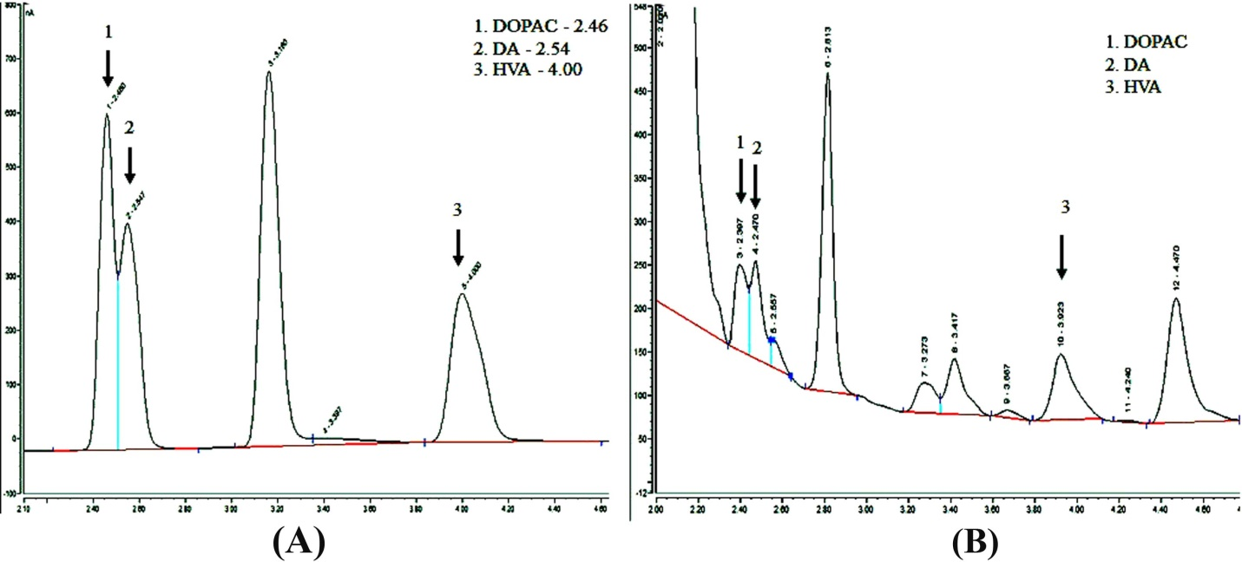

Figure S4: Characterization of retention time (RT) of standard DA and its metabolites (DOPAC and HVA) and brain-specific catecholamines levels: Chromatogram of the standard catecholamines (A) gives a particular RT (DOPAC- 2.46, DA- 2.54 and HVA- 4.00) comparing with which the corresponding RT of the catecholamines in the fly brain sample (B) was analyzed.

