Supplementary Information
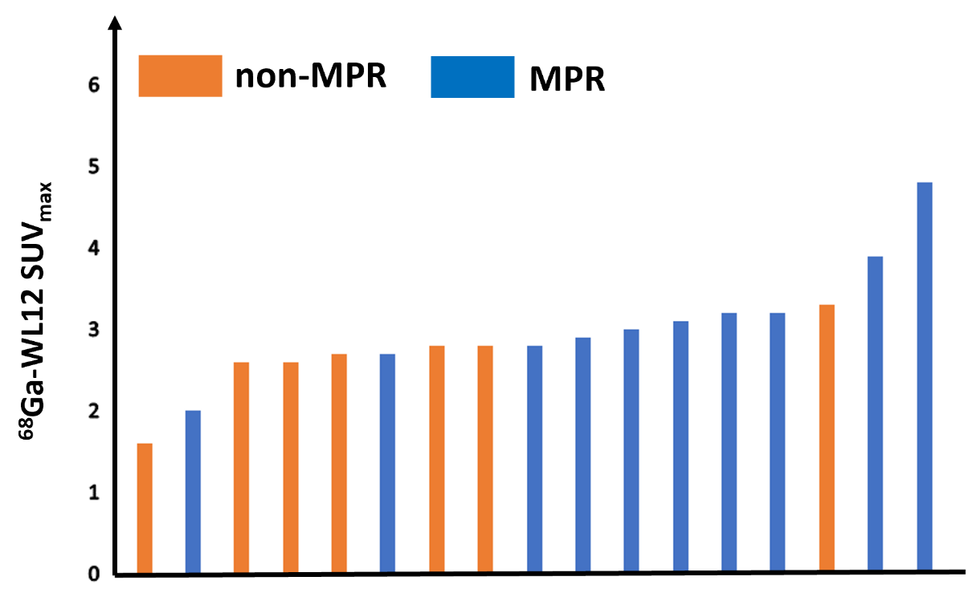
Supplementary Figure 1. Waterfall chart of ⁶⁸Ga-NOTA-WL12 SUV_{max}

