Supplementary Material
“Bears are like family”: Indigenous knowledge of human-polar bear coexistence amidst rapid social-ecological change.

Katharina M. Miller^{1,5*}, Georgina Berg^{2,3}, Indigenous Knowledge Keepers of Churchill³,
Michael Lickers¹, Dominique A. Henri^{4*}

¹ Royal Roads University, Victoria, BC, Canada
² Cree Elder, Churchill, MB, Canada
³ Indigenous Knowledge Keepers, Churchill, MB, Canada
⁴ Wildlife Research Division, Environment and Climate Change Canada, Montreal, QC, Canada
⁵ Carleton University, Ottawa, ON, Canada

*Katharina M. Miller, ktmiller@cmail.carleton.ca
*Dominique A. Henri, Dominique.Henri@ec.gc.ca

Keywords: polar bear, Ursus maritimus, coproduction of knowledge, coexistence, wildlife, Indigenous knowledge

Graphic Design: © Nickia McIvor

Submitted as supplementary file in: Miller, K. M., Berg, G., Indigenous Knowledge Keepers of Churchill, Lickers, M., & Henri, D. A. “Bears are like family”: Indigenous knowledge of human-polar bear coexistence amidst rapid socialecological change. Nature Communications Earth & Environment. In Press (2024).

Table of Contents
Background 3
Town of Churchill Map 3
Churchill Coastline Map 4
Churchill historical context 5
Churchill timeline 6
Arts-based dissemination of results 10
Episode 1: Distant Past 11
Episode 2: Past 12
Episode 3: Present 13
Episode 4: Future 14
Applied research for conservation action 15
Future visions 15
References 17

Background
The Churchill polar bear coexistence storywork research project¹ is a cocreated initiative to document Indigenous knowledge of human–polar bear coexistence in the community of Churchill, Manitoba, Canada². The results of this research project are presented in writing as well as through podcasts, created for the community to have a non-academic archived and culturally relevant version of the results². Although the project is location specific, the results may be relevant to other communities coexisting with bears, as well as researchers looking to find new ways to engage communities².
This supplementary material provides additional Churchill-specific nuance and detail to the peer-reviewed publication and may be particularly useful to researchers, government agencies, business owners, organizations, or others working or seeking to work in the region.
Town of Churchill Map
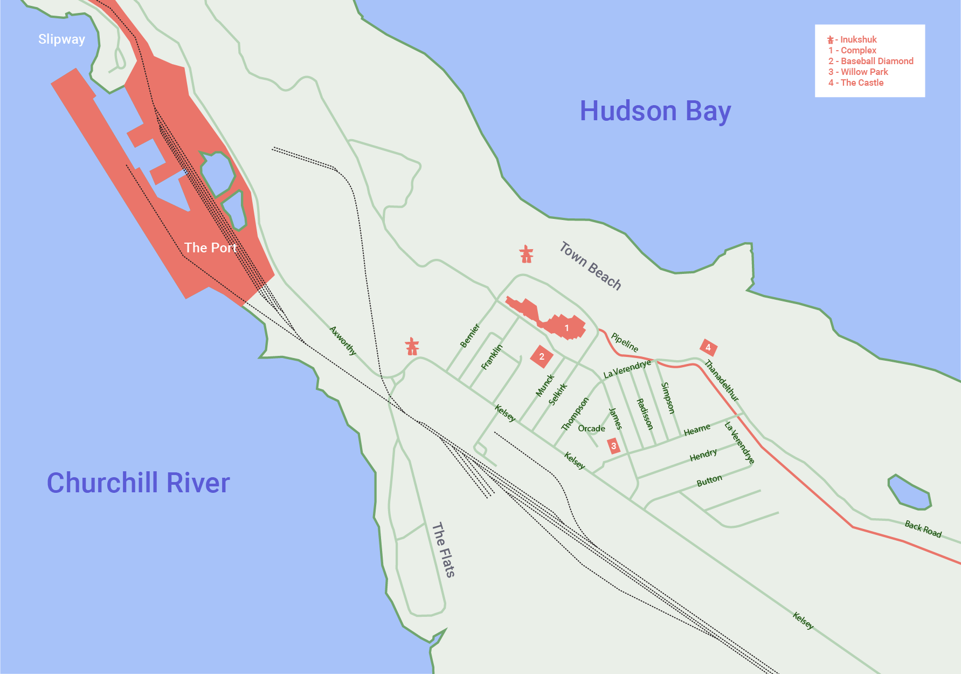
Supplementary Figure 1. A close-up map of the town of Churchill. This map provides context for locations mentioned in our research and podcasts, specifically an area called the Flats along the Churchill River, and the Pipeline which is referenced often by knowledge holders.

Churchill Coastline Map

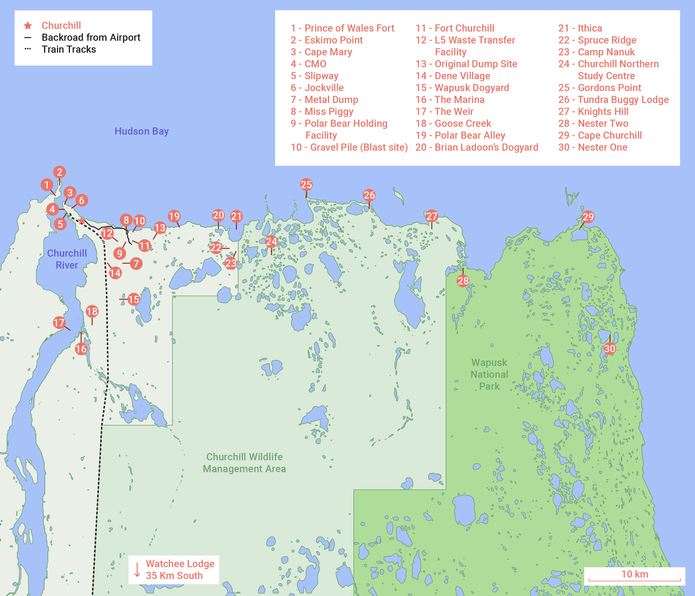
Supplementary Figure 1. A map of locations of interest related to human-polar bear coexistence along the coastline of Hudson Bay. Many land-based interactions between polar bears and people take place between the town of Churchill and Cape Churchill in Wapusk National Park. This map provides context for locations mentioned in our research and podcasts.

Churchill historical context
The depth of nuance and historical information about any given place cannot be contained within the bounds of a single research paper. Churchill, Manitoba, Canada, has a rich history and a unique story from pre-colonial times through present day, which could be endlessly studied, documented, and explored, as it continues to be recreated. During this research project the lead author took notes of significant dates and events that arose in sharing circles, stories, community engagement and academic literature reviewed. Although not exhaustive, it provides a unique depiction of the intersection of significant Indigenous events and other events related to polar bears that illustrate some of the changes over time that are explored throughout the Churchill polar bear coexistence storywork project^{1,2}.
By weaving notable Indigenous events and events related to polar bears the timeline created shows the interplay between colonization and wildlife management, highlighting the rapid social and cultural change that occurred, and adding human dimensions to the understanding of polar bear coexistence in the region². Research shows that the Arctic has experienced rapid ecological change over the last century, including significant human caused climate warming³. By considering ecological and social change together, stewards can develop a more comprehensive understanding to better inform conservation actions^{2,4,5}.
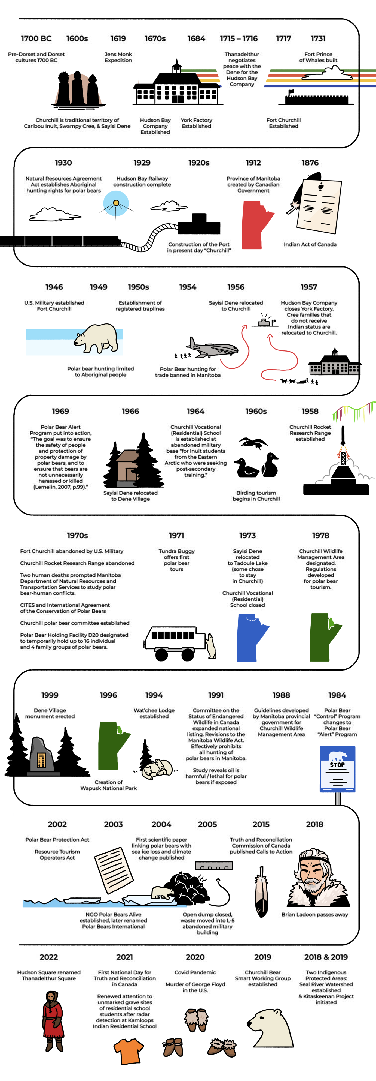
© Nickia McIvor

Supplementary Figure 3. A timeline of notable Indigenous events and events related to polar bears in Churchill, Manitoba, Canada. By looking at ecological change alongside cultural, social, and economic change this graphic was designed to illustrate a more inclusive narrative of human-polar bear relationships. This graphic is cocreated with graphic designer and knowledge holder Nickia McIver.
Churchill Timeline Contents
Date | Description
1700 BC | Pre-Dorset and Dorset cultures 1700 B.C^{6,7}.
1600’s | Churchill is traditional territory of the Inuit, Swampy Cree, and Sayisi Dene⁸.
1619 | Jens Monk expedition^{2,9}.
1670’s | Hudson Bay Company established⁸.
1684 | York Factory established⁸.
1715-1716 | Thanadelthur negotiates peace with the Sayisi Dene for the Hudson Bay Company^{2,10}.
1717 | Fort Churchill established by the Hudson Bay Company⁸.
1731 | Fort Prince of Whales built⁸.
1876 | Indian Act of Canada passed¹¹.
1912 | Province of Manitoba expands to include Churchill region¹².
1920’s | Construction of the Port of Churchill⁸.
1929 | Hudson Bay railway construction completed^{8,13}.
1930 | Natural Resources Agreement Act establishes Aboriginal hunting rights for polar bears¹⁴.
1946 | U.S. Military established a base called Fort Churchill near the present day airport¹⁵.
1949 | Polar bear hunting limited to Aboriginal people¹⁶.
1950’s | Establishment of registered traplines¹³.
1954 | Polar bear hunting for trade banned in Manitoba¹⁶.
1956 | Sayisi Dene relocated from Duck Lake to Churchill^{17,18}.
1957 | Hudson Bay Company closed York Factory. Cree families that did not receive Indian status are relocated to Churchill^{8,19}.
1958 | Churchill Rocket Research Range established¹⁴.
1960’s | Birding tourism begins in Churchill¹³.
1964 | Churchill Vocational School established, “for Inuit students from the Eastern Arctic who were seeking post-secondary training²⁰.”
1966 | Sayisi Dene relocated from Camp 10 to Dene Village^{17,18}.
1969 | Polar Bear Control program established¹³.
1970’s | Fort Churchill is abandoned by the U.S. military¹⁵.
1970’s | Churchill Rocket Research Range is abandoned¹⁵.
1970’s | Two human deaths prompted Manitoba Department of Natural Resources and Transportation Services to study polar bear-human conflicts¹³.
1970’s | CITES²¹, and the International Agreement on the Conservation of polar bears²².
1970’s | Churchill polar bear committee is established¹³.
1970’s | Polar bear holding facility (called D20 locally) is designated to temporarily hold up to 16 individual polar bears and 4 family groups¹³.
1971 | Tundra Buggy offers first polar bear tours²³.
1973 | Sayisi Dene relocated to Tadoule Lake^{17,18}.
1973 | Churchill Vocational School (residential school) is closed²⁰.
1978 | Churchill Wildlife Management Area is designated. Regulations are developed for polar bear tourism²⁴.
1984 | Polar Bear Control program renamed to Polar Bear Alert¹³.
1988 | Wildlife viewing guidelines are developed by Manitoba provincial government for Churchill Wildlife Management Area¹³.
1991 | Committee on the Status of Endangered Wildlife in Canada expanded national listing. Revisions to the Manitoba Wildlife Act effectively prohibits all hunting of polar bears in Manitoba¹³.
1991 | Study reveals oil is harmful and lethal to polar bears if exposed²⁵.
1994 | Wat’chee Lodge is established as a tourist destination to view mother polar bears and their cubs emerging from dens²⁶.
1996 | Wapusk National Park is established²⁷.
1999 | Dene Village monument is erected¹⁷.
2002 | Polar Bear Protection Act is passed²⁸.
2002 | Resource Tourism Operators Act is passed²⁹.
2003 | Charitable organization Polar Bears International established, originally called Polar Bears Alive³⁰.
2004 | First scientific paper linking polar bears with sea ice loss and climate change is published³¹.
2005 | Open dump is closed and waste is moved into abandoned military building (locally called L5) ^{13,32}.
2015 | Truth and Reconciliation Commission of Canada published Calls to Action³³.
2018 | Local legend, Brian Ladoon, known for his Canadian Eskimo dogs and their interactions with polar bears, passes away³⁴.
2018 | Two Indigenous protected areas are initiated: Seal River Watershed³⁵ and Kitaskeenan³⁶.
2019 | Churchill Bear Smart Working Group is established³⁷.
2020 | Covid-19 pandemic occurred³⁸.
2020 | George Floyd is murdered in the United States, with many protests that followed³⁹.
2021 | First National Day for Truth and Reconciliation in Canada⁴⁰.
2021 | Renewed attention to unmarked grave sites of residential school students after radar detection at Kamloops Indian Residential School⁴¹.
2022 | Hudson Square renamed Thanadelthur Square⁴².

Supplementary Table 1. The table above includes additional details and references for the dates and events included in the timeline (supplementary figure 1). Although not exhaustive, this list provides cultural, economic, and social context relevant to our research.
Arts-based dissemination of results
Four podcasts were created as a non-academic dissemination of the research results, specifically to return the knowledge back to the community in an approachable archived format^{1,2}. The podcasts are available to the community on the project website (churchillpolarbearcoexistence.com¹).
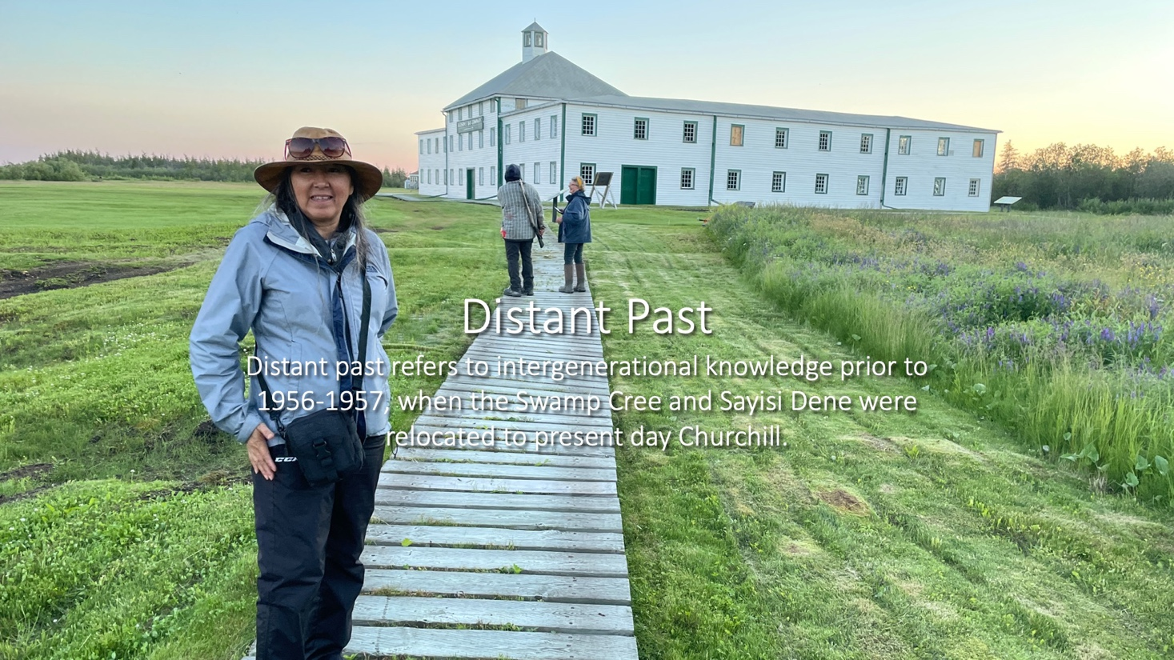
Supplementary Figure 4. The thumbnail image for a podcast on Indigenous knowledge of human-polar bear coexistence from the distant past time period. Knowledge from the distant past is shared, weaving content by theme, through the voices of the knowledge holders that contributed to this study. Photo: Katharina M. Miller.
Episode 1: Distant past
In the distant past, defined by this project as intergenerational knowledge prior to 1957, when the Cree and Dene were relocated to present-day Churchill, the fur trade was the primary economy on the shores of Hudson Bay. Polar bears were not often seen, and when spotted they were killed, with the meat primarily used for dog food and the hide sold to a trading post. Much intergenerational knowledge was lost when people were relocated to Churchill, where, to quote a Cree knowledge holderª, it was “all about a new life.” To listen to this podcast see Supplementary Video 1.
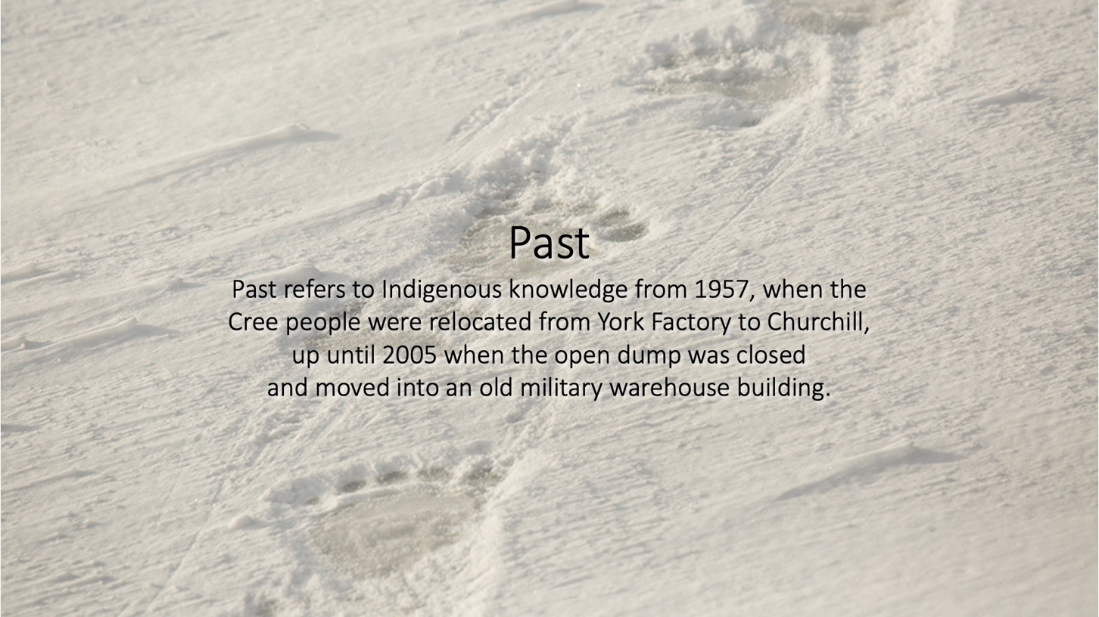
Supplementary Figure 5. The thumbnail image for a podcast on Indigenous knowledge of human-polar bear coexistence from the past time period. Knowledge from the past is shared, weaving content by theme, through the voices of the knowledge holders that contributed to this study. Photo: Katharina M. Miller.
Episode 2: Past
From 1957–2005, defined by this project as the past, the era of the fur trade came to an end and a new era of tourism began². Knowledge holders recalled the military shot a lot of polar bears and kept the hides, hanging them on their walls or using them as rugs. They also recalled seeing large numbers of bears eating burning garbage at the open dump. Concurrently, tourism began and polar bears started to become more valuable alive than dead. In 2005, the open dump was closed and moved inside an old military warehouse (known locally by the name L5)^{13,33}. Once the military left and the open dump closed, people started to see a lot more polar bears coming through town. Most contributors’ first memories of a polar bear occurred during this time period, outside of a cabin at the Flats, by a house in town, or at the dump. Even though all knowledge holders had encountered polar bears many times, they did not speak of polar bears fearfully, but rather with respect and sometimes even humor and joy. To listen to this podcast see Supplementary Video 2.
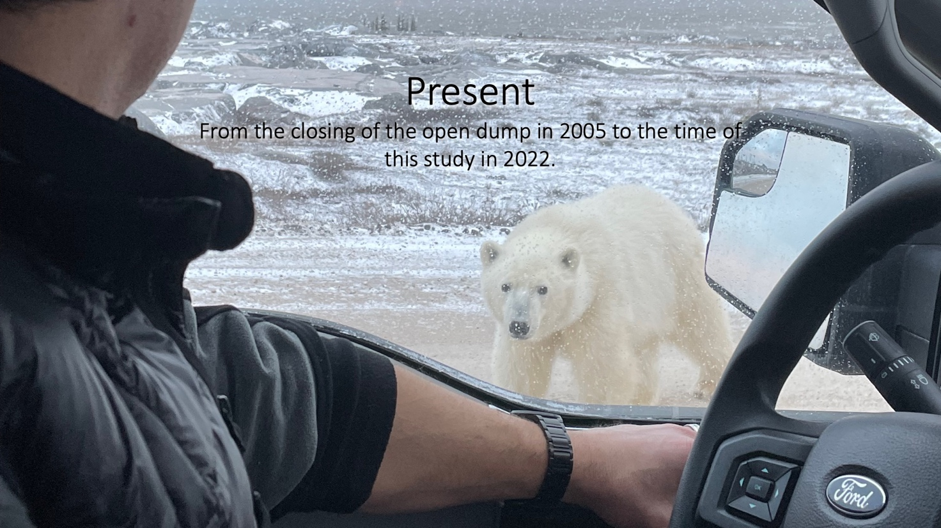
Supplementary Figure 6. The thumbnail image for a podcast on Indigenous knowledge of human-polar bear coexistence from the present time period. Knowledge from the present is shared, weaving content by theme, through the voices of the knowledge holders that contributed to this study. Photo: Katharina M. Miller
Episode 3: Present
In the present, defined as 2005–2022 for this study, most people’s knowledge of polar bears came through tourism and land-based activities.² Of knowledge holders, 83% were connected to tourism through their job in some way. Unlike their parents, children are now told not to play in the rocks along the coastline or walk on a local landmark frequently visited by polar bears known as “the Pipeline.” Many parents now drive their kids around town, especially at night, and raise their kids to always be bear aware, including having an exit plan when they are walking around town and utilizing buildings and vehicles to stay safe. Contributors generally shared that living with polar bears is a normal part of life and emphasized that if the bears are respected, they will reciprocate that respect. The Cree, Dene, and Métis knowledge holders expressed they have the utmost respect for Inuit culture related to polar bears, and specifically Inuit rights to harvest polar bears for cultural, economic, and subsistence purposes. To listen to this podcast see Supplementary Video 3.
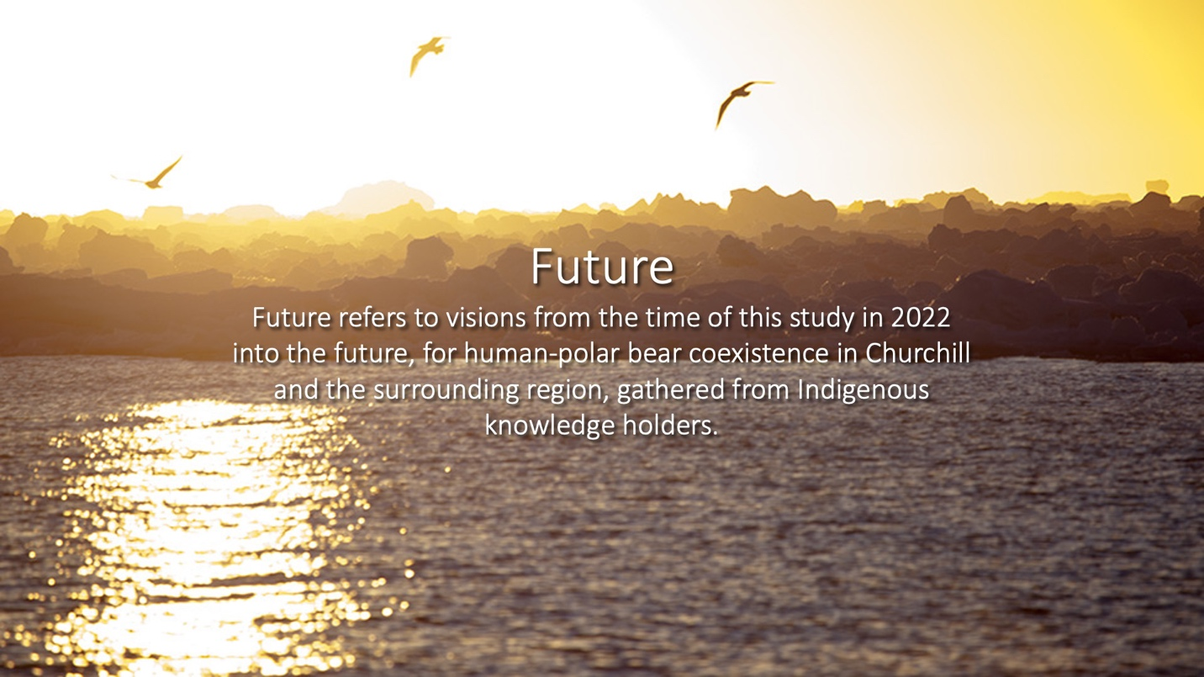
Supplementary Figure 7. The thumbnail image for a podcast on Indigenous knowledge of human-polar bear coexistence from the future time period. Knowledge for the future is shared, weaving content by theme, through the voices of the knowledge holders that contributed to this study. Photo: Katharina M. Miller
Episode 4: Future
Knowledge holders had many visions for the future of human–polar bear coexistence in Churchill, which synthesized into the five main themes:
- Protect tourism as an important industry and economy.
- Support proactive management and less invasive research.
- Elevate Indigenous knowledge in research and management.
- Improve bear safety education and awareness.
- Cultivate a culture of coexistence.
To listen to this podcast see Supplementary Video 4.
Applied research for conservation action
Scholars suggest that research involving Indigenous people should have real-world applications^{5,43} The inclusion of future visions in the research results provides recommendations for conservation action and supports self-determination and reconciliation^{2,5} (see Supplementary Figure 6).
Future visions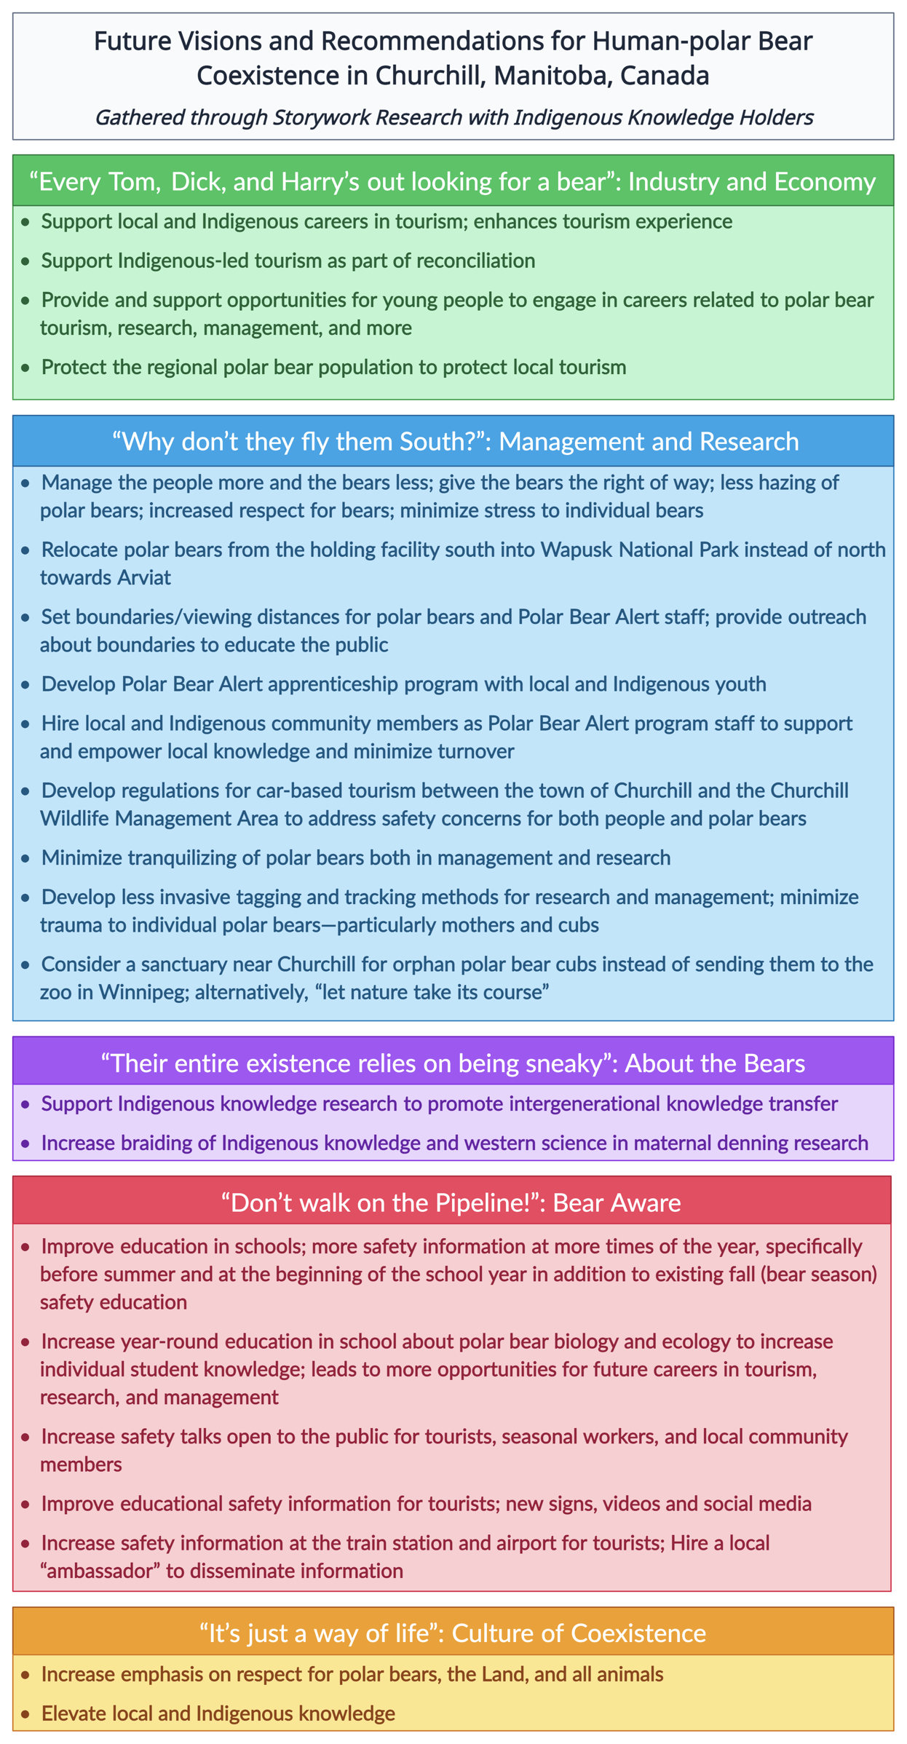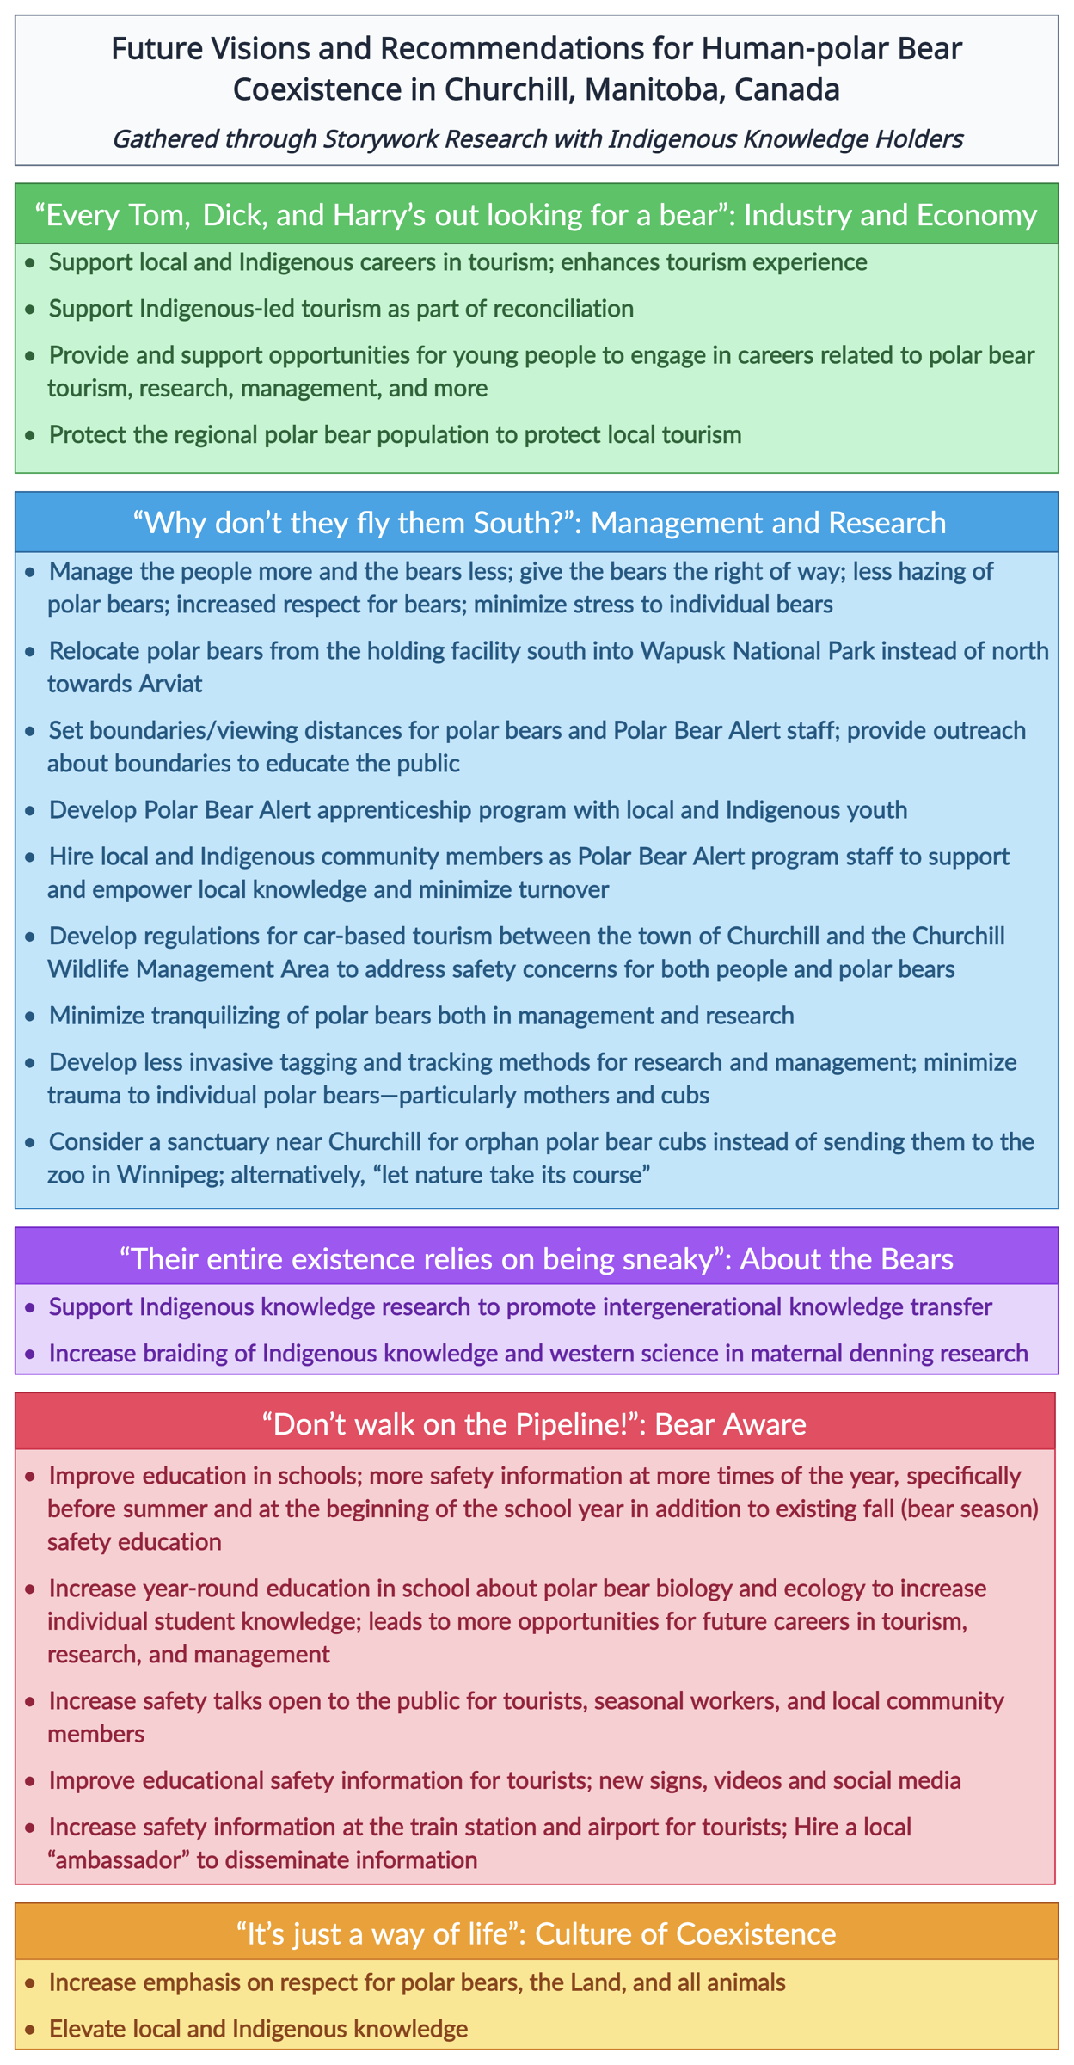
Supplementary Figure 8. Future visions research results for human–polar bear coexistence in Churchill, Canada as articulated by knowledge holders. The details in this figure relate to contributor’s future visions of human–polar bear coexistence, which may be relevant to specific audiences. Graphic: Katharina M. Miller.
References
- Miller, K. M. Indigenous Knowledge of Human-polar Bear Coexistence in Churchill, Manitoba: Churchill Storywork Project. https://www.churchillpolarbearcoexistence.com (2023).
- Miller, K. Indigenous Knowledge of Human–Polar Bear Coexistence in Churchill, Manitoba. Master’s thesis. (Royal Roads University, 2023).
- Rantanen, M. et al. The Arctic has warmed nearly four times faster than the globe since 1979. Commun Earth Environ 3, 168 (2022). https://doi.org/10.1038/s43247-022-00498-3
- Mayer, P. et al. Mapping human-and bear-centered perspectives on coexistence using a participatory Bayesian framework. J. Nat. Conserv. 73, 126387 (2023).
- Gagnon, C. A. et al. Climate, caribou and human needs linked by analysis of Indigenous and scientific knowledge. Nat. Sustain. 6, 769–779 (2023).
- Anderson, J. M., & Hodgetts, L. M. Pre-Dorset technological organization and land use in Southwestern Hudson Bay. Canad. J. Archaeol. 31, 224–249. (2007).
- Meyer, D. A. Pre-Dorset Settlements at the Seahorse Gully Site (Univ. of Ottawa Press, 1970).
- Brandson, L. E. Churchill Hudson Bay: A Guide to Natural and Cultural Heritage (Churchill Eskimo Museum Inc., 2012).
- Jens Munk North-West Passage expedition 1619–20. Royal Museums Greenwich. https://www.rmg.co.uk/stories/topics/jens-munk-north-west-passage-expedition-1619-20 (2024).
- Thanadelthur. Hudson’s Bay Company History Foundation. https://www.hbcheritage.ca/people/women/thanadelthur (2024).
- Indian Act of Canada. National Centre for Truth and Reconciliation. https://nctr.ca/wp-content/uploads/2021/04/1876_Indian_Act_Reduced_Size.pdf (2024).
- Manitoba Timeline. Manitoba Historical Society Archives. https://www.mhs.mb.ca/docs/features/timeline.shtml (2024).
- Lemelin, R. H. Human-polar bear interactions in Churchill, Manitoba: The socio-ecological perspective in Marine Wildlife and Tourism Management: Insights from the Natural and Social Sciences. 91–108 (CAB International, 2007).
- Natural Resources Agreement Act, 1938, CCSM c N40 [Manitoba]. https://www.canlii.org/en/mb/laws/stat/ccsm-c-n40/latest/ccsm-c-n40.html
- Fort Churchill. Manitoba Historical Society Archives. https://www.mhs.mb.ca/docs/sites/fortchurchill.shtml (2024).
- Polar Bears. Government of Manitoba. https://www.gov.mb.ca/nrnd/fish-wildlife/polar_bears/index.html (2024).
- Petch, V. P. Relocation and Loss of Homeland: The Story of the Sayisi Dene of Northern Manitoba Doctoral diss. (University of Manitoba, 1998).
- Bussidor, I., & Bilgen-Reinart, U. Night spirits: The story of the relocation of the Sayisi Dene (Vol. 10). (Univ. of Manitoba Press, 2000).
- Beardy, F., & Coutts, R. Voices from Hudson Bay: Cree Stories from York Factory (Vol. 5). (McGill-Queen’s University Press, 1996).
- Where were Manitoba’s residential schools—and what stands there now? CBC News. https://www.cbc.ca/news/canada/manitoba/residential-schools-list-1.6053586 (2021).
- Polar Bear. Convention on International Trade in Endangered Species of Wild Fauna and Flora. https://cites.org/eng/gallery/species/mammal/polar_bear.html (2021).
- Polar Bear Range States. The 1973 Agreement on the Conservation of Polar Bears. https://polarbearagreement.org/about-us/1973-agreement (1973).
- Savage, J. Tundra Buggy Adventure Tour: How to have the Ultimate Family Subarctic Experience in Churchill. https://adventureawaits.ca/tundra-buggy-adventure/ (2022).
- Lemelin, R. H. The gawk, the glance, and the gaze: Ocular consumption and polar bear tourism in Churchill, Manitoba, Canada. Curr. Issues Tour. 9, 516–534 (2006).
- Hurst, R. J., Watts, P. D., & Oritsland, N. A. Metabolic compensation in oil-exposed polar bears. J. Therm. Biol. 16, 53–56 (1991).
- Watchee Expeditions. Home. https://www.watchee.com (2018).
- Parks Canada History. Wapusk National Park of Canada Pronounced “Waa-pusk.” http://parkscanadahistory.com/publications/fact-sheets/eng/wapusk.pdf (2024).
- The Legislative Assembly of Manitoba. Bill 43: Polar Bear Protection Act. https://web2.gov.mb.ca/bills/37-3/b043e.php (2002).
- The Legislative Assembly of Manitoba. Bill 50: Resource Tourism Operators Act. https://web2.gov.mb.ca/laws/statutes/2002/c04602e.php (2002).
- Brody, M. Bozeman’s White Bears. https://www.mtoutlaw.com/environment-bozemans-white-bears (2024).
- Derocher, A. E., Lunn, N. J., Stirling, I. Polar Bears in a Warming Climate. Integr. Comp. Biol. 44, 163–176 (2004).
- Smith, T. S., et al. Anthropogenic food: An emerging threat to polar bears. Oryx. 57, 1–10 (2022).
- Truth and Reconciliation Commission of Canada. Calls to Action. https://publications.gc.ca/collections/collection_2015/trc/IR4-8-2015-eng.pdf (2015).
- Selden, S. Churchill Loses a Legend. https://churchillpolarbears.org/tag/brian-ladoon/ (2018).
- Seal River Watershed. Seal River Watershed & Ancestral Lands Protected Area. https://www.sealriverwatershed.ca/vision (2019).
- Kitaskeenan Kaweekanawaynichikatek - Our Land We Want to Protect. Vision Document. https://www.kitaskeenan.ca/vision_overview.html (2023).
- Churchill Bear Smart Manitoba. Home. https://churchillbearsmart.ca (2023).
- World Health Organization. Coronavirus Disease 2019 (COVID-19) Pandemic. https://www.who.int/europe/emergencies/situations/covid-19 (2024).
- Hill, E., et al. How George Floyd was Killed in Police Custody. The New York Times. https://www.nytimes.com/2020/05/31/us/george-floyd-investigation.html (2020).
- Parliament of Canada. Chapter 11: An Act to amend the Bills of Exchange Act, the Interpretation Act and the Canada Labour Code (National Day for Truth and Reconciliation). https://www.parl.ca/DocumentViewer/en/43-2/bill/C-5/royal-assent (2021).
- Cooper, A. Canada’s unmarked graves: How residential schools carried out “cultural genocide” against indigenous children. CBS News. https://www.cbsnews.com/news/canada-residential-schools-unmarked-graves-indigenous-children-60-minutes-2022-02-06 (2022, February 6).
- Athabasca Basin Development. Thanadelthur Square Gathering. https://athabascabasin.ca/giving-back/thanadelthur-square-gathering (2022).
- Yua, E. et al. A framework for co-production of knowledge in the context of Arctic research. Ecol. Soc. 27, 34. (2022).

