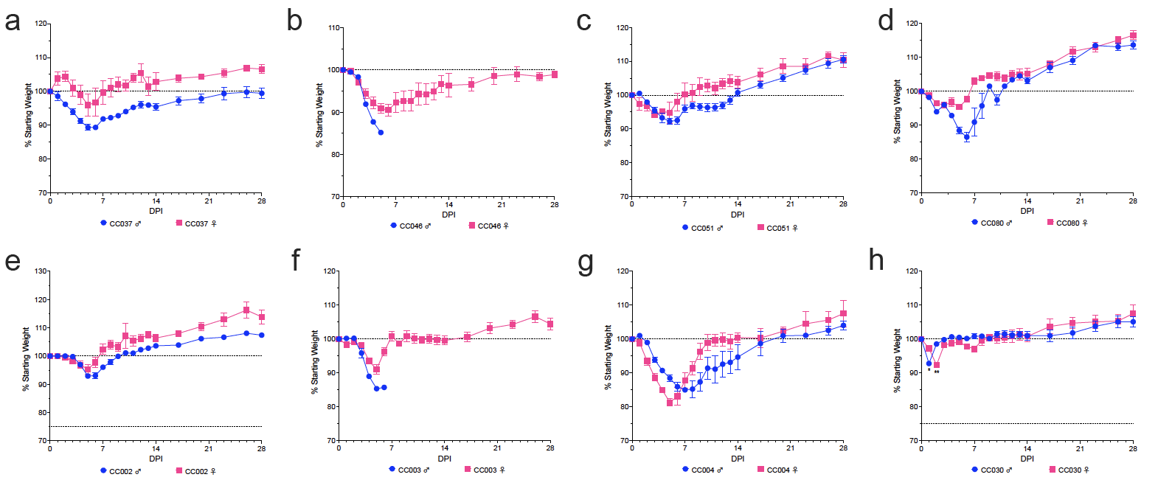

Fig. S1.
Weight loss comparisons between male and female mice of each strain of CC mice susceptible to symptomatic disease after infection with MA-CCHFV. Male and female mice of each CC strain were infected with MA-CCHFV and monitored for weight loss. N = 5 mice per sex for each strain, except strains CC037 which had 3 female mice and CC004 which had 4 female mice. Statistics were calculated with a two-way ANOVA or mixed-effect analysis with Sidak’s multiple comparison test for weight loss comparisons. *P < 0.05, **P < 0.01, ***P < 0.001, ****P < 0.0001.

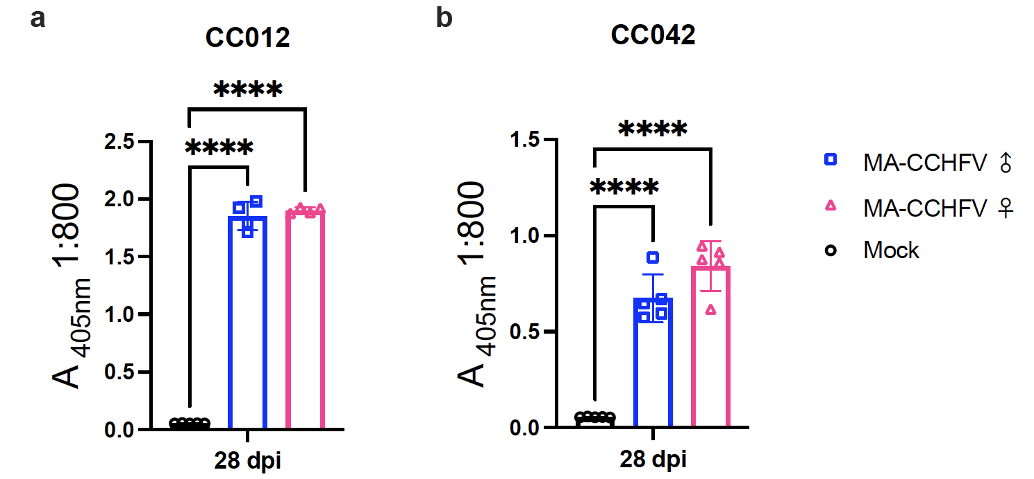

Fig. S2.
IgG responses to CCHFV in the sera of MA-CCHFV infected male and female mice of strains CC012 and CC042. Sera from male and female mice of strains CC012 and CC042 infected with MA-CCHFV were analyzed at 28 days post-infection for CCHFV-specific IgG responses by ELISA compared to mock sera . N = 4 mice per sex for strain CC012J and N = 5 mice per sex for strain CC042. Statistics were calculated with a one-way ANOVA with Tukey’s multiple comparison test. *P < 0.05, **P < 0.01, ***P < 0.001, ****P < 0.0001.

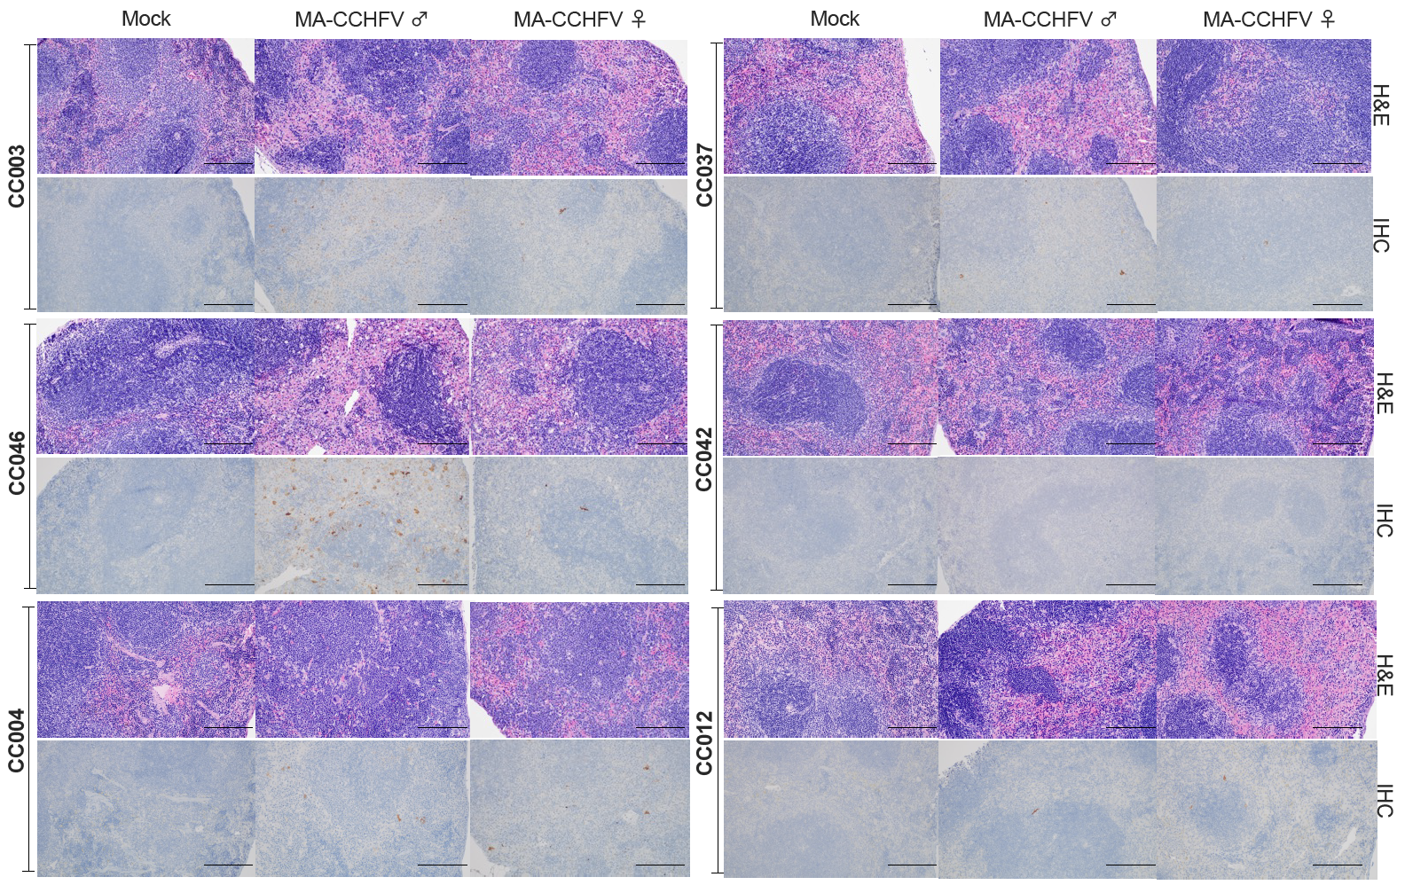

Fig. S3.
Pathology and anti-CCHFV immunoreactivity in spleens of male and female mice of each strain of CC mice after infection with MA-CCHFV. Male and female mice of 6 CC strains were infected with MA-CCHFV and necropsied at peak disease. Spleen sections were analyzed for pathology by H&E staining and for CCHFV antigen by anti-NP IHC.

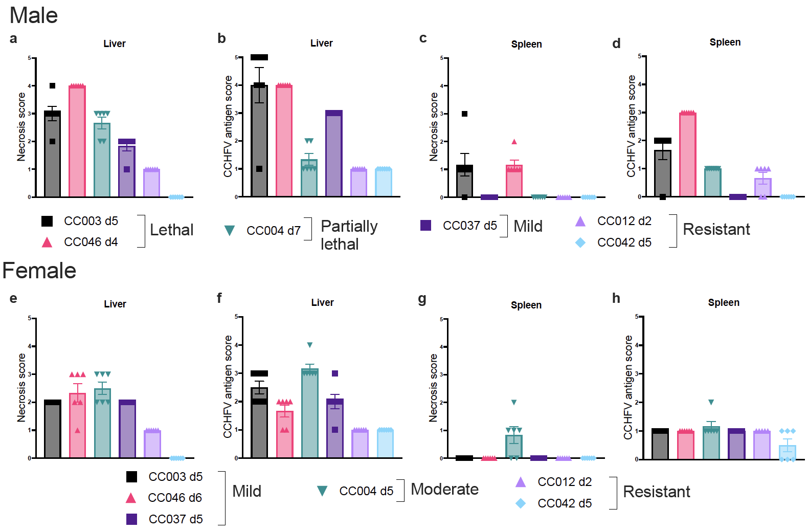

Fig. S4.
Pathology scores in livers and anti-CCHFV immunoreactivity scores in livers and spleens of male and female mice of the 6 strains of CC mice after infection with MA-CCHFV. Male and female mice of 6 CC strains were infected with MA-CCHFV and necropsied at peak disease. Liver and spleen sections processed for pathology and CCHFV antigen by IHC were scored for necrosis and CCHFV antigen on a scale of 1-5.

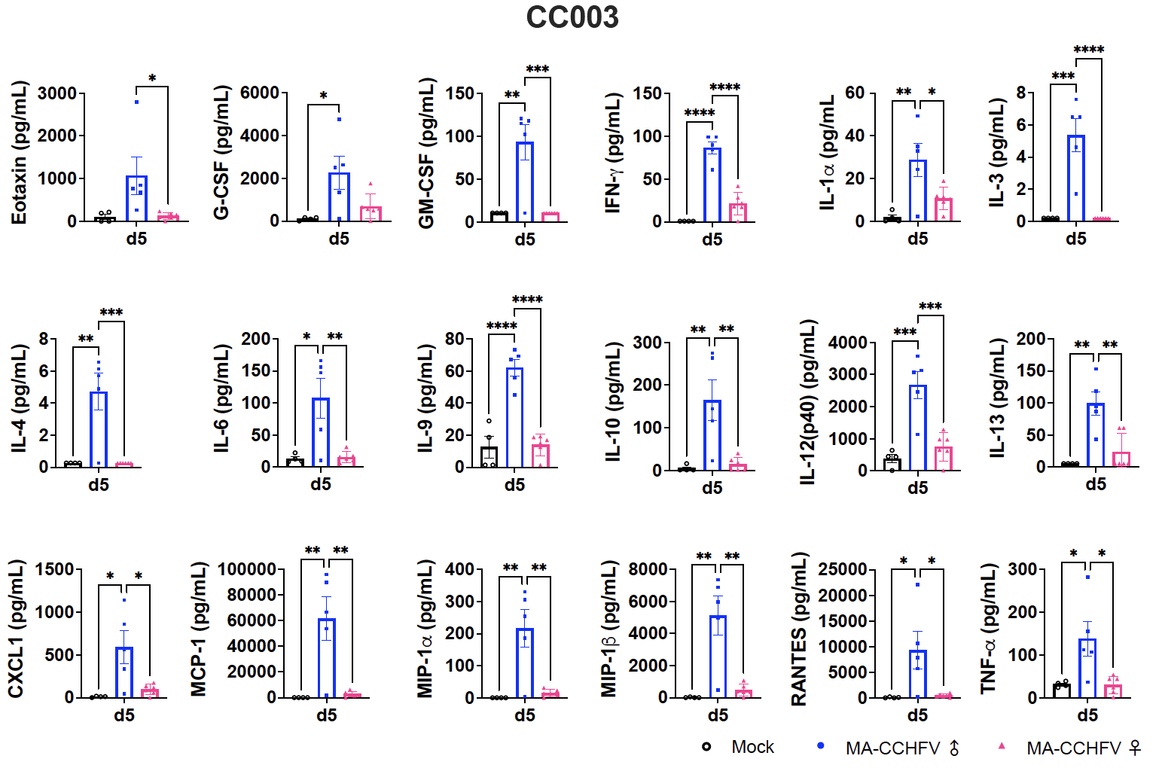

Fig. S5.
Inflammatory responses to CCHFV in the sera of MA-CCHFV infected male and female mice of strain CC003. Sera from infected male and female mice at day 5 post-infection were analyzed for inflammatory cytokine levels compared to mock sera. N = 5 male mice and N = 6 female mice. Statistics were calculated with a one-way ANOVA with Tukey’s multiple comparison test. *P < 0.05, **P < 0.01, ***P < 0.001, ****P < 0.0001.

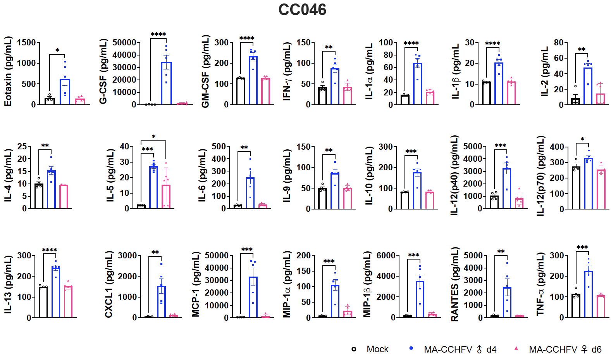

Fig. S6.
Inflammatory responses to CCHFV in the sera of MA-CCHFV infected male and female mice of strain CC046. Sera from infected male mice at day 4 and female mice at day 6 post-infection were analyzed for inflammatory cytokine levels compared to mock sera. N = 5 male mice and N = 6 female mice. Statistics were calculated with a one-way ANOVA with Tukey’s multiple comparison test. *P < 0.05, **P < 0.01, ***P < 0.001, ****P < 0.0001.

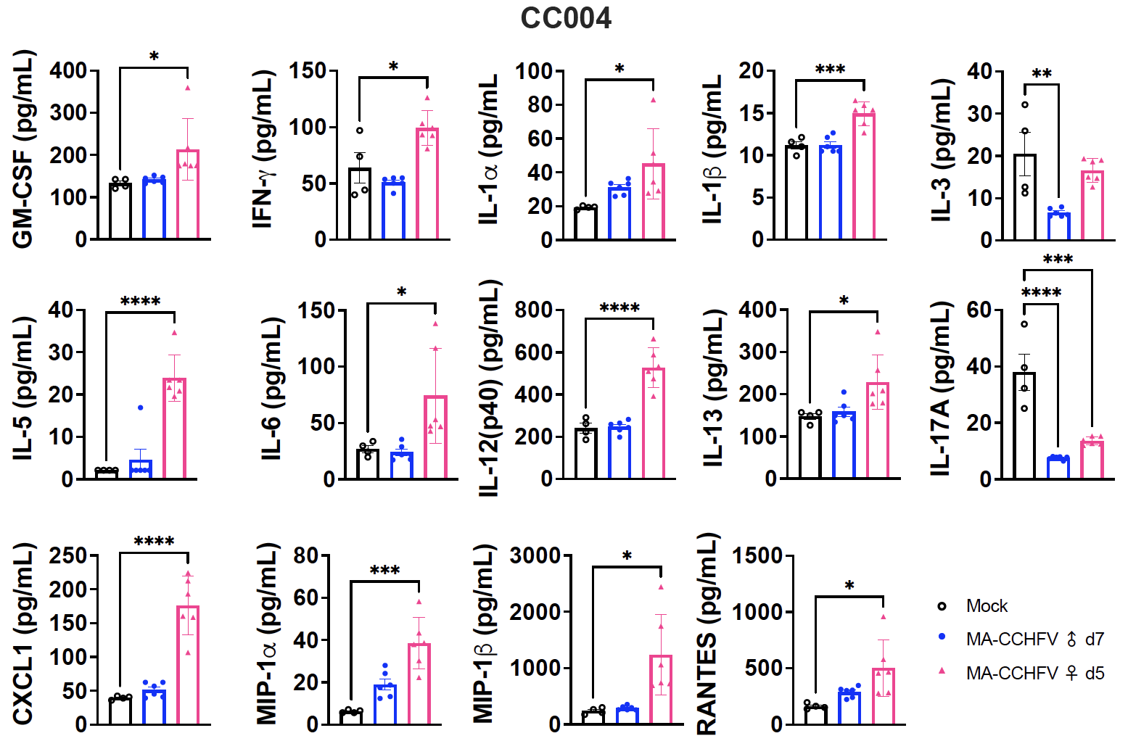

Fig. S7.
Inflammatory responses to CCHFV in the sera of MA-CCHFV infected male and female mice of strain CC004. Sera from infected male mice at day 7 and female mice at day 5 post-infection were analyzed for inflammatory cytokine levels compared to mock sera. N = 6 mice per sex. Statistics were calculated with a one-way ANOVA with Tukey’s multiple comparison test. *P < 0.05, **P < 0.01, ***P < 0.001, ****P < 0.0001.

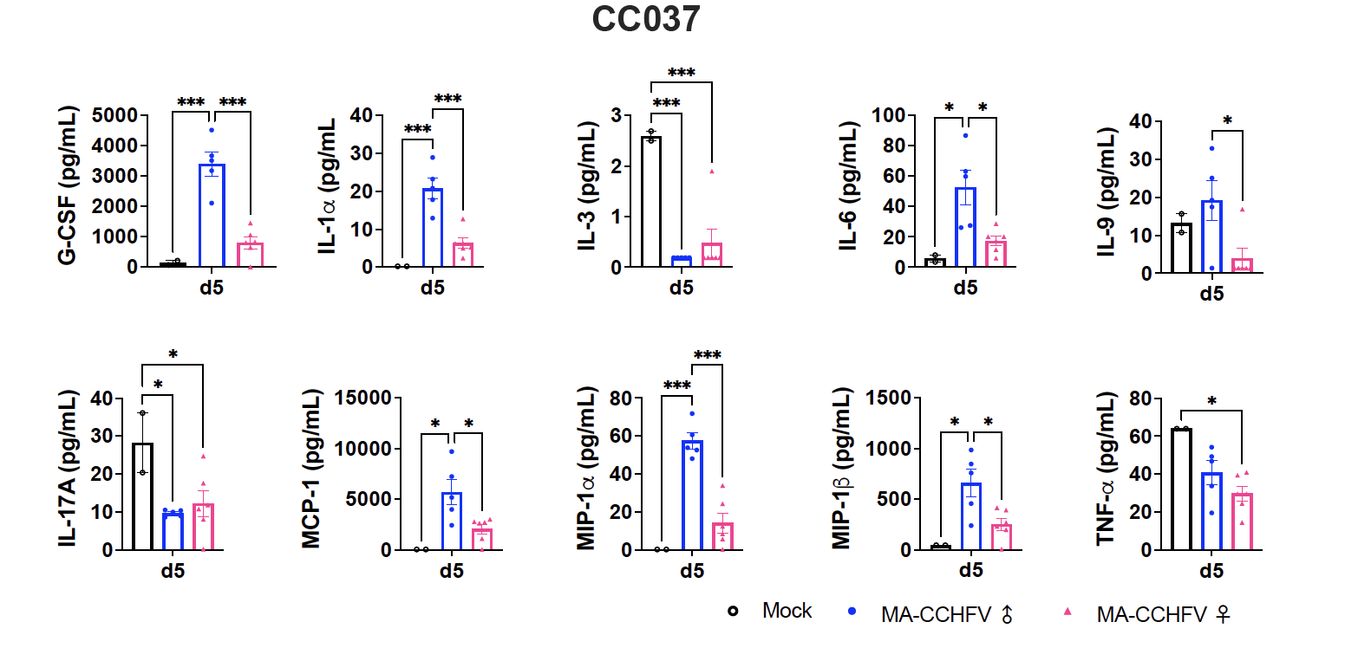

Fig. S8.
Inflammatory responses to CCHFV in the sera of MA-CCHFV infected male and female mice of strain CC037. Sera from infected male and female mice at day 5 post-infection were analyzed for inflammatory cytokine levels compared to mock sera. N = 5 male mice and N = 6 female mice. Statistics were calculated with a one-way ANOVA with Tukey’s multiple comparison test. *P < 0.05, **P < 0.01, ***P < 0.001, ****P < 0.0001.

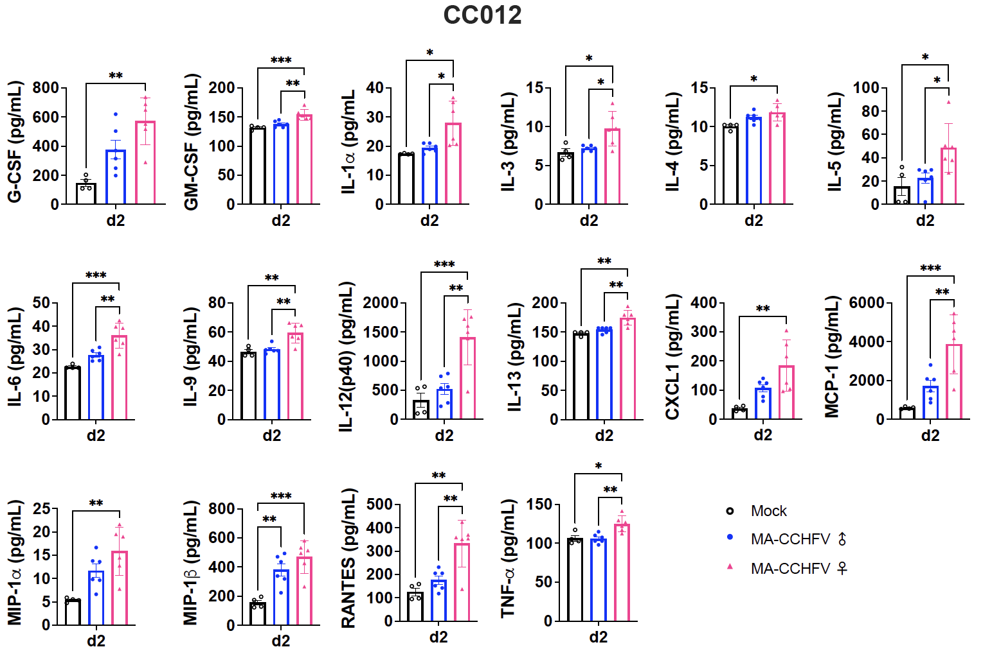

Fig. S9.
Inflammatory responses to CCHFV in the sera of MA-CCHFV infected male and female mice of strain CC012. Sera from infected male and female mice at day 2 post-infection were analyzed for inflammatory cytokine levels compared to mock sera. N = 6 mice per sex. Statistics were calculated with a one-way ANOVA with Tukey’s multiple comparison test. *P < 0.05, **P < 0.01, ***P < 0.001, ****P < 0.0001.

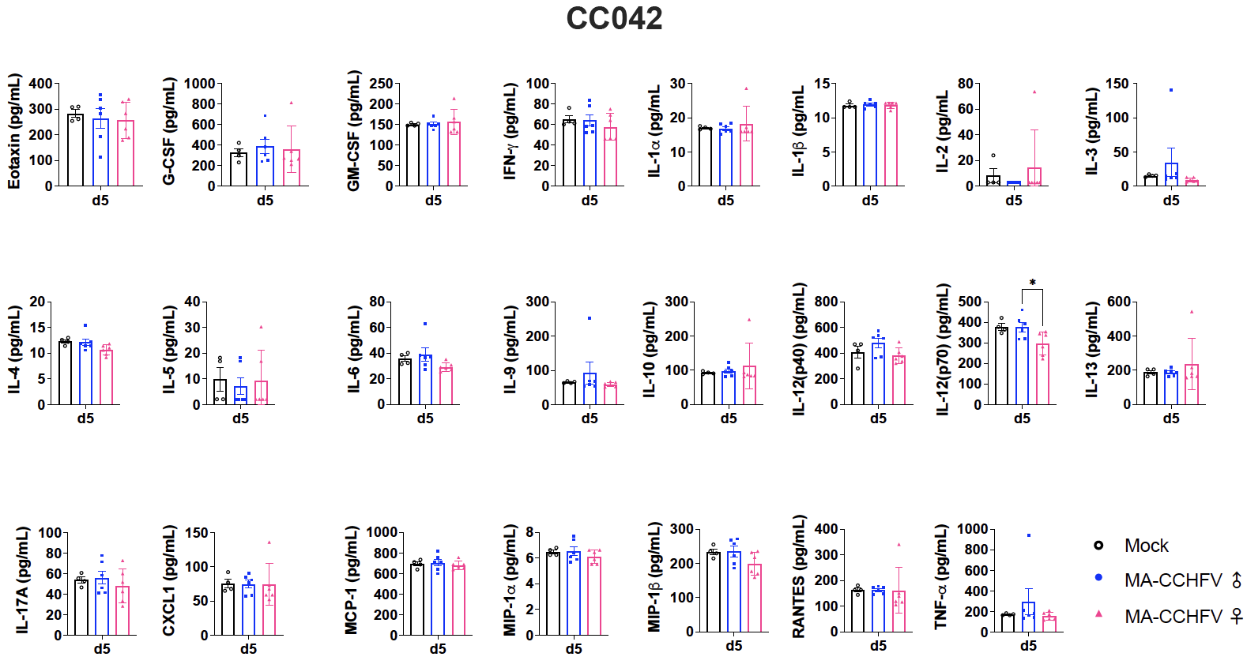

Fig. S10.
Inflammatory responses to CCHFV in the sera of MA-CCHFV infected male and female mice of strain CC042. Sera from infected male and female mice at day 5 post-infection were analyzed for inflammatory cytokine levels compared to mock sera. N = 6 mice per sex. Statistics were calculated with a one-way ANOVA with Tukey’s multiple comparison test. *P < 0.05, **P < 0.01, ***P < 0.001, ****P < 0.0001.

