Predicting MGMT Methylation in Glioblastoma for Informed Clinical Decisions: An AI-Driven Approach in Resource-Limited Settings

Supplementary Materials

Supplementary Figures and Tables:

Question | Answer
Tumor Location | Type 1: in contact with SVZ and cortex
 | Type 2: in contact with SVZ
 | Type 3: in contact with cortex
 | Type 4: NA
Presence of necrosis
 | No
 | Intermediate (<50%)
 | Severe (>50%)
Contrast Enhancing
 | Nodular
 | Ring like
 | Patchy
 | NA
Laterality
 | Left
 | Right
Greatest diameter of contrast enhancing lesion
 | ≥ 1.5cm
 | < 1.5cm
 | NA
Binary classification (yes or no)
Well defined borders
Hemorrhage
Cystic format
Multifocality
Midline crossing
Table S1: Neuro-radiologist evaluation form.
SVZ: subventricular zone
NA: Not Applicable

Feature | Code | Type
MGMT | TARGET | Boolean
MUT TERT | CF1 | Boolean
MUT EGFR | CF2 | Boolean
AMPLI EGFR | CF3 | Boolean
PTEN | CF4 | Boolean
BRAF V600E | CF5 | Boolean
CDKN2A/B | CF6 | Boolean
NOTCH1 | CF7 | Boolean
TMB | CF8 | Number
MSI | CF9 | Boolean
GFAP (IHQ) | CF10 | Boolean
Sinaptofisina (IHQ) | CF11 | Boolean
KI-67 | CF12 | Number
IDH1 | CF13 | Boolean
IDH2 | CF14 | Boolean
IDH | CF13b | Boolean
ATRX PRES | CF15 | Boolean
TP53 HIPER | CF16 | Number
TSC1 | CF17 | Boolean
EXPRESSÃO TERT | CF18 | Boolean
Sexo | CF19 | Boolean
Idade | CF20 | Number
Sobrevivência a partir da cirurgia (dias) | CF21 | Number
KPS | CF22 | Number
Versions PyRadiomics | H1 | Text
Versions Numpy | H2 | Text
Versions SimpleITK | H3 | Text
Versions PyWavelet | H4 | Text
Versions Python | H5 | Text
Configuration Settings | H6 | Text
Configuration EnabledImageTypes | H7 | Text
Image-original Hash | RF1 | Text
Image-original Dimensionality | RF2 | Text
Image-original Spacing | RF3 | Text
Image-original Size | RF4 | Text
Image-original Mean | RF5 | Number
Image-original Minimum | RF6 | Number
Image-original Maximum | RF7 | Number
Mask-original Hash | RF8 | Text
Mask-original Spacing | RF9 | Text
Mask-original Size | RF10 | Text
Mask-original BoundingBox | RF11 | Text
Mask-original VoxelNum | RF12 | Number
Mask-original VolumeNum | RF13 | Number
Mask-original CenterOfMassIndex | RF14 | Text
Mask-original CenterOfMass | RF15 | Text
shape Elongation | RF16 | Number
shape Flatness | RF17 | Number
shape LeastAxisLength | RF18 | Number
shape MajorAxisLength | RF19 | Number
shape Maximum2DDiameterColumn | RF20 | Number
shape Maximum2DDiameterRow | RF21 | Number
shape Maximum2DDiameterSlice | RF22 | Number
shape Maximum3DDiameter | RF23 | Number
shape MeshVolume | RF24 | Number
shape MinorAxisLength | RF25 | Number
shape Sphericity | RF26 | Number
shape SurfaceArea | RF27 | Number
shape SurfaceVolumeRatio | RF28 | Number
shape VoxelVolume | RF29 | Number
firstorder 10Percentile | RF30 | Number
firstorder 90Percentile | RF31 | Number
firstorder Energy | RF32 | Number
firstorder Entropy | RF33 | Number
firstorder InterquartileRange | RF34 | Number
firstorder Kurtosis | RF35 | Number
firstorder Maximum | RF36 | Number
firstorder MeanAbsoluteDeviation | RF37 | Number
firstorder Mean | RF38 | Number
firstorder Median | RF39 | Number
firstorder Minimum | RF40 | Number
firstorder Range | RF41 | Number
firstorder RobustMeanAbsoluteDeviation | RF42 | Number
firstorder RootMeanSquared | RF43 | Number
firstorder Skewness | RF44 | Number
firstorder TotalEnergy | RF45 | Number
firstorder Uniformity | RF46 | Number
firstorder Variance | RF47 | Number
glcm Autocorrelation | RF48 | Number
glcm ClusterProminence | RF49 | Number
glcm ClusterShade | RF50 | Number
glcm ClusterTendency | RF51 | Number
glcm Contrast | RF52 | Number
glcm Correlation | RF53 | Number
glcm DifferenceAverage | RF54 | Number
glcm DifferenceEntropy | RF55 | Number
glcm DifferenceVariance | RF56 | Number
glcm Id | RF57 | Number
glcm Idm | RF58 | Number
glcm Idmn | RF59 | Number
glcm Idn | RF60 | Number
glcm Imc1 | RF61 | Number
glcm Imc2 | RF62 | Number
glcm InverseVariance | RF63 | Number
glcm JointAverage | RF64 | Number
glcm JointEnergy | RF65 | Number
glcm JointEntropy | RF66 | Number
glcm MCC | RF67 | Number
glcm MaximumProbability | RF68 | Number
glcm SumAverage | RF69 | Number
glcm SumEntropy | RF70 | Number
glcm SumSquares | RF71 | Number
gldm DependenceEntropy | RF72 | Number
gldm DependenceNonUniformity | RF73 | Number
gldm DependenceNonUniformityNormalized | RF74 | Number
gldm DependenceVariance | RF75 | Number
gldm GrayLevelNonUniformity | RF76 | Number
gldm GrayLevelVariance | RF77 | Number
gldm HighGrayLevelEmphasis | RF78 | Number
gldm LargeDependenceEmphasis | RF79 | Number
gldm LargeDependenceHighGrayLevelEmphasis | RF80 | Number
gldm LargeDependenceLowGrayLevelEmphasis | RF81 | Number
gldm LowGrayLevelEmphasis | RF82 | Number
gldm SmallDependenceEmphasis | RF83 | Number
gldm SmallDependenceHighGrayLevelEmphasis | RF84 | Number
gldm SmallDependenceLowGrayLevelEmphasis | RF85 | Number
glrlm GrayLevelNonUniformity | RF86 | Number
glrlm GrayLevelNonUniformityNormalized | RF87 | Number
glrlm GrayLevelVariance | RF88 | Number
glrlm HighGrayLevelRunEmphasis | RF89 | Number
glrlm LongRunEmphasis | RF90 | Number
glrlm LongRunHighGrayLevelEmphasis | RF91 | Number
glrlm LongRunLowGrayLevelEmphasis | RF92 | Number
glrlm LowGrayLevelRunEmphasis | RF93 | Number
glrlm RunEntropy | RF94 | Number
glrlm RunLengthNonUniformity | RF95 | Number
glrlm RunLengthNonUniformityNormalized | RF96 | Number
glrlm RunPercentage | RF97 | Number
glrlm RunVariance | RF98 | Number
glrlm ShortRunEmphasis | RF99 | Number
glrlm ShortRunHighGrayLevelEmphasis | RF100 | Number
glrlm ShortRunLowGrayLevelEmphasis | RF101 | Number
glszm GrayLevelNonUniformity | RF102 | Number
glszm GrayLevelNonUniformityNormalized | RF103 | Number
glszm GrayLevelVariance | RF104 | Number
glszm HighGrayLevelZoneEmphasis | RF105 | Number
glszm LargeAreaEmphasis | RF106 | Number
glszm LargeAreaHighGrayLevelEmphasis | RF107 | Number
glszm LargeAreaLowGrayLevelEmphasis | RF108 | Number
glszm LowGrayLevelZoneEmphasis | RF109 | Number
glszm SizeZoneNonUniformity | RF110 | Number
glszm SizeZoneNonUniformityNormalized | RF111 | Number
glszm SmallAreaEmphasis | RF112 | Number
glszm SmallAreaHighGrayLevelEmphasis | RF113 | Number
glszm SmallAreaLowGrayLevelEmphasis | RF114 | Number
glszm ZoneEntropy | RF115 | Number
glszm ZonePercentage | RF116 | Number
glszm ZoneVariance | RF117 | Number
ngtdm Busyness | RF118 | Number
ngtdm Coarseness | RF119 | Number
ngtdm Complexity | RF120 | Number
ngtdm Contrast | RF121 | Number
ngtdm Strength | RF122 | Number
Table S2: Codebook for each variable. The prefix T_ represented that those features were extracted from the T1 with contrast weighted image. Prefix F_ from the Flair weighted image, and the TF_ means that the variables were extracted from the VOI created using the Flair sequence but applied to the T1 sequence.

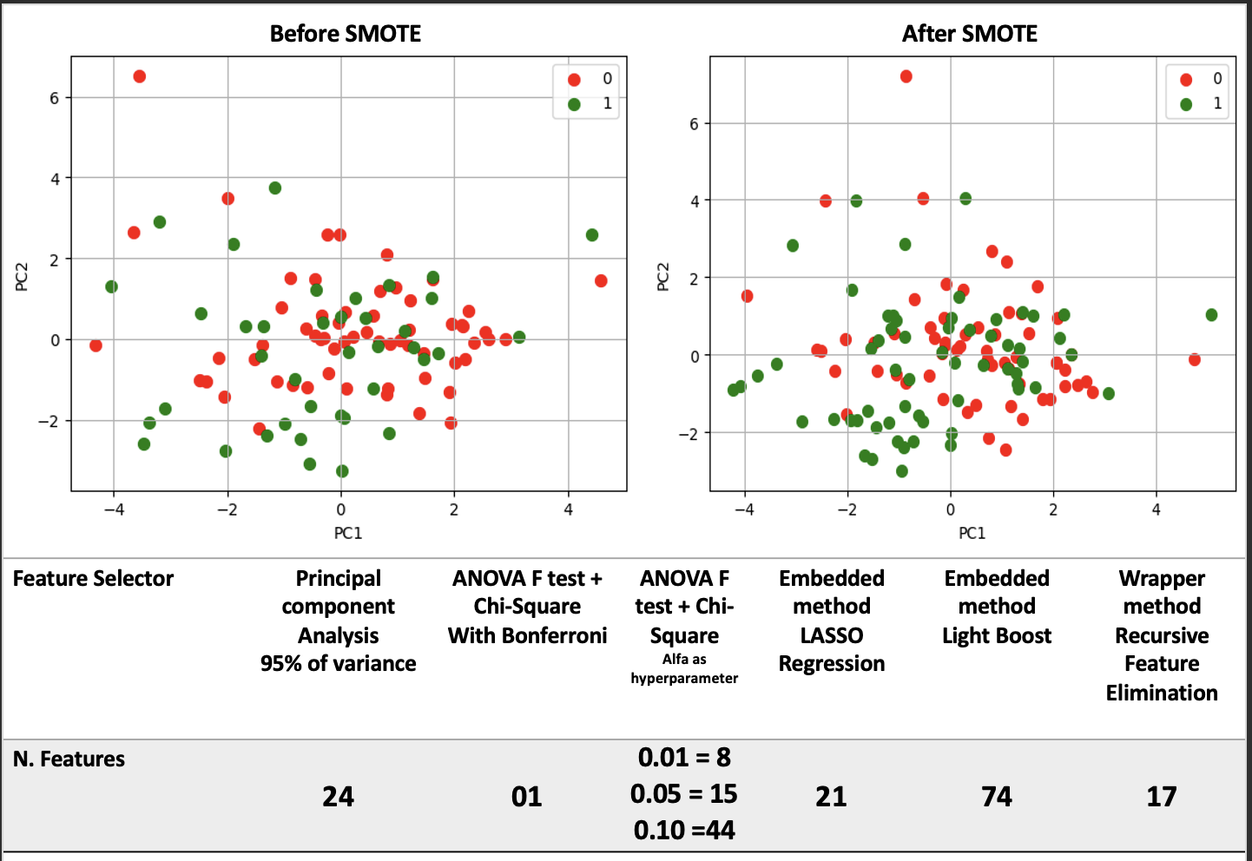
Figure S1 - Visualization before and after SMOTE for fixing imbalances in Public Data and the number of features selected by each feature selector. Red dots represents the patients with without MGMT methylation, green dots represents those with methylated MGMT.

Model | Accuracy | AUC | Recall | Prec. | F1 | Kappa | MCC
RFE + LDA | 0.7568 | 0.7807 | 0.8333 | 0.7143 | 0.7692 | 0.5153 | 0.5221
MultiVar (0.1) + XGBC | 0.6757 | 0.7602 | 0.7778 | 0.6364 | 0.7000 | 0.3547 | 0.3632
MultiVar (0.01) + LDA | 0.7027 | 0.7310 | 0.6667 | 0.7059 | 0.6857 | 0.4041 | 0.4047
LASSO + Ridge | 0.5946 | 0.7222 | 0.5556 | 0.5882 | 0.5714 | 0.1874 | 0.1877
LightBoost + XGBC | 0.6486 | 0.7164 | 0.5000 | 0.6923 | 0.5806 | 0.2916 | 0.3031
PCA + LightGBM | 0.6216 | 0.6842 | 0.4444 | 0.6667 | 0.5333 | 0.2360 | 0.2498
MultiVar (0.05) + XGBC | 0.5135 | 0.6608 | 0.5000 | 0.5000 | 0.5000 | 0.0263 | 0.0263

Table S3 - Performances of top ML classifiers.
Open access codes
Source: https://github.com/RestiniFarinha/MGMT_methylation.git
The aforementioned document contains Python code used for feature selection, as well as machine learning and deep learning models. Recommendations for its use can also be found within the document.

