B: RNA-Seq
A: ATAC-Seq

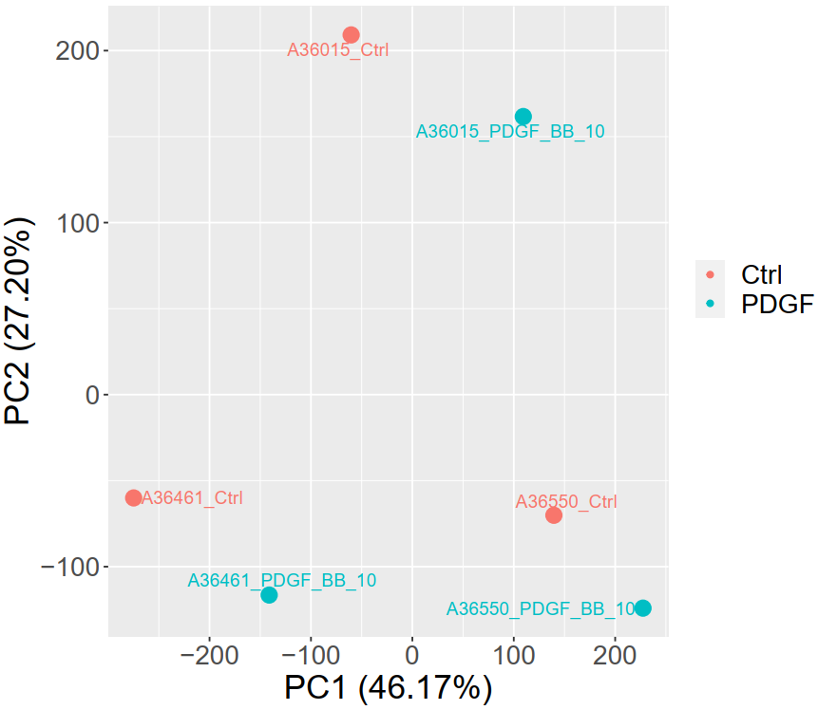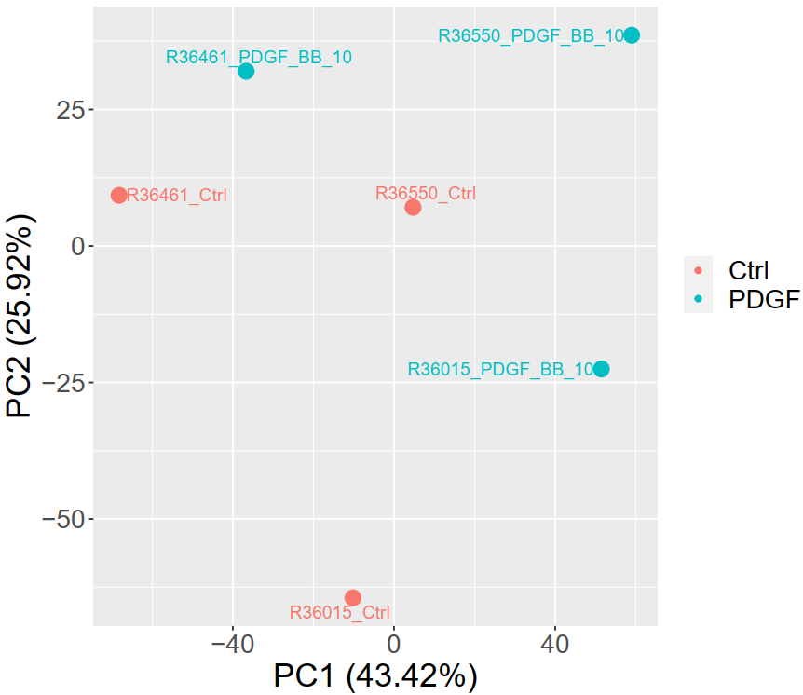
Figure S1. Principle component analysis of PDGF-BB treated and control samples in ATAC-seq (A) and RNA-seq (B).

