Supporting Information

for

Structural Characterization of Disulfide-Linked p53-Derived Peptide Dimers

Magdalena, C. DiGiorno,†,¶ Nisansala Vithanage,‡,¶ Clara G. Victorio,† Dale F. Kreitler,§
Victor K. Outlaw,‡,* and Nicholas Sawyer†,*
†Department of Chemistry and Biochemistry, Fordham University, Bronx, New York 10458, United States
‡Department of Chemistry, University of Missouri, Columbia, Missouri 65211, United States
§National Synchrotron Light Source II, Brookhaven National Laboratory, Building 745, Upton, NY, USA
¶M.C.D. and N.V. contributed equally to this work.
*Corresponding Authors: Email: nsawyer@fordham.edu, victoroutlaw@missouri.edu

Table of Contents

Supporting Material | Page
Supporting Figures
Figure S1. Analytical HPLC chromatograms for all peptides………………………………… | S3-S6
Figure S2. Morphology of CV1 dimer crystals | S7
Figure S3. MALDI mass spectra for trypsin digests of peptide dimers……………………… | S8-S12
Figure S4. Circular dichroism spectra of peptide dimers as a function of temperature ……… | S13-S17
Supporting Tables
Table S1. MALDI mass spectrometry characterization of peptides…………………………… | S18
Table S2. X-ray crystallography data table for CV1 dimer X-ray structure (PDB 9C5S) …… | S19

CV1-bt
T2A-bt
F3A-bt
N5A-bt
L6A-bt

Figure S1. Analytical HPLC chromatograms for all peptides (bt = bisthiol)
W7Y-bt
L9A-bt
L10A-bt
Q12A-bt
N13A-bt

Figure S1. Analytical HPLC chromatograms for all peptides (bt = bisthiol)
CV1-dimer
T2A-dimer
F3A-dimer
N5A-dimer
W7Y-dimer

Figure S1. Analytical HPLC chromatograms for all peptides
L9A-dimer
L10A-dimer
Q12A-dimer
N13A-dimer

Figure S1. Analytical HPLC chromatograms for all peptides

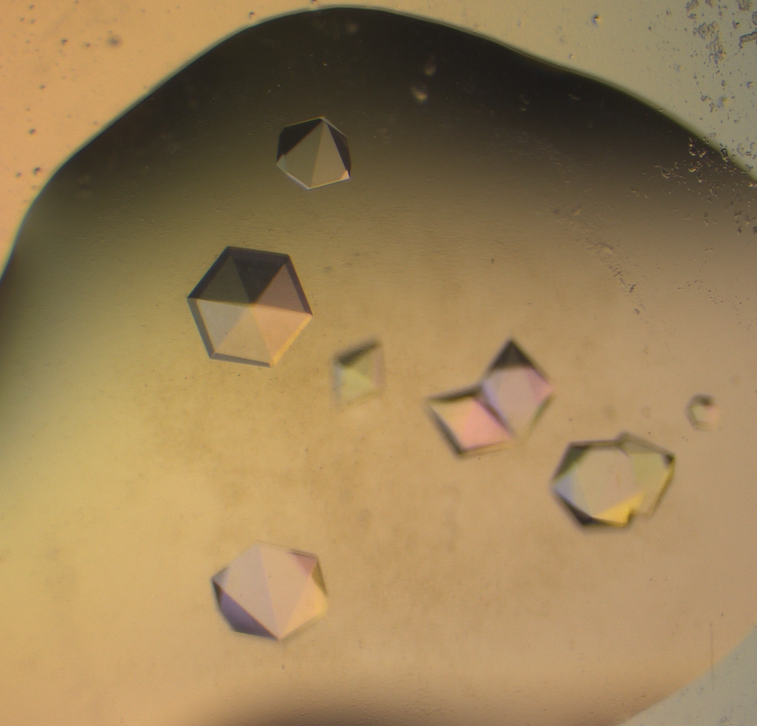

Figure S2. Morphology of CV1 dimer crystals

Figure S2. MALDI mass spectra for trypsin digests of peptide dimers

Figure S2. MALDI mass spectra for trypsin digests of peptide dimers

Figure S2. MALDI mass spectra for trypsin digests of peptide dimers

Figure S2. MALDI mass spectra for trypsin digests of peptide dimers

Figure S2. MALDI mass spectra for trypsin digests of peptide dimers

Figure S3. Circular dichroism spectra of peptide dimers as a function of temperature

Figure S3. Circular dichroism spectra of peptide dimers as a function of temperature

Figure S3. Circular dichroism spectra of peptide dimers as a function of temperature

Figure S3. Circular dichroism spectra of peptide dimers as a function of temperature

Figure S3. Circular dichroism spectra of peptide dimers as a function of temperature

Table S1. MALDI mass spectrometry characterization of peptides. Ac indicates an acetylated N-terminus and -NH₂ indicates an amidated C-termini (CONH₂). Amino acid residues substituted with alanine are in bold and underlined.

Peptide Name | Sequence | Expected m/z (M+H⁺) | Observed m/z (M+H⁺)
CV1-bt | Ac-CTFANLWRLLAQNC-NH₂ | 1693.8 | 1693.6
T2A-bt | Ac-CAFANLWRLLAQNC-NH₂ | 1663.8 | 1663.6
F3A-bt | Ac-CTAANLWRLLAQNC-NH₂ | 1617.8 | 1617.5
N5A-bt | Ac-CTFAALWRLLAQNC-NH₂ | 1650.8 | 1650.6
L6A-bt | Ac-CTFANAWRLLAQNC-NH₂ | 1651.8 | 1651.6
W7Y-bt | Ac-CTFANLYRLLAQNC-NH₂ | 1670.8 | 1671.0
L9A-bt | Ac-CTFANLWRALAQNC-NH₂ | 1651.8 | 1652.0
L10A-bt | Ac-CTFANLWRLAAQNC-NH₂ | 1651.8 | 1652.0
Q12A-bt | Ac-CTFANLWRLLAANC-NH₂ | 1636.8 | 1637.1
N13A-bt | Ac-CTFANLWRLLAQAC-NH₂ | 1650.8 | 1651.0
CV1-dimer | (Ac-CTFANLWRLLAQNC-NH₂)₂ | 3382.6 | 3382.4
T2A-dimer | (Ac-CAFANLWRLLAQNC-NH₂)₂ | 3322.6 | 3322.7
F3A-dimer | (Ac-CTAANLWRLLAQNC-NH₂)₂ | 3230.6 | 3230.6
N5A-dimer | (Ac-CTFAALWRLLAQNC-NH₂)₂ | 3296.6 | 3296.1
W7Y-dimer | (Ac-CTFANLYRLLAQNC-NH₂)₂ | 3336.6 | 3336.6
L9A-dimer | (Ac-CTFANLWRALAQNC-NH₂)₂ | 3298.5 | 3298.3
L10A-dimer | (Ac-CTFANLWRLAAQNC-NH₂)₂ | 3298.5 | 3298.5
Q12A-dimer | (Ac-CTFANLWRLLAANC-NH₂)₂ | 3268.6 | 3268.8
N13A-dimer | (Ac-CTFANLWRLLAQAC-NH₂)₂ | 3296.6 | 3297.0

Table S2. X-ray crystallography data table for CV1 dimer X-ray structure (PDB 9C5S)
Data collection
X-ray source | NSLS-II 17-ID-1
X-ray detector | Dectris Eiger X 9M
Detector distance (mm) | 100
Oscillation range (º) | 0.1
Wavelength (Å) | 0.92008
Space group | P 2₁ 2₁ 2
a / b / c (Å) | 51.4 / 56.9 / 84.3
α / β / γ (º) | 90.0 / 90.0 / 90.0
Matthews coefficient (Å³/Da) | 2.76
Solvent content (%) | 55.4
Resolution range (Å) | 33.23–1.01 (1.068–1.010)
Number of observations | 371496 (13294)
Unique reflections | 35044 (1752)
Completeness | 88.6 (28.9)
Redundancy | 10.6 (7.6)
Mean I/σ(I) | 15.0 (1.3)
CC1/2* | 0.999 (0.524)
R_{merge} | 0.045 (1.553)
R_{meas} | 0.048 (1.667)
R_{pim} | 0.015 (0.600)
Wilson B-factor (Å²) | 14.12
Refinement statistics
Refinement program | Phenix.refine: 1.20.1-4487-000
Resolution range (Å) | 33.23–1.01 (1.040–1.010)
No. of unique reflections used in refinement | 35041
Completeness (%) | 88.6
Reflections in cross-validation set | 1699
R-value (work) | 19.0
R-value (free) | 20.2
R-value (overall) | 19.1
Coordinate error (ML, Å) | 0.10
Mean ADP (Å²) | 21.9

