SUPPLEMENTAL MATERIAL
Cardiomyocyte mitochondrial mono-ADP-ribosylation dictates cardiac tolerance to sepsis by configuring bioenergetic reserve

Expanded Methods
Experimental animals
The mouse strain of cardiac-specific inducible knockout of the MacroD1 gene (cKO) was generated from Cyagen Biosciences (Shanghai, China) by crossing α-myosin heavy chain promoter-driven Cre mice (αMHC^{MerCreMer}) with floxed MacroD1 (MacroD1^{flox/flox}) mice. Tamoxifen (40 mg/kg/d) was dosed intraperitoneally for five consecutive days in 8-week mice, and after another week, they were employed for ensuing experiments. Genotypes were determined by the polymerase chain reaction (PCR) using tail DNA.
To construct the lipopolysaccharide (LPS)-induced sepsis model, mice were intraperitoneally injected with LPS 10 mg/kg for 18, 96, or 168 hours to further analysis. An identical volume of saline was given to the control animals.
The mouse model of cecal ligation and perforation (CLP)-induced sepsis was generated as described before(62). Briefly, mice were anesthetized with 3 % isoflurane and exposed to 0.5 L/min oxygen mixed with 1.5 % isoflurane. A 2.5 cm midline incision was done to access the cecum and adjacent intestine. The cecum was ligated with a 4-silk suture at 1 cm from the cecal tip, perforated with a 21-gauge needle, and gently pushed to expel feces from the perforation site. Subsequently, the cecum was reintroduced into the abdominal cavity, and the laparotomy site was sutured with 6-silk sutures. The sham animals were subjected to the same surgical operation, except that the cecum was not ligated and perforated.
Preparation of blood serum, tissue lysates
Blood samples were obtained after the animals were sacrificed, and serum was isolated by centrifugation at 3,000 g/min for 15 minutes at 4 °C. The serum preparations and tissues were stored at -80 °C until used.
Quantification of cytokines
The contents of IL-1β, TNF-α, LDH, and cTnT in the supernatants of mouse serum were tested following the manufacturer’s instructions (Mlbio ELISA kit).
Isolation of cardiomyocytes
Ventricular myocytes of two-day-old Sprague–Dawley (SD) rats (NRCMs) or mice (NMCMs) were enzymatically isolated and cultured as previously described(63). Briefly, the ventricles of SD rats or mice were detached and cut into small pieces, then digested with 0.75 mg/ml collagenase type II (Worthington) in PBS three times for 15 minutes at 37°C each time. To stop the digestion, the separated cells were submerged in fetal bovine serum (FBS) and centrifuged at 1000 rpm for five minutes to form pellets. Subsequently, the pelleted cells were re-suspended and cultivated in Dulbecco's modified Eagle's medium (DMEM) with 1% penicillin-streptomycin, 10% FBS, and 1% bromodeoxyuridine for 90 minutes to allow fibroblast adhere to the cell dish. Finally, the floating cardiomyocytes were transferred to a new cell culture dish for further experiments.
Adult mouse ventricular myocytes (AMCMs) were collected, as previously reported(64). Briefly, after given 4% isoflurane anesthesia, the adult mouse’s heart was quickly extracted and then given calcium-free Tyrode's solution for five minutes before receiving an enzyme solution (trypsin, collagenase type II, and protease) perfusion in a Langendorff perfusion device. After that, the left ventricle was extracted and fragmented in an enzymatic solution containing 0.2% bovine serum albumin. The tissue suspension was filtered through a 100 μm cell strainer, after which the AMCMs were pelleted by gravity settling and resuspended in solutions containing different concentrations of calcium three times for 20 minutes each time and plated on laminin coated dishes.
Quantitative RT-PCR
Total RNA from tissue and cells was extracted using TRIZOL (TAKARA, Japan), and reversed RNA for cDNA using the TAKARA PrimeScriptTM RT reagent kit (TAKARA, Japan). Real-time PCR was run with TB Green Fast qPCR Mix (TAKARA, Japan) on a Roche LightCycler480 instrument II. The results were defined from the threshold cycle (Ct), and the 2^{−△△Ct} method was used to calculate the relative expression levels. The primers used were listed in the Supplemental Tables 1-3.
Echocardiography
A Vevo 3100 System (Visual Sonics) with an MS400 Transducer was used to perform the echocardiographic evaluation in anaesthetised (1.5% isoflurane) mice. Left ventricular function was assessed across the middle of the left ventricle using an M-Mode scan.
Transmission electron microscopy
Mice were subjected to transcardial perfusion with 0.1 M PBS (pH 7.4) immediately after sacrifice by intraperitoneally injecting 100 mg/kg pentobarbital sodium. Hearts were extracted, cut into 1-2 mm³ sections, and fixed in the buffer containing 2.5% glutaraldehyde and 0.1 M calcium carbonate at room temperature for 2 hours. The sectioned samples were kept at 4 °C overnight, embedded and ultramicrosectioned to obtain 90 nm flakes, and photographed using a Hitachi HT7800 transmission electron microscope (Hitachi, Japan).
Extraction of mitochondria, cytoplasm without mitochondria, and the nucleus
A mitochondria isolation kit was used to separate mitochondrial and cytosolic fractions of ventricle tissues using differential centrifugation according to the manufacturer's instructions (Beyotime, C3606). Nucleus fraction was extracted by nuclear protein extraction kit (Beyotime, P0027). The protein concentrations were determined using an assay kit (BioRad, Hercules, CA).
Blue Native PAGE (BN-PAGE) assay
The expression of mitochondrial complexes was detected using the Blue Native PAGE (BN-PAGE) assay following the manufacturer's instructions (Zhongke Ruitai Technology, RTD6136). Briefly, mitochondria was extracted from heart tissue and the protein concentration was determined. Then, 200 μg of mitochondria were dissolved in a mixture of 5 μl 4×BN/CN-PAGE protein sample buffer and 15 μl 10% digitonin solution. The resulting mixture was placed on ice for 20 minutes, followed by centrifugation at 4℃ 20000×g for 10 minutes. Next, 7.5 μl of the supernatant was taken and mixed with 2.5 μl 5% G-250 dye and loaded onto a 3-12% PAGE Bis-Tris gel, which was run according to the manufacturer's protocols. Finally, the gel was subjected to Coomassie brilliant blue staining to detect the expression of mitochondrial complexes.
Mitochondrial complexes activity assays
Mitochondrial complexes activity was detected according to the manufacturer's experimental protocol (Abbkine, KTB1850 for mitochondrial complex I activity analysis; KTB1860 for mitochondrial complex II; KTB1870 for mitochondrial complex III; KTB1880 for mitochondrial complex IV; KTB1890 for mitochondrial complex V) .
Immunohistochemistry
Following collection, hearts were fixed in 10% formalin or implanted in OCT (SAKURA) as needed. Immunohistochemistry was performed as previously described(65). Antibodies used for immunostaining were as followed：α-SMA (1:100) and MPO (1:100). After DAPI counterstaining, the tissue slides were microphotographed.
For Masson’s staining, the hearts of mice were extracted, fixed with formaldehyde, embedded in paraffin, and sectioned at 8 μm thickness. The sections were stained using regular protocols(26) and imaged with a DM5000B microscope (Leica).
Proximity ligation assay (PLA)
The proximity ligation assay was performed in triplicate with the Duolink proximity ligation assay kit (Millipore Sigma DUO92101). AMCMs were plated onto confocal dishes, fixed with 4% formaldehyde for 20 minutes, permeabilized by 0.3% Triton X-100 for 10 minutes, and blocked with Duolink blocking buffer for 30 minutes. After incubation with primary antibodies anti-NLRP3 (1:100) and anti-ASC (1:50) at 4 °C overnight, AMCMs were sequentially washed with buffer A twice for 5 minutes at room temperature, incubated with the plus and minus assay probes for 1 h at 37°C, washed twice with Duolink buffer A and then incubated with 1× ligation buffer containing ligase for 30 minutes at 37°C. Following washing with buffer A twice for 5 minutes at room temperature and incubation by 1× DuoLink Amplification Buffer with polymerase for 100 minutes at 37°C, AMCMs were washed twice with Duolink wash buffer B, mounted with Duolink proximity ligation assay mounting medium and 4’,6-diamidino-2-phenylindole (DAPI). The speckles were imaged using a Leica SP8 confocal microscope.
Gene silencing and overexpression of NRCMs
NRCMs were isolated and cultured in DMEM/F12 medium containing 10% FBS and 0.1 mM BrdU for 36 hours. Following the transfection with MacroD1 siRNA or NC, recombinant adenovirus vectors carrying the MacroD1 gene (Adv-MacroD1, OED) or the GFP gene (Adv-GFP, Vect) at the multiplicity-of-infection of 50 for 36 hours, NRCMs were treated with indicated reagents and then used to further examinations. siRNAs and adenovirus were obtained from Generay Biotech (Shanghai, China) and WZ Bioscience (Shandong, China), respectively. The sequence of siRNAs was listed in the Supplemental Table 4.
Transfection of siRNA or/and Plasmids for HEK293 cells or AC16 cells
HEK293 or AC16 cells were transfected with indicated siRNAs or plasmids using Lipofectamine 3000 (Thermo Fisher, L3000008) in line with the manufacturer’s instructions for 36 hours. Then, the cells were subjected to the corresponding treatment followed by protein extraction of cells or other experiments. The plasmids and siRNA employed in the experiment included siRNA MacroD1 (Si-M), siRNA Ndufb9 (Si-Ndufb9), siRNA Sirt3 (Si-Sirt3), His-tagged MacroD1 plasmid, His-tagged MacroD1 with truncated N-terminus (MacroD1^{△MTS}) plasmid, Flag-tagged Ndufb9 plasmid, His-tagged MacroD1 with truncated Macro domain (MacroD1 mut) plasmid, Flag-tagged Ndufb9^{R173A} mutant plasmid, Flag-tagged SM-Ndufb9 plasmid, and Flag-tagged SM-Ndufb9^{R173A} mutant plasmid. Plasmids and siRNAs were constructed and supplied by Hanheng Biotechnology (Shanghai, China) and Generay Biotech (Shanghai, China), respectively. The sequences of siRNAs were listed in the Supplemental Table 4.
Immunocytochemistry
The isolated NRCMs were seeded at an adequate density on confocal dishes. After washing three times with PBS, the cells were treated with 4 % formaldehyde buffer at room temperature for 30 minutes. Next, the cells were rinsed three times using PBS and permeabilized with PBS containing 1% Triton100×. Following the three times rinsing with PBS, cells were blocked by 3% BSA for 30 minutes at room temperature and incubated with primary antibodies overnight at 4 °C. Nuclei were counterstained with DAPI after incubation with secondary antibodies at room temperature for another hour. The antibodies included ASC (1:50), NLRP3 (1:100), MacroD1 (1:100), TOM20 (1:100).
Cell bioenergetic profiling
Oxygen consumption rate (OCR) was measured using a Seahorse XFe96 cell efflux analyzer (Agilent Technologies, USA). Briefly, 3 × 10⁴ cells per well were plated in assay microplates for 24 hours followed by related treatments. After the culture medium was replaced by Seahorse XF DMEM buffer supplementing with 10 mM glucose, 2 mM glutamine, and 1 mM pyruvate, cells were cultured for 1 hour in a CO₂-free incubator at 37 °C. OCR was detected in real-time when the plate was sequentially injected with 1.5 μM oligomycin, 0.5 μM FCCP, and 0.5 μM Rot/AA.
The Seahorse XF Palmitate Oxidation Stress Kit (Agilent Technologies, USA) was used to evaluate fatty acid oxidation (FAO) metabolism following the manufacturer's instructions. The FAO test was conducted over two days with two pretreatment steps. NRCMs were plated at a density of 3×10⁴ cells per well for 24 hours. The medium was then replaced by substrate-limited growth medium, i.e., DMEM supplemented with 0.5 mM glucose, 1.0 mM GlutaMAX, 0.5 mM carnitine, and 1% FBS, and cells were incubated for 24 hours. After removing the substrate-limited growth medium, cells were incubated with substrate-limited analysis medium (Seahorse XF DMEM medium containing 2 mM glucose and 0.5 mM carnitine) for another 45 minutes in a CO₂-free incubator. Before the assay, the analysis medium was refreshed and added BSA or palmitate-BSA. OCR was measured in real-time while the sequential injection of 4 µM etomoxir, 1.5 μM oligomycin, 0.5 μM FCCP, and 0.5 μM Rotenone/Antimycin (Rot/AA).
Assay of ROS and ATP contents
According to the manufacturer’s instructions, NRCMs or AC16 cardiomyocytes were cultured in a medium containing 5 μM MitoSOX (MCE, HY-D1055) and 1× Hoechst 33342 (Beyotime, C1028) for 30 minutes at 37 ℃ to detect mitochondrial ROS levels.
In frozen sections of rat hearts, the OCT was removed by washing with PBS. To prepare the Dihydroethidium (DHE; Invitrogen) (5 µM) dye, the original solution was diluted with PBS solution. The tissue was incubated with the diluted DHE dye solution for 30 min in the dark. After then, the slides were washed with PBS three times to stop the staining process. Nuclei were counterstained with DAPI for 10 min and washed with PBS. The anti-fluorescence quenching solution was applied to the tissue before being covered with a coverslip.
The ATP contents of tissues or cells were quantified using ATP Assay Kit (Beyotime, S0026). Briefly, 20 mg of fresh heart tissue was homogenized in normal saline, centrifuged at 3,000 g/min for 10 minutes, and the supernatant was collected. Tests were conducted separately by the manufacturer's instructions.
NAD⁺ assay
To evaluate the levels of NAD⁺ within cells, the NAD⁺/NADH Assay Kit (Beyotime, S0175) was employed according to the guidelines provided by the manufacturer.
Co-immunoprecipitation
On detecting mono-ADP-ribosylation assay, the cells were cultured under different treatments in a 10 cm dish and harvested with precooled PBS on ice. Cells were pelleted by 500 × g centrifugation at 4 °C for 5 min, lysed, and boiled for 5 min in 200 μl immunoprecipitation (IP) buffer (Beyotime, P0013) containing 250 nM ADP-HPD (Sigma-Aldrich, A0627), 2.5 μM Olaparib (McdChem Express, HY-10162), and 1× protease inhibitor cocktail (Epizyme Biotech, GRF101). For heart tissue, 80 mg heart tissue was mechanically homogenized for 60 s at 60 hz and boiled for 5 min after adding 400 μl IP buffer containing 250 nM ADP-HPD, 2.5 μM Olaparib, and 1× protease inhibitor cocktail. The lysates of cells or heart tissues were sonicated on ice and centrifuged for 10 min at 12,000 × g before the supernatant was transferred to a fresh tube. A BCA protein assay kit (Beyotime, P0009) was used to determine the protein concentration, and the lysate was diluted with LPS containing 250 nM ADP-HPD, 2.5 μM Olaparib, and 1× protease inhibitor cocktail. 400 μg protein of lysates containing 4 μg anti-Ndufb9 antibody was shaken in a 1.5 ml tube for 8 hours at 4 °C. Then, 20 μl prewashed protein A/G magnetic beads (Med Chem Express, HY-K0202) were transferred to the sample, incubated, and shaken for 2 hours at room temperature. The beads were separated by a magnetic rack and washed three times with PBS. The homologous IgG was used as a negative control, and 20% lysate as input control. Finally, the beads were boiled in 1% SDS loading buffer, electrophoresed, western transferred, and blotted with the indicated antibodies.
To conduct co-immunoprecipitation, cells or heart tissues were lysed in IP lysis buffer containing a protease inhibitor cocktail and incubated with the indicated antibodies on a rotator overnight at 4 ℃. The protein A/G magnetic beads were added and incubated for 2 hours at 4 ℃. The beads were then separated by a magnetic rack and washed three times with PBS, boiled in 1% SDS loading buffer, electrophoresed, western transferred, and blotted with the indicated antibodies. The antibodies used in the co-immunoprecipitation experiments included MacroD1, Ndufb9, Flag, His, ASC, NLRP3, MT-ND5.
Mass spectrometry analysis
As for mass spectrometry analysis for mono-ADP-ribosylation of mitochondrial protein, mitochondrial fractions of Flox or cKO mice hearts (n=5 for each group) were extracted and pooled according to the manufacturer’s instructions (Beyotime, C3606). Briefly, mitochondria samples were lysed and boiled for 5 min in 250 μl IP buffer containing 250 nM ADP-HPD, 2.5 μM Olaparib, and 1× protease inhibitor cocktail, and sonicated with ultrasound on ice. The lysates were centrifuged for 10 min at 12,000 × g before the supernatant was transferred to a fresh tube. Next, the lysates were diluted with IP buffer containing 250 nM ADP-HPD, 2.5 μM Olaparib, and 1× protease inhibitor cocktail. Then, the lysates were digested with sequencing-grade trypsin (Promega, USA), purified, and lyophilized to get peptides. The lyophilized peptides were dissolved in 1× AP buffer (50 mM TRIS pH 8.0, 50 mM NaCl, 1 mM MgCl₂, and 250 μM DTT) and incubated with 4 μg anti-mono-ADPr antibody for 4 to 6 hours. After that, 20 μl protein A/G magnetic beads prewashed by PBS were added to the peptide mixture and incubated for 2 hours in a head-over-tail mixer. After magnetic beads were separated by a magnetic rack and washed with cold PBS and MilliQ water, the ADP-ribosylated peptides were eluted with 0.5% trifluoroacetic acid (TFA) and further treatment for mass spectrometry. Q Exactive HF-X mass spectrometer (Thermo Scientific) was used to analyze the peptide samples, and data analysis was performed by the Byonic software (Protein Metrics, Cupertino, CA, USA). Proteins were identified according to the UniProt Mus musculus Proteome database.
To identify MacroD1-interacted proteins, the mitochondrial fractions of hearts from wild type mice (n=5 for each group) were extracted and pooled according to the manufacturer’s instruction and then lysed with 250 μl immunoprecipitation (IP) lysis buffer and centrifuged at 12,000 × g for 15 minutes to collect the supernatant. The lysate was incubated with the anti-MacroD1 or IgG antibody at 4 ℃ overnight and with protein A/G magnetic beads for another 8 hours. Bead-antibody-antigen complexes were collected using a magnetic separator and washed twice with IP lysis buffer. The precipitated samples were placed in -20 ℃ and sent to the Institute of Botany, Chinese Academy of Sciences for further processing. The final peptides were sequenced and analyzed using a Q Exactive HF-X mass spectrometer. Mass spectrometry analysis, including the treatment and extraction of peptide samples, etc., was conducted by the Institute of Botany, Chinese Academy of Sciences.
RNA sequencing and analysis
RNA sequencing analysis was conducted by Paiseno Biotechnology Co., Ltd. Briefly, Total RNAs were extracted from the left ventricular tissues of mice for RNA sequencing. An Agilent Bioanalyzer was employed to evaluate the quality of RNA. Sequencing libraries were generated using the TruSeq RNA Sample Preparation Kit (Illumina, San Diego, CA, USA). High-throughput sequencing was performed using the NovaSeq 6000 Sequencing System (Illumina). Raw reads from each library were mapped to the mouse genome (GRCm39).
The DESeq (v.1.24.0 R package), with the criteria of |Log₂FC (fold change)| > 1 and adj. p-value < 0.05, was used to identify the differentially expressed genes (DEGs) in WT and cKO samples. KEGG pathway enrichment analysis and Gene Set Enrichment Analysis (GSEA) performed with clusterProfiler R package (4.7.1.3). The Bioconductor package pheatmap (v.1.0.12) was used to create heat maps.
Western blotting
The proteins of cells or tissue samples were extracted for Western blotting examination. Briefly, RIPA or IP lysis buffer was used to extract the total protein from the cultured cells or tissue, and a BCA Protein Assay Kit (Beyotime, P0009) was used to measure the protein concentrations. The proteins were boiled in a denatured loading buffer containing sodium dodecyl sulfate (SDS) (EpiZyme, LT101) and then loaded onto a 10% or 12% polyacrylamide gel. Following electrophoresis, the gels were transferred onto nitrocellulose transfer membranes. The transfer membranes were blocked with 5% fat-free dry milk for 1 hour to minimize background staining and then incubated with indicated primary antibodies and HRP-conjugated secondary antibodies. Western blotting procedure was carried out using an ECL Western Blotting Detection Kit.
Details of antibodies used in immunofluorescence, western blotting, and Co-immunoprecipitation were available in supplemental Table 5.
Supplementary Figure 1
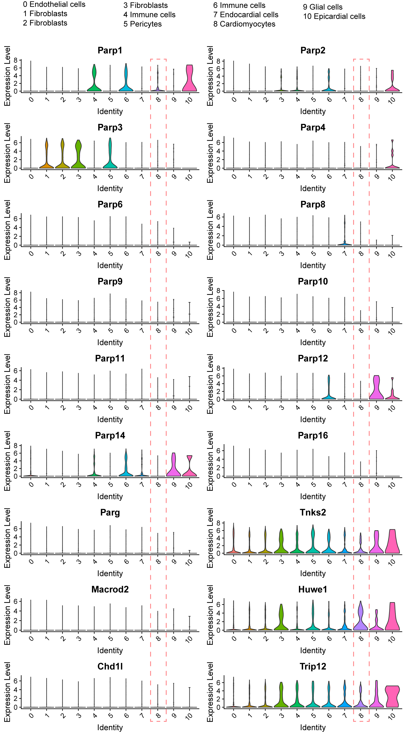
Supplementary Figure 1 continued
Supplementary Figure 1. Expression of NAD⁺ signaling pathway-associated genes based on single cell analysis of hearts from mice.
Supplementary Figure 2
Supplementary Figure 2. MacroD1 is predominantly expressed in the hearts of humans, according to the Human Protein Atlas database.
Supplementary Figure 3
Supplementary Figure 3. The expression of MacroD1 in mice hearts, neonatal rat cardiomyocytes (NRCMs) and AC16 cells stimulated by LPS. A, RT-qPCR analysis of MacroD1 in hearts of wild type mice introperitoneally administered by saline (CON) or 10 mg/kg LPS (n=5). B and C, Western blotting analysis of MacroD1 protein in NRCMs (B) and AC16 cells (C) induced by LPS (100 ng/ml) in serial time points (n=4). D and E, Western blotting analysis of mitochondrial MacroD1 protein in hearts of wild type mice introperitoneally administered by saline (CON) or 10 mg/kg LPS (n=4). F and G, RT-qPCR of MacroD1 mRNA in NRCMs induced by LPS at 100ng/ml (F, n=5) or 1 μg/ml (G, n=5) concentration in serial time points. H and I, RT-qPCR analysis of MacroD1 mRNA in AC16 cardiomyocytes induced by LPS at 100 ng/ml (H, n=5) or 1 μg/ml (I, n=5) concentration in serial time points. ***p <0.001; ns, not significant.
Supplementary Figure 4

Supplementary Figure 4. Genotype identification of cardiomyocyte-specific conditional MacroD1 knockout (cKO) mice. A, Schematic diagram depicting the site of sequence detected by primer for targeted allele. B and C, The primers used for genotyping Flox (MacroD1^{flox/flox} control) and cKO (MacroD1^{flox/flox}/αMHC^{MerCreMer}) mice. D and E, Reverse transcription-PCR showing amplified RNA sequences and the identification of genotype of mice.
Supplementary Figure 5

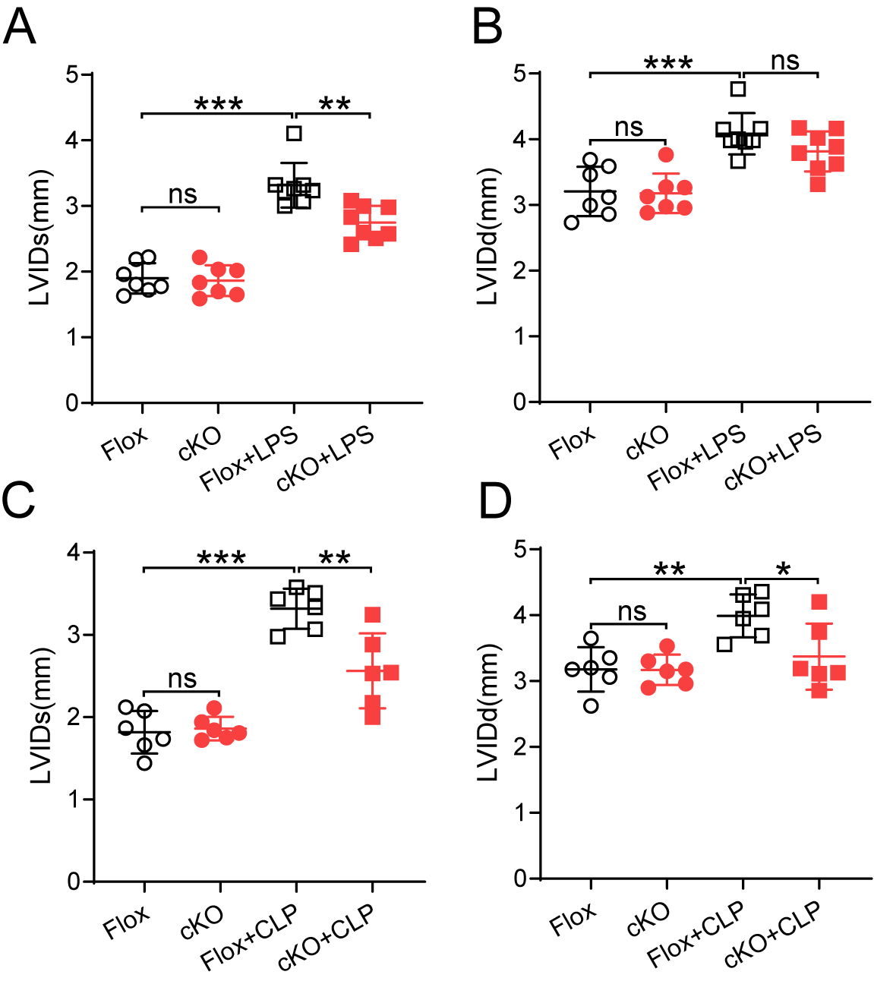
Supplementary Figure 5. Echocardiographic evaluation of cardiac function from mice subjected to LPS stimulation or cecal ligation and puncture (CLP) surgery. A and B, Left ventricular internal Diameter at end-systole (LVIDs) and Left Ventricular Internal Diameter at end-diastole (LVIDd) of hearts from mice with intraperitoneal administration of LPS (10 mg/kg) for 18 hours (n=7). C and D, LVIDs and LVIDd of hearts from mice subjected to sham or CLP surgery for 24 hours (n=6). Flox, MacroD1^{flox/flox} control; cKO, MacroD1^{flox/flox}/αMHC^{MerCreMer}; *p <0.05; **p <0.01; ***p <0.001; ns, not significant.
Supplementary Figure 6
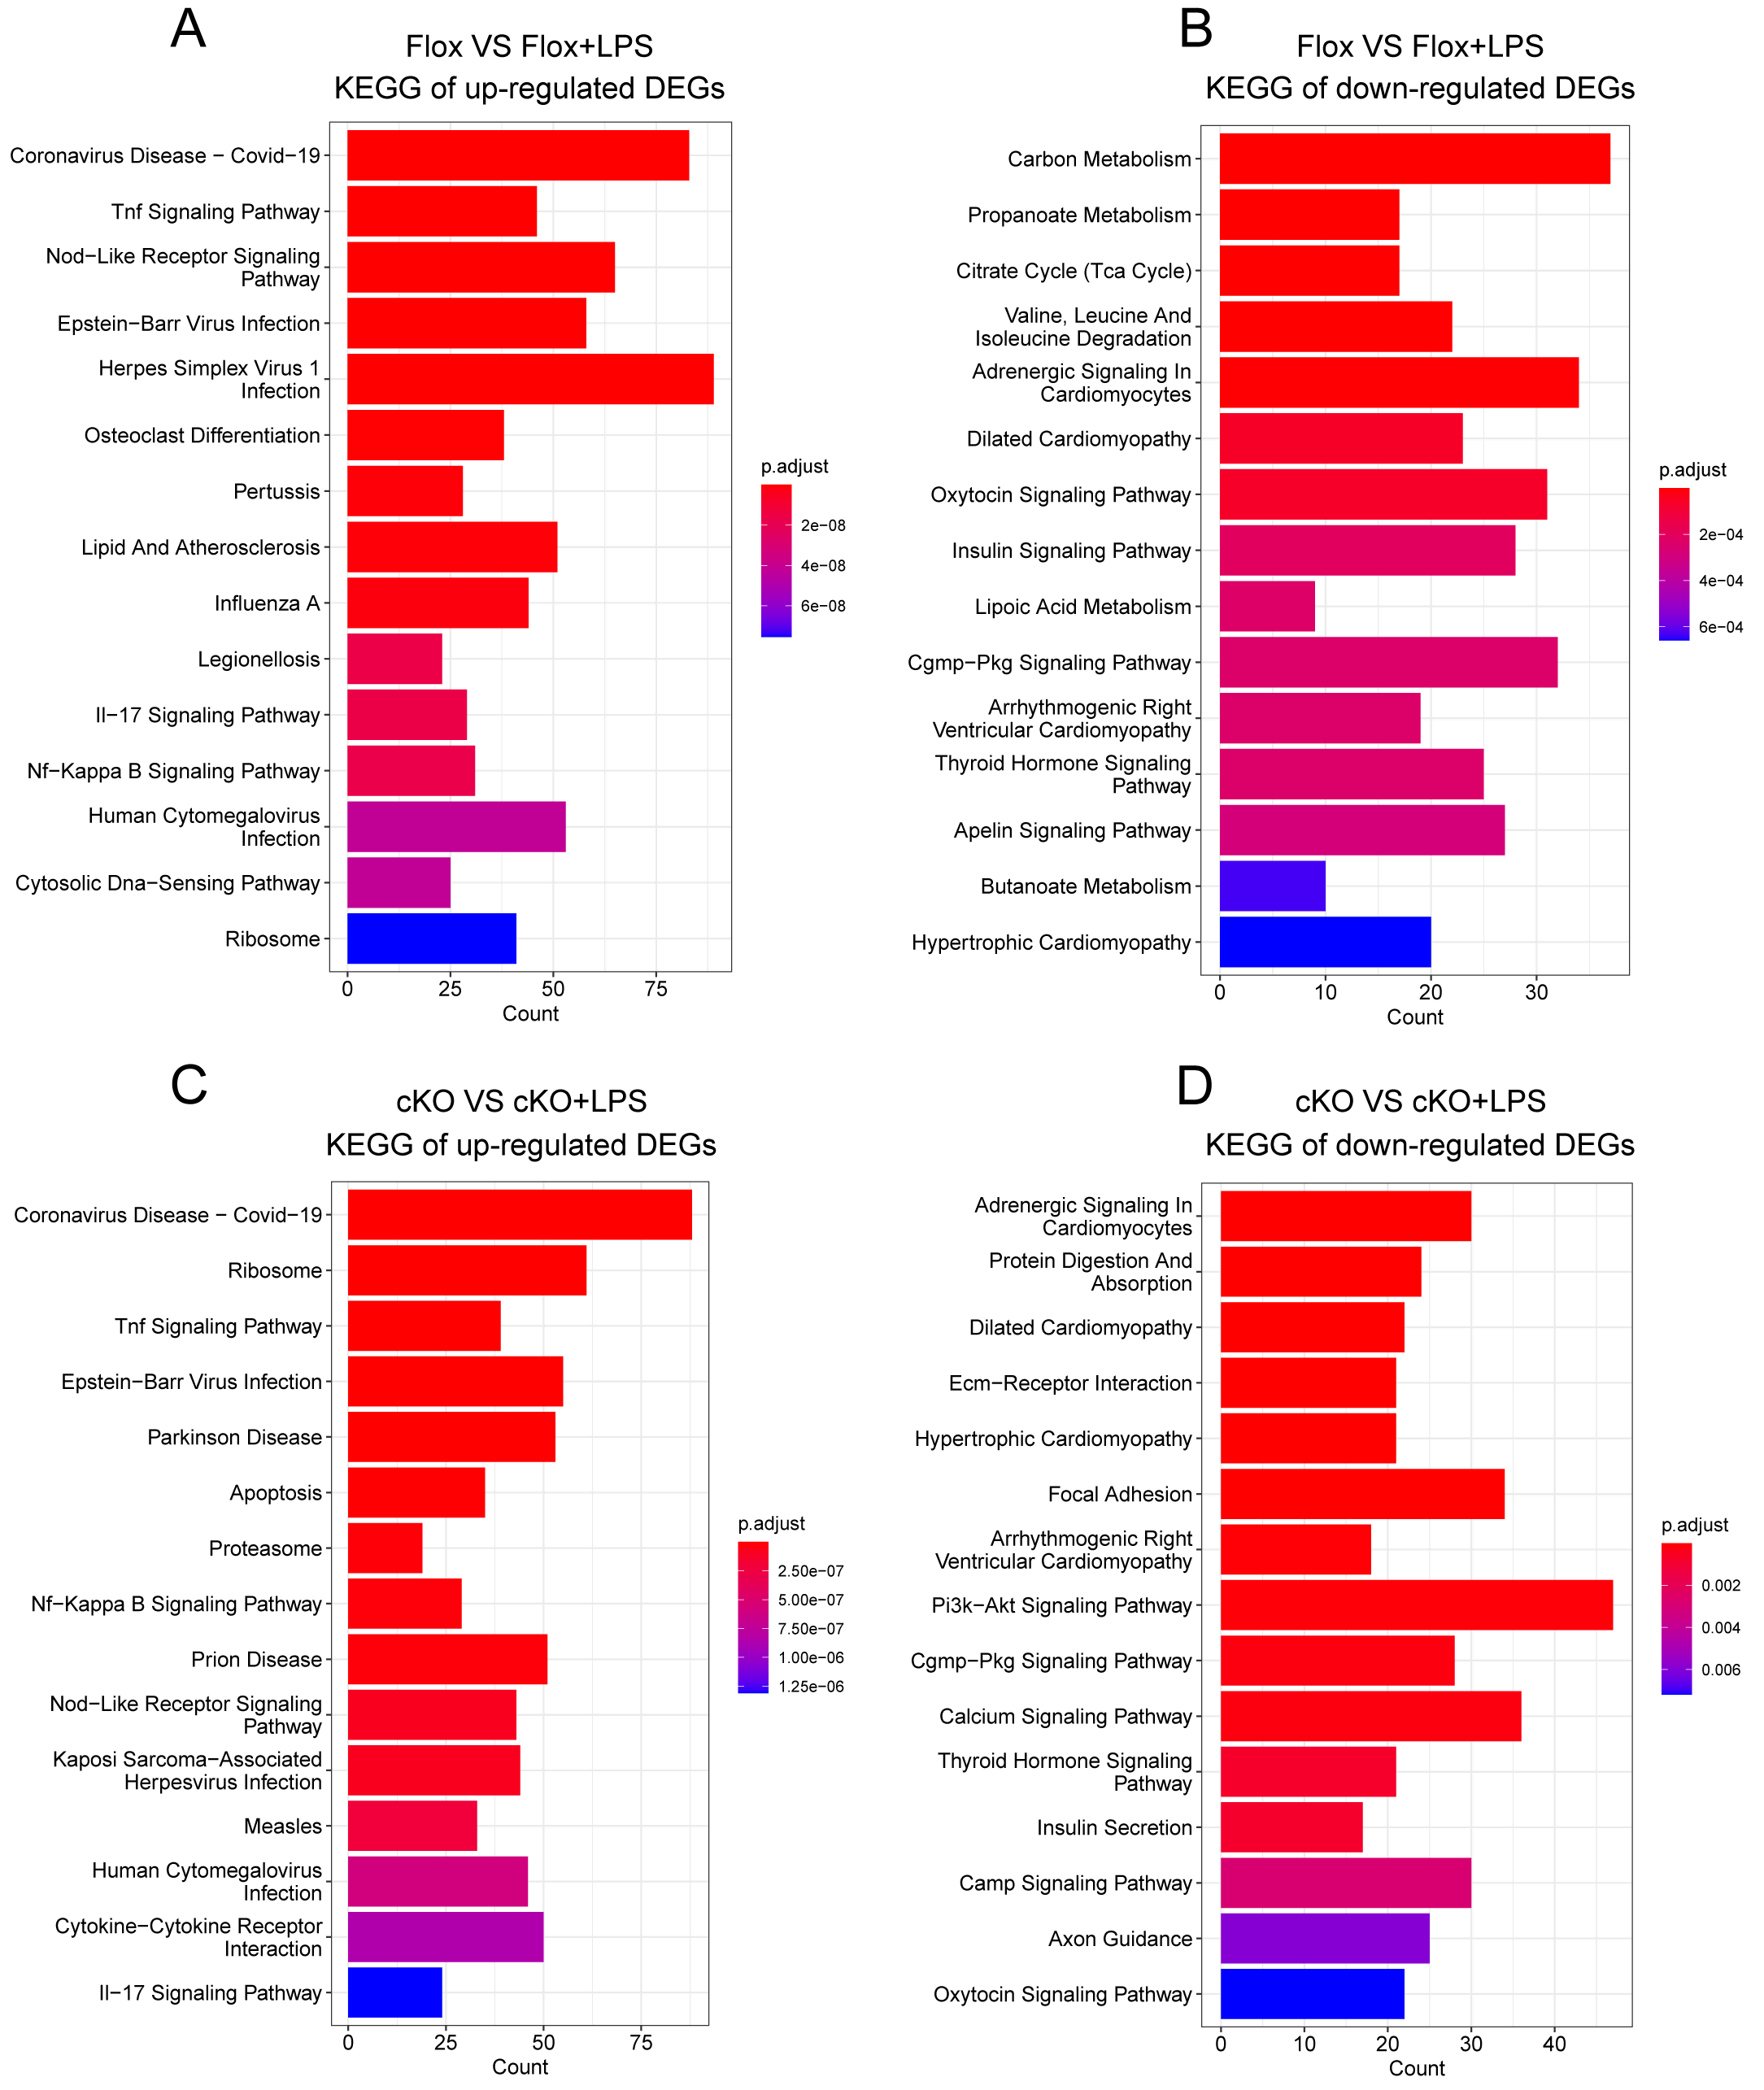
Supplementary Figure 6. KEGG enrichment analysis of differentially-expressed genes (DEGs). A and B, Bar plots showing the top 15 enriched KEGG pathways associated with the up-regulated or down-regulated DEGs from the hearts of Flox mice with/without LPS challenge. C and D, Bar plots showing the top 15 enriched KEGG pathways associated with the up-regulated or down-regulated DEGs from the hearts of cKO mice with/without LPS challenge. Flox, MacroD1^{flox/flox} control; cKO, MacroD1^{flox/flox}/αMHC^{MerCreMer}.
Supplementary Figure 7
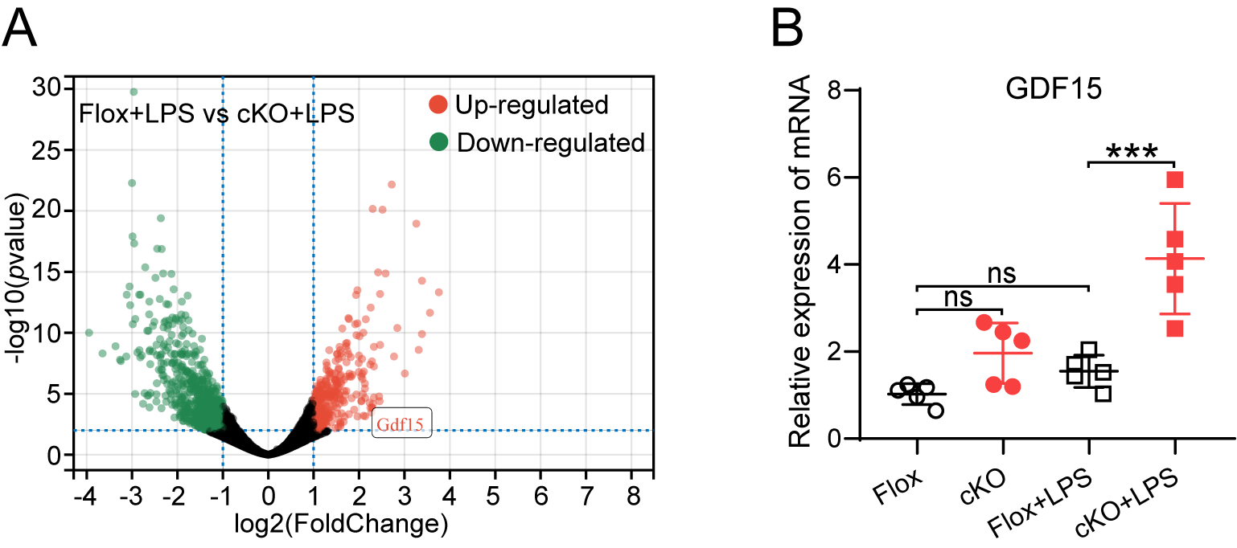
Supplementary Figure 7. GDF15 is up-regulated in cKO mice hearts. A, Volcano plot showing the expression of GDF15 in hearts of mice subjected to LPS (10mg/kg) stimulation. B, Real-time polymerase chain reaction (RT-qPCR) validation of GDF15 mRNA in hearts from Flox and cKO mice with/without LPS administration (n=5). ***p <0.001; ns, not significant. Flox, MacroD1^{flox/flox} control; cKO, MacroD1^{flox/flox}/αMHC^{MerCreMer}.
Supplementary Figure 8
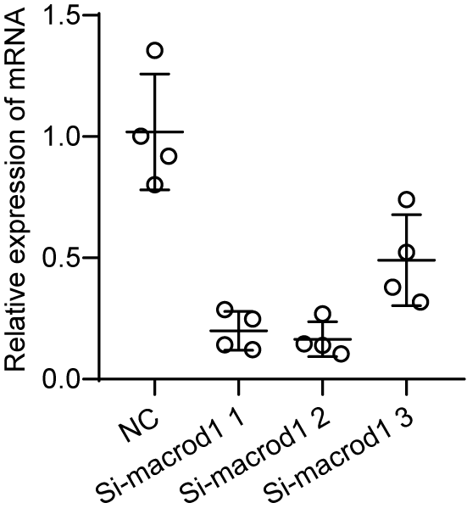
Supplementary Figure 8. Qualificative real-time polymerase chain reaction (RT-qPCR) analysis validates the knockdown efficiency of MacroD1 in neonatal rat cardiomyocytes (n=4). The 2nd interfering sequence was used to further experiments with MacroD1 knockdown.
Supplementary Figure 9
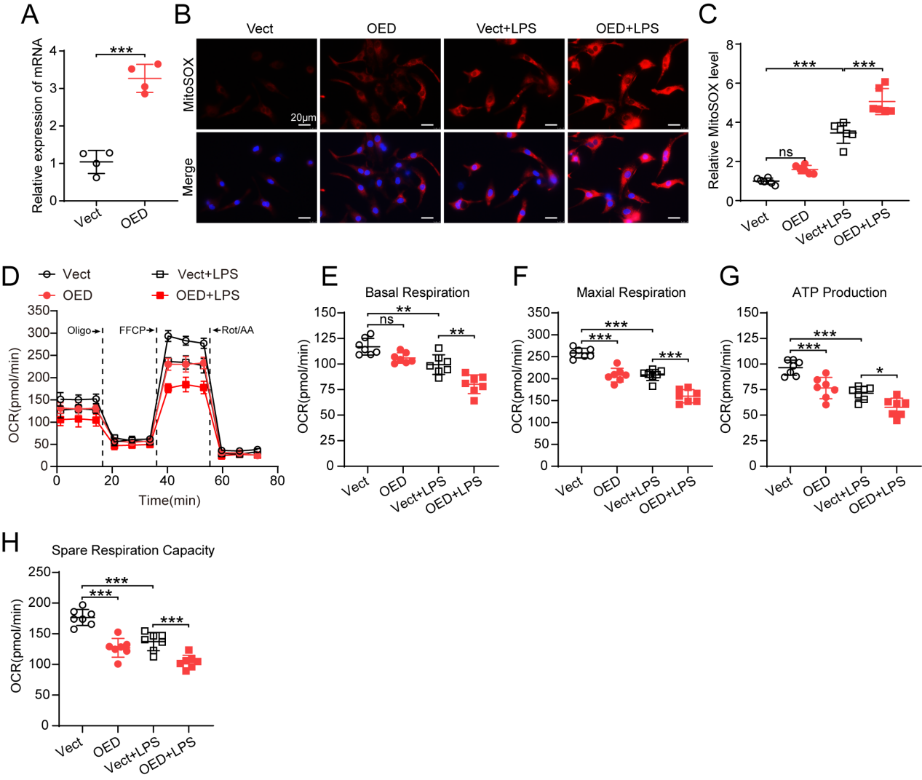
Supplementary Figure 9. MacroD1 overexpression aggravates LPS-induced mitochondrial dysfunction in neonatal rat cardiomyocytes (NRCMs). A, Quantitative real-time polymerase chain reaction (RT-qPCR) validation of MacroD1 overexpression in NRCMs infected with adenovirus empty (Vect) or adenovirus overexpressing MacroD1 (OED). B and C, Representative fluorescence images and quantification of MitoSOX in NRCMs infected with Vect or OED treated with/without LPS (1 μg/ml) for 18 hours (n=6). D, Seahorse mitochondrial stress test was carried out in NRCMs (OCR: Oxygen consumption rate; Oligo: Oligomycin; Rot/AA: Rotenone/Antimycin). D-H, Quantification of basal respiration (E), maximal respiration (F), ATP-linked respiration (G), and spare respiration capacity (H) of NRCMs (n=7). *p <0.05; **p <0.01; ***p <0.001; ns, not significant.
Supplementary Figure 10
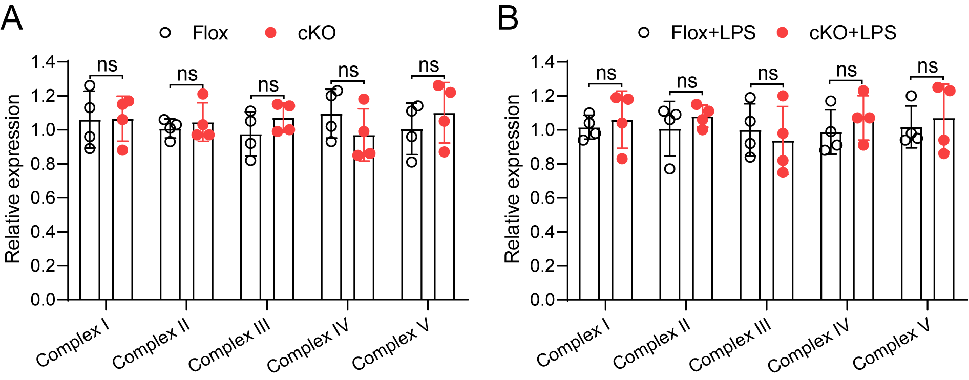
Supplementary Figure 10. MacroD1 knockout does not affect the expression of mitochondrial complexes in mice hearts. A, Quantification of mitochondrial complexes expression in the hearts of Flox and cKO mice (n=4). B, Quantification of the expression of mitochondrial complexes in the hearts of mice with LPS (10 mg/kg) administration for 18 hours (n=4). ns, not significant.
Supplementary Figure 11
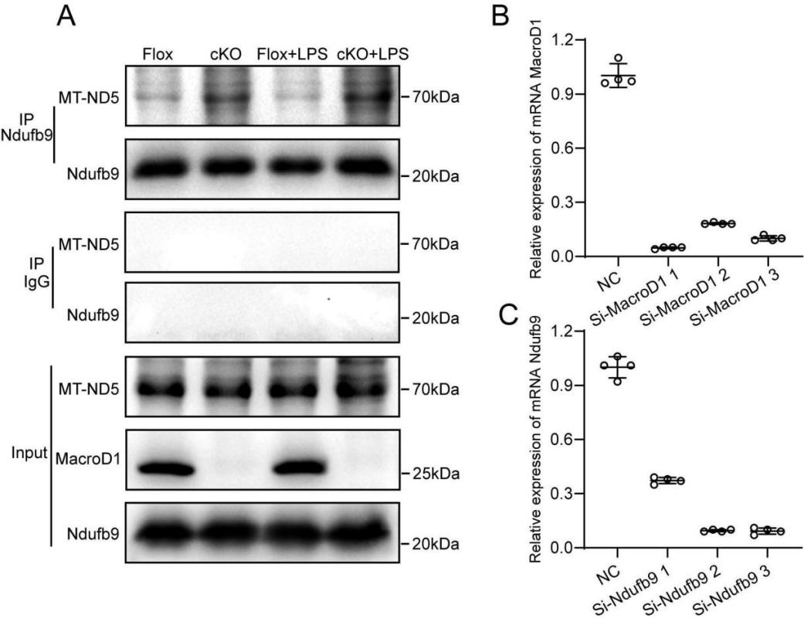
Supplementary Figure 11. Interaction between Ndufb9 and MT-ND5, and real-time polymerase chain reaction (RT-qPCR) analysis of MacroD1 and Ndufb9. A, The protein lysates from the hearts of MacroD1^{flox/flox} controls and cKO mice with and without administration of 10 mg/kg LPS for 18 hours were immunoprecipitated with Ndufb9 antibody, and then western blotting examination of Ndufb9 and MT-ND5 proteins. An enhanced immunoprecipitation of MT-ND5 proteins was detected in cKO hearts while decreased in MacroD1^{flox/flox} hearts subjected to the LPS challenge. B and C, RT-qPCR analysis of knockdown efficiency of MacroD1 (B, n=4) and Ndufb9 (C, n=4) in AC16 cells. The Si-MacroD1 1 or Si-Ndufb9 2 was used to further experiments with MacroD1 knockdown or Ndufb9 knockdown, respectively. Flox, MacroD1^{flox/flox} control; cKO, MacroD1^{flox/flox}/αMHC^{MerCreMer}.
Supplementary Figure 12
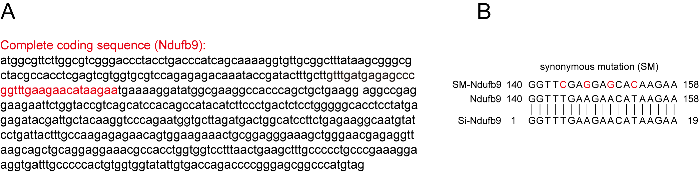
Supplementary Figure 12. Synonymous mutation of the targeted sequence of Ndufb9 corresponding to Ndufb9 siRNA. A, The completed coded sequence of Ndufb9 from Homo sapiens, with the red indicating the targeted sequence corresponding to Ndufb9 siRNA. B, The mutated sites of the targeted sequence of Ndufb9.
Supplementary Figure 13
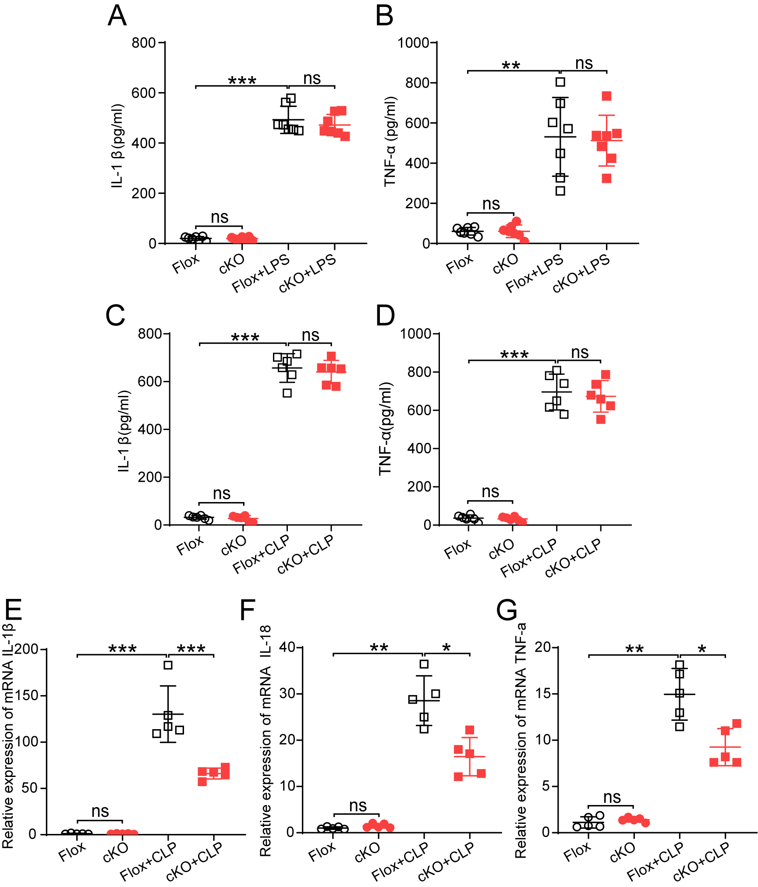
Supplementary Figure 13. MacroD1 knockout alleviates inflammation in hearts but not the serum of mice subjected to LPS stimulation or cecal ligation and puncture (CLP) surgery. A and B, The serum levels of IL-1β (A) and TNF-α (B) from Flox and cKO mice with/without LPS (10mg/kg) administration for 18 hours (n=7). C and D, The serum levels of IL-1β (C) and TNF-α (D) from Flox and cKO mice subjected to sham or CLP surgery (n=6) for 24 hours. E-G, Quantitative real-time polymerase chain reaction (RT-qPCR) analysis of IL-1β (E), IL-18 (F), and TNF-α (G) in the hearts of mice (n=5 for each group). Flox, MacroD1^{flox/flox} control; cKO, MacroD1^{flox/flox}/αMHC^{MerCreMer}. *p <0.05; **p <0.01; ***p <0.001; ns, not significant.
Supplementary Figure 14

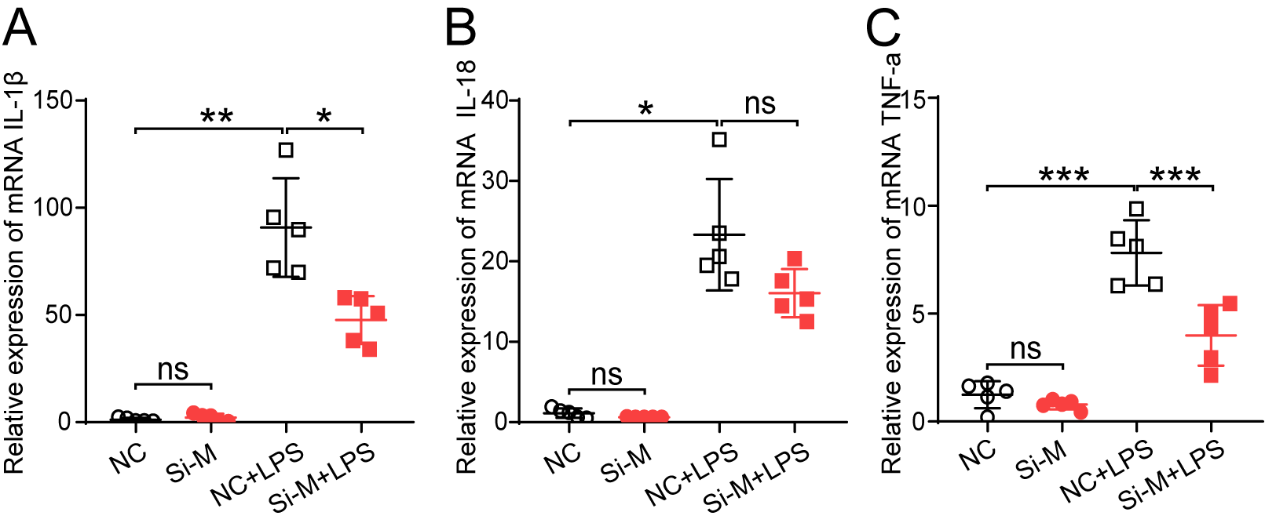
Supplementary Figure 14. MacroD1 knockdown ameliorates inflammation of cardiomyocytes induced by LPS in vitro. A-C, Real-time polymerase chain reaction (RT-qPCR) analysis of IL-1β (A), IL-18 (B), and TNF-α (C) in neonatal rat cardiomyocytes transfected with scrambled control (NC) or MacroD1 siRNA (Si-M) for 36 hours and then treated with/without LPS (1 μg/ml) for 18 hours and ATP (3 mM) for 2 hours (n=5 for each group). *p <0.05; **p <0.01; ***p <0.001; ns, not significant.
Supplementary Figure 15
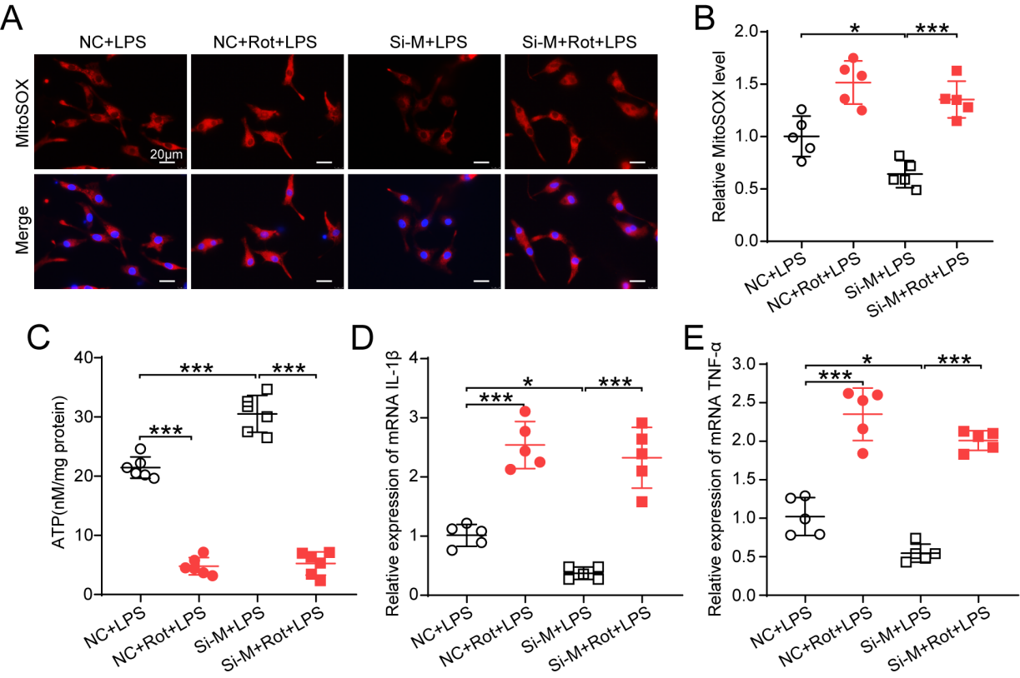
Supplementary Figure 15. Complex I inhibitor rotenone (Rot) abolishes the protection of MacroD1 knockdown against mitochondrial dysfunction and inflammation. A and B, Fluorescent staining and quantification of MitoSOX in neonatal rat cardiomyocytes (NRCMs) transfected with scrambled control (NC) or MacroD1 siRNA (Si-M) for 36 hours and treated with/without Rot (0.5 μM) for 18 hours in the presence of LPS (1 μg/ml) (n=5). C, ATP levels of NRCMs (n=6). D and E, Quantitative real-time polymerase chain reaction (RT-qPCR) analysis of IL-1β (D; n=5) and TNF-α (E; n=5) in NRCMs. *p <0.05; ***p <0.001.
Supplementary Figure 16
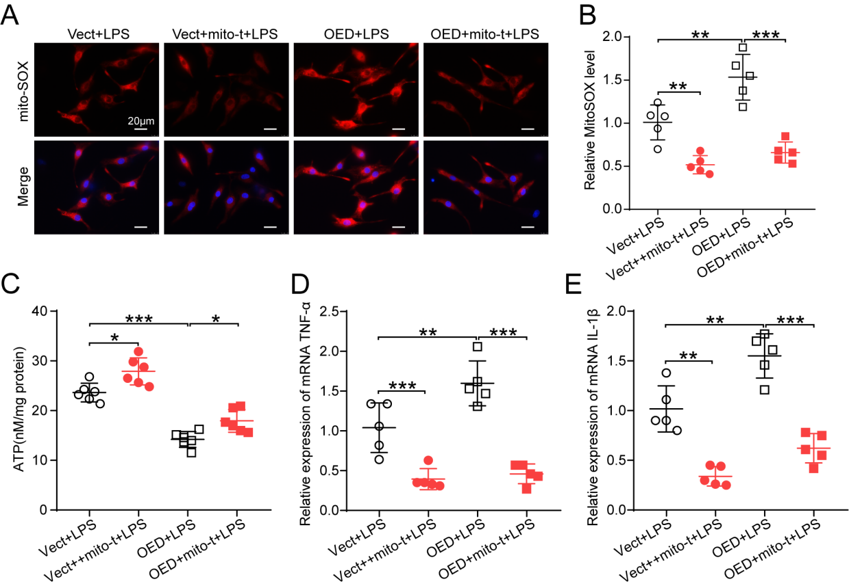
Supplementary Figure 16. Elimination of mitochondrial ROS protects against mitochondrial function and inhibits inflammation. A and B, Fluorescent staining and quantification of MitoSOX in neonatal rat cardiomyocytes (NRCMs) infected with adenovirus empty (Vect) or adenovirus overexpressing MacroD1 (OED) for 36 hours and treated with/without mito-TEMPO (mito-t; 200 nM) for 18 hours in the presence of LPS (1 μg/ml) (n=5). C, ATP levels of NRCMs (n=6). D and E, Quantitative real-time polymerase chain reaction (RT-qPCR) analysis of IL-1β (D; n=5) and TNF-α (E; n=5) in NRCMs. *p <0.05; **p <0.01; ***p <0.001.
Supplementary Figure 17
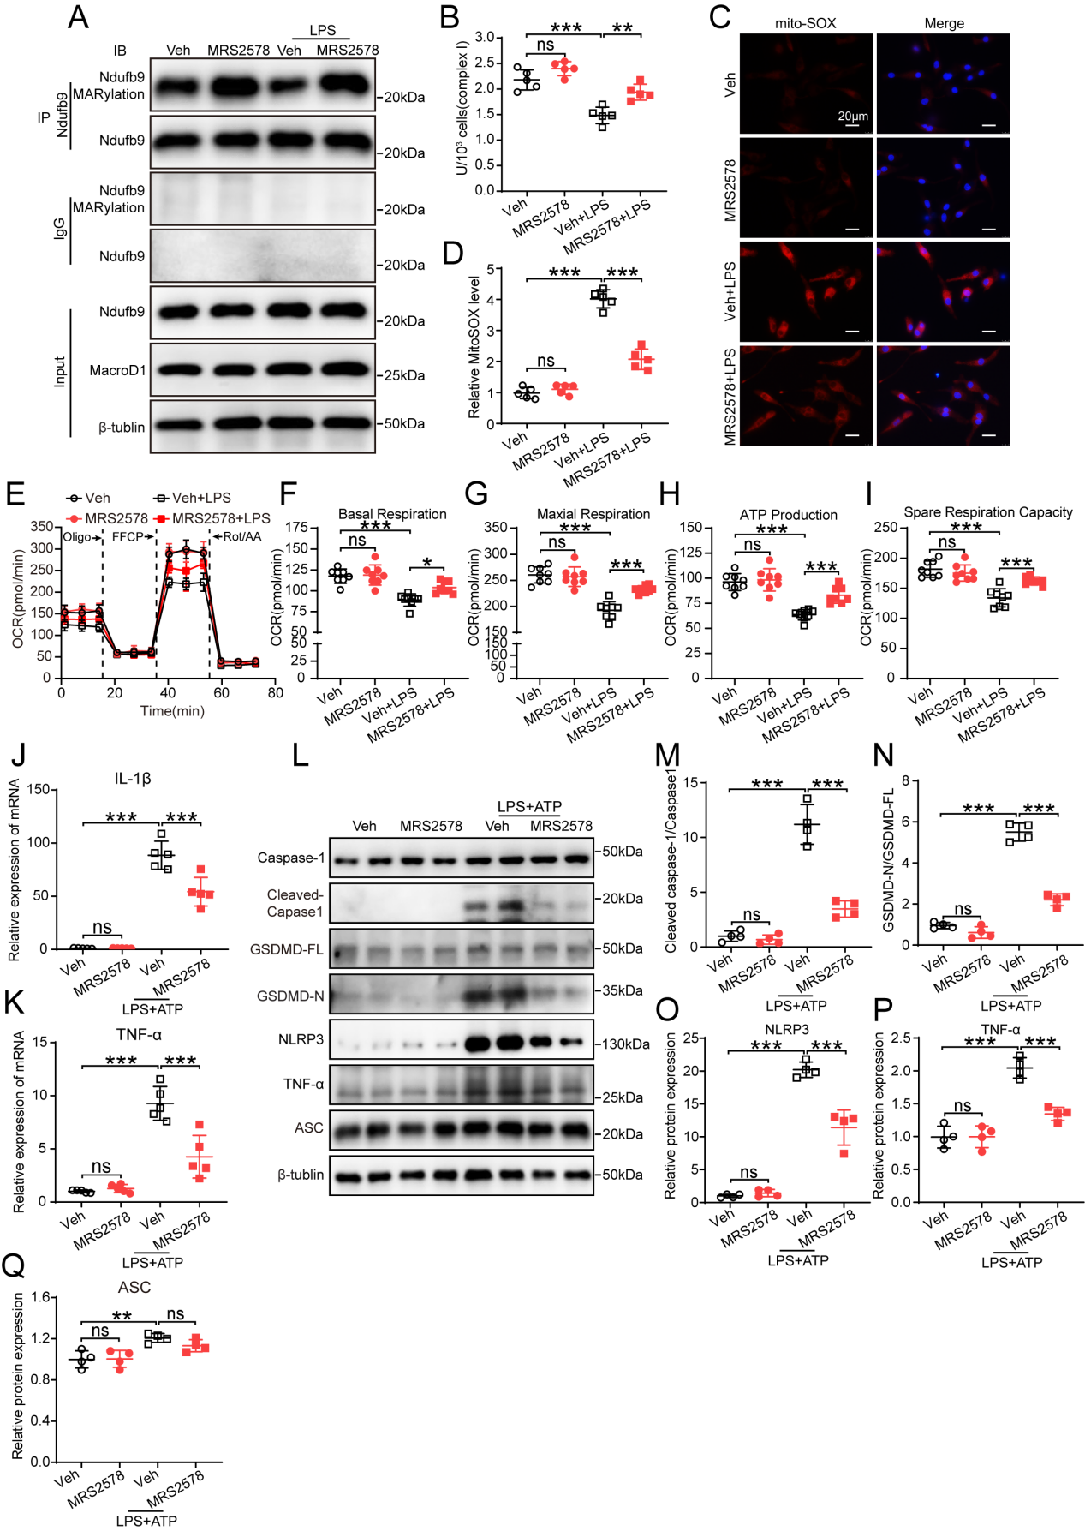
Supplementary Figure 17. Pharmacological inhibition of MacroD1 alleviates LPS-induced mitochondrial dysfunction and NLRP3 inflammasome activation of cardiomyocytes. Associated detections (A-I) were performed 18 hours after cardiomyocytes were treated with vehicle (Veh) and MRS2578 (10 μM) in the presence or absence of LPS (1 μg/ml). A, Western blotting (WB) examination of Ndufb9 MARylation in neonatal mice cardiomyocytes (NMCMs). B, Mitochondrial complex I activity of neonatal rat cardiomyocytes (NRCMs) (n=5). C and D, Fluorescent staining and quantification of MitoSOX in NRCMs (n=5). E, Seahorse analysis for detection of the oxygen consumption rate of NRCMs (n=8) (OCR: Oxygen consumption rate; Oligo: Oligomycin; Rot/AA: Rotenone/Antimycin). F-I, Quantification of basal respiration (F), maximal respiration (G), ATP-linked respiration (H), and spare respiration capacity (I) of NRCMs in seahorse assay (n=8) . J and K, Real-time polymerase chain reaction (RT-qPCR) analysis of IL-1β (J; n=5), and TNF-α (K; n=5) in NRCMs treated with ATP (3mM) 18 hours after vehicle (Veh) and MRS2578 (10 μM) or LPS (1 μg/ml) for 2 hours. L-Q, WB analysis of NLRP3 inflammasome pathway-related proteins in NRCMs treated with ATP (3mM) 18 hours after vehicle (Veh) and MRS2578 (10 μM) or LPS (1 μg/ml) for 2 hours (n=4). *p <0.05; **p <0.01; ***p <0.001; ns, not significant.
Supplementary Figure 18
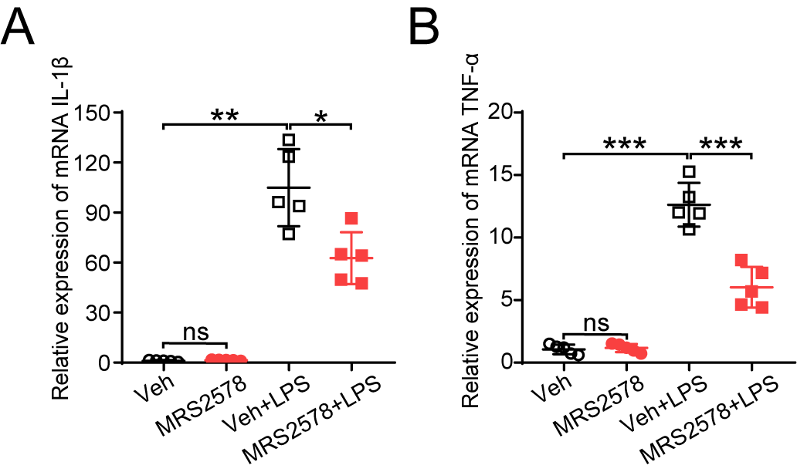
Supplementary Figure 18. MRS2578 treatment inhibits IL-1β (A; n=5), and TNF-α (B; n=5) mRNA expression in mice hearts stimulated by LPS. *p <0.05; **p <0.01; ***p <0.001; ns, not significant.
Supplementary Figure 19
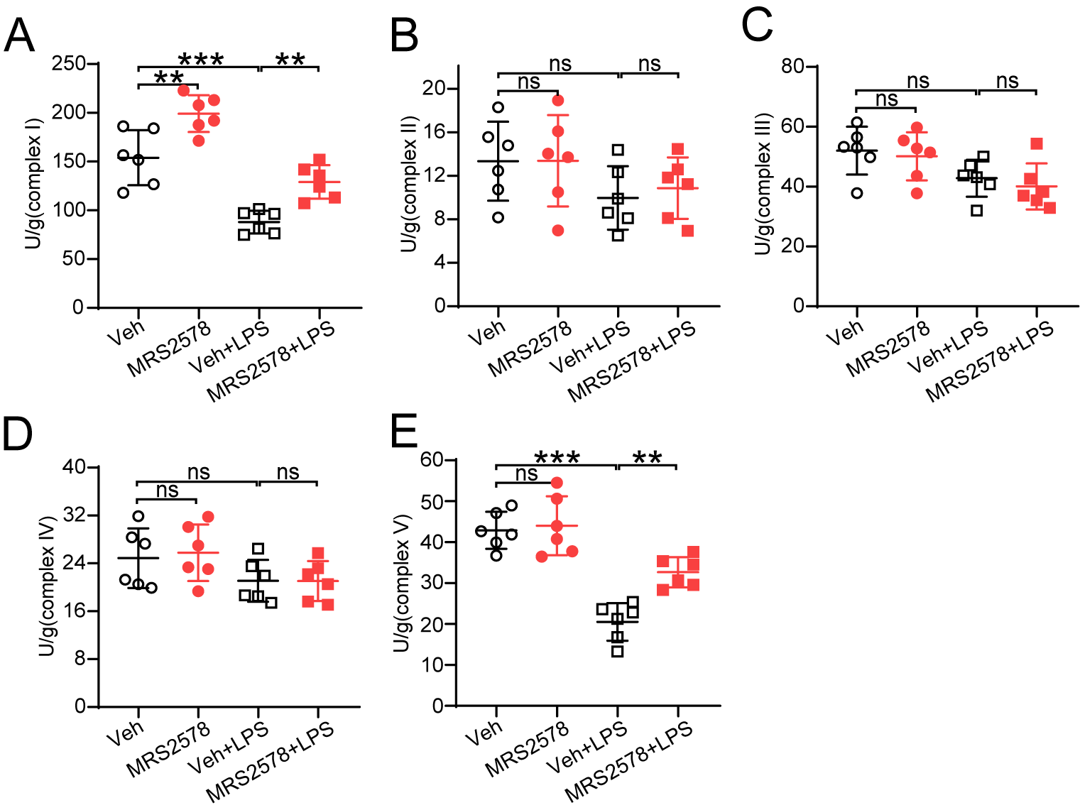
Supplementary Figure 19. Effect of MRS2578 therapy on cardiac mitochondrial complex activities in septic insult. n=6. **p <0.01; ***p <0.001; ns, not significant.
Supplementary Figure 20
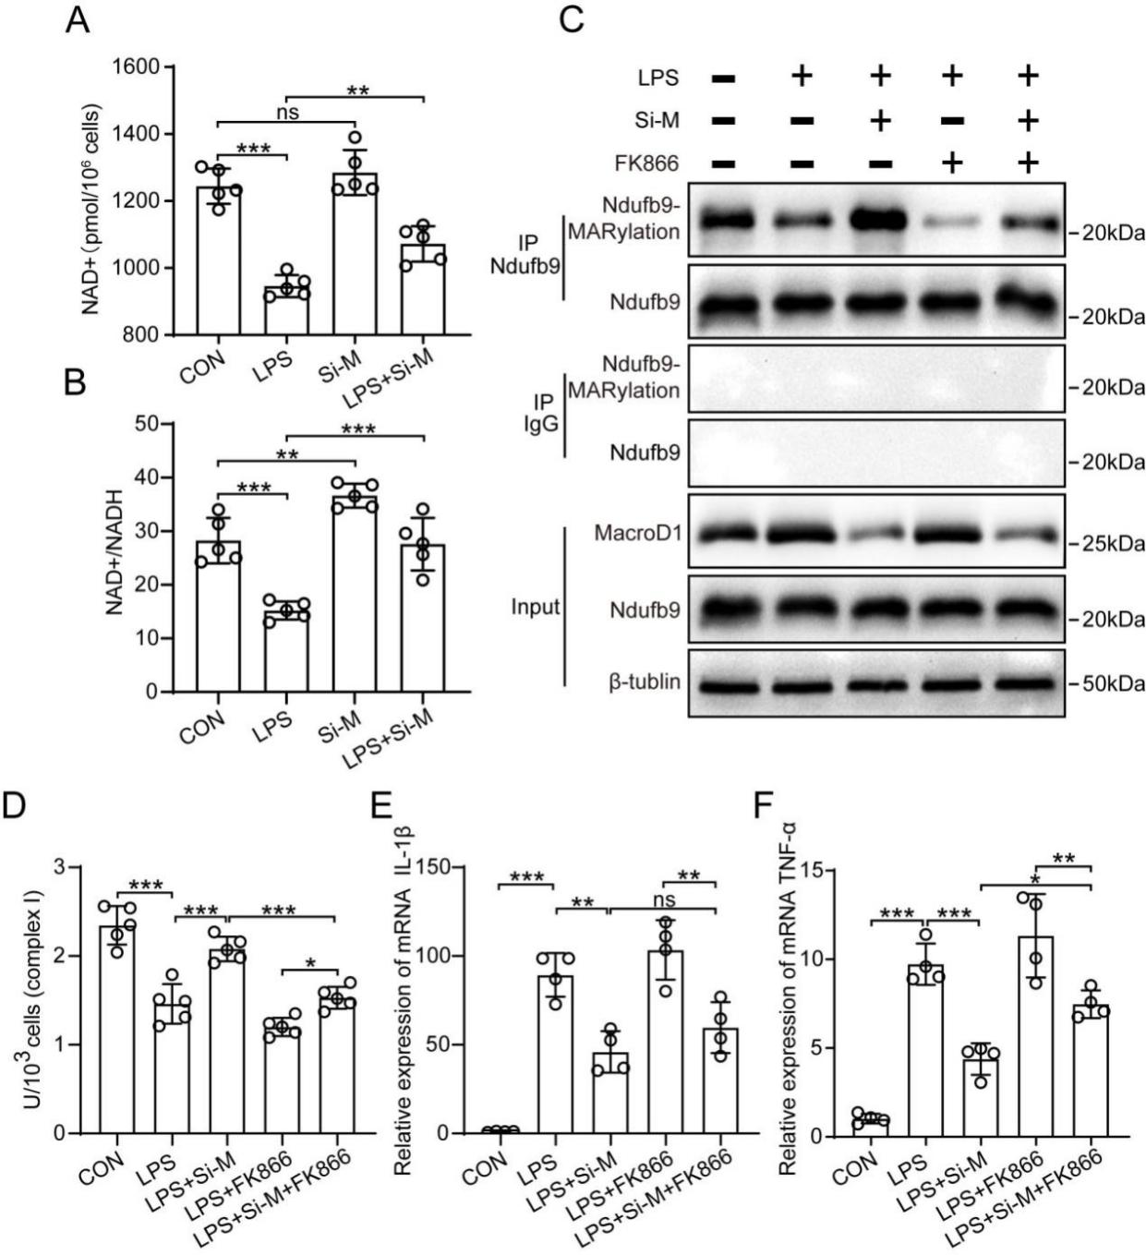
Supplementary Figure 20. NAD⁺ underpins the MacroD1-Ndufb9-complex I-NLRP3 inflammasome axis. A and B, NAD⁺ levels (A) and NAD⁺/NADH ratio (B) in AC16 cells transfected with MacroD1 siRNAs (Si-M) in the presence and absence of 18 hours treatment of LPS (1 μg/ml) (n=5). C-F, AC16 cells were transfected with MacroD1 siRNA (Si-M) or scrambled RNAs for 36 hours and then treated with LPS (1 μg/ml) and/or FK866 (10 µmol/L) for 18 hours. Co-IP assay for Ndufb9 MARylation (C), Complex I activity analysis (D) (n=5), and quantitative real-time polymerase chain reaction analysis of IL-1β and TNF-α mRNAs (E and F) (n=4). *p <0.05; **p <0.01; ***p <0.001; ns, not significant.
Supplementary Figure 21
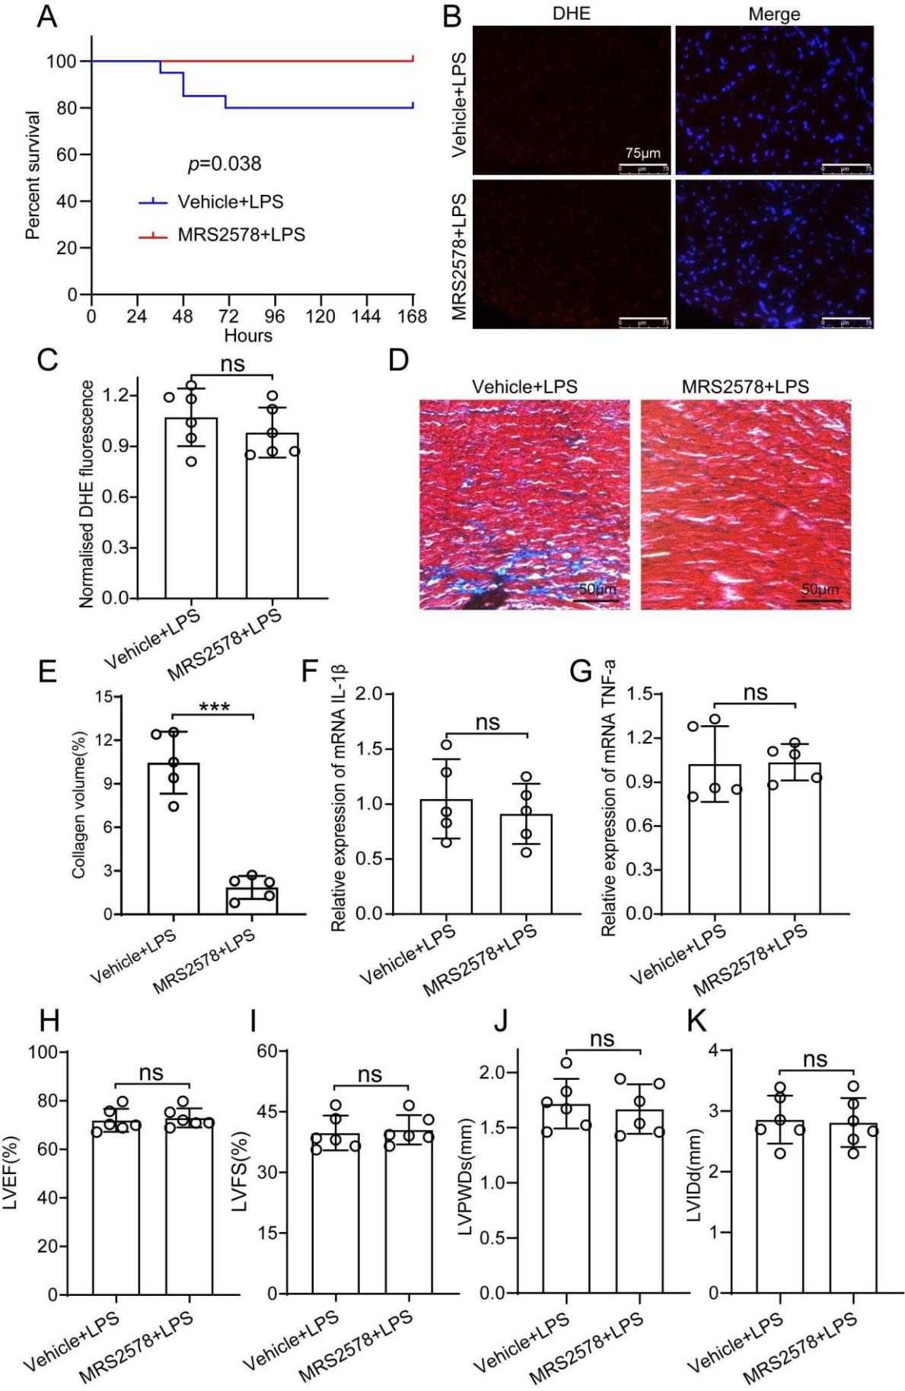
Supplementary Figure 21. Late effects of MacroD1 blocking on survival rate, myocardial function, and pathology after the LPS challenge. Wild-type mice with early administration of MacroD1 inhibitor MRS2578 were randomly grouped for LPS injection (10 mg/kg), and were sacrificed on day 7 for further analysis. A, Kaplan-Meier survival rate analysis (n=20). B, Representative fluorescent staining of dihydroethidium (DHE) of heart tissue sections. C, Quantification of DHE fluorescent intensity revealed comparable mitochondrial ROS levels in mice with and without MRS2578 (n=6). D and E, Masson’s staining and quantification of heart tissues (n=5). F and G, Quantitative PCR analysis of IL-1β and TNF-α mRNAs (n=5). H-K, Echocardiographic analysis of LVEF, LVFS, LVIDs, and LVIDd (n=6). ***p <0.001; ns, not significant.
Supplementary Figure 22
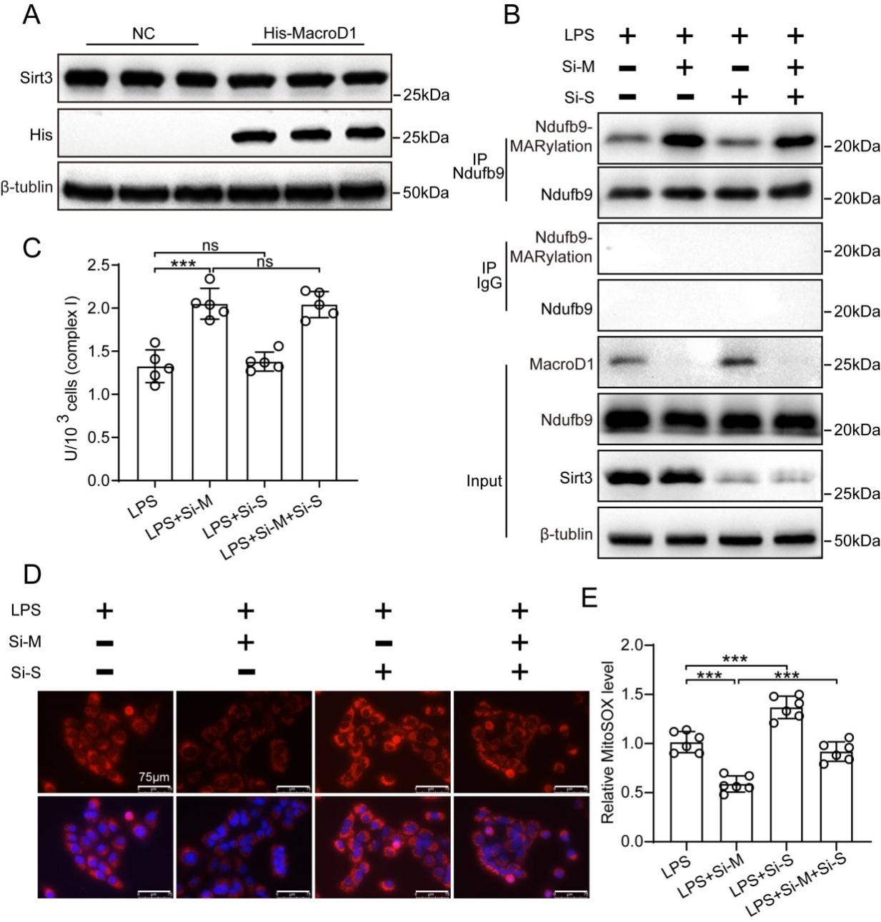
Supplementary Figure 22. MacroD1 regulates mitochondrial Ndufb9 MARylation and complex I activity independent of Sirt3. A, Western blotting analysis of Sirt3 protein in AC16 cells overexpressing MacroD1. B-E, AC16 cells were transfected with MacroD1 siRNAs (Si-M) or Sirt3 siRNAs (Si-S) for 36 hours, and then treated with LPS (1 μg/ml) for 18 hours. Co-IP assay for Ndufb9 MARylation (B) and Complex I activity analysis (C), (n=5). Mitochondrial ROS was examined by MitoSOX fluorescent staining (D) and quantified (E) (n=6). ***p <0.001; ns, not significant.
Supplementary Figure 23
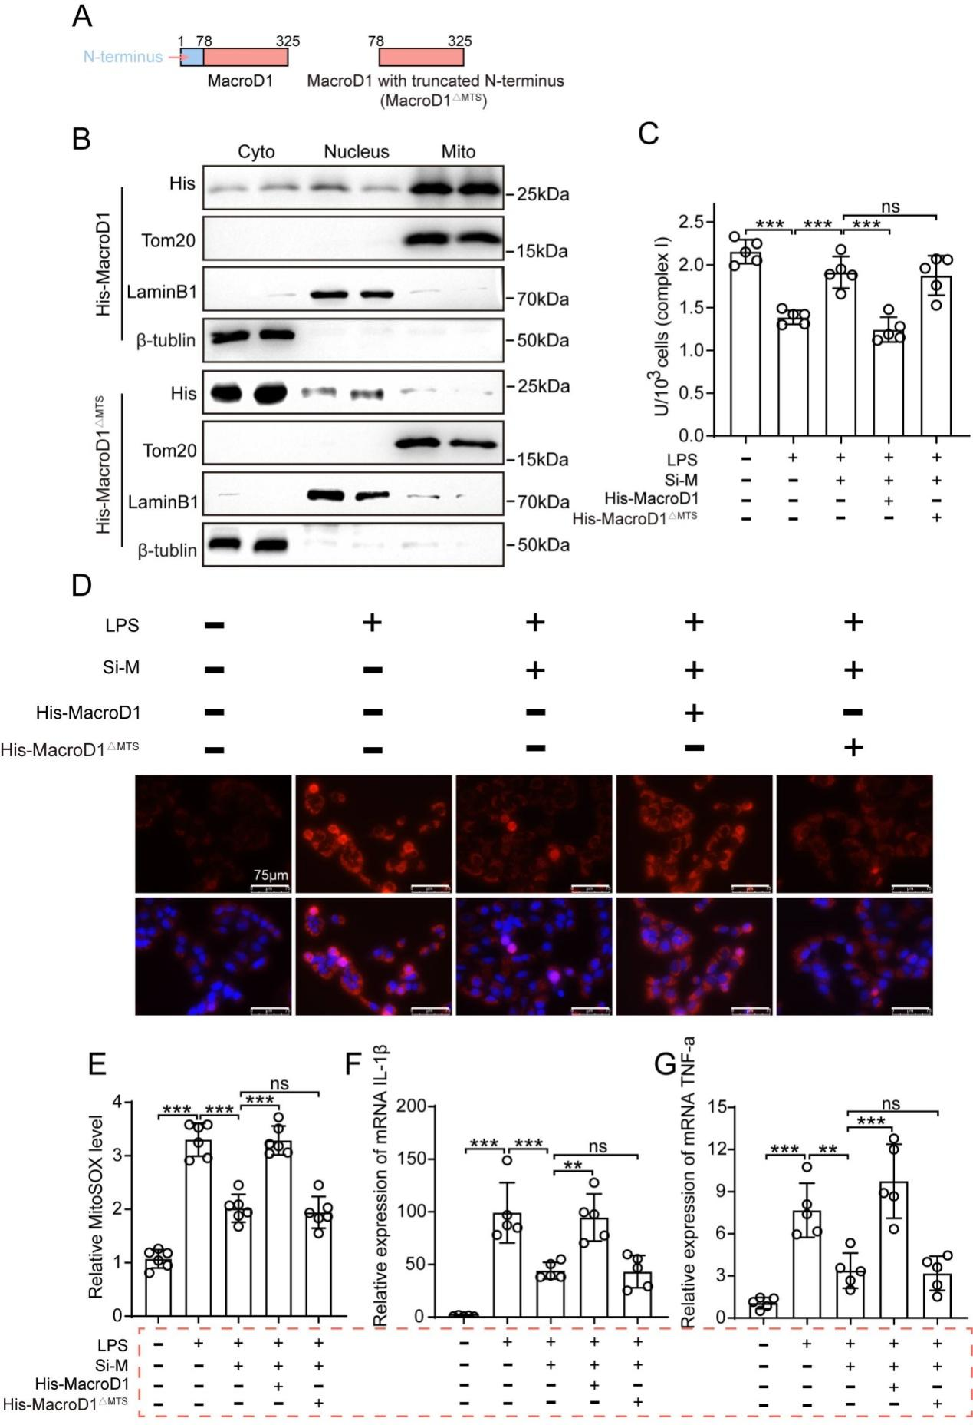
Supplementary Figure 23. Cytoplasmic MacroD1 does not regulate mitochondrial complex I-coupled inflammasome activation. A, Schematic diagram of the domain compositions of wild-type MacroD1 and its mutants truncating the mitochondrial targeting sequence in the N-terminus (MacroD1^{MTS}). B, Western blotting examination of MacroD1 protein in fractions of AC16 human cardiomyocytes transfected with plasmids entrapping His-tagged MacroD1 (M-WT) or its mutants truncating the mitochondrial targeting sequence (His-MacroD1^{MTS}). Cyto, cytoplasm; Mito, mitochondria. C-G, AC16 cardiomyocytes were transfected with siRNA MacroD1 (Si-M) and plasmids of M-WT, or MacroD1^{MTS} for 36 hours and then treated with/without LPS (1 μg/ml) for 18 hours. Complex I activity (C), MitoSOX fluorescent staining (D), and quantification (E) (n=5). F and G, Quantitative PCR test of IL-1β and TNF-α mRNAs in AC16 cardiomyocytes (n=5). **p <0.01; ***p <0.001; ns, not significant.
Supplementary Table 1. Mouse primers used for RT-qPCR
Gene | Forward primer 5’-3’ | Reverse primer 5’-3’
β-actin  IL-1β  IL-18  TNF-α  Acat1  Hadh  Acadm  Aco2  Sucla2  Dld  Pccb  Pcca  Bckdha  Acads  Suclg2  Mmut | CCTCTATGCCAACACAGTGC  GCAACTGTTCCTGAACTCAACT  GTGAACCCCAGACCAGACTG  GACGTGGAACTGGCAGAAGAG  AGAGCATGTCCAATGTCCCA  TCAAGCATGTGACCGTCATCG  AGGGTTTAGTTTTGAGTTGACGG  ATCGAGCGGGGAAAGACATAC  ACCCTTTCGCTGCATGAATAC  GAGCTGGAGTCGTGTGTACC  GCGGCGATTAGGATTCGGG  TTCATACCAATGCCTAGTGGTGT  CTCCTGTTGGGACGATCTGG  TGGCGACGGTTACACACTG  CCCCGAAGATGGCTGAACC  TTTTTGCTATCGCCCCATTACC | CCTGCTTGCTGATCCACATC  ATCTTTTGGGGTCCGTCAACT  CCTGGAACACGTTTCTGAAAGA  TTGGTGGTTTGTGAGTGTGAG  GCTGAGAGCGTACGTATCCT  TGGATTTTGCCAGGATGTCTTC  CCCCGCTTTTGTCATATTCCG  TGATGGTACAGCCACCTTAGG  CCTGTGCCTTTATCACAACATCC  CCTATCACTGTCACGTCAGCC  TGCGCTCTTTAACTGAAACCG  GACAGCCTCATCCGCCATTTT  CATTGGGCTGGATGAACTCAA  GTAGGCCAGGTAATCCAAGCC  ACCTCCTTTCAAACCGCTATTG  CCTCTGGGTTTTTGCCTTTCAG

Supplementary Table 2. Rat primers used for RT-qPCR
Gene | Forward primer 5’-3’ | Reverse primer 5’-3’
β-actin  IL-1β  IL-18  TNF-α  MacroD1 | TCTTCCAGCCTTCCTTCCTG  GGGATGATGACGACCTGCTA  TGATATCGACCGAACAGCCA  CGTCGTAGCAAACCACCAAG  TGAGTGACAAGCAGAGGGAG | CACACAGAGTACTTGCGCTC  TGTCGTTGCTTGTCTCTCCT  CCTGGCACACGTTTCTGAAA  GAGGCTGACTTTCTCCTGGT  GGAGTTGTTGGCAGCATTGA

Supplementary Table 3. Human primers used for RT-qPCR
Gene | Forward primer 5’-3’ | Reverse primer 5’-3’
β-actin  MacroD1  Ndufb9  Sirt3 | CATCCGCAAAGACCTGTACG  ACATGGAAGGAGATGGCGAA  TCAGCATCCACAGCCATACA  ACTACTTTCTCCGGCTGCTT | CCTGCTTGCTGATCCACATC  AGTCTTACAGCTCTGCAGGG  AACCTCTCGTTCCCAGCTTT  ACAATGTCGGGCTTCACAAC

Supplementary Table 4. SiRNAs used in the experiment
Species | Gene | Sequence
Rattus norveg  Rattus norveg  Rattus norveg  Homo sapiens  Homo sapiens  Homo sapiens  Homo sapiens  Homo sapiens  Homo sapiens  Homo sapiens | MacroD1 SiRNA 1  MacroD1 SiRNA 2  MacroD1 SiRNA 3  MacroD1 SiRNA 1  MacroD1 SiRNA 2  MacroD1 SiRNA 3  Ndufb9 SiRNA 1  Ndufb9 SiRNA 2  Ndufb9 SiRNA 3  Sirt3 SiRNA | CCAAGUAUAAGAAGGACAATT  GCGGAGGUAGUGCUAGCUATT  GUGUGUUCCUGGAGAAGGATT  CAAGCAGCUCAAUGAGAAATT  AGAAGGACGAGGACAUCUATT  AGAAGAUCCCGACAUGGAATT  AGUGAAAUAUGUUACAGAATT  GGUUUGAAGAACAUAAGAATT  GAGAGAUACGAUUGCUACATT  CCACCUGCACAGUCUGCCAAATT

Supplementary Table 5. Detailed information of antibody
Antibody | Supplier | Item number
MacroD1  GAPDH  TOM20  β-tublin  NLRP3  ASC  GSDMD  Caspase-1  TNF-α  Flag  His  Ndufb9  α-SMA  MPO  mono-ADPr  Anti-Mouse IgG  Anti-Rabbit IgG  Anti-Rabbit IgG heavy chain  Anti-Mouse IgG heavy chain  MT-ND5  Sirt3  Anti-RabbitIgG Light Chain  LaminB1 | Gifted by YM. Mu lab at Chinese PLA General Hospital, Beijing, China  Abclonal  Santa Cruz  Cell Signaling Technology  Abclonal  Santa Cruz  Abcam  Abclonal  Abclonal  Cell Signaling Technology  Cell Signaling Technology  Abcam  Abclonal  HycultBiotech  Sigma-Aldrich  Proteintech  Proteintech  Abbkine  Abbkine  Abclonal  Abcam  Abbkine  Abclonal | AC001  sc-17764  2148S  A5652  sc-514414  ab210070  A0964  A0277  14793S  12698S  ab200198  A17910  HM1051-20UG  MABE1076  SA00001-1  SA00001-2  A25222  A25112  A17972  ab217319  A25022  A11495

Supplementary Table 6. Echocardiographic parameters of Flox and cKO mice stimulated by LPS or saline
 | Saline |  | LPS
Heart rates  LVID;s  LVID;d  LVEF  LVFS  LVPW;s  LVPW;d  IVS;s  IVS;d | Flox  480±16  1.901±0.231  3.206±0.374  72.584±3.699  40.631±3.366  1.303±0.114  0.854±0.141  1.316±0.079  0.838±0.113 | cKO  486±17  1.864±0.234  3.177±0.3  73.457±4.464  41.392±3.998  1.357±0.083  0.911±0.045  1.308±0.123  0.808±0.111 | Flox  491±20  3.318±0.339  4.083±0.313  39.222±5.649  18.833±3.076  0.949±0.131  0.788±0.185  1.031±0.153  0.786±0.099 | cKO  483±16  2.749±0.255  3.816±0.305  54.701±4.709  27.963±3.045  1.105±0.131  0.757±0.116  1.152±0.136  0.8±0.093
LVID; s (mm) = Left Ventricular Internal Diameter at end-systole;
LVID; d (mm) = Left Ventricular Internal Diameter at end-diastole;
LVEF (%) = Left Ventricular Ejection Fraction;
LVFS (%) = Left Ventricular Fractional Shortening;
LVPW; s (mm) = Left Ventricular Posterior Wall thickness at systole;
LVPW; d (mm) = Left Ventricular Posterior Wall thickness at diastole;
IVS; s (mm) = Interventricular Septum thickness at systole;
IVS; d (mm) = Interventricular Septum thickness at diastole.
Supplementary Table 7. Echocardiographic parameters of Flox and cKO mice subjected to cecal ligation and perforation (CLP) or sham surgery
 | Sham |  | CLP
Heart rates  LVID;s  LVID;d  LVEF  LVFS  LVPW;s  LVPW;d  IVS;s  IVS;d | Flox  477±13  1.817±0.259  3.177±0.339  75.077±5.33  42.865±4.566  1.268±0.112  0.775±0.223  1.319±0.175  0.924±0.235 | cKO  478±14  1.896±0.17  3.173±0.298  72.054±4.298  40.136±3.74  1.23±0.177  0.825±0.153  1.287±0.221  0.871±0.308 | Flox  477±9  3.317±0.244  3.991±0.324  35.634±3.817  16.815±2.109  0.981±0.17  0.741±0.208  0.943±0.226  0.709±0.118 | cKO  489±19  2.563±0.455  3.371±0.5  48.941±8.311  24.162±4.953  1.127±0.136  0.774±0.103  1.103±0.111  0.794±0.183
LVID; s (mm) = Left Ventricular Internal Diameter at end-systole;
LVID; d (mm) = Left Ventricular Internal Diameter at end-diastole;
LVEF (%) = Left Ventricular Ejection Fraction;
LVFS (%) = Left Ventricular Fractional Shortening;
LVPW; s (mm) = Left Ventricular Posterior Wall thickness at systole;
LVPW; d (mm) = Left Ventricular Posterior Wall thickness at diastole;
IVS; s (mm) = Interventricular Septum thickness at systole;
IVS; d (mm) = Interventricular Septum thickness at diastole.
Supplementary Table 8. Echocardiographic parameters of mice injected with/without LPS under the treatment of Vechicle or MRS2578
 | Saline |  | LPS
Heart rates  LVID;s  LVID;d  LVEF  LVFS  LVPW;s  LVPW;d  IVS;s  IVS;d | Vehicle  482±14  1.927±0.292  3.37±0.423  75.039±3.828  42.914±3.391  1.303±0.059  0.886±0.081  1.251±0.146  0.813±0.063 | MRS2578  482±9  1.859±0.297  3.195±0.451  73.598±6.179  41.685±5.701  1.31±0.169  0.809±0.104  1.242±0.171  0.75±0.261 | Vehicle  474±13  3.169±0.577  3.891±0.559  39.54±7.682  18.961±4.117  0.999±0.178  0.73±0.109  0.941±0.097  0.731±0.092 | MRS2578  487±17  2.507±0.388  3.532±0.492  56.808±3.924  29.086±2.487  1.099±0.192  0.74±0.151  1.11±0.131  0.758±0.062
LVID; s (mm) = Left Ventricular Internal Diameter at end-systole;
LVID; d (mm) = Left Ventricular Internal Diameter at end-diastole;
LVEF (%) = Left Ventricular Ejection Fraction;
LVFS (%) = Left Ventricular Fractional Shortening;
LVPW; s (mm) = Left Ventricular Posterior Wall thickness at systole;
LVPW; d (mm) = Left Ventricular Posterior Wall thickness at diastole;
IVS; s (mm) = Interventricular Septum thickness at systole;
IVS; d (mm) = Interventricular Septum thickness at diastole.
Supplementary Table 9. Late effects of MacroD1 blocking on myocardial function of mice. Wild-type mice with early administration of MacroD1 inhibitor MRS2578 were randomly grouped for LPS injection (10 mg/kg), and were sacrificed on day 7 for echocardiographic analysis of mice.
 | Vehicle+LPS | MRS2578+LPS
Heart rates  LVID;s  LVID;d  LVEF  LVFS  LVPW;s  LVPW;d  IVS;s  IVS;d | 503±13  1.716±0.225  2.859±0.395  71.937±4.768  39.777±4.292  1.369±0.081  0.946±0.093  1.461±0.101  0.952±0.165 | 503±15  1.668±0.225  2.812±0.403  72.973±3.94  40.549±3.614  1.382±0.093  0.945±0.112  1.429±0.168  0.89±0.154
LVID; s (mm) = Left Ventricular Internal Diameter at end-systole;
LVID; d (mm) = Left Ventricular Internal Diameter at end-diastole;
LVEF (%) = Left Ventricular Ejection Fraction;
LVFS (%) = Left Ventricular Fractional Shortening;
LVPW; s (mm) = Left Ventricular Posterior Wall thickness at systole;
LVPW; d (mm) = Left Ventricular Posterior Wall thickness at diastole;
IVS; s (mm) = Interventricular Septum thickness at systole;
IVS; d (mm) = Interventricular Septum thickness at diastole.

