Supplementary Figures
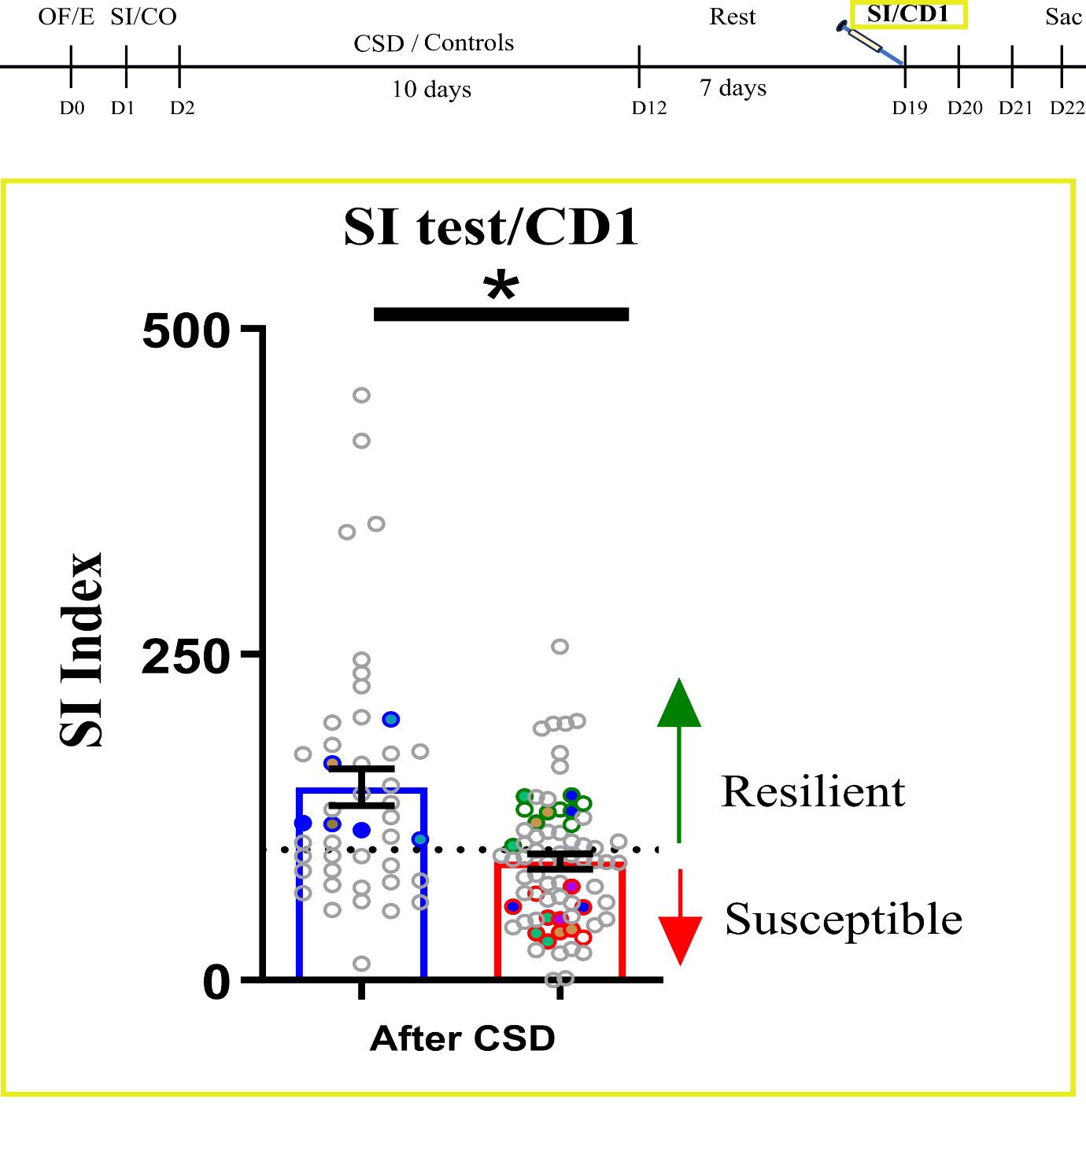
Supplementary Fig 1: Selection of mouse for methylome sequencing. SI indices of mice that were selected for RRBS-seq. 2 pairs of mice (fill color-matched) were pooled to contribute to one sample each for control, resilient and susceptible groups, with one sample for the susceptible group pooled from 3 mice. Non-filled circles indicate SI indices of mice that were selected but did not pass quality check after sequencing.
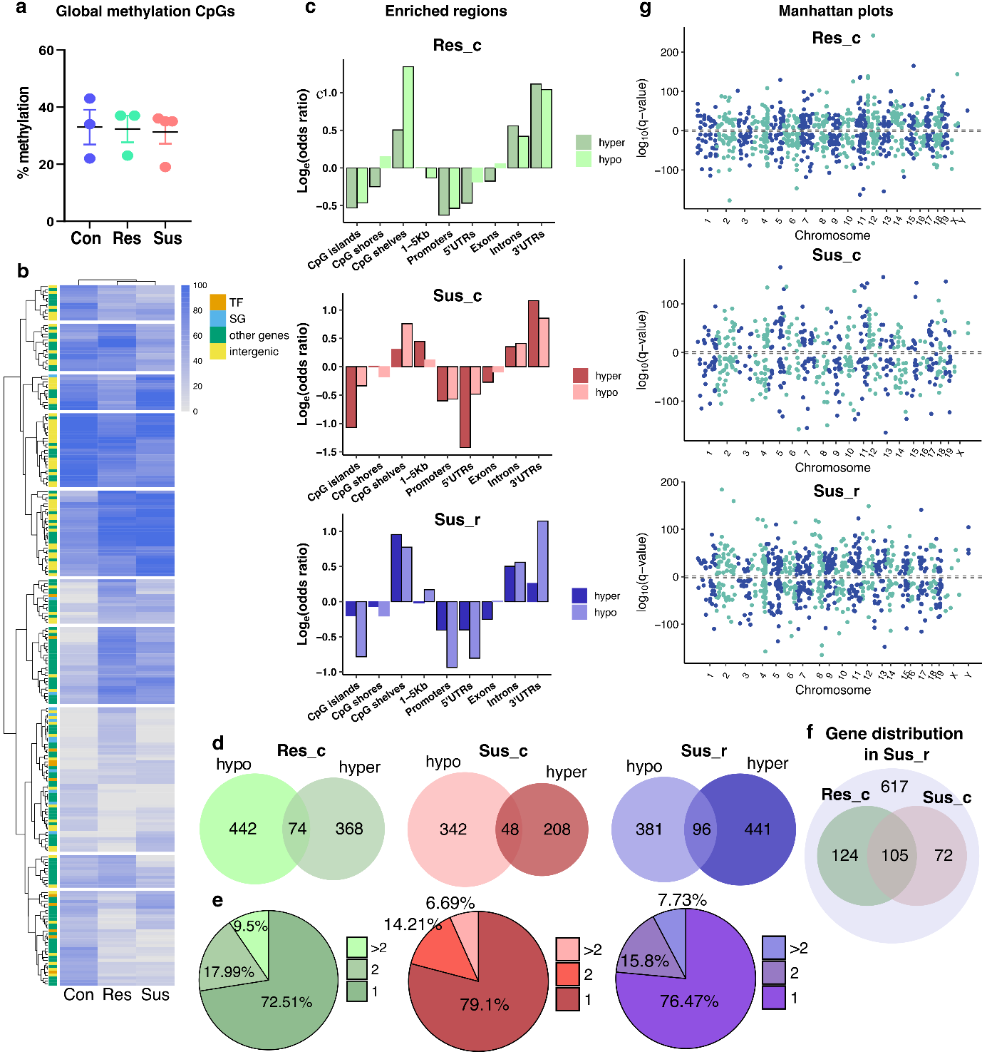

Supplementary Fig 2: Base resolution methylation landscape of single differentially methylated cytosines (dmCs) from RRBS-seq. a. Global methylation percentage of CpG dinucleotides for control, resilient and susceptible groups (N = 3, 3 and 4 respectively). b. Heatmap depicting methylation percentage of all differentially methylated cytosines (dmCs) in the CpG context, detected in all three phenotypes, segregated into intergenic regions and genic regions (color-coded by their known functions as transcription factors, synaptic genes and other genes). Cytosines with similar methylation levels were grouped together using hierarchical clustering. c. Log odds ratio depicting enrichment of the dmCs in CpG shelves, introns and 3’UTRs. Black frames around the bars indicate statistically significant log odds ratios (p<0.05). d. Venn diagrams depicting the number of genes (dmGs) that contain hypomethylated or hypermethylated cytosines (CpGs) in the respective comparisons of resilient to control (Res_c), susceptible to control (Sus_c) and susceptible to resilient (Sus_r) e. Pie chart showing the fraction of genes classified by the criterion of harbouring only 1 dmC, 2 dmCs or more f. Venn diagram showing the genes specific to Res_c (green) or Sus_c (red) in the direct comparison of the two stressed phenotypes g. Manhattan plot of the dmCs along their chromosomal positions. q-values indicate significance of the difference in methylation, with the sign corresponding to the direction of change (gain or loss of methylation).

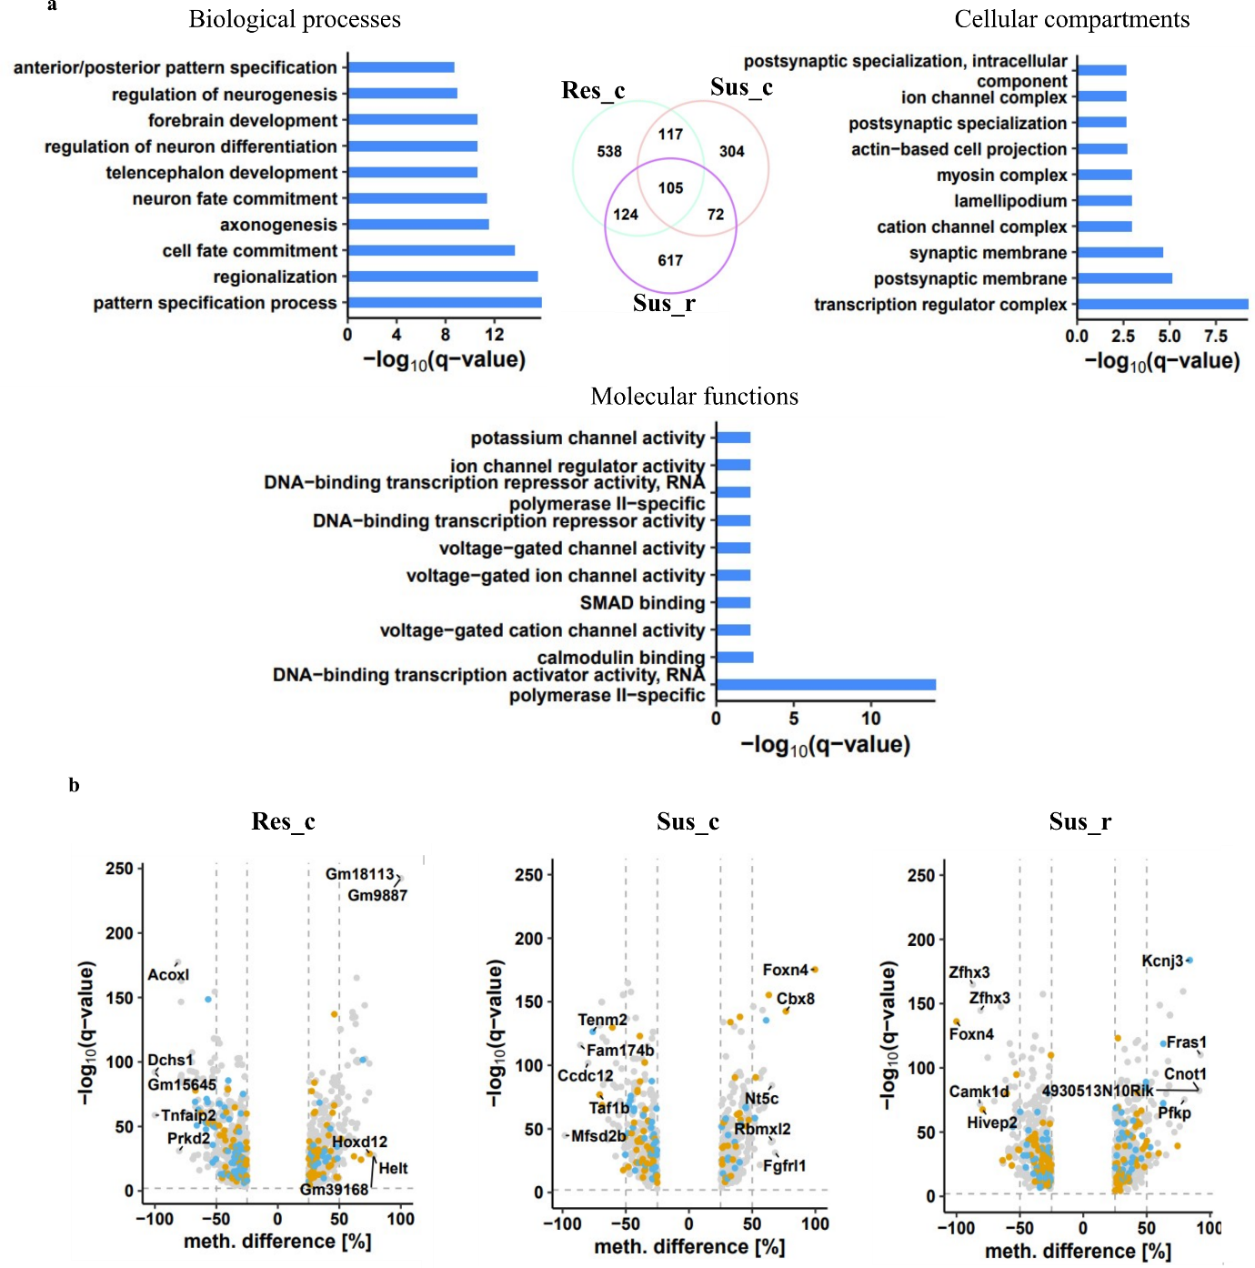

Supplementary Fig 3: Functional assignment of the differentially methylated genes (dmGs) corresponding to the differentially methylated cytosines (dmCs). a. Venn diagram and top 10 gene ontology terms of collective stress response dmGs (combined from all pairwise comparisons). b. Volcano plots of the dmGs depicting the distribution of TFs (orange) and synaptic genes (blue) in the population of dmGs for Res_c, Sus_c and Sus_r. % of synaptic genes: TFs for the dual comparison are 46.62:53.37; 40.86:59.13; 41.14:58.85, respectively.
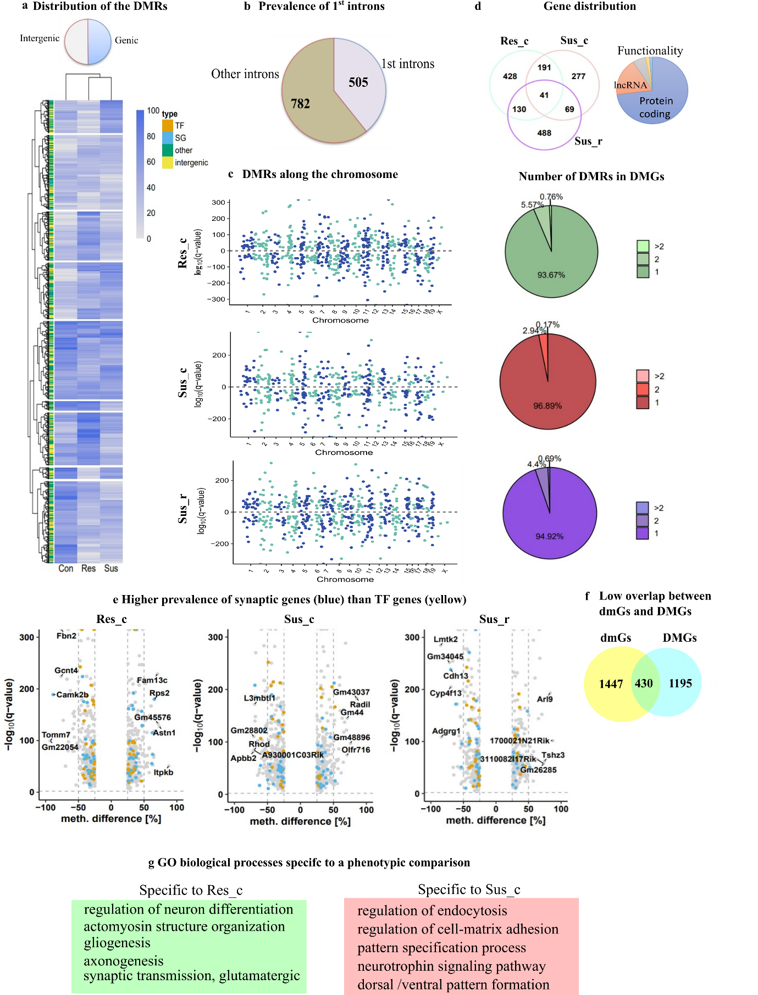

Supplementary Fig 4: Alterations in the methylation landscape (differentially methylated genes of the DMRs) and biological processes following stress exposure: a. Heatmap of absolute methylation percentage of the DMRs detected in all three phenotypes segregated into intergenic regions and genic regions. b. Most intronic DMRs are located in the 1st introns. c. Manhattan plots showing the distribution of DMRs across all chromosomes. Q-values indicate significance of the difference in methylation, with the sign corresponding to the direction of change (gain or loss of methylation). d. Venn diagram depicting the number of genes overlapping between the different phenotypic comparisons of Res_c, Sus_c and Sus_r, with most genes belonging to protein coding genes. Pie charts identify the fraction of DMGs harbouring 1 or more DMRs in the respective comparisons of Res_c (green), Sus_c (red) and Sus_r (purple). e. Volcano plots of the DMRs showing the distribution of synaptic genes (blue) and transcription factors (orange). % of synaptic genes:TFs for the dual comparisons of Res_c, Sus_c and Sus_r – 66.66:33.33, 55.17:44.82, 56.48:43.51, respectively. f. Venn diagram showing the overlap between the dmGs and DMGs. g. GO BPs specifically enriched in the phenotypic comparisons (q<0.05).

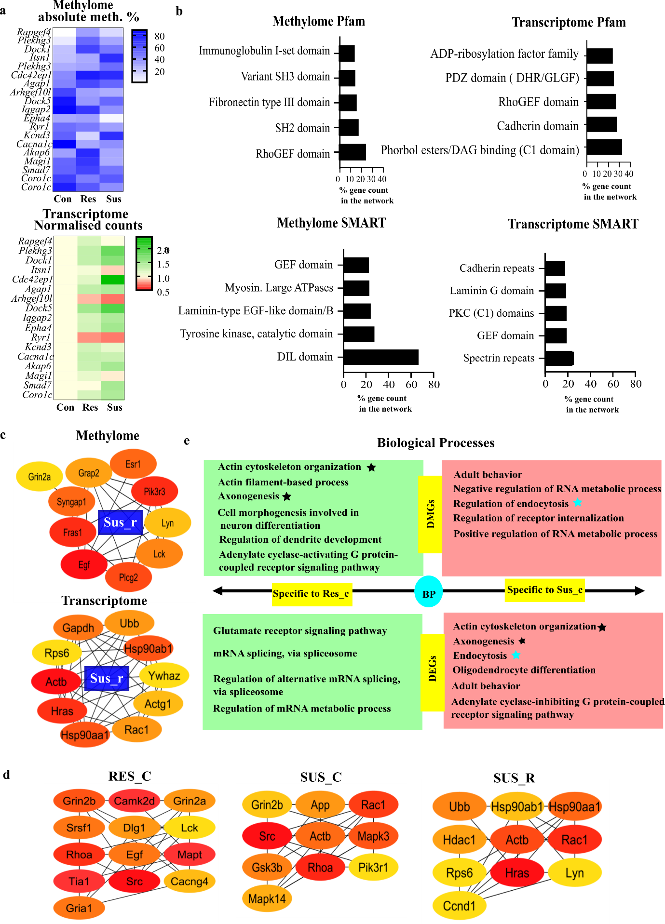

Supplementary Fig 5: Multi-omics analyses: a. Absolute methylation levels and read counts of selected genes common to both DMGs and DEGs. b. Top represented Pfam and SMART protein domains in the network of methylome (DMGs) and transcriptome (DEGs), combined from all phenotypic comparisons. c. Top 10 hub genes of Sus_r DMGs. Top 10 hub genes of Sus_r DEGs. Colour code from red to yellow denotes ranks of the hubs in ascending order. d. Top 10 hub genes of RES_C, SUS_C and SUS_R of the DMGs and DEGs combined as per their specific comparison groups. e. GO terms of BP (Enrichr) specific to either Res_c or Sus_c, depicting similar BP in the divergent phenotypes at different omics levels (DMGs and DEGs).

