Table 1. Class definitions with representative examples for radar signatures associated with trees.

class TA | class TB | class TC | class TD | class TE
group of shallow, prominent hyperbolas | group of shallow, faint hyperbolas | complex signal containing multiple shallow/deep hyperbolas and/or flat-lying reflectors | flat-lying reflector but no hyperbolas | no discernible signature
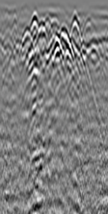 | 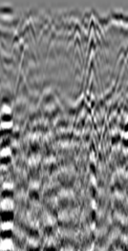 | 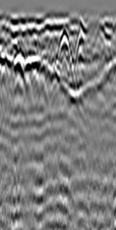 | 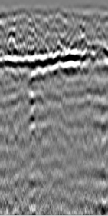 | 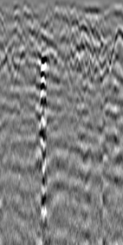

Table 2. Class definitions with representative examples for radar signatures associated with markers.
class MA | class MB | class MC | class MD | class ME | class MF
isolated or multiple deep flat-topped hyperbolas | deep flat-topped hyperbola with shallow hyperbolas | complex signal involving multiple shallow/deep hyperbolas and/or flat-lying reflectors | group of shallow hyperbolas with no deep flat-topped hyperbola | flat-lying reflector but no hyperbolas | no discernible signal
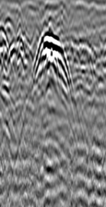 | 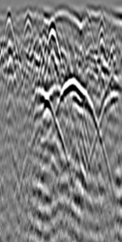 | 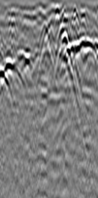 | 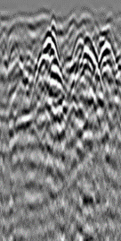 | 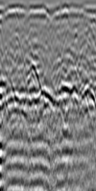 | 