Accession | Species | Type | Gene | Family | Country | Host | Link
QPD01627 | Volzhskoe tick virus | prot | GPC | Unclass | Russia | Hyalomma marginatum | https://www.ncbi.nlm.nih.gov/nuccore/QPD01627
USL85430 | Ixodes ricinus bunyavirus-like virus 1 | prot | GPC | Unclass | Croatia | Ixodes ricinus | https://www.ncbi.nlm.nih.gov/nuccore/USL85430
USL85420 | Bronnoya virus | prot | GPC | Unclass | Croatia | Ixodes ricinus | https://www.ncbi.nlm.nih.gov/nuccore/USL85420
ASY03251 | Bronnoya virus | prot | GPC | Unclass | Norway | Ixodes ricinus | https://www.ncbi.nlm.nih.gov/nuccore/ASY03251
BBD75426 | Ixodes scapularis bunyavirus | prot | GPC | Peribunyaviridae | Japan | na | https://www.ncbi.nlm.nih.gov/nuccore/BBD75426
YP010084299 | California encephalitis orthobunyavirus | prot | GPC | Peribunyaviridae | na | na | https://www.ncbi.nlm.nih.gov/nuccore/YP010084299
YP010085089 | Leptomonas shilevirus | prot | GPC | Leishbuviridae | na | na | https://www.ncbi.nlm.nih.gov/nuccore/YP010085089
YP010086061 | Salehabad phlebovirus | prot | GPC | Phenuiviridae | na | na | https://www.ncbi.nlm.nih.gov/nuccore/YP010086061
YP009664554 | Ferak feravirus | prot | GPC | Phasmaviridae | na | na | https://www.ncbi.nlm.nih.gov/nuccore/YP009664554
YP009664558 | Turlock orthobunyavirus | prot | GPC | Peribunyaviridae | na | na | https://www.ncbi.nlm.nih.gov/nuccore/YP009664558
YP009666905 | Batai orthobunyavirus | prot | GPC | Peribunyaviridae | na | na | https://www.ncbi.nlm.nih.gov/nuccore/YP009666905
YP009666318 | Millipede wumivirus | prot | GPC | Wupedeviridae | na | na | https://www.ncbi.nlm.nih.gov/nuccore/YP009666318
YP009666938 | Guertu bandavirus | prot | GPC | Phenuiviridae | na | na | https://www.ncbi.nlm.nih.gov/nuccore/YP009666938
YP009667022 | Witwatersrand orthobunyavirus | prot | GPC | Peribunyaviridae | na | na | https://www.ncbi.nlm.nih.gov/nuccore/YP009667022
YP009667046 | Tacaiuma orthobunyavirus | prot | GPC | Peribunyaviridae | na | na | https://www.ncbi.nlm.nih.gov/nuccore/YP009667046
YP009507851 | Hazara orthonairovirus | prot | GPC | Nairoviridae | na | na | https://www.ncbi.nlm.nih.gov/nuccore/YP009507851
YP009512940 | Punta Toro phlebovirus | prot | GPC | Phenuiviridae | na | na | https://www.ncbi.nlm.nih.gov/nuccore/YP009512940
YP009361837 | Nairobi sheep disease orthonairovirus | prot | GPC | Nairoviridae | na | na | https://www.ncbi.nlm.nih.gov/nuccore/YP009361837
YP009345126 | Myriapod hubavirus | prot | GPC | Mypoviridae | na | na | https://www.ncbi.nlm.nih.gov/nuccore/YP009345126
YP009329880 | Lincruvirus wenlingense | prot | GPC | Cruliviridae | na | na | https://www.ncbi.nlm.nih.gov/nuccore/YP009329880
YP009047241 | Heartland bandavirus | prot | GPC | Phenuiviridae | na | na | https://www.ncbi.nlm.nih.gov/nuccore/YP009047241
YP003848705 | Rift Valley fever phlebovirus | prot | GPC | Phenuiviridae | na | na | https://www.ncbi.nlm.nih.gov/nuccore/YP003848705
YP003104765 | European mountain ash ringspot-associated virus | prot | GPC | Fimoviridae | na | na | https://www.ncbi.nlm.nih.gov/nuccore/YP003104765
YP001497160 | Akabane orthobunyavirus | prot | GPC | Peribunyaviridae | na | na | https://www.ncbi.nlm.nih.gov/nuccore/YP001497160
YP006504094 | Dabie bandavirus | prot | GPC | Phenuiviridae | na | na | https://www.ncbi.nlm.nih.gov/nuccore/YP006504094
YP009225 | Tomato spotted wilt orthotospovirus | prot | GPC | Tospoviridae | na | na | https://www.ncbi.nlm.nih.gov/nuccore/YP009225
NP955542 | Dugbe orthonairovirus | prot | GPC | Nairoviridae | na | na | https://www.ncbi.nlm.nih.gov/nuccore/NP955542
NP950235 | rimean-Congo hemorrhagic fever orthonairovirus | prot | GPC | Nairoviridae | na | na | https://www.ncbi.nlm.nih.gov/nuccore/NP950235
NP942586 | Tula orthohantavirus | prot | GPC | Hantaviridae | na | na | https://www.ncbi.nlm.nih.gov/nuccore/NP942586
NP942554 | Dobrava-Belgrade orthohantavirus | prot | GPC | Hantaviridae | na | na | https://www.ncbi.nlm.nih.gov/nuccore/NP942554
NP942557 | Seoul orthohantavirus | prot | GPC | Hantaviridae | na | na | https://www.ncbi.nlm.nih.gov/nuccore/NP942557
NP941983 | Puumala orthohantavirus | prot | GPC | Hantaviridae | na | na | https://www.ncbi.nlm.nih.gov/nuccore/NP941983
NP941987 | Hantaan orthohantavirus | prot | GPC | Hantaviridae | na | na | https://www.ncbi.nlm.nih.gov/nuccore/NP941987
NP604472 | Andes orthohantavirus | prot | GPC | Hantaviridae | na | na | https://www.ncbi.nlm.nih.gov/nuccore/NP604472
NP899218 | Argentinian mammarenavirus | prot | GPC | Arenaviridae | na | na | https://www.ncbi.nlm.nih.gov/nuccore/NP899218
NP671969 | La Crosse orthobunyavirus | prot | GPC | Peribunyaviridae | na | na | https://www.ncbi.nlm.nih.gov/nuccore/NP671969
NP694851 | Lymphocytic choriomeningitis mammarenavirus | prot | GPC | Arenaviridae | na | na | https://www.ncbi.nlm.nih.gov/nuccore/NP694851
Table S1 Downloaded representative sequences of GPC of different bunyaviruses.

Accession | Species | Type | Gene | Family | Country | Host | Link
BBD75425 | Ixodes scapularis bunyavirus | prot | RdRp | Peribunyaviridae | Japan | Ixodes scapularis | https://www.ncbi.nlm.nih.gov/nuccore/BBD75425
QPB70159 | Almazovo tick virus | prot | RdRp | Unclass | Russia | Ixodes ricinus | https://www.ncbi.nlm.nih.gov/nuccore/QPB70159
USL85421 | Bronnoya virus | prot | RdRp | Unclass | Croatia | Ixodes ricinus | https://www.ncbi.nlm.nih.gov/nuccore/USL85421
ASY03250 | Bronnoya virus | prot | RdRp | Unclass | Norway | Ixodes ricinus | https://www.ncbi.nlm.nih.gov/nuccore/ASY03250
USL85429 | Ixodes ricinus bunyavirus-like virus 1 | prot | RdRp | Unclass | Croatia | Ixodes ricinus | https://www.ncbi.nlm.nih.gov/nuccore/USL85429
QKK82912 | Ubmeje virus | prot | RdRp | Unclass | Sweden | Ixodes uriae | https://www.ncbi.nlm.nih.gov/nuccore/QKK82912
QPD01626 | Volzhskoe tick virus | prot | RdRp | Unclass | Russia | Hyalomma marginatum | https://www.ncbi.nlm.nih.gov/nuccore/QPD01626
YP010084300 | California encephalitis orthobunyavirus | prot | RdRp | Peribunyaviridae | USA | na | https://www.ncbi.nlm.nih.gov/nuccore/YP010084300
YP010085090 | Leptomonas shilevirus | prot | RdRp | Leishbuviridae | Madagascar | na | https://www.ncbi.nlm.nih.gov/nuccore/YP010085090
YP010086058 | Salehabad phlebovirus | prot | RdRp | Phenuiviridae | Iran | na | https://www.ncbi.nlm.nih.gov/nuccore/YP010086058
YP009664550 | Ferak feravirus | prot | RdRp | Phasmaviridae | Cote d Ivoire | na | https://www.ncbi.nlm.nih.gov/nuccore/YP009664550
YP009664559 | Turlock orthobunyavirus | prot | RdRp | Peribunyaviridae | India | na | https://www.ncbi.nlm.nih.gov/nuccore/YP009664559
YP009666319 | Millipede wumivirus | prot | RdRp | Wupedeviridae | China | na | https://www.ncbi.nlm.nih.gov/nuccore/YP009666319
YP009666906 | Batai orthobunyavirus | prot | RdRp | Peribunyaviridae | Malaysia | na | https://www.ncbi.nlm.nih.gov/nuccore/YP009666906
YP009666941 | Guertu bandavirus | prot | RdRp | Phenuiviridae | China | na | https://www.ncbi.nlm.nih.gov/nuccore/YP009666941
YP009667021 | Witwatersrand orthobunyavirus | prot | RdRp | Peribunyaviridae | South Africa | na | https://www.ncbi.nlm.nih.gov/nuccore/YP009667021
YP009667044 | Tacaiuma orthobunyavirus | prot | RdRp | Peribunyaviridae | Brazil | na | https://www.ncbi.nlm.nih.gov/nuccore/YP009667044
YP009507850 | Hazara orthonairovirus | prot | RdRp | Nairoviridae | Pakistan | na | https://www.ncbi.nlm.nih.gov/nuccore/YP009507850
YP009361832 | Nairobi sheep disease orthonairovirus | prot | RdRp | Nairoviridae | China | na | https://www.ncbi.nlm.nih.gov/nuccore/YP009361832
YP009512941 | Punta Toro phlebovirus | prot | RdRp | Phenuiviridae | Panama | na | https://www.ncbi.nlm.nih.gov/nuccore/YP009512941
YP009345128 | Myriapod hubavirus | prot | RdRp | Mypoviridae | China | na | https://www.ncbi.nlm.nih.gov/nuccore/YP009345128
YP009329879 | Lincruvirus wenlingense | prot | RdRp | Cruliviridae | China | na | https://www.ncbi.nlm.nih.gov/nuccore/YP009329879
YP009047242 | Heartland bandavirus | prot | RdRp | Phenuiviridae | USA | na | https://www.ncbi.nlm.nih.gov/nuccore/YP009047242
YP006504091 | SFTS phlebovirus | prot | RdRp | Phenuiviridae | China | na | https://www.ncbi.nlm.nih.gov/nuccore/YP006504091
YP003848704 | Rift Valley fever phlebovirus | prot | RdRp | Phenuiviridae | Egypt | na | https://www.ncbi.nlm.nih.gov/nuccore/YP003848704
YP003104764 | European mountain ash ringspot-associated emaravirus | prot | RdRp | Fimoviridae | na | na | https://www.ncbi.nlm.nih.gov/nuccore/YP003104764
YP001497159 | Akabane orthobunyavirus | prot | RdRp | Peribunyaviridae | na | na | https://www.ncbi.nlm.nih.gov/nuccore/YP001497159
YP325663 | Crimean-Congo hemorrhagic fever orthonairovirus | prot | RdRp | Nairoviridae | na | na | https://www.ncbi.nlm.nih.gov/nuccore/YP325663
NP942555 | Dobrava-Belgrade orthohantavirus | prot | RdRp | Hantaviridae | Greece | na | https://www.ncbi.nlm.nih.gov/nuccore/NP942555
NP942558 | Seoul orthohantavirus | prot | RdRp | Hantaviridae | na | na | https://www.ncbi.nlm.nih.gov/nuccore/NP942558
NP942124 | Tula orthohantavirus | prot | RdRp | Hantaviridae | na | na | https://www.ncbi.nlm.nih.gov/nuccore/NP942124
NP941976 | Sin Nombre orthohantavirus | prot | RdRp | Hantaviridae | na | na | https://www.ncbi.nlm.nih.gov/nuccore/NP941976
NP941982 | Hantaan orthohantavirus | prot | RdRp | Hantaviridae | na | na | https://www.ncbi.nlm.nih.gov/nuccore/NP941982
NP899217 | Argentinian mammarenavirus | prot | RdRp | Arenaviridae | na | na | https://www.ncbi.nlm.nih.gov/nuccore/NP899217
NP671968 | La Crosse orthobunyavirus | prot | RdRp | Peribunyaviridae | na | na | https://www.ncbi.nlm.nih.gov/nuccore/NP671968
NP604473 | Andes orthohantavirus | prot | RdRp | Hantaviridae | na | na | https://www.ncbi.nlm.nih.gov/nuccore/NP604473
NP694851 | Lymphocytic choriomeningitis mammarenavirus | prot | RdRp | Arenaviridae | Arenaviridae | na | https://www.ncbi.nlm.nih.gov/nuccore/NP694851
NP690576 | Dugbe orthonairovirus | prot | RdRp | Nairoviridae | na | na | https://www.ncbi.nlm.nih.gov/nuccore/NP690576
NP694845 | Lymphocytic choriomeningitis mammarenavirus | prot | RdRp | Arenaviridae | na | na | https://www.ncbi.nlm.nih.gov/nuccore/NP694845
NP049362 | Tomato spotted wilt orthotospovirus | prot | RdRp | Tospoviridae | na | na | https://www.ncbi.nlm.nih.gov/nuccore/NP049362
QDF45211 | Sandfly fever Naples phlebovirus | prot | RdRp | Phenuiviridae | Switzerland | na | https://www.ncbi.nlm.nih.gov/nuccore/QDF45211
AWH61702 | Uukuniemi phlebovirus | prot | RdRp | Phenuiviridae | Czech Republic | na | https://www.ncbi.nlm.nih.gov/nuccore/AWH61702
AFH89032 | Erve orthonairovirus | prot | RdRp | Nairoviridae | na | na | https://www.ncbi.nlm.nih.gov/nuccore/AFH89032
Table S2 Downloaded representative sequences of RdRp of different bunyaviruses.

Accession | Species | Family | Gene | Link
ASY03250 | Bronnoya virus | Unclass | RdRp | https://www.ncbi.nlm.nih.gov/nuccore/ASY03250
QKK82912 | Ubmeje virus | Unclass | RdRp | https://www.ncbi.nlm.nih.gov/nuccore/QKK82912
QPB70159 | Almazovo tick virus | Unclass | RdRp | https://www.ncbi.nlm.nih.gov/nuccore/QPB70159
QPD01626 | Volzhskoe tick virus | Unclass | RdRp | https://www.ncbi.nlm.nih.gov/nuccore/QPD01626
QSW03630 | Lichuan virus | Unclass | RdRp | https://www.ncbi.nlm.nih.gov/nuccore/QSW03630
P20470 | Bunyawera virus | Peribunyaviridae | RdRp | https://www.ncbi.nlm.nih.gov/nuccore/P20470
P23456 | Hantaan virus | Hantaviridae | RdRp | https://www.ncbi.nlm.nih.gov/nuccore/P23456
P28976 | Tomato spotted wilt virus | Tospoviridae | RdRp | https://www.ncbi.nlm.nih.gov/nuccore/P28976
P33453 | Uukuniemi virus S23 | Phenuiviridae | RdRp | https://www.ncbi.nlm.nih.gov/nuccore/P33453
Q85431 | Rice stripe virus | Phenuiviridae | RdRp | https://www.ncbi.nlm.nih.gov/nuccore/Q85431
Q8JPR2 | La Crosse virus L78 | Peribunyaviridae | RdRp | https://www.ncbi.nlm.nih.gov/nuccore/Q8JPR2
Table S3 Downloaded RdRp sequences of different bunyaviruses used for the motif searching

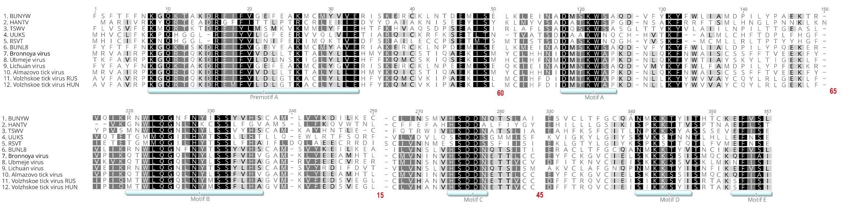
Figure S1 The RdRp of Volzhskoe tick virus and other bunyaviruses display conserved motifs A to E and premotif A. The selected bunyaviruses: BUNYW – Bunyawera virus(P20470), HANTV – Hantaan virus (P23456), TSWV – Tomato spotted wilt virus (P28976), UUKS – Uukuniemi virus S23 (P33453), RSVT – Rice stripe virus (Q85431) and BUNL8 – La Crosse virus L78 (Q8JPR2). The most closely related species of unclassified bunyaviruses are indicated by numbers 7-11. The red numbers below the alignment indicate the number of deleted positions.

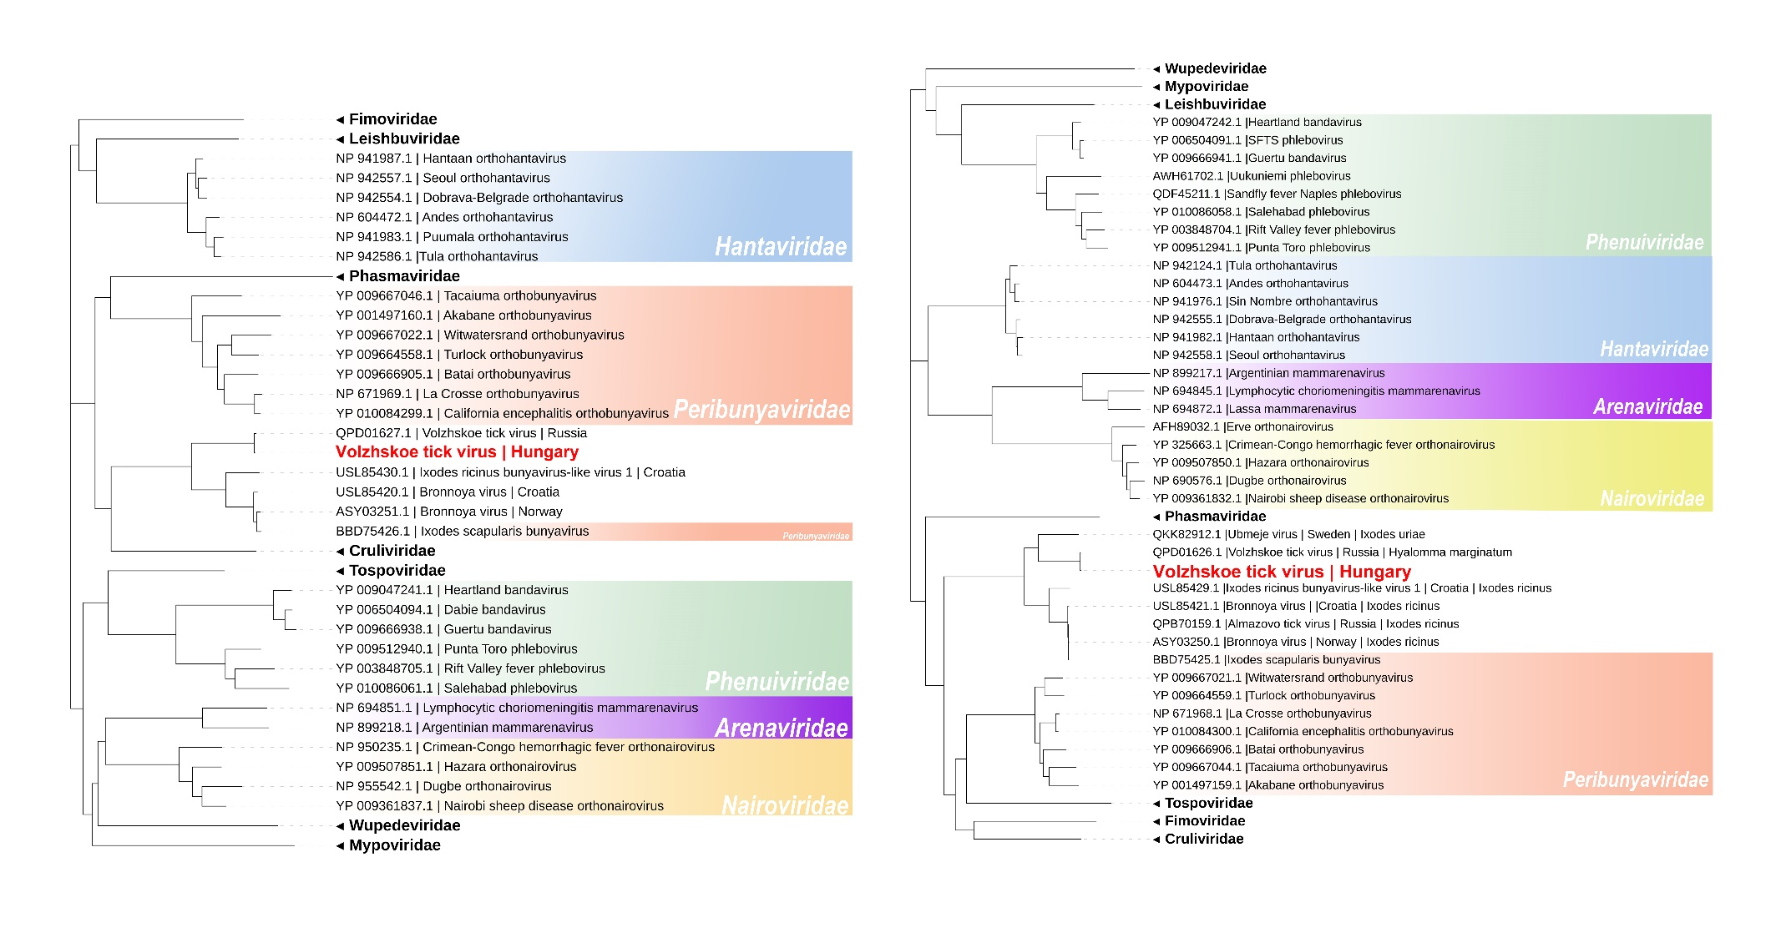
Figure S2 Maximum likelihood phylogenetic trees based on the segment M (A) and segment L (B) of representative Bunyavirales and the newly identified Volzhskoe tick virus (red). The trees were coloured by families.

