Supplementary Table 1: Overview of online tests in the Amsterdam Cognition Scan.
Online cognitive tests  (by cognitive domain) | Description | Outcome
Learning and memory  - Wordlist immediate recall  - Wordlist delayed recall | Participants are asked to remember a list of 15 unrelated words of 5 trials  Participants recall the list of words after a 25-min delay | Total number of correct words (trial 1 to 5)  Total number of correct words
Attention and working memory  - Digit sequences I  - Digit sequences II  - Box tapping | Participants recite strings of random digits of increasing length, forward  Participants recite strings of random digits of increasing length, backward  Participants are asked to remember the order in which a number of blocks blink on a screen | Total number of correctly repeated sequences  Total number of correctly repeated sequences  Total number of correctly repeated sequences
Processing speed  - Connect the dots I  - Reaction time | Participants are instructed to click numbered circles in increasing order, as quickly as possible and without making mistakes  Participants are instructed to release the mouse button as fast as possible, after a white block appears on the screen | Completion time  Mean reaction time
Executive functioning  - Connect the dots II  - Place the beads | Participants are instructed to alternate clicking numbered and lettered circles in increasing numerical/alphabetical order as fast as possible and without making mistakes  Participants have to rebuilt a construction consisting of three sticks on which three distinctive beads are placed. The aim is to use as few moves as possible to rebuilt the construction. | Completion time  Total number of extra moves
Motor performance  - Fill the grid | Participants are instructed to fill a grid (containing 25 squares) with blocks as quickly as possible. As soon as the lock appears underneath the grid, it has to be dragged to the square in which a plus sign is shown | Completion time

Supplementary 2: Description of the used normative data in this study.
660 healthy Dutch individuals (52% male, aged 20-86 years) participated in the LOG IN study in which they completed the Amsterdam Cognition Scan (ACS), an online neuropsychological test battery. 471 individuals completed the ACS again 6 months later. Normative data adjusted for age, gender, education and/or computer experience was established using regression-based norming with generalized additive models for location, scale and shape (GAMLSS). Practice effects were quantified and the influence of age, gender, education and computer experience was investigated using multiple regression analysis (MRA).
GAMLSS yielded demographically-adjusted regression-based norms for ACS tests. Practice effects were small but significant for multiple tests. MRA showed that higher age was associated with smaller practice effects on most tests, whereas gender and education influenced practice effects only on a few tests. Computer experience had no influence on any practice effect, but did influence test performance on several speed-based tests and was included in their respective norms.
(Luijedijk et al., 2024).

Supplementary Table 3: Objective cognitive functioning measured with the Amsterdam Cognition Scan at 6 months.

 | Melanoma patients  N=12 |  | Breast cancer patients  N=15
 | Mean Z-score | No. with impaired cognitive functioning* | Mean Z-score | No. with impaired cognitive functioning*
Learning and memory  - Wordlist immediate recall  - Wordlist delayed recall | -0.37  -0.11 | 1 (8.3%)  1 (8.3%) | -0.34  -0.09 | -  -
Attention and working memory  - Digit sequences I  - Digit sequences II  - Box tapping | -0.33  -0.57  0.80 | 1 (8.3%)  2 (17%)  - | -0.05  -0.19  0.97 | 1 (6.6%)  2 (13%)  -
Processing speed  - Connect the dots I  - Reaction time | 0.44  0.68 | 1 (8.3%)  - | 0.39  -0.02 | -  3 (20%)
Executive functioning  - Connect the dots II  - Place the beads | -0.09  0.21 | -  2 (17%) | 0.29  0.28 | 1 (6.6%)  3 (20%)
Motor performance  - Fill the grid | -0.53 | 1 (8.3%) | 0.02 | 2 (13%)
*≥1.5 SD below the mean of the control group. N: number.

Supplementary Figure 4: Clinically relevant HRQoL of patients with clinically relevant cognitive impairment at six months after start treatment, split by tumor type:

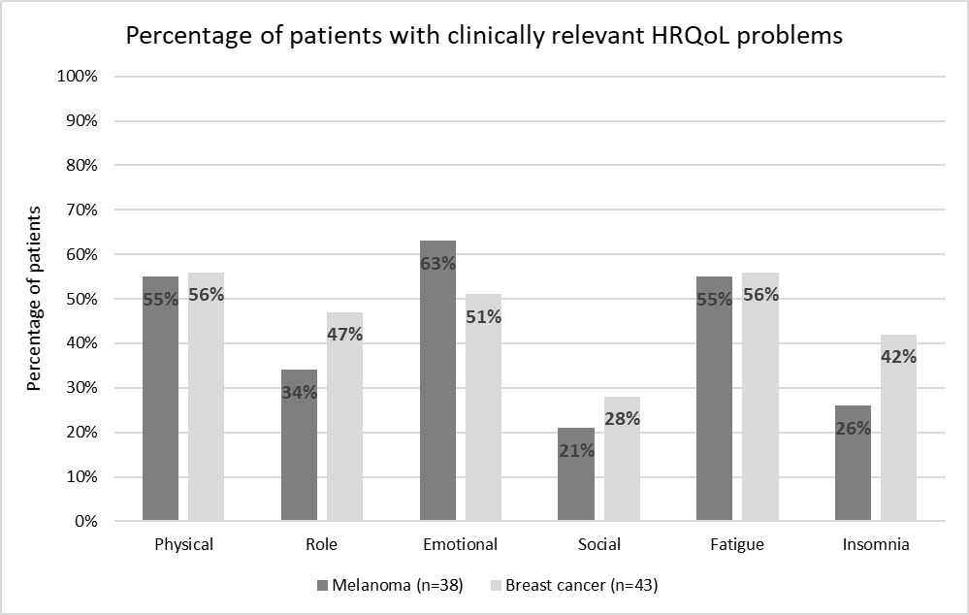

Supplementary Figure 5: Clinically relevant HRQoL of patients with and without objectively measured cognitive impairment at six months after start treatment, split by tumor type:
