Supplementary Information of
Potts model solver based on hybrid physical and digital architecture

Supplementary Note 1: Comparison of mapping schemes

To compare the Potts model mapping with the Ising model mapping, we here consider a four-color problem as an example. The standard Ising mapping [1] requires $4N(=MN)$ spins, where $M$ is the number of colors. The Ising Hamiltonian is given by $H_{Ising} =J_{A}\sum_{l}{ \sum_{ij}{A_{ij}\frac{σ_{li}+1}{2}\frac{σ_{lj}+1}{2}}+J_{C}\sum_{i}{{\left(\sum_{l}{\frac{σ_{li}+1}{2}}-1\right)}^{2}}},$ where a spin $σ_{li}$ represents a color $l=\{1,2,3,4\} (≡\{red, blue, yellow, green\})$ at$i$-th node. The first term with $J_{A}$ imposes that the adjacent sites should be different colors. The second term with $J_{c}$ imposes that each site should be colored with one of four colors. This Ising Hamiltonian with $4N$ nodes has a Hilbert space with a size of $2^{4N}$. The second term imposes a constraint for the Hilbert space, which reduces the size of space to $2^{2N}(=M^{N})$ from $2^{4N}$. The Potts mapping needs not such a redundant expansion of the space, where the Hamiltonian is simply given by $H_{Potts}= \sum_{ij}{A_{ij}δ(S_{i},S_{j})}$ and a size of Hilbert space is $M^{N}.$ Such a smaller size implementation will be advantages of the Potts model mapping. In addition, $H_{Ising}$ has two independent terms of Hamiltonian, $J_{C}$ and $J_{A}$ terms. The ratio $J_{C}/J_{A}$ affects the success probability to reach the exact ground state, and the tuning of $J_{C}/J_{A}$ will be important in practice. Note that, once the parameter tuning is succeeded, the expansion of the Hilbert space that causes a change in an energy landscape affects success probability (and may improve it). The Potts model needs not such a parameter tuning. However, the Potts model has a complex interaction with a Kronecker delta.
In the present Potts solver, to circumvent the complexity of the Potts Hamiltonian, we approximately map a Potts problem on the iterative Ising problems. We should note that Ising Hamiltonian in each iterative problem is very simple, which has no competing Ising interactions, such as $J_{C}$ and $J_{A},$and no magnetic field terms (no constraint Hamiltonian), and the number of nodes ($∼N$) is smaller than that of the simple Ising mapping $(∼MN)$. Thus, required resources are significantly suppressed. However, as the tradeoff, additional computation time is required. It is important to mention that the reduction of nodes causes another problem. The existence of the exact solution in the reduced space ($≤2^{N}$) at the last stage is not assured as mentioned in the main text. Note that the original Hilbert space of $M^{N}$ can be reproduced by considering all of the states in all $L(=log_{2}M)$ stages: $M^{N}={\left(2^{N}\right)}^{log_{2}M }$, while possible choices of the final solution will be limited after a certain solution will be selected in each stage. Note that decrease in the cost energy function (Potts energy) is assured in this scheme as discussed in the main text.
In Supplementary Table 1, we compare these three kinds of mapping, Ising model, Potts model, and iterative Ising model mapping. Three kinds of mapping have both merit and demerit. It is better to select a mapping scheme depending on problems. We can expect that a variety of solvers based on different mapping, such as the present Potts solver, allows us to extend applications of the physical-model-solver computation. The iterative Ising model mapping used in the present Potts solver can suppress the resource cost, such as the number of spins, while additional computational time for iterations is required. If the physical-solver architecture can get a solution of Ising problems significantly fast by comparison with standard digital architectures, the present hybrid architecture based on the iterative Ising-solver calculations is expected to show high performance. However, the communication cost between physical and digital architecture is a serious problem in the hybrid computation. A coherent Ising machine (CIM) with a measurement feedback system can cut the communication cost by coding the $J_{ij}$-update logics into the measurement feedback system.

Supplementary Table 1: Comparative chart of Ising, Potts, and iterative Ising model mapping for graph coloring with $M$ colors and $N$ nodes.

Mapping method | Required Ising spins | Hilbert space size  (in each stage) | Mapping accuracy | Physical implementation
Ising model | $MN$  △ | $2^{MN}$ (too large)^{*2} | Exact  ○ | Not difficult^{*5}  △
Potts model | $-$ | $M^{N} (=2^{log_{2}M×N})$  ○ | Exact  ○ | Not easy^{*6}  △
Iterative Ising model | $N$ ${{\left(∼2N\right)}^{*1}}^{ }$  ○ | $≤2^{N}$^{*3} (too small)^{*4} | Approximation^{*4}  × | Easy^{*5}  ○
- The iterative Ising model mapping sometime requires additional nodes as mentioned in Supplementary Note 2.
- The expansion of Hilbert space requires a parameter tuning to search the best solution, which affects success probability.
- The size of Hilbert space in each stage is smaller than $2^{N}$ because of the reduction of graph and block-diagonalized interaction matrix.
- The small size Hilbert space causes a degradation of the solution accuracy, which can be compensated by using feedback algorithms.
- The iterative Ising model mapping requires no magnetic field terms, and the number of spins is smaller than the Ising mapping.
- Potts interactions are difficult to implement in physical systems. There are few proposals in Refs. [2,3].

Supplementary Note 2: How to avoid the limitation of $M=2^{L}$

The present Potts solver (without feedback algorithms) has a limitation of $M$ the number of groups, where $M$ obeys a relation $M=2^{L}$ with an integer $L$. Here, we discuss methods for avoiding this limitation by focusing on clustering and coloring.
For clustering, fortunately, this limitation does not matter, because the convergence property assures that an optimized $M$ can be determined spontaneously as a result of the competition between ferromagnetic and antiferromagnetic correlations in each Ising problem, as discussed in the main text (see Fig. 3a-d). Thus, we just consider the upper limit of $M$and $L$: $M_{max} ≤N$ and $L_{max}≤ceil\left(\log_{2}{N}\right)$, where $ceil(x)$ is the ceiling function. Practically, the stationary condition is satisfied at a smaller $L$ than $L_{max}$. For the present experiments with $N=47$, as shown in Fig. 3e in the main text, $L_{max}$ equals to 6, while the best solution is found at $L=3$ with $M=5$.
For coloring, any integer $M≠2^{L}$can be available by extending a model Hamiltonian and a graph structure as follows. For simplicity, we explain it briefly with $M=3:$ $(i)$ Set $L=2$ with a minimum $L$ satisfying $2^{L}>M$. $(ii)$ Then, modify a graph structure by adding ($2^{L}-M$)-extra-nodes (one node for $M=3$) into the original graph. $(iii)$ Extend an interaction matrix, where the extra-nodes interact with all other nodes ($J_{ij}=1$ for either $i$ or $j$ is the extra nodes). $(iv)$ Finally, solve Ising model with ($N+2^{L}-M$)-nodes $L$-times as a usual way. For $M=3$, an extra node interacting with all nodes should solely occupy a certain color, and the remaining three colors are used to the objective $M=3$ coloring-problem on the original graph. The number of additional nodes is smaller than that of the standard Ising mapping as detailed in Supplementary Note 1: The present method requires $N+2^{L}- M(<2N)$ nodes, while the standard Ising mapping requires $MN(<N^{2})$ nodes. For the $M=3$ coloring, $N+1$ and 3$N$ nodes are required for the Potts and Ising mapping, respectively$.$

Supplementary Note 3: Reduction of graph and interaction matrix

Supplementary Figure 1 shows obtained grouping in each stage extracted from the same data as those shown in Figure 3a-e in the main text. By obeying equation $S_{i}^{\left(l\right)}=S_{i}^{\left(l-1\right)}+\frac{1+s_{i}^{\left(l\right)}}{2}M^{\left(l-1\right)}$ [Equation (3) in the main text], changes in colors (groups) are strictly restricted: A certain color region is split up into two regions with additional one color, or keeps its color. In other words, the boundaries of color domains created in each stage cannot move at forward stages. These points can be understood from the reduction of an interaction matrix and a graph schematically depicted in Fig.1a in the main text. The reduction of interactions and graph can be defined with the same manner; $J_{ij}^{(l)}=W_{ij}^{(l)}J_{ij}$ and $A_{ij}^{(l)}=W_{ij}^{(l)}A_{ij}^{ }$, respectively, with a weight matrix $W_{ij}^{(l+1)}=δ(S_{i}^{\left(l\right)},S_{j}^{\left(l\right)})$. Simply put, a graph is reduced to individual subgraphs consisting of nodes with a same spin (color). Note that we proposed feedback algorithms to overcome such restrictions in the update process.

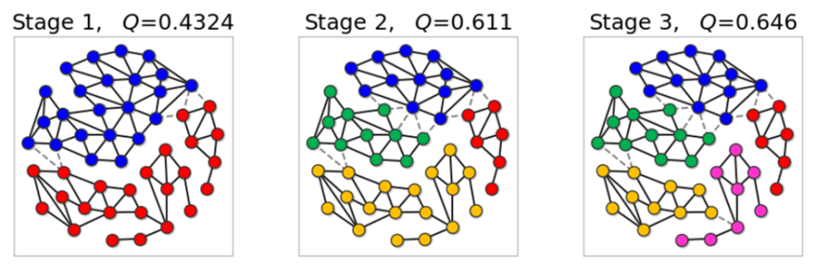
Supplementary Figure 1: Obtained groups and modularity in stages $1,2,3$ for a clustering problem. These results were extracted from the same stages as those shown in Fig. 3a-e in the main text.

Supplementary Note 4: Domain formation in Ising solutions

A magnetic domain is a small region in which spins are in the same value. Formation of magnetic domains can be sometime found in solutions of the CIM as shown in Supplementary Figure 1 (see left panel). Detection of the domain formation can be utilized to a digital feedback algorithm as follows, which is effective for graph clustering.
As shown in Supplementary Figure 1, at stage one, there are two red domains separated by a blue domain. The nodes in these two separated red domains have no FM correlations with each other. Namely, projections of ${\left[A_{ij}^{\left(l\right)}\right]}^{n}$ for positive integer $n$ cannot connect the nodes in separated domains, where $A_{ij}^{(l)}$ is a reduced adjacency matrix as mentioned in Supplementary Note 3. On the other hand, the separated nodes have AFM correlations of $W_{ij}^{(l)}B_{i}B_{j}$ with $W_{ij}^{(l)}=1$ for $S_{i}^{(l)}=S_{j}^{(l)} (=red color)$. Because of the totally AFM correlations, these nodes in separated domains should be in different groups. In fact, as shown in Supplementary Figure 1, these separated regions become different groups at stage two as expected.
By detecting such separated domains, we can implement the following domain separation (DS) feedback algorithm: $(i)$ Find the separation of domains. $(ii)$ Number domains with integers $0,1,2,…, M^{\left(l\right)}-1$, where $M^{\left(l\right)}$ is the total number of separated domains. The obtained integer numbers represent Potts spins $S_{i}^{{\left(l\right)}^{'}}.$ Here, the available spin component is generalized to $M^{(l)}≥2^{l}$ from $M^{(l)}=2^{l}$. $(iii)$ Redefine a weight matrix as $W_{ij}^{{{\left(l\right)}^{'}}^{ }}=δ\left(S_{i}^{{\left(l\right)}^{'}},S_{j}^{{\left(l\right)}^{'}}\right).$ It takes a calculation time of $O\left(N^{2}\right) or O(N_{edge})$ to detect separated domains and to number them.
Supplementary Figure 2 shows an example of a change in grouping with the DS feedback, where a state at stage one is the same as that in Supplementary Figure 1. By using DS feedback, one of the red domains is changed to green. As a result, modularity increases to 0.4975 from 0.4323. This improvement of modularity can be determined from the removed matrix elements of the AFM correlations, $∝\left[W_{ij}^{(l)}-W_{ij}^{{\left(l\right)}^{'}} \right]B_{i}B_{j},$ as shown in Fig. 3g in the main text. The number of groups is generalized to $M^{(1)}=3$ (>$2^{l}$). At stage two, the green and blue regions are split up, and then, the colored graph found at stage three in Supplementary Figure 1 (corresponding to the best solution) can be obtained even at earlier stage ($l=2$). Thus, the total computational time can be substantially decreased by the DS feedback algorithm.

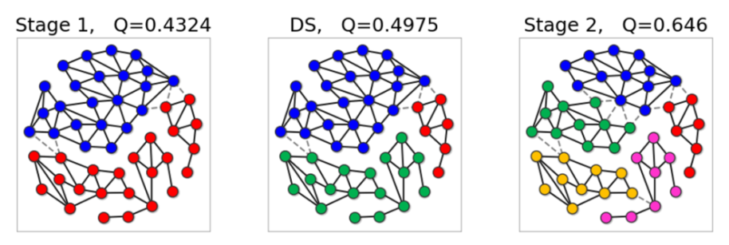
Supplementary Figure 2: Change in grouping and modularity with domain separation (DS) feedback. All of maps are experimentally obtained.

Supplementary Figure 3 shows initial-domain dependence of solutions. At stage one, before performing DS feedback, states with the large number of domains have lower modularity (higher energy). This behavior shows analogy with those found in one-dimensional Ising model with nearest neighbor coupling, which has been simulated by the CIM [3]. Once domains are created due to fluctuations, it is difficult (or takes long time) to flip all spins in a domain, while it is easy to locally optimize position and shape of the domain walls as much as possible. With the DS feedback, by cutting unnecessary AFM connections among these partially optimized domains, multi-domain states immediately change to higher modularity (lower Potts energy) states than those with a smaller number of domains. These facts suggest that multi-domain solutions with higher energy at early stages do not degrade accuracy of the final solution of Potts problems. We can thus expect that feedback algorithms can increase tolerance against fluctuations or imperfections of a physical solver.

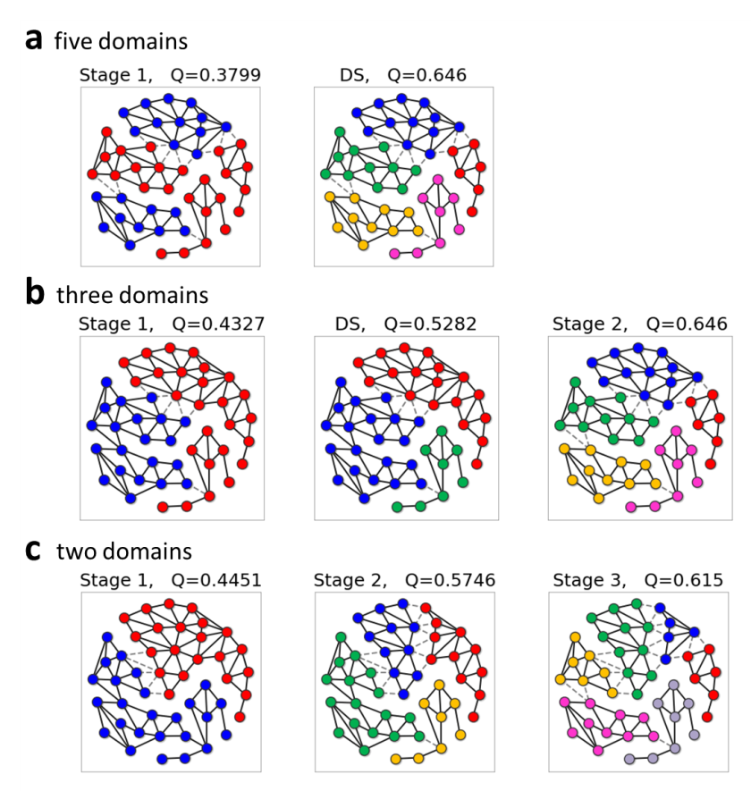
Supplementary Figure 3: Evolution of grouping and modularity in each stage obtained by using DS feedback for different states at stage one. All of the results were experimentally obtained. Due to experimental fluctuations, various solutions with different number of domains were obtained at stage one. Some of different initial states converge to the same final solution as shown in a and b and also Supplementary Figure 2. As shown in c, a lower energy solution at stage one than a and b finally reaches a higher energy solution.

Supplementary Note 5: Potts Hamiltonian for a Group Reunion feedback

At each stage, with a certain grouping given by $S_{i}^{(l)}=\left\{0,1,…,M^{ (l)}-1\right\},$ we can define a new Potts Hamiltonian $H_{Potts}= \sum_{gg^{'}}{J_{gg^{'}}}δ\left(S_{g},S_{g^{'}}\right)$ with group-group interactions $J_{gg^{'}}≡\sum_{ij}{J_{ij}δ\left(S_{i}^{(l)},g\right)} δ\left(S_{j}^{(l)},g^{'}\right)$on a new graph with $M^{ (l)}$ nodes (see Figure 3h in the main text). This new Hamiltonian describes a task to find the best way for improving Potts energy by executing reunion of groups. We call this task a group reunion (GR) feedback. Note that a calculation of an interaction matrix $J_{gg^{'}}^{ }$ takes $O\left(N^{2}\right) or O\left(N_{edge}\right).$ Diagonal elements $J_{gg}$ are irrelevant for a ground state search, while the sum of $J_{gg}$ represents the present Potts energy defined as $E_{Potts}^{old}\left[≡\sum_{ij}{J_{ij}δ(S_{i}^{(l)},S_{j}^{(l)})}\right]=\sum_{g}{J_{gg}}.$ If a solution of the newly defined model has lower energy as $E_{Potts}^{new}\left[=\sum_{gg^{'}}{J_{gg^{'}}δ(S_{g}^{ },S_{g^{'}}^{ })}\right]< E_{Potts}^{old}$, the reunion of groups decreases Potts energy (increases modularity). If all of the elements of $J_{gg^{'}}$are positive except for the diagonal elements $J_{gg}$, the ground state of the Potts model for a GR task is a trivial AFM state, which can be written as $S_{g}^{*}=g$: Namely, all of the nodes should be different groups, meaning no need to perform GR. Note that $J_{gg^{'}}^{ }$ is apt to be positive except for diagonal elements, because this effective group-group interaction $J_{gg^{'}}^{ }$ is calculated from the previously-optimized grouping $S_{i}^{(l)}$. However, as discussed in the main text (see Fig. 1a), the one-way feedforward approximation loses the information of $J_{ij}$ at forward stages due to the reduction of an interaction matrix. The GR task with $J_{gg^{'}}^{ }$can compensate this lost information, even though the size of $J_{gg^{'}}^{ }$ is smaller than that of $J_{ij}.$
We consider the following approximation to solve the Potts Hamiltonian for a GR task within a calculation time of $O\left(N^{2}\right) or O\left(N_{edge}\right)$ without considering full Hilbert space of ${M^{\left(l\right)}}^{M^{ (l)}}$: $(i)$ Perform the reunion for $g_{a} and g_{b}$ for a negative and minimum $J_{g_{a}g_{b}}$ without considering other negative elements. Here, a search of a minimum negative element requires a computation time of $O\left(M^{(l)2}\right)$. $(ii)$ Then, recalculate the matrix $J_{gg^{'}}$ for new groups, where this recalculation takes only $O\left(M^{(l)}\right)$. $(iii)$ Repeat it until all of $J_{gg^{'}}(g≠g^{'})$ become positive, or repeat it a few times.
We discuss that this approximated calculation scheme provides good solutions for a small $M^{(l)}$. For examples, when all of $J_{gg^{'}}(g≠g^{'})$ are positive except for one certain set of $g_{a} and g_{b}$, the nodes belonging to these groups $g_{a} and g_{b}$ should join one group, and the other groups should be unchanged. The Potts energy is decreased as $ΔE_{Potts}(≡E_{Potts}^{new}-E_{potts}^{old})=2J_{g_{a}g_{b}}.$ Such a ground state can be obtained exactly by this approximation. This can be generalized to the independent set of such pairs. Furthermore, let us consider the following case of two negative elements $J_{g_{a}g_{b}}<0,$ $J_{g_{a}g_{c}}<0$ with other positive elements including $J_{g_{b}g_{c}}>0$: Here, it is enough to consider the Potts Hamiltonian with three nodes, where the number of groups should be taken into account up to $M=2$. The ground state of the present task is easily obtained: $(S_{g_{a}}^{*} , S_{g_{b}}^{*} ,S_{g_{c}}^{*})=(0,0,0)$ for $J_{g_{a}g_{b}}+J_{g_{a}g_{c}}+J_{g_{b}g_{c}}<0$, or $(S_{g_{a}}^{*} , S_{g_{b}}^{*} ,S_{g_{c}}^{*})=(0,0,1)$ for $J_{g_{a}g_{b}}+J_{g_{a}g_{c}}+J_{g_{b}g_{c}}>0$ and $J_{g_{a}g_{b}}<J_{g_{a}g_{c}}$, or $(S_{g_{a}}^{*} , S_{g_{b}}^{*} ,S_{g_{c}}^{*})=(0,1,0)$ for $J_{g_{a}g_{b}}+J_{g_{a}g_{c}}+J_{g_{b}g_{c}}>0$ and $J_{g_{a}g_{b}}>J_{g_{a}g_{c}}$. All of cases discussed here can be exactly solved by the present approximation. When $M$is small, either case mentioned here frequently occurs, because $J_{gg^{'}}^{ }$ is apt to be positive as mentioned above. In fact, in the present experiments, almost all of the reunion tasks can be exactly solved except for 2 cases in 1000 trials.
Supplementary Figure 4 shows a change in grouping as an example of this GR feedback. Here, we also used DS feedback. At the end of stage three, the group-group interaction becomes negative between blue and green groups, and thus, these two are unified. Before the stage three, all of $J_{gg^{'}}^{ }$ is positive except for the diagonal elements. Modularity increases to 0.646 from 0.6257. It should be emphasized that the GR feedback allows us to remove domain walls created at the former stages, suggesting that a degradation of solution accuracy caused by the one-way feedforward approximation can be compensated.
Finally, we discuss large $M$ $\left(>\sqrt{N}\right)$cases, where the above approximation does not work well. Here, we can perform a recurrent Potts-solver feedback with an input of $J_{gg'}$ into the new first stage. Such a feedback is not installed in the present experiments.

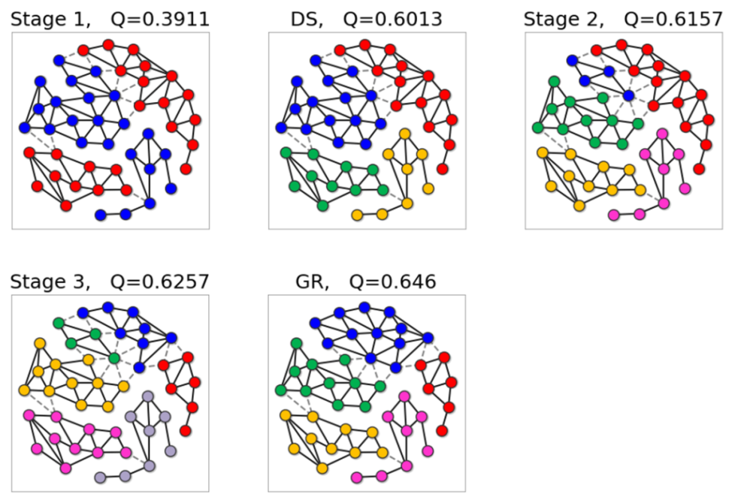
Supplementary Figure 4: Evolution of grouping and modularity by group reunion (GR) feedback and DS feedback. All of solutions are obtained in experiments.

Supplementary Note 6: Comparison with other algorithms for clustering approach

To compare our experimental results with other algorithms, we used popular and reliable heuristic algorithms, the Louvain greedy algorithm [4] and Infomap algorithms [5]. In Supplementary Figure 5a and b, we summarize histograms of modularity for 1000 trials obtained by the Potts solver experiments and numerical simulations of other algorithms, respectively. All methods find the same best solution shown in Supplementary Figure 6a. We also used simulated annealing [6] method to confirm that the same best solution can be obtained. The greedy algorithm reaches the best solution with $Q=0.646$ with a small rate (about 2%), and the second and third best solution with $Q∼0.643$ (shown in Supplementary Figure 6b and c) was obtained frequently (over 70%). The Infomap algorithm gets the best solution with highest probability of about 60%. Louvain and Infomap algorithms are run in about a few ms and a few second, respectively, with a standard CPU: Intel(R) Xeon(R) CPU E5-2697 v2 @ 2.70GHz. However, the number of nodes is too small to evaluate the run time for these algorithms. Further benchmark study, e.g., in Refs [7], is left for our future work, because the current experimental setup is limited for the number of nodes.
In Supplementary Figure 5c, we also show a histogram obtained by metropolis sampling for 10⁶ trials at different temperatures $t=1/βC^{2}$, which approximate thermal distributions. Metropolis sampling was done as follows [6]. We sample spin sets by changing $S_{i}→S_{i}^{'} (=\left\{0,1,…,M-1\right\})$ with a rate of $\exp\left(-β_{n}ΔE_{i}\right)$for $ΔE_{i}≥0$, or $1$for $ΔE<0$, where $β_{n}$ is inverse temperature at the $n$-th step of an annealing process, and $ΔE_{i}=$ $2\sum_{j}{J_{ij}[δ\left(S_{i}^{'},S_{j}\right)-δ(S_{i},S_{j})]}.$ The number of spin component is set as $M=2^{l}$ to compare it with a Potts solver at stage $l.$ At a high temperature $t=0.0043$, histogram spreads widely with a peak at around $Q∼0.6$ (not shown data in $Q<0.6$ for clear vision). At lower temperatures, a broad peak shrinks and moves toward higher $Q$, and tall and narrow peaks grow at around $Q∼0.64$, corresponding to the best and the second best solutions. The experimental histograms cover widely the high-$Q$ states appearing in metropolis sampling at low temperatures, even though the present Potts solver cannot guarantee to reproduce the Boltzmann distributions. In fact, some of states, e.g., the second highest $Q$ state, are not likely to be obtained by the present method. The extension of feedback algorithms may allow us to use the Potts solver as a sampling machine.
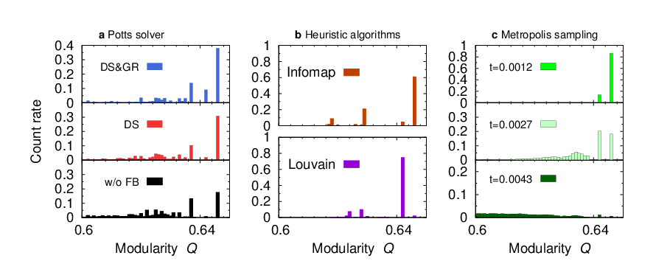
Supplementary Figure 5: Histograms of $Q$ values obtained by various method: a, Potts solver experiments with or without feedback algorithms for 1000 trials. b, Infomap algorithm and Louvain greedy algorithm for 1000 trials. c, metropolis sampling for 10⁶ trials at $t=0.0012, 0.0027, and 0.043.$ Metropolis sampling picked up all possible solutions with Boltzmann weights.

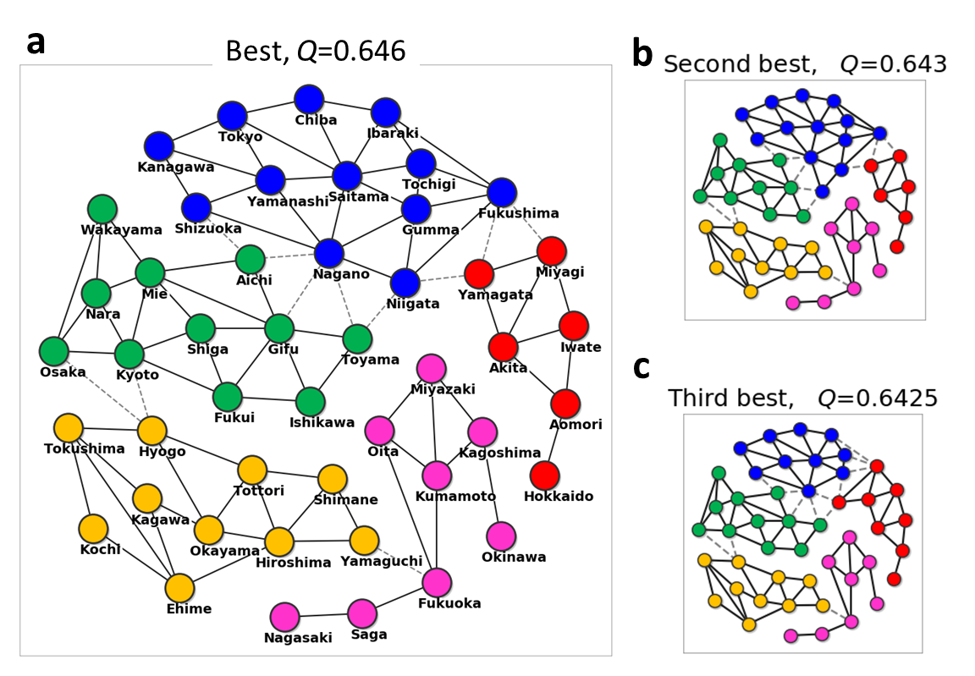
Supplementary Figure 6: Best three solutions of clustering based on the modularity. The five regions in these solutions are similar (not equivalent) to the traditional regional divisions in Japan. Red: Hokkaidō- Tōhoku area. Blue: Kantō-kōshin’etsu area. Green: merged Kinki, Tōkai, and Hokuriku area. Yellow: Chūgoku-Shikoku area. Pink: Kyūshū-Okinawa area.

Supplementary Note 7: Detailed experimental results for coloring

Supplementary Figure 7 shows evolutions of DOPO pulses for a coloring problem with the same experimental condition as those described in the main text. Each Ising-solver calculation takes 500 μs with 100 steps of 5 μs. Several DOPOs oscillate very slowly, whereas energy converges soon in each stage. This suggests that up and down spin states are energetically degenerate. For examples, as shown in Supplementary Figure 7d, at stage two, the reduction of a graph defined by $A_{ij}^{(2)}=W_{ij}^{(1)}A_{ij}^{ }$ causes a lot of local degeneracy. At stage one, a certain node surrounded by the same number of up and down spin nodes shows a local degeneracy.

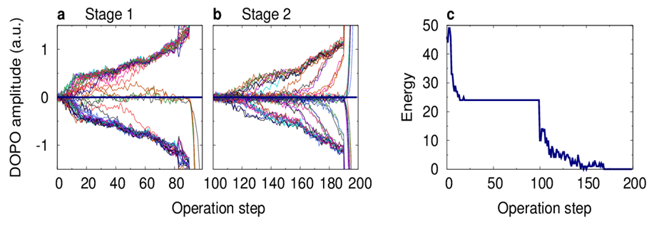
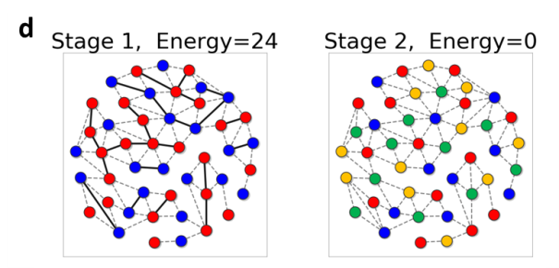

Supplementary Figure 7: Experimental results for graph coloring. a and b, DOPO amplitudes of 47 nodes as a function of operation step for stage 1 and 2. c Change in Potts energy. d Solutions at stage one and two. Solid lines represent edges defined by $A_{ij}^{(l)},$ and dotted lines are reduced edges.

Supplementary Note 8: Origins of failures of coloring

For graph coloring, an approximation of the one-way feedforward connection sometimes yields instances of $J_{ij}^{(2)}$ at stage two that provide a zero success rate as discussed in the main text. This is because the reduction of a graph causes geometrical frustrations of graph at the stage two. Supplementary Figure 8 shows failed coloring results caused by two kinds of typical geometrical frustrations. One is a triangle shape, and another one is a closed loop structure consisting of the odd number of nodes $(n≥5)$. As shown in left panels in Supplementary Figure 8, these structures cannot be colored correctly with two colors at stage two. The triangle shape can be regarded as the special case of the odd number loop with $n=3$.
Let us discuss the ring structures with $n≥5.$ As shown in Supplementary Figure 8b, the ring structure created by odd-number blue nodes at stage one cannot be colored correctly. This ring structure is equivalent to the structure known as a Kempe chain. It has been discussed in the pioneering studies on the four color problems [8]. In many cases, a mistake on a Kempe chain can be correctly colored, while this correction cannot be used if a Kempe chain has correlations with other Kempe chains [9]. Such a correction method could practically improve a success rate.

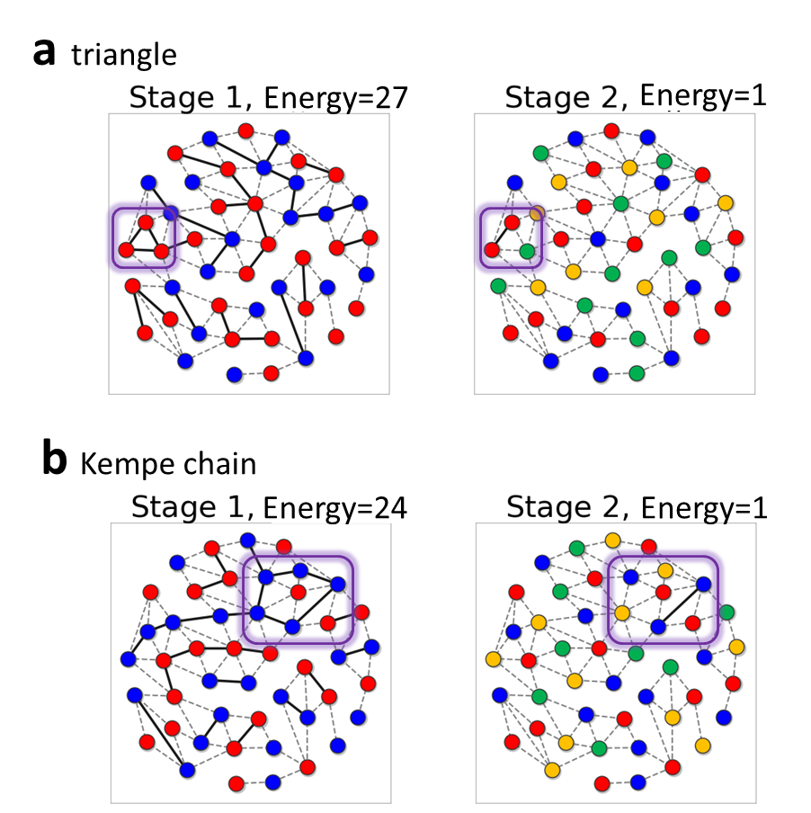
Supplementary Figure 8: Failed coloring results with remaining edges at the last stage. Violet squares represent typical geometrical frustrations at stage one and related mistakes at stage two: a, triangle and b, odd number closed loop structure (Kempe chain), that inevitably induce failed coloring at stage two. These frustrations can be eliminated by a leaning method mentioned in the main text and in Supplementary Note 10.

Supplementary Note 9: Network of Ising solvers

Supplementary Figure 9 represents schematically the present hybrid computation framework, which can be written as a network structure of Ising model solvers connected via digital processing. Note that each node of the graph in Supplementary Figure 9 represents (not a spin state, but) an Ising model defined by a block diagonal matrix of ${ J}_{ij}^{\left(l\right)}$ in the $l$-th stage, which consists of a group of nodes with the same Potts spin $S_{i}^{(l)}$ in the original graph (e.g., a group of prefectures in the map of Japan). As a stage goes forward, each Ising node is split up into two (or more with DS feedback), or is unchanged if a ferromagnetic state becomes energetically favorable, and some nodes are merged with each other by using GR feedback. Such an evolution of the graph can be written by the updates of the weight matrix $W_{ij}^{(l)}$ defined by $J_{ij}^{(l)}=W_{ij}^{(l)}J_{ij}^{ }$. Here, the weight matrix is given by $W_{ij}^{(l+1)}=δ\left(S_{i}^{\left(l\right)},S_{j}^{\left(l\right)}\right),$ and is determined via an “activation” function given by a solution of the Ising solver. Here, weights $W_{ij}^{(l+1)}$are determined so as to decrease Potts energy $E_{Potts}^{ }$. From this point of view, the iterative computation of Ising solvers can be regarded as a learning algorithm for a weight matrix $W_{ij}^{(l)}$ based on the Ising-node network.

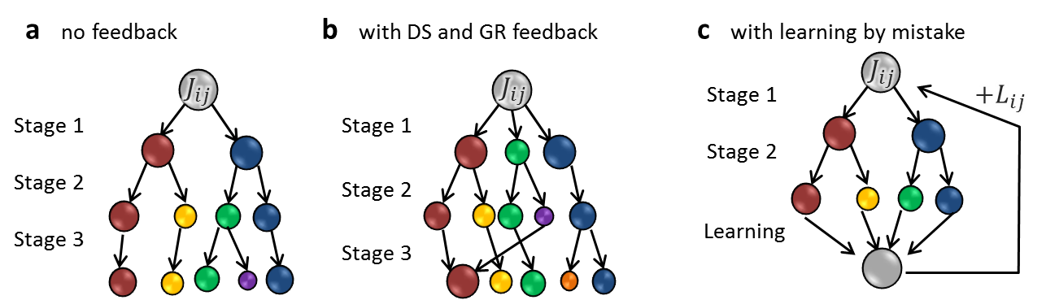
Supplementary Figure 9: Schematic view of the present hybrid computation algorithm, which shows a network structure of Ising model nodes. a, Network without feedback; b, with DS and GR feedback; c, with learning by mistake. Each node in this graph is an Ising model that contains a group of nodes in the original graph.

Supplementary Note 10: Learning by mistake

We discuss learning by mistake feedback for coloring problem. It is convenient for us to consider the network structure of Ising models as discussed in Supplementary Note 9. The present learning by mistake is given by $J_{ij}^{new}=J_{ij}^{old}+w L_{ij}$with $L_{ij}=W_{ij}^{(2)}A_{ij}.$ This learning method shows analogy with the simple perceptron learning (error correction learning) [10] given by $w_{i}^{new}=w_{i}^{old}-η\left(d_{i}-y_{i}\right)x_{i},$ where $w_{i}^{ }$ is a weight, $d_{i}$ is a desired output, $x_{i}$ and $y_{i}$ are input and output. In the present method, the input is the adjacency matrix $J_{ij}=A_{ij}$, and the output is $W_{ij}^{(2)}A_{ij}$. For the map-coloring problem, we know that the desired output should be zero $W_{ij}^{(2)}A_{ij}=0$. The learning rate $η$ is given by $\frac{w}{w_{0}},$ and we expect that $η=1 (w_{0}=w$) causes an unstable learning process, which is consistent with the present experimental results shown in Fig. 4b in the main text.

References

- Lucas, A., Ising formulations of many NP problems. Frontiers in Physics 2, 5 (2014),

- Parihar, A., Shukla, N., Jerry, M., Datta, S. & Raychowdhury, A. Vertex coloring of graphs via phase dynamics of coupled oscillatory networks. Scientific reports 7, 911 (2017).

- Sakaguchi, H., et al, Community detection by laser network dynamics. J. Phys. Commun. 2 015005 (2018)

- Blondel, V. D., et al, Fast unfolding of communities in large networks. Journal of Statistical Mechanics: Theory and Experiment 10, P1000 (2008); https://sites.google.com/site/findcommunities/

- Rosvall, M. & Bergstrom, C. T., Maps of random walks on complex networksreveal community structure. PNAS 105, 1118-1123 (2008); http://www.mapequation.org/code.html

- Kirkpatrick, S., Gelatt Jr, C. D. & Vecchi, M. P., Optimization by Simulated Annealing. Science 220 671–680 (1983)

- Lancichinetti, A. & Fortunato S, Community detection algorithms: A comparative analysis. Phys. Rev. E 80 056117 (2009).

- Kempe, A. B., On the Geographical Problem of the Four Colours, American Journal of Mathematics 2, 193–220 (1879)

- Heawood, P. J., Map-Colour Theorem, Quarterly Journal of Mathematics 24, 332–338 (1879)

- Rosenblatt, F., The Perceptron: A Probabilistic Model for Information Storage and Organization in the Brain. Psychological Review 65, 386-408 (1958).

