Sorghum rhizosphere bacteriome studies to pinpoint, isolate and assess plant beneficial bacteria
Chandan Kumarª, Alfonso Esposito^{a,h}, Iris Bertaniª, Samson Musonerimana^{b,c}, Mulissa Jida Midekssa^{d}, Kassahun Tesfaye^{d,e}, Devin Coleman Derr^{f,g}, Lara Donaldson^{i}, Silvano Piazzaª, Cristina Bezª, Vittorio Venturi^{a,j*}
- International Center for Genetic Engineering and Biotechnology, Trieste Italy
- Institut des Sciences Agronomiques du Burundi (ISABU), Bujumbura, Burundi
- Faculté d’Agronomie de de Bioingeniérie (FABI), Université du Burundi, Bujumbura, Burundi
- Bio and Emerging Technology Institute, Addis Ababa, Ethiopia
- Institute of Biotechnology, Addis Ababa University, Addis Ababa, Ethiopia
- Plant Gene Expression Center, USDA-ARS, Albany, CA, USA
- Department of Plant and Microbial Biology, University of California, Berkeley, CA, USA
- Faculty of Medicine and Surgery, University of Enna “Kore”, Cittadella Universitaria, 94100, Enna, Italy
- International Center for Genetic Engineering and Biotechnology, Cape Town, South Africa
- African Genome Center, University Mohammed VI Polytechnic (UM6P), Ben Guerir, Morocco
* Corresponding: Vittorio Venturi: vittorio.venturi@um6p.ma; venturi@icgeb.org

Supplementary Figures:

S1: Set up of the experimental filed supplemented by 100%, 50%, 0% of chemical fertilizer in three block and treated with the different consortia and controls in each block.

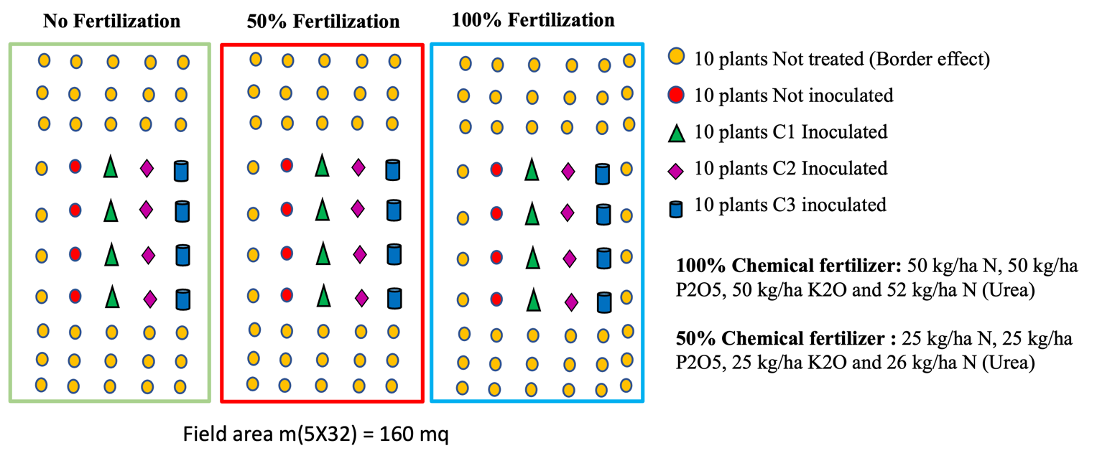

S2: The inoculated consortia displayed a positive effect on plant growth, compared to the uninoculated control.

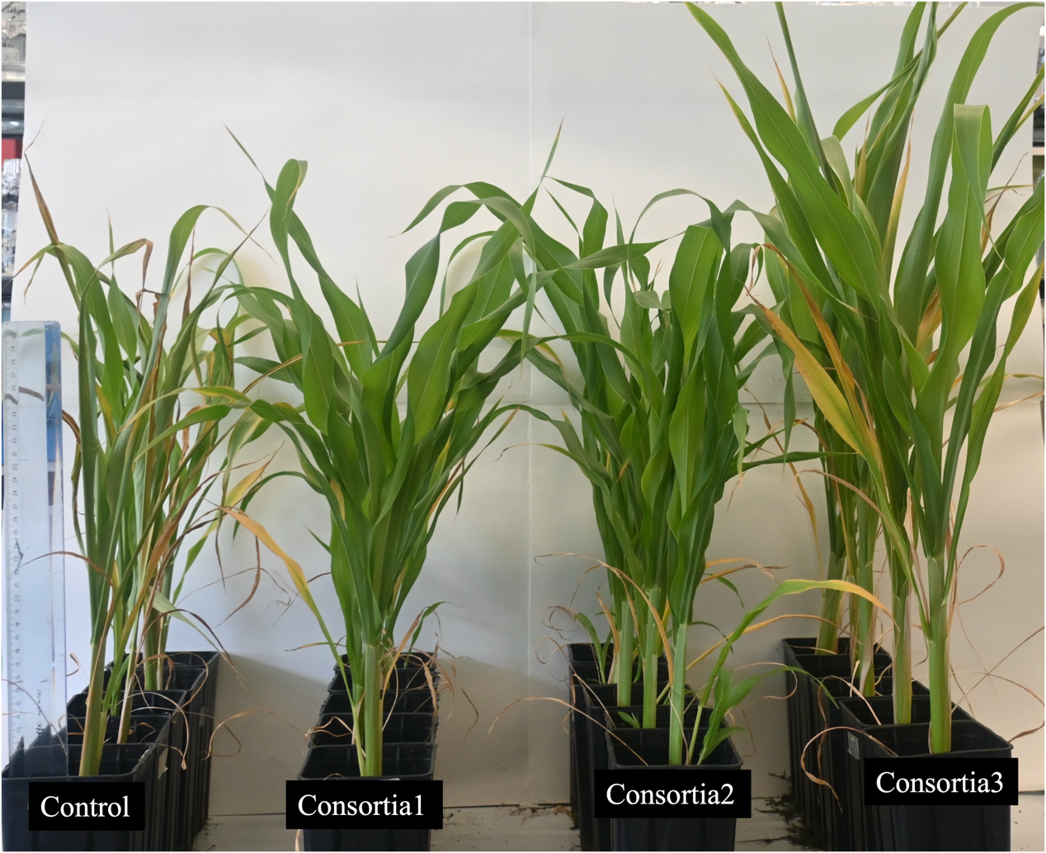

Supplementary Tables

S1: Sorghum genotype accessions used for the rhizosphere microbiome experiment conducted in Italy.
Sl. No. | Accession_name | SAP_ID | Origin Country | Race
1 | SC17 | PI533903, IS12537C | Ethiopia | bicolor
2 | SC21 | PI534127, IS12541C | Ethiopia | kafir-bicolor
3 | SC38 | PI534135, IS12558C | Ethiopia | durra
4 | SC52 | PI533830, IS2501C | Sudan | caudatum
5 | SC63 | PI533912, IS12573C | Sudan | caudatum
6 | SC115 | PI533965, IS2683C | Uganda | caudatum-bicolor
7 | SC145 | IS12636C | Ethiopia | bicolor
8 | SC192 | PI576390, IS1105C | India | durra
9 | SC 210 | PI 533942 | Mosambique | caudatum-durra
10 | SC 233 | PI 533746 | Ethiopia | bicolor-caudatum
11 | SC279 | PI534070, IS7419C, NSL50595 | Nigeria | guinea
12 | SC309 | PI533754, IS2483C | Sudan | bicolor
13 | SC322 | PI533821, IS1309C, NSL51676 | Tanzania | caudatum
14 | SC334 | PI533986, IS3499C | Sudan | caudatum
15 | SC525 | IS7671C | Nigeria | guinea
16 | SC557 | PI533939, IS1318C | Mosambique | caudatum
17 | SC 562 | PI 533987 | Ethiopia | bicolor
18 | SC569 | PI534092, IS7780C | Nigeria | caudatum
19 | SC598 | PI576337, IS2748C | Uganda
20 | SC603 | PI533936, IS1168C | Tanzania | guinea
21 | SC606 | PI597946, IS3106C | China | guinea-bicolor
22 | SC609 | PI576332, IS1213C | China | bicolor
23 | SC614 | PI533940, IS1333C | Tanzania | bicolor
24 | SC621 | IS5030C, NSL51265 | India | bicolor
25 | SC624 | PI576366, IS6164C | India | durra-bicolor
26 | SC625 | PI534097, IS8003C | Japan | kafir
27 | SC628 | PI533979, IS3169C | South Africa | kafir
28 | SC630 | PI533937, IS1269C | Zambia | kafir
29 | SC645 | PI534108, IS8231C | Uganda | kafir-caudatum
30 | SC655 | PI533976, IS2862C | South Africa | kafir-caudatum
31 | SC659 | PI576333, IS2225C | United States | guinea-kafir
32 | SC663 | PI533948, IS2232C | United States | guinea-kafir
33 | SC672 | PI595702, IS2837C | Zimbabwe | kafir-caudatum
34 | SC 695 | PI 656106 | South Africa | kafir
35 | SC 701 | PI 533985 | Sudan | caudatum
36 | SC 702 | PI 656107 | Sudan
37 | SC 704 | PI 534099 | India | bicolor-caudatum
38 | SC 720 | PI 659696 | India | bicolor-durra
39 | SC 757 | PI 576352 | Tanzania | caudatum
40 | SC 782 | PI 576364 | United States | kafir
41 | SC 833 | PI 656108 | Japan | caudatum
42 | SC 941 | PI 576347 | Nigeria | caudatum-durra
43 | SC 1103 | PI 576434 | Zambia | guinea
44 | SC 1104 | PI 576435 | Tanzania | guinea
45 | SC 1218 | PI 656074 | Uganda | caudatum
46 | SC 1229 | PI 576415 | India | bicolor-durra

S2. List and composition of bacterial growth media used for isolation of bacterial strains from Sorghum bicolor rhizosphere samples.
Rhizobium medium | gr/L
Yeast extract | 1
Mannitol | 10
Soil exract* | 200ml
Agar | 16
pH | 7
* Soil extract 1L
Air dried Soil | 160
Sodium Carbonate | 0,4
Water | 800

YEM Congo red | gr/L
Yeast extract | 1
Mannitol | 10
Dipotassium phosphate | 0,5
Magnesium sulfate | 0,2
Sodium chloride | 0,1
Congo red | 0,025
Agar | 20

BF MEDIUM | gr/L
Disodium phosphate | 0,45
Magnesium sulfate | 0,1
Ferric Chloride | 0,02
Calcium Chloride | 0,04
Mannitol | 1
Sodium Glutamate | 1,1
Agar | 16
after autocleve sterilization | mg/L
Biotin | 0,5
Thiamine | 0,5
Calcium pantothenate | 0,5
Cycloheximide | 100
Pentachloronitrobenzene | 3,5
Benomyl | 5
Jensen medium | gr/L
Sucrose | 20
Dipotassium phosphate | 1
Magnesium sulfate | 0,5
Sodium chloride | 0,5
Ferrous sulphate | 0,1
Sodium molybdate | 0,005
Calcium Carbonate | 2
Agar | 16

NBRIP | gr/L
Glucose | 10
Calcium phosphate | 5
Magnesium chloride | 5
Magnesium sulfate | 0,25
Potassium chloride | 0,2
Ammonium sulfate | 0,1
Agar | 16

Tryptic Soy Agar (TS) | gr/L
TS | 6
Agar | 16

TSA | gr/L
TS | 6
Agar | 16
Supplement with CuSo4 | 0.2/0.4/0.8
TSA | gr/L
TS | 6
Agar | 16
Supplement with NaCl | 40/80/120

#Genera | #Strain
Bacillus sp. | 71
Enterobacter sp. | 71
Pseudomonas sp. | 26
NA | 24
Priestia sp. | 23
Pantoea sp. | 19
Peribacillus sp. | 8
Agrobacterium sp. | 7
Paenibacillus sp. | 7
Stenotrophomonas sp. | 6
Citrobacter sp. | 5
Rhizobium sp. | 5
Serratia sp. | 5
Streptomyces sp. | 5
Micrococcus sp. | 4
Cytobacillus sp. | 3
Neobacillus sp. | 3
Klebsiella sp. | 2
Microbacter sp. | 2
Promicromonaspora sp. | 2
Sinorhizobium sp. | 2
Achromobacter sp. | 1
Agromyces sp. | 1
Alcaligens sp. | 1
Arthrobacter sp. | 1
Bordelella sp. | 1
Bradyrhizobium sp. | 1
Brevibacillus sp. | 1
Cupriavidus sp. | 1
Digitaria sp. | 1
Ensifer sp. | 1
Erwinia sp. | 1
Glycomyces sp. | 1
Inquilinus sp. | 1
Ixodes sp. | 1
Massilia sp. | 1
Microbacterium sp. | 1
Microvirgu terrestris sp. | 1
Paraburkholderia sp. | 1
Pseudorthrobacter sp. | 1
Ralstonia sp. | 1
Staphylococcus sp. | 1
S3. List of culturable strains (n= 321) isolated from Sorghum bicolor rhizosphere samples.

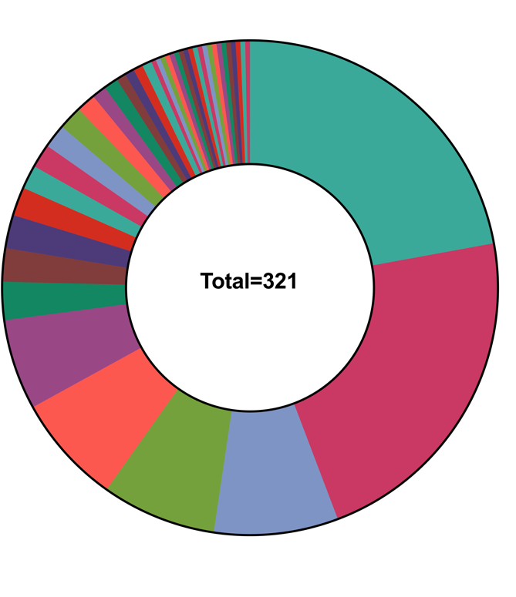
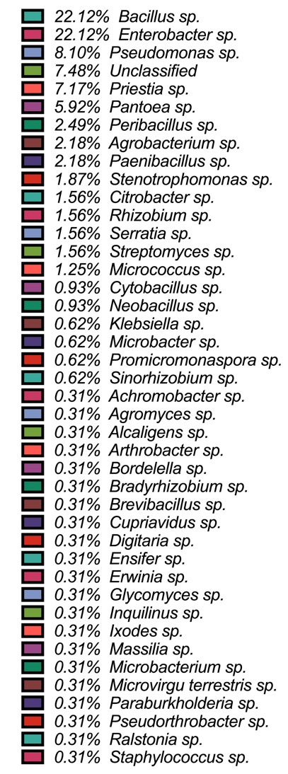

S4. Summary of the functional annotation of the eight strains used in the three consortia.

 | Pseudomonas chlororaphis subsp. aurantiaca SRG 32 | Enterobacter asburiae SRG25 | Pantoea dispersa SRG11 | Priestia megaterium SRG70 | Rhizobium wenxiniae SRG248 | Streptomyces sp. SRG181 | Paenibacillus illinoisensis SRG287 | Paraburkholderia sp. SRG18
Total Length (bp) | 6,841,436 | 4,650,833 | 5,098,449 | 5,614,296 | 6,128,823 | 8,776,229 | 6,616,332 | 7,724,548
No. of contigs | 87 | 41 | 61 | 90 | 111 | 497 | 46 | 137
No. of Sequences | 70 | 31 | 45 | 67 | 78 | 492 | 32 | 105
GC Content (%) | 62.9% | 55.9% | 57.4% | 37.6% | 58.8% | 71.1% | 47.0% | 62.5%
N50 | 217,573 | 493,601 | 627,472 | 769,157 | 710,011 | 27,805 | 1,019,943 | 184,691
Gap Ratio (%) | 0.0% | 0.0% | 0.0% | 0.0% | 0.0% | 0.0% | 0.0% | 0.0%
No. of CDSs | 6,143 | 4,422 | 4,769 | 5,806 | 5,872 | 7,46 | 5,988 | 6,774
No. of rRNA | 3 | 1 | 1 | 3 | 1 | 3 | 2 | 2
No. of tRNA | 63 | 75 | 75 | 81 | 54 | 82 | 88 | 55
No. of CRISPRs | 0 | 0 | 0 | 1 | 0 | 5 | 0 | 0
Coding Ratio (%) | 87.6% | 89.4% | 87.8% | 82.9% | 86.8% | 79.8% | 86.7% | 84.9%

