Supporting Information
From an Azaarene to the Spine of Fused Bicyclics: Cycloaddition-Induced Scaffold Hopping of 5-Hydroxypyrazoles

You Zhou,¹ Shuang-Gui Lei,¹ Baihetiguli Abudureheman,¹ Li-Sheng Wang,¹ Zhi-Cheng Yu,¹ Jia-Chen Xiang,^{2,*} and An-Xin Wu^{1, 3,*}

Affiliations:
1. National Key Laboratory of Green Pesticide, International Joint Research Center for Intelligent Biosensor Technology and Health, College of Chemistry, Central China Normal University, Wuhan 430079, P.R. China.
2. School of Chemistry and Chemical Engineering, Southeast University, Nanjing 211189, P.R. China.
3. State Key Laboratory of Applied Organic Chemistry, Lanzhou University, Lanzhou, 730000 P. R. China.

Correspondence and requests for materials should be addressed to A-X. W. (email: chwuax@mail.ccnu.edu.cn) and J-C. X (email: xiangjiachen@seu.edu.cn)

Table of Contents page
- General.……………………………………………….....................................S2
- Screening of the reaction conditions ……………………..……..……………S3
- Synthetic operation method of target product and substrate.......................S4-S11
- Mechanistic studies….………………………………………...……….S12-S14
- Characterization data for compounds………………………..…..……. S15-S47
- Crystallographic data and molecular structure of 4e and 6p...................S48-S51
- ¹H, ¹³C and ¹⁹F NMR spectra of compounds…………..……...............S52-S132

1. General
All substrates and reagents were commercially available and used without further purification. TLC analysis was performed using pre-coated glass plates. Column chromatography was performed using silica gel (200–300 mesh). ¹H, ¹³C, ¹⁹F spectra were recorded in CDCl₃ on Bruker 400 MHz NMR (AVANCE III HD 400) spectrometers and chemical shifts of ¹H NMR are reported in ppm, relative to the internal standard of tetramethylsilane (TMS, δ = 0.00 ppm). Chemical shifts of ¹³C NMR were reported in ppm with the solvent as the internal standard (CDCl₃, δ = 77.0 ppm). Data are reported as follows: chemical shift, multiplicity (s = singlet, d = doublet, t = triplet, m = multiplet), coupling constants (Hz) and integration. ¹³C spectra were recorded in CDCl₃ on 100 MHz NMR spectrometers and resonances (δ) are given in ppm. ¹⁹F spectra were recorded in CDCl₃ on 376 MHz NMR spectrometers and resonances (δ) are given in ppm. ³¹P spectra were recorded in CDCl₃ on 162 MHz NMR spectrometers and resonances (δ) are given in ppm. The high resolution mass spectrometers were obtained on an Agilent LC1290-TOF 6224 or German Thermo Fisher Q Exactive equipped with an electrospray source. The X-ray crystal-structure determinations of 4e and 6p were obtained on a Bruker APEX DUO CCD system. Melting points were determined using XT-4 apparatus and not corrected.

2. Screening of the reaction conditionsª

Entry | I₂ (equiv.) | Additives (equiv.) | Temp (℃) | Yield (%)^{b}
1 | 1.0 | - | 100 | 47
2 | 1.0 | t-BuCOOH (1.0) | 100 | 45
3 | 1.0 | CF₃COOH (1.0) | 100 | 38
4 | 1.0 | 50% HI (1.0) | 100 | 46
5 | 1.0 | TfOH (1.0) | 100 | 50
6 | 1.0 | Tf₂NH (1.0) | 100 | 48
7 | 1.0 | TsOH (1.0) | 100 | 47
8 | 1.0 | FeCl₃ (1.0) | 100 | 47
9 | 1.0 | CuCl₂ (1.0) | 100 | 39
10 | 1.0 | Cu(OTf)₂ (1.0) | 100 | 63
11 | 1.0 | ZnCl₂ (1.0) | 100 | 58
12 | 1.0 | NiCl₂ (1.0) | 100 | 60
13 | 1.0 | K₂S₂O₈ (1.0) | 100 | 19
14 | 1.0 | PhI(OAc)₂ (1.0) | 100 | 12
15 | 1.0 | 70% TBHP (1.0) | 100 | 43
16 | 1.0 | DTBP (1.0) | 100 | 72
17 | 1.0 | AIBN (1.0) | 100 | 70
18 | 1.0 | DCP (1.0) | 100 | 67
19 | 0.5 | DTBP (1.0) | 100 | 60
20 | 1.5 | DTBP (1.0) | 100 | 63
21 | 2.0 | DTBP (1.0) | 100 | 57
22 | 1.0 | DTBP (2.0) | 100 | 75
23 | 1.0 | DTBP (3.0) | 100 | 70
24 | 1.0 | DTBP (2.0) | 80 | 59
25 | 1.0 | DTBP (2.0) | 90 | 68
26 | 1.0 | DTBP (2.0) | 110 | 72
27 | 1.0 | DTBP (2.0) | 120 | 62

ªReaction conditions: 1a (1.2 mmol), 2a (1.0 mmol), 3a (1.0 mmol) ,I₂(x mmol) and Additives (x mmol) at T ℃ for 8 h under air. ^{b}Isolated yields.

3. Synthetic operation method of target product and substrate
Synthesis of Acetophenone derived from active molecules (1aa-1af)¹
4-Acetylbenzoic acid (11a, 10 mmol, 1642 mg), (-)-menthol (10 mmol, 1563 mg), [or (+)-borneol (10 mmol, 1543 mg), 1-adamantanamine (10 mmol, 1513 mg)] and 4-dimethylaminopyridine (DMAP, 3 mmol, 366 mg) were added to a 100 mL round-bottomed flask, then 50 mL of dichloromethane was added and mixed well to form a solution, and add the condensation reagent N, N-diisopropylcarbodiimide (DIC, 15 mmol, 1890 mg) while stirring the solution. Keep the mixture stirred at room temperature for 6 hours using a magnetic stirrer to complete the reaction. At the end of the reaction, the organic phase was extracted and partitioned with ethyl acetate and NaCl aqueous solution, and the crude product mixture was obtained after rotary evaporation under reduced pressure. Finally, the pure target product was obtained by column chromatography separation with a yield higher than 90%.

Carboxylic acid (10 mmol), 4-hydroxyacetophenone(11b, 10 mmol, 1362 mg), [or 4-aminoacetophenone (11c, 10 mmol, 1352 mg)] and 4-dimethylaminopyridine (DMAP, 3 mmol, 366 mg) were added to a 100 mL round-bottomed flask, then 50 mL of dichloromethane was added and mixed well to form a solution, and add the condensation reagent N, N-diisopropylcarbodiimide (DIC, 15 mmol, 1890 mg) while stirring the solution. Keep the mixture stirred at room temperature for 6 hours using a magnetic stirrer to complete the reaction. At the end of the reaction, the organic phase was extracted and partitioned with ethyl acetate and NaCl aqueous solution, and the crude product mixture was obtained after rotary evaporation under reduced pressure. Finally, the pure target product was obtained by column chromatography separation with a yield higher than 90%.

Synthesis method of 5-aminopyrazole (2)²
General procedure for 3-methyl-5-aminopyrazole: The substituted hydrazine hydrochloride (8, 5.0 mmol) was placed in a 38 mL glass reaction tube, and then K₂CO₃ (5.0 mmol, 690 mg) was added separately, followed by 15 mL of DMSO and 2 mL of H₂O as solvent, so that the mixture was stirred well on the reaction pot, and then 3-aminocrotononitrile (9, 6.0 mmol, 492 mg) was added, and finally the reaction was carried out at 110 ℃ for 5h. The target product in the reaction solution could be detected by TLC, and after the reaction was completed, the fraction was extracted with NaCl aqueous solution and ethyl acetate, and the combined organic phases were spun dry, and finally the pure target product was obtained by column chromatography (eluent polarity, EA:PE=5:1-3:1, yield above 90%).

Synthesis method of 5-hydroxypyrazole (3)³
General procedure for 5-hydroxypyrazole: Add methyl 3-methoxyacrylate (10 mmol, 1160 mg) and phenylhydrazine (10 mmol, 1080 mg) [or benzylhydrazine (10 mmol, 1220 mg)] to a 38mL glass tube, and add 20mL n-propanol as the reaction solvent, and finally the reaction was carried out at 120 ℃ for 8h. The target product in the reaction solution could be detected by TLC, and after the reaction was completed, the fraction was extracted with NaCl aqueous solution and ethyl acetate, and the combined organic phases were spun dry, and finally the pure target product was obtained by column chromatography (eluent polarity, EA, yield above 60%).

NMR spectra of 3-hydroxypyrazole in DMSO-d₆
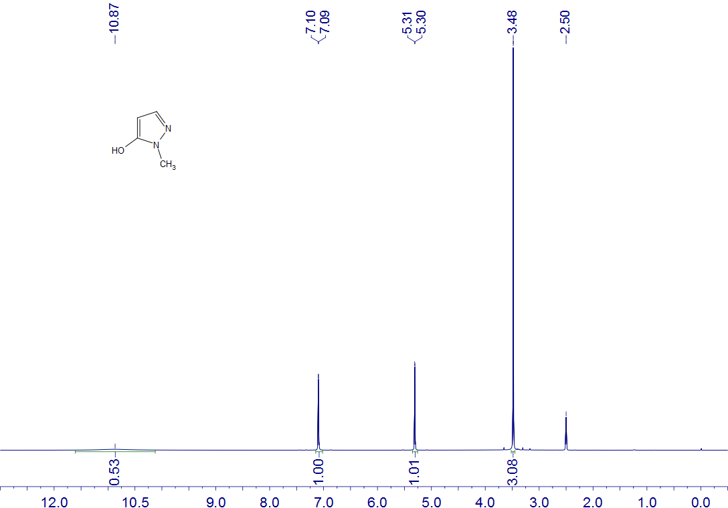
3a
DMSO-d₆
400 MHz

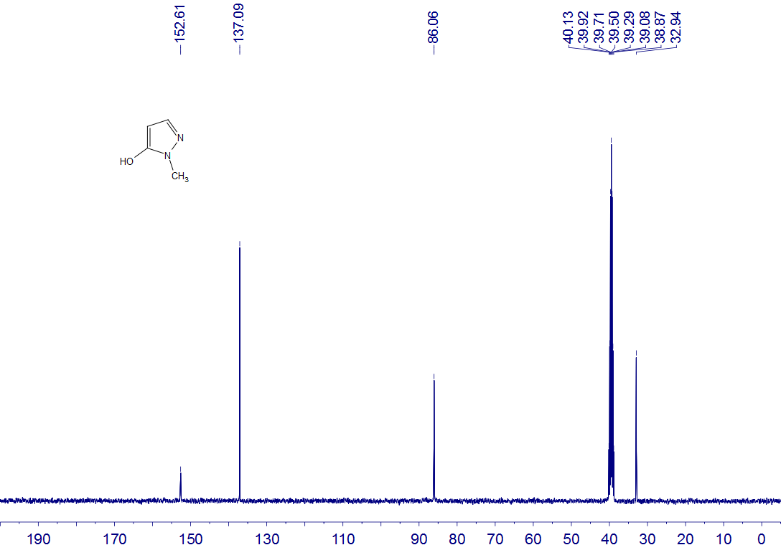
3a
DMSO-d₆
100 MHz

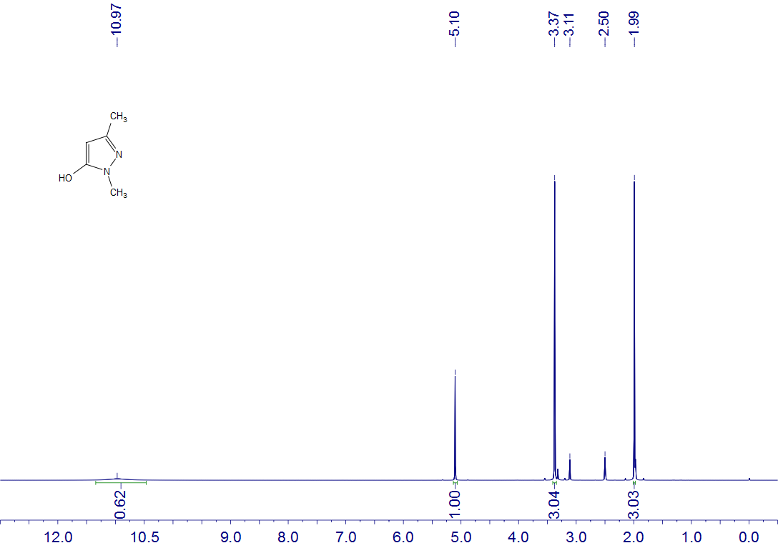
3f
DMSO-d₆
400 MHz

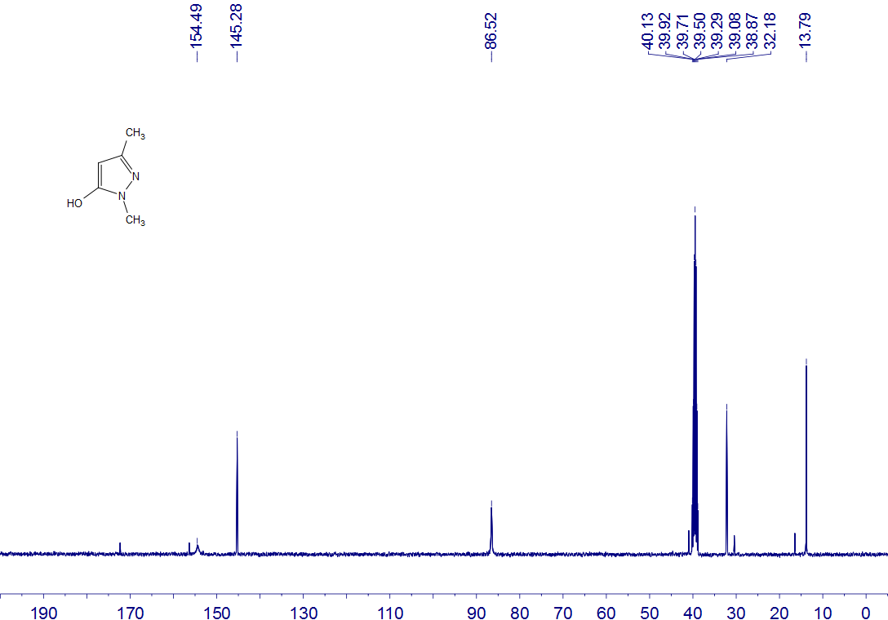
3f
DMSO-d₆
100 MHz

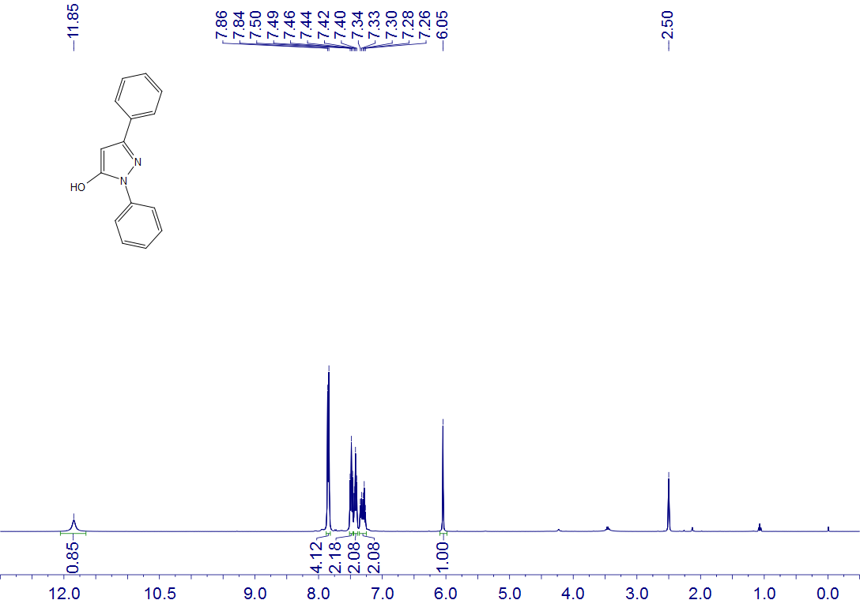
3g
DMSO-d₆
400 MHz

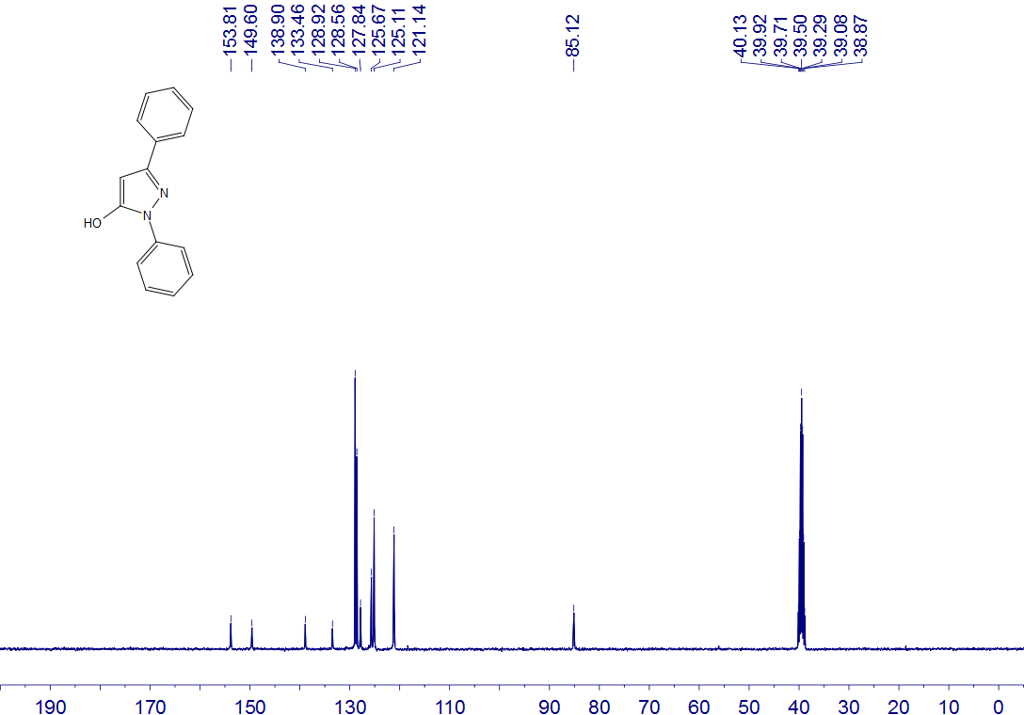
3g
DMSO-d₆
100 MHz

General procedure for the synthesis of 4-7 (4a or 5t as example)
1.0 mmol scale (4a): The reactions did not require the protection of inert gases. In a 35 mL sealed tube were added acetophenone (1a) (144 mg, 1.2 mmol), iodine (254 mg, 1.0 mmol) and dimethyl sulfoxide (5 mL) and the resulting mixture was stirred at 100 ℃ (heating block), the reaction tube was removed after about 1 hour. Then additional 2a (173 mg, 1.0 mmol), 3a (98 mg, 1.0 mmol) and DTBP (292 mg, 2.0 mmol) were added at room temperature, followed by reaction at 100 ℃ for 4 hours until substrate conversion was almost complete by TLC analysis. After the reaction stopped and cooled at room temperature, the reaction mixture was quenched with saturated Na₂S₂O₃ solution (50 mL) and NaCl solution (150 mL). The mixture was then extracted with EtOAc (150mL × 2), and the organic layers were separated and merged. The mixture was dried with anhydrous Na₂SO₄ and concentrated under reduced pressure. The crude product was purified by column chromatography on silica gel (eluent: petroleum ether/EtOAc = 12:1) to afford the product 4a (275 mg, 75% yield).

8.0 mmol scale (5t): The reactions did not require the protection of inert gases. In a 100 mL round flask were added p-methylacetophenone (1b) (1.29 g, 9.6 mmol), iodine (2.03 g, 8 mmol) and dimethyl sulfoxide (30 mL) and the resulting mixture was stirred in oil bath heating at 100 ℃, the round flask was removed after about 1.5 hour. Then additional 2a (1.38 g, 8.0 mmol), 3a (0.78 g, 8.0 mmol) and DTBP (2.34 g, 16 mmol) were added at room temperature, followed by reaction at 100 ℃ for 6 hours until substrate conversion was almost complete by TLC analysis. After the reaction stopped and cooled at room temperature, the reaction mixture was quenched with saturated Na₂S₂O₃ solution (150 mL) and NaCl solution (400 mL). The mixture was then extracted with EtOAc (300mL × 2), and the organic layers were separated and merged. The mixture was dried with anhydrous Na₂SO₄ and concentrated under reduced pressure. The crude product was purified by column chromatography on silica gel (eluent: petroleum ether/EtOAc = 8:1) to afford the product 5t (1.81 g, 71% yield).

Post-modification methods of 4n molecules
Product of para-bromine 4n (134 mg, 0.3 mmol), phenylacetylene (46 mg, 0.45 mmol), Pd(PPh₃)₂Cl₂(9.8 mg, 0.015 mmol), CuI (5.7 mg, 0.03 mmol), NEt₃ (2 mL) and THF (2 mL). The vial was then purged with argon and sealed, and heated under an argon atmosphere 80 ℃ for 10 h. Until the disappearance of starting material was observed, as monitored by thin layer chromatography. The reaction mixture was diluted with EtOAc (200 mL x 2) and washed with NaCl solution (400 mL), and the aqueous phase was then extracted with EtOAc (40 mL x 2). The combined organic layers were dried over anhydrous Na₂SO₄ and concentrated using a rotary evaporator under reduced pressure. The crude product was purified by column chromatography on silica gel (eluent: petroleum ether/EtOAc = 12:1) to afford the product 8 (120 mg, 86% yield).⁴

A mixture of 4n (134 mg, 0.3 mmol), di-p-tolylphosphine oxide (104 mg, 0.45 mmol), palladium (II) acetate (4.5 mg, 0.02 mmol), (t-Bu₃)PHBF₄ (12.0 mg, 0.04 mmol), Cs₂CO₃ (196 mg, 0.6 mmol) and dry-toluene (4 mL), and heated under an argon atmosphere 110 ℃ for 10 h. After the mixture was cooled to room temperature, NaCl solution (400 mL) and EtOAc (200 mL x 2) were added. The organic layer was separated and washed with brine, dried over anhydrous Na₂SO₄ and evaporated to dryness under reduced pressure. The crude product was purified by column chromatography on silica gel (eluent: petroleum ether/EtOAc = 2:1) to afford the product 9 (149 mg, 84% yield).⁵

References
1. (a) Seeberger, Peter H. ; Pereira, Claney L.; Khan, Naeem; Xiao, Guozhi; Diago-Navarro, Elizabeth. Angew. Chem. Int. Ed., 2017, 56, 13973-13978. (b) Rochon, Kristina; Proteau-Gagne, Arnaud; Bourassa, Philippe; Nadon, Jean-Francois; Cote, Jerome. ACS Chemical Neuroscience, 2013, 4, 1204-1216.

2. (a) Maura Marinozzi, Andrea Carotti, Emanuele Sansone, Antonio Macchiarulo, Emiliano Rosatelli, Roccaldo Sardella. Bioorg. Med. Chem. 2012, 20, 3429-3445. (b) Bhaskar Deka, Pranjal K. Baruah, Mohit L. Deb. Org. Biomol. Chem., 2018, 16, 7806-7810. (c) Lei Pan, Feng Jin, Rui Fu, Ke Gao, Shaofang Zhou, Xiaoguang Bao. Eur. J. Org. Chem. 2020, 2020, 2956-2961.

3. (a) Preparation method of 1-aryl-5-hydroxypyrazole. China, CN104059020 A 2014-09-24. (b) Method and device for preparing hydroxypyrazole compounds via continuous reaction. China, CN109320457 A 2019-02-12.

4. Domaradzki, M. E.; Long, Y.; She, Z.; Liu, X.; Zhang, G.; Chen, Y. J. Org. Chem., 2015, 80, 11360-11368.

5. (a). Kailu Zheng, Hannan Yang, Fan Ni, Zhanxiang Chen, Shaolong Gong, Zhenghong Lu and Chuluo Yang. Adv. Optical Mater., 2019, 7, 1900727.

4. Mechanistic studies
The mechanism of HRMS
The reactions did not require the protection of inert gases. In a 35 mL sealed tube were added deuterated acetophenone-d₃ (1a-D) (148 mg, 1.2 mmol), iodine (254 mg, 1.0 mmol) and dimethyl sulfoxide (5 mL) and the resulting mixture was stirred at 100 ℃ (heating block), the reaction tube was removed after about 1 hour. Then additional 2a (173 mg, 1.0 mmol), 3a (98 mg, 1.0 mmol) and DTBP (292 mg, 2.0 mmol) were added at room temperature, followed by reaction at 100 ℃ for 40 mins, then wait for the reaction to cool to room temperature. Take 0.5 mL of reaction solution and dilute it with 4 mL of EtOAc. Then 1.5 mL of the extraction solution was added into the test bottle, the samples were immediately monitored by German Thermo Fisher Q Exactive high resolution mass spectrometers.

Spectrum of HRMS:
1ab-D

A

B

C

D

4a
6. Characterization data for compounds
1,7-dimethyl-3,9-diphenyl-3,7-dihydro-6H-pyrazolo[4',3':5,6]pyrido[3,4-d]pyridazin-6-one (4a):
Yield 75%; 275 mg; yellow solid; column chromatography, silica gel (PE:EA, 12:1); mp 235–237 ℃. ¹H NMR (400 MHz, CDCl₃) δ 9.70 (s, 1H), 8.12 (d, J = 8.0 Hz, 2H), 7.60-7.50 (m, 7H), 7.37 (t, J = 7.2 Hz, 1H), 3.95 (s, 3H), 1.59 (s, 3H). ¹³C NMR (100 MHz, CDCl₃) δ 158.4, 152.4, 150.1, 144.3, 143.7, 138.3, 138.2, 130.7, 129.6, 129.3, 129.12, 129.09, 127.0, 122.4, 117.7, 107.6, 39.6, 15.2. HRMS (ESI-TOF): m/z [M+H]⁺ calcd for C₂₂H₁₈N₅O⁺: 368.1506; found: 368.1505.

1,7-dimethyl-3-phenyl-9-(p-tolyl)-3,7-dihydro-6H-pyrazolo[4',3':5,6]pyrido[3,4-d] pyridazin-6-one (4b):
Yield 74%; 281 mg; white solid; column chromatography, silica gel (PE:EA, 12:1); mp 211–213 ℃. ¹H NMR (400 MHz, CDCl₃) δ 9.69 (s, 1H), 8.12 (d, J = 8.0 Hz, 2H), 7.54 (t, J = 7.6 Hz, 2H), 7.46 (d, J = 7.6 Hz, 2H), 7.38-7.33 (m, 3H), 3.94 (s, 3H), 2.47 (s, 3H), 1.63 (s, 3H). ¹³C NMR (100 MHz, CDCl₃) δ 158.5, 152.4, 150.1, 144.4, 143.8, 139.7, 138.3, 135.3, 130.8, 129.7, 129.13, 129.10, 126.9, 122.4, 117.8, 107.7, 39.6, 21.4, 15.4. HRMS (ESI-TOF): m/z [M+H]⁺ calcd for C₂₃H₂₀N₅O⁺: 382.1662; found: 382.1662.

9-(4-(tert-butyl)phenyl)-1,7-dimethyl-3-phenyl-3,7-dihydro-6H-pyrazolo[4',3':5,6]pyrido [3,4-d]pyridazin-6-one (4c):
Yield 77%; 325 mg; light yellow solid; column chromatography, silica gel (PE:EA, 12:1); mp 223–225 ℃. ¹H NMR (400 MHz, CDCl₃) δ 9.68 (s, 1H), 8.13 (d, J = 8.0 Hz, 2H), 7.56-7.48 (m, 6H), 7.36 (t, J = 7.2 Hz, 1H), 3.94 (s, 3H), 1.57 (s, 3H), 1.39 (s, 9H). ¹³C NMR (100 MHz, CDCl₃) δ 158.4, 153.1, 152.4, 150.0, 144.4, 143.8, 138.3, 135.2, 130.9, 129.1, 128.9, 126.9, 126.1, 122.3, 117.7, 107.8, 39.6, 34.8, 31.2, 14.9. HRMS (ESI-TOF): m/z [M+H]⁺ calcd for C₂₆H₂₆N₅O⁺: 424.2132; found: 424.2130.

9-(4-cyclohexylphenyl)-1,7-dimethyl-3-phenyl-3,7-dihydro-6H-pyrazolo[4',3':5,6]pyrido [3,4-d]pyridazin-6-one (4d):
Yield 72%; 323 mg; light yellow solid; column chromatography, silica gel (PE:EA, 12:1); mp 204–206 ℃. ¹H NMR (400 MHz, CDCl₃) δ 9.67 (s, 1H), 8.12 (d, J = 8.0 Hz, 2H), 7.52 (t, J = 7.6 Hz, 2H), 7.47 (d, J = 7.6 Hz, 2H), 7.36 (d, J = 7.6 Hz, 3H), 3.93 (s, 3H), 2.64-2.57 (m, 1H), 1.94-1.87 (m, 4H), 1.78 (d, J = 12.4 Hz, 1H), 1.56 (s, 3H), 1.52-1.38 (m, 4H), 1.32-1.25 (m, 1H). ¹³C NMR (100 MHz, CDCl₃) δ 158.4, 152.3, 150.0, 149.9, 144.5, 143.8, 138.3, 135.5, 130.8, 129.1, 129.0, 127.6, 126.8, 122.3, 117.7, 107.7, 44.4, 39.6, 34.3, 26.7, 26.0, 14.9. HRMS (ESI-TOF): m/z [M+H]⁺ calcd for C₂₈H₂₈N₅O⁺: 450.2288; found: 450.2288.

9-(4-methoxyphenyl)-1,7-dimethyl-3-phenyl-3,7-dihydro-6H-pyrazolo[4',3':5,6]pyrido [3,4-d]pyridazin-6-one (4e):
Yield 70%; 278 mg; light yellow solid; column chromatography, silica gel (PE:EA, 8:1); mp 183–185 ℃. ¹H NMR (400 MHz, CDCl₃) δ 9.69 (s, 1H), 8.13 (d, J = 7.2 Hz, 2H), 7.58-7.47 (m, 4H), 7.37 (t, J = 6.4 Hz, 1H), 7.06 (d, J = 7.6 Hz, 2H), 3.94 (s, 3H), 3.90 (s, 3H), 1.70 (s, 3H). ¹³C NMR (100 MHz, CDCl₃) δ 160.7, 158.4, 152.4, 150.1, 144.2, 143.7, 138.3, 130.8, 130.7, 130.5, 129.1, 126.9, 122.4, 117.8, 114.5, 107.8, 55.5, 39.6, 15.5. HRMS (ESI-TOF): m/z [M+H]⁺ calcd for C₂₃H₂₀N₅O₂⁺: 398.1612; found: 398.1612.

9-(2-methoxyphenyl)-1,7-dimethyl-3-phenyl-3,7-dihydro-6H-pyrazolo[4',3':5,6]pyrido [3,4-d]pyridazin-6-one (4f):
Yield 72%; 285 mg; light yellow solid; column chromatography, silica gel (PE:EA, 8:1); mp 220–222 ℃. ¹H NMR (400 MHz, CDCl₃) δ 9.71 (s, 1H), 8.13 (d, J = 8.0 Hz, 2H), 7.56-7.48 (m, 4H), 7.34 (t, J = 7.2 Hz, 1H), 7.15 (t, J = 7.2 Hz, 1H), 7.02 (d, J = 8.4 Hz, 1H), 3.94 (s, 3H), 3.64 (s, 3H), 1.64 (s, 3H). ¹³C NMR (100 MHz, CDCl₃) δ 158.6, 158.5, 152.3, 150.2, 143.5, 141.9, 138.4, 132.2, 131.5, 131.4, 129.0, 127.2, 126.8, 122.4, 121.0, 117.2, 111.2, 107.6, 55.5, 39.6, 15.0. HRMS (ESI-TOF): m/z [M+H]⁺ calcd for C₂₃H₂₀N₅O₂⁺: 398.1612; found: 398.1611.

9-(benzo[d][1,3]dioxol-5-yl)-1,7-dimethyl-3-phenyl-3,7-dihydro-6H-pyrazolo[4',3':5,6] pyrido[3,4-d]pyridazin-6-one (4g):
Yield 70%; 287 mg; yellow solid; column chromatography, silica gel (PE:EA, 6:1); mp 246–248 ℃. ¹H NMR (400 MHz, CDCl₃, CF₃COOD) δ 9.65 (s, 1H), 7.88 (d, J = 8.0 Hz, 2H), 7.55 (t, J = 7.6 Hz, 2H), 7.44 (t, J = 7.2 Hz, 1H), 7.10 (s, 1H), 6.98 (dd, J = 19.6 Hz, 8.0 Hz, 2H), 6.13 (s, 1H), 6.07 (s, 1H), 3.99 (s, 3H), 1.86 (s, 3H). ¹³C NMR (100 MHz, CDCl₃, CF₃COOD) δ 159.2, 151.8, 150.4, 149.2, 148.5, 145.6, 144.4, 136.9, 131.5, 131.0, 129.3, 128.3, 123.7, 123.5, 117.6, 109.5, 108.9, 107.5, 101.8, 40.3, 15.2. HRMS (ESI-TOF): m/z [M+H]⁺ calcd for C₂₃H₁₈N₅O₃⁺: 412.1404; found: 412.1401.

1,7-dimethyl-3-phenyl-9-(4-((trimethylsilyl)methoxy)phenyl)-3,7-dihydro-6H-pyrazolo [4',3':5,6]pyrido[3,4-d]pyridazin-6-one (4h):
Yield 74%; 347 mg; gray solid; column chromatography, silica gel (PE:EA, 10:1); mp 133–135 ℃. ¹H NMR (400 MHz, CDCl₃) δ 9.66 (s, 1H), 8.12 (d, J = 8.0 Hz, 2H), 7.52 (t, J = 8.0 Hz, 2H), 7.46 (d, J = 8.4 Hz, 2H), 7.35 (t, J = 7.6 Hz, 1H), 7.09 (d, J = 8.8 Hz, 2H), 3.92 (s, 3H), 3.67 (s, 2H), 1.70 (s, 3H), 0.19 (s, 9H). ¹³C NMR (100 MHz, CDCl₃) δ 162.7, 158.4, 152.4, 150.0, 144.3, 143.8, 138.3, 130.8, 130.3, 130.2, 129.0, 126.8, 122.3, 117.7, 114.7, 107.8, 61.5, 39.5, 15.6, -3.14. HRMS (ESI-TOF): m/z [M+H]⁺ calcd for C₂₆H₂₈N₅O₂Si⁺: 470.2007; found: 470.2006.

1,7-dimethyl-9-(4-(methylthio)phenyl)-3-phenyl-3,7-dihydro-6H-pyrazolo[4',3':5,6] pyrido[3,4-d]pyridazin-6-one (4i):
Yield 73%; 301 mg; light yellow solid; column chromatography, silica gel (PE:EA, 10:1); mp 210–212 ℃. ¹H NMR (400 MHz, CDCl₃) δ 9.67 (s, 1H), 8.12 (d, J = 8.0 Hz, 2H), 7.53 (t, J = 8.0 Hz, 2H), 7.48 (d, J = 8.4 Hz, 2H), 7.40-7.34 (m, 3H), 3.93 (s, 3H), 2.55 (s, 3H), 1.70 (s, 3H). ¹³C NMR (100 MHz, CDCl₃) δ 158.4, 152.4, 150.0, 143.8, 143.5, 141.0, 138.3, 134.6, 130.6, 129.5, 129.1, 126.9, 126.4, 122.3, 117.7, 107.6, 39.6, 15.7, 15.4. HRMS (ESI-TOF): m/z [M+H]⁺ calcd for C₂₃H₂₀N₅OS⁺: 414.1383; found: 414.1381.

9-(4-fluorophenyl)-1,7-dimethyl-3-phenyl-3,7-dihydro-6H-pyrazolo[4',3':5,6]pyrido[3,4-d]pyridazin-6-one (4j):
Yield 71%; 273 mg; white solid; column chromatography, silica gel (PE:EA, 12:1); mp 193–195 ℃. ¹H NMR (400 MHz, CDCl₃) δ 9.69 (s, 1H), 8.12 (d, J = 7.6 Hz, 2H), 7.65-7.47 (m, 4H), 7.38 (t, J = 7.2 Hz, 1H), 7.28-7.19 (m, 2H), 3.94 (s, 3H), 1.67 (s, 3H). ¹³C NMR (100 MHz, CDCl₃) δ 163.5 (d, J = 249.0 Hz, ¹J_{CF}), 158.4, 152.4, 150.1, 143.3, 143.2, 138.3, 134.4, 131.2 (d, J = 9.0 Hz, ³J_{CF}), 130.5, 129.1, 127.0, 122.4, 117.7, 116.3 (d, J = 22.0 Hz, ²J_{CF}), 107.5, 39.6, 15.5. ¹⁹F NMR (376 MHz, CDCl₃) δ -110.62. HRMS (ESI-TOF): m/z [M+H]⁺ calcd for C₂₂H₁₇N₅OF⁺: 386.1412; found: 386.1415.

9-(3,5-difluorophenyl)-1,7-dimethyl-3-phenyl-3,7-dihydro-6H-pyrazolo[4',3':5,6]pyrido [3,4-d]pyridazin-6-one (4k):
Yield 72%; 290 mg; yellow solid; column chromatography, silica gel (PE:EA, 12:1); mp 257–259 ℃. ¹H NMR (400 MHz, CDCl₃, CF₃COOD) δ 9.70 (s, 1H), 7.87 (d, J = 7.6 Hz, 2H), 7.57 (t, J = 7.6 Hz, 2H), 7.47 (t, J = 7.2 Hz, 1H), 7.17 (d, J = 4.8 Hz, 2H), 7.07 (t, J = 8.4 Hz, 1H), 4.04 (s, 3H), 1.83 (s, 3H). ¹³C NMR (100 MHz, CDCl₃, CF₃COOD) δ 163.4 (dd, ¹J_{CF} = 250.0 Hz, ³J_{CF} = 12.0 Hz), 159.2, 151.7, 150.7, 143.9, 143.4, 140.1 (t, ³J_{CF} = 9.0 Hz), 136.7, 130.8, 129.4, 128.6, 123.9, 117.6, 112.8 (dd, ²J_{CF} = 19.0 Hz, ⁴J_{CF} = 8.0 Hz), 107.0, 105.7 (t, ²J_{CF} = 25.0 Hz), 40.6, 15.2. ¹⁹F NMR (376 MHz, CDCl₃, CF₃COOD) δ -107.45. HRMS (ESI-TOF): m/z [M+H]⁺ calcd for C₂₂H₁₆N₅OF₂⁺: 404.1317; found: 404.1313.

9-(2-chlorophenyl)-1,7-dimethyl-3-phenyl-3,7-dihydro-6H-pyrazolo[4',3':5,6]pyrido[3,4-d]pyridazin-6-one (4l):
Yield 69%; 277 mg; yellow solid; column chromatography, silica gel (PE:EA, 12:1); mp 244–246 ℃. ¹H NMR (400 MHz, CDCl₃) δ 9.72 (s, 1H), 8.11 (d, J = 8.0 Hz, 2H), 7.63-7.43 (m, 6H), 7.36 (t, J = 7.6 Hz, 1H), 3.95 (s, 3H), 1.64 (s, 3H). ¹³C NMR (100 MHz, CDCl₃) δ 158.5, 152.3, 150.3, 143.3, 141.7, 138.3, 137.0, 135.0, 132.2, 131.3, 130.1, 129.1, 127.3, 127.0, 122.5, 117.1, 107.1, 39.7, 14.7. HRMS (ESI-TOF): m/z [M+H]⁺ calcd for C₂₂H₁₇N₅OCl⁺: 402.1116; found: 402.1114.

9-(2,4-dichlorophenyl)-1,7-dimethyl-3-phenyl-3,7-dihydro-6H-pyrazolo[4',3':5,6]pyrido [3,4-d]pyridazin-6-one (4m):
Yield 71%; 309 mg; yellow solid; column chromatography, silica gel (PE:EA, 12:1); mp 178–180 ℃. ¹H NMR (400 MHz, CDCl₃) δ 9.69 (s, 1H), 8.11 (d, J = 7.6 Hz, 2H), 7.60-7.45 (m, 5H), 7.36 (t, J = 7.2 Hz, 1H), 3.93 (s, 3H), 1.73 (s, 3H). ¹³C NMR (100 MHz, CDCl₃) δ 158.4, 152.3, 150.2, 142.8, 140.6, 138.2, 136.7, 135.9, 135.6, 132.9, 131.0, 129.8, 129.0, 127.7, 127.0, 122.5, 117.0, 106.9, 39.7, 15.2. HRMS (ESI-TOF): m/z [M+H]⁺ calcd for C₂₂H₁₆N₅OCl₂⁺: 436.0726; found: 436.0729.

9-(4-bromophenyl)-1,7-dimethyl-3-phenyl-3,7-dihydro-6H-pyrazolo[4',3':5,6]pyrido[3,4-d]pyridazin-6-one (4n):
Yield 69%; 307 mg; light yellow solid; column chromatography, silica gel (PE:EA, 12:1); mp 222–224 ℃. ¹H NMR (400 MHz, CDCl₃) δ 9.62 (s, 1H), 8.11 (d, J = 7.6 Hz, 2H), 7.67 (d, J = 7.6 Hz, 2H), 7.52 (t, J = 7.6 Hz, 2H), 7.45 (d, J = 7.6 Hz, 2H), 7.35 (t, J = 7.2 Hz, 1H), 3.92 (s, 3H), 1.67 (s, 3H). ¹³C NMR (100 MHz, CDCl₃) δ 158.2, 152.3, 150.0, 143.2, 143.0, 138.2, 137.0, 132.2, 130.8, 130.1, 129.0, 126.9, 123.9, 122.2, 117.6, 107.3, 39.6, 15.7. HRMS (ESI-TOF): m/z [M+H]⁺ calcd for C₂₂H₁₇N₅OBr⁺: 446.0611; found: 446.0613.

9-(3-bromophenyl)-1,7-dimethyl-3-phenyl-3,7-dihydro-6H-pyrazolo[4',3':5,6]pyrido[3,4-d]pyridazin-6-one (4o):
Yield 65%; 289 mg; light yellow solid; column chromatography, silica gel (PE:EA, 12:1); mp 229–231 ℃. ¹H NMR (400 MHz, CDCl₃) δ 9.66 (s, 1H), 8.12 (d, J = 7.2 Hz, 2H), 7.75 (s, 1H), 7.69 (d, J = 7.2 Hz, 1H), 7.57-7.48 (m, 3H), 7.43-7.35 (m, 2H), 3.94 (s, 3H), 1.68 (s, 3H). ¹³C NMR (100 MHz, CDCl₃) δ 158.3, 152.3, 150.1, 143.2, 142.6, 140.0, 138.2, 132.7, 132.2, 130.6, 130.2, 129.1, 127.9, 127.0, 123.1, 122.4, 117.6, 107.3, 39.7, 15.7. HRMS (ESI-TOF): m/z [M+H]⁺ calcd for C₂₂H₁₇N₅OBr⁺: 446.0611; found: 446.0611.

9-(4-iodophenyl)-1,7-dimethyl-3-phenyl-3,7-dihydro-6H-pyrazolo[4',3':5,6]pyrido[3,4-d] pyridazin-6-one (4p):
Yield 73%; 359 mg; yellow solid; column chromatography, silica gel (PE:EA, 12:1); mp 239–241 ℃. ¹H NMR (400 MHz, CDCl₃) δ 9.63 (s, 1H), 8.11 (d, J = 8.0 Hz, 2H), 7.87 (d, J = 8.0 Hz, 2H), 7.52 (t, J = 8.0 Hz, 2H), 7.37-7.30 (m, 3H), 3.92 (s, 3H), 1.67 (s, 3H). ¹³C NMR (100 MHz, CDCl₃) δ 158.2, 152.3, 150.0, 143.2, 143.1, 138.21, 138.17, 137.6, 130.9, 130.1, 129.0, 126.9, 122.3, 117.6, 107.4, 95.6, 39.6, 15.8. HRMS (ESI-TOF): m/z [M+H]⁺ calcd for C₂₂H₁₇N₅OI⁺: 494.0472; found: 494.0468.

1,7-dimethyl-3-phenyl-9-(4-(trifluoromethyl)phenyl)-3,7-dihydro-6H-pyrazolo[4',3':5,6] pyrido[3,4-d]pyridazin-6-one (4q):
Yield 70%; 304 mg; light yellow solid; column chromatography, silica gel (PE:EA, 12:1); mp 188–190 ℃. ¹H NMR (400 MHz, CDCl₃) δ 9.64 (s, 1H), 8.11 (d, J = 8.0 Hz, 2H), 7.81 (d, J = 8.0 Hz, 2H), 7.72 (d, J = 8.0 Hz, 2H), 7.52 (t, J = 8.0 Hz, 2H), 7.36 (t, J = 7.6 Hz, 1H), 3.94 (s, 3H), 1.58 (s, 3H). ¹³C NMR (100 MHz, CDCl₃) δ 158.2, 152.3, 150.0, 143.0, 142.6, 141.6, 138.2, 131.7 (q, J = 32.0 Hz, ²J_{CF}), 130.0, 129.7, 129.1, 127.0, 126.0 (q, J = 3.0 Hz, ⁴J_{CF}), 123.7 (q, J = 271.0 Hz, ¹J_{CF}), 122.3, 117.6, 107.2, 39.7, 15.6. ¹⁹F NMR (376 MHz, CDCl₃) δ -62.66. HRMS (ESI-TOF): m/z [M+H]⁺ calcd for C₂₃H₁₇N₅OF₃⁺: 436.1380; found: 436.1378.

1,7-dimethyl-3-phenyl-9-(3-(trifluoromethoxy)phenyl)-3,7-dihydro-6H-pyrazolo[4',3':5,6] pyrido[3,4-d]pyridazin-6-one (4r):
Yield 71%; 320 mg; light yellow solid; column chromatography, silica gel (PE:EA, 10:1); mp 190–192 ℃. ¹H NMR (400 MHz, CDCl₃) δ 9.59 (s, 1H), 8.11 (d, J = 8.0 Hz, 2H), 7.57 (t, J = 8.0 Hz, 1H), 7.54-7.45 (m, 4H), 7.42 (d, J = 8.0 Hz, 1H), 7.33 (t, J = 7.2 Hz, 1H), 3.91 (s, 3H), 1.60 (s, 3H). ¹³C NMR (100 MHz, CDCl₃) δ 158.1, 152.2, 149.8, 149.59, 149.57, 143.0, 142.3, 140.0, 138.2, 130.5, 130.0, 128.9, 127.8, 126.8, 122.04, 121.96, 121.9, 120.3 (q, J = 257.0 Hz, ¹J_{CF}), 117.5, 107.2, 39.6, 15.2. ¹⁹F NMR (376 MHz, CDCl₃) δ -57.65. HRMS (ESI-TOF): m/z [M+H]⁺ calcd for C₂₃H₁₇N₅O₂F₃⁺: 452.1329; found: 452.1326.

methyl 4-(1,7-dimethyl-6-oxo-3-phenyl-6,7-dihydro-3H-pyrazolo[4',3':5,6]pyrido[3,4-d] pyridazin-9-yl)benzoate (4s):
Yield 67%; 284 mg; yellow solid; column chromatography, silica gel (PE:EA, 6:1); mp 228–230 ℃. ¹H NMR (400 MHz, CDCl₃) δ 9.62 (s, 1H), 8.20 (d, J = 7.6 Hz, 2H), 8.11 (d, J = 8.0 Hz, 2H), 7.66 (d, J = 7.6 Hz, 2H), 7.51 (t, J = 7.6 Hz, 2H), 7.34 (t, J = 7.2 Hz, 1H), 3.99 (s, 3H), 3.93 (s, 3H), 1.58 (s, 3H). ¹³C NMR (100 MHz, CDCl₃) δ 166.2, 158.2, 152.2, 149.9, 143.1, 143.0, 142.3, 138.2, 130.9, 130.2, 130.0, 129.3, 129.0, 126.8, 122.1, 117.5, 107.3, 52.3, 39.6, 15.6. HRMS (ESI-TOF): m/z [M+H]⁺ calcd for C₂₄H₂₀N₅O₃⁺: 426.1561; found: 426.1560.

4-(1,7-dimethyl-6-oxo-3-phenyl-6,7-dihydro-3H-pyrazolo[4',3':5,6]pyrido[3,4-d] pyridazin-9-yl)benzonitrile (4t):
Yield 66%; 258 mg; yellow solid; column chromatography, silica gel (PE:EA, 6:1); mp 275–277 ℃. ¹H NMR (400 MHz, CDCl₃, CF₃COOD) δ 9.72 (s, 1H), 7.92 (d, J = 7.6 Hz, 2H), 7.85 (d, J = 7.6 Hz, 2H), 7.78 (d, J = 7.6 Hz, 2H), 7.57 (t, J = 7.2 Hz, 2H), 7.52-7.45 (m, 1H), 4.05 (s, 3H), 1.69 (s, 3H). ¹³C NMR (100 MHz, CDCl₃, CF₃COOD) δ 159.2, 151.6, 150.8, 143.8, 143.6, 141.9, 136.6, 133.1, 130.7, 130.1, 129.5, 128.8, 124.1, 117.7, 117.4, 113.4, 107.0, 40.6, 15.5. HRMS (ESI-TOF): m/z [M+H]⁺ calcd for C₂₃H₁₇N₆O₃⁺: 393.1458; found: 393.1457.

1,7-dimethyl-9-(4-nitrophenyl)-3-phenyl-3,7-dihydro-6H-pyrazolo[4',3':5,6]pyrido[3,4-d] pyridazin-6-one (4u):
Yield 70%; 288 mg; yellow solid; column chromatography, silica gel (PE:EA, 6:1); mp 262–264 ℃. ¹H NMR (400 MHz, CDCl₃, CF₃COOD) δ 9.82 (s, 1H), 8.48 (d, J = 8.4 Hz, 2H), 7.89 (d, J = 8.4 Hz, 2H), 7.68-7.58 (m, 5H), 4.10 (s, 3H), 1.76 (s, 3H). ¹³C NMR (100 MHz, CDCl₃, CF₃COOD) δ 159.4, 151.4, 150.8, 148.8, 144.5, 143.9, 143.3, 135.2, 131.9, 130.6, 130.4, 129.9, 125.5, 124.7, 118.2, 107.5, 40.9, 15.2. HRMS (ESI-TOF): m/z [M+H]⁺ calcd for C₂₂H₁₇N₆O₃⁺: 413.1357; found: 413.1355.

3-(1,7-dimethyl-6-oxo-3-phenyl-6,7-dihydro-3H-pyrazolo[4',3':5,6]pyrido[3,4-d] pyridazin-9-yl)benzonitrile (4v):
Yield 68%; 266 mg; yellow solid; column chromatography, silica gel (PE:EA, 6:1); mp 253–255 ℃. ¹H NMR (400 MHz, CDCl₃, CF₃COOD) δ 9.70 (s, 1H), 7.98 (s, 1H), 7.90 (t, J = 7.2 Hz, 3H), 7.85 (d, J = 7.6 Hz, 1H), 7.73 (t, J = 7.6 Hz, 1H), 7.56 (t, J = 7.6 Hz, 2H), 7.46 (t, J = 7.2 Hz, 1H), 4.03 (s, 3H), 1.66 (s, 3H). ¹³C NMR (100 MHz, CDCl₃, CF₃COOD) δ 159.1, 151.8, 150.5, 143.3, 138.8, 136.9, 133.8, 133.5, 132.7, 130.6, 130.2, 129.4, 128.4, 123.6, 117.5, 117.4, 113.3, 106.9, 40.5, 15.6. HRMS (ESI-TOF): m/z [M+H]⁺ calcd for C₂₃H₁₇N₆O₃⁺: 393.1458; found: 393.1455.

1,7-dimethyl-9-(3-nitrophenyl)-3-phenyl-3,7-dihydro-6H-pyrazolo[4',3':5,6]pyrido[3,4-d] pyridazin-6-one (4w):
Yield 67%; 276 mg; light yellow solid; column chromatography, silica gel (PE:EA, 6:1); mp 249–251 ℃. ¹H NMR (400 MHz, CDCl₃) δ 9.66 (s, 1H), 8.51 (s, 1H), 8.41 (d, J = 8.0 Hz, 1H), 8.11 (d, J = 8.0 Hz, 2H), 7.89 (d, J = 7.6 Hz, 1H), 7.74 (t, J = 8.0 Hz, 1H), 7.53 (t, J = 8.0 Hz, 2H), 7.37 (t, J = 7.2 Hz, 1H), 3.95 (s, 3H), 1.61 (s, 3H). ¹³C NMR (100 MHz, CDCl₃) δ 158.2, 152.3, 150.1, 148.6, 142.5, 141.5, 139.8, 138.2, 135.2, 130.1, 129.8, 129.1, 127.1, 124.3, 124.2, 122.3, 117.6, 107.0, 39.7, 16.2. HRMS (ESI-TOF): m/z [M+H]⁺ calcd for C₂₂H₁₇N₆O₃⁺: 413.1357; found: 413.1359.

1,7-dimethyl-9-(4-(methylsulfonyl)phenyl)-3-phenyl-3,7-dihydro-6H-pyrazolo[4',3':5,6] pyrido[3,4-d]pyridazin-6-one (4x):
Yield 73%; 324 mg; yellow solid; column chromatography, silica gel (PE:EA, 3:1); mp 265–267 ℃. ¹H NMR (400 MHz, CDCl₃, CF₃COOD) δ 9.78 (s, 1H), 8.20 (d, J = 8.0 Hz, 2H), 7.91 (d, J = 8.0 Hz, 2H), 7.72 (d, J = 7.6 Hz, 2H), 7.62-7.53 (m, 3H), 4.08 (s, 3H), 3.26 (s, 3H), 1.68 (s, 3H). ¹³C NMR (100 MHz, CDCl₃, CF₃COOD) δ 159.3, 151.24, 151.21, 144.0, 143.9, 142.9, 141.1, 135.8, 131.4, 130.7, 129.7, 128.4, 125.0, 118.0, 107.2, 44.4, 40.8, 15.2. HRMS (ESI-TOF): m/z [M+H]⁺ calcd for C₂₃H₂₀N₅O₃S⁺: 446.1281; found: 446.1275.

1,7-dimethyl-9-(naphthalen-1-yl)-3-phenyl-3,7-dihydro-6H-pyrazolo[4',3':5,6]pyrido [3,4-d]pyridazin-6-one (4y):
Yield 68%; 283 mg; yellow solid; column chromatography, silica gel (PE:EA, 12:1); mp 251–253 ℃. ¹H NMR (400 MHz, CDCl₃, CF₃COOD) δ 9.82 (s, 1H), 8.11 (dd, J = 6.8 Hz, 2.8 Hz, 1H), 8.00 (d, J = 8.4 Hz, 1H), 7.80 (d, J = 8.0 Hz, 2H), 7.67-7.61 (m, 2H), 7.60-7.50 (m, 4H), 7.48-7.41 (m, 2H), 4.06 (s, 3H), 1.06 (s, 3H). ¹³C NMR (100 MHz, CDCl₃, CF₃COOD) δ 159.4, 151.8, 151.0, 145.0, 144.4, 136.7, 134.3, 133.7, 133.1, 132.7, 130.8, 129.3, 128.8, 128.6, 128.5, 127.7, 126.9, 125.4, 124.4, 124.1, 117.3, 107.0, 40.6, 14.3. HRMS (ESI-TOF): m/z [M+H]⁺ calcd for C₂₆H₂₀N₅O⁺: 418.1662; found: 418.1661.

1,7-dimethyl-9-(naphthalen-2-yl)-3-phenyl-3,7-dihydro-6H-pyrazolo[4',3':5,6]pyrido [3,4-d]pyridazin-6-one (4z):
Yield 72%; 300 mg; light yellow solid; column chromatography, silica gel (PE:EA, 12:1); mp 191–193 ℃. ¹H NMR (400 MHz, CDCl₃) δ 9.73 (s, 1H), 8.13 (d, J = 8.0 Hz, 2H), 8.02 (d, J = 11.6 Hz, 2H), 7.95 (d, J = 7.2 Hz, 1H), 7.88 (d, J = 7.2 Hz, 1H), 7.69 (d, J = 8.4 Hz, 1H), 7.61-7.50 (m, 4H), 7.37 (t, J = 7.2 Hz, 1H), 3.98 (s, 3H), 1.44 (s, 3H). ¹³C NMR (100 MHz, CDCl₃) δ 158.5, 152.4, 150.2, 144.3, 143.6, 138.3, 135.4, 133.4, 133.1, 130.7, 129.1, 129.0, 128.8, 128.3, 127.9, 127.2, 127.00, 126.99, 126.4, 122.4, 117.8, 107.7, 39.7, 15.7. HRMS (ESI-TOF): m/z [M+H]⁺ calcd for C₂₆H₂₀N₅O⁺: 418.1662; found: 418.1660.

9-(9H-fluoren-2-yl)-1,7-dimethyl-3-phenyl-3,7-dihydro-6H-pyrazolo[4',3':5,6]pyrido[3,4-d]pyridazin-6-one (5a):
Yield 70%; 318 mg; white solid; column chromatography, silica gel (PE:EA, 12:1); mp 242–244 ℃. ¹H NMR (400 MHz, CDCl₃) δ 9.70 (s, 1H), 8.13 (d, J = 8.0 Hz, 2H), 7.92 (d, J = 8.0 Hz, 1H), 7.87 (d, J = 7.6 Hz, 1H), 7.76 (s, 1H), 7.61-7.51 (m, 4H), 7.44 (t, J = 7.2 Hz, 1H), 7.37 (dd, J = 13.6 Hz, 6.8 Hz, 2H), 4.00 (s, 2H), 3.96 (s, 3H), 1.61 (s, 3H). ¹³C NMR (100 MHz, CDCl₃) δ 158.4, 152.4, 150.1, 144.6, 144.0, 143.7, 143.6, 143.0, 140.7, 138.3, 136.4, 130.8, 129.1, 128.1, 127.5, 127.0, 126.9, 125.8, 125.2, 122.4, 120.40, 120.38, 117.8, 107.8, 39.6, 36.9, 15.7. HRMS (ESI-TOF): m/z [M+H]⁺ calcd for C₂₉H₂₂N₅O⁺: 456.1819; found: 456.1820.

9-(furan-2-yl)-1,7-dimethyl-3-phenyl-3,7-dihydro-6H-pyrazolo[4',3':5,6]pyrido[3,4-d] pyridazin-6-one (5b):
Yield 60%; 214 mg; yellow solid; column chromatography, silica gel (PE:EA, 8:1); mp 191–193 ℃. ¹H NMR (400 MHz, CDCl₃) δ 9.62 (s, 1H), 8.12 (d, J = 8.0 Hz, 2H), 7.60 (s, 1H), 7.53 (t, J = 7.6 Hz, 2H), 7.35 (t, J = 7.2 Hz, 1H), 6.84 (s, 1H), 6.65 (s, 1H), 3.92 (s, 3H), 1.96 (s, 3H). ¹³C NMR (100 MHz, CDCl₃) δ 158.3, 152.3, 149.8, 149.6, 143.9, 143.2, 138.3, 135.1, 130.4, 129.0, 126.9, 122.3, 117.1, 112.3, 111.3, 107.3, 39.7, 13.1. HRMS (ESI-TOF): m/z [M+H]⁺ calcd for C₂₀H₁₆N₅O₂⁺: 358.1299; found: 358.1296.

1,7-dimethyl-3-phenyl-9-(thiophen-2-yl)-3,7-dihydro-6H-pyrazolo[4',3':5,6]pyrido[3,4-d] pyridazin-6-one (5c):
Yield 66%; 246 mg; yellow solid; column chromatography, silica gel (PE:EA, 8:1); mp 218–220 ℃. ¹H NMR (400 MHz, CDCl₃) δ 9.61 (s, 1H), 8.11 (d, J = 8.0 Hz, 2H), 7.54-7.49 (m, 3H), 7.35 (t, J = 6.8 Hz, 1H), 7.23 (s, 1H), 7.16 (d, J = 3.2 Hz, 1H), 3.92 (s, 3H), 1.85 (s, 3H).¹³C NMR (100 MHz, CDCl₃) δ 158.2, 152.4, 149.8, 143.8, 138.5, 138.2, 138.1, 131.1, 129.7, 129.0, 127.8, 127.5, 126.8, 122.2, 117.4, 107.5, 39.6, 14.7. HRMS (ESI-TOF): m/z [M+H]⁺ calcd for C₂₀H₁₆N₅OS⁺: 374.1070; found: 374.1069.

1,7-dimethyl-3-phenyl-9-(thiophen-3-yl)-3,7-dihydro-6H-pyrazolo[4',3':5,6]pyrido[3,4-d] pyridazin-6-one (5d):
Yield 68%; 253 mg; white solid; column chromatography, silica gel (PE:EA, 8:1); mp 204–206 ℃. ¹H NMR (400 MHz, CDCl₃) δ 9.65 (s, 1H), 8.12 (d, J = 8.0 Hz, 2H), 7.60-7.50 (m, 4H), 7.38 (d, J = 7.2 Hz, 1H), 7.33 (d, J = 4.8 Hz, 1H), 3.93 (s, 3H), 1.81 (s, 3H).¹³C NMR (100 MHz, CDCl₃) δ 158.4, 152.4, 150.0, 143.8, 140.0, 138.6, 138.3, 131.0, 129.1, 128.7, 127.1, 127.0, 126.4, 122.4, 117.5, 107.6, 39.6, 14.5. HRMS (ESI-TOF): m/z [M+H]⁺ calcd for C₂₀H₁₆N₅OS⁺: 374.1070; found: 374.1070.

9-(2,5-dimethylfuran-3-yl)-1,7-dimethyl-3-phenyl-3,7-dihydro-6H-pyrazolo[4',3':5,6] pyrido[3,4-d]pyridazin-6-one (5e):
Yield 67%; 357 mg; yellow solid; column chromatography, silica gel (PE:EA, 8:1); mp 226–228 ℃. ¹H NMR (400 MHz, CDCl₃) δ 9.63 (s, 1H), 8.14 (d, J = 8.0 Hz, 2H), 7.52 (t, J = 7.6 Hz, 2H), 7.35 (t, J = 7.2 Hz, 1H), 6.18 (s, 1H), 3.92 (s, 3H), 2.37 (s, 3H), 2.13 (s, 3H), 2.08 (s, 3H). ¹³C NMR (100 MHz, CDCl₃) δ 158.3, 152.3, 150.8, 150.0, 149.2, 143.4, 138.3, 138.1, 131.4, 128.9, 126.8, 122.2, 118.9, 117.4, 108.5, 107.5, 39.5, 15.5, 13.3, 12.3. HRMS (ESI-TOF): m/z [M+H]⁺ calcd for C₂₂H₂₀N₅O₂⁺: 386.1612; found: 386.1606.

9-(2,5-dimethylthiophen-3-yl)-1,7-dimethyl-3-phenyl-3,7-dihydro-6H-pyrazolo[4',3':5,6] pyrido[3,4-d]pyridazin-6-one (5f):
Yield 73%; 292 mg; light yellow solid; column chromatography, silica gel (PE:EA, 8:1); mp 202–204 ℃. ¹H NMR (400 MHz, CDCl₃) δ 9.68 (s, 1H), 8.13 (d, J = 8.0 Hz, 2H), 7.53 (t, J = 7.6 Hz, 2H), 7.36 (t, J = 7.2 Hz, 1H), 6.75 (s, 1H), 3.93 (s, 3H), 2.49 (s, 3H), 2.26 (s, 3H), 1.95 (s, 3H).¹³C NMR (100 MHz, CDCl₃) δ 158.4, 152.3, 150.1, 143.9, 140.0, 138.3, 137.8, 137.3, 134.4, 131.5, 129.0, 127.4, 126.9, 122.4, 117.3, 107.5, 39.6, 15.1, 14.2, 13.6. HRMS (ESI-TOF): m/z [M+H]⁺ calcd for C₂₂H₂₀N₅OS⁺: 402.1383; found: 402.1381.

9-(benzofuran-2-yl)-1,7-dimethyl-3-phenyl-3,7-dihydro-6H-pyrazolo[4',3':5,6]pyrido [3,4-d]pyridazin-6-one (5g):
Yield 66%; 268 mg; white solid; column chromatography, silica gel (PE:EA, 8:1); mp 210–212 ℃. ¹H NMR (400 MHz, CDCl₃) δ 9.66 (s, 1H), 8.12 (d, J = 7.6 Hz, 2H), 7.71 (d, J = 7.2 Hz, 1H), 7.56-7.50 (m, 3H), 7.43-7.33 (m, 3H), 7.23 (s, 1H), 3.96 (s, 3H), 1.86 (s, 3H).¹³C NMR (100 MHz, CDCl₃) δ 158.4, 154.8, 152.3, 151.5, 149.9, 143.8, 138.2, 135.0, 130.2, 129.1, 128.1, 127.0, 125.8, 123.7, 122.4, 121.9, 117.2, 111.8, 107.6, 107.3, 39.9, 13.9. HRMS (ESI-TOF): m/z [M+H]⁺ calcd for C₂₄H₁₈N₅O₂⁺: 408.1455; found: 408.1443.

9-(benzo[b]thiophen-2-yl)-1,7-dimethyl-3-phenyl-3,7-dihydro-6H-pyrazolo[4',3':5,6] pyrido[3,4-d]pyridazin-6-one (5h):
Yield 62%; 262 mg; yellow solid; column chromatography, silica gel (PE:EA, 8:1); mp 192–194 ℃. ¹H NMR (400 MHz, CDCl₃) δ 9.64 (s, 1H), 8.12 (d, J = 7.2 Hz, 2H), 7.92 (s, 1H), 7.80 (s, 1H), 7.53 (t, J = 6.8 Hz, 2H), 7.46-7.40 (m, 3H), 7.36 (t, J = 6.8 Hz, 1H), 3.95 (s, 3H), 1.88 (s, 3H). ¹³C NMR (100 MHz, CDCl₃) δ 158.2, 152.4, 149.9, 143.7, 140.0, 139.2, 138.4, 138.2, 130.6, 129.1, 127.0, 126.4, 125.6, 125.0, 124.2, 122.4, 122.3, 117.5, 107.5, 39.8, 15.7. HRMS (ESI-TOF): m/z [M+H]⁺ calcd for C₂₄H₁₈N₅OS⁺: 424.1227; found: 424.1225.

9-(1H-indol-3-yl)-1,7-dimethyl-3-phenyl-3,7-dihydro-6H-pyrazolo[4',3':5,6]pyrido[3,4-d] pyridazin-6-one (5i):
Yield 59%; 239 mg; yellow solid; column chromatography, silica gel (PE:EA, 3:1); mp 272–274 ℃. ¹H NMR (400 MHz, CDCl₃, CF₃COOD) δ 9.75 (s, 1H), 8.87 (s, 1H), 7.80 (d, J = 7.6 Hz, 2H), 7.56 (t, J = 7.2 Hz, 2H), 7.50-7.43 (d, J = 8.4 Hz, 4H), 7.30 (t, J = 7.6 Hz, 1H), 7.16 (t, J = 7.2 Hz, 1H), 4.05 (s, 3H), 1.56 (s, 3H). ¹³C NMR (100 MHz, CDCl₃, CF₃COOD) δ 159.3, 151.6, 150.9, 144.9, 141.5, 136.3, 135.5, 133.2, 129.5, 128.9, 126.6, 125.2, 124.3, 123.7, 121.6, 119.0, 117.9, 113.4, 111.9, 108.0, 40.6, 14.8. HRMS (ESI-TOF): m/z [M+H]⁺ calcd for C₂₄H₁₉N₆O⁺: 407.1615; found: 407.1617.

1,7-dimethyl-3-phenyl-9-(quinolin-3-yl)-3,7-dihydro-6H-pyrazolo[4',3':5,6]pyrido[3,4-d] pyridazin-6-one (5j):
Yield 52%; 217 mg; light yellow solid; column chromatography, silica gel (PE:EA, 4:1); mp 235–237 ℃. ¹H NMR (400 MHz, CDCl₃) δ 9.70 (s, 1H), 9.14 (s, 1H), 8.37 (s, 1H), 8.24 (d, J = 8.4 Hz, 1H), 8.12 (d, J = 8.0 Hz, 2H), 7.90 (d, J = 8.0 Hz, 1H), 7.85 (t, J = 7.6 Hz, 1H), 7.67 (t, J = 7.6 Hz, 1H), 7.53 (t, J = 7.6 Hz, 2H), 7.36 (t, J = 7.2 Hz, 1H), 3.98 (s, 3H), 1.47 (s, 3H). ¹³C NMR (100 MHz, CDCl₃) δ 158.2, 152.3, 150.1, 150.0, 147.9, 142.7, 141.1, 138.2, 136.2, 131.2, 130.8, 130.3, 129.5, 129.1, 128.1, 127.8, 127.3, 127.0, 122.3, 117.6, 107.2, 39.8, 16.6. HRMS (ESI-TOF): m/z [M+H]⁺ calcd for C₂₅H₁₉N₆O⁺: 419.1615; found: 419.1613.

1,7-dimethyl-3,9-di-p-tolyl-3,7-dihydro-6H-pyrazolo[4',3':5,6]pyrido[3,4-d]pyridazin-6-one (5k):
Yield 79%; 312 mg; light yellow solid; column chromatography, silica gel (PE:EA, 12:1); mp 240–242 ℃. ¹H NMR (400 MHz, CDCl₃) δ 9.67 (s, 1H), 7.95 (d, J = 8.0 Hz, 2H), 7.45 (d, J = 7.6 Hz, 2H), 7.33 (d, J = 7.6 Hz, 4H), 3.93 (s, 3H), 2.47 (s, 3H), 2.42 (s, 3H), 1.62 (s, 3H). ¹³C NMR (100 MHz, CDCl₃) δ 158.5, 152.3, 150.0, 144.4, 143.5, 139.7, 136.9, 135.9, 135.4, 130.8, 129.7, 129.6, 129.2, 122.5, 117.7, 107.5, 39.6, 21.4, 21.1, 15.4. HRMS (ESI-TOF): m/z [M+H]⁺ calcd for C₂₄H₂₂N₅O⁺: 396.1819; found: 396.1821.

3-(4-methoxyphenyl)-1,7-dimethyl-9-(p-tolyl)-3,7-dihydro-6H-pyrazolo[4',3':5,6]pyrido [3,4-d]pyridazin-6-one (5l):
Yield 73%; 300 mg; yellow solid; column chromatography, silica gel (PE:EA, 8:1); mp 201–203 ℃. ¹H NMR (400 MHz, CDCl₃) δ 9.59 (s, 1H), 7.93 (d, J = 8.0 Hz, 2H), 7.44 (d, J = 7.2 Hz, 2H), 7.38-7.28 (m, 2H), 7.01 (d, J = 8.0 Hz, 2H), 3.91 (s, 3H), 3.84 (s, 3H), 2.46 (s, 3H), 1.60 (s, 3H). ¹³C NMR (100 MHz, CDCl₃) δ 158.3, 151.9, 149.8, 144.3, 143.1, 139.5, 135.3, 131.4, 130.6, 129.6, 129.0, 123.8, 117.4, 114.0, 107.1, 55.4, 39.4, 21.3, 15.2. HRMS (ESI-TOF): m/z [M+H]⁺ calcd for C₂₄H₂₂N₅O₂⁺: 412.1768; found: 412.1770.

3-(4-fluorophenyl)-1,7-dimethyl-9-(p-tolyl)-3,7-dihydro-6H-pyrazolo[4',3':5,6]pyrido [3,4-d]pyridazin-6-one (5m):
Yield 69%; 275 mg; yellow solid; column chromatography, silica gel (PE:EA, 12:1); mp 216–218 ℃. ¹H NMR (400 MHz, CDCl₃) δ 9.62 (s, 1H), 8.13-8.07 (m, 2H), 7.44 (d, J = 7.6 Hz, 2H), 7.34 (d, J = 7.6 Hz, 2H), 7.19 (t, J = 8.4 Hz, 2H), 3.92 (s, 3H), 2.47 (s, 3H), 1.61 (s, 3H). ¹³C NMR (100 MHz, CDCl₃) δ 161.0 (d, J = 245.0 Hz, ¹J_{CF}), 158.3, 152.1, 150.0, 144.2, 143.7, 139.7, 135.2, 134.5 (d, J = 3.0 Hz, ⁴J_{CF}), 130.7, 129.7, 129.1, 123.8 (d, J = 8.0 Hz, ³J_{CF}), 117.7, 115.8 (d, J = 23.0 Hz, ²J_{CF}), 107.6, 39.5, 21.3, 15.3. ¹⁹F NMR (376 MHz, CDCl₃) δ -114.91. HRMS (ESI-TOF): m/z [M+H]⁺ calcd for C₂₃H₁₉N₅OF⁺: 400.1568; found: 400.1568.

3-(4-chlorophenyl)-1,7-dimethyl-9-(p-tolyl)-3,7-dihydro-6H-pyrazolo[4',3':5,6]pyrido [3,4-d]pyridazin-6-one (5n):
Yield 71%; 295 mg; yellow solid; column chromatography, silica gel (PE:EA, 12:1); mp 219–221 ℃. ¹H NMR (400 MHz, CDCl₃) δ 9.65 (s, 1H), 8.15 (d, J = 8.4 Hz, 2H), 7.45 (t, J = 8.0 Hz, 4H), 7.34 (d, J = 7.6 Hz, 2H), 3.93 (s, 3H), 2.47 (s, 3H), 1.61 (s, 3H). ¹³C NMR (100 MHz, CDCl₃) δ 158.3, 152.3, 150.1, 144.3, 144.1, 139.8, 137.0, 135.3, 132.1, 130.7, 129.7, 129.10, 129.07, 123.0, 117.8, 108.0, 39.6, 21.4, 15.4. HRMS (ESI-TOF): m/z [M+H]⁺ calcd for C₂₃H₁₉N₅OCl⁺: 416.1273; found: 416.1271.

3-(4-bromophenyl)-1,7-dimethyl-9-(p-tolyl)-3,7-dihydro-6H-pyrazolo[4',3':5,6]pyrido [3,4-d]pyridazin-6-one (5o):
Yield 66%; 303 mg; yellow solid; column chromatography, silica gel (PE:EA, 12:1); mp 215–217 ℃. ¹H NMR (400 MHz, CDCl₃) δ 9.63 (s, 1H), 8.09 (d, J = 8.0 Hz, 2H), 7.60 (d, J = 8.0 Hz, 2H), 7.43 (d, J = 7.6 Hz, 2H), 7.33 (d, J = 7.6 Hz, 2H), 3.93 (s, 3H), 2.47 (s, 3H), 1.60 (s, 3H). ¹³C NMR (100 MHz, CDCl₃) δ 158.3, 152.3, 150.1, 144.2, 144.1, 139.8, 137.5, 135.3, 132.0, 130.7, 129.7, 129.1, 123.2, 119.9, 117.8, 108.0, 39.6, 21.4, 15.4. HRMS (ESI-TOF): m/z [M+H]⁺ calcd for C₂₃H₁₉N₅OBr⁺: 460.0767; found: 460.0766.

3-(2,6-dimethylphenyl)-1,7-dimethyl-9-(p-tolyl)-3,7-dihydro-6H-pyrazolo[4',3':5,6] pyrido[3,4-d]pyridazin-6-one (5p):
Yield 78%; 319 mg; yellow solid; column chromatography, silica gel (PE:EA, 12:1); mp 147–149 ℃. ¹H NMR (400 MHz, CDCl₃) δ 9.65 (s, 1H), 7.51 (d, J = 7.6 Hz, 2H), 7.38 (d, J = 7.6 Hz, 2H), 7.31 (q, J = 7.6 Hz, 1H), 7.21 (d, J = 7.6 Hz, 2H), 3.94 (s, 3H), 2.48 (s, 3H), 1.92 (s, 6H), 1.67 (s, 3H). ¹³C NMR (100 MHz, CDCl₃) δ 158.5, 153.2, 150.5, 144.4, 143.7, 139.6, 136.7, 135.4, 135.3, 131.0, 129.6, 129.1, 128.3, 117.4, 105.6, 39.5, 21.3, 17.5, 15.3. HRMS (ESI-TOF): m/z [M+H]⁺ calcd for C₂₅H₂₄N₅O⁺: 410.1975; found: 410.1973.

3-(2,4-dichlorophenyl)-1,7-dimethyl-9-(p-tolyl)-3,7-dihydro-6H-pyrazolo[4',3':5,6]pyrido [3,4-d]pyridazin-6-one (5q):
Yield 72%; 324 mg; yellow solid; column chromatography, silica gel (PE:EA, 12:1); mp 210–212 ℃. ¹H NMR (400 MHz, CDCl₃) δ 9.64 (s, 1H), 7.62 (s, 1H), 7.51-7.41 (m, 4H), 7.36 (d, J = 7.2 Hz, 2H), 3.93 (s, 3H), 2.48 (s, 3H), 1.64 (s, 3H). ¹³C NMR (100 MHz, CDCl₃) δ 158.3, 153.6, 150.6, 144.7, 144.2, 139.7, 135.8, 135.1, 133.8, 133.0, 131.0, 130.4, 130.3, 129.7, 129.1, 127.8, 117.8, 106.7, 39.5, 21.3, 15.3. HRMS (ESI-TOF): m/z [M+H]⁺ calcd for C₂₃H₁₈N₅OCl₂⁺: 450.0883; found: 450.0882.

1,7-dimethyl-3-(3-nitrophenyl)-9-(p-tolyl)-3,7-dihydro-6H-pyrazolo[4',3':5,6]pyrido[3,4-d]pyridazin-6-one (5r):
Yield 68%; 289 mg; yellow solid; column chromatography, silica gel (PE:EA, 6:1); mp 226–228 ℃. ¹H NMR (400 MHz, CDCl₃, CF₃COOD) δ 9.61 (s, 1H), 9.08 (s, 1H), 8.68 (d, J = 8.0 Hz, 1H), 8.10 (d, J = 8.0 Hz, 1H), 7.64 (t, J = 8.4 Hz, 1H), 7.45 (d, J = 8.0 Hz, 2H), 7.36 (d, J = 8.0 Hz, 2H), 3.95 (s, 3H), 2.49 (s, 3H), 1.61 (s, 3H). ¹³C NMR (100 MHz, CDCl₃, CF₃COOD) δ 159.0, 152.5, 150.3, 148.4, 145.9, 145.3, 140.4, 139.0, 134.5, 131.0, 129.95, 129.86, 129.1, 127.1, 121.0, 117.8, 116.5, 108.4, 40.2, 21.3, 15.2. HRMS (ESI-TOF): m/z [M+H]⁺ calcd for C₂₃H₁₉N₆O₃⁺: 427.1513; found: 427.1515.

1,7-dimethyl-3-(pyridin-2-yl)-9-(p-tolyl)-3,7-dihydro-6H-pyrazolo[4',3':5,6]pyrido[3,4-d]pyridazin-6-one (5s):
Yield 56%; 213 mg; white solid; column chromatography, silica gel (PE:EA, 3:1); mp 226–228 ℃. ¹H NMR (400 MHz, CDCl₃) δ 9.75 (s, 1H), 8.70 (d, J = 3.6 Hz, 1H), 8.37 (d, J = 8.4 Hz, 1H), 7.94 (t, J = 7.6 Hz, 1H), 7.45 (d, J = 7.6 Hz, 2H), 7.36-7.30 (m, 3H), 3.94 (s, 3H), 2.47 (s, 3H), 1.68 (s, 3H). ¹³C NMR (100 MHz, CDCl₃) δ 158.2, 152.7, 150.5, 150.3, 149.1, 145.1, 144.2, 139.8, 138.3, 135.2, 130.7, 129.7, 129.0, 122.1, 118.1, 117.1, 108.5, 39.5, 21.3, 15.5. HRMS (ESI-TOF): m/z [M+H]⁺ calcd for C₂₂H₁₉N₆O⁺: 383.1615; found: 383.1613.0

1,3,7-trimethyl-9-(p-tolyl)-3,7-dihydro-6H-pyrazolo[4',3':5,6]pyrido[3,4-d]pyridazin-6-one (5t):
Yield 83%; 264 mg; white solid; column chromatography, silica gel (PE:EA, 7:1); mp 188–190 ℃. ¹H NMR (400 MHz, CDCl₃) δ 9.60 (s, 1H), 7.42 (d, J = 7.6 Hz, 2H), 7.32 (d, J = 7.6 Hz, 2H), 4.16 (s, 3H), 3.93 (s, 3H), 2.46 (s, 3H), 1.54 (s, 3H). ¹³C NMR (100 MHz, CDCl₃) δ 158.6, 152.7, 149.5, 144.4, 142.1, 139.5, 135.3, 130.7, 129.6, 129.1, 116.9, 105.8, 39.5, 34.0, 21.3, 15.1. HRMS (ESI-TOF): m/z [M+H]⁺ calcd for C₁₈H₁₈N₅O⁺: 320.1506; found: 320.1508.

1,3,7-trimethyl-9-(thiophen-3-yl)-3,7-dihydro-6H-pyrazolo[4',3':5,6]pyrido[3,4-d] pyridazin-6-one (5u):
Yield 76%; 236 mg; white solid; column chromatography, silica gel (PE:EA, 6:1); mp 195–197 ℃. ¹H NMR (400 MHz, CDCl₃) δ 9.53 (s, 1H), 7.56 (s, 1H), 7.51-7.48 (s, 1H), 7.30 (d, J = 4.4 Hz, 1H), 4.14 (s, 3H), 3.91 (s, 3H), 1.72 (s, 3H). ¹³C NMR (100 MHz, CDCl₃) δ 158.5, 152.7, 149.3, 142.1, 139.9, 138.6, 130.9, 128.7, 126.8, 126.3, 116.6, 105.5, 39.5, 33.9, 14.2. HRMS (ESI-TOF): m/z [M+H]⁺ calcd for C₁₅H₁₄N₅OS⁺: 312.0914; found: 312.0913.

1,7-dimethyl-9-phenyl-3,7-dihydro-6H-pyrazolo[4',3':5,6]pyrido[3,4-d]pyridazin-6-one (5v):
Yield 69%; 200 mg; yellow solid; column chromatography, silica gel (PE:EA, 3:1); mp 261–263 ℃. ¹H NMR (400 MHz, DMSO-d₆) δ 14.08 (s, 1H), 9.32 (s, 1H), 7.55-7.50 (m, 5H), 3.76 (s, 3H), 1.33 (s, 3H). ¹³C NMR (100 MHz, DMSO-d₆) δ 157.7, 154.5, 148.6, 143.8, 142.2, 138.1, 130.2, 129.5, 129.3, 128.8, 116.4, 104.5, 39.1, 14.5. HRMS (ESI-TOF): m/z [M+H]⁺ calcd for C₁₆H₁₄N₅O⁺: 292.1193; found: 292.1191.

3-(tert-butyl)-1,7-dimethyl-9-phenyl-3,7-dihydro-6H-pyrazolo[4',3':5,6]pyrido[3,4-d] pyridazin-6-one (5w):
Yield 76%; 263 mg; white solid; column chromatography, silica gel (PE:EA, 10:1); mp 256–258 ℃. ¹H NMR (400 MHz, CDCl₃) δ 9.60 (s, 1H), 7.56-7.48 (m, 5H), 3.93 (s, 3H), 1.84 (s, 9H), 1.50 (s, 3H). ¹³C NMR (100 MHz, CDCl₃) δ 158.7, 152.6, 147.6, 144.5, 139.9, 138.4, 130.2, 129.3, 129.2, 128.9, 116.4, 106.9, 60.5, 39.4, 29.1, 15.0. HRMS (ESI-TOF): m/z [M+H]⁺ calcd for C₂₀H₂₂N₅O⁺: 348.1819; found: 348.1817.

3-cyclohexyl-1,7-dimethyl-9-phenyl-3,7-dihydro-6H-pyrazolo[4',3':5,6]pyrido[3,4-d] pyridazin-6-one (5x):
Yield 79%; 294 mg; white solid; column chromatography, silica gel (PE:EA, 10:1); mp 220–222 ℃. ¹H NMR (400 MHz, CDCl₃) δ 9.59 (s, 1H), 7.56-7.50 (m, 5H), 5.04-4.96 (m, 1H), 3.92 (s, 3H), 2.12-1.98 (m, 4H), 1.96-1.90 (m, 2H), 1.77 (d, J = 12.8 Hz, 1H), 1.60-1.49 (m, 2H), 1.52 (s, 3H), 1.39-1.28 (m, 1H). ¹³C NMR (100 MHz, CDCl₃) δ 158.5, 151.7, 148.8, 144.3, 141.6, 138.2, 130.5, 129.3, 129.2, 128.8, 116.9, 105.6, 55.8, 39.4, 32.1, 25.4, 25.1, 14.9. HRMS (ESI-TOF): m/z [M+H]⁺ calcd for C₂₂H₂₄N₅O⁺: 374.1975; found: 374.1976.

3-benzyl-1,7-dimethyl-9-phenyl-3,7-dihydro-6H-pyrazolo[4',3':5,6]pyrido[3,4-d] pyridazin-6-one (5y):
Yield 76%; 289 mg; yellow solid; column chromatography, silica gel (PE:EA, 8:1); mp 175–177 ℃. ¹H NMR (400 MHz, CDCl₃) δ 9.65 (s, 1H), 7.53-5.49 (m, 5H), 7.36 (d, J = 7.2 Hz, 2H), 7.29-7.23 (m, 3H), 5.70 (s, 2H), 3.92 (s, 3H), 1.50 (s, 3H). ¹³C NMR (100 MHz, CDCl₃) δ 158.6, 152.6, 149.7, 144.3, 142.6, 138.1, 136.3, 130.6, 129.4, 129.2, 128.9, 128.5, 128.0, 127.8, 117.2, 105.9, 50.7, 39.5, 15.0. HRMS (ESI-TOF): m/z [M+H]⁺ calcd for C₂₃H₂₀N₅O⁺: 382.1662; found: 382.1662.

ethyl 2-(1,7-dimethyl-6-oxo-9-phenyl-6,7-dihydro-3H-pyrazolo[4',3':5,6]pyrido[3,4-d] pyridazin-3-yl)acetate (5z):
Yield 62%; 233 mg; yellow solid; column chromatography, silica gel (PE:EA, 6:1); mp 173–175 ℃. ¹H NMR (400 MHz, CDCl₃) δ 9.64 (s, 1H), 7.57-7.50 (m, 5H), 5.32 (s, 2H), 4.24 (q, J = 7.2 Hz, 2H), 3.94 (s, 3H), 1.52 (s, 3H), 1.28 (t, J = 7.2 Hz, 3H). ¹³C NMR (100 MHz, CDCl₃) δ 167.6, 158.6, 153.3, 150.0, 144.3, 143.4, 138.1, 130.8, 129.6, 129.3, 129.0, 117.5, 106.2, 61.8, 48.2, 39.6, 15.0, 14.0. HRMS (ESI-TOF): m/z [M+H]⁺ calcd for C₂₀H₂₀N₅O₃⁺: 378.1561; found: 378.1559.

1-cyclopropyl-3,7-dimethyl-9-(p-tolyl)-3,7-dihydro-6H-pyrazolo[4',3':5,6]pyrido[3,4-d] pyridazin-6-one (6a):
Yield 73%; 251 mg; white solid; column chromatography, silica gel (PE:EA, 10:1); mp 210–212 ℃. ¹H NMR (400 MHz, CDCl₃) δ 9.59 (s, 1H), 7.47 (d, J = 7.6 Hz, 2H), 7.29 (d, J = 7.6 Hz, 2H), 4.12 (s, 3H), 3.94 (s, 3H), 2.42 (s, 3H), 0.74-0.69 (m, 2H), 0.57-0.50 (m, 1H), 0.39-0.33 (m, 2H). ¹³C NMR (100 MHz, CDCl₃) δ 158.6, 152.4, 149.3, 147.2, 144.4, 139.0, 135.4, 130.4, 129.5, 128.6, 117.0, 106.0, 39.5, 34.0, 21.2, 10.2, 10.0. HRMS (ESI-TOF): m/z [M+H]⁺ calcd for C₂₀H₂₀N₅O⁺: 346.1662; found: 346.1662.

3,7-dimethyl-9-(p-tolyl)-3,7-dihydro-6H-pyrazolo[4',3':5,6]pyrido[3,4-d]pyridazin-6-one (6b):
Yield 82%; 250 mg; white solid; column chromatography, silica gel (PE:EA, 8:1); mp 183–185 ℃. ¹H NMR (400 MHz, CDCl₃) δ 9.63 (s, 1H), 7.46 (d, J = 8.0 Hz, 2H), 7.39 (d, J = 7.6 Hz, 2H), 7.18 (s, 1H), 4.21 (s, 3H), 3.96 (s, 3H), 2.51 (s, 3H). ¹³C NMR (100 MHz, CDCl₃) δ 158.8, 151.3, 149.6, 144.8, 140.0, 133.0, 132.7, 130.0, 129.6, 128.8, 116.7, 107.2, 39.8, 34.4, 21.4. HRMS (ESI-TOF): m/z [M+H]⁺ calcd for C₁₇H₁₆N₅O⁺: 306.1349; found: 306.1346.

3-ethyl-7-methyl-9-(p-tolyl)-3,7-dihydro-6H-pyrazolo[4',3':5,6]pyrido[3,4-d]pyridazin-6-one (6c):
Yield 77%; 245 mg; yellow solid; column chromatography, silica gel (PE:EA, 8:1); mp 177–179 ℃. ¹H NMR (400 MHz, CDCl₃) δ 9.64 (s, 1H), 7.46 (d, J = 7.6 Hz, 2H), 7.39 (d, J = 7.6 Hz, 2H), 7.17 (s, 1H), 4.65 (q, J = 7.2 Hz, 2H), 3.96 (s, 3H), 2.50 (s, 3H), 1.54 (t, J = 7.2 Hz, 3H). ¹³C NMR (100 MHz, CDCl₃) δ 158.9, 150.8, 149.5, 144.9, 140.0, 133.1, 132.8, 130.1, 129.7, 128.9, 116.8, 107.4, 42.6, 39.8, 21.4, 14.9. HRMS (ESI-TOF): m/z [M+H]⁺ calcd for C₁₈H₁₈N₅O⁺: 320.1506; found: 320.1504.

7-methyl-3-phenyl-9-(p-tolyl)-3,7-dihydro-6H-pyrazolo[4',3':5,6]pyrido[3,4-d]pyridazin-6-one (6d):
Yield 72%; 264 mg; yellow solid; column chromatography, silica gel (PE:EA, 10:1); mp 177–179 ℃. ¹H NMR (400 MHz, CDCl₃) δ 9.71 (s, 1H), 8.15 (d, J = 8.0 Hz, 2H), 7.55 (t, J = 7.6 Hz, 2H), 7.49 (d, J = 7.6 Hz, 2H), 7.44-7.36 (m, 3H), 7.32 (s, 1H), 3.97 (s, 3H), 2.52 (s, 3H). ¹³C NMR (100 MHz, CDCl₃) δ 158.6, 151.1, 150.2, 144.7, 140.2, 138.5, 134.5, 132.6, 130.1, 129.8, 129.2, 128.9, 127.2, 122.2, 117.3, 109.0, 39.9, 21.5. HRMS (ESI-TOF): m/z [M+H]⁺ calcd for C₂₂H₁₈N₅O⁺: 368.1506; found: 368.1504.

1-(tert-butyl)-7-methyl-3-phenyl-9-(p-tolyl)-3,7-dihydro-6H-pyrazolo[4',3':5,6]pyrido [3,4-d]pyridazin-6-one (6e):
Yield 54%; 228 mg; light yellow solid; column chromatography, silica gel (PE:EA, 12:1); mp 266–268 ℃. ¹H NMR (400 MHz, CDCl₃) δ 9.59 (s, 1H), 8.21 (d, J = 8.0 Hz, 2H), 7.55 (t, J = 7.6 Hz, 2H), 7.36 (t, J = 7.6 Hz, 1H), 7.30 (d, J = 7.6 Hz, 2H), 7.21 (d, J = 8.0 Hz, 2H), 3.92 (s, 3H), 2.37 (s, 3H), 0.99 (s, 9H). ¹³C NMR (100 MHz, CDCl₃) δ 158.3, 154.6, 152.4, 149.0, 145.4, 139.6, 138.6, 135.7, 130.3, 129.7, 129.0, 128.9, 126.8, 122.4, 118.8, 107.3, 39.1, 35.1, 29.9, 21.2. HRMS (ESI-TOF): m/z [M+H]⁺ calcd for C₂₆H₂₆N₅O⁺: 424.2132; found: 424.2128.

7-methyl-1,3-diphenyl-9-(p-tolyl)-3,7-dihydro-6H-pyrazolo[4',3':5,6]pyrido[3,4-d] pyridazin-6-one (6f):
Yield 65%; 287 mg; light yellow solid; column chromatography, silica gel (PE:EA, 12:1); mp 225–227 ℃. ¹H NMR (400 MHz, CDCl₃) δ 9.74 (s, 1H), 8.22 (d, J = 8.0 Hz, 2H), 7.54 (t, J = 7.6 Hz, 2H), 7.37 (t, J = 7.2 Hz, 1H), 7.15 (t, J = 8.0 Hz, 4H), 7.10-7.05 (m, 1H), 7.02 (t, J = 7.2 Hz, 2H), 6.69 (d, J = 7.6 Hz, 2H), 3.95 (s, 3H), 2.11 (s, 3H). ¹³C NMR (100 MHz, CDCl₃) δ 158.2, 152.5, 150.4, 147.4, 144.1, 138.8, 138.3, 134.2, 133.8, 130.0, 129.2, 129.0, 128.6, 128.2, 127.4, 127.3, 127.2, 122.6, 118.8, 106.2, 39.6, 20.9. HRMS (ESI-TOF): m/z [M+H]⁺ calcd for C₂₈H₂₂N₅O⁺: 444.1819; found: 444.1818.

1,7-dimethyl-9-(p-tolyl)isoxazolo[4',5':5,6]pyrido[3,4-d]pyridazin-6(7H)-one (6g):
Yield 61%; 186 mg; white solid; column chromatography, silica gel (PE:EA, 8:1); mp 217–219 ℃. ¹H NMR (400 MHz, CDCl₃) δ 9.74 (s, 1H), 7.43 (d, J = 7.2 Hz, 2H), 7.38 (d, J = 7.2 Hz, 2H), 3.93 (s, 3H), 2.49 (s, 3H), 1.55 (s, 3H). ¹³C NMR (100 MHz, CDCl₃) δ 172.4, 157.6, 155.9, 152.9, 143.4, 140.3, 134.3, 132.1, 129.9, 129.2, 119.5, 105.1, 39.6, 21.3, 12.6. HRMS (ESI-TOF): m/z [M+H]⁺ calcd for C₁₇H₁₅N₄O₂⁺: 307.1190; found: 307.1191.

1,7-dimethyl-9-(p-tolyl)isoxazolo[4',5':5,6]pyrido[3,4-d]pyridazin-6(7H)-one (6h):
Yield 63%; 213 mg; yellow solid; column chromatography, silica gel (PE:EA, 7:1); mp 193–195 ℃. ¹H NMR (400 MHz, CDCl₃) δ 9.75 (s, 1H), 7.45 (d, J = 8.0 Hz, 2H), 7.41 (d, J = 8.0 Hz, 2H), 3.94 (s, 3H), 2.57 (s, 3H), 1.63 (s, 3H). ¹³C NMR (100 MHz, CDCl₃) δ 172.5, 157.7, 155.8, 153.1, 142.9, 141.9, 133.4, 132.0, 129.6, 126.4, 119.6, 105.1, 39.8, 15.3, 13.0. HRMS (ESI-TOF): m/z [M+H]⁺ calcd for C₁₇H₁₅N₄O₂S⁺: 339.0910; found: 339.0909.

1-methyl-3,9-diphenyl-3,7-dihydro-6H-pyrazolo[4',3':5,6]pyrido[3,4-d]pyridazin-6-one (6i):
Yield 66%; 332 mg; yellow solid; column chromatography, silica gel (DCM:EA, 3:1); mp 292–294 ℃. ¹H NMR (400 MHz, DMSO-d₆) δ 13.40 (s, 1H), 9.47 (s, 1H), 8.09 (d, J = 8.0 Hz, 2H), 7.62-7.54 (m, 7H), 7.41 (t, J = 7.6 Hz, 1H), 1.46 (s, 3H). ¹³C NMR (100 MHz, DMSO-d₆) δ 158.5, 152.2, 149.2, 144.2, 143.3, 138.4, 138.0, 131.1, 129.4, 129.3, 129.2, 128.9, 126.9, 122.1, 118.0, 107.7, 14.8. HRMS (ESI-TOF): m/z [M+H]⁺ calcd for C₂₁H₁₆N₅O⁺: 354.1349; found: 354.1341.

7-benzyl-1-methyl-3,9-diphenyl-3,7-dihydro-6H-pyrazolo[4',3':5,6]pyrido[3,4-d] pyridazin-6-one (6j):
Yield 73%; 323 mg; light yellow solid; column chromatography, silica gel (PE:EA, 10:1); mp 204–206 ℃. ¹H NMR (400 MHz, CDCl₃) δ 9.69 (s, 1H), 8.10 (d, J = 7.6 Hz, 2H), 7.60-7.49 (m, 9H), 7.37-7.32 (m, 3H), 7.30 (d, J = 7.2 Hz, 1H), 5.49 (s, 2H), 1.57 (s, 3H). ¹³C NMR (100 MHz, CDCl₃) δ 158.0, 152.4, 150.3, 144.5, 143.7, 138.3, 138.2, 136.2, 130.6, 129.6, 129.3, 129.09, 129.07, 128.8, 128.6, 127.9, 127.0, 122.4, 118.1, 107.7, 55.1, 15.2. HRMS (ESI-TOF): m/z [M+H]⁺ calcd for C₂₈H₂₂N₅O⁺: 444.1819; found: 444.1818.

1-methyl-3,7,9-triphenyl-3,7-dihydro-6H-pyrazolo[4',3':5,6]pyrido[3,4-d]pyridazin-6-one (6k):
Yield 65%; 278 mg; yellow solid; column chromatography, silica gel (PE:EA, 10:1); mp 191–193 ℃. ¹H NMR (400 MHz, CDCl₃) δ 9.75 (s, 1H), 8.14 (d, J = 8.0 Hz, 2H), 7.75 (d, J = 8.0 Hz, 2H), 7.64-7.59 (m, 2H), 7.56-7.47 (m, 7H), 7.42-7.33 (m, 2H), 1.62 (s, 3H). ¹³C NMR (100 MHz, CDCl₃) δ 157.9, 152.6, 150.5, 144.9, 143.8, 141.1, 138.3, 138.1, 130.5, 129.7, 129.3, 129.1, 128.7, 128.0, 127.0, 125.3, 122.3, 118.6, 107.8, 15.2. HRMS (ESI-TOF): m/z [M+H]⁺ calcd for C₂₇H₂₀N₅O⁺: 430.1662; found: 430.1663.

1,3-dimethyl-7,9-diphenyl-3,7-dihydro-6H-pyrazolo[4',3':5,6]pyrido[3,4-d]pyridazin-6-one (6l):
Yield 71%; 260 mg; white solid; column chromatography, silica gel (PE:EA, 6:1); mp 206–208 ℃. ¹H NMR (400 MHz, CDCl₃) δ 9.69 (s, 1H), 7.73 (d, J = 8.0 Hz, 2H), 7.61-7.56 (m, 2H), 7.54-7.46 (m, 5H), 7.39 (t, J = 7.6 Hz, 1H), 4.18 (s, 3H), 1.53 (s, 3H). ¹³C NMR (100 MHz, CDCl₃) δ 158.3, 153.0, 150.0, 145.1, 142.3, 141.1, 138.1, 130.5, 129.6, 129.3, 129.0, 128.7, 128.0, 125.4, 117.9, 106.0, 34.1, 14.9. HRMS (ESI-TOF): m/z [M+H]⁺ calcd for C₂₂H₁₈N₅O⁺: 368.1506; found: 368.1505.

1,5,7-trimethyl-3-phenyl-9-(p-tolyl)-3,7-dihydro-6H-pyrazolo[4',3':5,6]pyrido[3,4-d]pyridazin-6-one (6m):
Yield 59%; 233 mg; yellow solid; column chromatography, silica gel (PE:EA, 10:1); mp 201–203 ℃. ¹H NMR (400 MHz, CDCl₃) δ 8.21 (d, J = 8.0 Hz, 2H), 7.51 (t, J = 8.0 Hz, 2H), 7.43 (d, J = 8.0 Hz, 2H), 7.34-7.29 (m, 3H), 3.90 (s, 3H), 3.27 (s, 3H), 2.45 (s, 3H), 1.56 (s, 3H). ¹³C NMR (100 MHz, CDCl₃) δ 162.0, 158.9, 151.1, 144.1, 143.6, 139.5, 138.6, 135.8, 132.4, 129.7, 128.9, 126.4, 121.8, 117.0, 107.4, 40.1, 28.1, 21.4, 15.5. HRMS (ESI-TOF): m/z [M+H]⁺ calcd for C₂₄H₂₂N₅O⁺: 396.1819; found: 396.1817.

1,3,5,7-tetramethyl-9-(p-tolyl)-3,7-dihydro-6H-pyrazolo[4',3':5,6]pyrido[3,4-d]pyridazin -6-one (6n):
Yield 61%; 262 mg; white solid; column chromatography, silica gel (PE:EA, 10:1); mp 206–208 ℃. ¹H NMR (400 MHz, CDCl₃) δ 8.22 (d, J = 7.6 Hz, 2H), 8.04-7.95 (m, 2H), 7.91 (d, J = 6.8 Hz, 1H), 7.84 (d, J = 6.8 Hz, 1H), 7.67 (d, J = 8.0 Hz, 1H), 7.58-7.48 (m, 4H), 7.32 (t, J = 6.8 Hz, 1H), 3.93 (s, 3H), 3.29 (s, 3H), 1.36 (s, 3H).¹³C NMR (100 MHz, CDCl₃) δ 162.1, 158.9, 151.1, 143.9, 143.4, 138.6, 135.8, 133.3, 133.1, 132.3, 128.9, 128.5, 128.3, 127.8, 127.1, 126.8, 126.4, 126.3, 121.8, 117.1, 107.3, 40.1, 28.1, 15.8. HRMS (ESI-TOF): m/z [M+H]⁺ calcd for C₂₇H₂₂N₅O⁺: 432.1819; found: 432.1819.

1,3,5,7-tetramethyl-9-(p-tolyl)-3,7-dihydro-6H-pyrazolo[4',3':5,6]pyrido[3,4-d]pyridazin -6-one (6o):
Yield 65%; 216 mg; white solid; column chromatography, silica gel (PE:EA, 7:1); mp 198–200 ℃. ¹H NMR (400 MHz, CDCl₃) δ 7.39 (d, J = 7.6 Hz, 2H), 7.28 (d, J = 7.2 Hz, 2H), 4.10 (s, 3H), 3.89 (s, 3H), 3.23 (s, 3H), 2.44 (s, 3H), 1.47 (s, 3H).¹³C NMR (100 MHz, CDCl₃) δ 161.4, 159.1, 151.4, 144.2, 142.0, 139.3, 135.8, 132.5, 129.6, 129.0, 116.3, 105.3, 40.0, 33.6, 27.9, 21.3, 15.2. HRMS (ESI-TOF): m/z [M+H]⁺ calcd for C₁₉H₂₀N₅O⁺: 334.1662; found: 334.1661.

1-cyclopropyl-3,5,7-trimethyl-9-(p-tolyl)-3,7-dihydro-6H-pyrazolo[4',3':5,6]pyrido[3,4-d]pyridazin-6-one (6p):
Yield 60%; 215 mg; white solid; column chromatography, silica gel (PE:EA, 10:1); mp 232–234 ℃. ¹H NMR (400 MHz, CDCl₃) δ 7.44 (d, J = 7.2 Hz, 2H), 7.24 (d, J = 7.2 Hz, 2H), 4.07 (s, 3H), 3.90 (s, 3H), 3.23 (s, 3H), 2.40 (s, 3H), 0.67-0.62 (m, 2H), 0.53-0.46 (m, 1H), 0.35-0.30 (m, 2H).¹³C NMR (100 MHz, CDCl₃) δ 161.3, 159.1, 151.2, 147.0, 144.2, 138.9, 135.9, 132.2, 129.6, 128.6, 116.4, 105.7, 40.0, 33.7, 27.8, 21.2, 10.2, 9.5. HRMS (ESI-TOF): m/z [M+H]⁺ calcd for C₂₁H₂₂N₅O⁺: 360.1819; found: 360.1818.

(1R,5R)-2-isopropyl-5-methylcyclohexyl 4-(1,7-dimethyl-6-oxo-3-phenyl-6,7-dihydro-3H-pyrazolo[4',3':5,6]pyrido[3,4-d]pyridazin-9-yl)benzoate (7a):
Yield 67%; 367 mg; yellow solid; column chromatography, silica gel (PE:EA, 6:1); mp 239–241 ℃. ¹H NMR (400 MHz, CDCl₃) δ 9.63 (s, 1H), 8.21 (d, J = 8.0 Hz, 2H), 8.12 (d, J = 8.0 Hz, 2H), 7.66 (dd, J = 16.4 Hz, 7.6 Hz, 2H), 7.52 (t, J = 8.0 Hz, 2H), 7.35 (t, J = 7.2 Hz, 1H), 4.99 (td, J = 10.8 Hz, 4.0 Hz, 1H), 3.93 (s, 3H), 2.19 (d, J = 11.6 Hz, 1H), 2.03-1.95 (m, 1H), 1.75 (d, J = 11.6 Hz, 2H), 1.61 (s, 3H), 1.60-1.51 (m, 2H), 1.17 (q, J = 12.0 Hz, 2H), 0.95 (t, J = 6.4 Hz, 7H), 0.83 (d, J = 6.8 Hz, 3H). ¹³C NMR (100 MHz, CDCl₃) δ 165.3, 158.2, 152.2, 149.9, 143.2, 143.1, 142.1, 138.2, 131.6, 130.1, 130.0, 129.24, 129.16, 129.0, 126.8, 122.1, 117.5, 107.3, 75.3, 47.1, 40.8, 39.6, 34.1, 31.3, 26.5, 23.6, 21.9, 20.6, 16.5, 15.8. HRMS (ESI-TOF): m/z [M+H]⁺ calcd for C₃₃H₃₆N₅O₃⁺: 550.2813; found: 550.2810.

(2S,4R)-1,7,7-trimethylbicyclo[2.2.1]heptan-2-yl 4-(1,7-dimethyl-6-oxo-3-phenyl-6,7-dihydro-3H-pyrazolo[4',3':5,6]pyrido[3,4-d]pyridazin-9-yl)benzoate (7b):
Yield 60%; 328 mg; light yellow solid; column chromatography, silica gel (PE:EA, 6:1); mp 286–288 ℃. ¹H NMR (400 MHz, CDCl₃) δ 9.67 (s, 1H), 8.22 (d, J = 8.0 Hz, 2H), 8.13 (d, J = 8.0 Hz, 2H), 7.68 (d, J = 6.4 Hz, 2H), 7.53 (t, J = 8.0 Hz, 2H), 7.36 (t, J = 7.6 Hz, 1H), 5.18 (d, J = 9.2 Hz, 1H), 3.94 (s, 3H), 2.56-2.48 (m, 1H), 2.22-2.07 (m, 1H), 1.90-1.81 (m, 1H), 1.80-1.76 (m, 1H), 1.63 (s, 3H), 1.48-1.41 (m, 1H), 1.38-1.31 (m, 1H), 1.18 (dd, J = 14.0 Hz, 3.2 Hz, 1H), 1.00 (s, 3H), 0.95 (s, 3H), 0.94 (s, 3H). ¹³C NMR (100 MHz, CDCl₃) δ 166.0, 158.3, 152.3, 150.0, 143.23, 143.15, 142.3, 138.3, 131.8, 130.1, 129.3, 129.1, 127.0, 122.3, 117.7, 107.4, 81.0, 49.1, 47.9, 44.9, 39.7, 36.8, 28.0, 27.4, 19.7, 18.9, 15.9, 13.6. HRMS (ESI-TOF): m/z [M+H]⁺ calcd for C₃₃H₃₄N₅O₃⁺: 548.2656; found: 548.2658.

N-((1s,3R,5r,7S)-adamantan-1-yl)-4-(1,7-dimethyl-6-oxo-3-phenyl-6,7-dihydro-3H-pyrazolo[4',3':5,6]pyrido[3,4-d]pyridazin-9-yl)benzamide (7c):
Yield 57%; 310 mg; light yellow solid; column chromatography, silica gel (PE:EA, 4:1); mp 298–300 ℃. ¹H NMR (400 MHz, CDCl₃) δ 9.64 (s, 1H), 8.10 (d, J = 7.6 Hz, 2H), 7.89 (d, J = 7.6 Hz, 2H), 7.61 (d, J = 7.6 Hz, 2H), 7.52 (t, J = 7.6 Hz, 2H), 7.36 (t, J = 7.2 Hz, 1H), 6.00 (s, 1H), 3.92 (s, 3H), 2.22-2.12 (m, 9H), 1.78-1.70 (m, 6H), 1.60 (s, 3H). ¹³C NMR (100 MHz, CDCl₃) δ 165.5, 158.2, 152.2, 149.9, 143.24, 143.15, 140.6, 138.2, 136.8, 130.1, 129.3, 129.0, 127.4, 126.9, 122.2, 117.5, 107.3, 41.5, 39.6, 36.2, 29.4, 15.9. HRMS (ESI-TOF): m/z [M+H]⁺ calcd for C₃₃H₃₃N₆O₂⁺: 545.2662; found: 545.2656.

4-(1,7-dimethyl-6-oxo-3-phenyl-6,7-dihydro-3H-pyrazolo[4',3':5,6]pyrido[3,4-d] pyridazin-9-yl)phenyl 4-(N,N-dipropylsulfamoyl)benzoate (7d):
Yield 65%; 422 mg; yellow solid; column chromatography, silica gel (PE:EA, 4:1); mp 209–211 ℃. ¹H NMR (400 MHz, CDCl₃) δ 9.70 (s, 1H), 8.37 (d, J = 7.6 Hz, 2H), 8.14 (d, J = 7.6 Hz, 2H), 7.98 (d, J = 8.0 Hz, 2H), 7.68 (d, J = 7.6 Hz, 2H), 7.54 (t, J = 7.2 Hz, 2H), 7.46-7.35 (m, 3H), 3.96 (s, 3H), 3.15 (t, J = 7.6 Hz, 4H), 1.75 (s, 3H), 1.58 (q, J = 7.6 Hz, 4H), 0.90 (t, J = 7.2 Hz, 6H). ¹³C NMR (100 MHz, CDCl₃) δ 163.5, 158.3, 152.3, 151.5, 149.9, 145.0, 143.4, 143.2, 138.2, 136.1, 132.3, 130.8, 130.6, 130.4, 129.0, 127.1, 126.9, 122.3, 122.2, 117.6, 107.5, 49.8, 39.6, 21.8, 15.5, 11.1. HRMS (ESI-TOF): m/z [M+H]⁺ calcd for C₃₅H₃₅N₆O₅S⁺: 651.2384; found: 651.2384.

(4S)-N-(4-(1,7-dimethyl-6-oxo-3-phenyl-6,7-dihydro-3H-pyrazolo[4',3':5,6]pyrido[3,4-d]pyridazin-9-yl)phenyl)-4,7,7-trimethyl-3-oxo-2-oxabicyclo[2.2.1]heptane-1-carboxamide (7e):
Yield 69%; 387 mg; yellow solid; column chromatography, silica gel (PE:EA, 4:1); mp 260–262 ℃. ¹H NMR (400 MHz, CDCl₃) δ 9.62 (s, 1H), 8.50 (s, 1H), 8.12 (d, J = 8.0 Hz, 2H), 7.91 (d, J = 7.6 Hz, 1H), 7.76 (d, J = 7.6 Hz, 1H), 7.57 (d, J = 8.0 Hz, 2H), 7.51 (t, J = 7.6 Hz, 2H), 7.35 (d, J = 7.2 Hz, 1H), 3.92 (s, 3H), 2.67-2.61 (m, 1H), 2.09-1.99 (m, 2H), 1.80-0.73 (m, 1H), 1.70 (s, 3H), 1.19 (s, 3H), 1.16 (s, 3H), 1.03 (s, 3H). ¹³C NMR (100 MHz, CDCl₃) δ 177.6, 165.4, 158.2, 152.2, 149.8, 143.4, 143.3, 138.2, 138.0, 134.5, 130.3, 129.95, 129.90, 128.9, 126.7, 122.0, 120.1, 120.0, 117.5, 107.5, 92.2, 55.3, 54.3, 39.5, 30.3, 28.9, 16.6, 16.4, 15.7, 9.6. HRMS (ESI-TOF): m/z [M+H]⁺ calcd for C₃₂H₃₁N₆O₄⁺: 563.2401; found: 563.2403.

(R)-N-(4-(1,7-dimethyl-6-oxo-3-phenyl-6,7-dihydro-3H-pyrazolo[4',3':5,6]pyrido[3,4-d]pyridazin-9-yl)phenyl)-2-(4-isobutylphenyl)propanamide (7f):
Yield 74%; 421 mg; light yellow solid; column chromatography, silica gel (PE:EA, 4:1); mp 206–208 ℃. ¹H NMR (400 MHz, CDCl₃) δ 9.63 (s, 1H), 8.10 (d, J = 8.0 Hz, 2H), 7.84 (s, 1H), 7.73 (d, J = 7.6 Hz, 1H), 7.64 (d, J = 7.6 Hz, 1H), 7.52-7.44 (m, 4H), 7.34 (t, J = 7.2 Hz, 1H), 7.28 (d, J = 8.0 Hz, 2H), 7.14 (d, J = 7.6 Hz, 2H), 3.88 (s, 3H), 3.77 (q, J = 6.4 Hz, 1H), 2.45 (d, J = 7.2 Hz, 2H), 1.88-1.81 (m, 1H), 1.66 (s, 3H), 1.60 (d, J = 6.8 Hz, 3H), 0.89 (d, J = 6.4 Hz, 6H). ¹³C NMR (100 MHz, CDCl₃) δ 172.9, 158.3, 152.3, 149.9, 143.8, 143.5, 141.0, 139.5, 138.2, 137.9, 133.6, 130.5, 129.7, 129.0, 127.3, 126.8, 122.2, 119.6, 117.6, 107.6, 47.6, 44.9, 39.5, 30.0, 22.3, 18.6, 15.8. HRMS (ESI-TOF): m/z [M+H]⁺ calcd for C₃₅H₃₅N₆O₂⁺: 571.2816; found: 571.2815.

1,7-dimethyl-3-phenyl-9-(4-(phenylethynyl)phenyl)-3,7-dihydro-6H-pyrazolo[4',3':5,6] pyrido[3,4-d]pyridazin-6-one (8):
Yield 86%; 120 mg; yellow solid; column chromatography, silica gel (PE:EA, 12:1); mp 165–167 ℃. ¹H NMR (400 MHz, CDCl₃) δ 9.63 (s, 1H), 8.12 (d, J = 8.0 Hz, 2H), 7.68 (d, J = 8.0 Hz, 2H), 7.58-7.48 (m, 6H), 7.37-7.32 (m, 4H), 3.93 (s, 3H), 1.69 (s, 3H).¹³C NMR (100 MHz, CDCl₃) δ 158.2, 152.2, 149.9, 143.4, 143.3, 138.2, 137.7, 132.1, 131.5, 130.2, 129.2, 129.0, 128.5, 128.3, 126.8, 124.6, 122.6, 122.2, 117.6, 107.5, 91.1, 88.5, 39.6, 15.7. HRMS (ESI-TOF): m/z [M+H]⁺ calcd for C₃₀H₂₂N₅O⁺: 468.1819; found: 468.1819.

9-(4-(di-p-tolylphosphoryl)phenyl)-1,7-dimethyl-3-phenyl-3,7-dihydro-6H-pyrazolo [4',3':5,6]pyrido[3,4-d]pyridazin-6-one (9):
Yield 84%; 149 mg; yellow solid; column chromatography, silica gel (PE:EA, 2:1); mp 258–260 ℃. ¹H NMR (400 MHz, CDCl₃) δ 9.62 (s, 1H), 8.10 (d, J = 7.6 Hz, 2H), 7.92-7.81 (m, 2H), 7.68 (d, J = 6.8 Hz, 2H), 7.64-7.55 (m, 4H), 7.51 (t, J = 7.6 Hz, 2H), 7.34-7.28 (m, 5H), 3.92 (s, 3H), 2.42 (s, 6H), 1.60 (s, 3H).¹³C NMR (100 MHz, CDCl₃) δ 158.1, 152.1, 149.9, 142.9, 142.6 (d, J = 3.0 Hz, ⁴J_{CP}), 141.1 (d, J = 3.0 Hz, ⁴J_{CP}), 138.1, 134.9 (d, J = 101.0 Hz, ¹J_{CP}), 132.6 (d, J = 10.0 Hz, ³J_{CP}), 131.9 (d, J = 10.0 Hz, ³J_{CP}), 130.0, 129.2 (d, J = 12.0 Hz, ²J_{CP}), 129.1 (d, J = 12.0 Hz, ²J_{CP}), 128.9, 128.2, 126.9, 122.1, 117.5, 107.2, 39.6, 21.5, 15.5. ³¹P NMR (162 MHz, CDCl₃) δ 28.53. HRMS (ESI-TOF): m/z [M+H]⁺ calcd for C₃₆H₃₁N₅O₂P⁺: 596.2210; found: 596.2208.

6-chloro-1-methyl-3,9-diphenyl-3H-pyrazolo[4',3':5,6]pyrido[3,4-d]pyridazine (10):
Yield 91%; 67 mg; light yellow solid; column chromatography, silica gel (PE:EA, 10:1); mp 286-288 ℃. ¹H NMR (400 MHz, CDCl₃) δ 9.63 (s, 1H), 8.10 (d, J = 8.0 Hz, 2H), 7.73-7.66 (m, 2H), 7.62-7.50 (m, 5H), 7.39 (t, J = 7.6 Hz, 1H), 1.67 (s, 3H).¹³C NMR (100 MHz, CDCl₃) δ 158.3, 152.9, 151.1, 149.3, 144.2, 138.6, 138.0, 130.1, 129.8, 129.13, 129.07, 127.4, 126.8, 122.5, 117.3, 105.7, 15.2. HRMS (ESI-TOF): m/z [M+H]⁺ calcd for C₂₁H₁₅N₅Cl⁺: 372.1010; found: 372.1009.

7. Crystallographic data and molecular structure of 4e and 6p
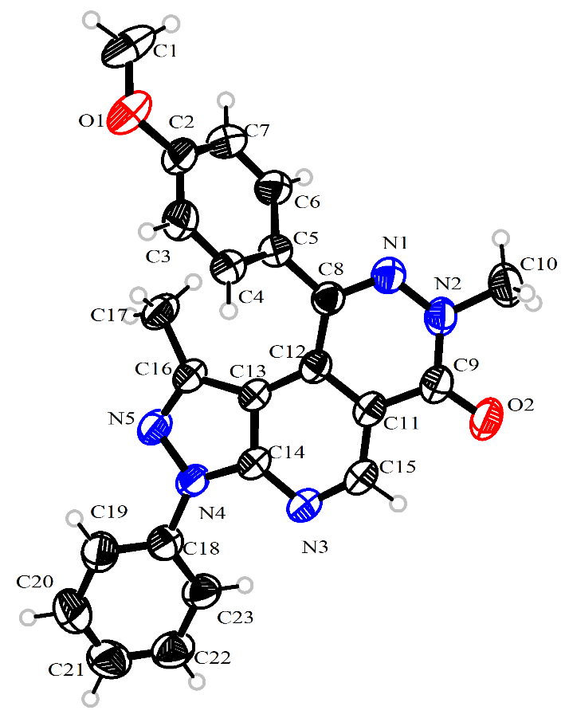
Figure 1. Molecular structure of 4e with 50% probability ellipsoids
Crystal Data for Compound 4e: CCDC 2344553 contains the supplementary crystallographic data for this paper. These data can be obtained free of charge from The Cambridge Crystallographic.
Sample preparation: In a 10 mL glass bottle, 15 mg of pure 4e was completely dissolved in the mixed solvent of 3 mL EtOAc, 1 mL EtOH, 1 mL CHCl₃; and then 2 mL of n-hexane was added slowly. After a week of solvent evaporation, some colorless transparent crystals were obtained. The crystals were mounted on a glass fiber for diffraction experiments. Intensity data were collected on a Bruker SMART APEX CCD diffractometer with Mo Kα radiation (0.71073 Å) at room temperature.
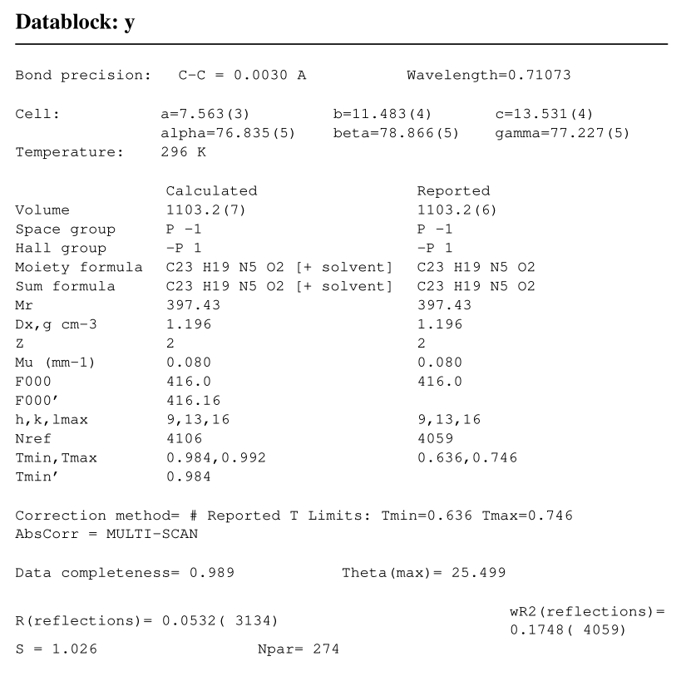

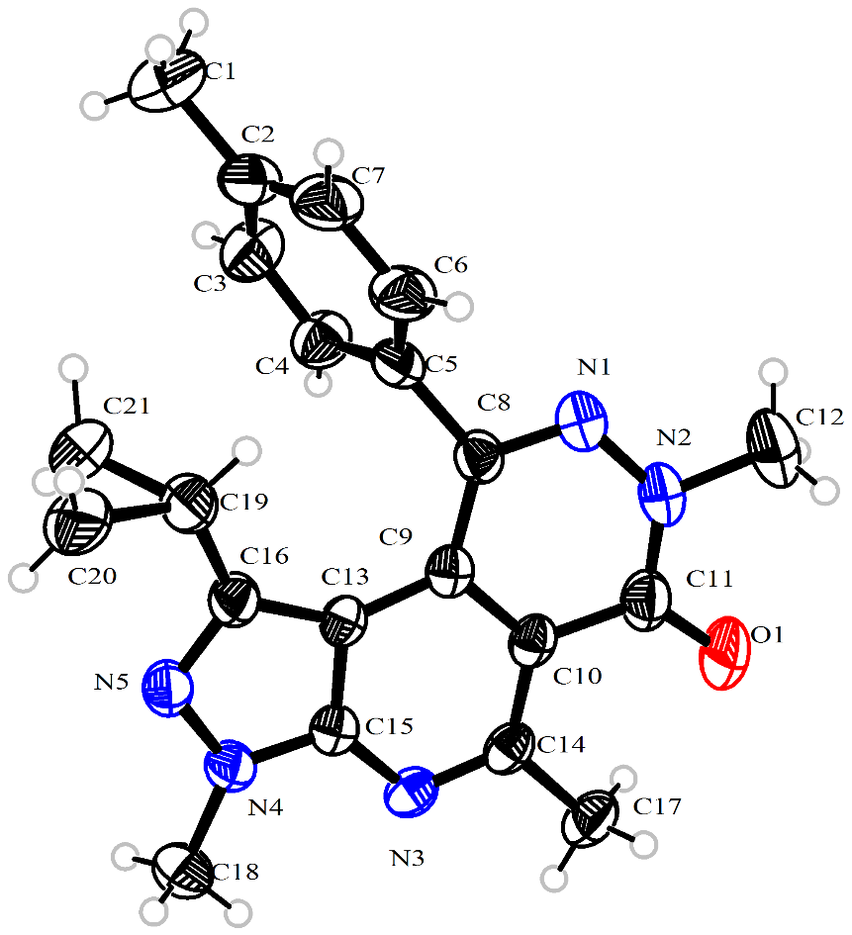
Figure 2. Molecular structure of 6p with 50% probability ellipsoids
Crystal Data for Compound 6p: CCDC 2344669 contains the supplementary crystallographic data for this paper. These data can be obtained free of charge from The Cambridge Crystallographic.
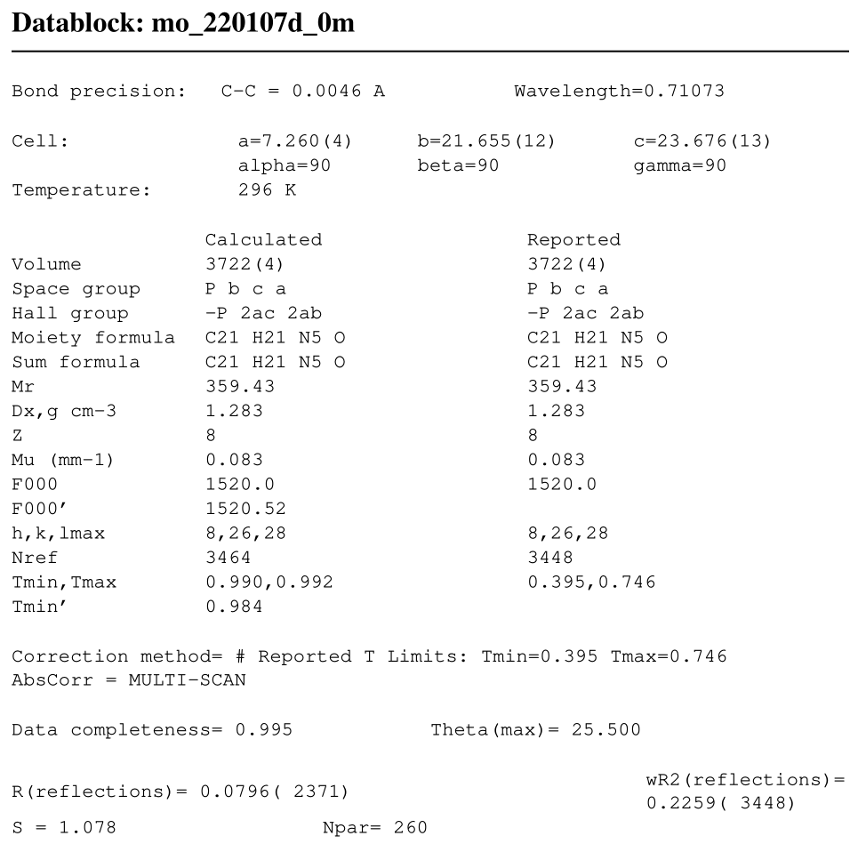
8.¹H, ¹³C and ¹⁹F NMR spectra of compounds
4a
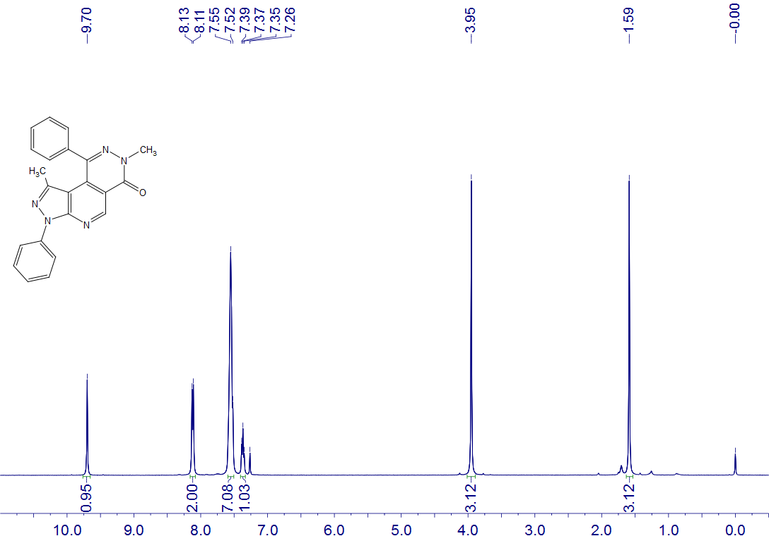
4a
CDCl₃
400 MHz

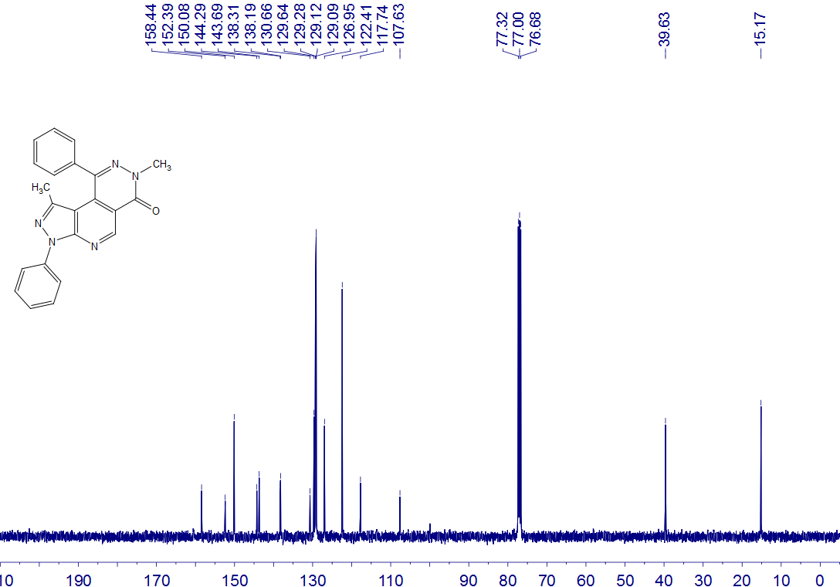
4a
CDCl₃
100 MHz

4b
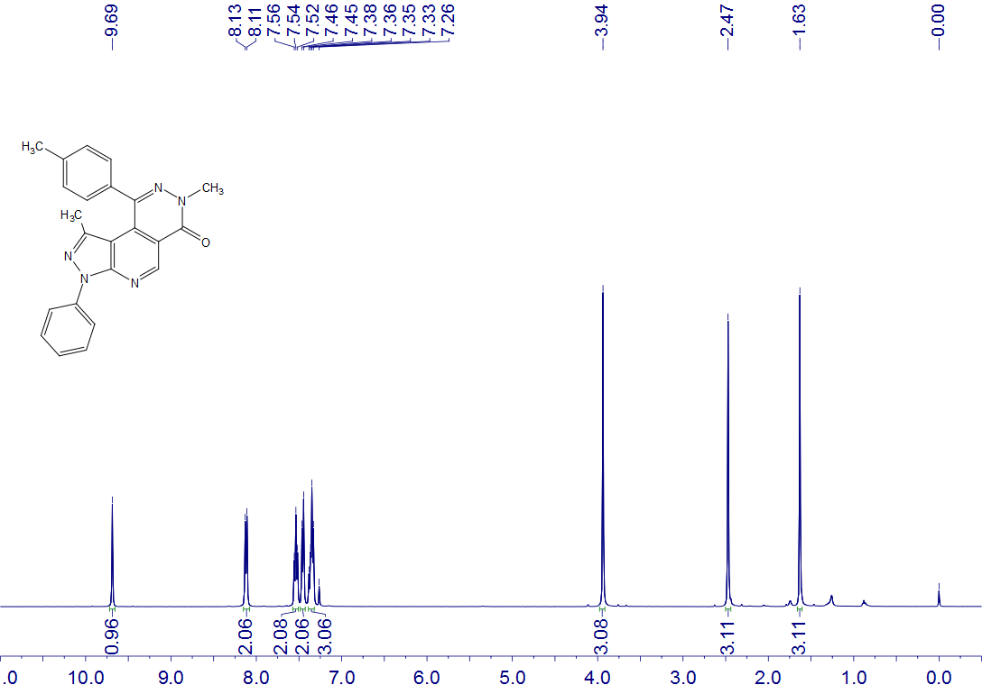
4b
CDCl₃
400 MHz

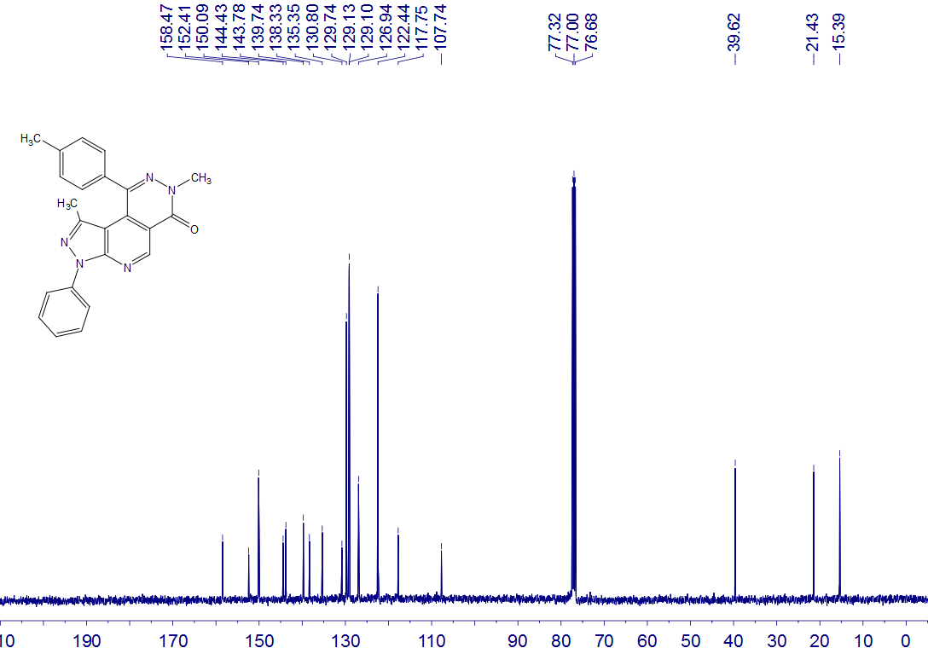
4b
CDCl₃
100 MHz

4c
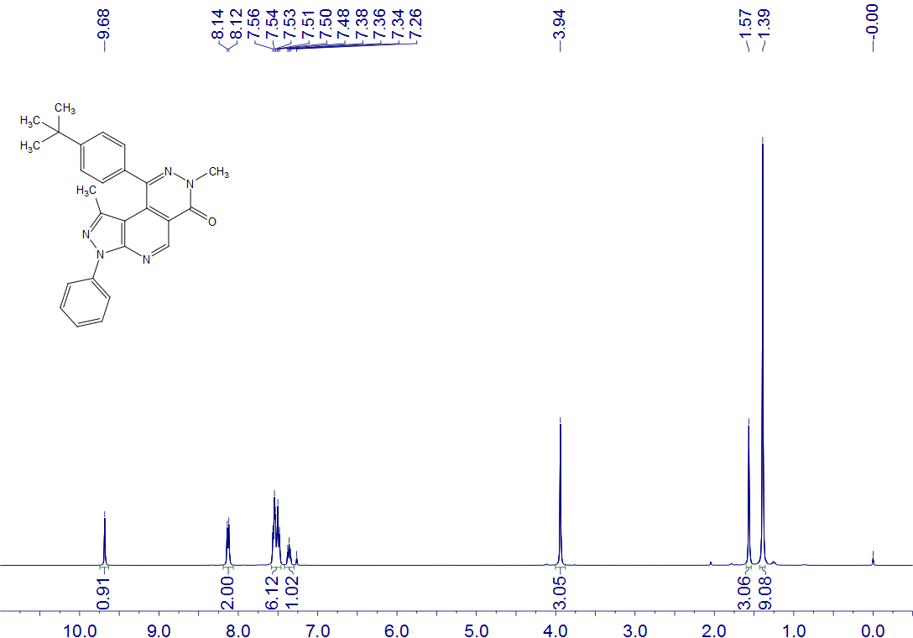
4c
CDCl₃
400 MHz

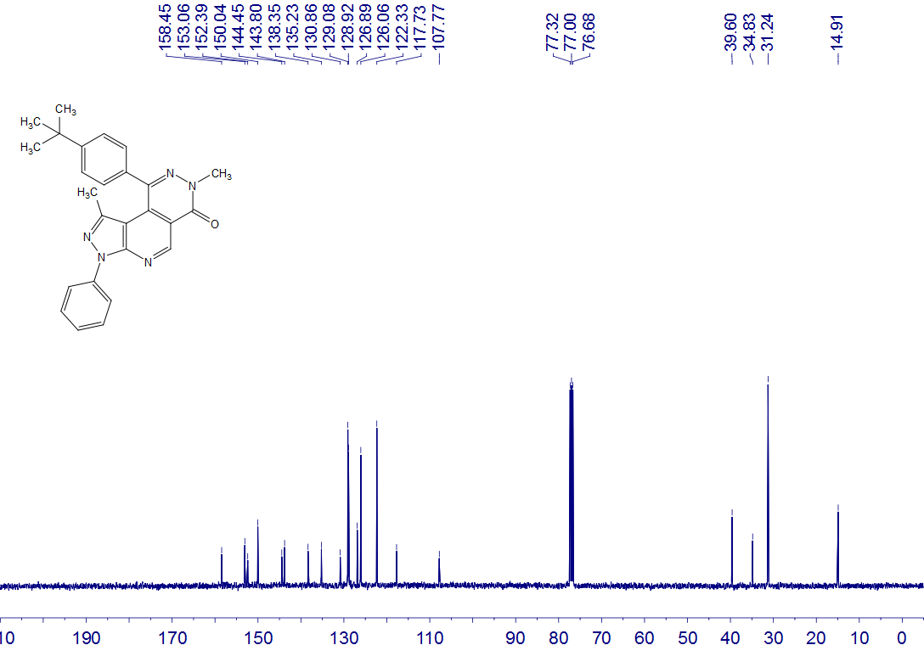
4c
CDCl₃
100 MHz

4d
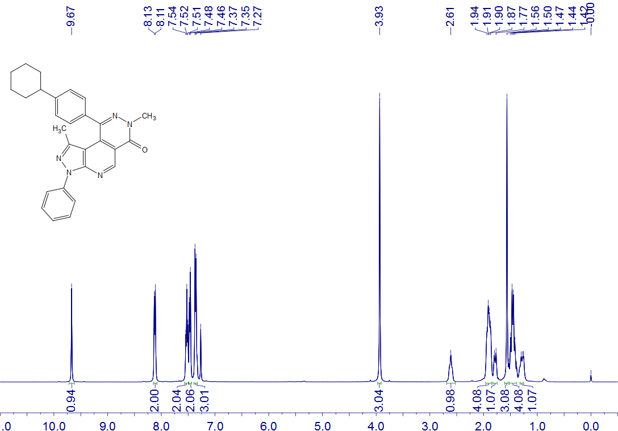
4d
CDCl₃
400 MHz

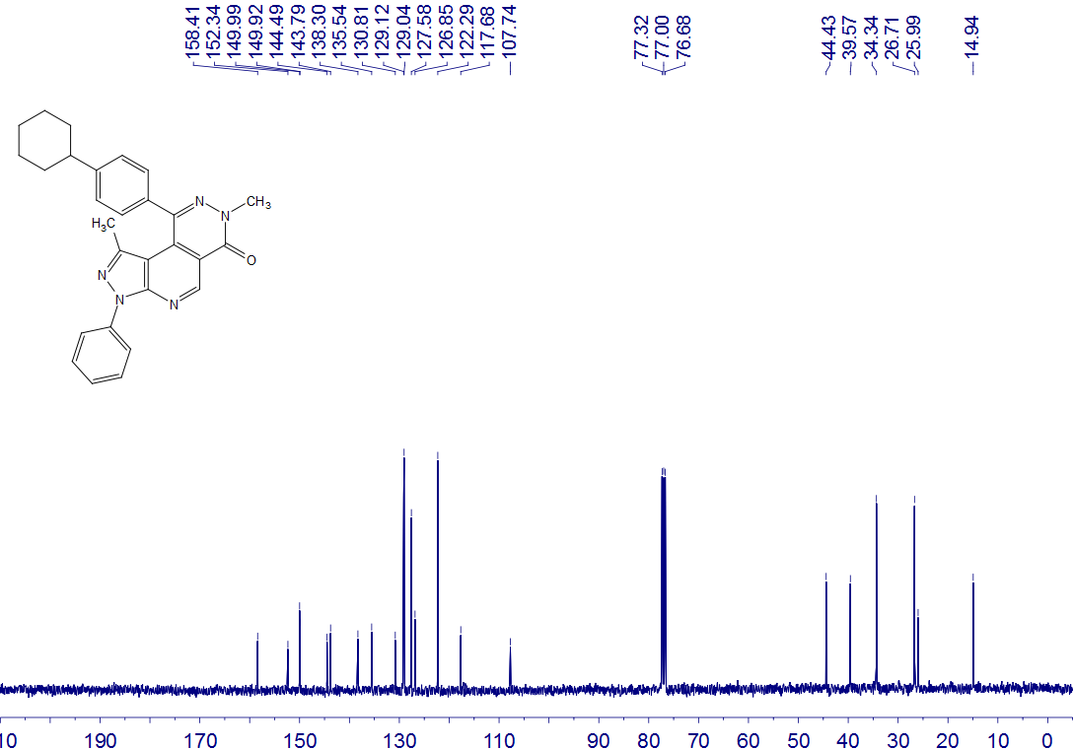
4d
CDCl₃
100 MHz

4e
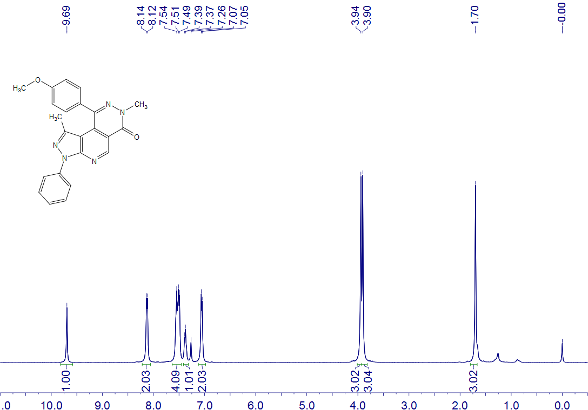
4e
CDCl₃
400 MHz

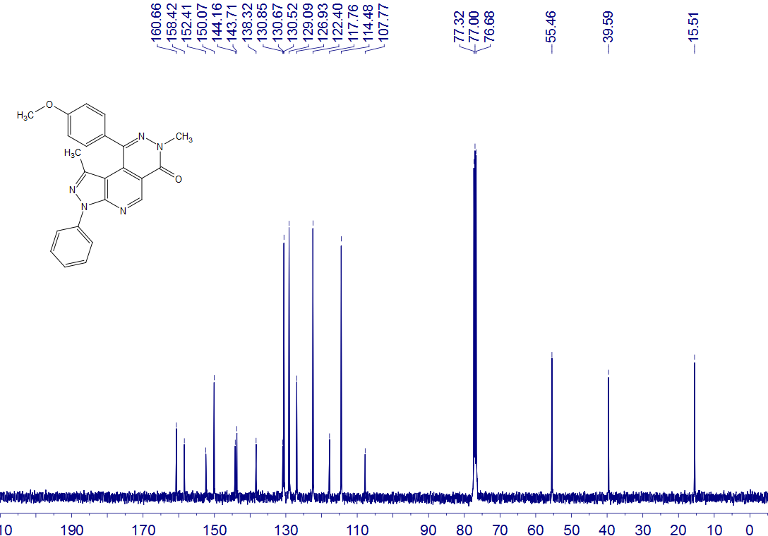
4e
CDCl₃
100 MHz

4f
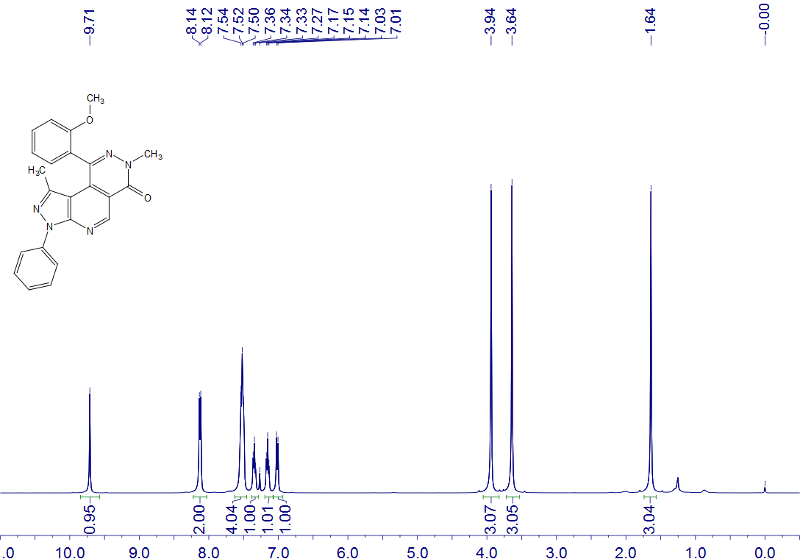
4f
CDCl₃
400 MHz

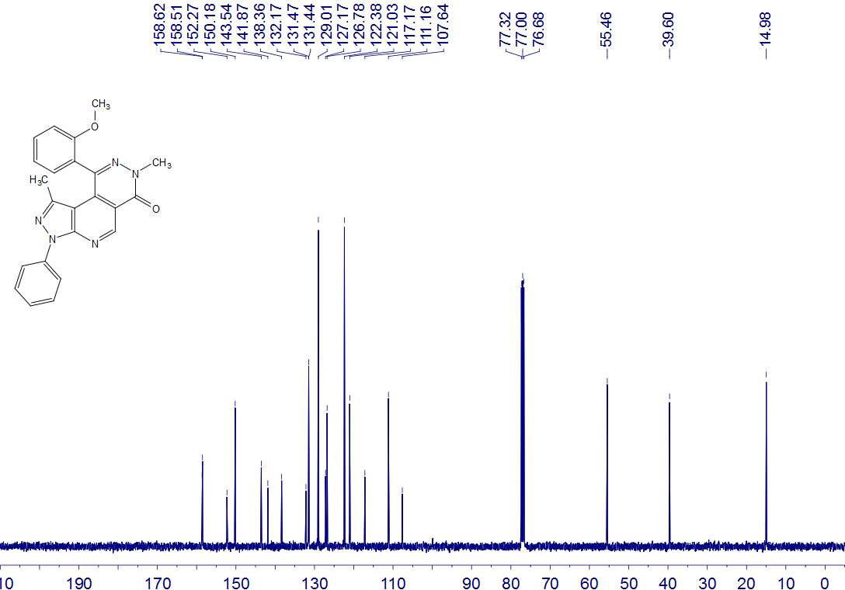
4f
CDCl₃
100 MHz

4g
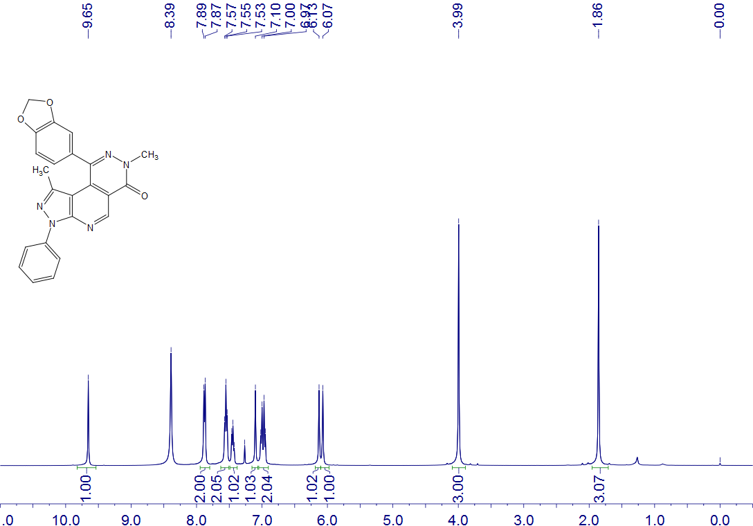
4g
CDCl₃
400 MHz

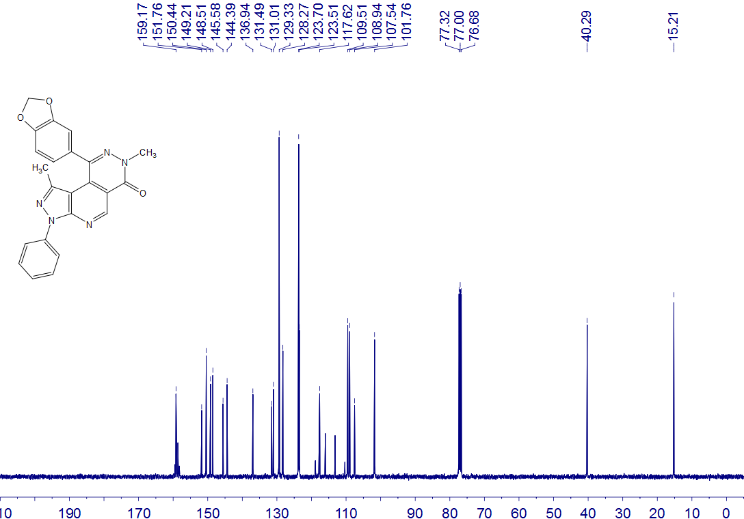
4g
CDCl₃
100 MHz

4h
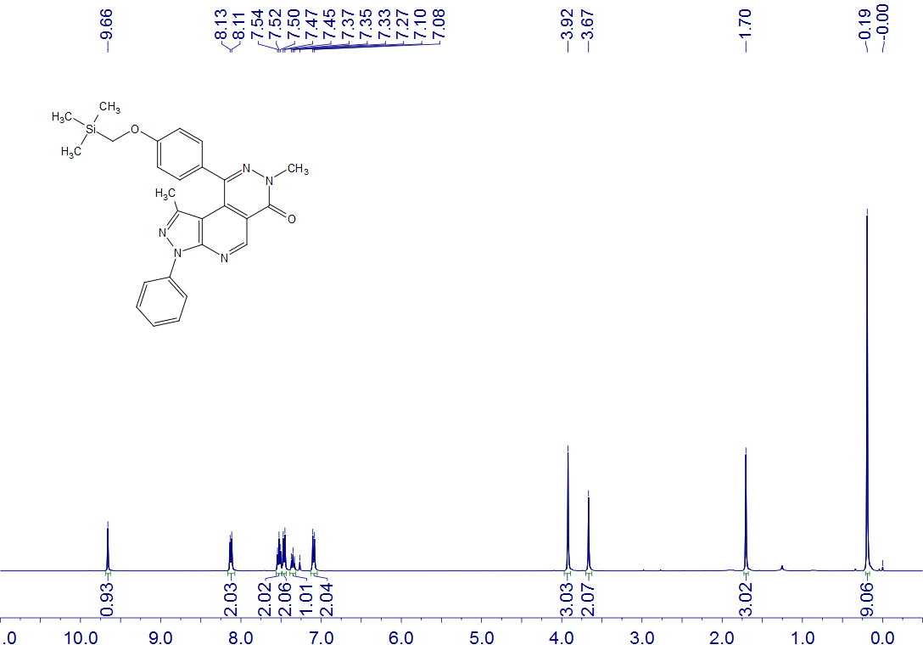
4h
CDCl₃
400 MHz

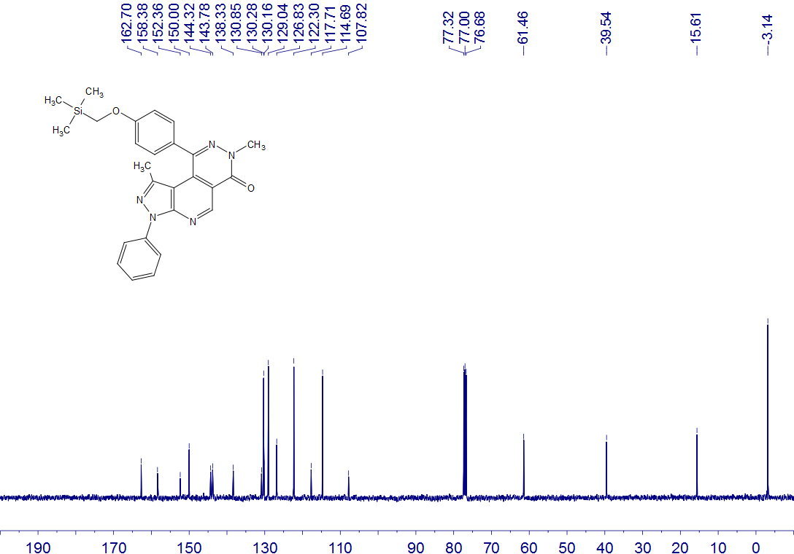
4h
CDCl₃
100 MHz

4i
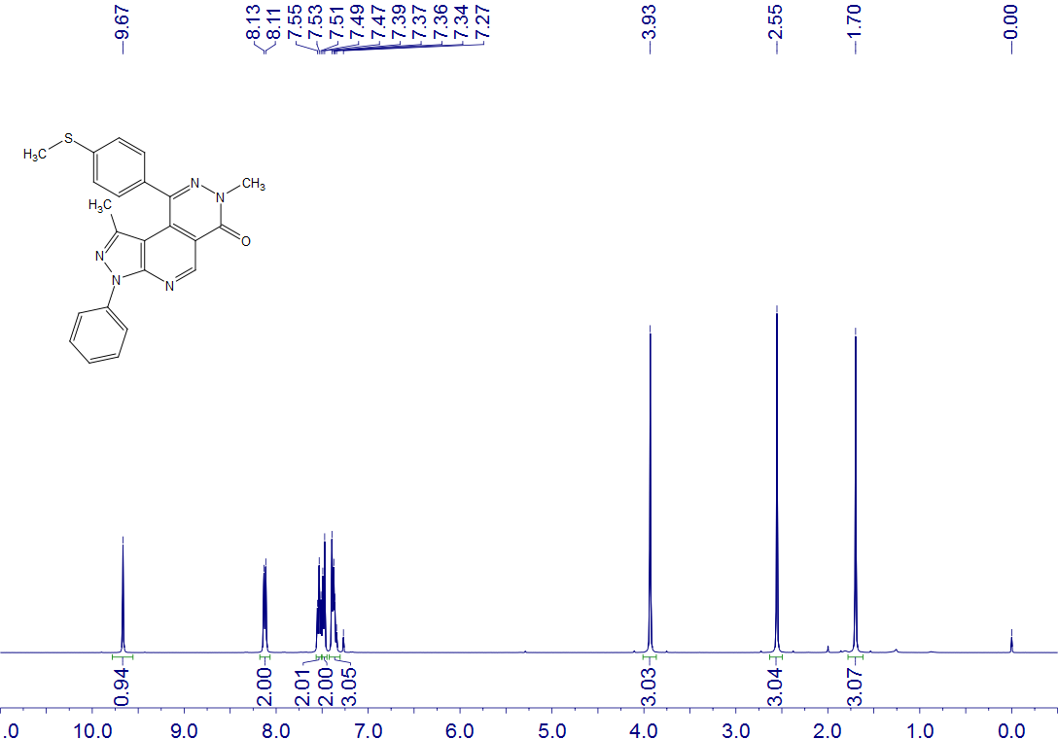
4i
CDCl₃
400 MHz

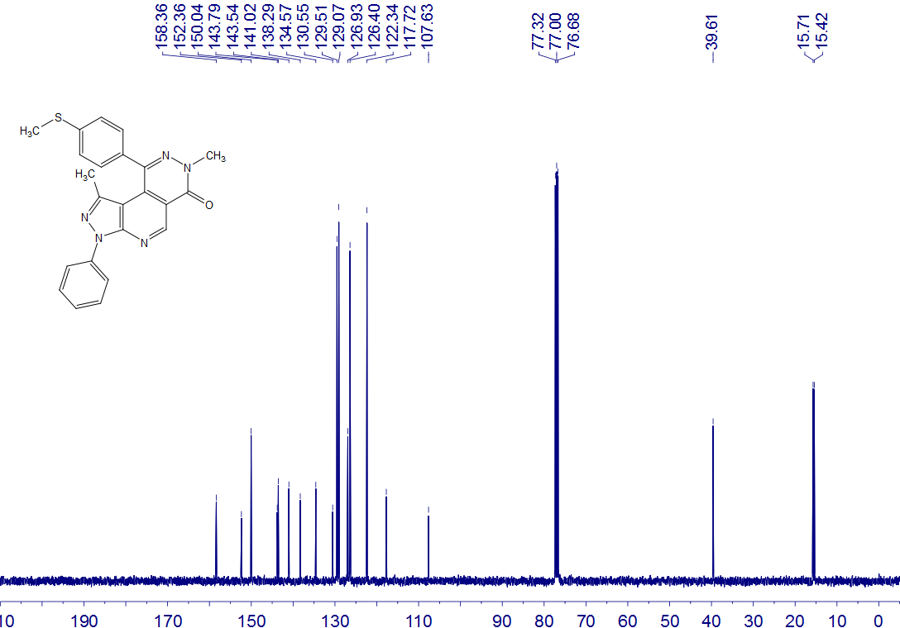
4i
CDCl₃
100 MHz

4j
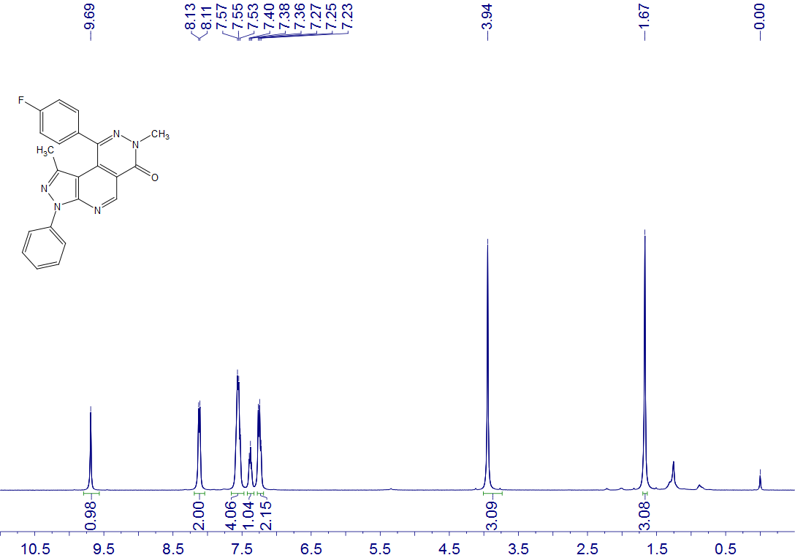
4j
CDCl₃
400 MHz

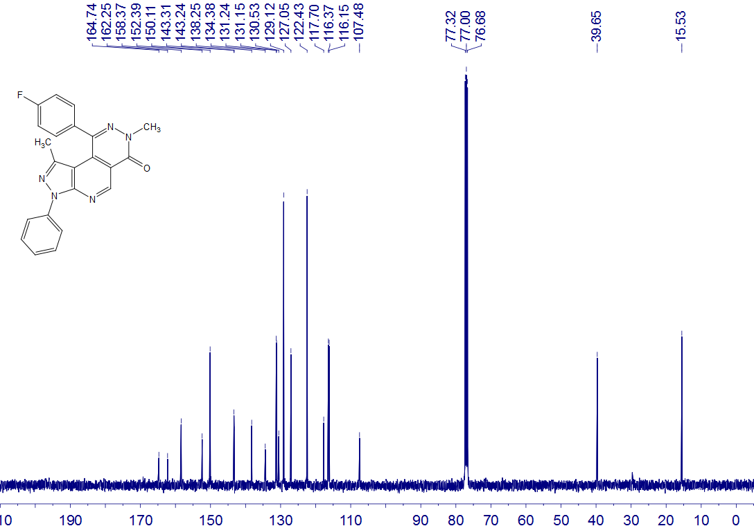
4j
CDCl₃
100 MHz

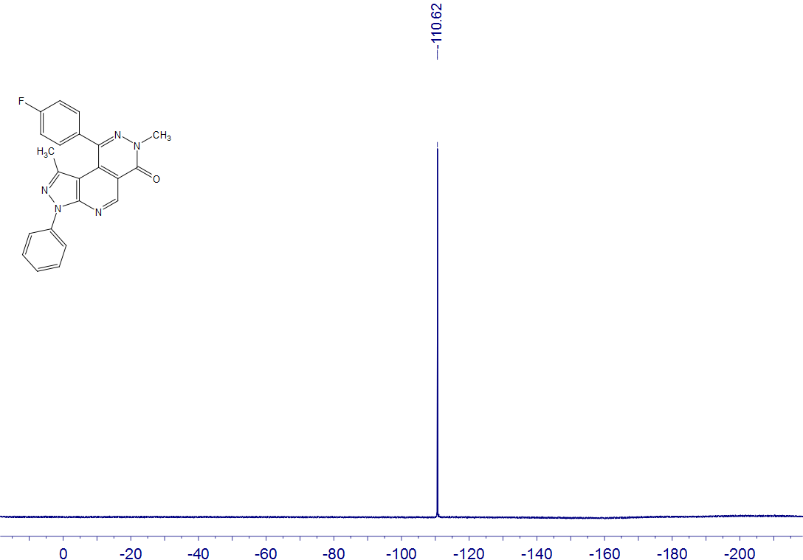
4j
CDCl₃
376 MHz

4k
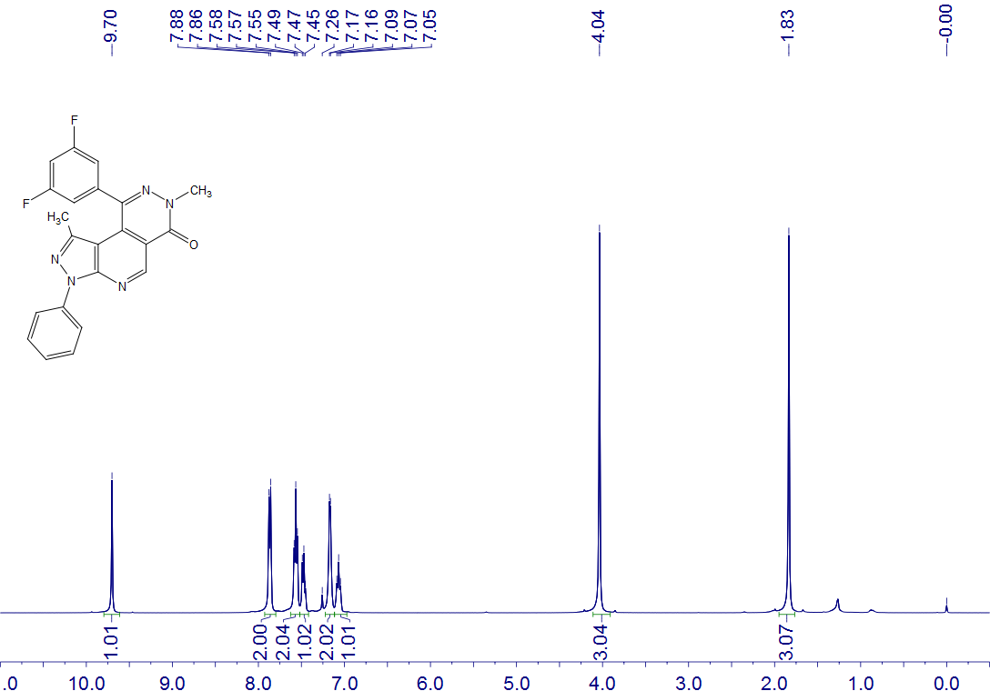
4k
CDCl₃, CF₃CO₂D
400 MHz

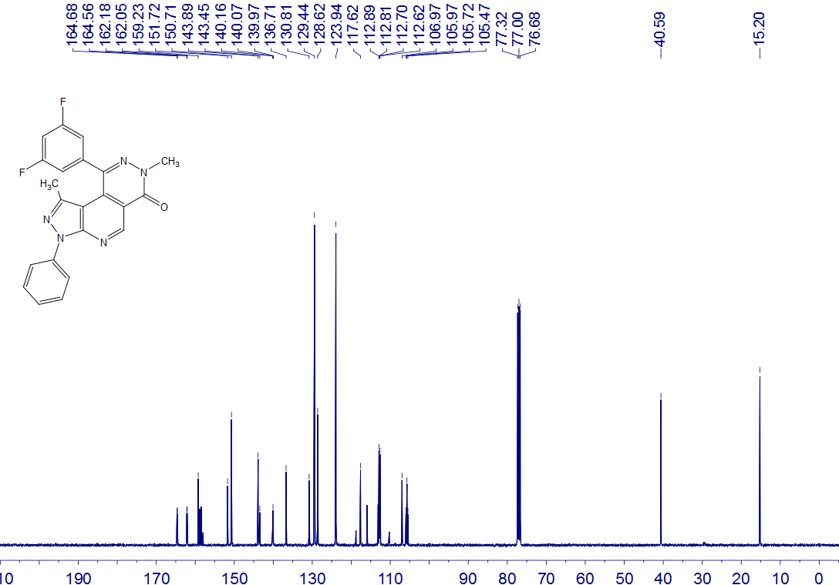
4k
CDCl₃, CF₃CO₂D
100 MHz

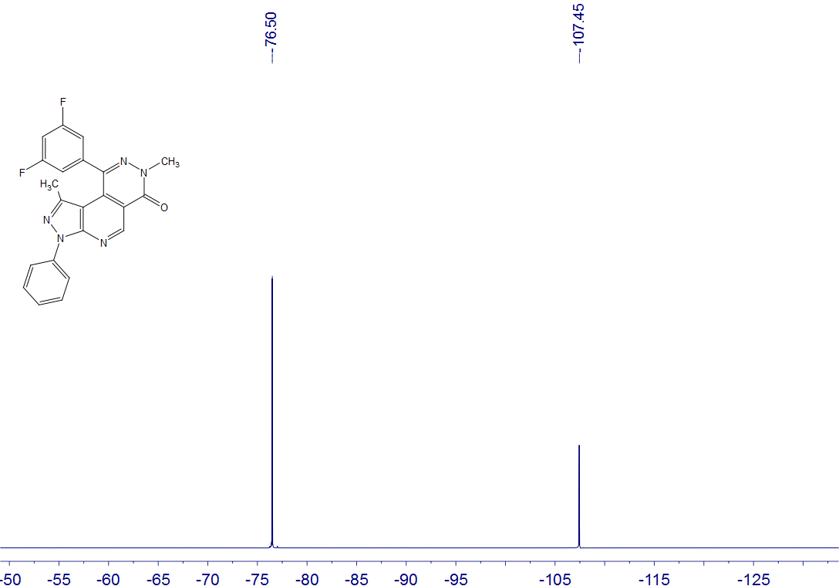
4k
CDCl₃, CF₃CO₂D
376 MHz

4l
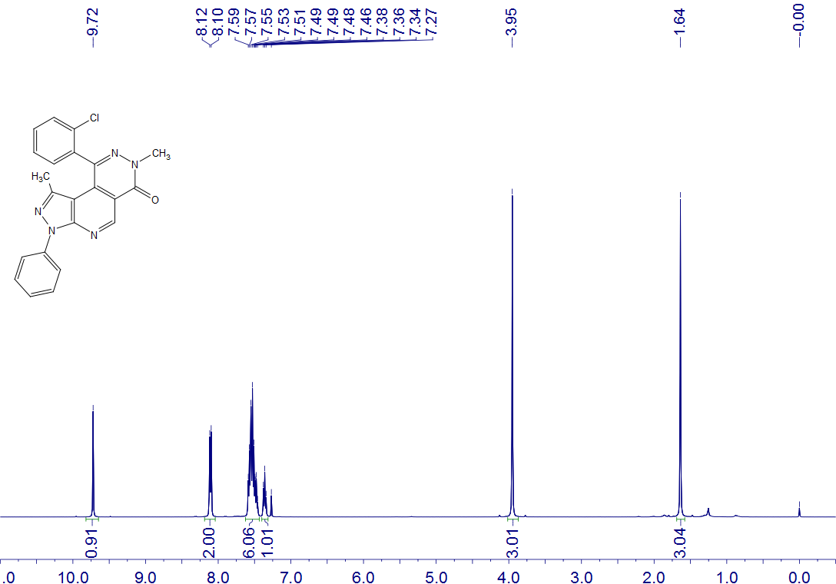
4l
CDCl₃
400 MHz

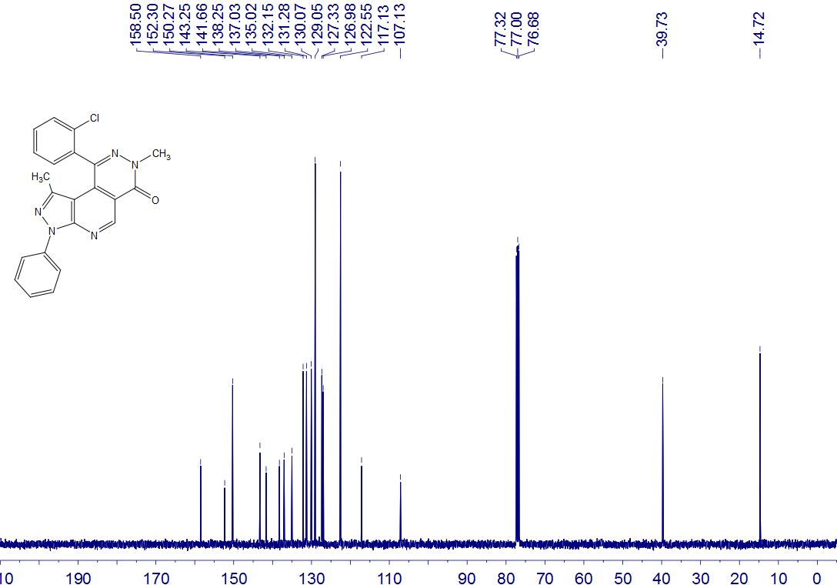
4l
CDCl₃
100 MHz

4m
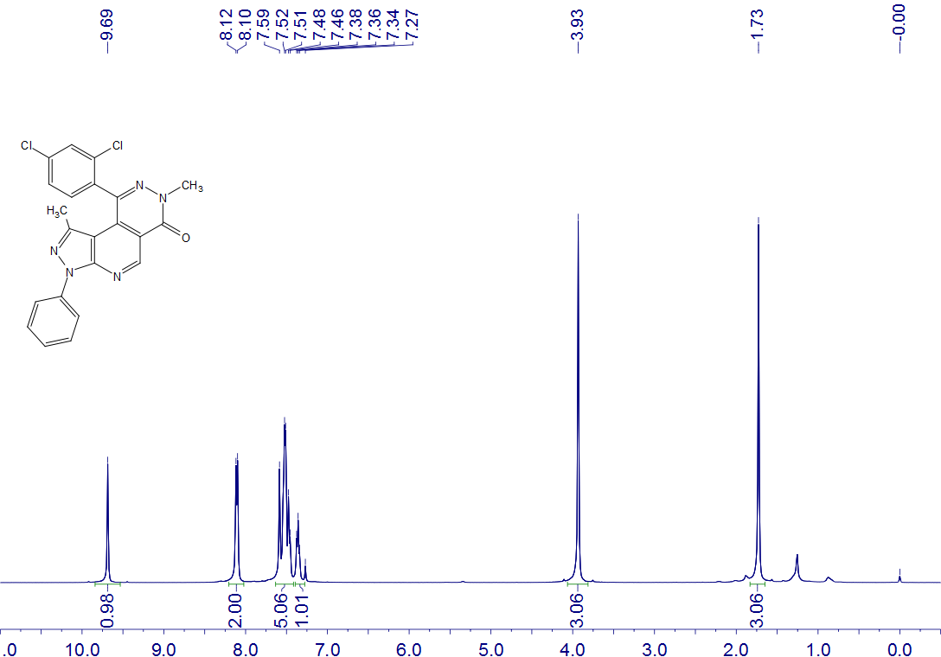
4m
CDCl₃
400 MHz

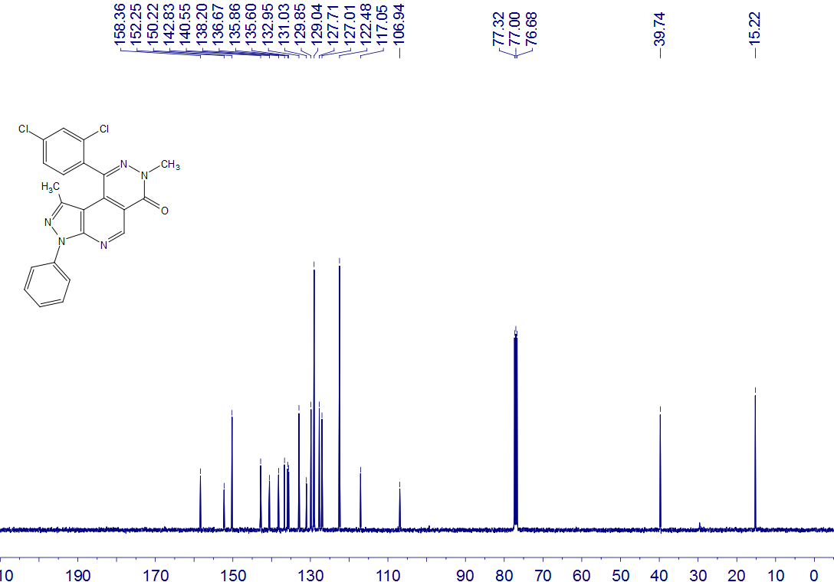
4m
CDCl₃
100 MHz

4n
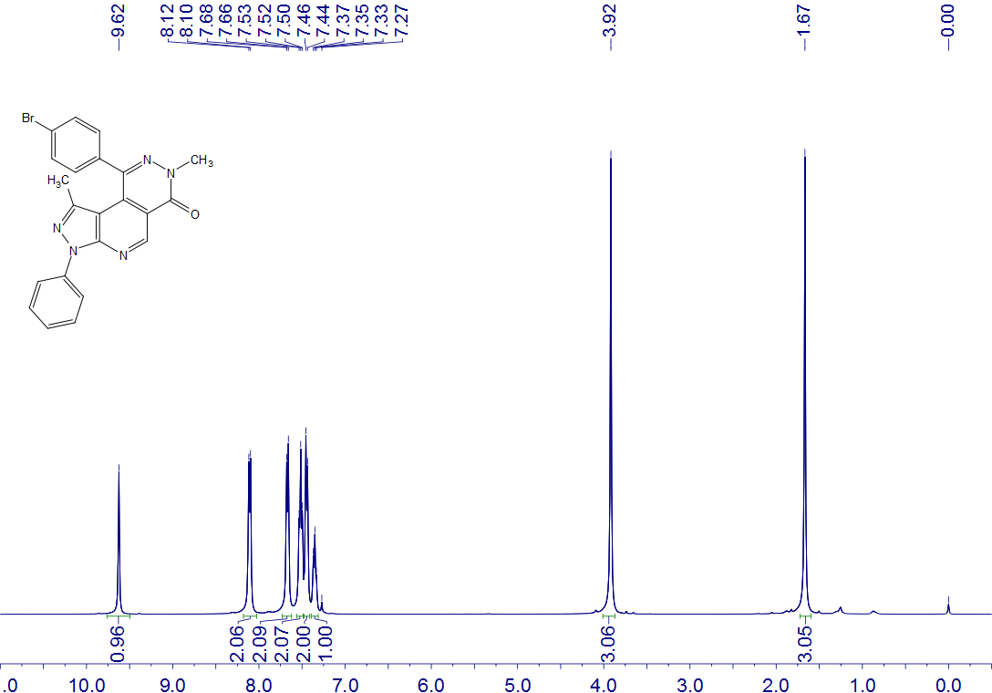
4n
CDCl₃
400 MHz

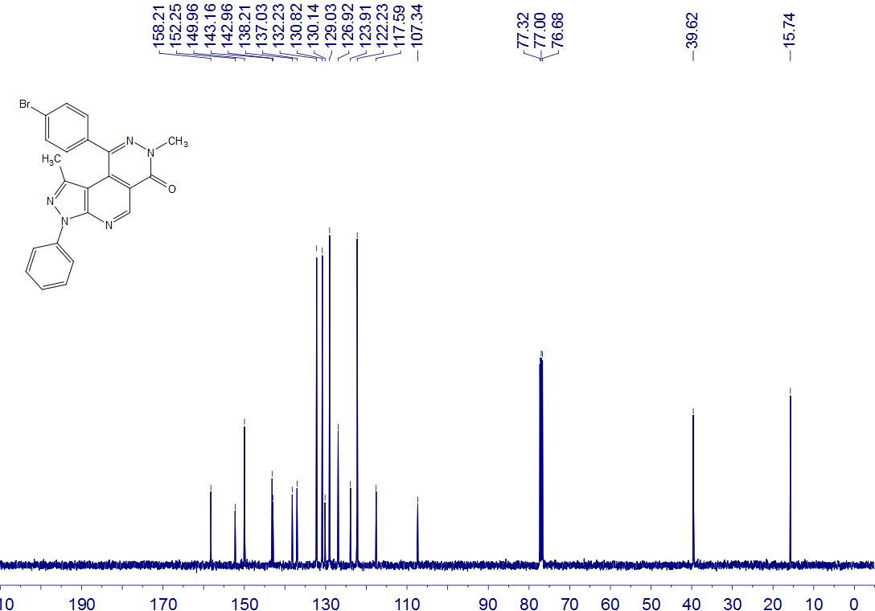
4n
CDCl₃
100 MHz

4o
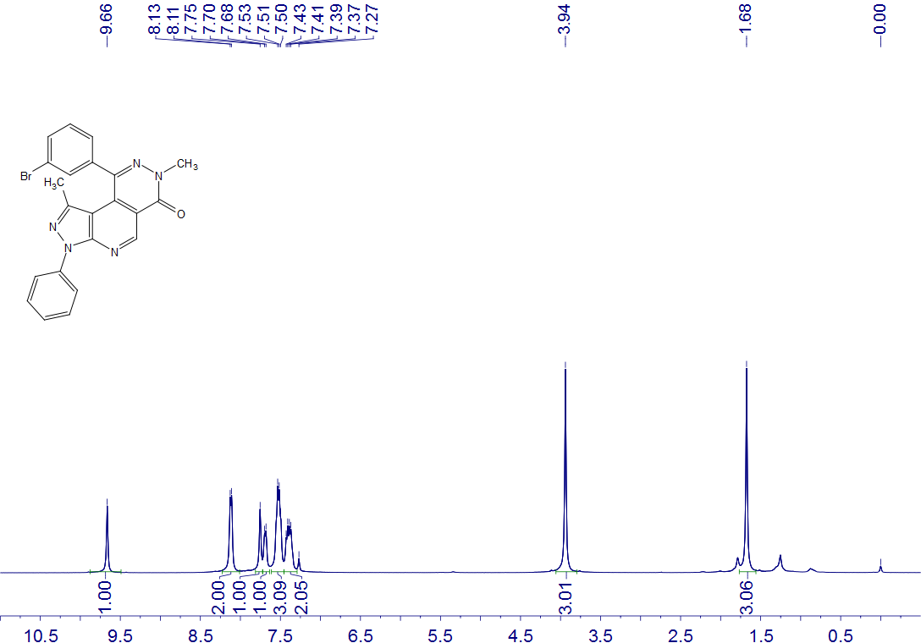
4o
CDCl₃
400 MHz

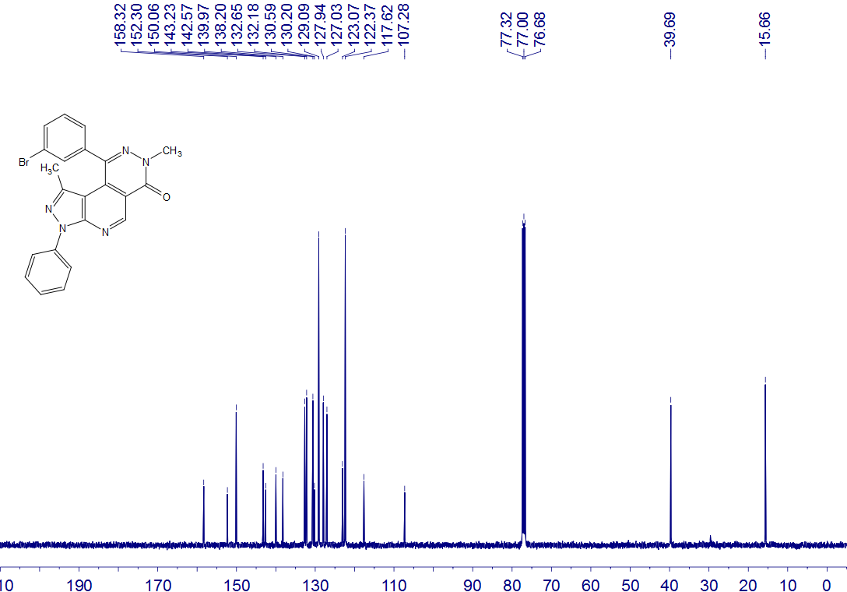
4o
CDCl₃
100 MHz

4p
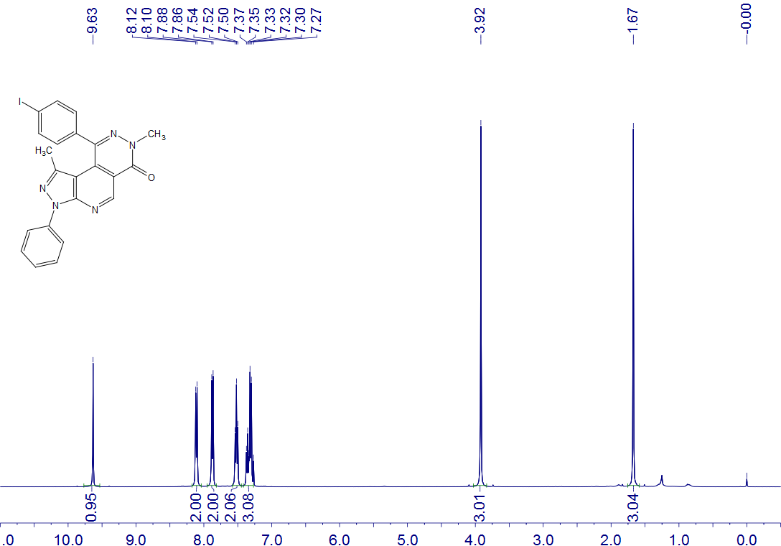
4p
CDCl₃
400 MHz

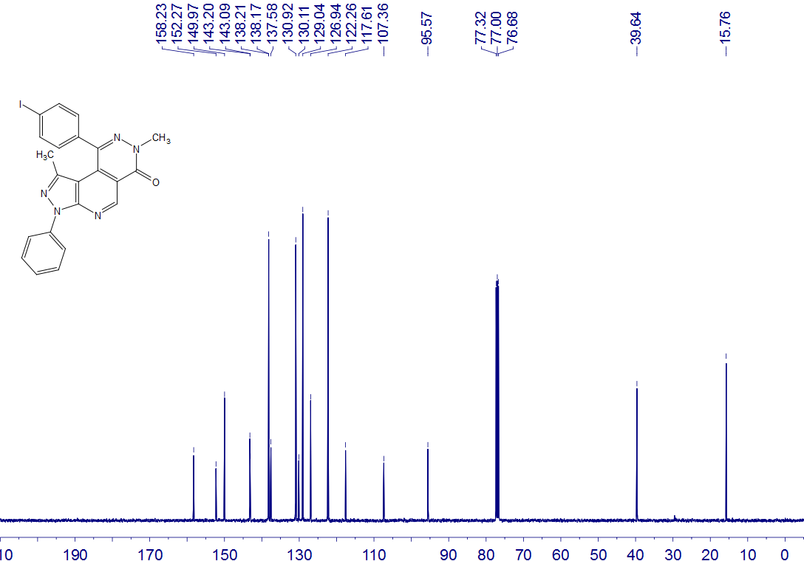
4p
CDCl₃
100 MHz

4q
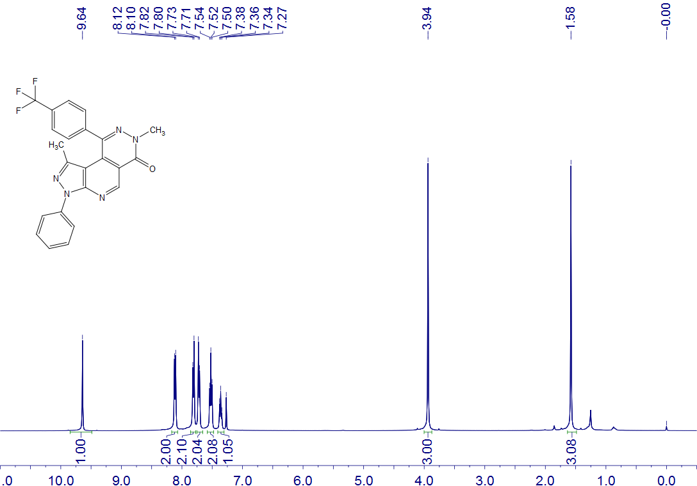
4q
CDCl₃
400 MHz

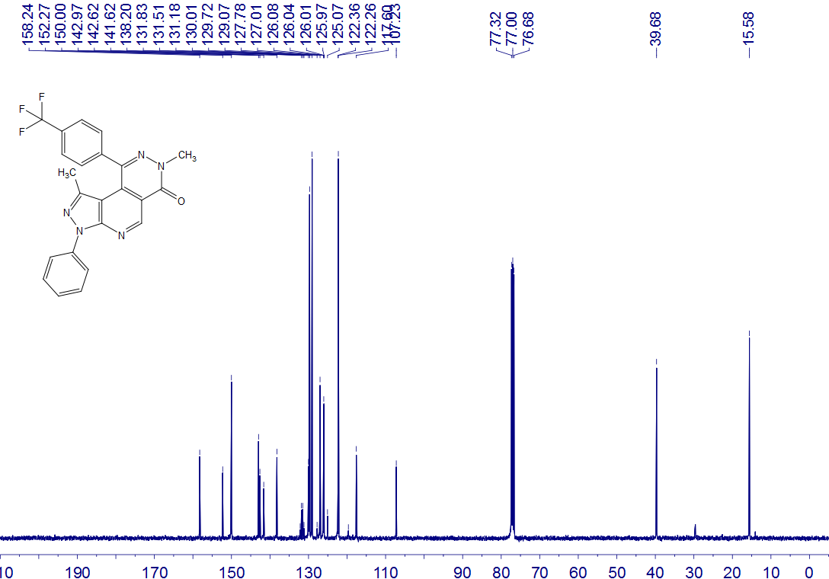
4q
CDCl₃
100 MHz

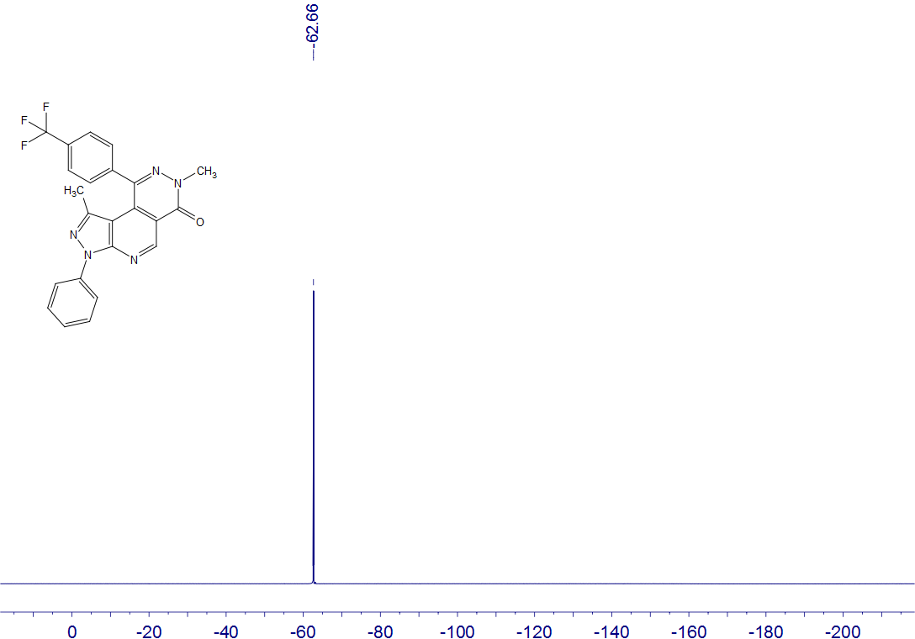
4q
CDCl₃
376 MHz

4r
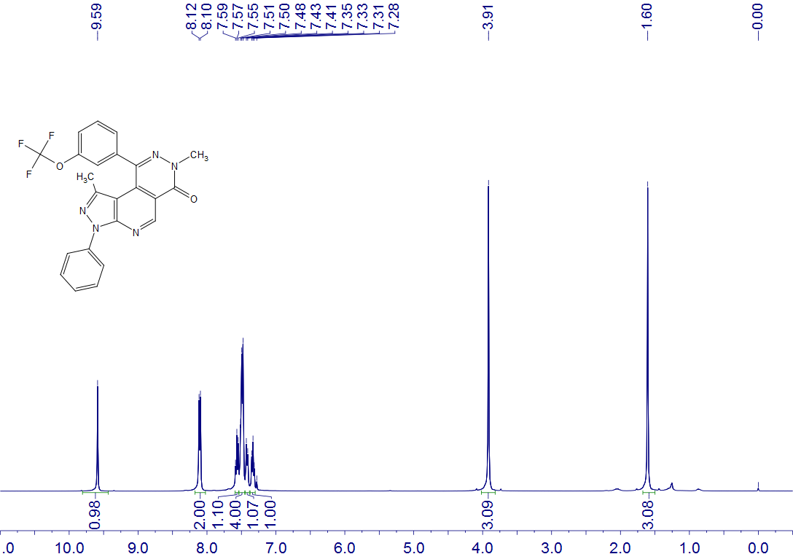
4r
CDCl₃
400 MHz

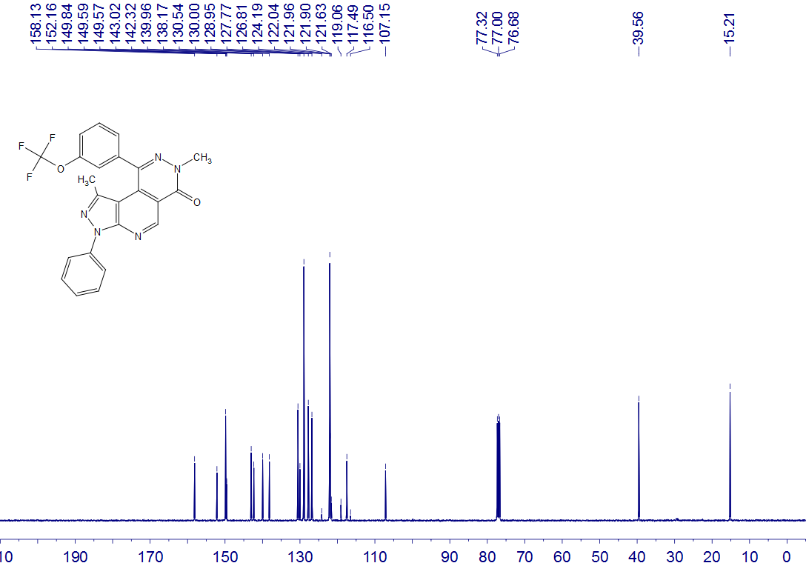
4r
CDCl₃
100 MHz

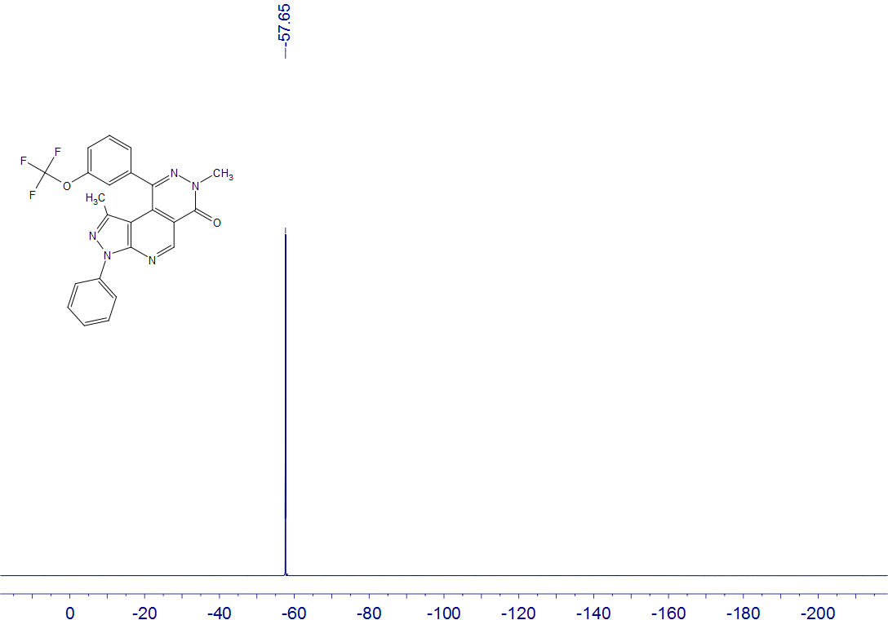
4r
CDCl₃
376 MHz

4s
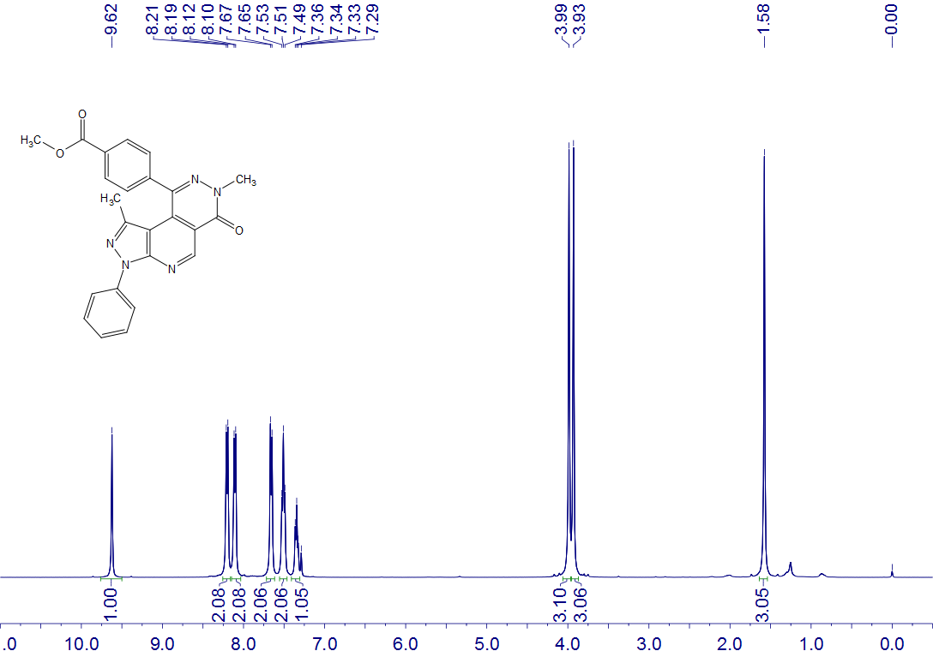
4s
CDCl₃
400 MHz

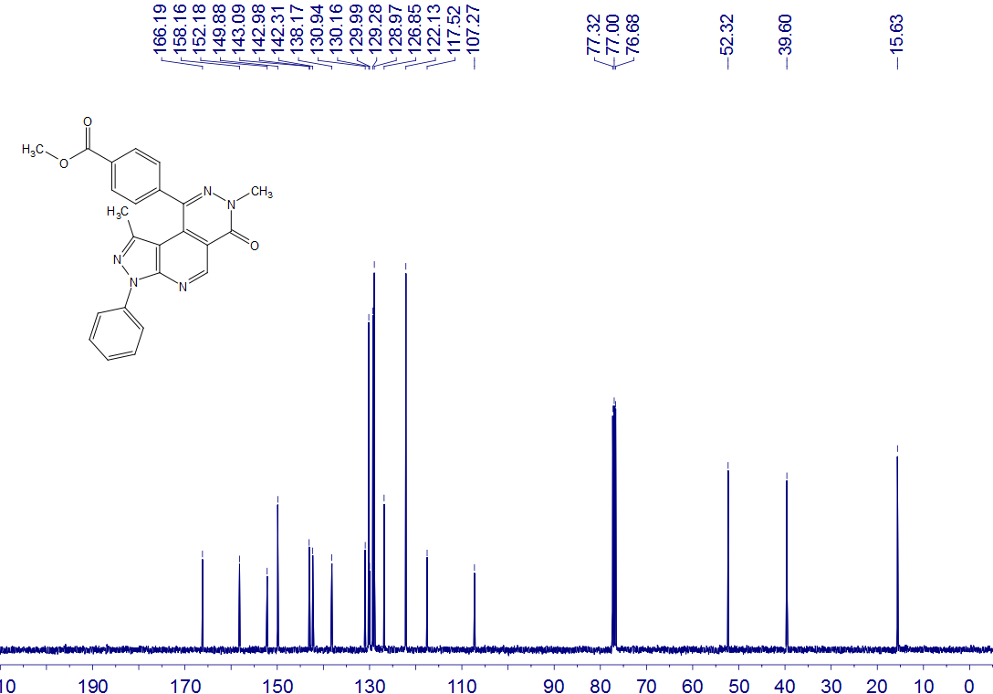
4s
CDCl₃
100 MHz

4t
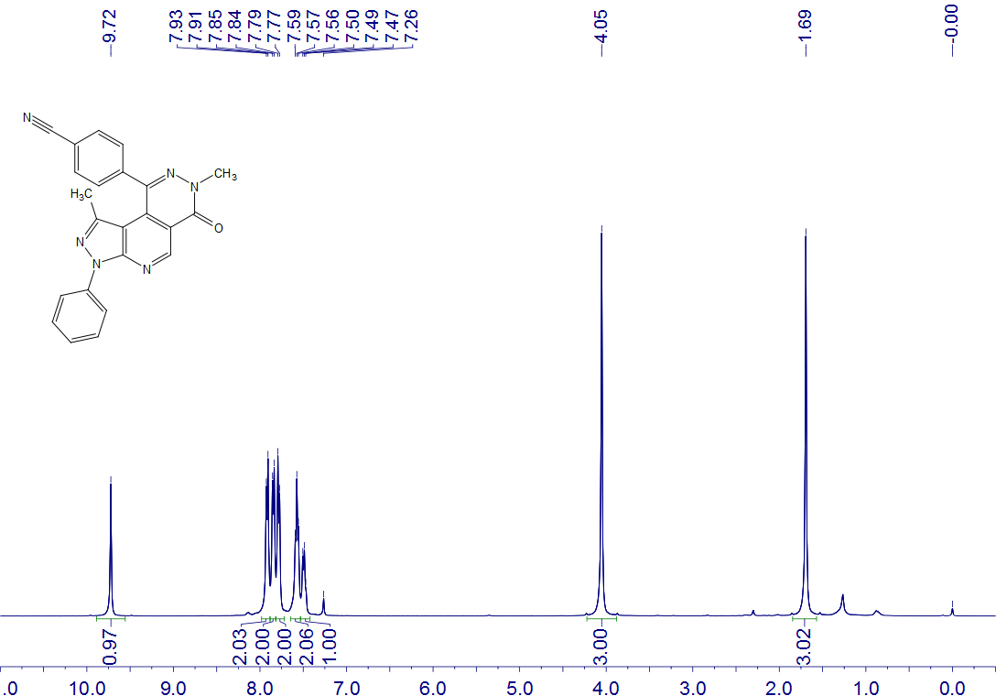
4t
CDCl₃, CF₃CO₂D
400 MHz

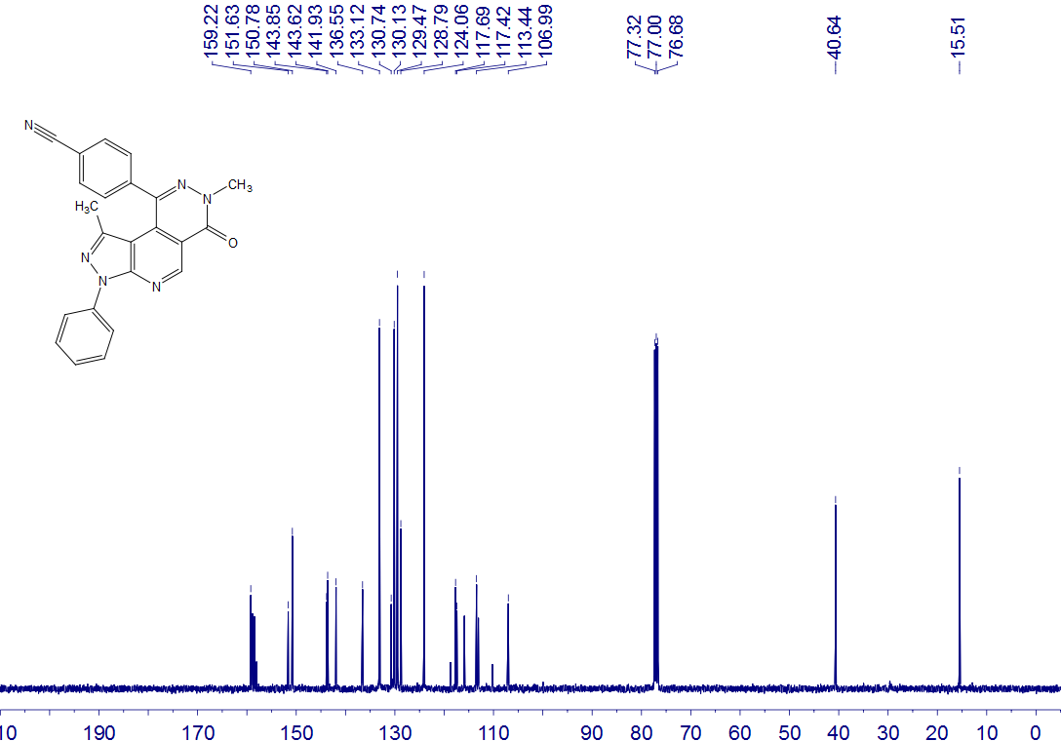
4t
CDCl₃, CF₃CO₂D
100 MHz

4u
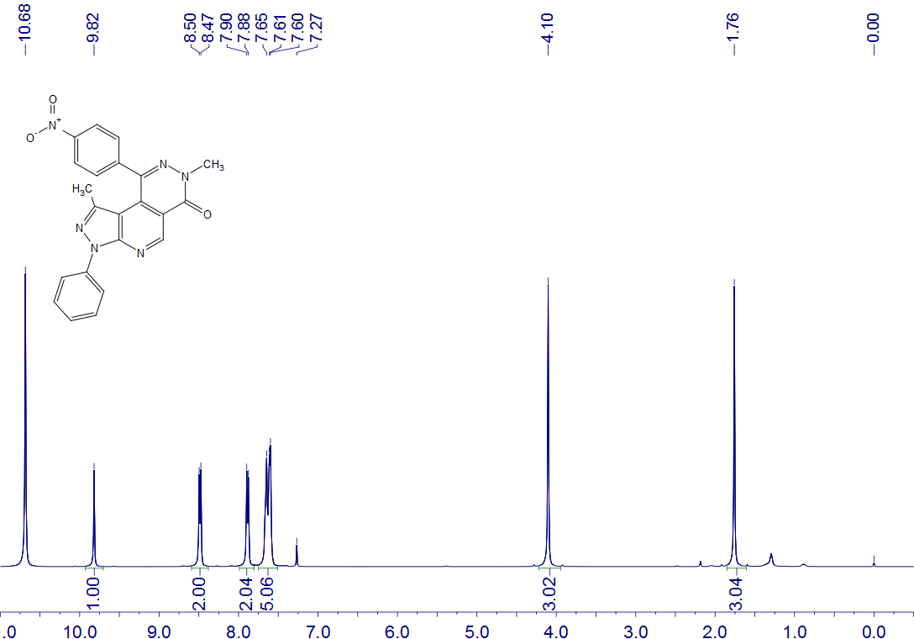
4u
CDCl₃, CF₃CO₂D
400 MHz

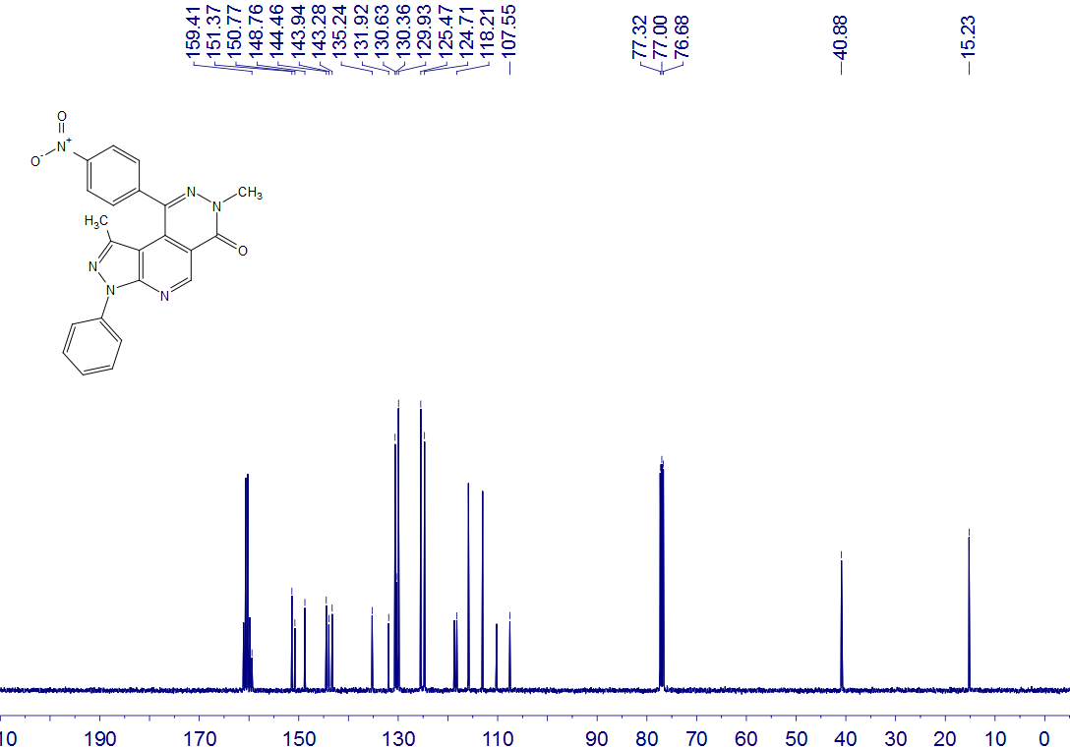
4u
CDCl₃, CF₃CO₂D
100 MHz

4v
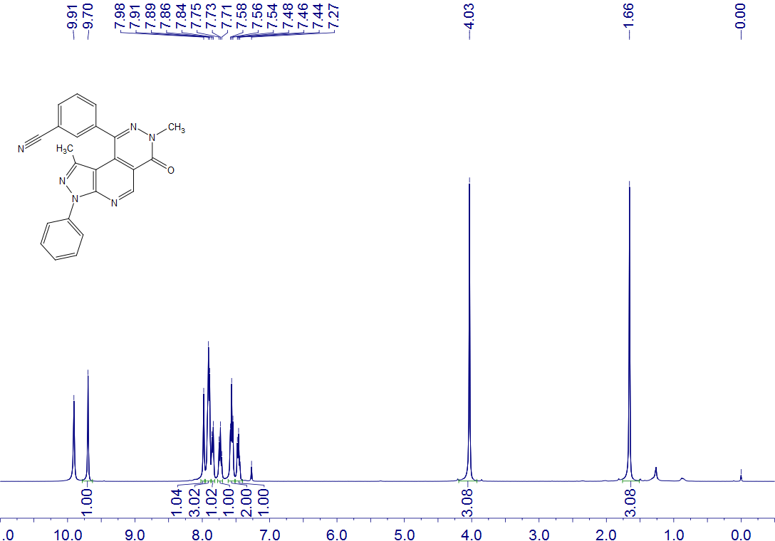
4v
CDCl₃, CF₃CO₂D
400 MHz

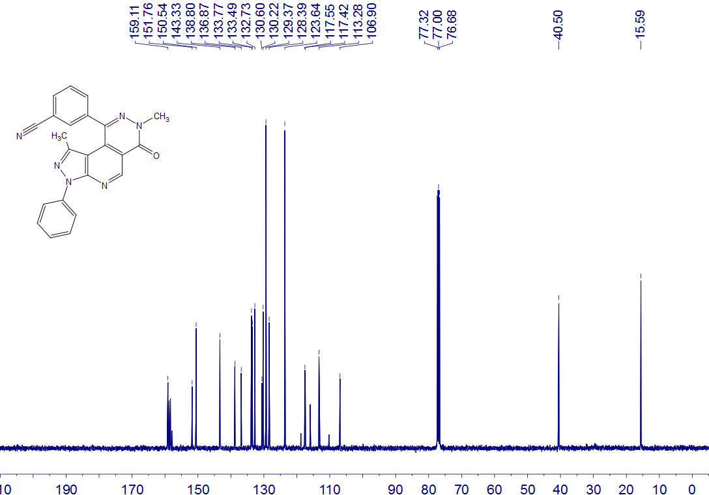
4v
CDCl₃, CF₃CO₂D
100 MHz

4w
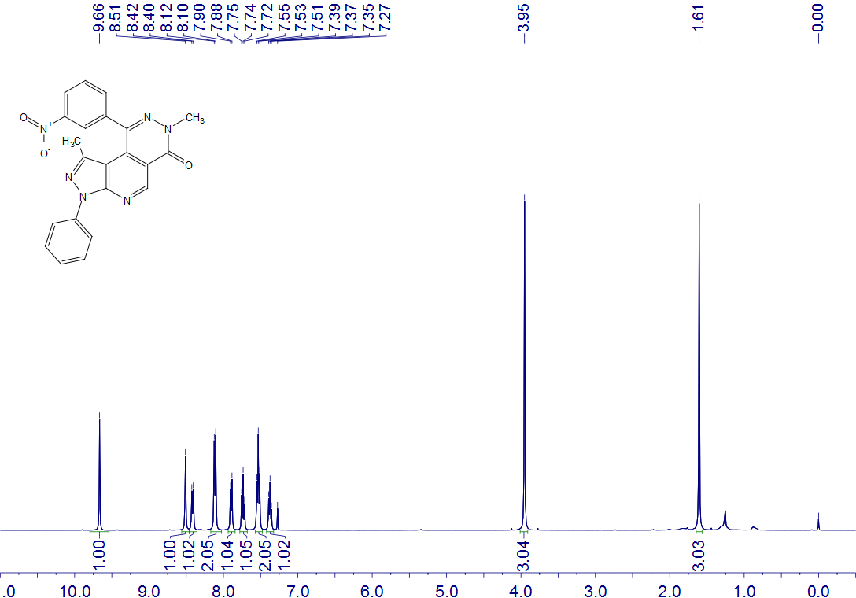
4w
CDCl₃
400 MHz

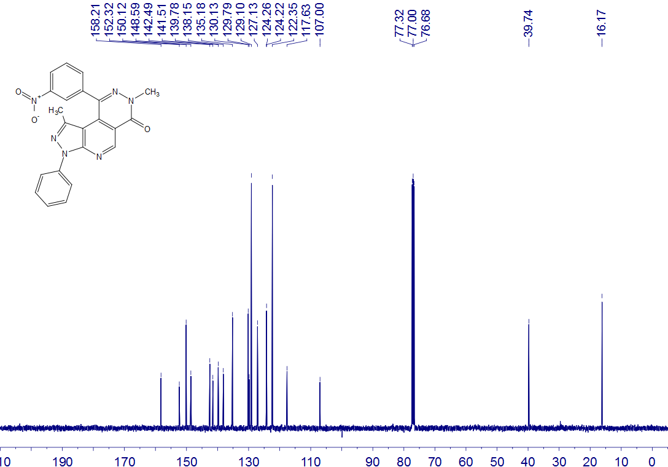
4w
CDCl₃
100 MHz

4x
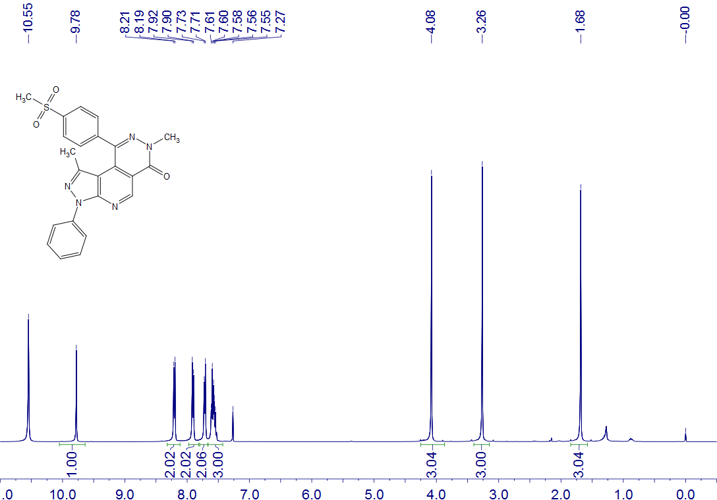
4x
CDCl₃, CF₃CO₂D
400 MHz

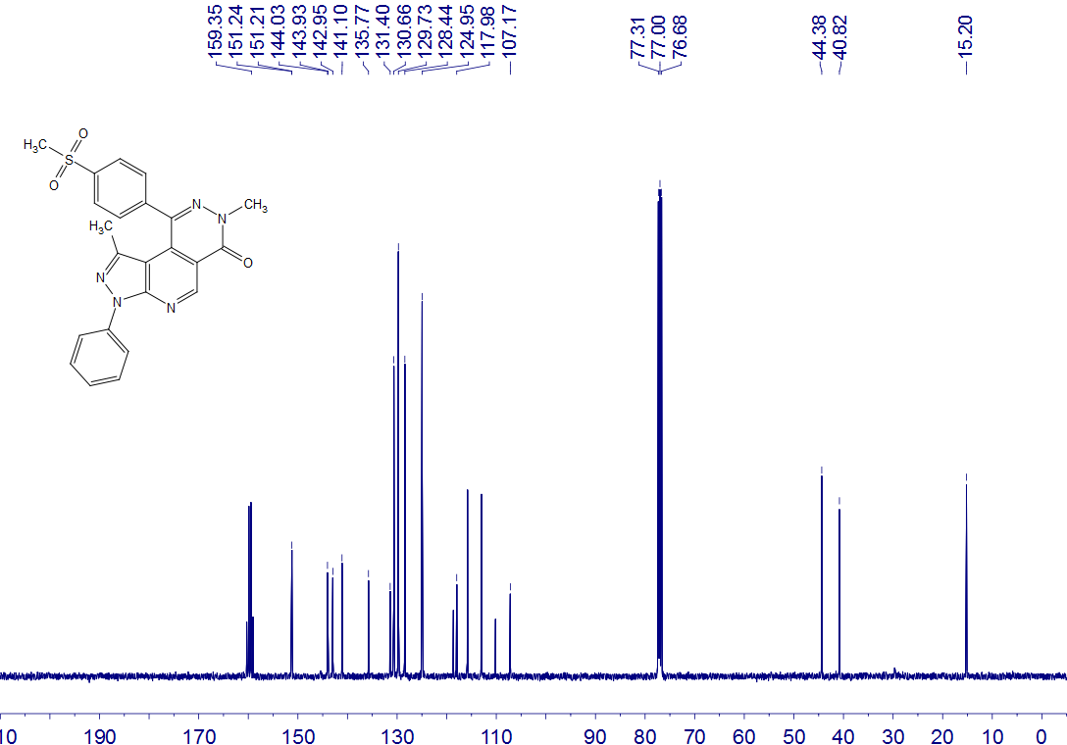
4x
CDCl₃, CF₃CO₂D
100 MHz

4y
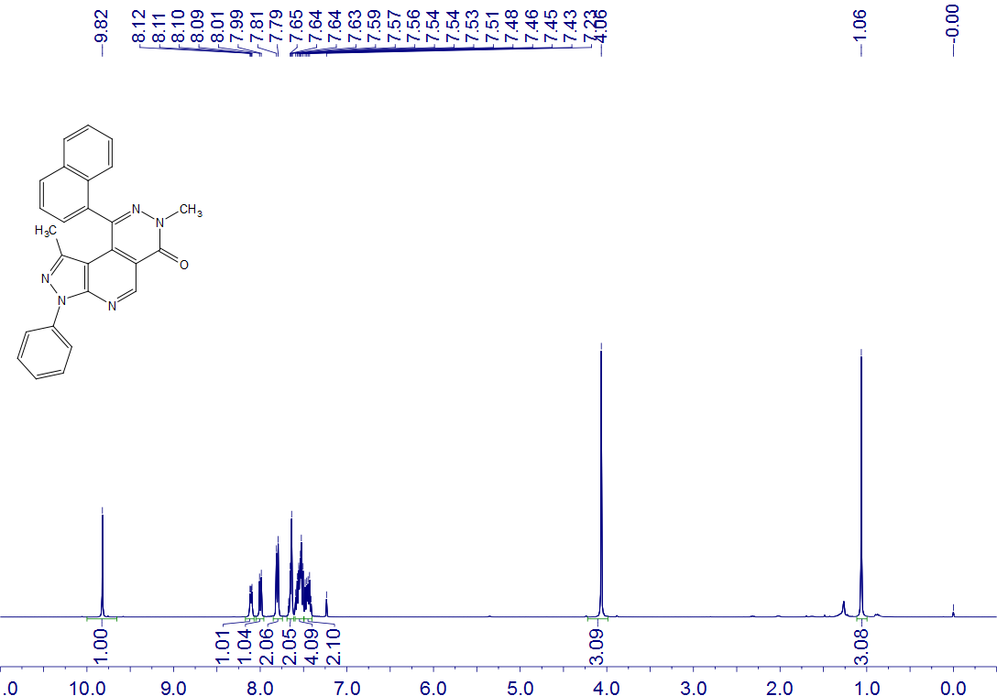
4y
CDCl₃, CF₃CO₂D
400 MHz

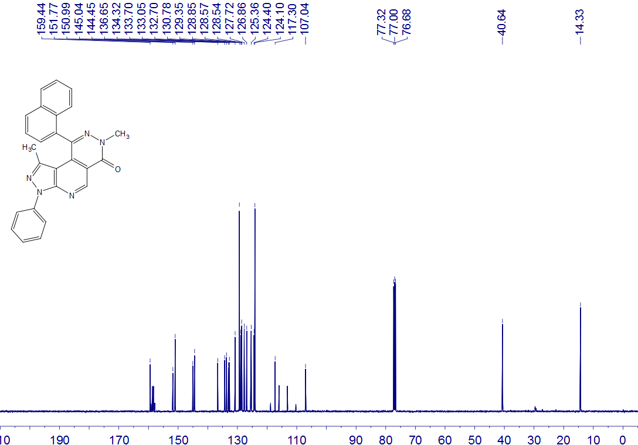
4y
CDCl₃, CF₃CO₂D
100 MHz

4z
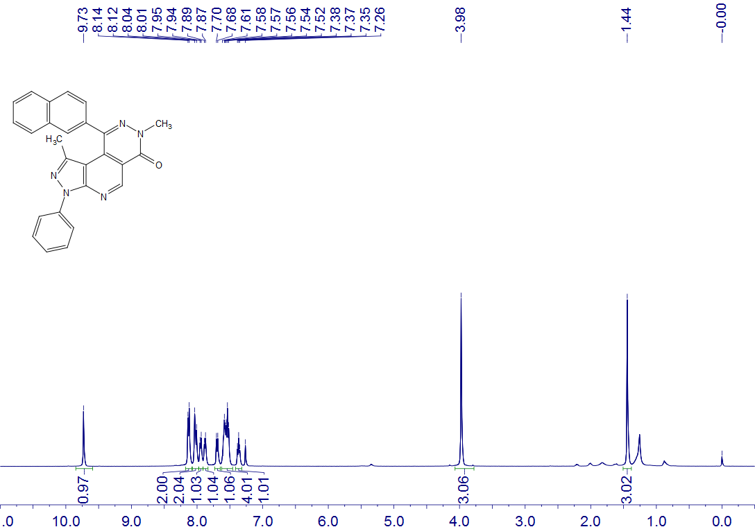
4z
CDCl₃
400 MHz

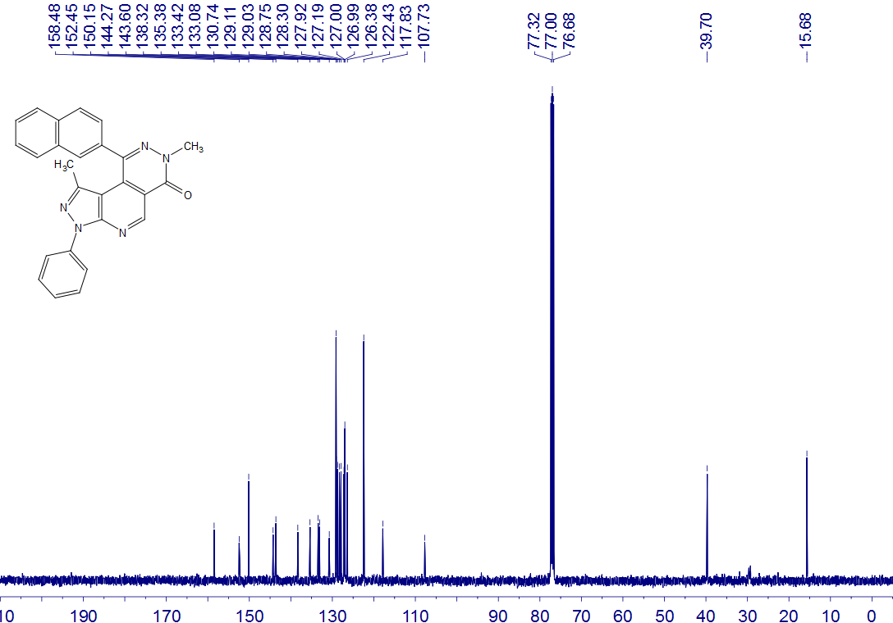
4z
CDCl₃
100 MHz

5a
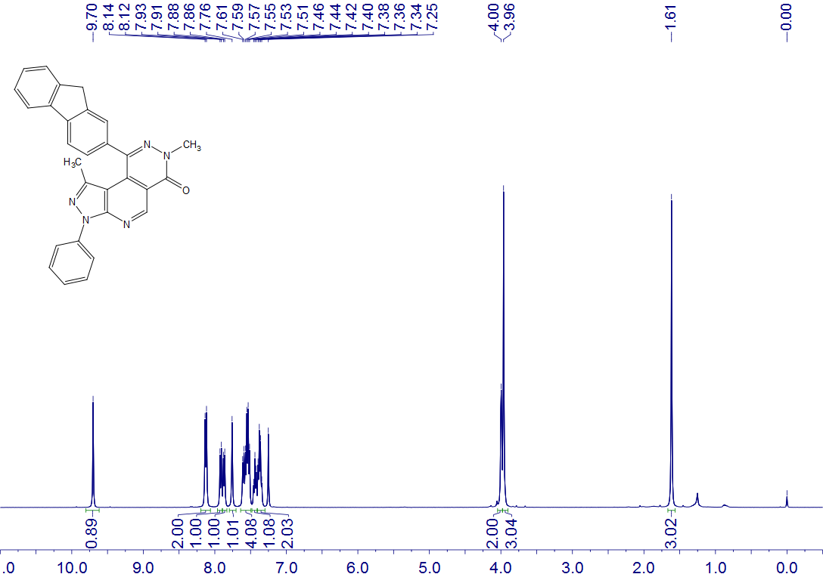
5a
CDCl₃
400 MHz

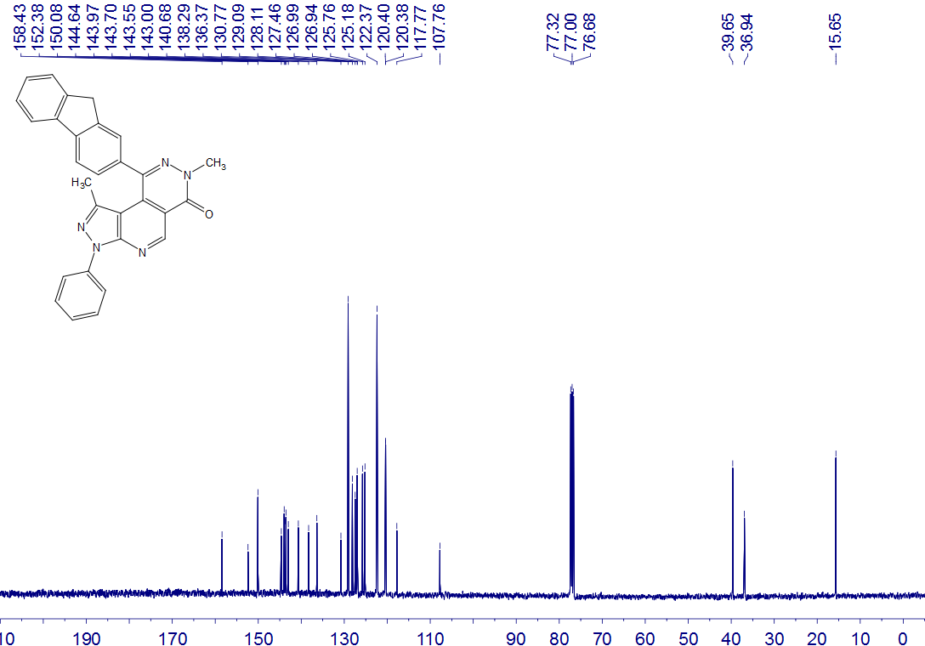
5a
CDCl₃
100 MHz

5b
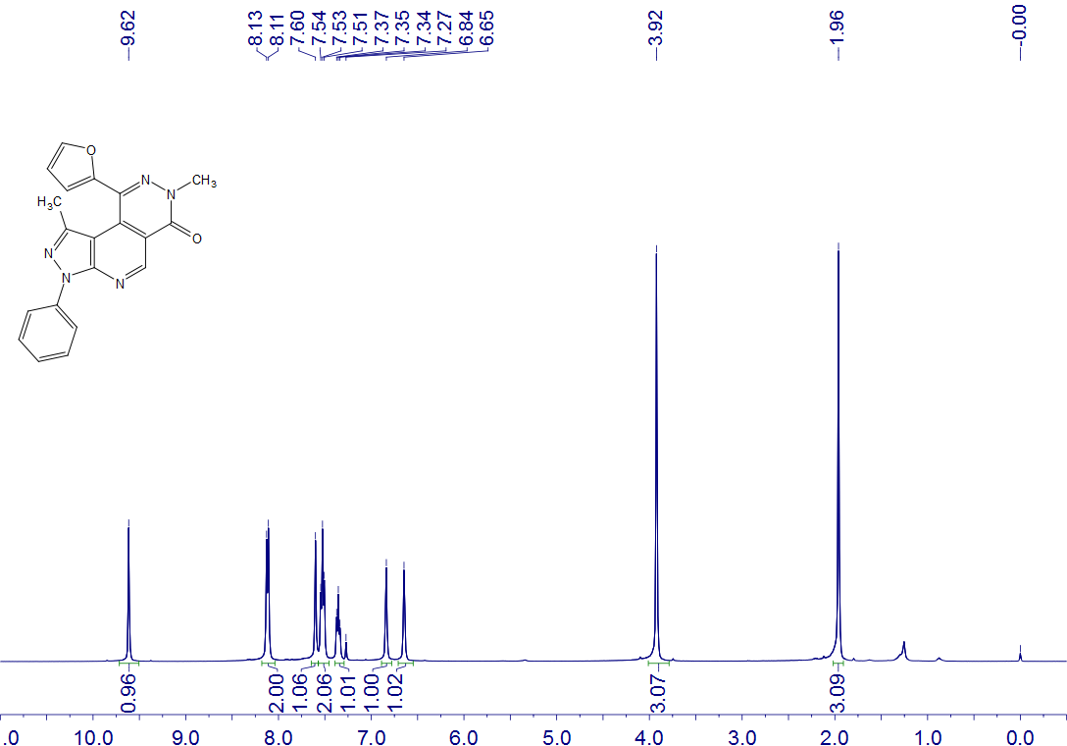
5b
CDCl₃
400 MHz

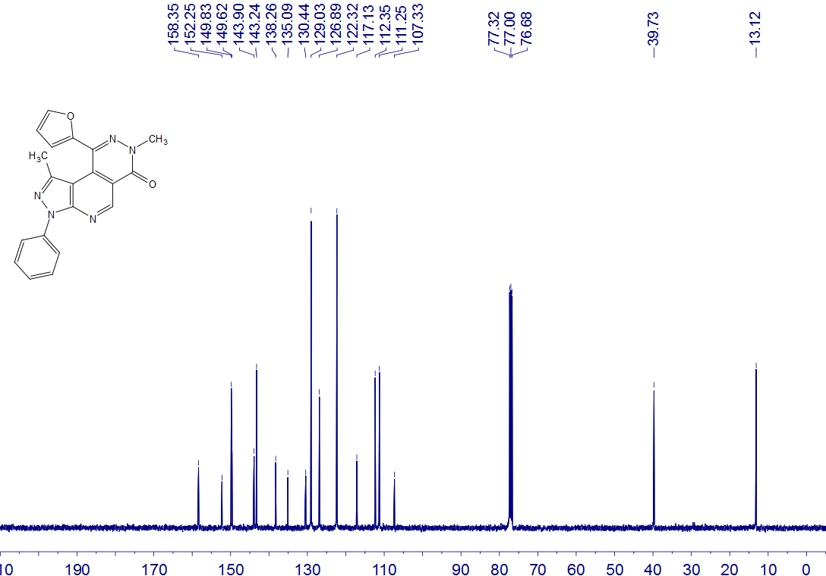
5b
CDCl₃
100 MHz

5c
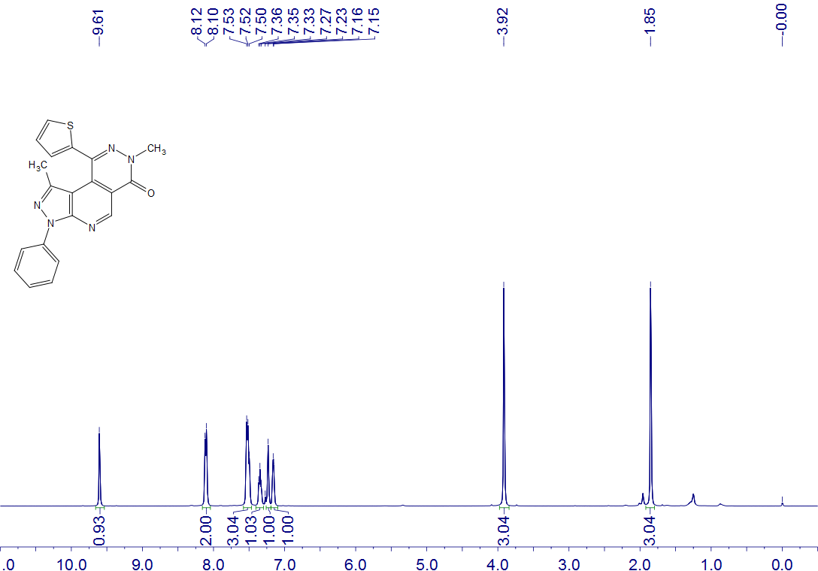
5c
CDCl₃
400 MHz

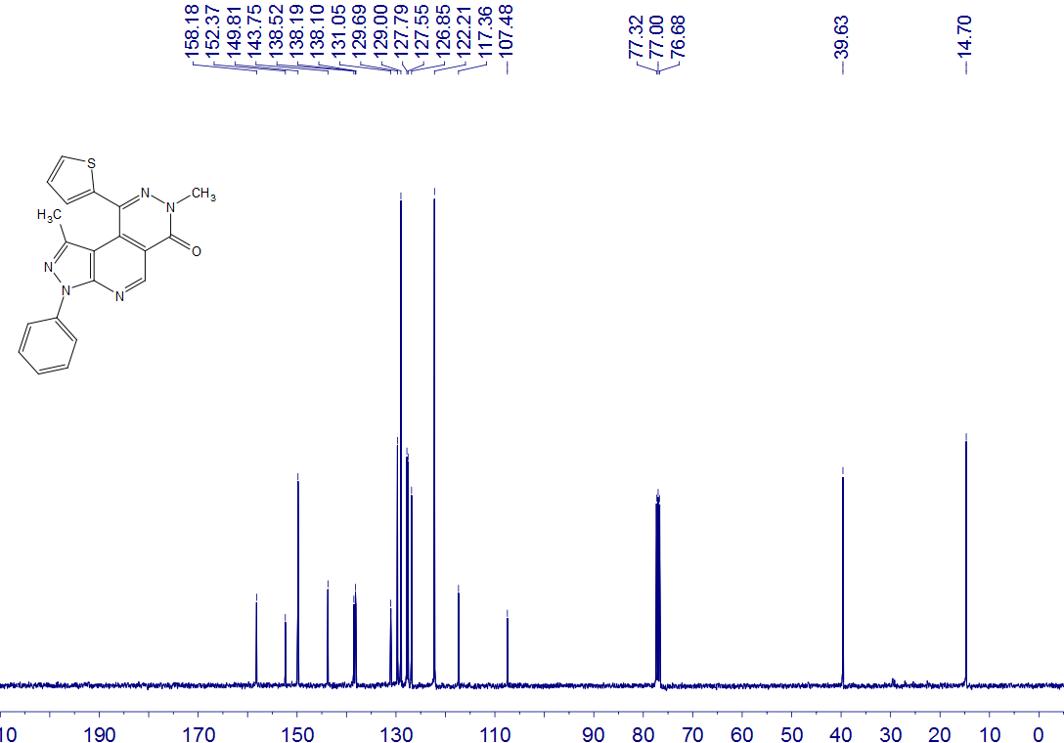
5c
CDCl₃
100 MHz

5d
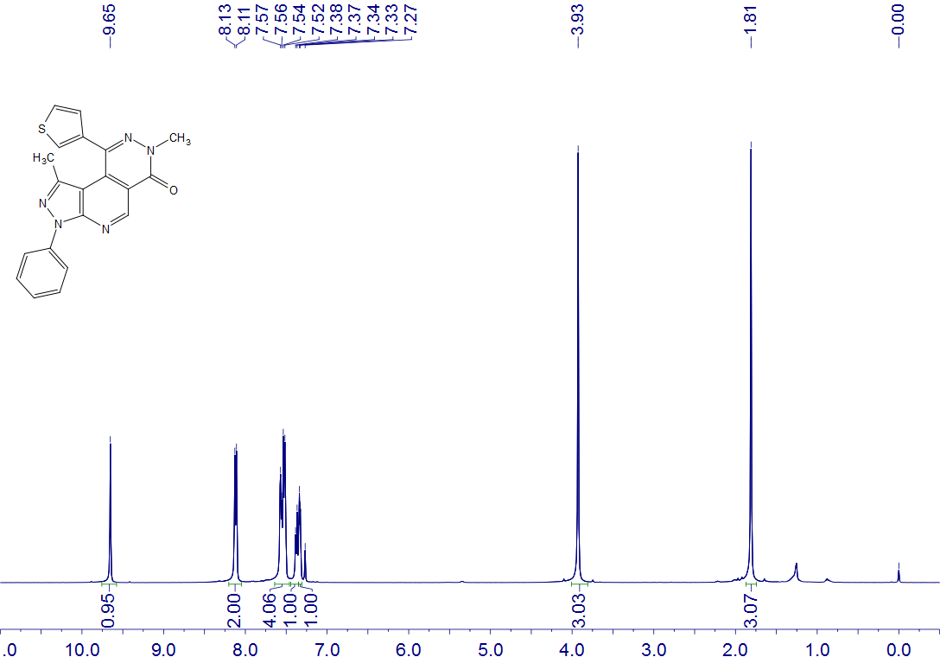
5d
CDCl₃
400 MHz

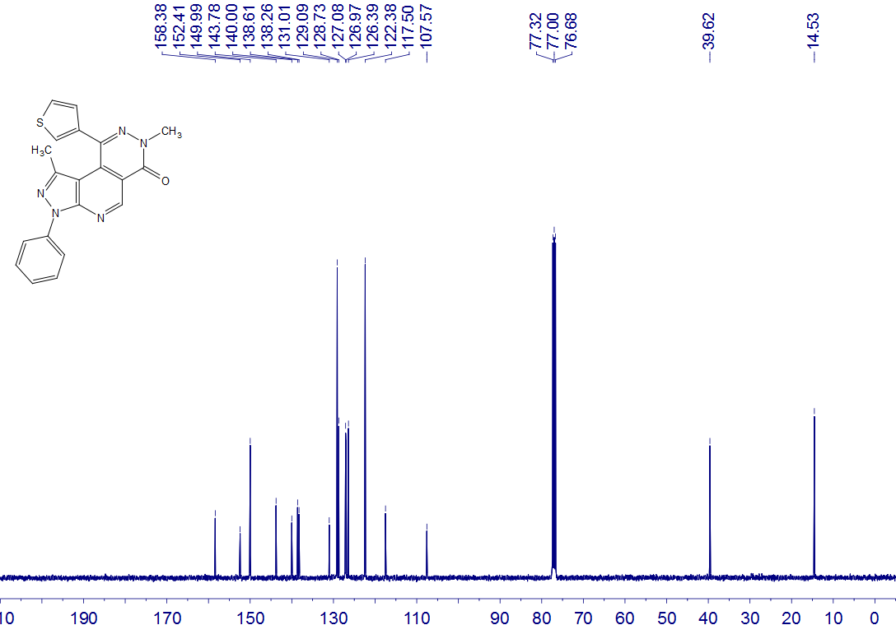
5d
CDCl₃
100 MHz

5e
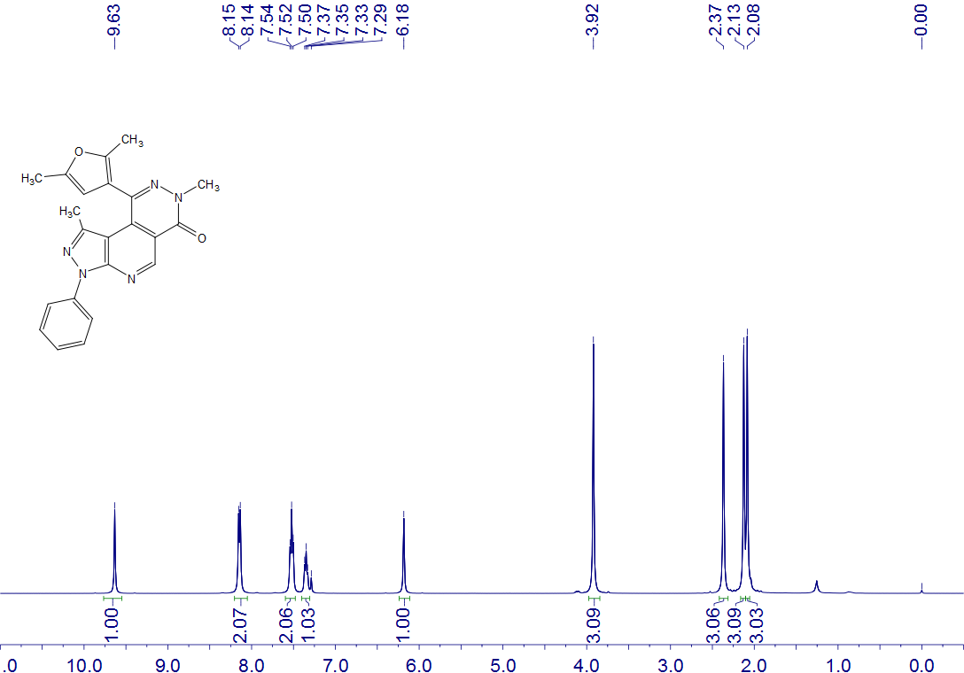
5e
CDCl₃
400 MHz

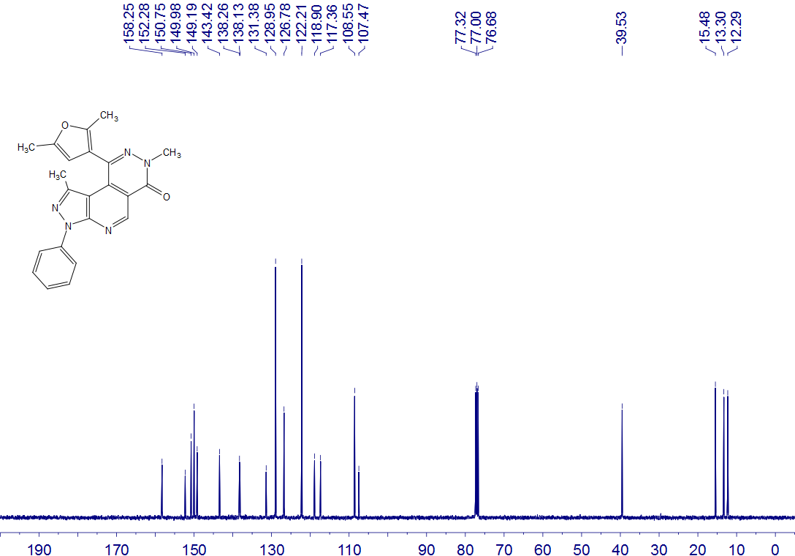
5e
CDCl₃
100 MHz

5f
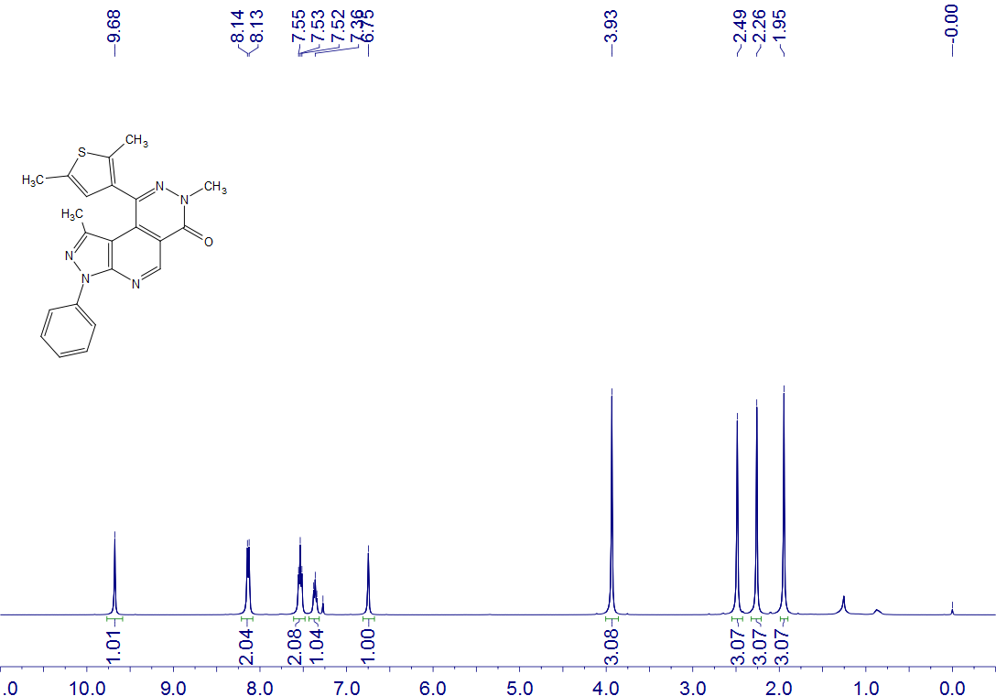
5f
CDCl₃
400 MHz

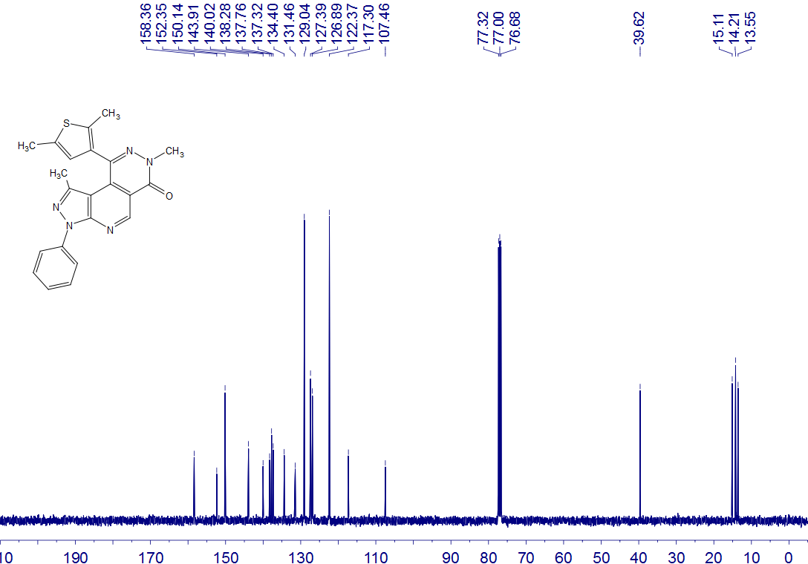
5f
CDCl₃
100 MHz

5g
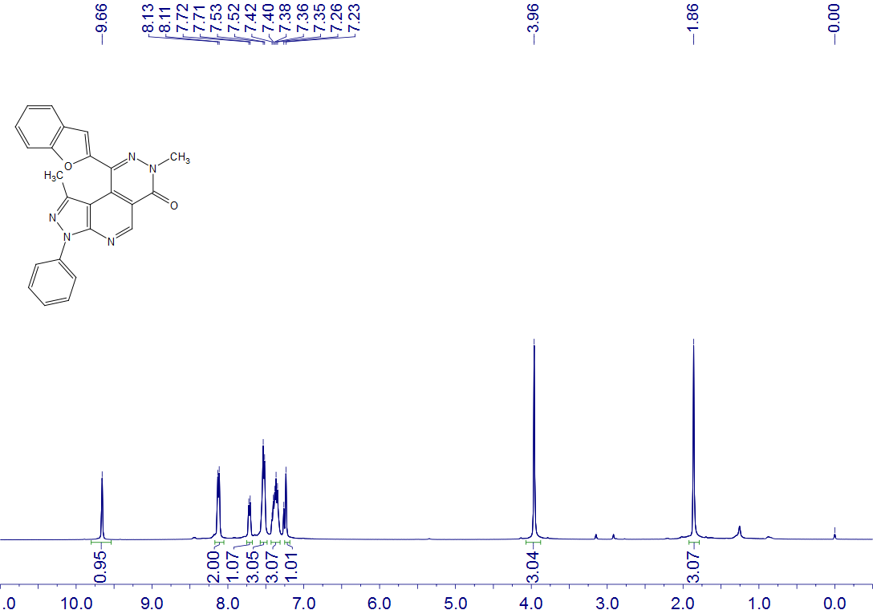
5g
CDCl₃
400 MHz

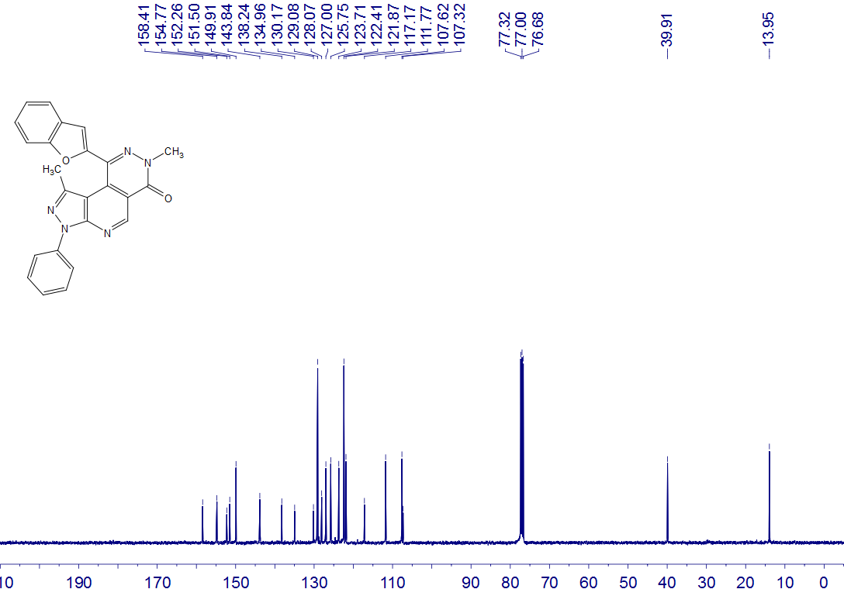
5g
CDCl₃
100 MHz

5h
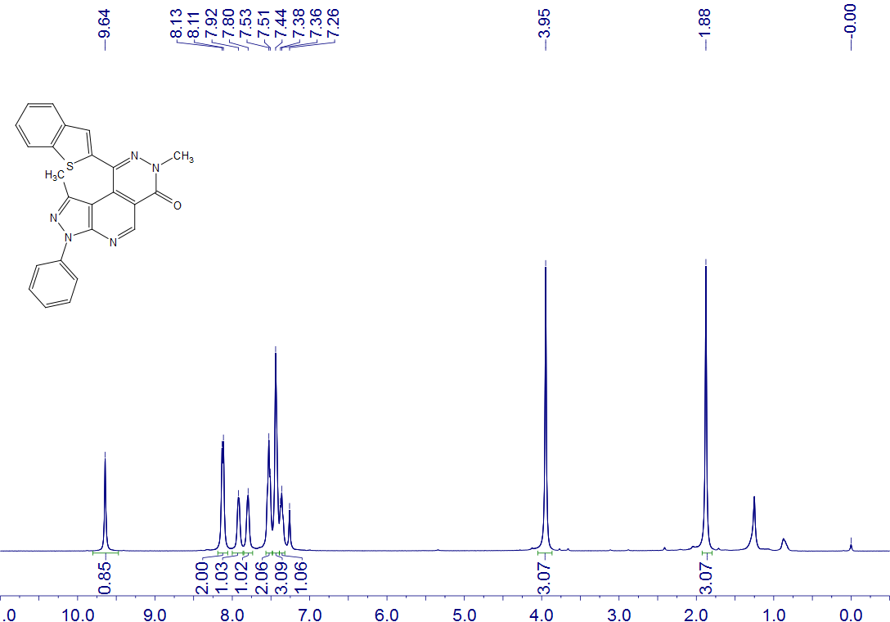
5h
CDCl₃
400 MHz

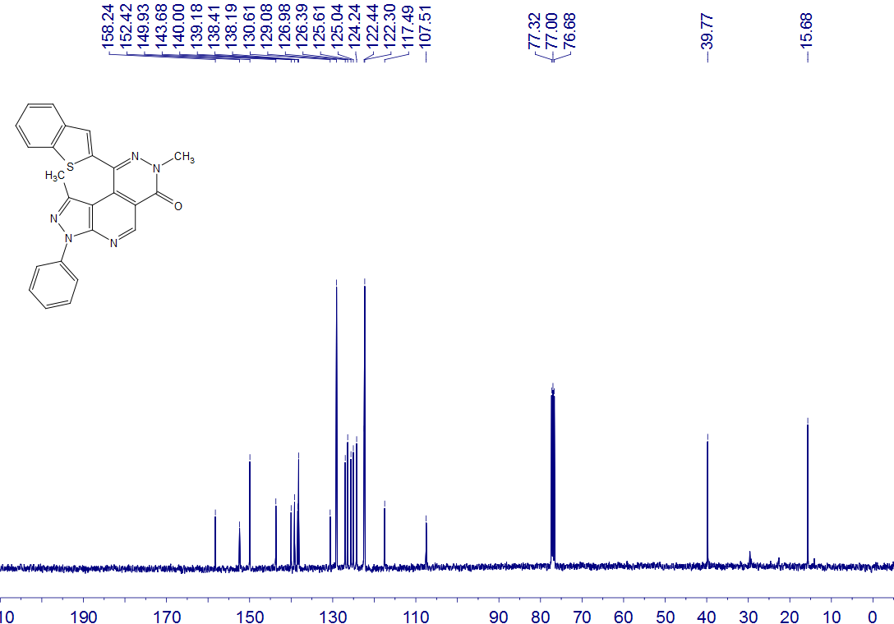
5h
CDCl₃
100 MHz

5i
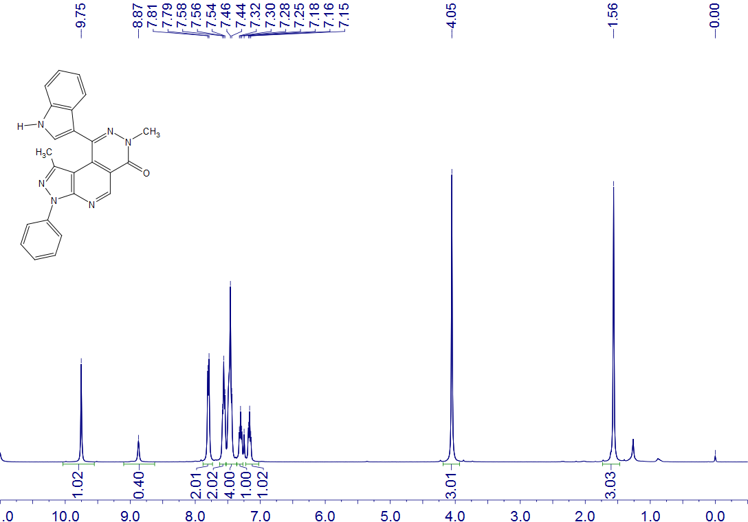
5i
CDCl₃ + CF₃COOD
400 MHz

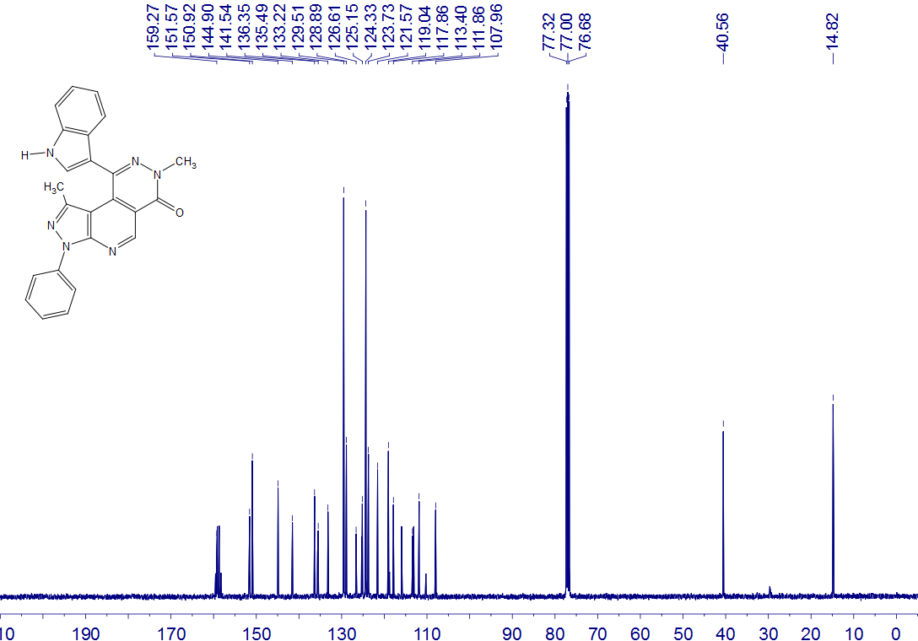
5i
CDCl₃ + CF₃COOD
100 MHz

5j
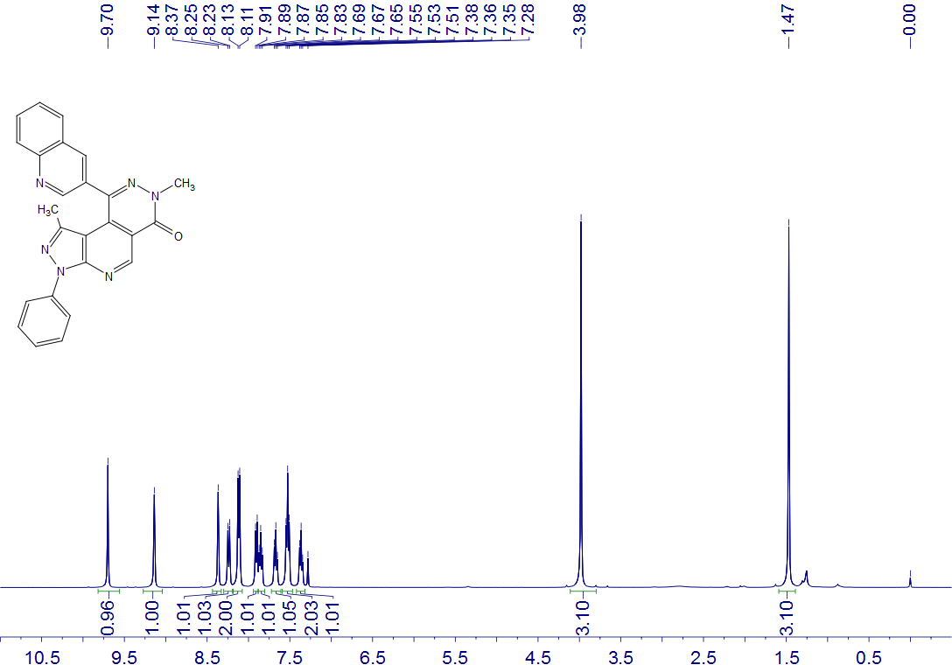
5j
CDCl₃
400 MHz

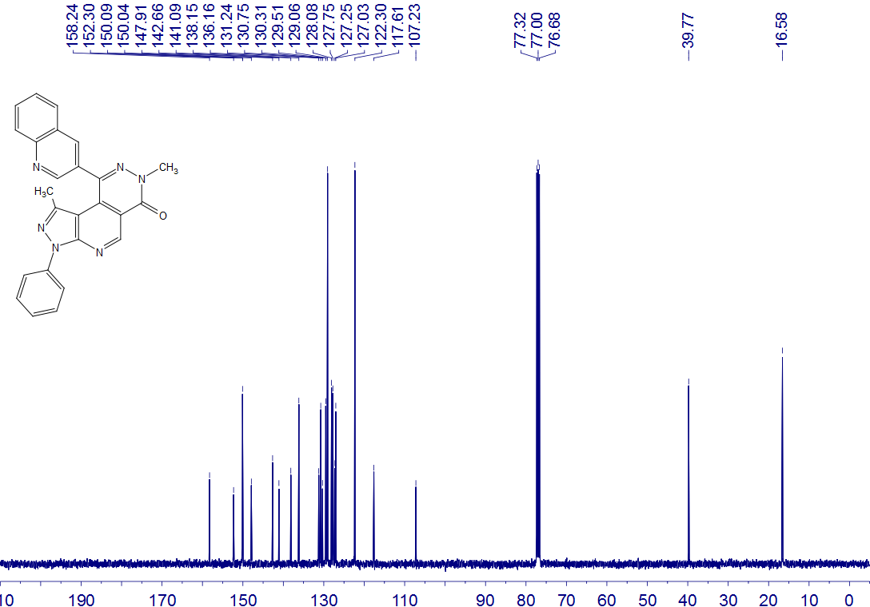
5j
CDCl₃
100 MHz

5k
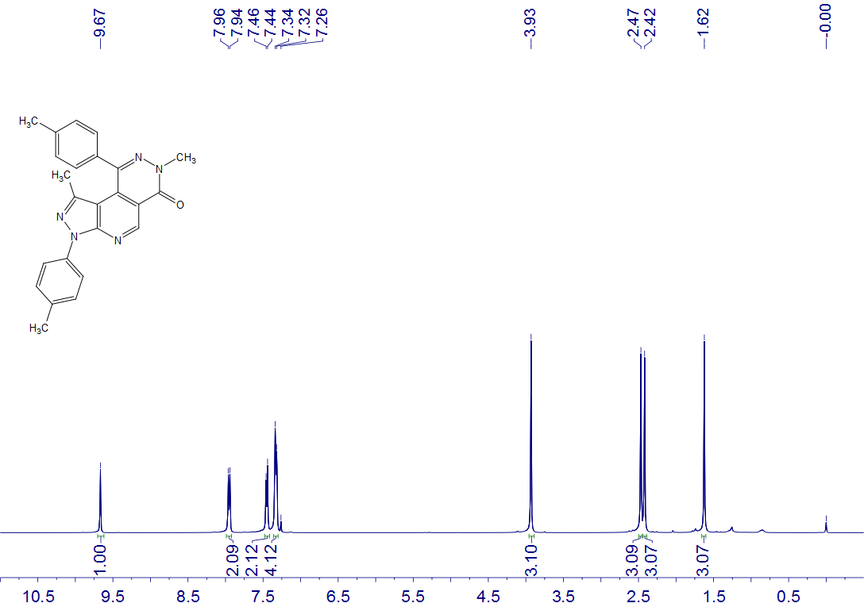
5k
CDCl₃
400 MHz

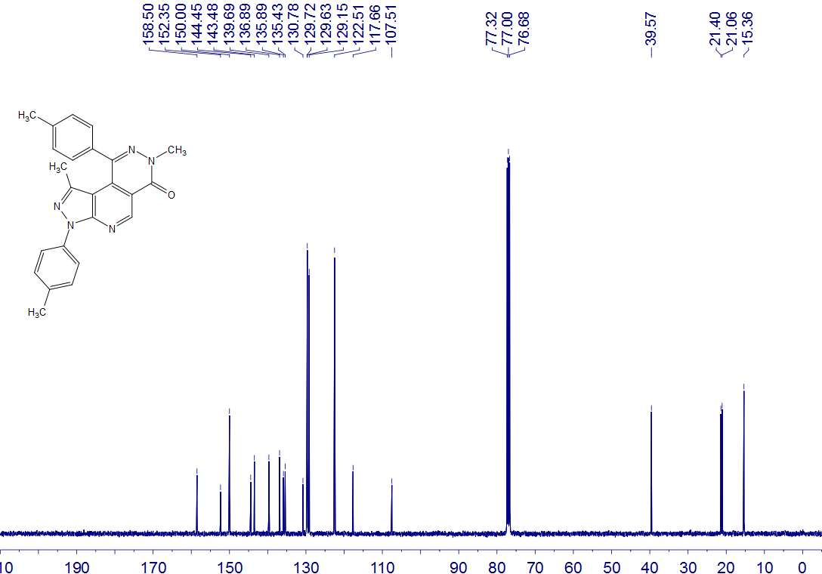
5k
CDCl₃
100 MHz

5l
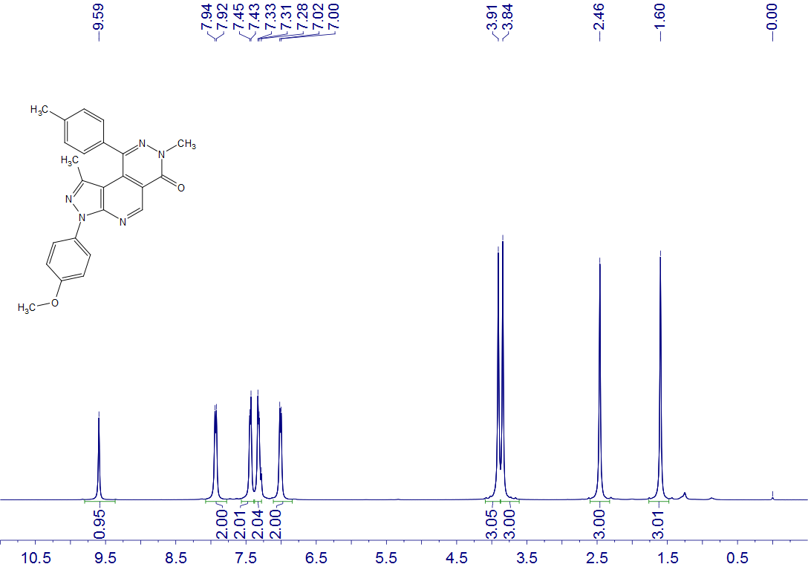
5l
CDCl₃
400 MHz

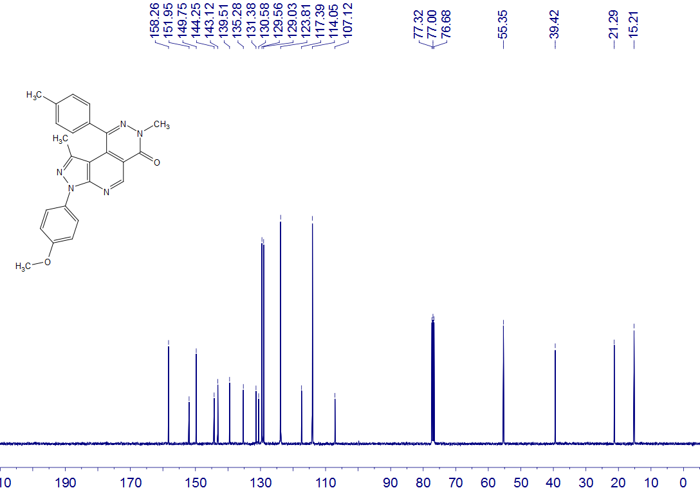
5l
CDCl₃
100 MHz

5m
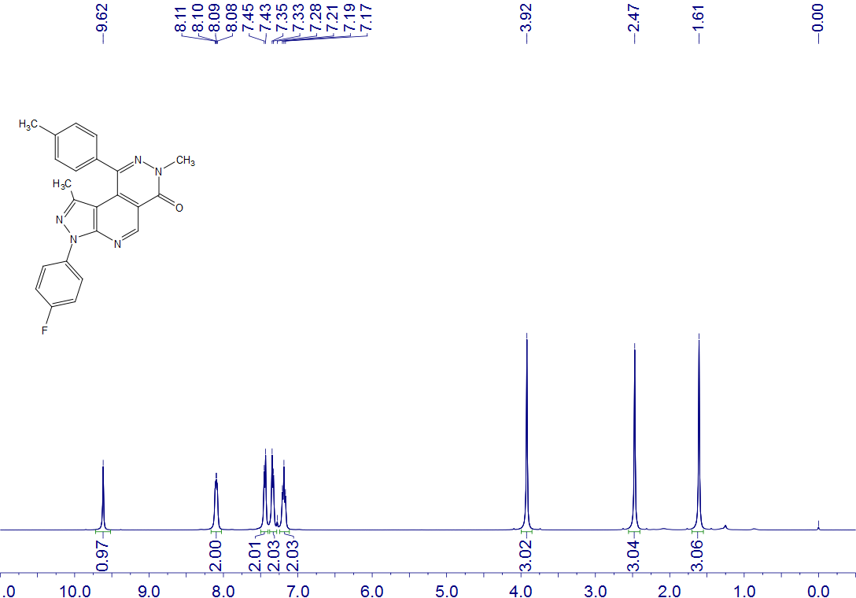
5m
CDCl₃
400 MHz

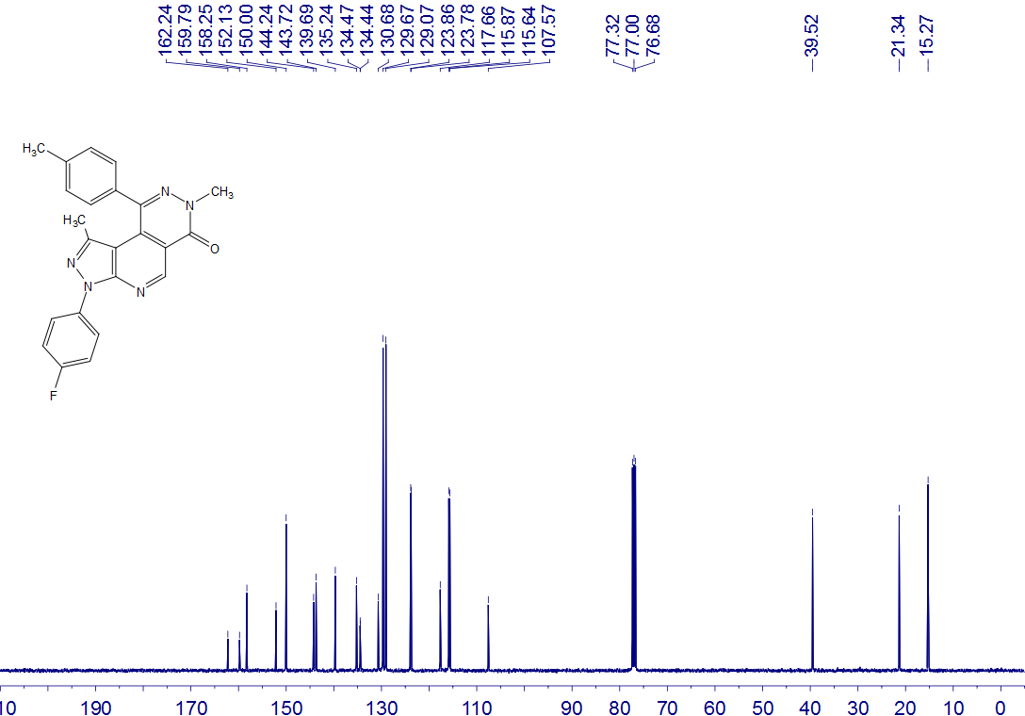
5m
CDCl₃
100 MHz

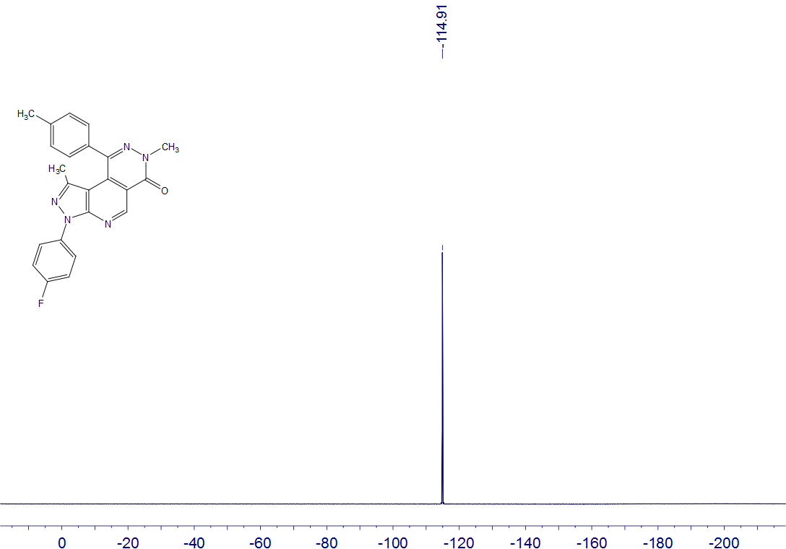
5m
CDCl₃
376 MHz

5n
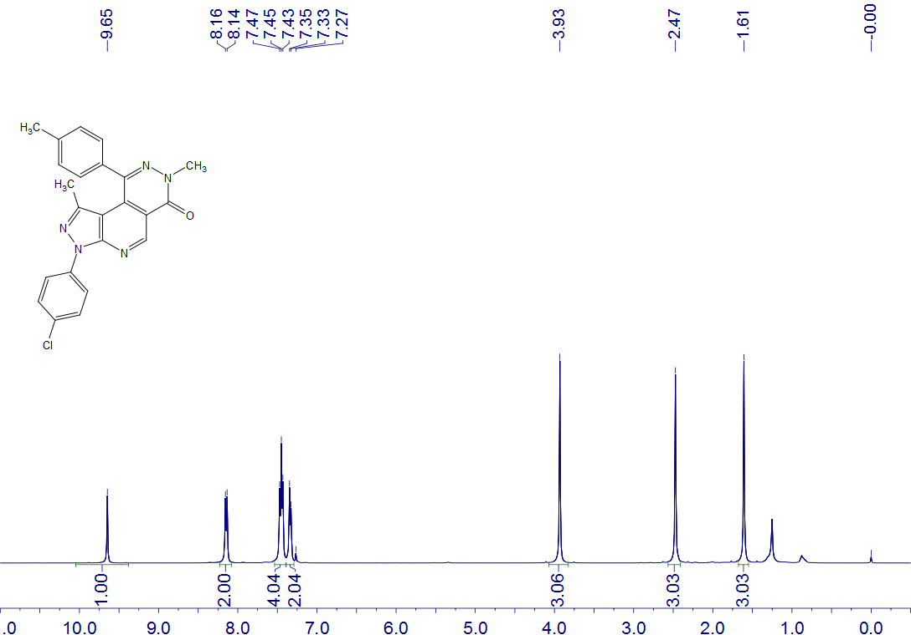
5n
CDCl₃
400 MHz

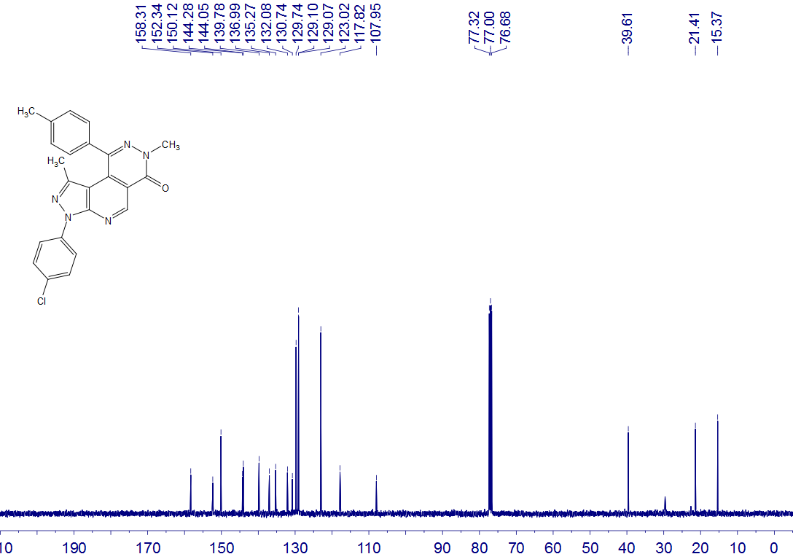
5n
CDCl₃
100 MHz

5o
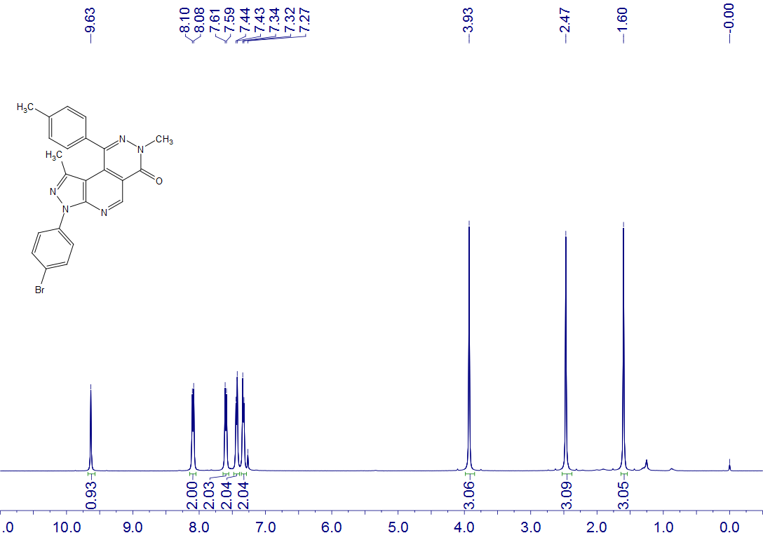
5o
CDCl₃
400 MHz

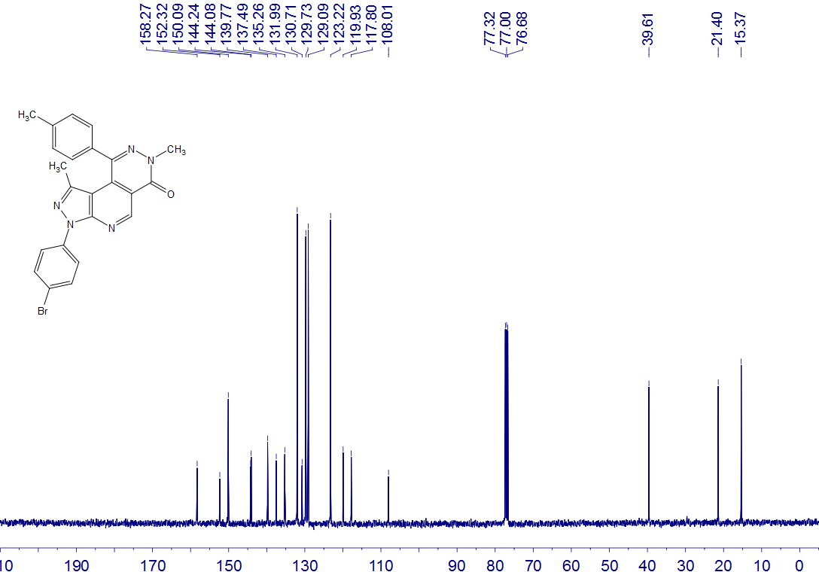
5o
CDCl₃
100 MHz

5p
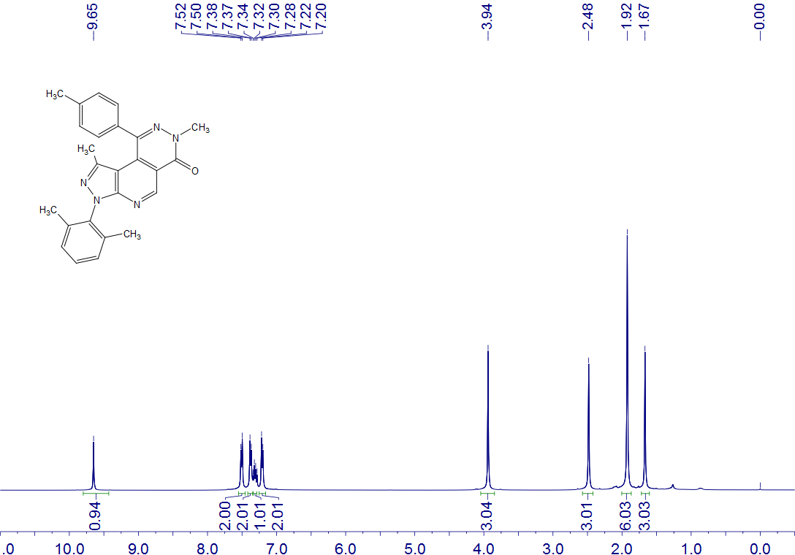
5p
CDCl₃
400 MHz

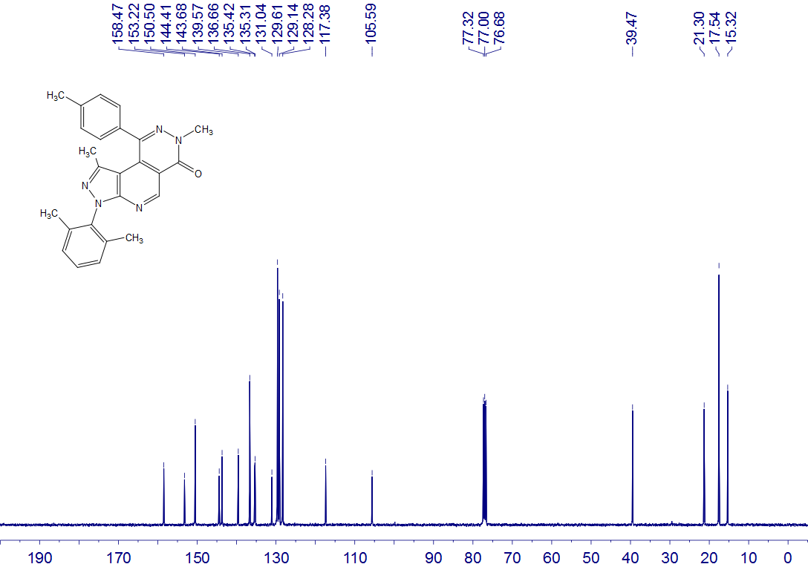
5p
CDCl₃
100 MHz

5q
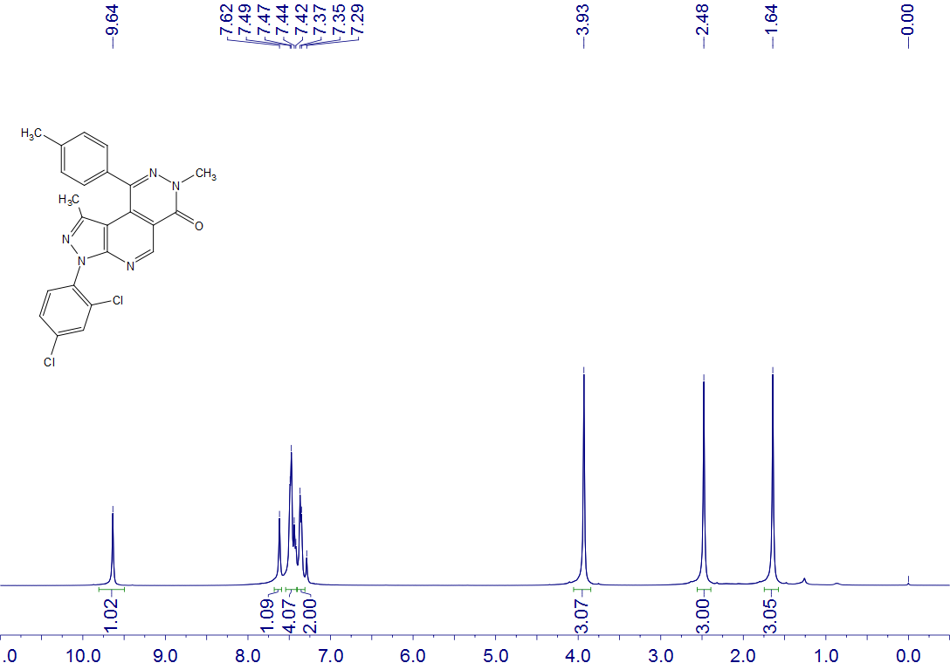
5q
CDCl₃
400 MHz

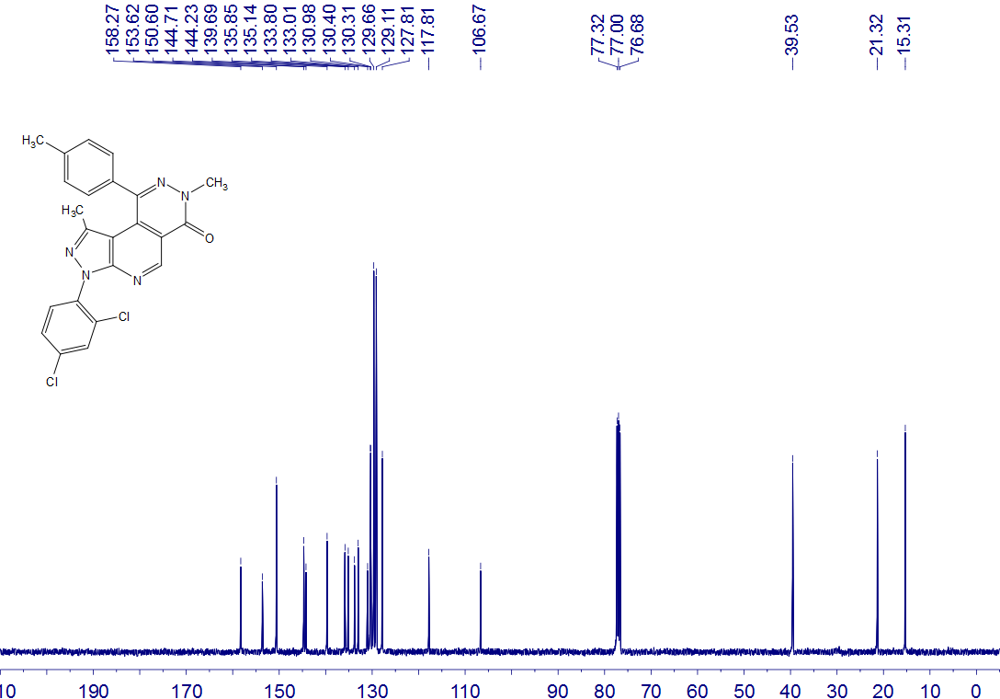
5q
CDCl₃
100 MHz

5r
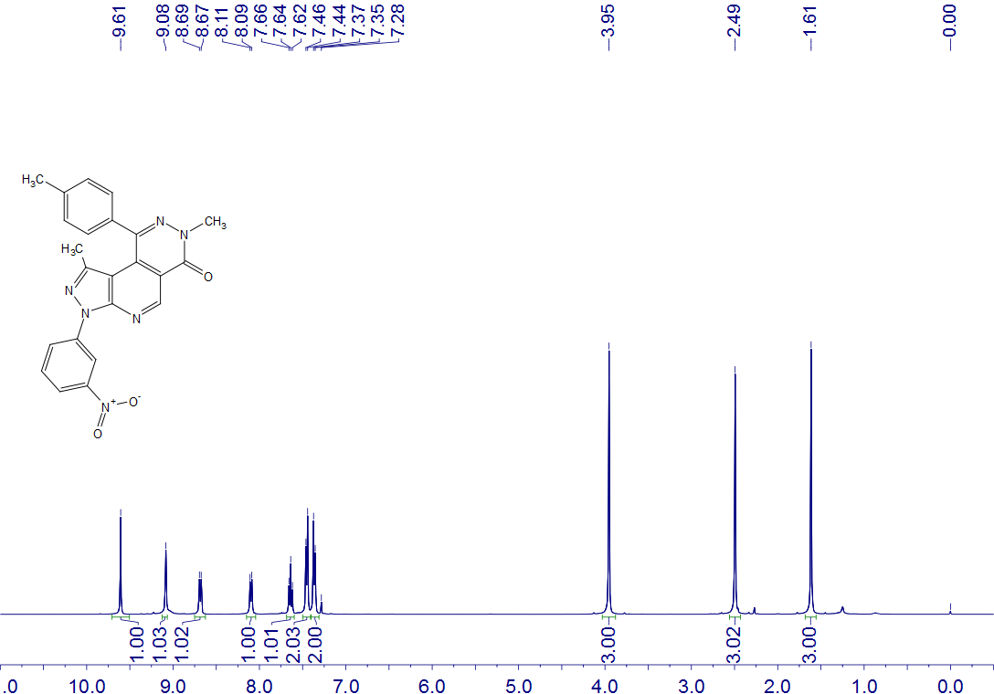
5r
CDCl₃, CD₃CO₂D
400 MHz

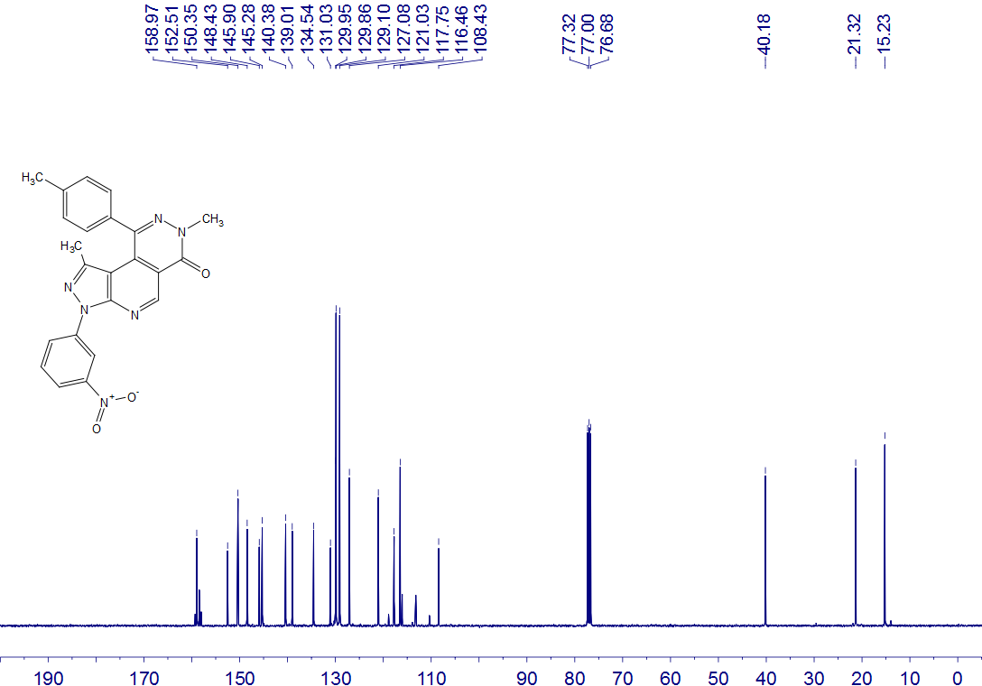
5r
CDCl₃, CD₃CO₂D
100 MHz

5s
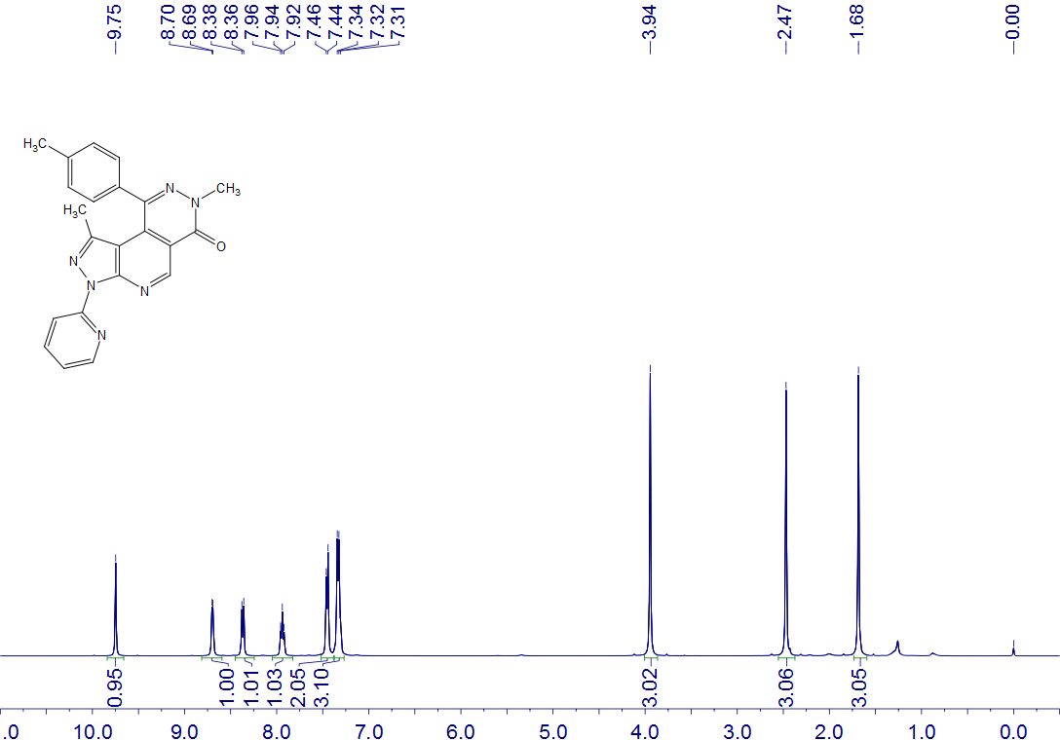
5s
CDCl₃
400 MHz

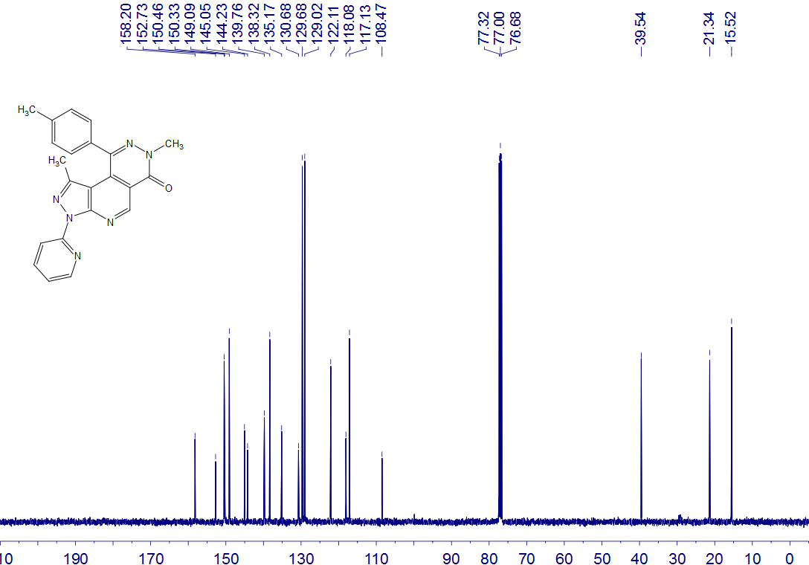
5s
CDCl₃
100 MHz

5t
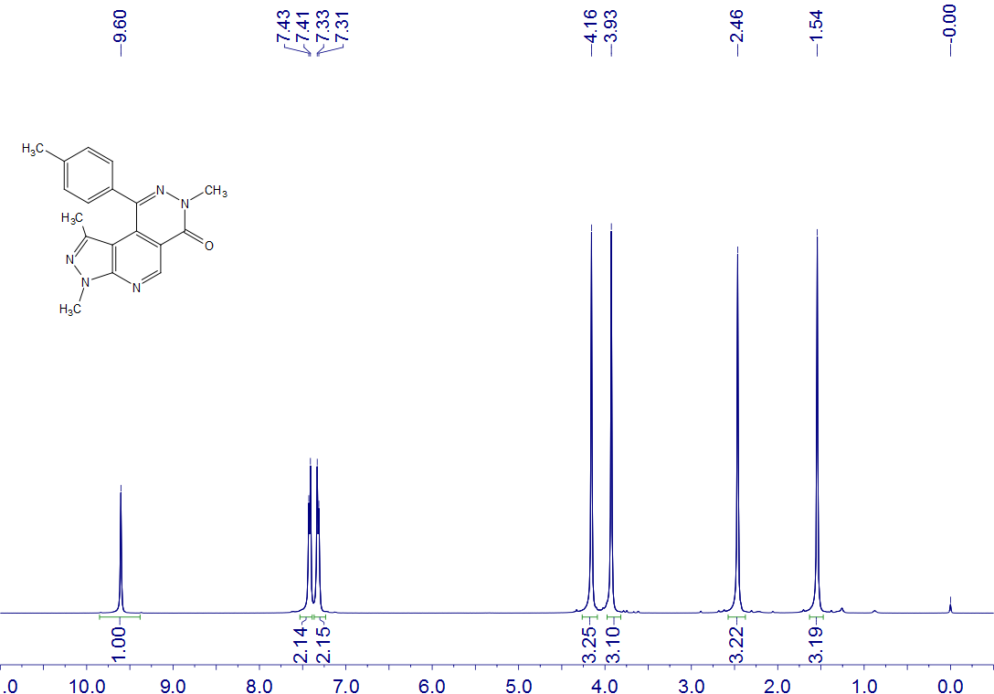
5t
CDCl₃
400 MHz

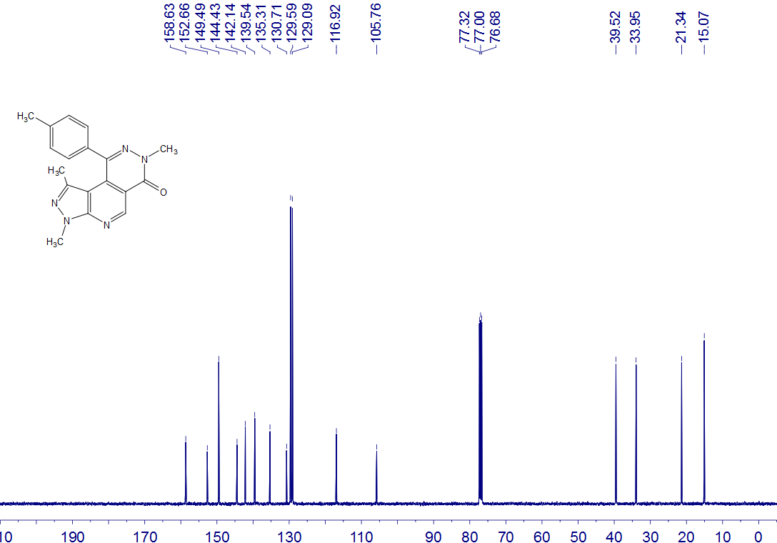
5t
CDCl₃
100 MHz

5u
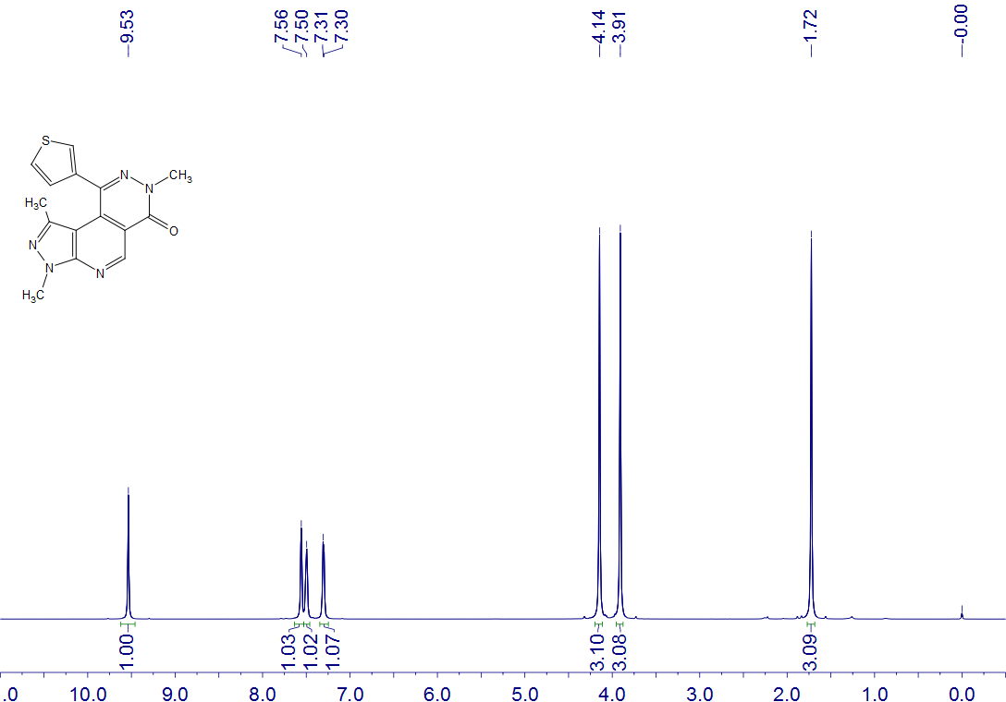
5u
CDCl₃
400 MHz

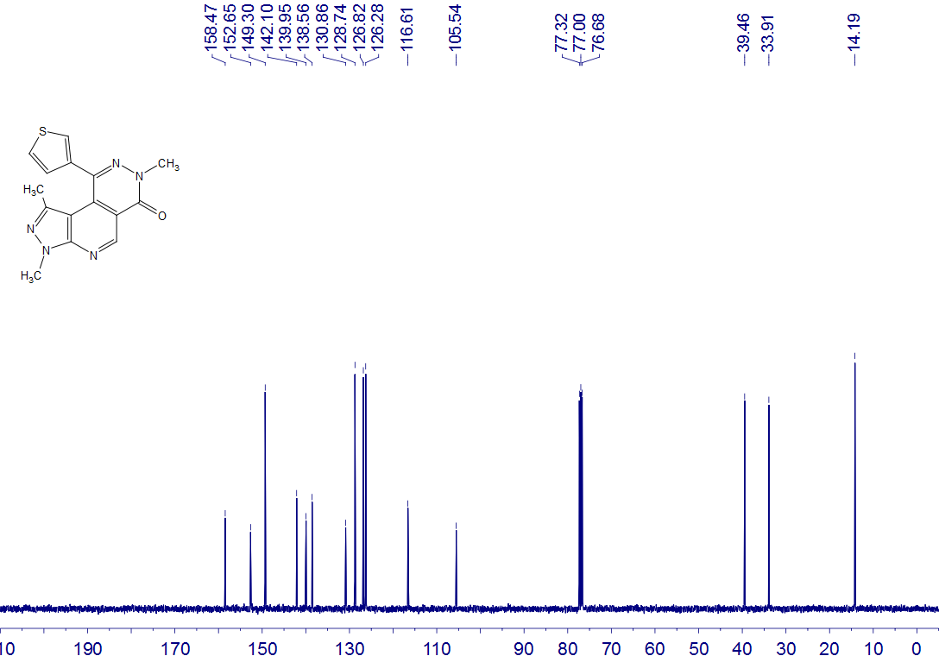
5u
CDCl₃
100 MHz

5v
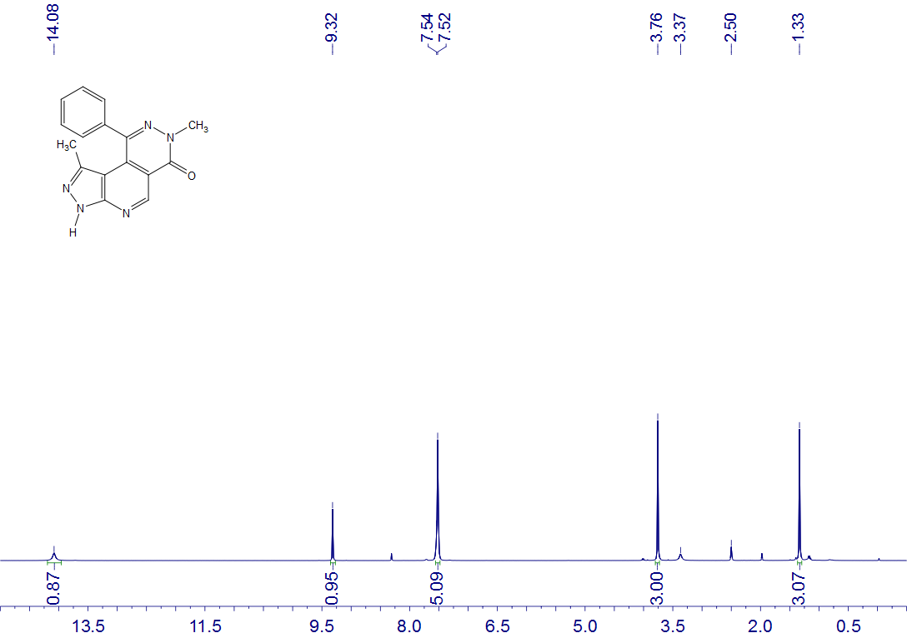
5v
DMSO-d₆
400 MHz

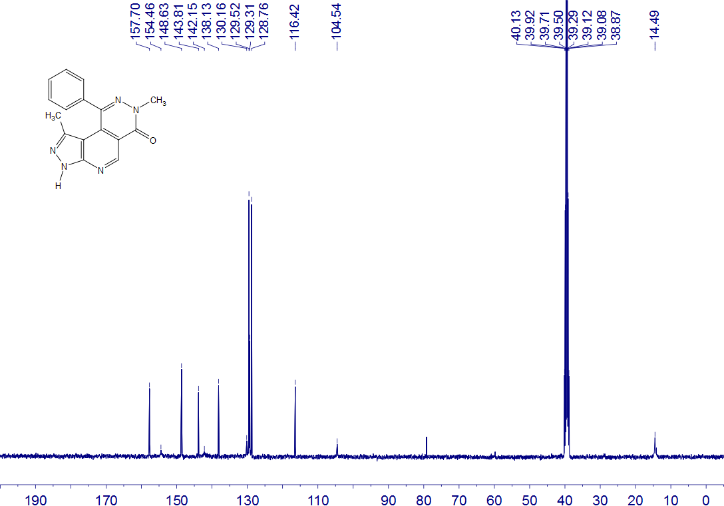
5v
DMSO-d₆
100 MHz

5w
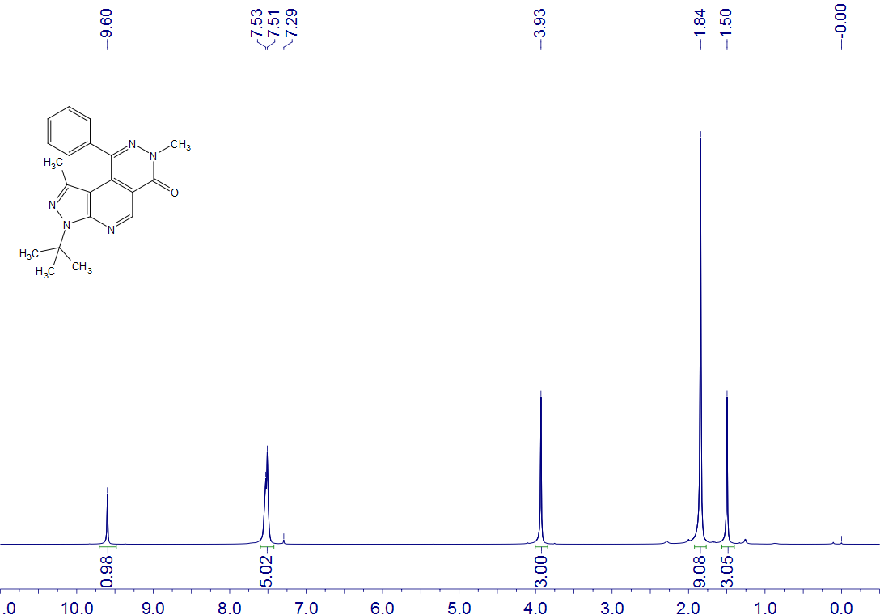
5w
CDCl₃
400 MHz

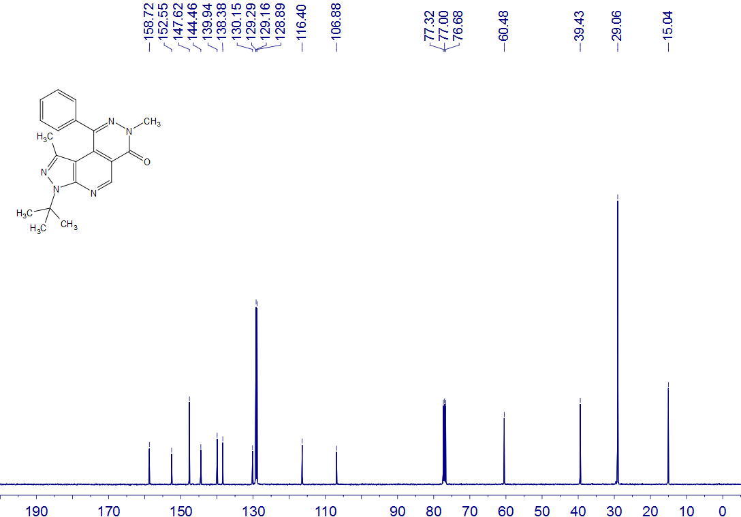
5w
CDCl₃
100 MHz

5x
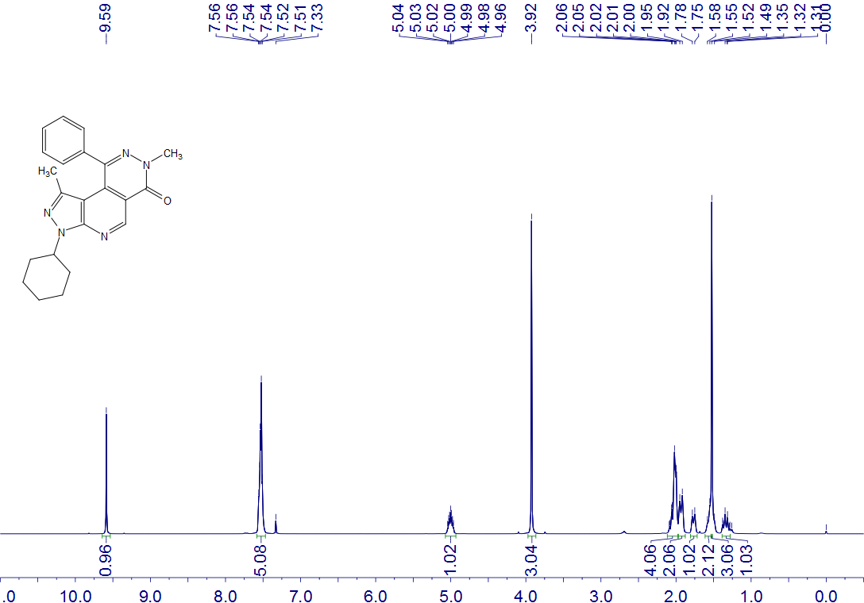
5x
CDCl₃
400 MHz

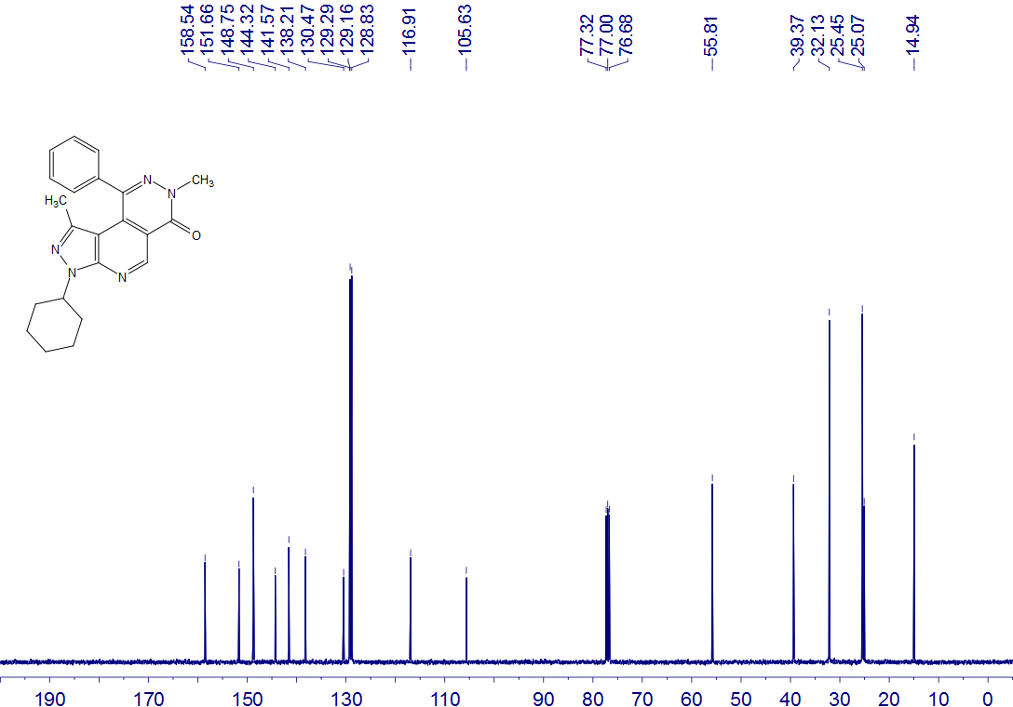
5x
CDCl₃
100 MHz

5y
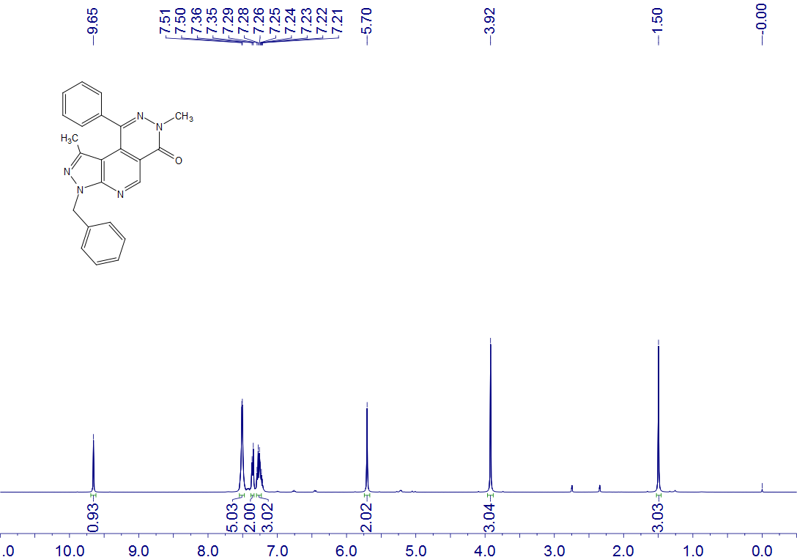
5y
CDCl₃
400 MHz

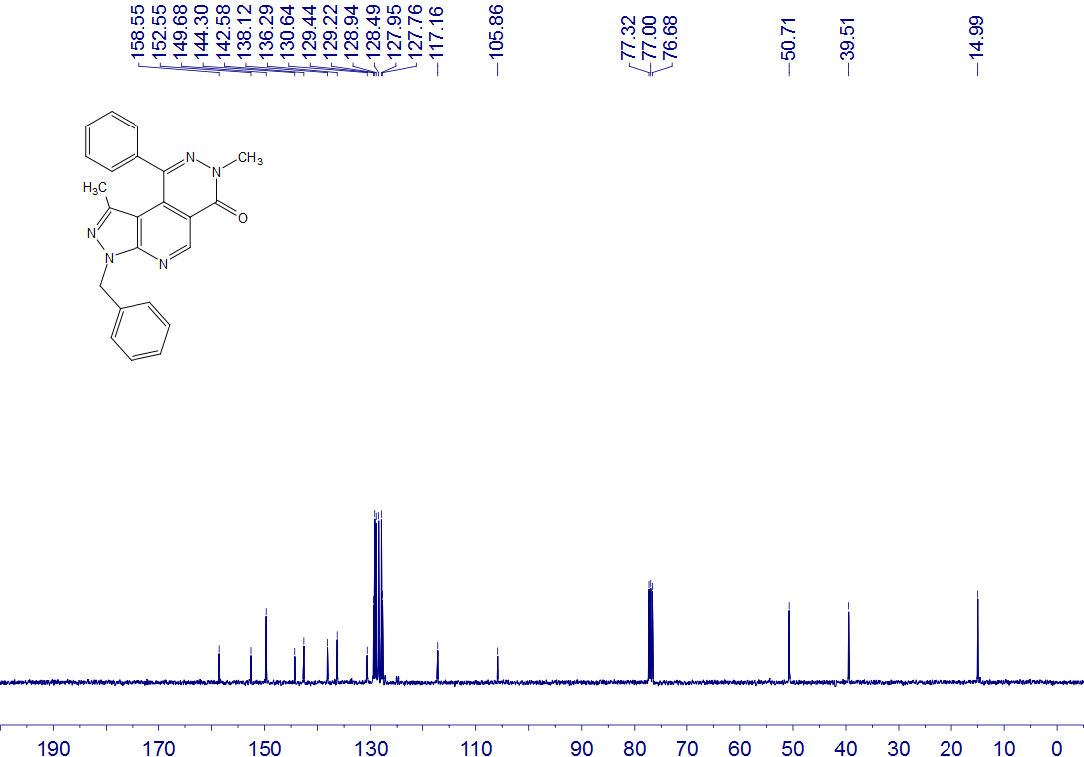
5y
CDCl₃
100 MHz
5z
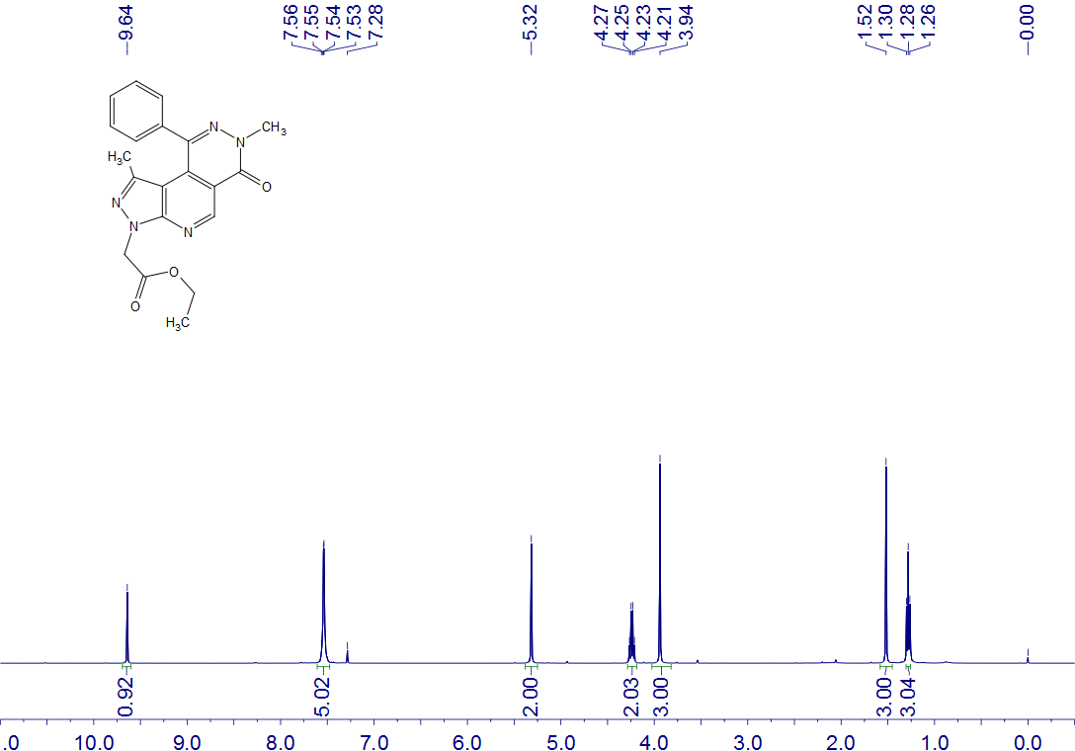
5z
CDCl₃
400 MHz

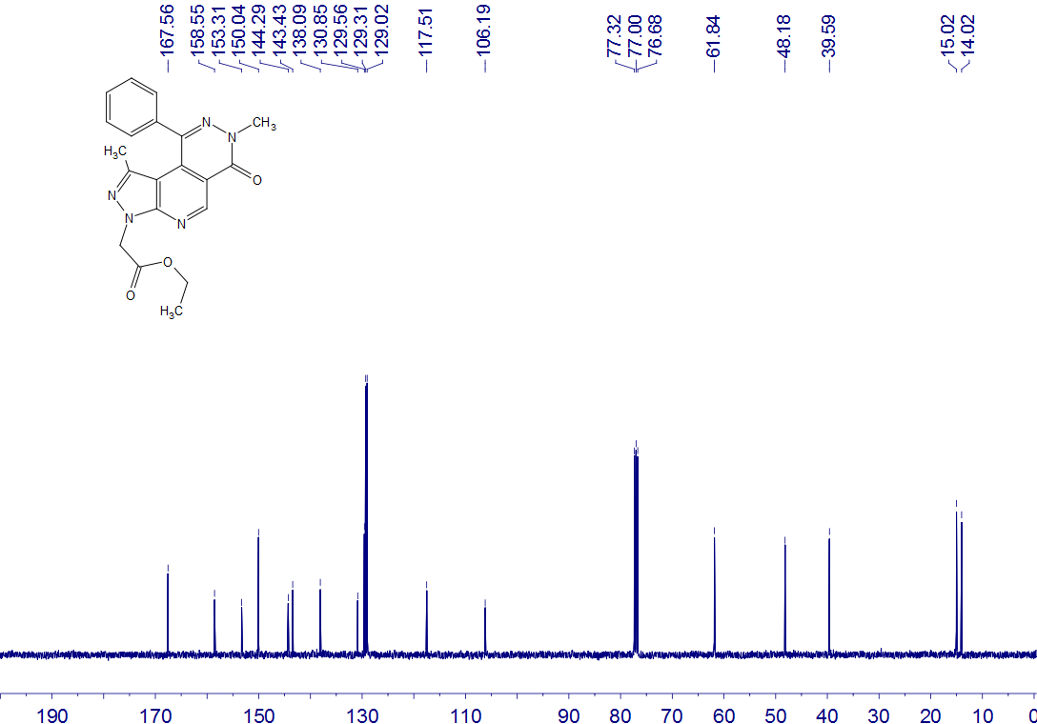
5z
CDCl₃
100 MHz

6a
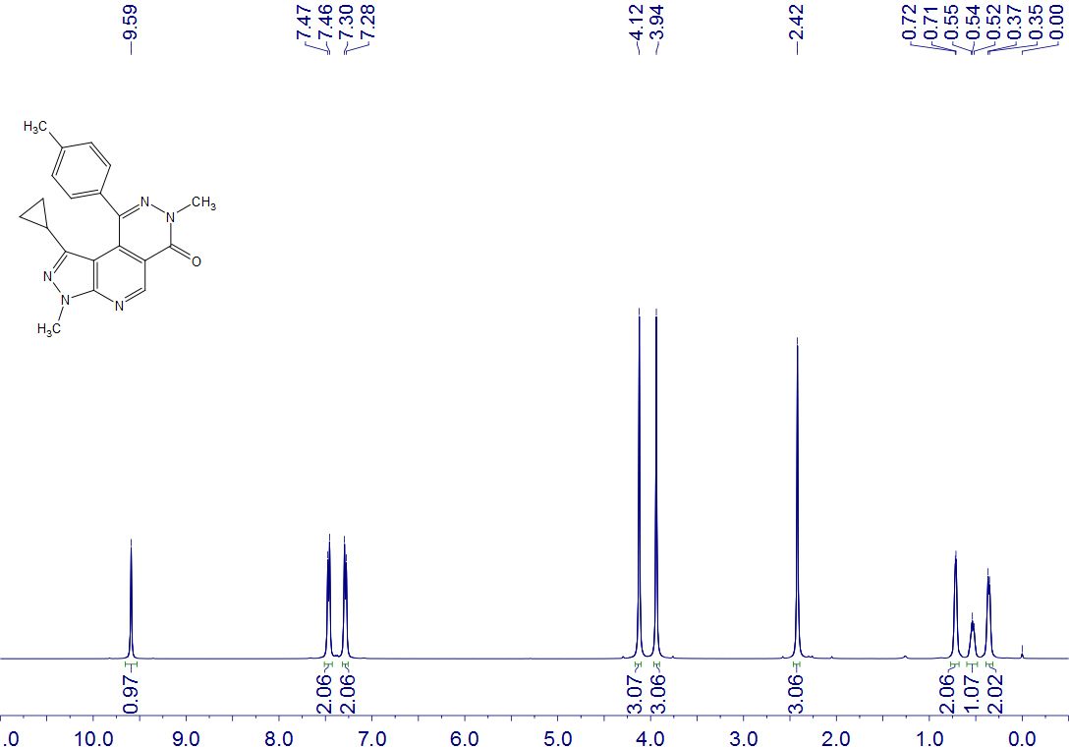
6a
CDCl₃
400 MHz

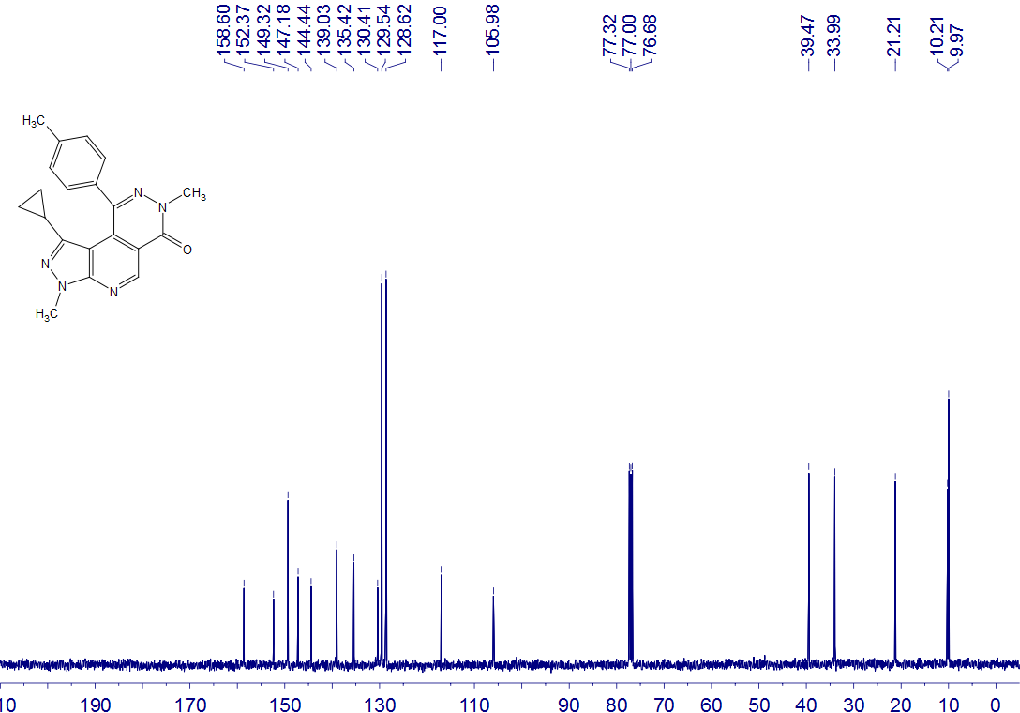
6a
CDCl₃
100 MHz
6b
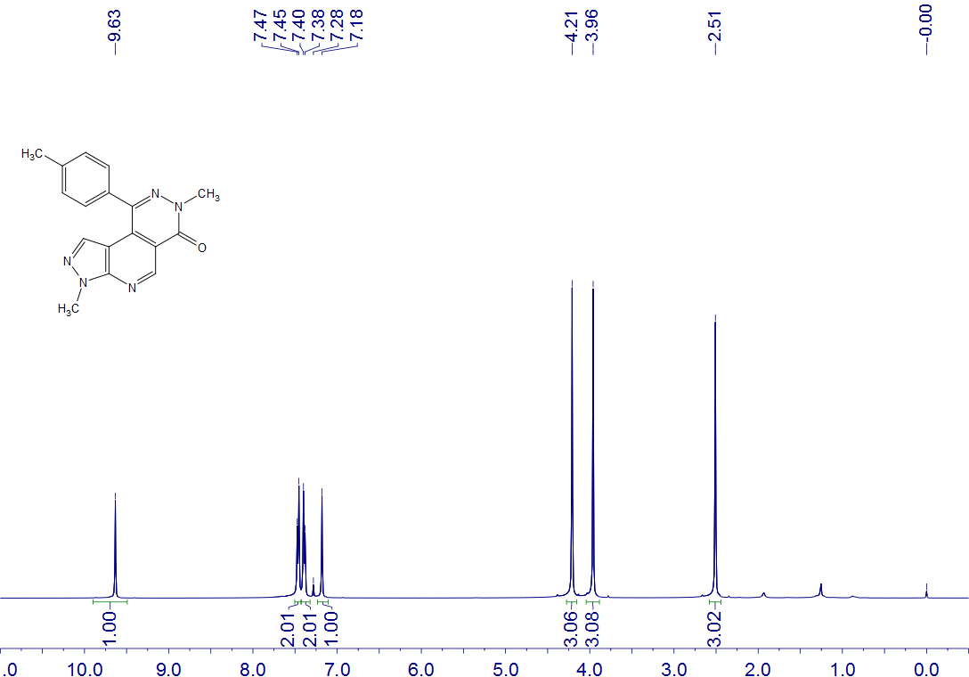
6b
CDCl₃
400 MHz

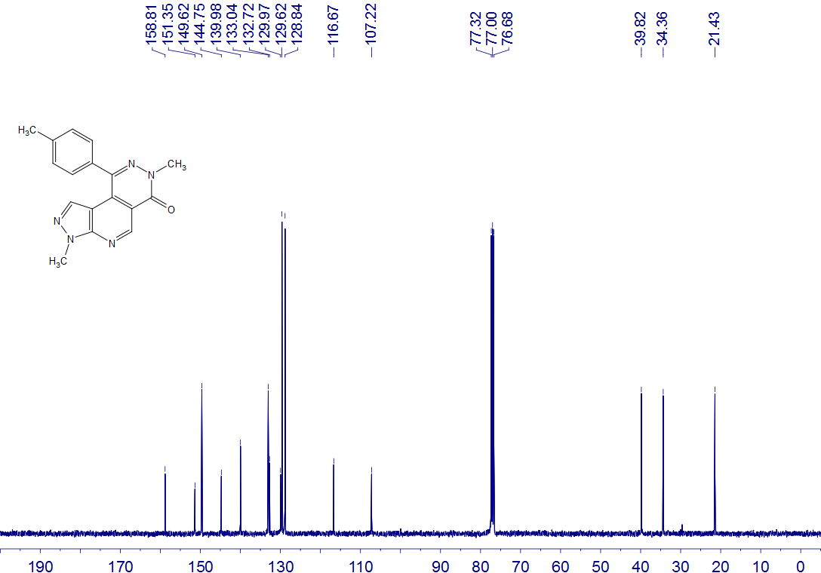
6b
CDCl₃
100 MHz

6c
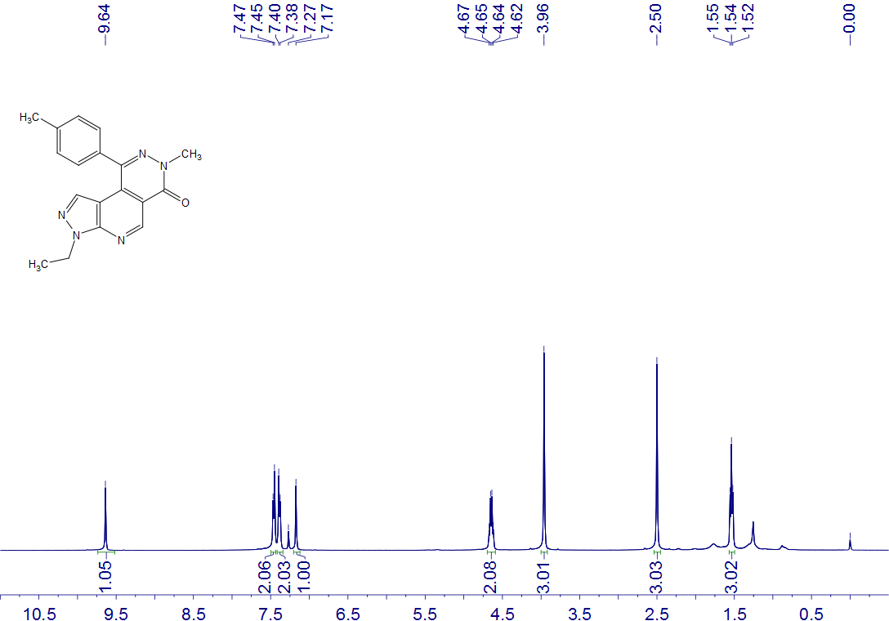
6c
CDCl₃
400 MHz

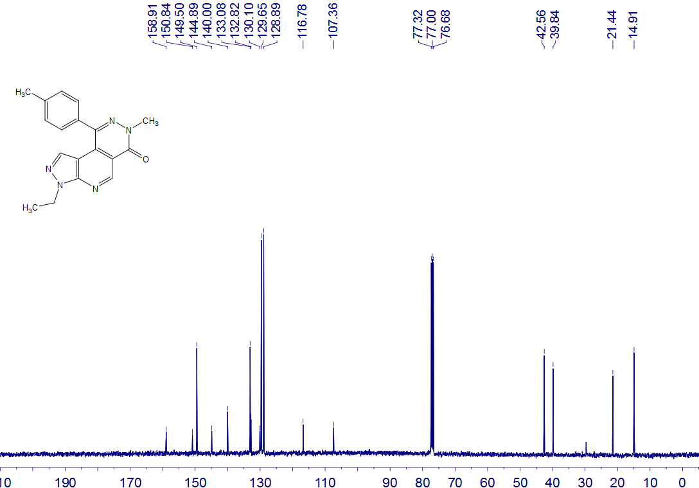
6c
CDCl₃
100 MHz

6d
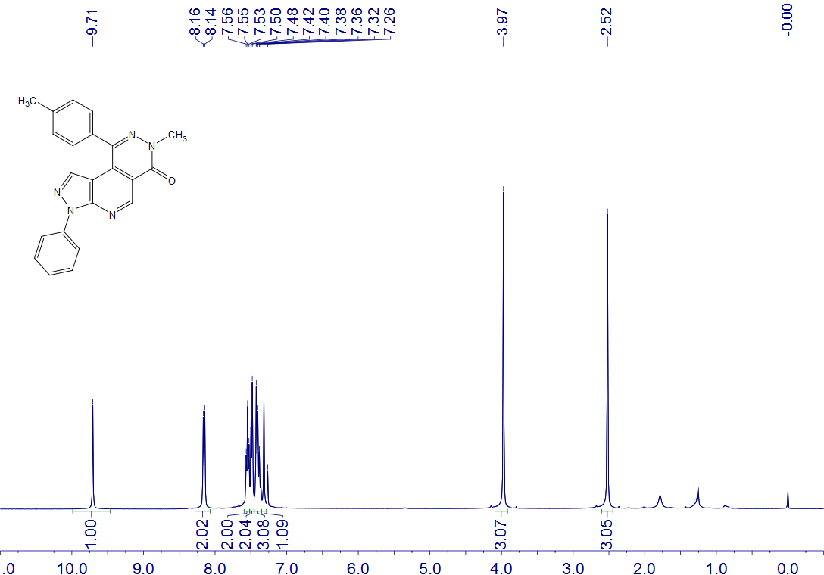
6d
CDCl₃
400 MHz

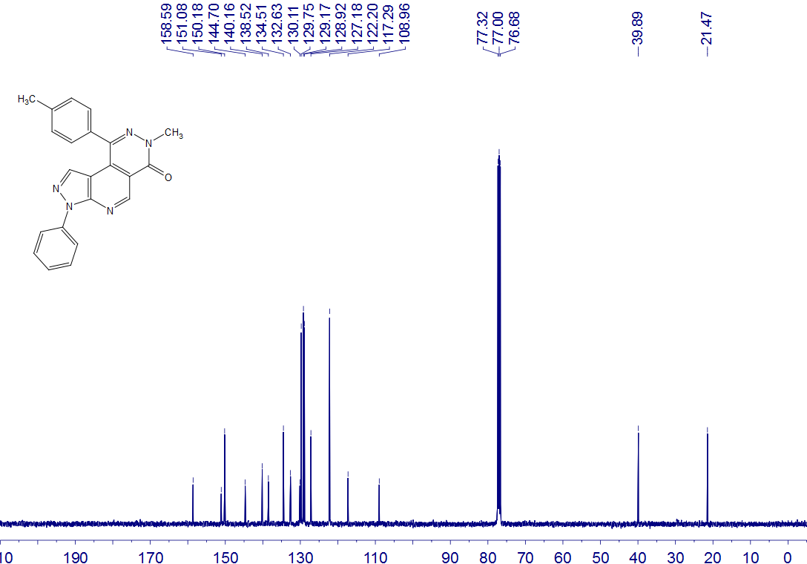
6d
CDCl₃
100 MHz

6e
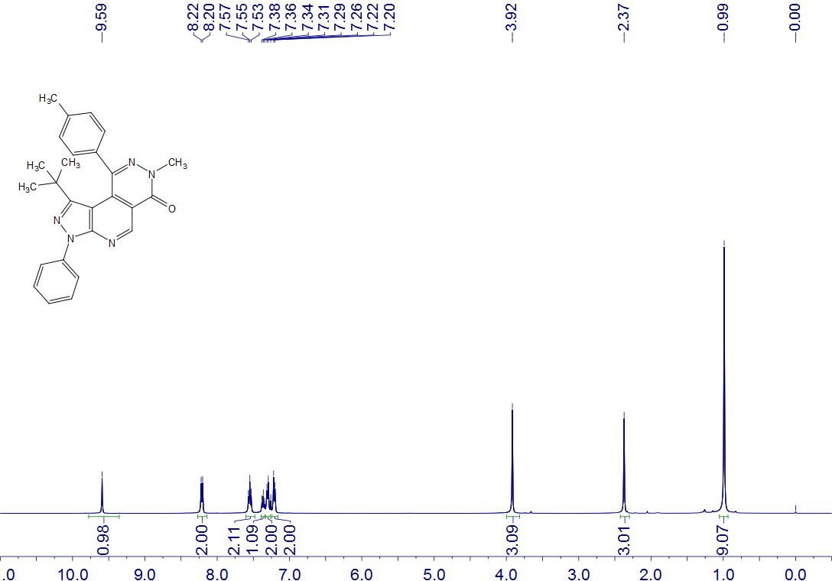
6e
CDCl₃
400 MHz

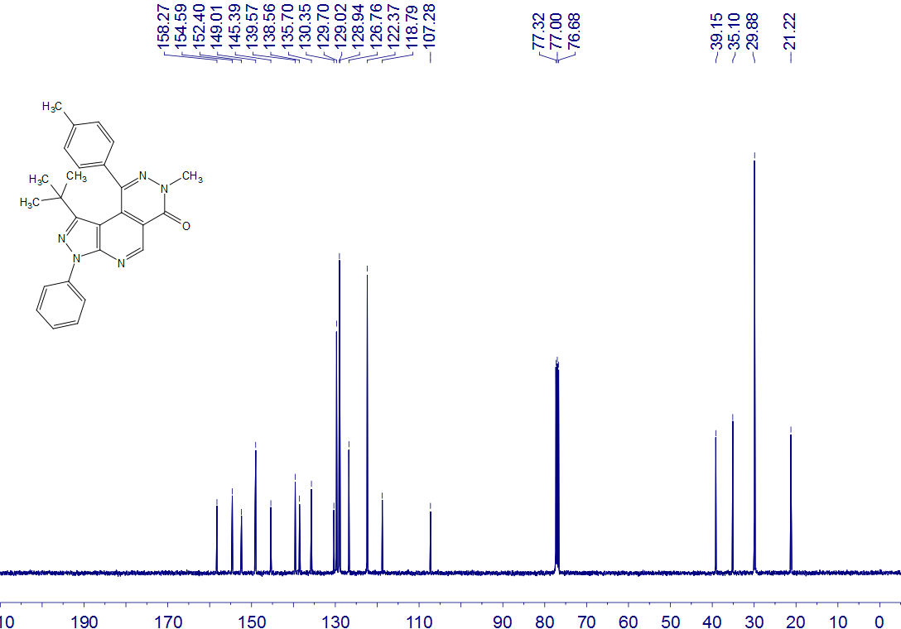
6e
CDCl₃
100 MHz

6f
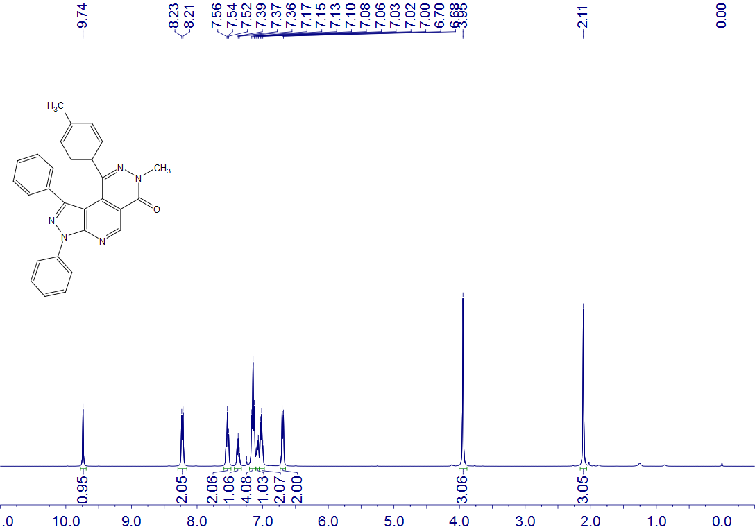
6f
CDCl₃
400 MHz

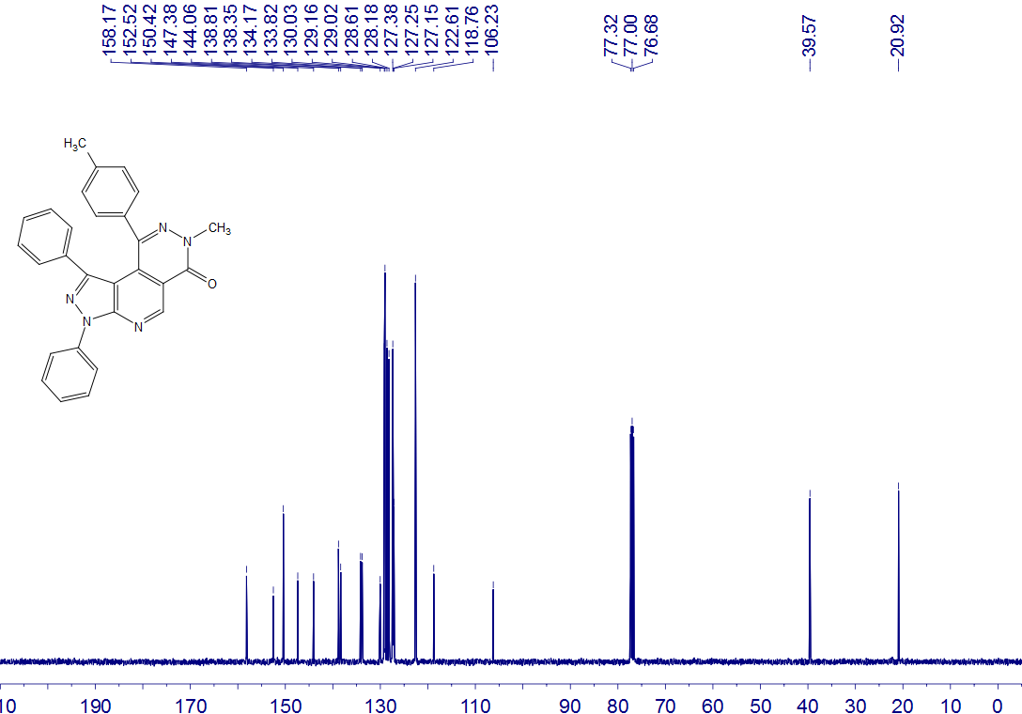
6f
CDCl₃
100 MHz

6g
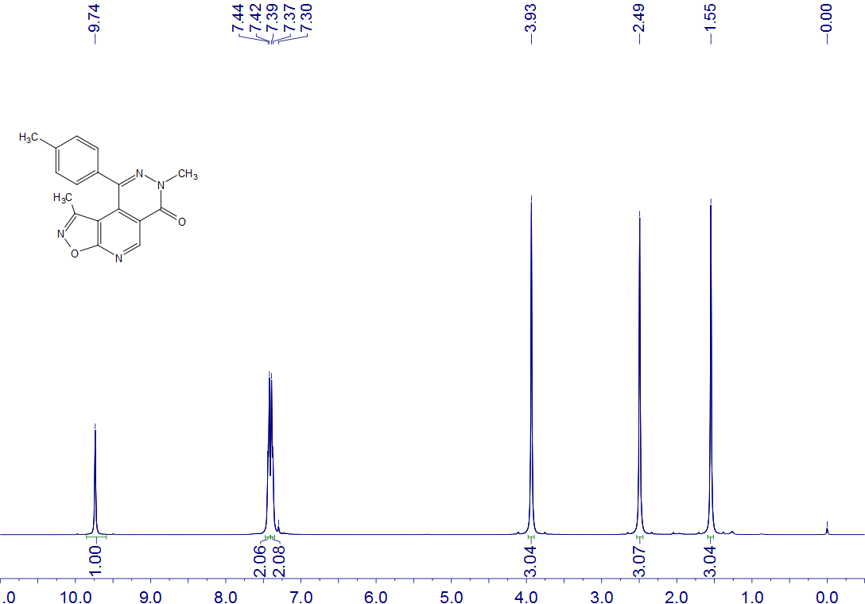
6g
CDCl₃
400 MHz

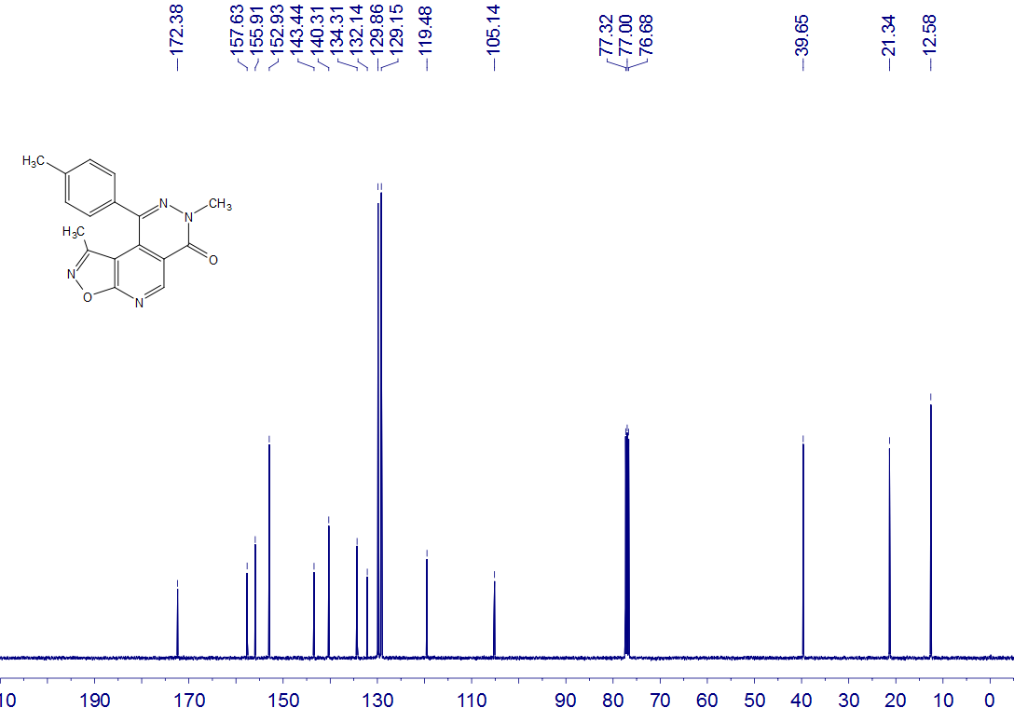
6g
CDCl₃
100 MHz

6h
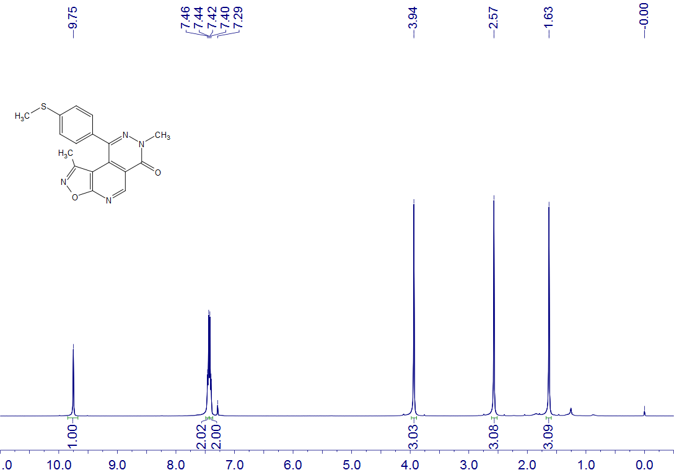
6h
CDCl₃
400 MHz

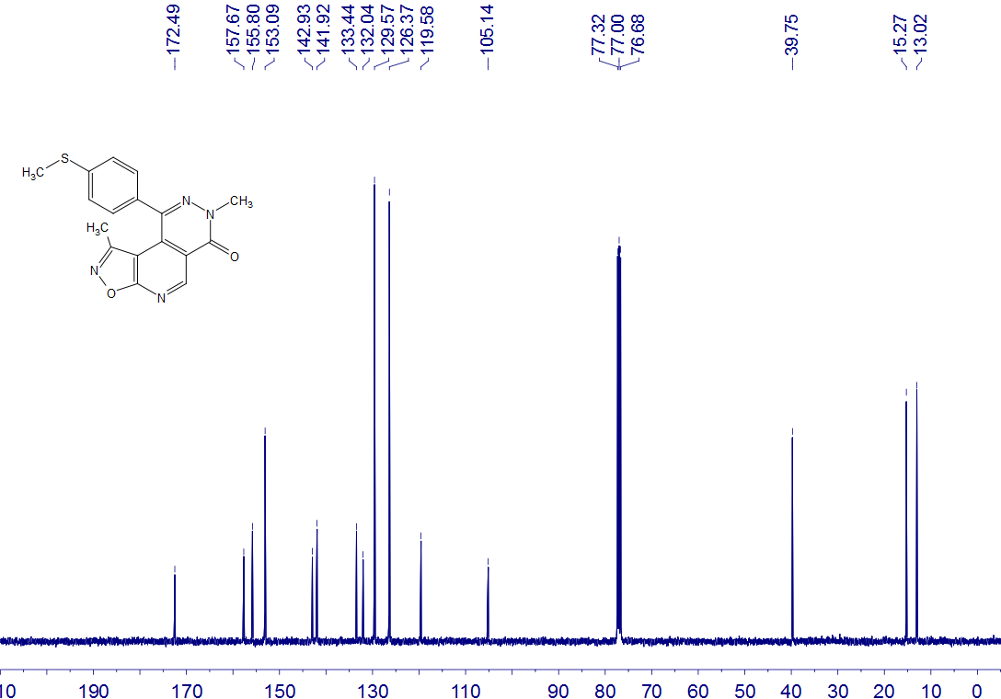
6h
CDCl₃
100 MHz

6i
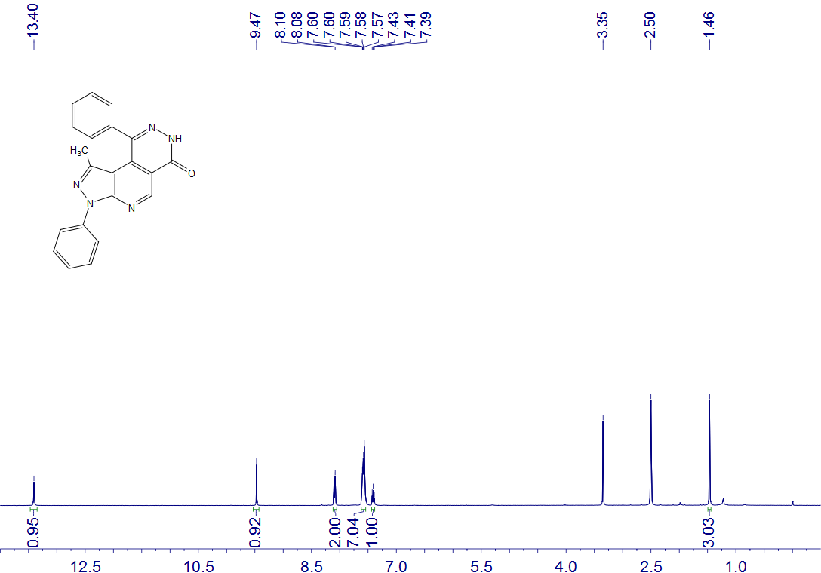
6i
DMSO-d₆
400 MHz

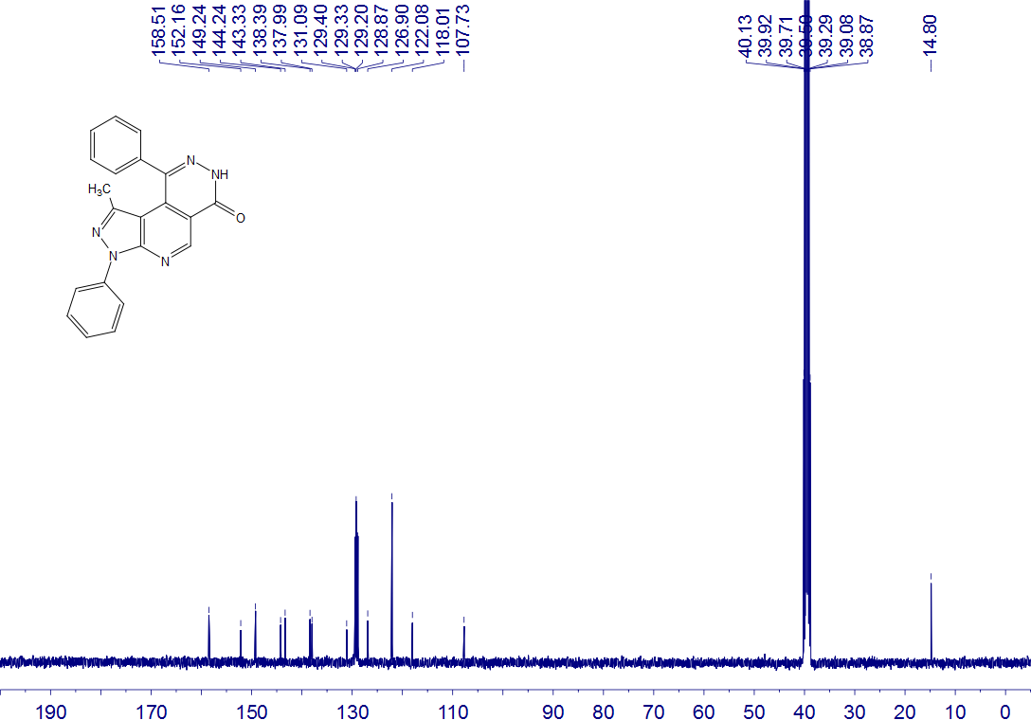
6i
DMSO-d₆
100 MHz

6j
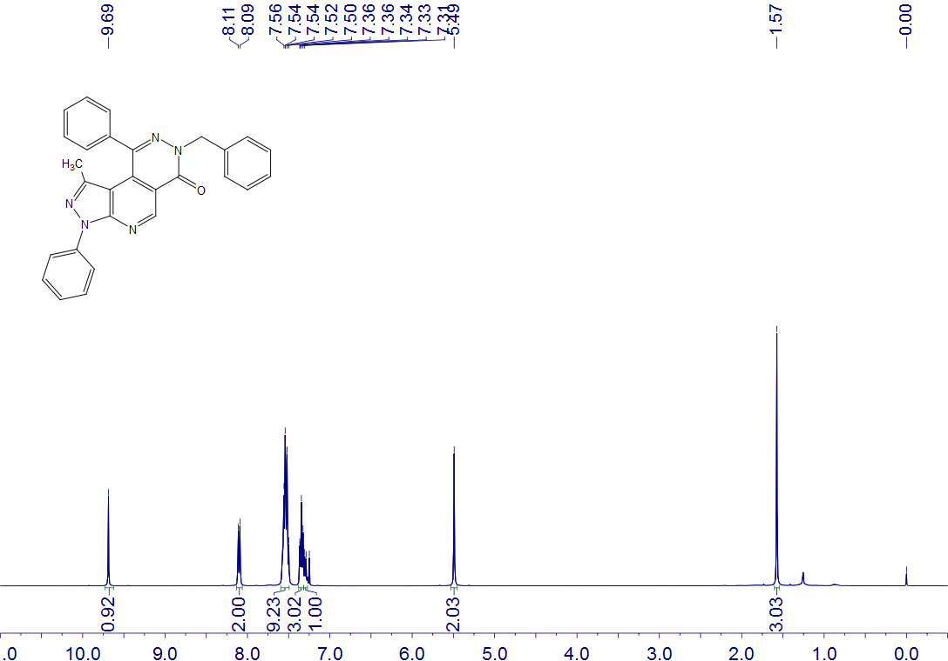
6j
CDCl₃
400 MHz

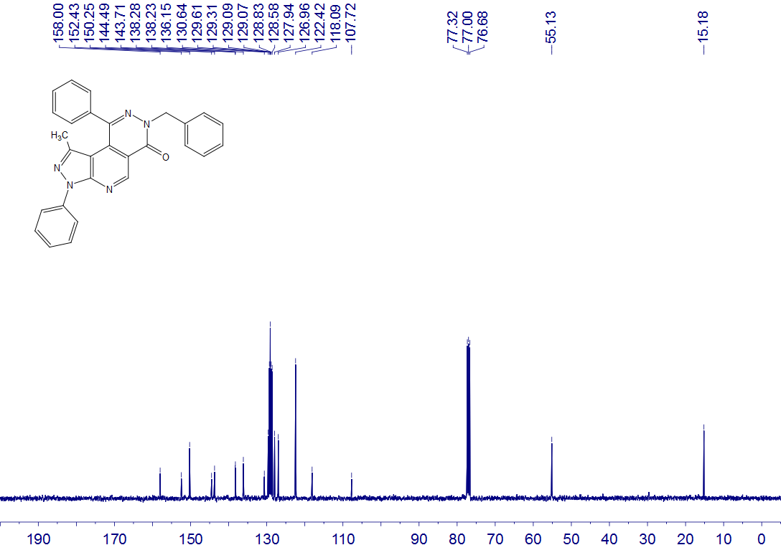
6j
CDCl₃
100 MHz

6k
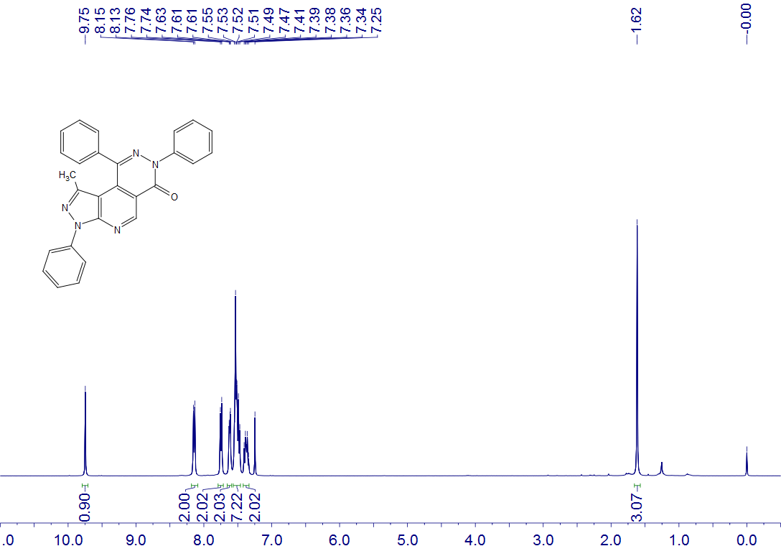
6k
CDCl₃
400 MHz

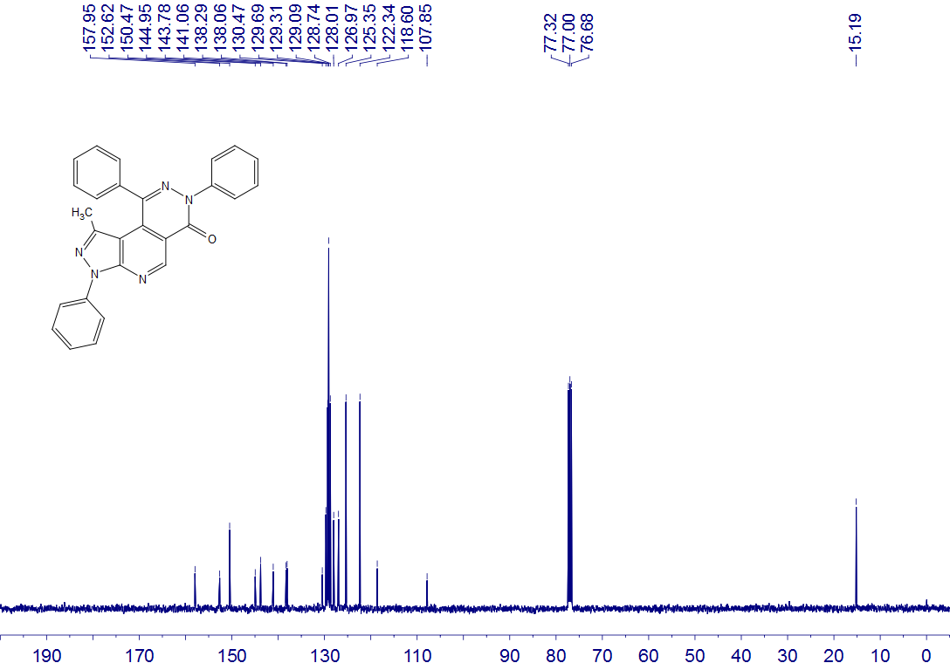
6k
CDCl₃
100 MHz

6l
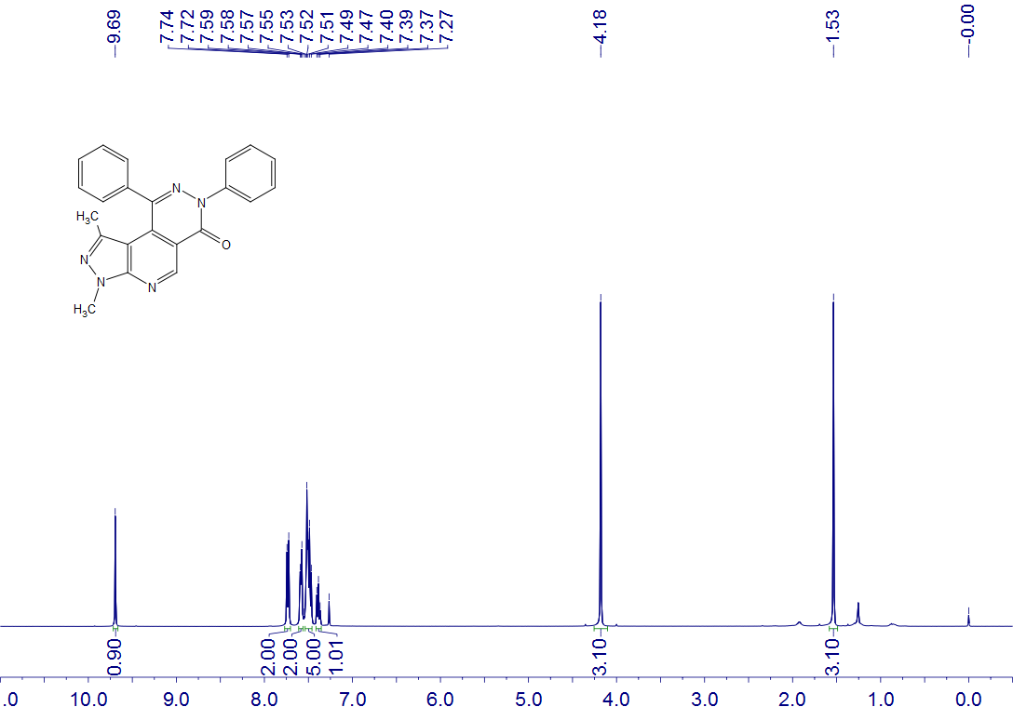
6l
CDCl₃
400 MHz

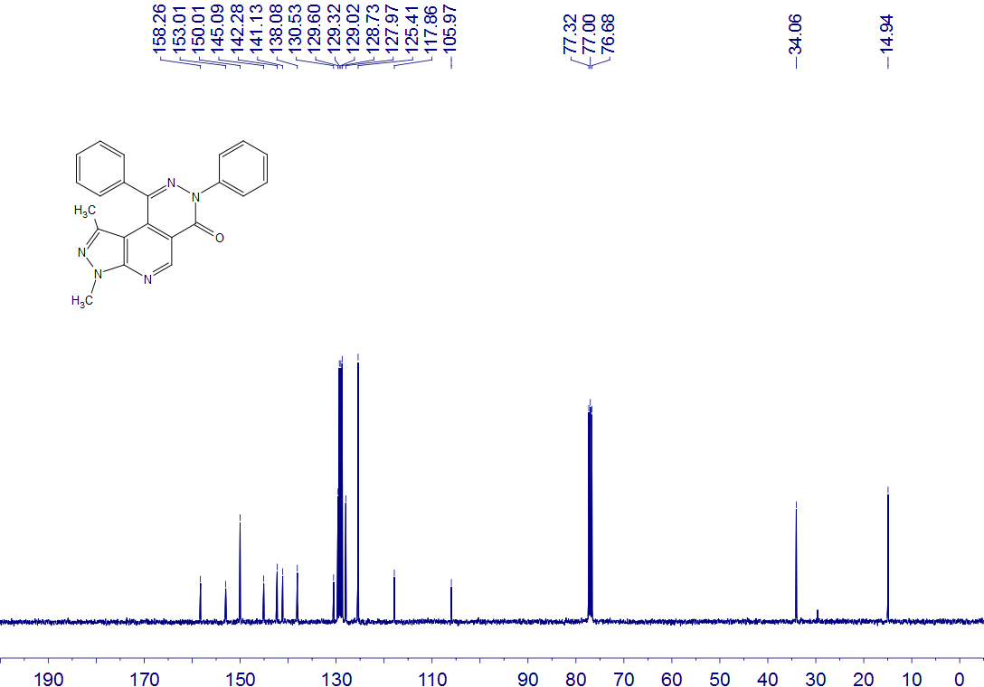
6l
CDCl₃
100 MHz

6m
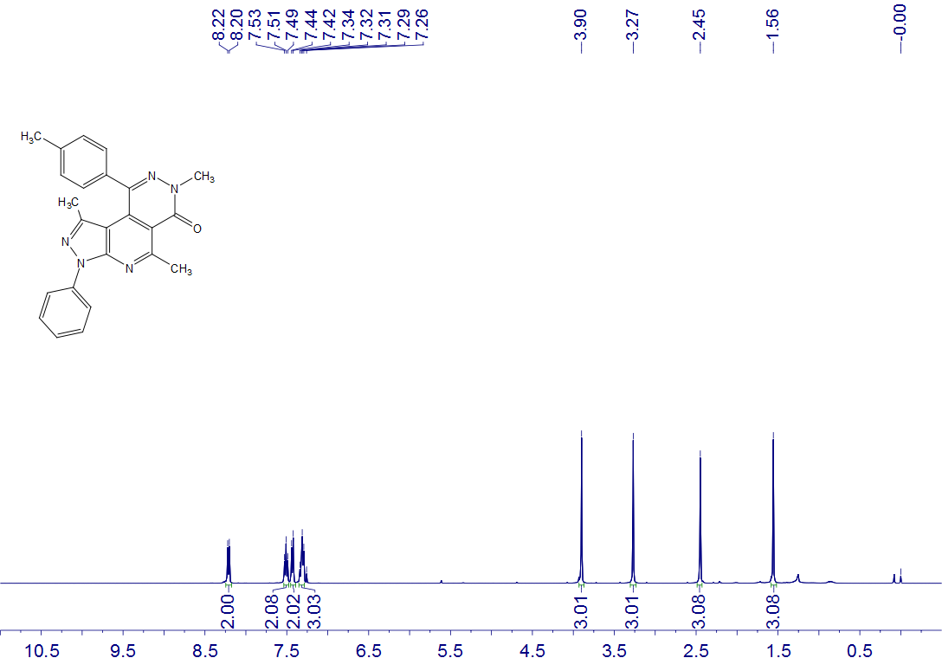
6m
CDCl₃
400 MHz

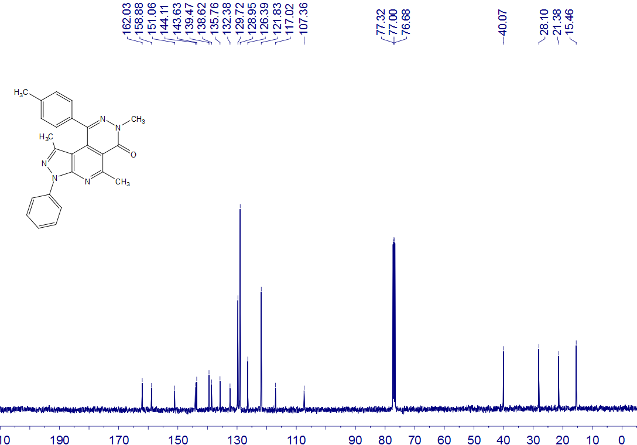
6m
CDCl₃
100 MHz

6n
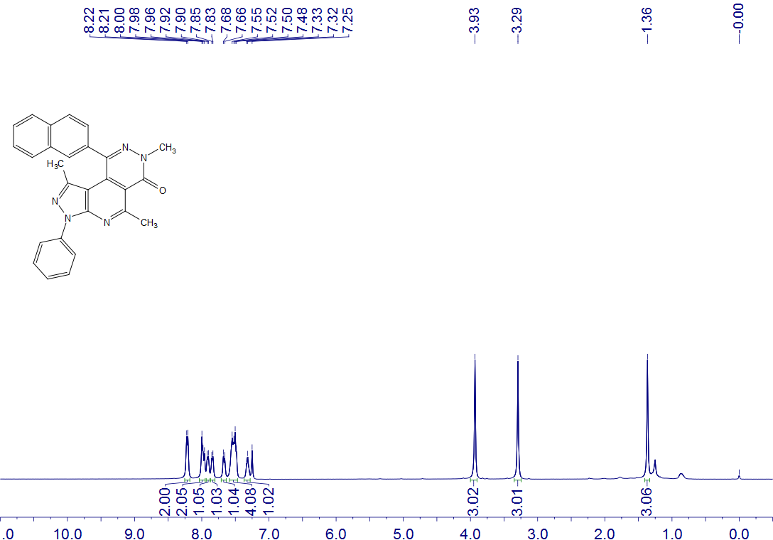
6n
CDCl₃
400 MHz

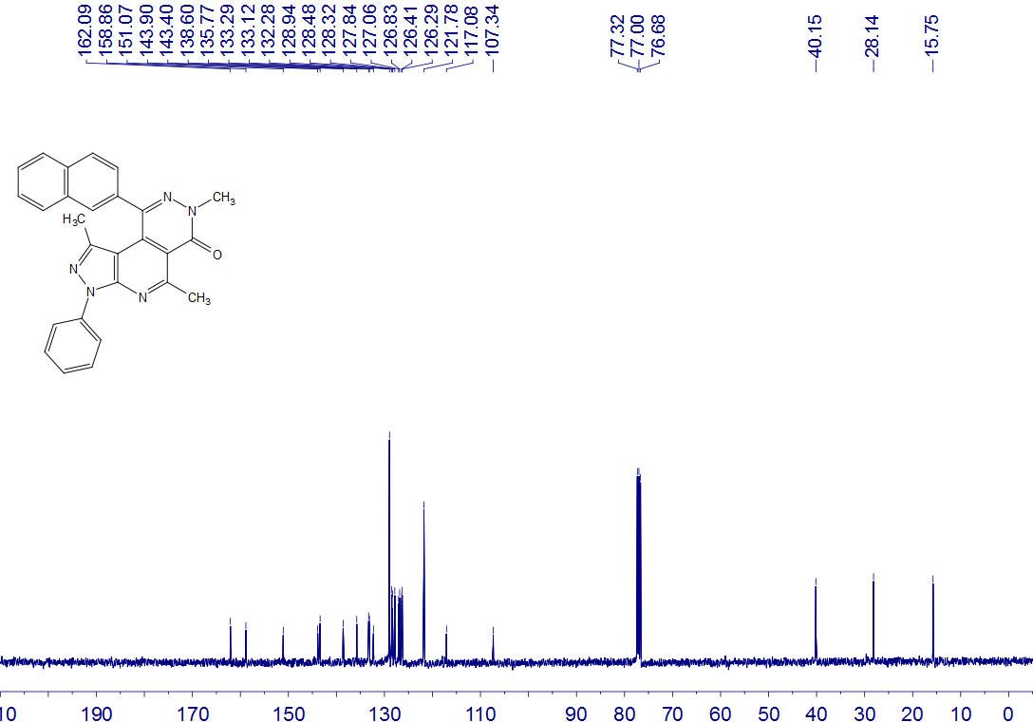
6n
CDCl₃
100 MHz

6o
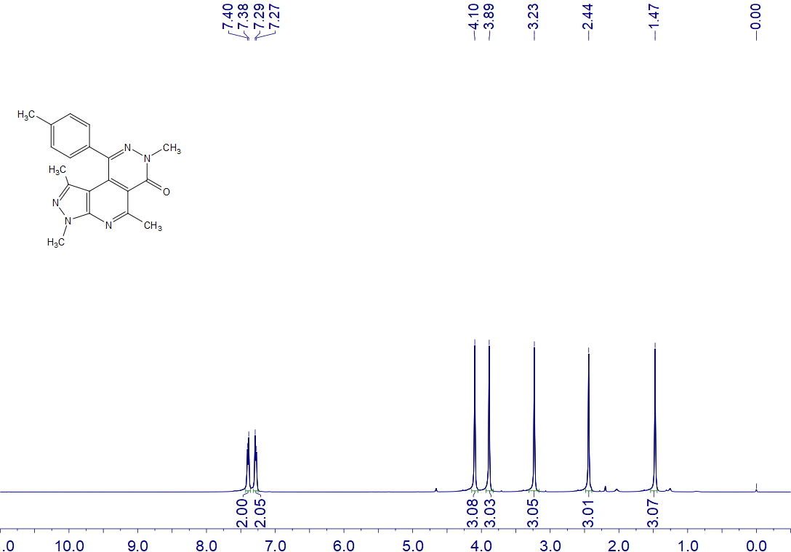
6o
CDCl₃
400 MHz

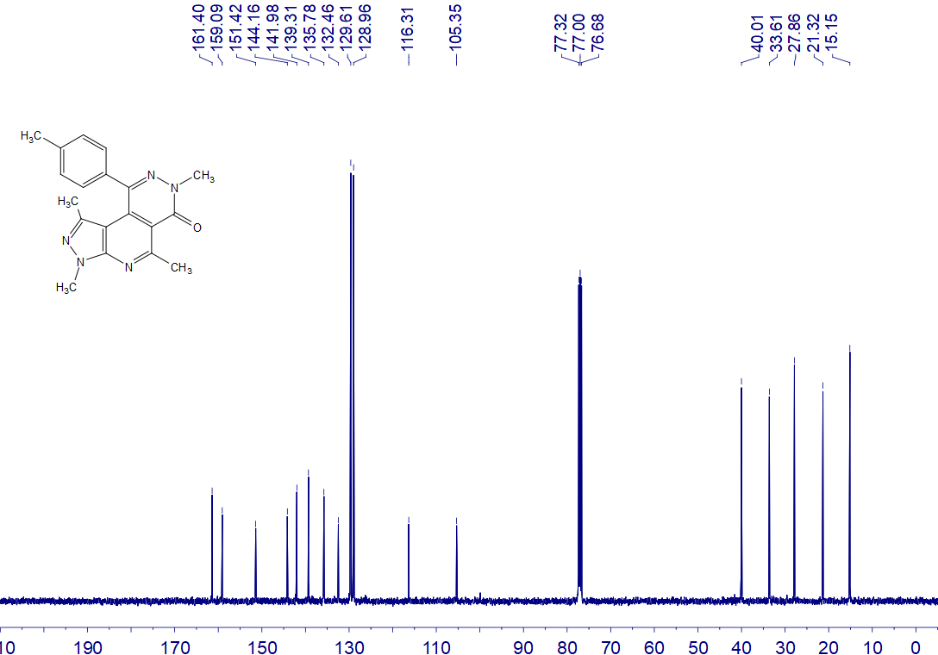
6o
CDCl₃
100 MHz

6p
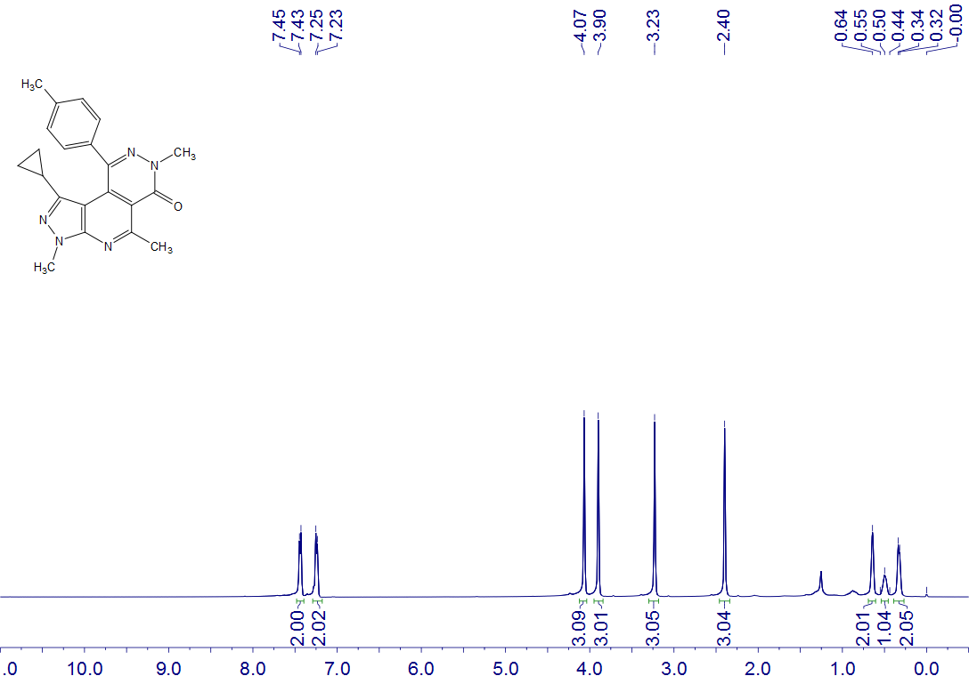
6p
CDCl₃
400 MHz

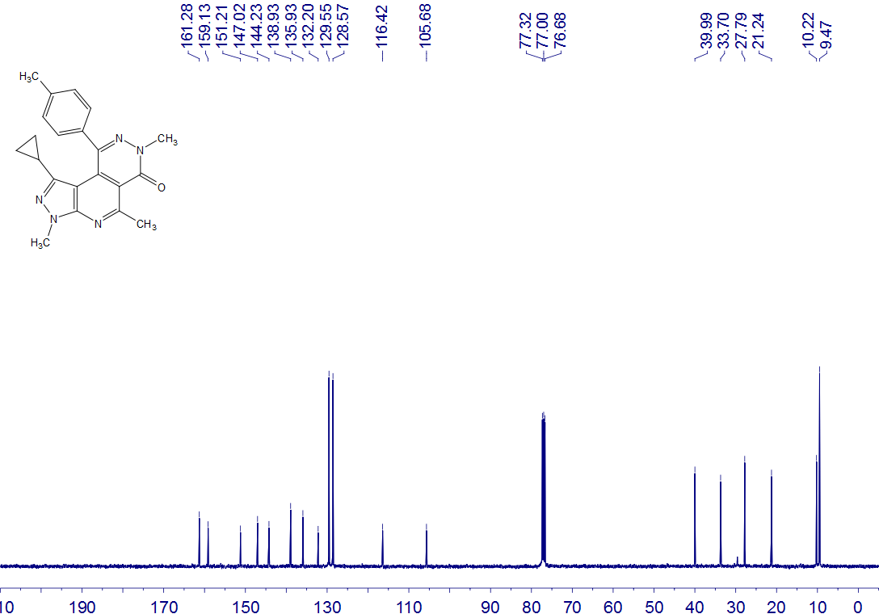
6p
CDCl₃
100 MHz

7a
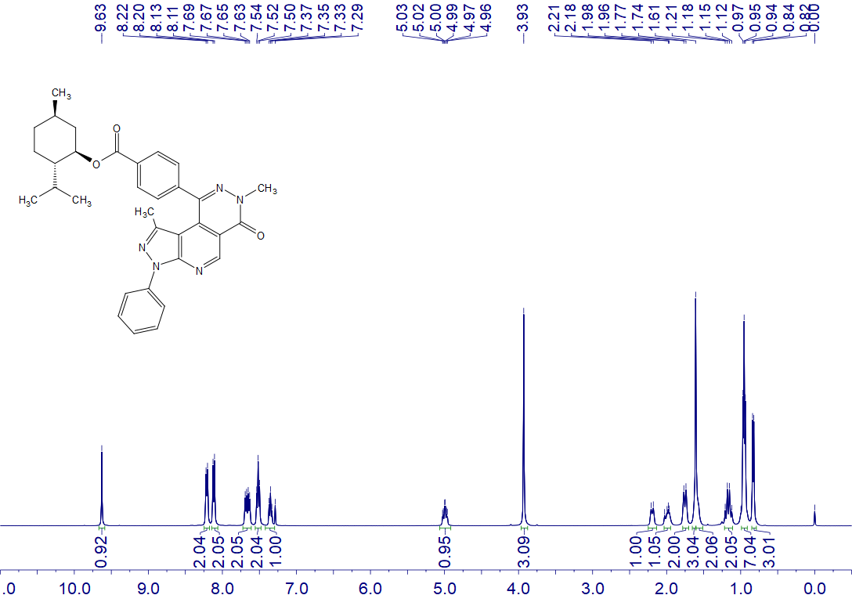
7a
CDCl₃
400 MHz

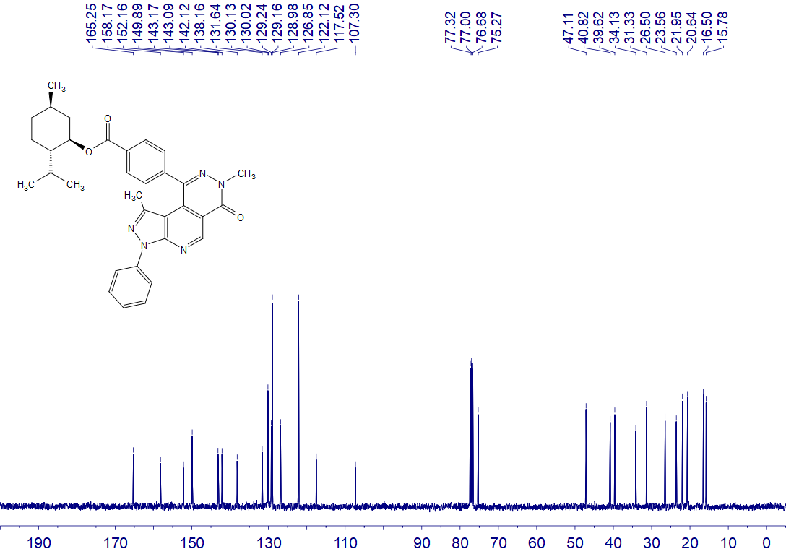
7a
CDCl₃
100 MHz

7b
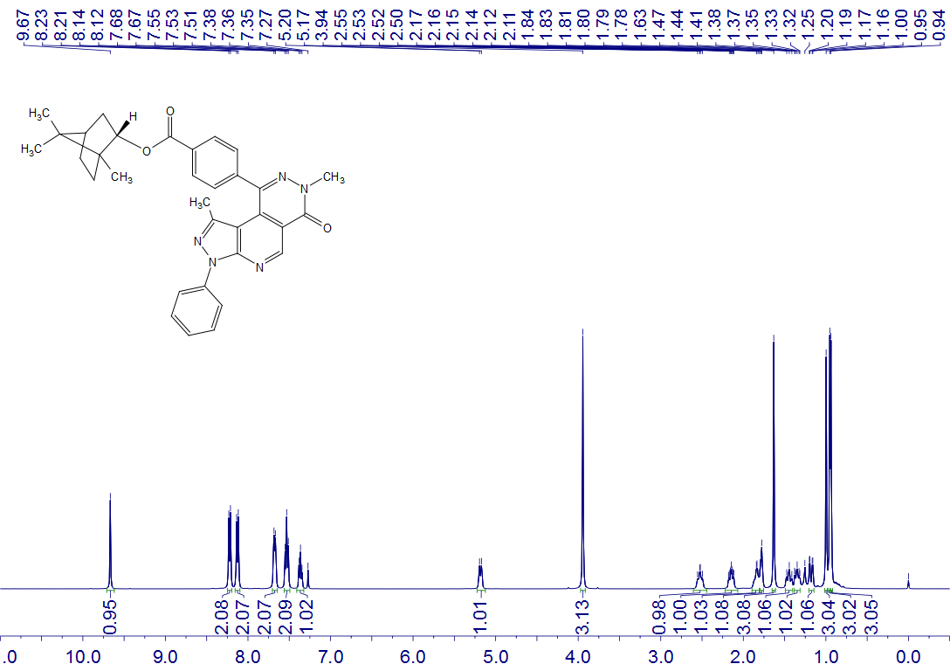
7b
CDCl₃
400 MHz

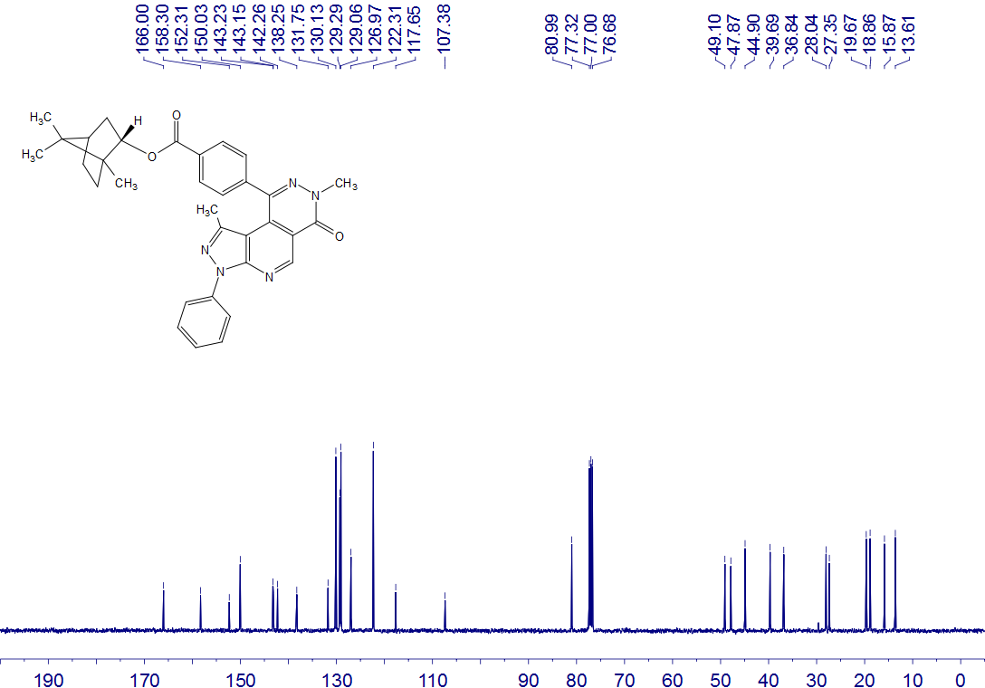
7b
CDCl₃
400 MHz

7c
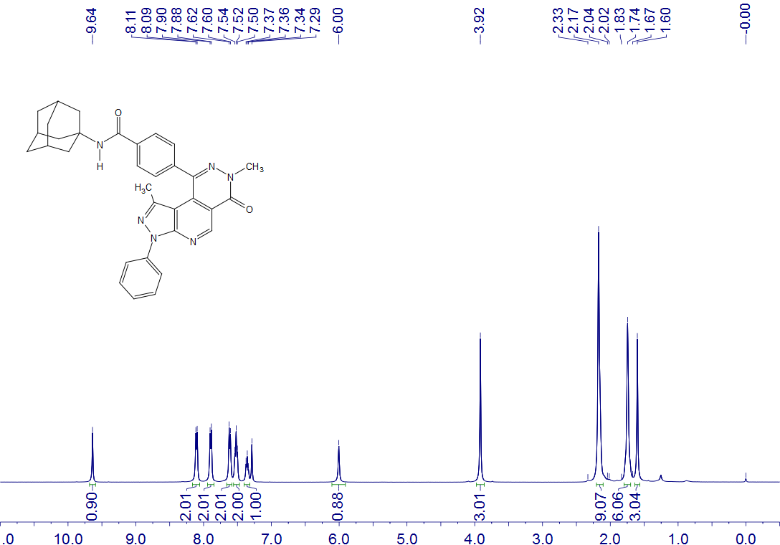
7c
CDCl₃
400 MHz

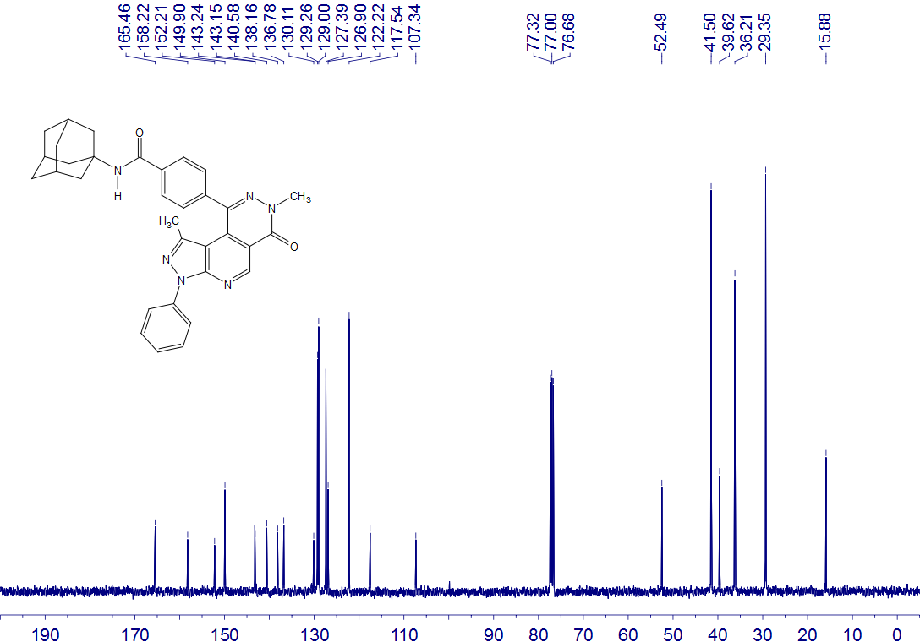
7c
CDCl₃
400 MHz

7d
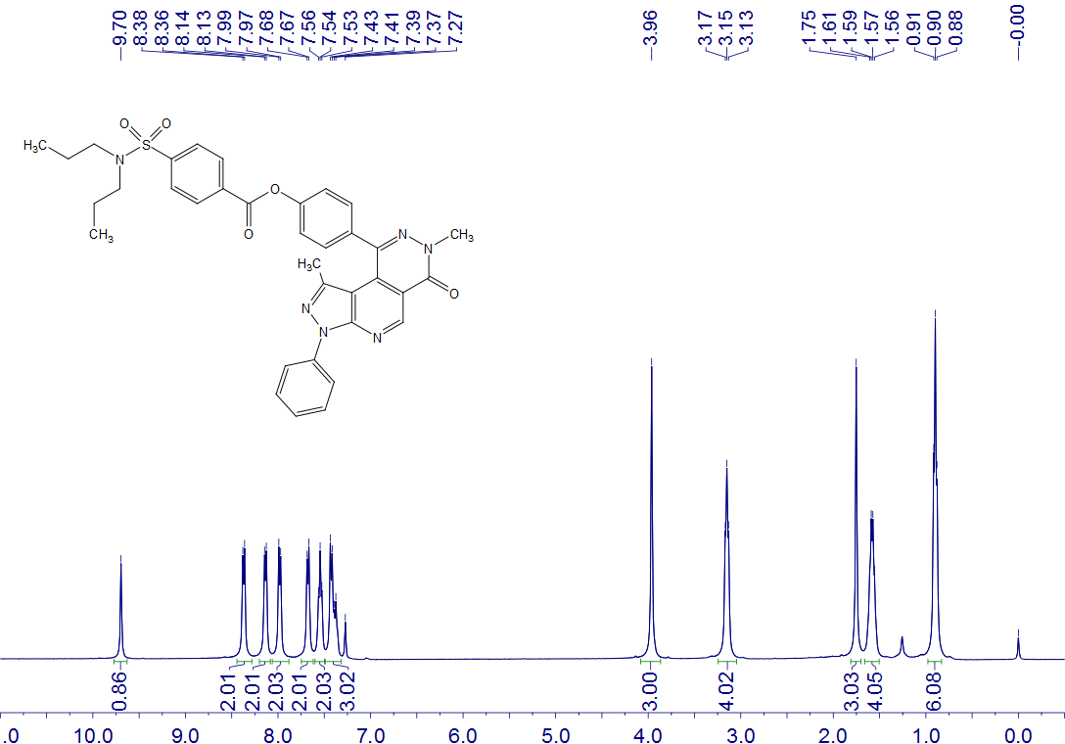
7d
CDCl₃
400 MHz

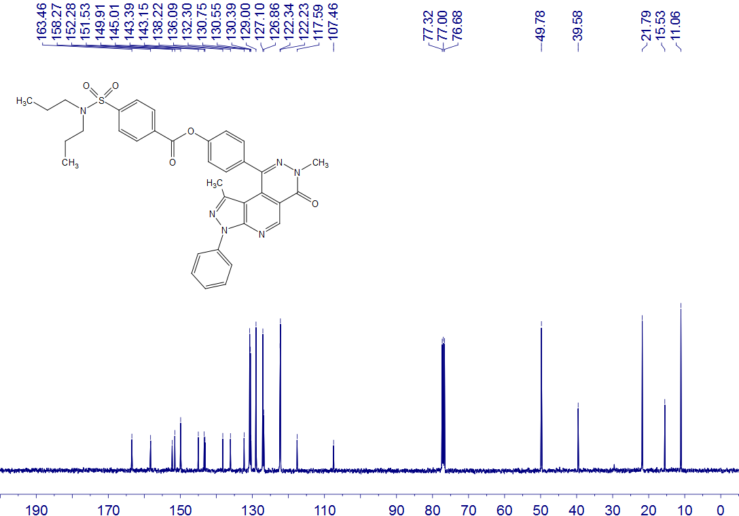
7d
CDCl₃
100 MHz

7e
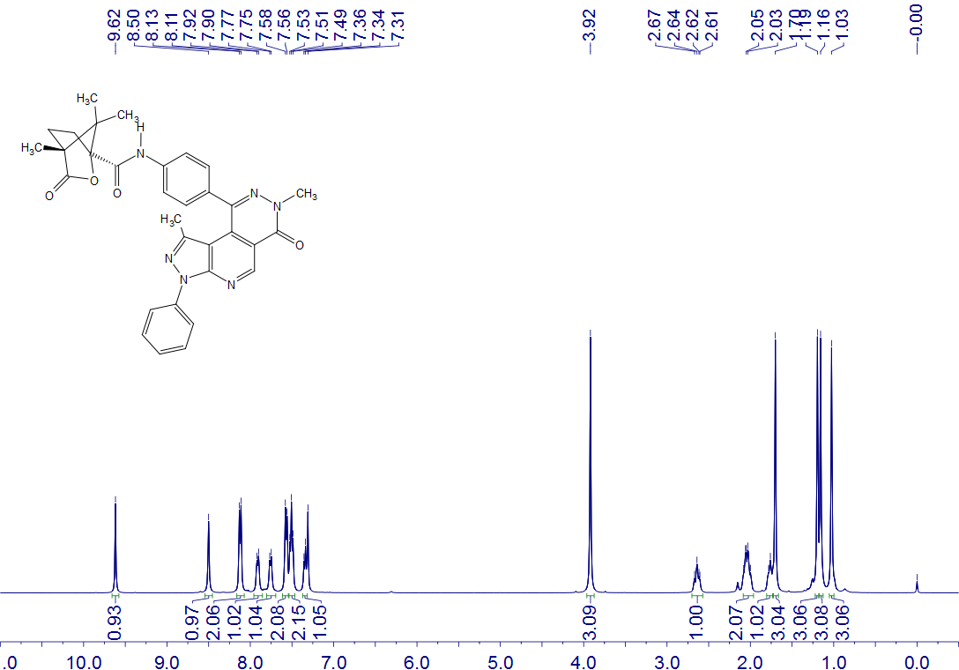
7e
CDCl₃
400 MHz

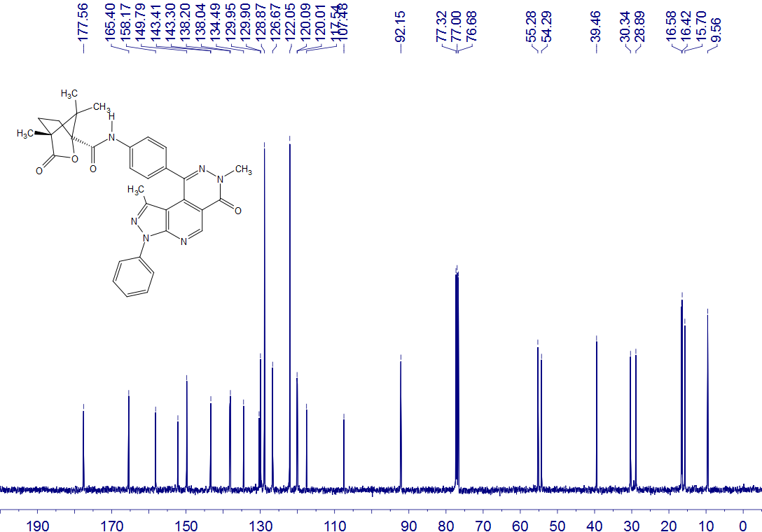
7e
CDCl₃
100 MHz

7f
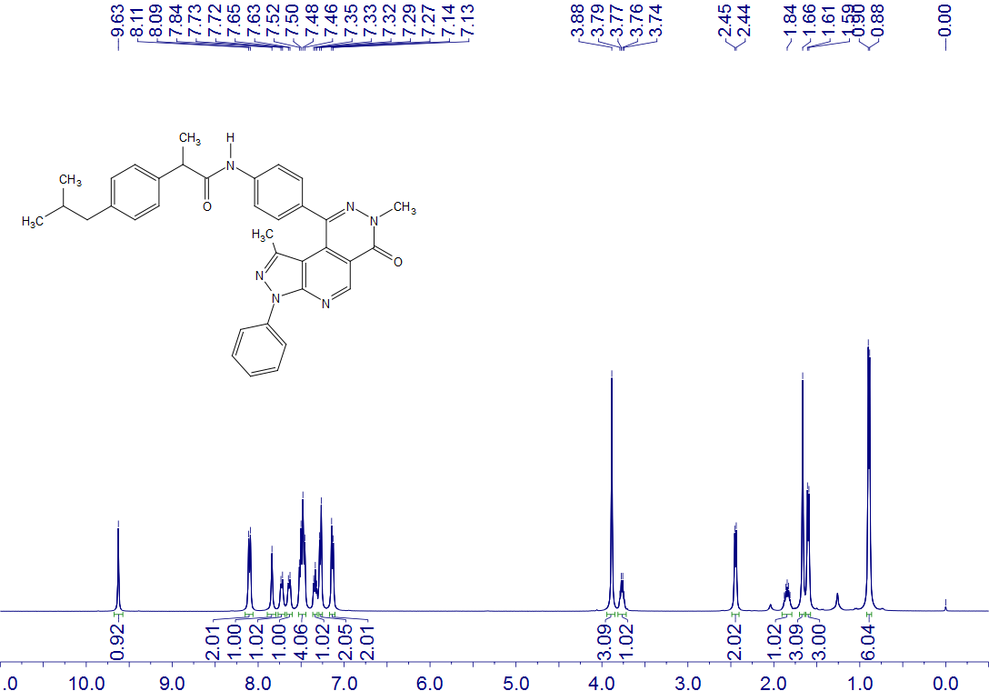
7f
CDCl₃
400 MHz

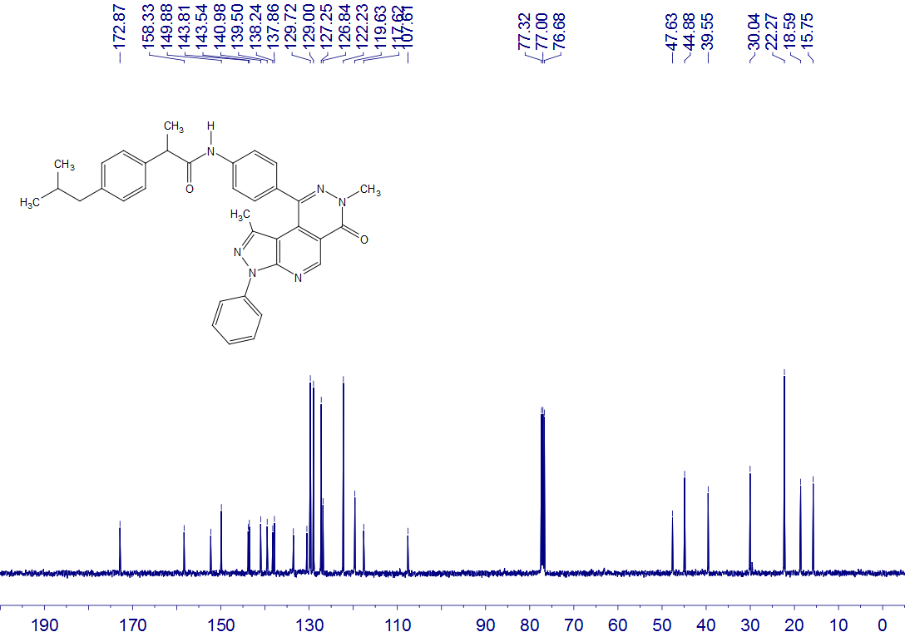
7f
CDCl₃
100 MHz

8
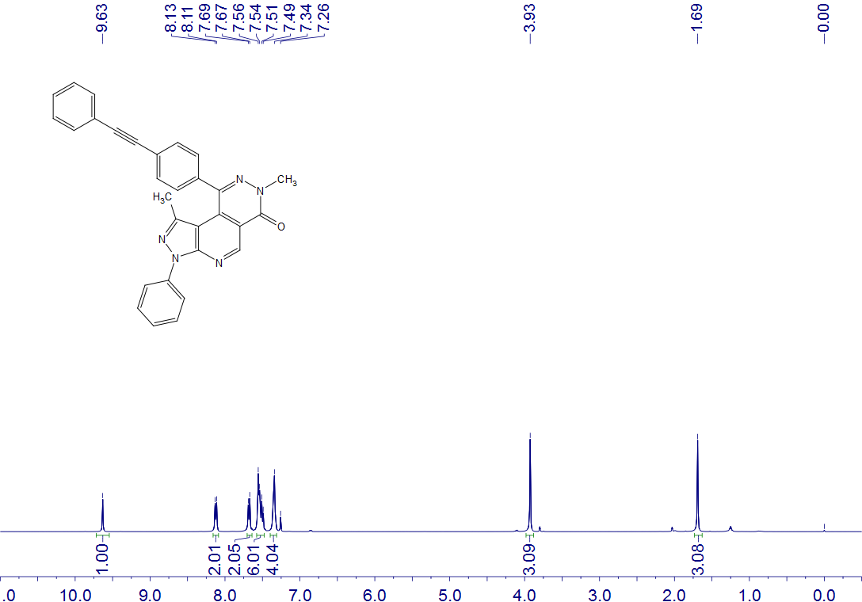
8
CDCl₃
400 MHz

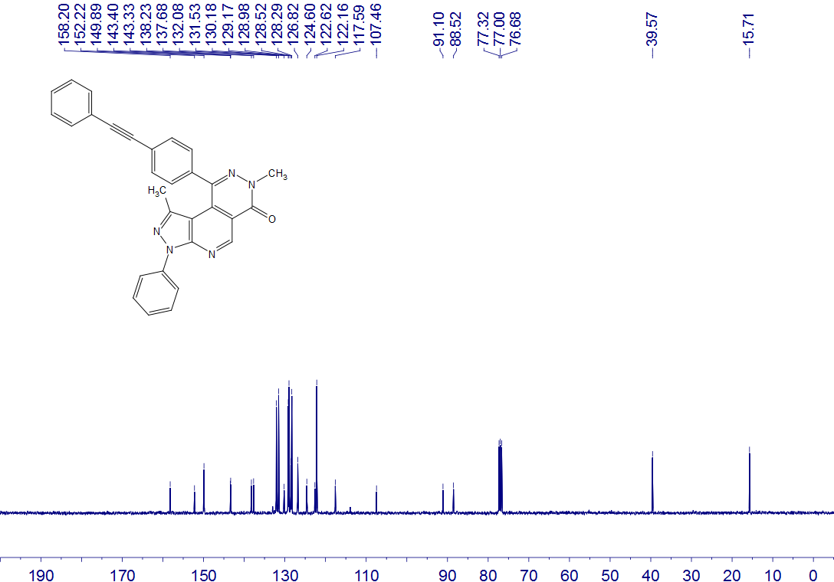
8
CDCl₃
100 MHz

9
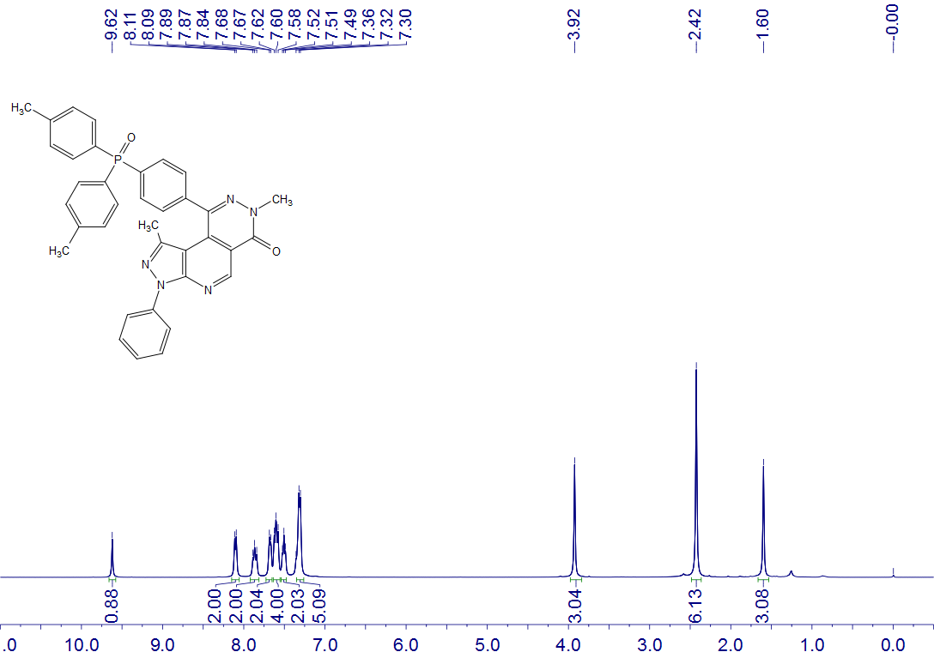
9
CDCl₃
400 MHz

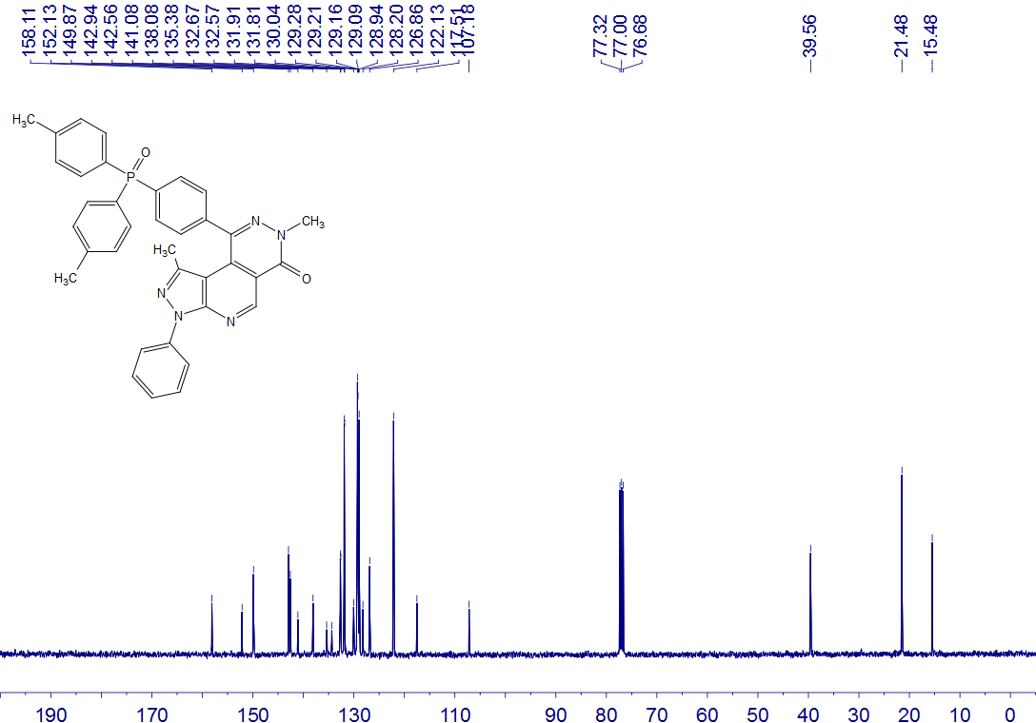
9
CDCl₃
100 MHz

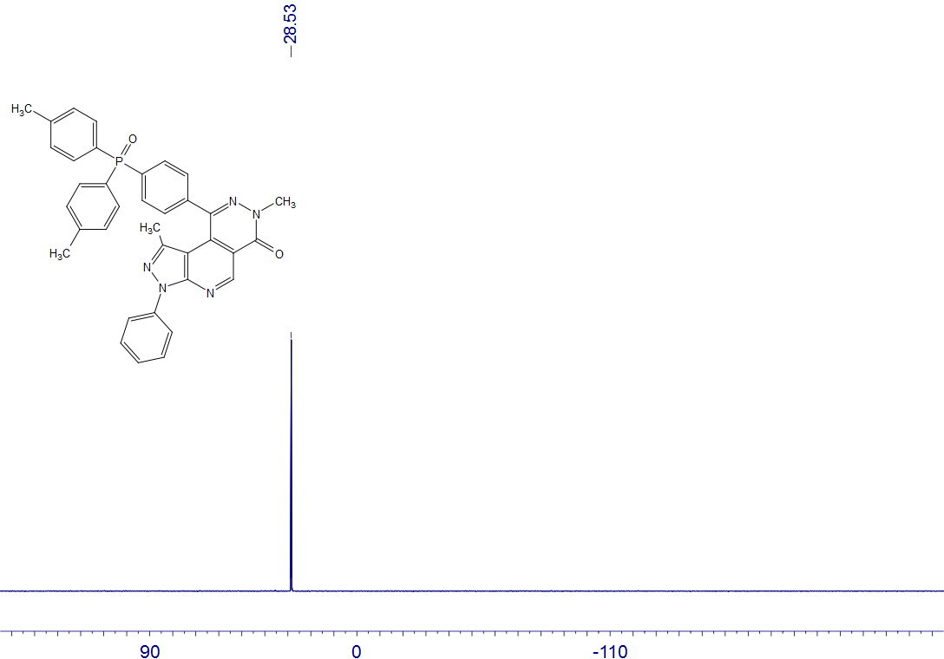
9
CDCl₃
162 MHz

10
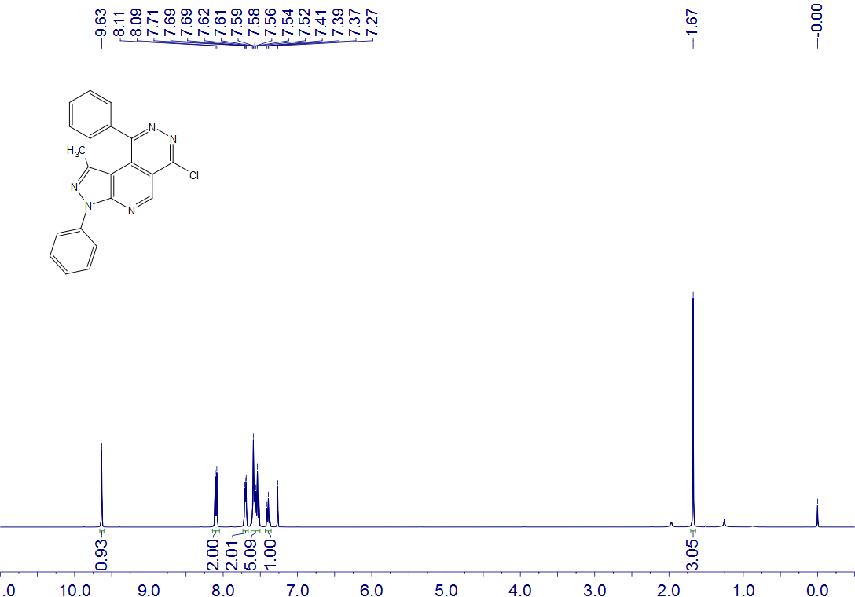
10
CDCl₃
400 MHz

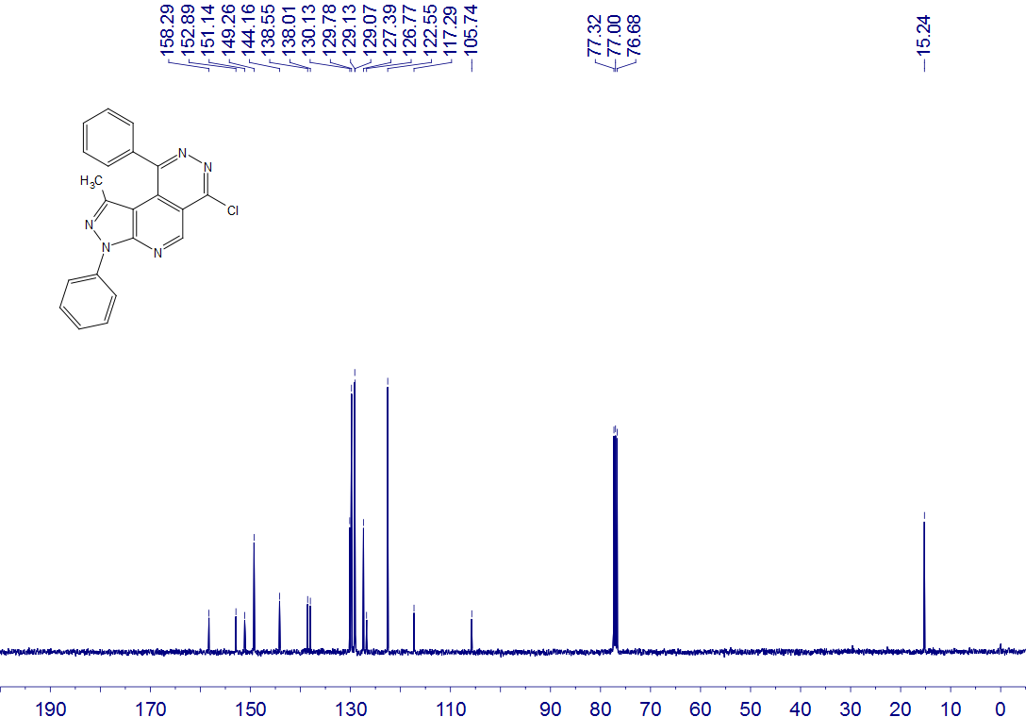
10
CDCl₃
100 MHz

