Rationally designed universal passivator for high-performance single-junction and tandem perovskite solar cells
Yinsu Feng^{a,1}, Jike Ding^{a,1}, Quanxing Ma^{a,b,1}, Hong Zhang^{b,*}, Jiajia Zhang^{c,*}, Zuolin Zhangª, Mengjia Liª, Taoran Gengª, Wenhuan Gaoª, Yang Wang^{d,*}, Boxue Zhang^{e}, Thierry Pauporté^{e}, Jian-Xin Tang^{e *}, Hongjian Chenª, Jiangzhao Chen^{g,*}, Cong Chen^{a,f*}

ª State Key Laboratory of Reliability and Intelligence of Electrical Equipment, School of Materials Science and Engineering, Hebei University of Technology, Tianjin 300401, China
^{b} State Key Laboratory of Photovoltaic Science and Technology, Shanghai Frontiers Science Research Base of Intelligent Optoelectronics and Perception, Institute of Optoelectronics, Fudan University, Shanghai, P. R. China
^{c} Anhui Provincial Key Laboratory of Green Carbon Chemistry, College of Chemistry and Materials Engineering, Fuyang Normal University, Fuyang 236037, China
^{d} CAS Key Laboratory of Green Printing, Beijing National Laboratory for Molecular Science (BNLMS), Institute of Chemistry, Chinese Academy of Sciences, Beijing, 100190 P. R. China
^{e} Chimie ParisTech, PSL Research University, CNRS, Institut de Recherche de Chimie Paris (IRCP), UMR8247, 11 rue P. et M. Curie, Paris, F-75005 France
^{f} Macao Institute of Materials Science and Engineering (MIMSE), Faculty of Innovation Engineering, Macau University of Science and Technology, Taipa, Macao, 999078 China
^{g} Faculty of Materials Science and Engineering, Kunming University of Science and Technology, Kunming 650093, China

¹ These authors contributed equally to this work.
*Corresponding authors
E-mail: hzhangioe@fudan.edu.cn (H.Z.); jjzh@wxc.edu.cn (J.Z.);wangyang@iccas.ac.cn (Y.W.), jxtang@must.edu.mo (J.T.), jzchen@kust.edu.cn (J.C.), chencong@hebut.edu.cn (C.C)

Tables in supporting information
Supplementary Table 1. Parameters of control, BGTS, VBETS, and LBETS modified devices with the best performance in reverse scan (RS) and forward scan (FS) test modes.
Samples  Test mode | V_{OC} (V) | Jsc (mA/cm²) | FF（%） | PCE（%） | HI（%）
Control RS | 1.16 | 25.47 | 79.28 | 23.44 | 4.39
Control FS | 1.15 | 25.37 | 76.69 | 22.41 | 4.39
BGTS RS | 1.17 | 25.66 | 79.32 | 23.82 | 2.73
BGTS FS | 1.16 | 25.66 | 77.74 | 23.17 | 2.73
VBETS RS | 1.20 | 25.98 | 81.35 | 25.26 | 1.15
VBETS FS | 1.20 | 26.01 | 80.35 | 24.97 | 1.15
LBETS RS | 1.18 | 25.87 | 81.27 | 24.77 | 2.26
LBETS FS | 1.18 | 25.70 | 80.16 | 24.21 | 2.26

Supplementary Table 2.Efficiency statistics of perovskite solar cells prepared in air in recent years
J_{sc} (mA/cm²) | V_{OC} (V) | FF（%） | PCE（%） | Ref.
21.45 | 0.94 | 77.00 | 15.60 | ¹
23.03 | 1.05 | 74.88 | 18.11 | ²
22.17 | 1.07 | 77.44 | 18.34 | ³
22.64 | 1.057 | 78.37 | 18.75 | ⁴
22.82 | 1.10 | 76.67 | 19.20 | ⁵
22.51 | 0.987 | 68.80 | 15.64 | ⁶
23.28 | 1.04 | 77.66 | 18.30 | ⁷
23.59 | 1.05 | 69 | 17.01 | ⁸
21.72 | 1.12 | 79 | 19.50 | ⁹
25.38 | 1.15 | 80.92 | 23.7 | ¹⁰
24.95 | 1.16 | 81.23 | 23.46 | ¹¹
16.98 | 1.334 | 81.61 | 18.49 | ¹²
22.06 | 1.14 | 79.85 | 19.83 | ¹³
22.05 | 1.168 | 80.92 | 20.84 | ¹⁴
21.63 | 1.14 | 76.85 | 19.00 | ¹⁵
22.37 | 1.13 | 77.95 | 20.01 | ¹⁶
23.52 | 1.11 | 82 | 21.30 | ¹⁷
24.92 | 1.164 | 82.87 | 24.04 | ¹⁸
24.85 | 1.188 | 80.26 | 23.69 | ¹⁹
25.75 | 1.16 | 81.23 | 23.46 | ²⁰
25.40 | 1.185 | 84.60 | 25.42 | ²¹
25.9 | 1.19 | 81.4 | 25.1 | ²²
25.68 | 1.191 | 82.28 | 25.15 | This work

Supplementary Table 3. Comparison of the historical PCEs of the PSC module with aperture area exceeding 30 cm². Specifically, * stands for the aperture area, and # stands for the active area for the PSC modules.
Area (cm²) | J_{sc} (mA/cm²) | V_{OC} (V) | FF（%） | PCE（%） | Ref.
36.1* | 1.97 | 10.5 | 75.7 | 15.7 | ²³
33.0* | - | - | - | 15.3 | ²⁴
42.9* | 19.71 | 13.142 | 73.5 | 15.86 | ²⁵
63.7* | 1.169 | 18.9 | 76.2 | 16.9 | ²⁶
53.64# | 1.890 | 13.56 | 69.6 | 17.82 | ²⁷
35.8* | 2.045 | 11.7 | 77.3 | 18.5 | ²⁸
65.0# | 1.67 | 15.35 | 76.1 | 19.54 | ²⁹
50* | 1.527 | 16.07 | 78 | 19.2 | ³⁰
64# | 1.457 | 18.43 | 76.60 | 20.6 | ³¹
81# | 1.71 | 15.46 | 76.3 | 20.15 | ³²
36# | 3 | 8.84 | 77.52 | 20.56 | ³³
33# | - | - | - | 20.31 | ³⁴
61.56# | 2.11 | 12.05 | 80.87 | 20.56 | ³⁵
70# | 1.34 | 20.71 | 73.54 | 20.5 | ³⁶
63.74* | 2.34 | 11.31 | 77.0 | 20.58 | ³⁷
100# | 1.452 | 17.98 | 80.60 | 21.04 | ³⁸
32.144* | 1.78 | 16.54 | 71.5 | 21.00 | This work
30.408# | 1.88 | 16.54 | 71.5 | 22.20 | This work

Figures in supporting information

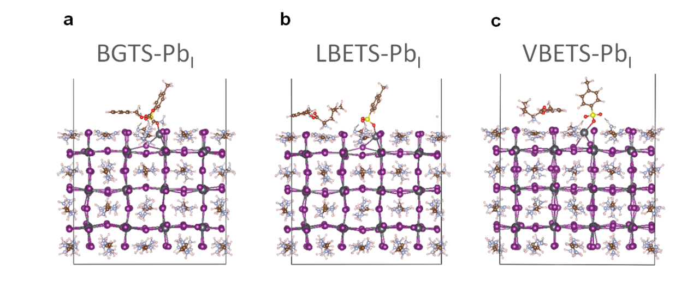
Supplementary Fig. 1. The passivation effect of three different organic salts for Pb²⁺ substituted I⁻ (Pb_{I}) defects.

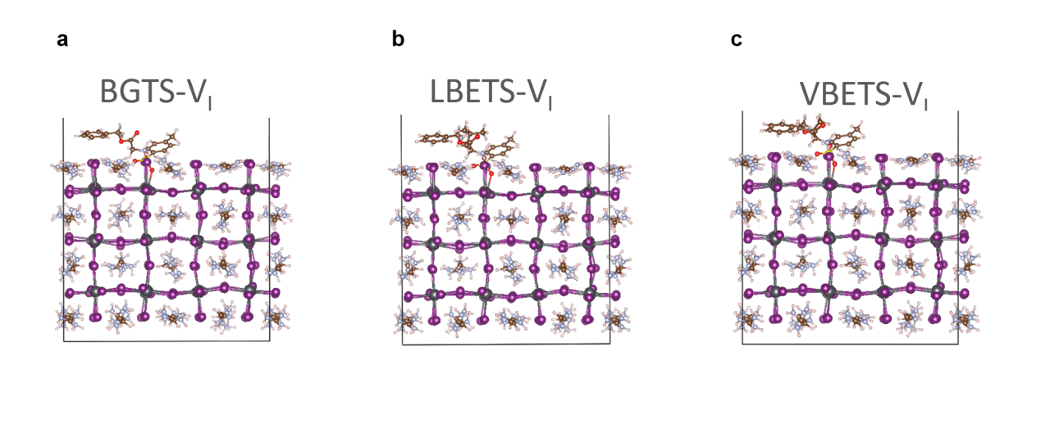
Supplementary Fig. 2. The passivation effect of three different organic salts for vacancy (V_{I}).

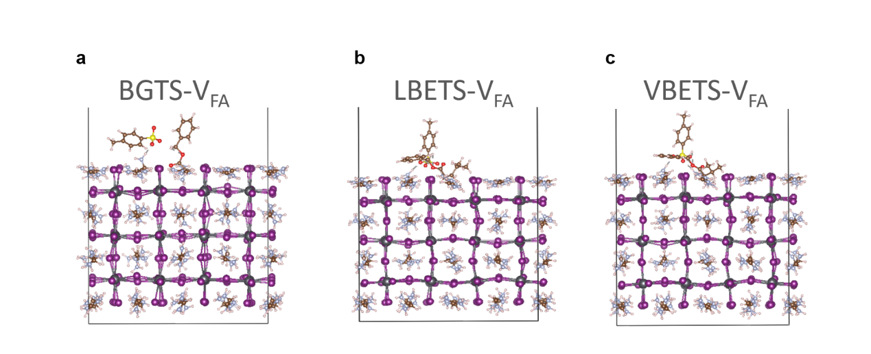
Supplementary Fig. 3. The passivation effect of three different organic salts for FA⁺ vacancy (V_{FA}).

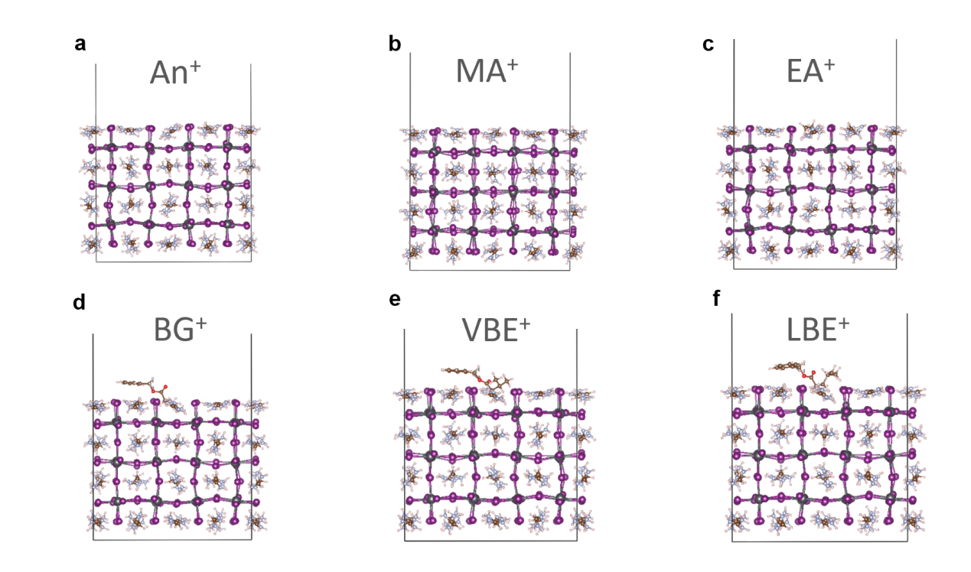
Supplementary Fig. 4. The binding energies of NH₄⁺ (An⁺), CH₃NH₃⁺ (MA⁺), CH₃CH₂NH₃⁺ (EA⁺), BG⁺, VBE⁺ and LBE⁺ with FAPbI₃ containing V_{FA} defects on the surface.

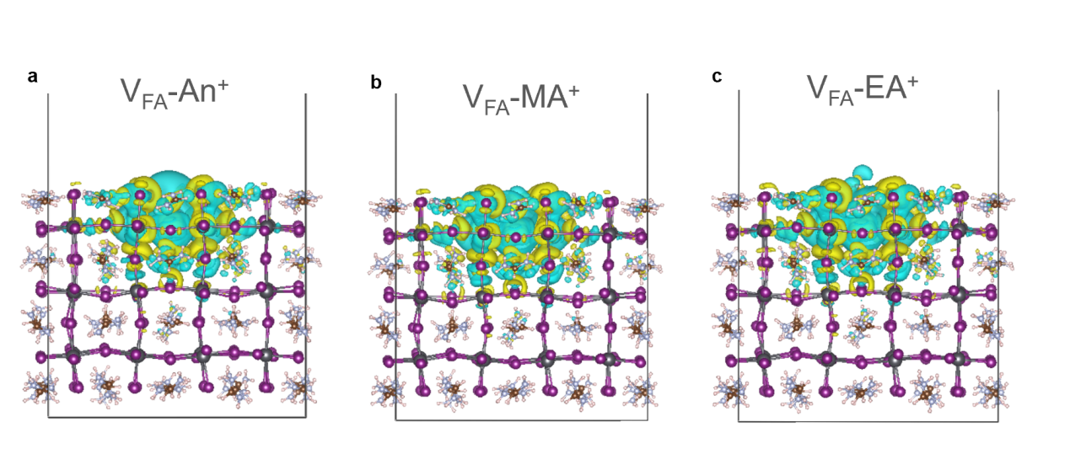
Supplementary Fig. 5. The charge density difference of An⁺, MA⁺ and EA⁺ with FAPbI₃ surface encompassing V_{FA} defects.

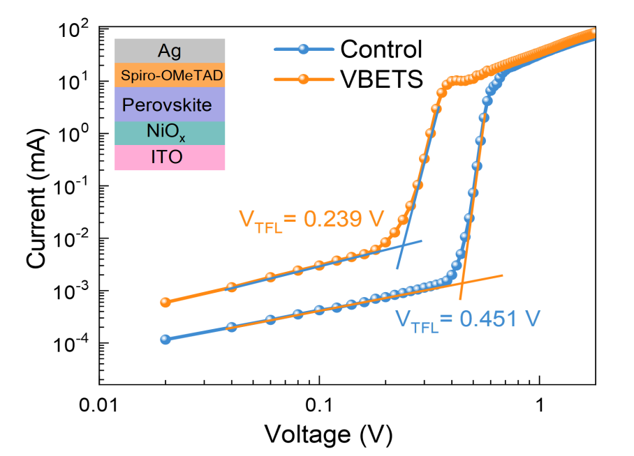
Supplementary Fig 6. I-V curves of the devices based on the structure of ITO/NiO_{x}/perovskite/Spiro-OMeTAD/Ag under dark.

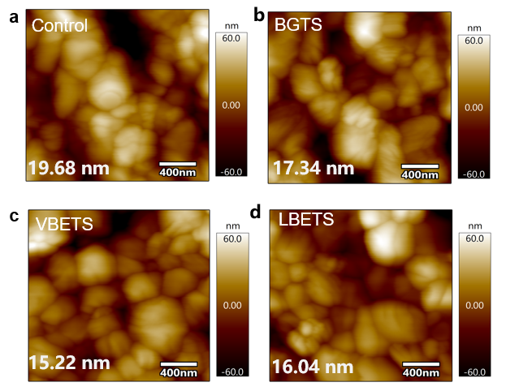
Supplementary Fig. 7. AFM image of the (a) control, (b) BGTS, (c) VBETS, and (d) LBETS-modified perovskite films.

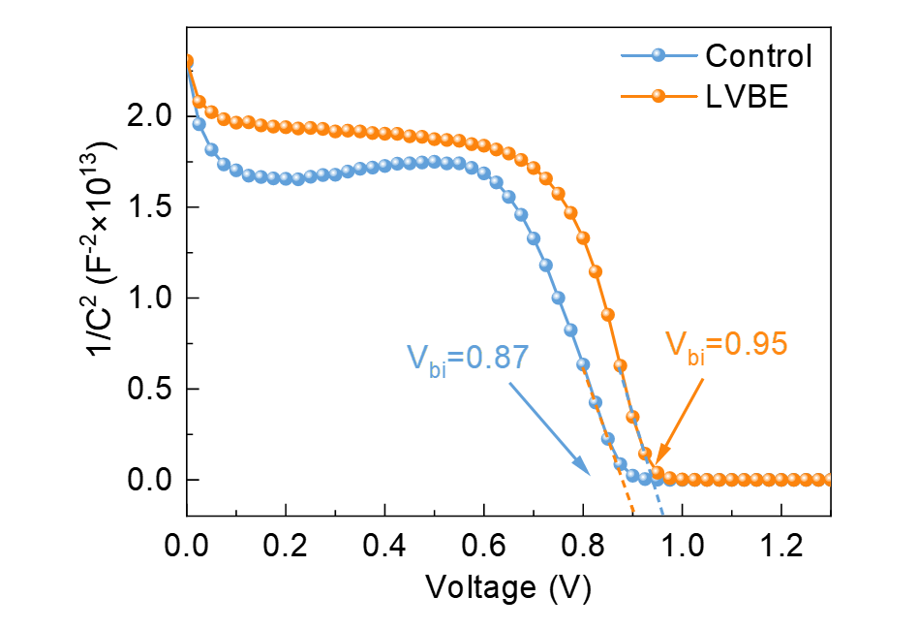
Supplementary Fig. 8. Mott−Schottky plots of the control and VBETS-modified PSCs.

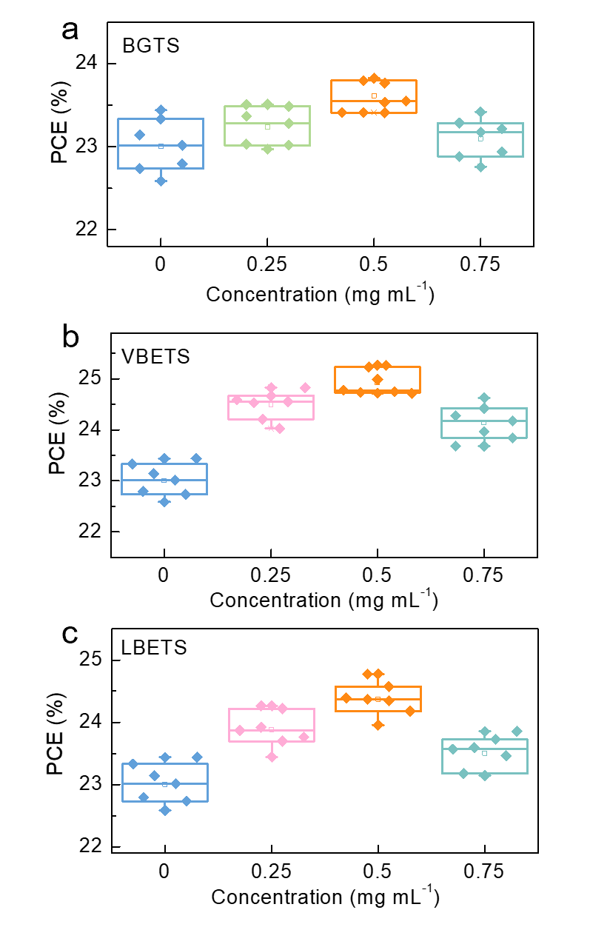
Supplementary Fig. 9. a-c, Statistical distribution diagram of the photovoltaic efficiency parameters of devices modified with different concentrations of (a) BGTS, (b) VBETS and (c) LBETS.

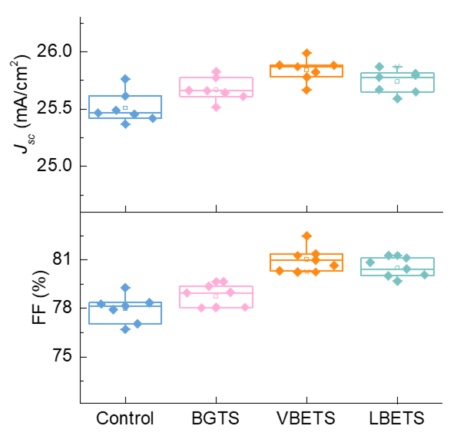
Supplementary Fig. 10. Statistical distribution diagram of the J_{SC} and FF parameters of the control and BGTS, VBETS, and LBETS-modified devices employing conventional bandgap 1.53 eV-perovskite.

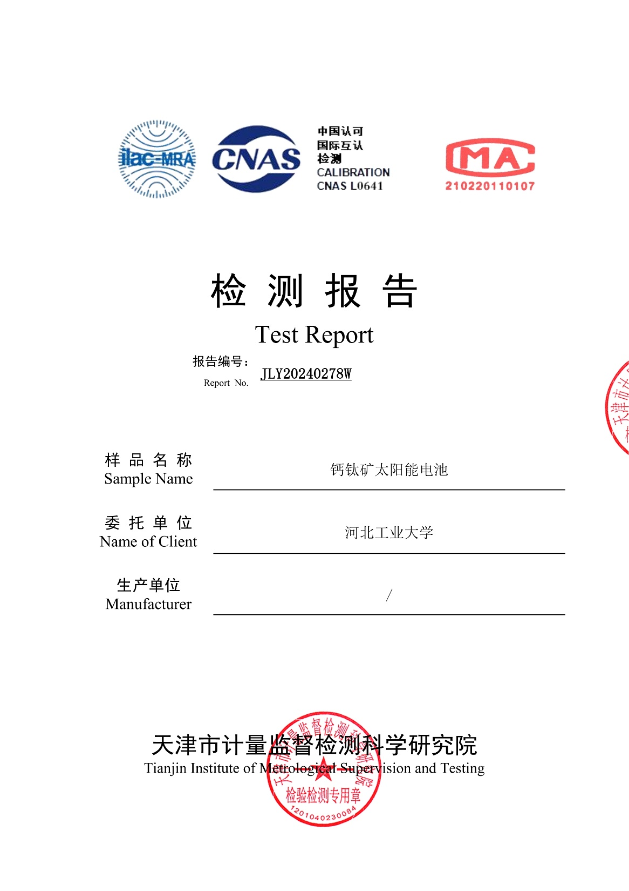
Supplementary Fig. 11. The efficiency testing report of NiOx and 1.53 eV- Cs_{0.05}MA_{0.05}FA_{0.9}PbI₃ based inverted p-i-n type perovskite solar cell devices prepared by the Cong Chen’ research group. The report consists of seven pages, and this is the first page. The testing agency is Tianjin Institute of Metrological Supervision and Testing, China.
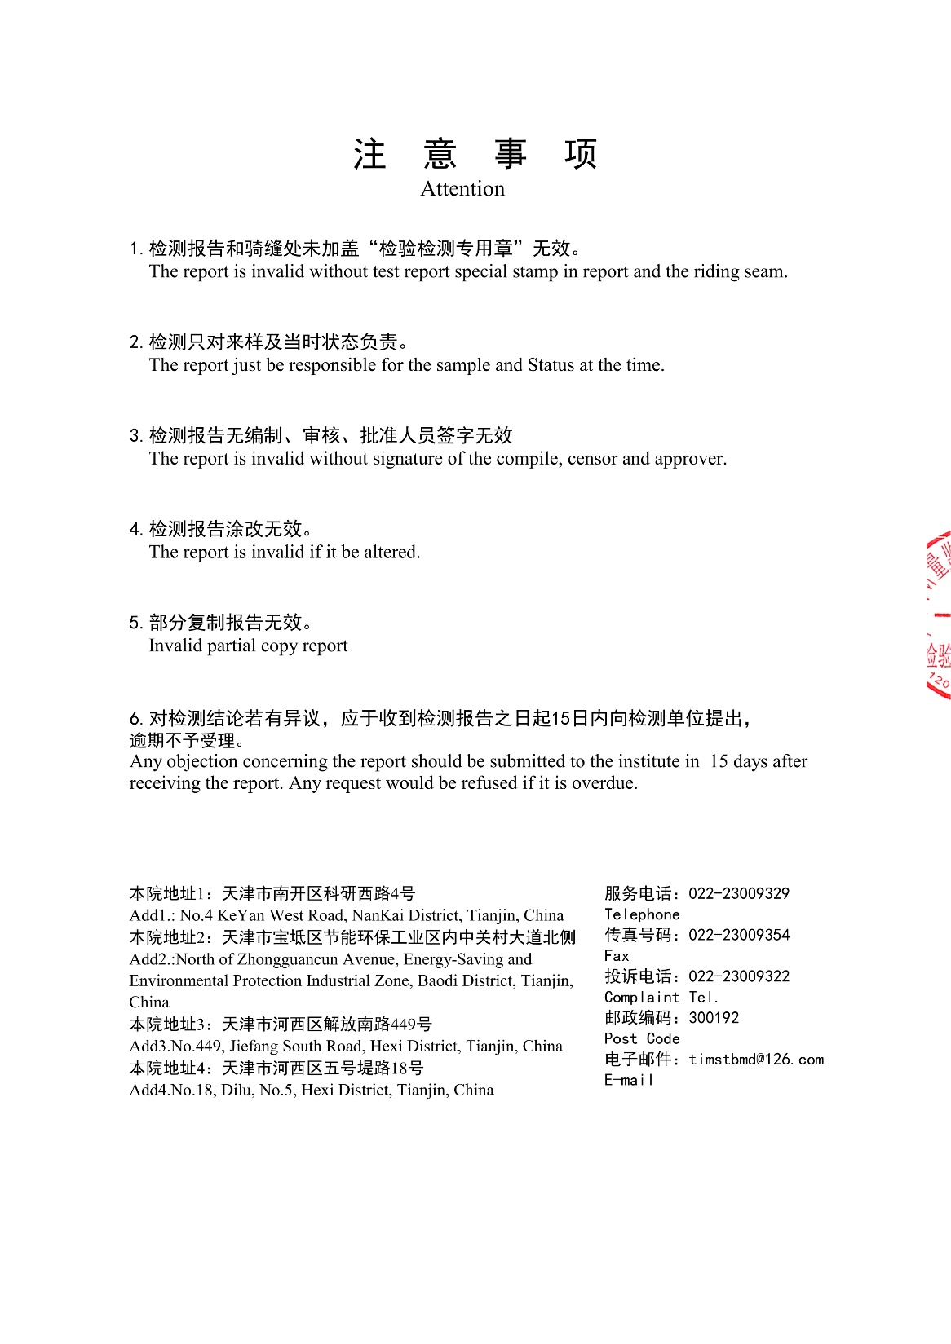
Supplementary Fig. 12. The efficiency testing report of NiOx and 1.53 eV- Cs_{0.05}MA_{0.05}FA_{0.9}PbI₃ based inverted p-i-n type perovskite solar cell devices prepared by the Cong Chen’ research group. The report consists of seven pages, and this is the second page. The testing agency is Tianjin Institute of Metrological Supervision and Testing, China.
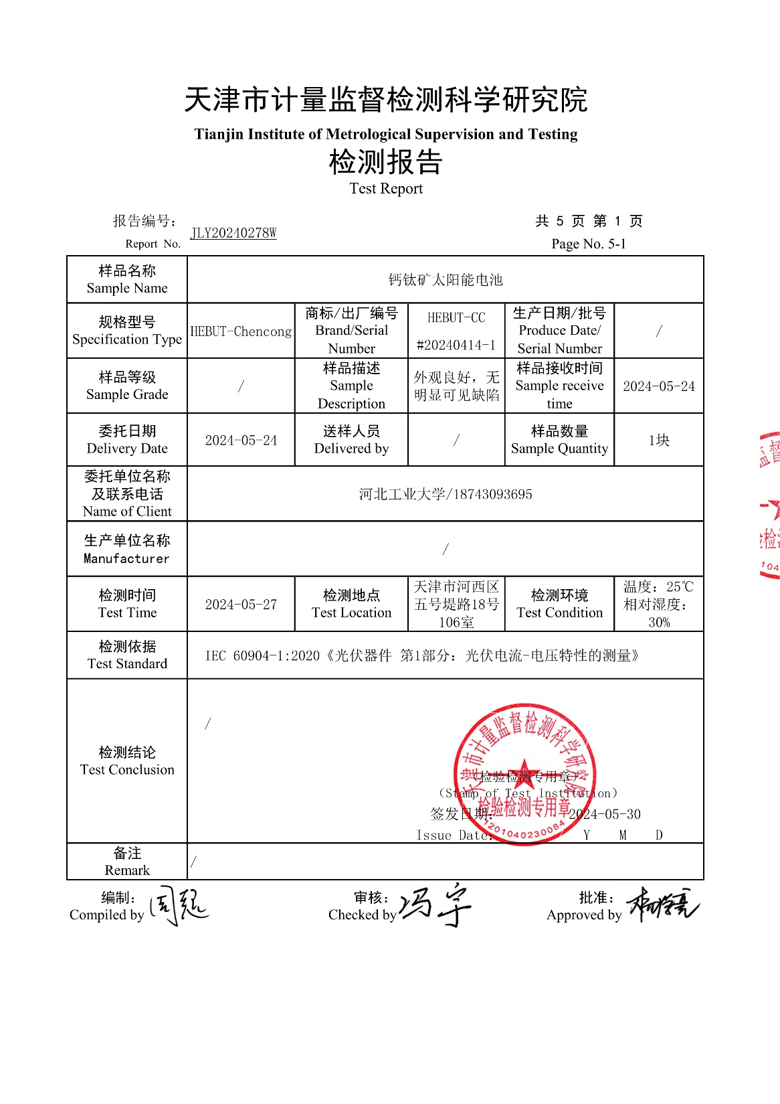
Supplementary Fig. 13. The efficiency testing report of NiOx and 1.53 eV- Cs_{0.05}MA_{0.05}FA_{0.9}PbI₃ based inverted p-i-n type perovskite solar cell devices prepared by the Cong Chen’ research group. The report consists of seven pages, and this is the third page. The testing agency is Tianjin Institute of Metrological Supervision and Testing, China.
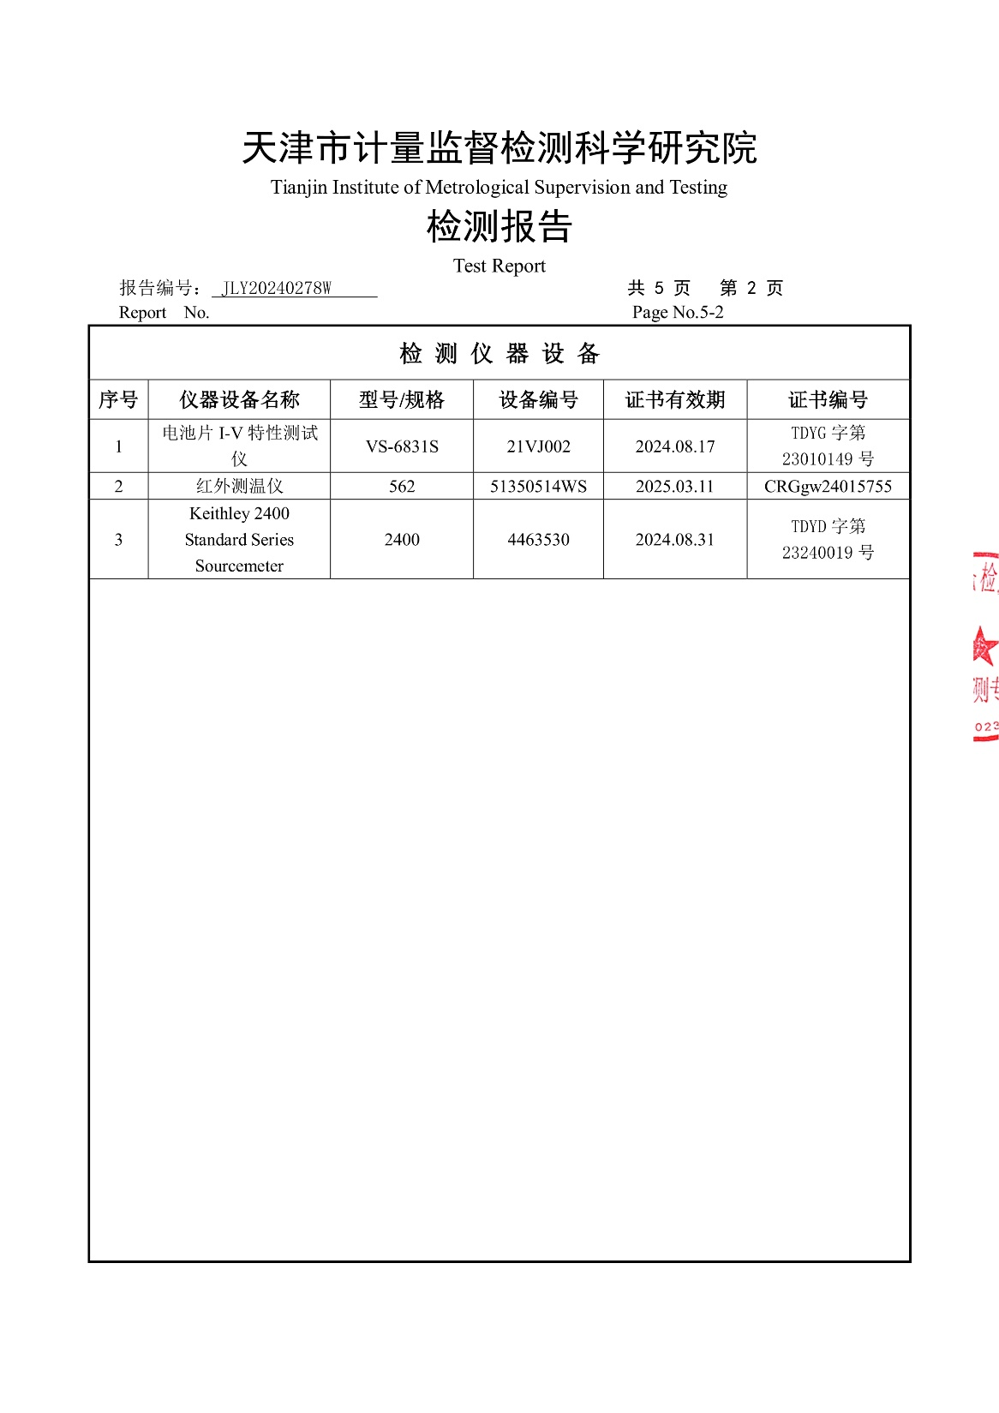
Supplementary Fig. 14. The efficiency testing report of NiOx and 1.53 eV-Cs_{0.05}MA_{0.05}FA_{0.9}PbI₃ based inverted p-i-n type perovskite solar cell devices prepared by the Cong Chen’ research group. The report consists of seven pages, and this is the fourth page. The testing agency is Tianjin Institute of Metrological Supervision and Testing, China.
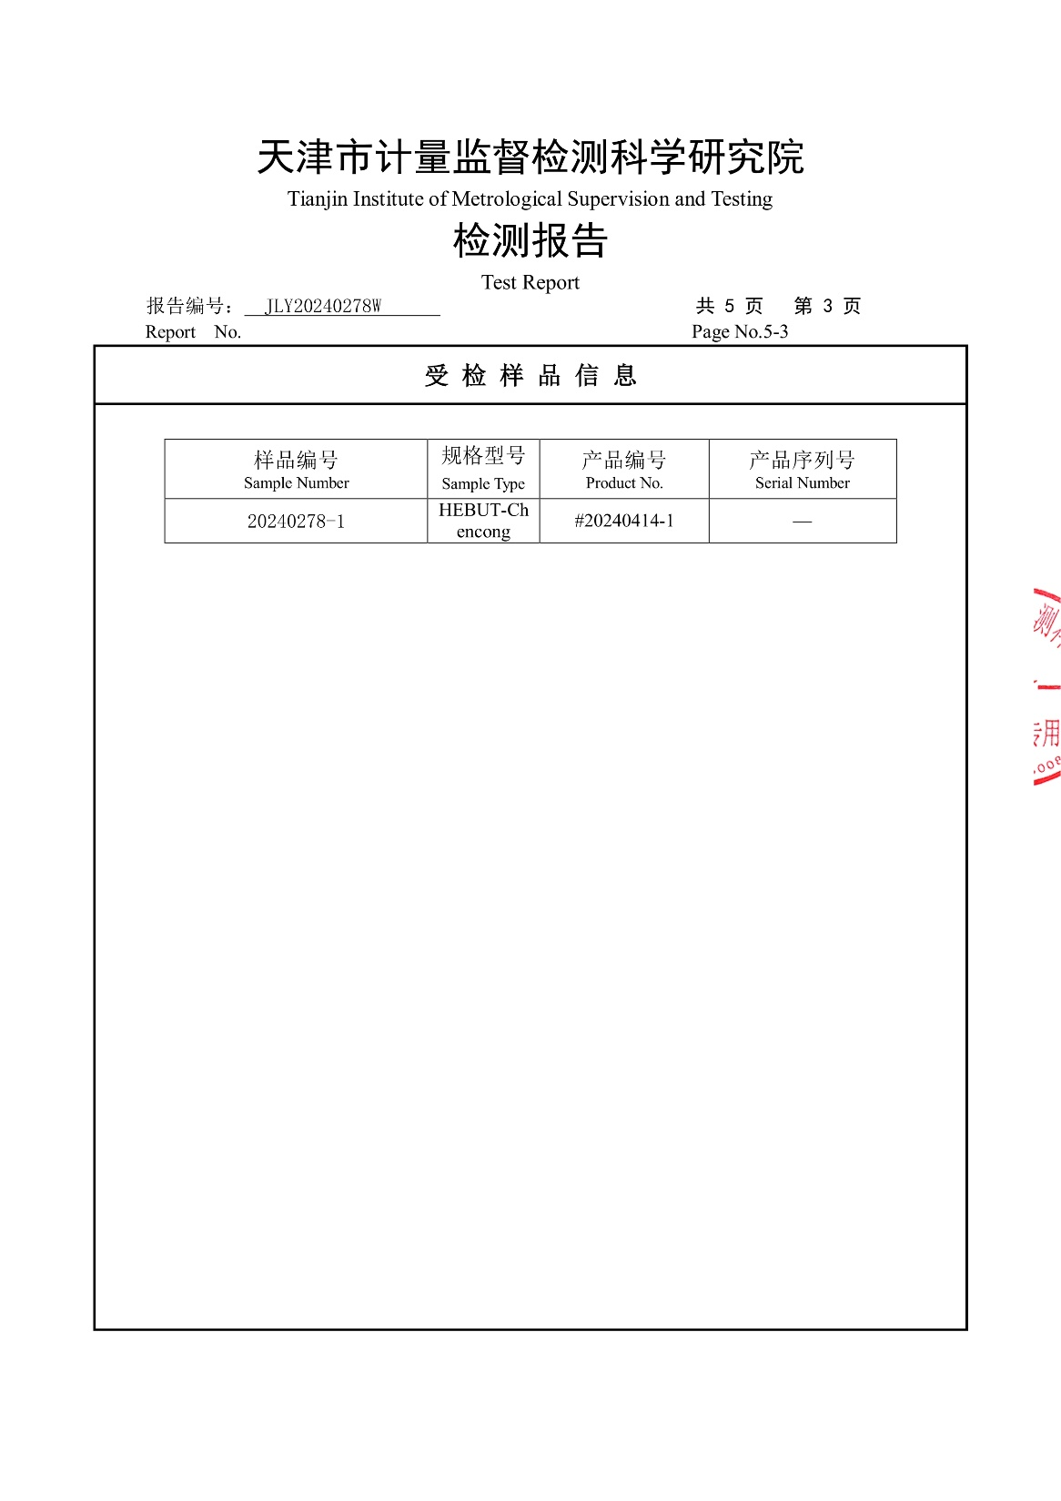
Supplementary Fig. 15. The efficiency testing report of NiOx and 1.53 eV-Cs_{0.05}MA_{0.05}FA_{0.9}PbI₃ based inverted p-i-n type perovskite solar cell devices prepared by the Cong Chen’ research group. The report consists of seven pages, and this is the fifth page. The testing agency is Tianjin Institute of Metrological Supervision and Testing, China.
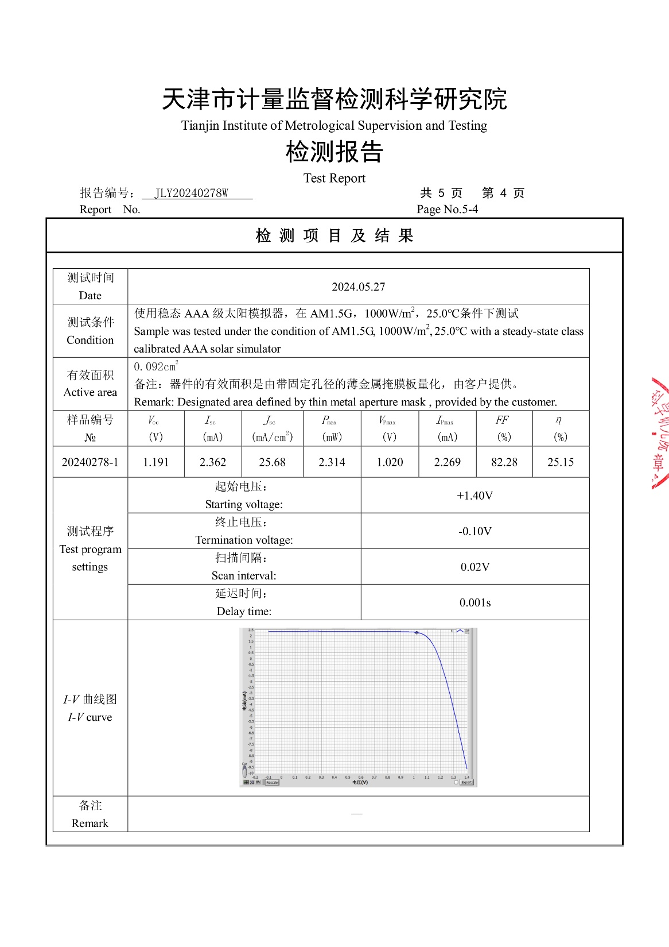
Supplementary Fig. 16. The efficiency testing report of NiOx and 1.53 eV-Cs_{0.05}MA_{0.05}FA_{0.9}PbI₃ based inverted p-i-n type perovskite solar cell devices prepared by the Cong Chen’ research group. The report consists of seven pages, and this is the sixth page. The testing agency is Tianjin Institute of Metrological Supervision and Testing, China.
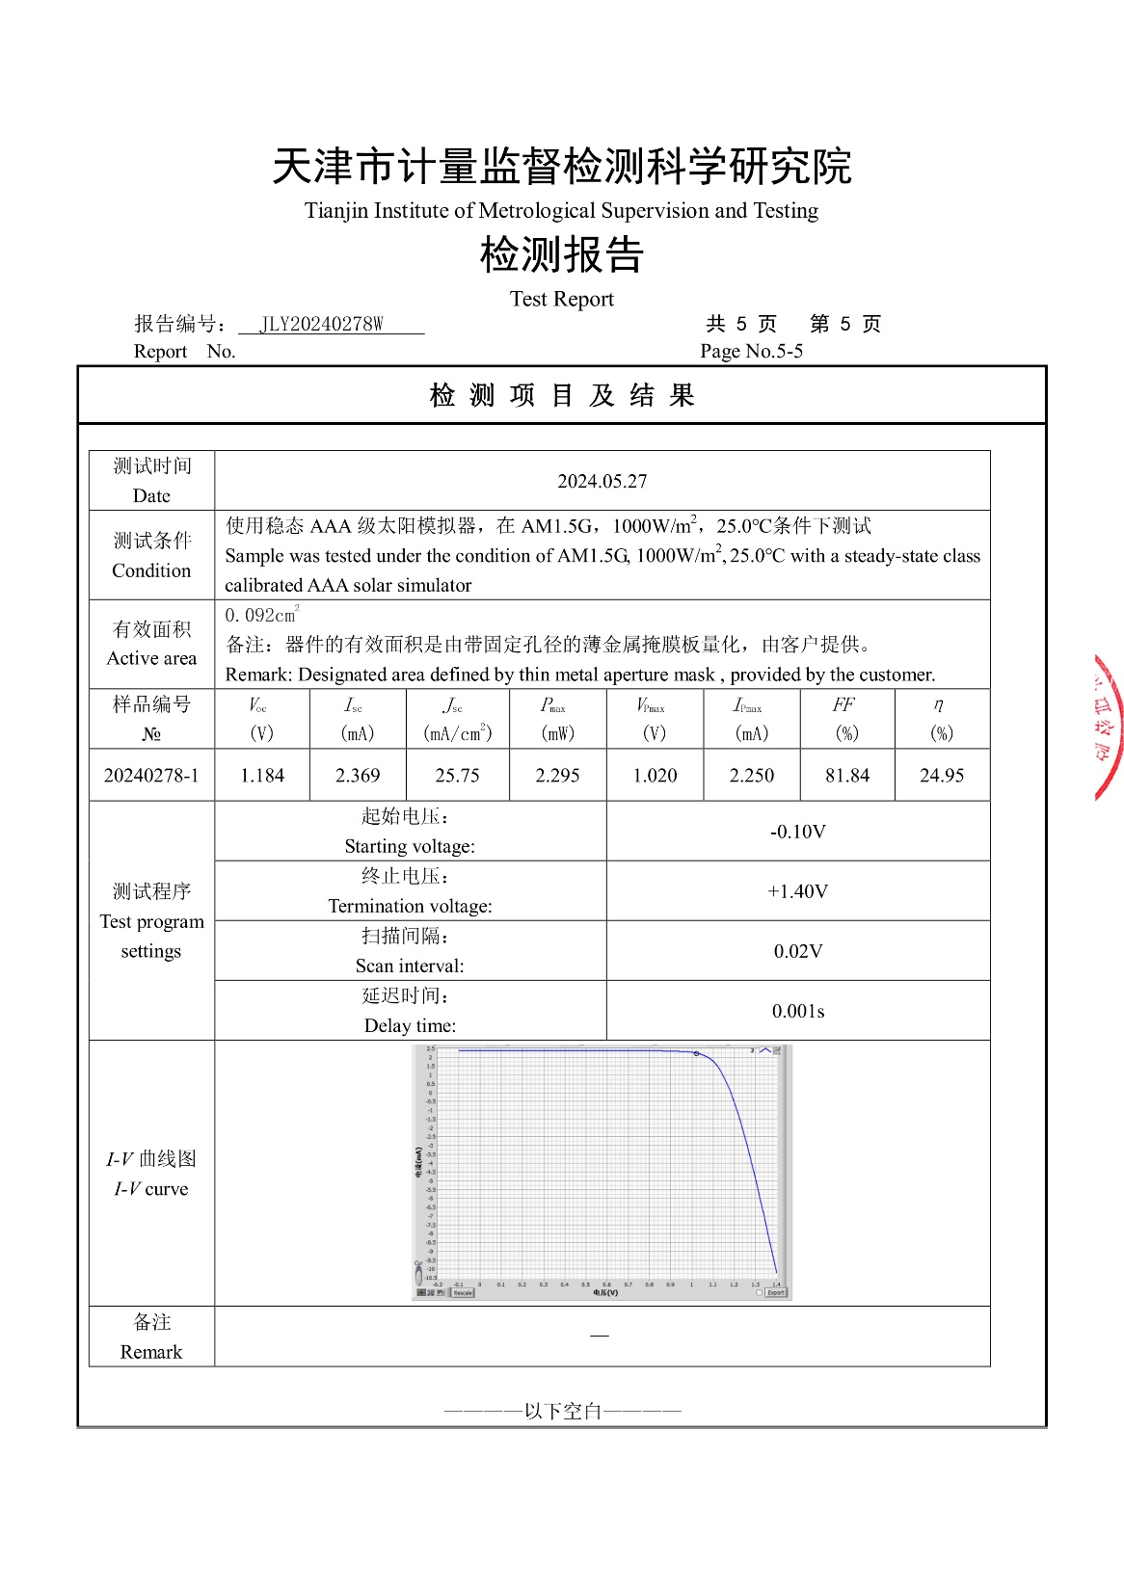
Supplementary Fig. 17. The efficiency testing report of NiOx and 1.53 eV-Cs_{0.05}MA_{0.05}FA_{0.9}PbI₃ based inverted p-i-n type perovskite solar cell devices prepared by the Cong Chen’ research group. The report consists of seven pages, and this is the seventh page. The testing agency is Tianjin Institute of Metrological Supervision and Testing, China.

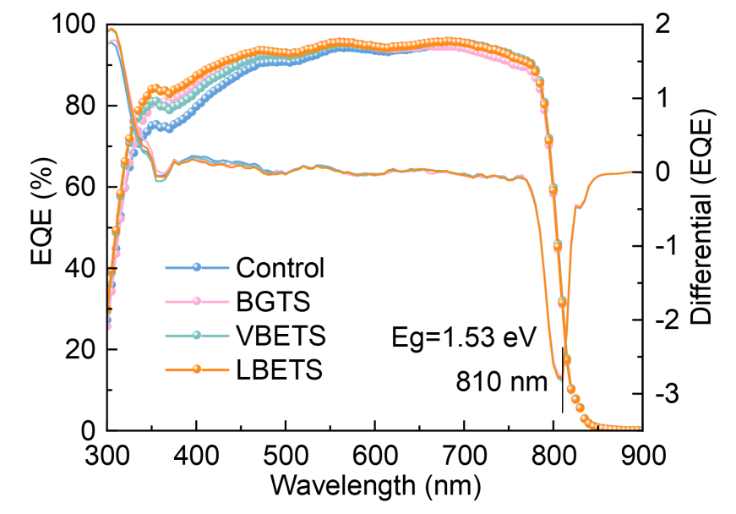
Supplementary Fig. 18. EQE and integrated J_{SC} curves of the control and BGTS, VBETS, and LBETS-modified 1.53 eV-Cs_{0.05}MA_{0.05}FA_{0.9}PbI₃ based PSC devices.

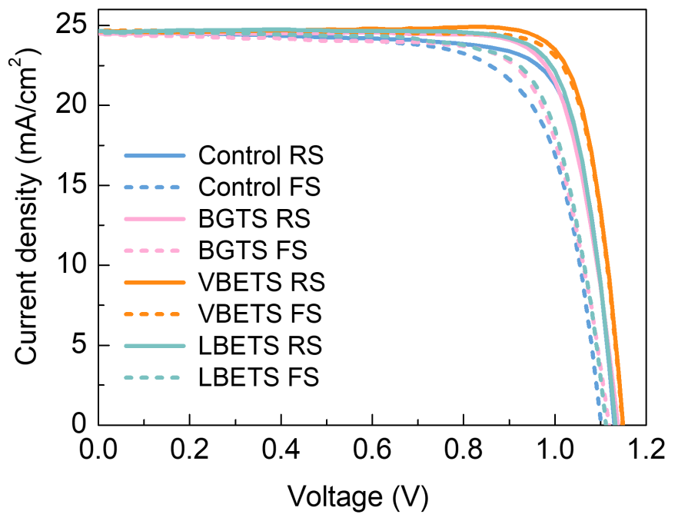
Supplementary Fig. 19. The champion J−V curves of the best-performing control BGTS, VBETS, and LBETS-modified PSC devices in RS and FS testing mode based on 1.58 eV- Cs_{0.05}(FA_{0.95}MA_{0.05})_{0.95}Pb(I_{0.95}Br_{0.05})₃.

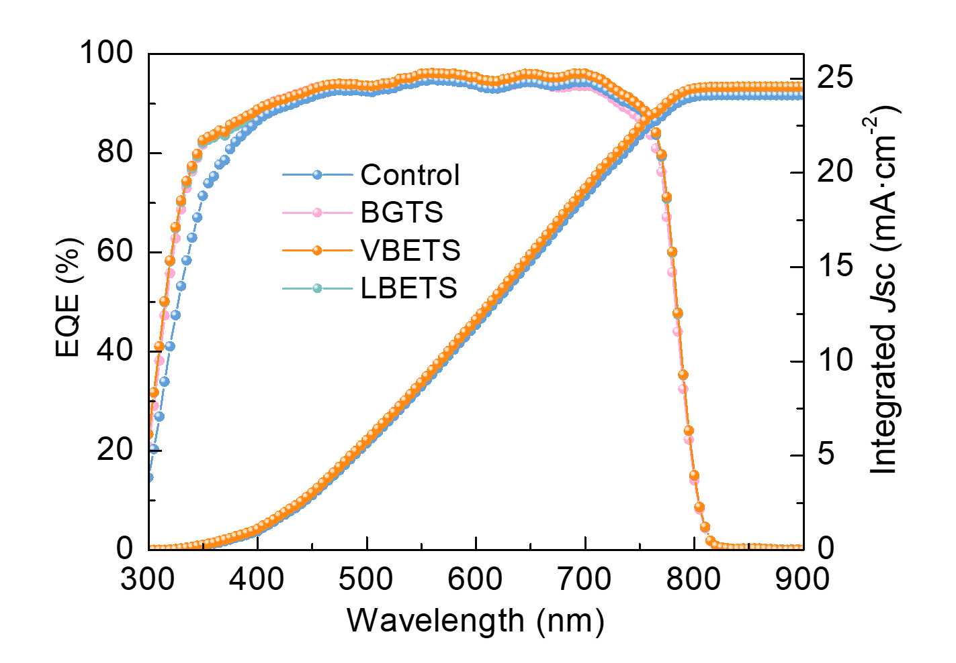
Supplementary Fig. 20. The EQE curves of the best-performing control BGTS, VBETS, and LBETS-modified PSC devices in RS and FS testing mode based on 1.58 eV- Cs_{0.05}(FA_{0.95}MA_{0.05})_{0.95}Pb(I_{0.95}Br_{0.05})₃.

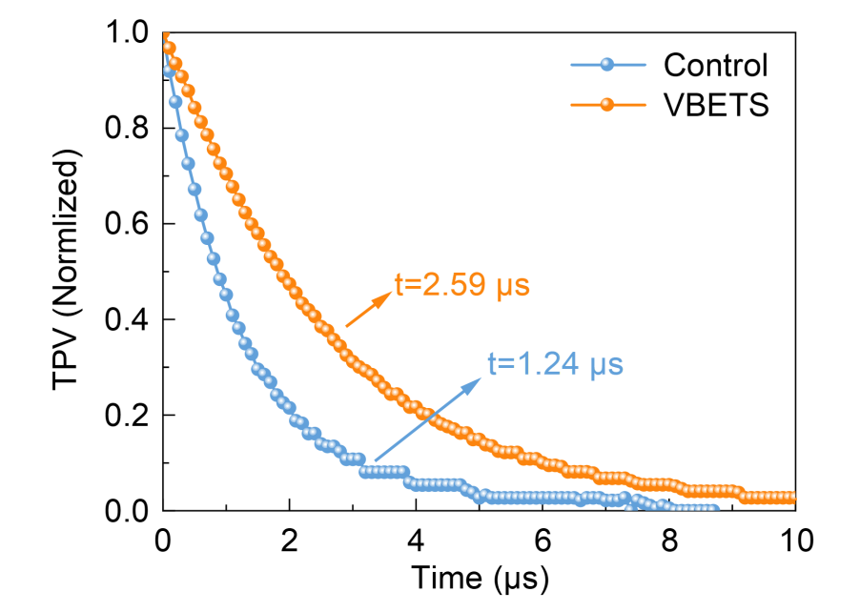
Supplementary Fig. 21. TPV curves for the control and VBETS-modified PSC devices.

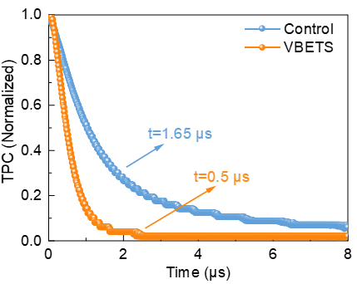
Supplementary Fig. 22. TPC curves for the control and VBETS-modified PSC devices.

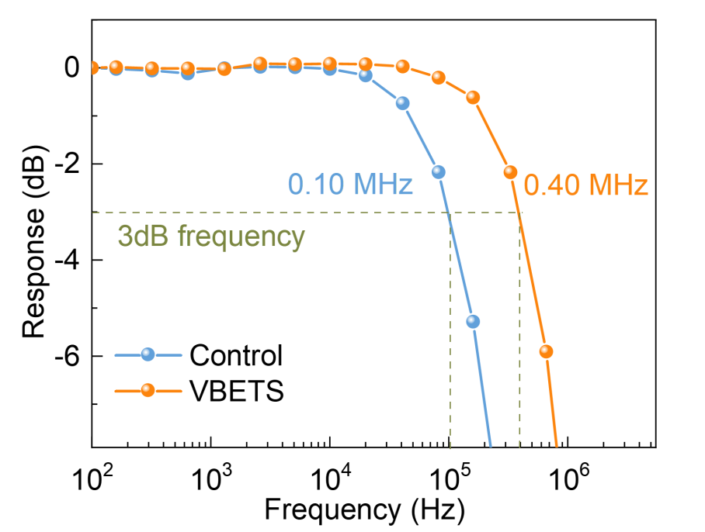
Supplementary Fig. 23. The frequency response of the control and VBETS-modified PSC devices.

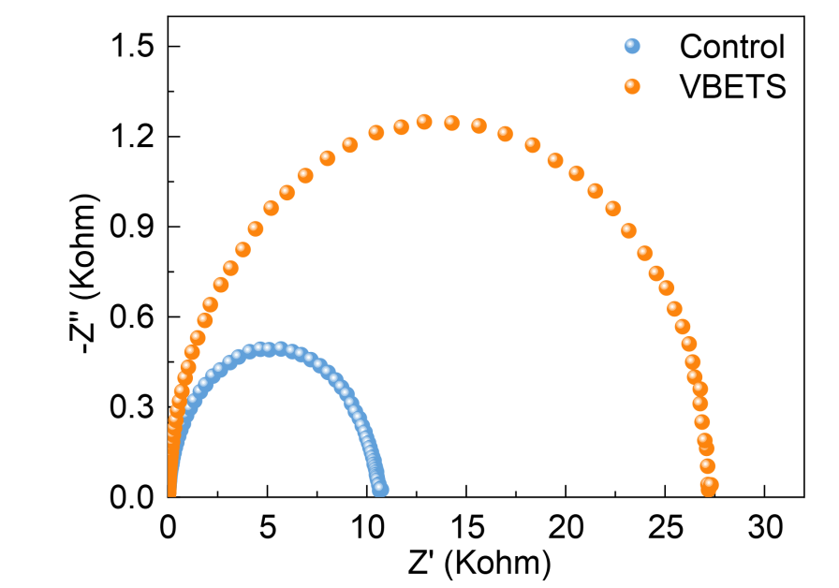
Supplementary Fig. 24. Nyquist plots of the PSCs with and without VBETS passivation under a bias of 0 V in the frequency range of 1 MHz to 0 Hz.

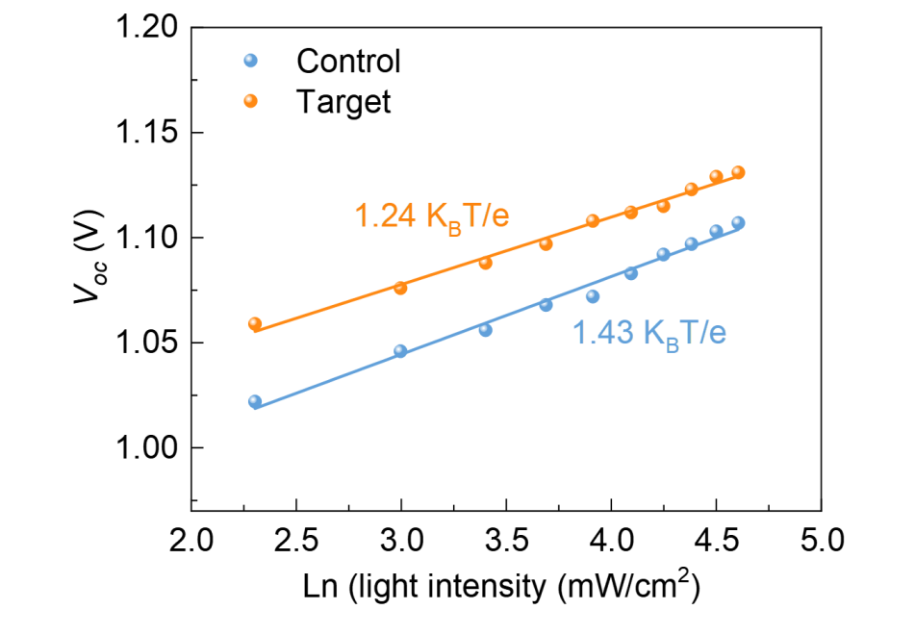
Supplementary Fig. 25. V_{OC} depends on various illumination intensities of the control and VBETS-modified PSCs.

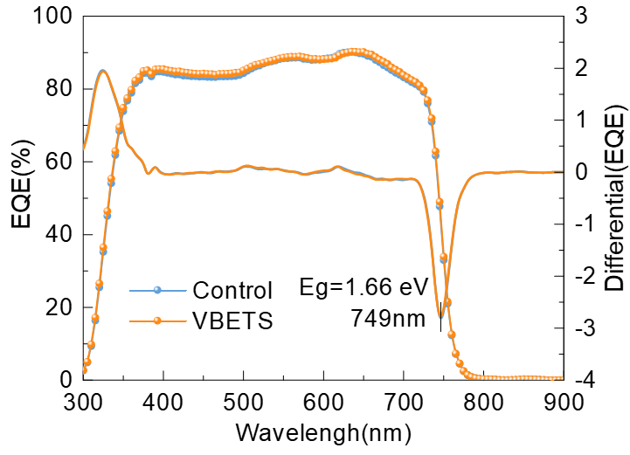
Supplementary Fig. 26. The EQE and integrated J_{SC} curves of the control and VBETS modified PSC devices based on WBG Cs_{0.05}FA_{0.8}MA_{0.15}Pb(I_{0.76}Br_{0.24})₃.

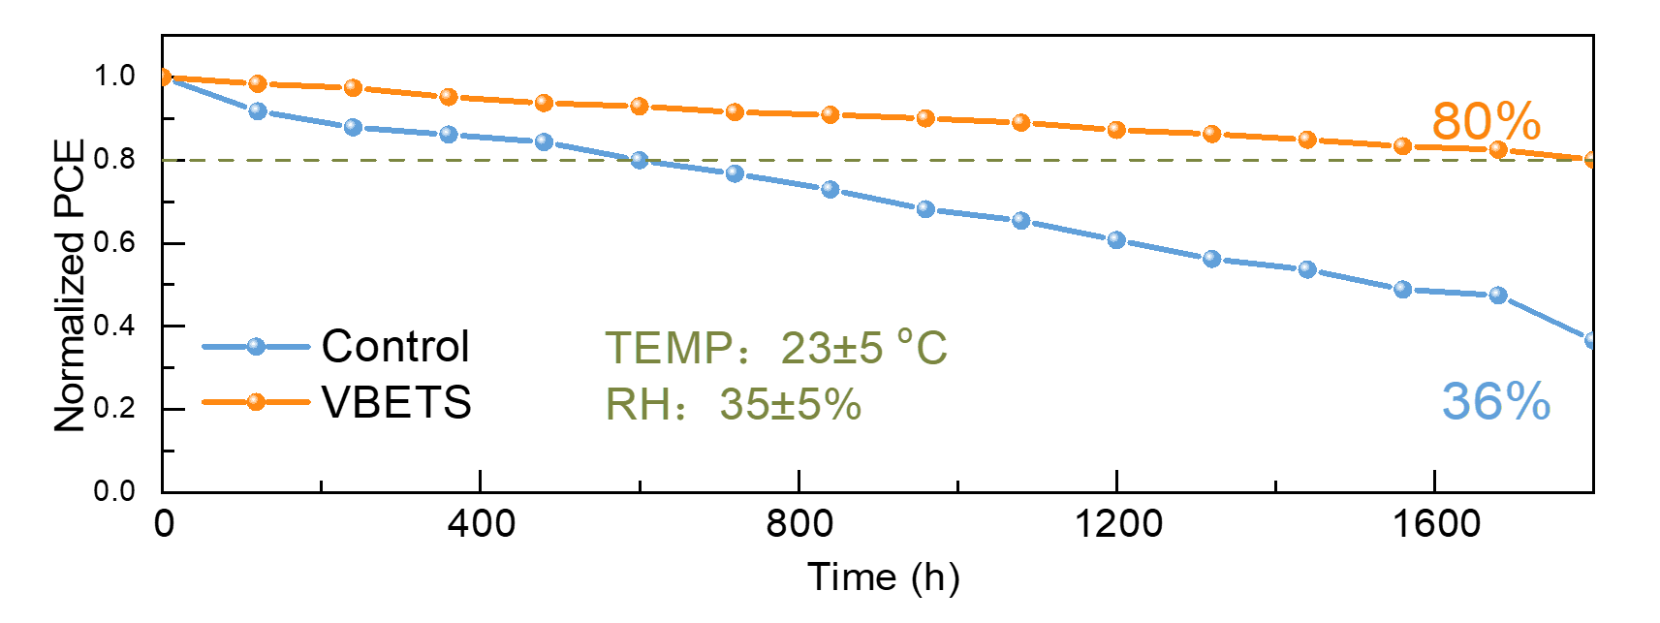
Supplementary Fig. 27. Long-term stability obtained from the internal test curves of the encapsulated control and VBETS-modified PSCs after 1600 h of ageing in ambient conditions.

References in supporting information
1. Rong, Y.; Hou, X.; Hu, Y.; Mei, A.; Liu, L.; Wang, P.; Han, H., Synergy of Ammonium Chloride and Moisture on Perovskite Crystallization for Efficient Printable Mesoscopic Solar Cells. Nature communications 2017, 8, 14555.
2. Cheng, Y.; Xu, X.; Xie, Y.; Li, H. W.; Qing, J.; Ma, C.; Lee, C. S.; So, F.; Tsang, S. W., 18% High‐Efficiency Air‐Processed Perovskite Solar Cells Made in a Humid Atmosphere of 70% Rh. Solar RRL 2017, 1, 1700097.
3. Wang, W.-T.; Sharma, J.; Chen, J.-W.; Kao, C.-H.; Chen, S.-Y.; Chen, C.-H.; Feng, Y.-C.; Tai, Y., Nanoparticle-Induced Fast Nucleation of Pinhole-Free Pbi2 Film for Ambient-Processed Highly-Efficient Perovskite Solar Cell. Nano Energy 2018, 49, 109-116.
4. Liu, H.; Zhang, P.; Wang, F.; Jia, C.; Chen, Y., Binary Synergetic Ions Reduce Defect Density in Ambient Air Processed Perovskite Solar Cells. Solar Energy 2020, 198, 335-342.
5. Zhang, W.; He, L.; Tang, D.; Li, X., Surfactant Sodium Dodecyl Benzene Sulfonate Improves the Efficiency and Stability of Air‐Processed Perovskite Solar Cells with Negligible Hysteresis. Solar RRL 2020, 4, 2000376.
6. Hussein, H. T.; Zamel, R. S.; Mohamed, M. S.; Mohammed, M. K., High-Performance Fully-Ambient Air Processed Perovskite Solar Cells Using Solvent Additive. Journal of Physics and Chemistry of Solids 2021, 149, 109792.
7. Castriotta, L. A.; Matteocci, F.; Vesce, L.; Cina, L.; Agresti, A.; Pescetelli, S.; Ronconi, A.; Löffler, M.; Stylianakis, M. M.; Di Giacomo, F., Air-Processed Infrared-Annealed Printed Methylammonium-Free Perovskite Solar Cells and Modules Incorporating Potassium-Doped Graphene Oxide as an Interlayer. ACS applied materials & interfaces 2021, 13, 11741-11754.
8. Ka, I.; Asuo, I. M.; Nechache, R.; Rosei, F., Highly Stable Air Processed Perovskite Solar Cells by Interfacial Layer Engineering. Chemical Engineering Journal 2021, 423, 130334.
9. Zhang, K.; Deng, Y.; Shi, X.; Li, X.; Qi, D.; Jiang, B.; Huang, Y., Interface Chelation Induced by Pyridine‐Based Polymer for Efficient and Durable Air‐Processed Perovskite Solar Cells. Angewandte Chemie International Edition 2022, 61, e202112673.
10. Wang, M.; Sun, H.; Meng, L.; Wang, M.; Li, L., A Universal Strategy of Intermolecular Exchange to Stabilize Α‐Fapbi3 and Manage Crystal Orientation for High‐Performance Humid‐Air‐Processed Perovskite Solar Cells. Advanced Materials 2022, 34, 2200041.
11. Wang, J.; Yuan, L.; Luo, H.; Duan, C.; Zhou, B.; Wen, Q.; Yan, K., Ambient Air Processed Highly Oriented Perovskite Solar Cells with Efficiency Exceeding 23% Via Amorphous Intermediate. Chemical Engineering Journal 2022, 446, 136968.
12. Xiao, H.; Zuo, C.; Zhang, L.; Zhang, W.; Hao, F.; Yi, C.; Liu, F.; Jin, H.; Ding, L., Efficient Inorganic Perovskite Solar Cells Made by Drop-Coating in Ambient Air. Nano Energy 2023, 106, 108061.
13. Zhu, Z.; Shang, J.; Tang, G.; Wang, Z.; Cui, X.; Jin, J.; Zhou, Y.; Zhang, X.; Zhang, D.; Liu, X., Vertical Distribution of Pbi2 Nanosheets for Robust Air-Processed Perovskite Solar Cells. Chemical Engineering Journal 2023, 454, 140163.
14. Zeng, G.; Liu, G.; Li, X., Hexamethylphosphoramide-Assisted Structure and Morphology Regulation of a Pbi2 Film for Air-Processed Efficient Perovskite Solar Cells Via a Two-Step Deposition Method. ACS Sustainable Chemistry & Engineering 2023, 11, 7664-7672.
15. Meng, Y.; Zhang, W.; Zhang, X.; Deng, Y.; Zhang, H.; Zeng, G.; Liu, G.; Li, X., Self‐Assembled 1d/3d Perovskite Heterostructure for Stable All‐Air‐Processed Perovskite Solar Cells with Improved Open‐Circuit Voltage. ChemSusChem 2023, 16, e202300257.
16. Wen, L.; Deng, Y.; Zeng, G.; Liu, G.; Li, X., Surface-Bulk-Passivated Perovskite Films Via 2-Thiophenemethylammonium Bromide and Pbbr2 for Air-Processed Perovskite Solar Cells with High-Stability. Chemical Engineering Journal 2023, 468, 143446.
17. Wang, Z.; Wang, J.; Zhu, S.; Ma, T.; Zhang, M.; Guo, M., Hydrogen Bond Network for Efficient and Stable Fully Ambient Air-Processed Perovskite Solar Cells with over 21% Efficiency. ACS Sustainable Chemistry & Engineering 2023, 11, 14559-14571.
18. Zhuang, J.; Liu, C. K.; Kang, B. C.; Cheng, H. Y.; Xiao, M. C.; Li, L.; Yan, F., Rapid Surface Reconstruction in Air-Processed Perovskite Solar Cells by Blade Coating. Advanced Materials 2024, 36.
19. Liu, C.; Su, H.; Pu, Y.; Guo, M.; Zhai, P.; Liu, Z.; Zhang, Z., Deep and Shallow Level Defect Passivation Via Fluoromethyl Phosphonate for High Performance Air-Processed Perovskite Solar Cells. Nano Energy 2023, 118, 108990.
20. Tian, C.; Wu, T.; Zhao, Y.; Zhou, X.; Li, B.; Han, X.; Li, K.; Hou, C.; Li, Y.; Wang, H., Anion‐Stabilized Precursor Inks toward Efficient and Reproducible Air‐Processed Perovskite Solar Cells. Advanced Energy Materials 2024, 2303666.
21. Meng, H.; Mao, K.; Cai, F.; Zhang, K.; Yuan, S.; Li, T.; Cao, F.; Su, Z.; Zhu, Z.; Feng, X., Inhibition of Halide Oxidation and Deprotonation of Organic Cations with Dimethylammonium Formate for Air-Processed P–I–N Perovskite Solar Cells. Nature Energy 2024, 1-12.
22. Shi, X.; Liu, T.; Dou, Y.; Hu, X.; Liu, Y.; Wang, F.; Wang, L.; Ren, Z.; Chen, S., Air‐Processed Perovskite Solar Cells with> 25% Efficiency and High Stability Enabled by Crystallization Modulation and Holistic Passivation. Advanced Materials 2024, 2402785.
23. Chen, H.; Ye, F.; Tang, W.; He, J.; Yin, M.; Wang, Y.; Xie, F.; Bi, E.; Yang, X.; Gratzel, M.; Han, L., A Solvent- and Vacuum-Free Route to Large-Area Perovskite Films for Efficient Solar Modules. Nature 2017, 550, 92-95.
24. Deng, Y.; Zheng, X.; Bai, Y.; Wang, Q.; Zhao, J.; Huang, J., Surfactant-Controlled Ink Drying Enables High-Speed Deposition of Perovskite Films for Efficient Photovoltaic Modules. Nature Energy 2018, 3, 560-566.
25. Dai, X.; Deng, Y.; Van Brackle, C. H.; Chen, S.; Rudd, P. N.; Xiao, X.; Lin, Y.; Chen, B.; Huang, J., Scalable Fabrication of Efficient Perovskite Solar Modules on Flexible Glass Substrates. Advanced Energy Materials 2019, 10.
26. Deng, Y.; Van Brackle, C. H.; Dai, X.; Zhao, J.; Chen, B.; Huang, J., Tailoring Solvent Coordination for High-Speed, Room-Temperature Blading of Perovskite Photovoltaic Films. Science Advances 2019, 5, eaax7537.
27. Bu, T.; Liu, X.; Li, J.; Huang, W.; Wu, Z.; Huang, F.; Cheng, Y.-B.; Zhong, J., Dynamic Antisolvent Engineering for Spin Coating of 10 × 10 Cm2 Perovskite Solar Module Approaching 18%. Solar RRL 2019, 4.
28. Chen, S.; Xiao, X.; Gu, H.; Huang, J., Iodine Reduction for Reproducible and High-Performance Perovskite Solar Cells and Modules. Science Advandes 2021, 7.
29. Bu, T.; Li, J.; Li, H.; Tian, C.; Su, J.; Tong, G.; Ono, L. K.; Wang, C.; Lin, Z.; Chai, N.; Zhang, X. L.; Chang, J.; Lu, J.; Zhong, J.; Huang, W.; Qi, Y.; Cheng, Y. B.; Huang, F., Lead Halide-Templated Crystallization of Methylamine-Free Perovskite for Efficient Photovoltaic Modules. Science 2021, 372, 1327-1332.
30. Chen, S.; Dai, X.; Xu, S.; Jiao, H.; Zhao, L.; Huang, J., Stabilizing Perovskite-Substrate Interfaces for High-Performance Perovskite Modules. Science 2021, 373, 902-907.
31. Kim, M.; Jeong, J.; Lu, H.; Lee, T. K.; Eickemeyer, F. T.; Liu, Y.; Choi, I. W.; Choi, S. J.; Jo, Y.; Kim, H. B.; Mo, S. I.; Kim, Y. K.; Lee, H.; An, N. G.; Cho, S.; Tress, W. R.; Zakeeruddin, S. M.; Hagfeldt, A.; Kim, J. Y.; Gratzel, M.; Kim, D. S., Conformal Quantum Dot-Sno(2) Layers as Electron Transporters for Efficient Perovskite Solar Cells. Science 2022, 375, 302-306.
32. Chung, J.; Kim, S. W.; Li, Y.; Mariam, T.; Wang, X.; Rajakaruna, M.; Saeed, M. M.; Abudulimu, A.; Shin, S. S.; Guye, K. N.; Huang, Z.; Westbrook, R. J. E.; Miller, E.; Subedi, B.; Podraza, N. J.; Heben, M. J.; Ellingson, R. J.; Ginger, D. S.; Song, Z.; Yan, Y., Engineering Perovskite Precursor Inks for Scalable Production of High‐Efficiency Perovskite Photovoltaic Modules. Advanced Energy Materials 2023, 13.
33. Chen, R.; Yang, Y.; Dai, Z.; Yuan, L.; Du, J.; Yang, P.; Yang, Y.; Shen, H.; Liu, Z.; Wang, H., Patch-Healed Grain Boundary Strategy to Stabilize Perovskite Films for High-Performance Solar Modules. Nano Energy 2023, 115.
34. Guo, H.; Yoon, G. W.; Li, Z. J.; Yun, Y.; Lee, S.; Seo, Y. H.; Jeon, N. J.; Han, G. S.; Jung, H. S., In Situ Polymerization of Cross‐Linked Perovskite–Polymer Composites for Highly Stable and Efficient Perovskite Solar Cells. Advanced Energy Materials 2023, 14.
35. Zhang, J.; Ji, X.; Wang, X.; Zhang, L.; Bi, L.; Su, Z.; Gao, X.; Zhang, W.; Shi, L.; Guan, G.; Abudula, A.; Hao, X.; Yang, L.; Fu, Q.; Jen, A. K.; Lu, L., Efficient and Stable Inverted Perovskite Solar Modules Enabled by Solid-Liquid Two-Step Film Formation. Nanomicro Lett 2024, 16, 190.
36. Tian, R.; Liu, C.; Meng, Y.; Wang, Y.; Cao, R.; Tang, B.; Walsh, D.; Do, H.; Wu, H.; Wang, K.; Sun, K.; Yang, S.; Zhu, J.; Li, X.; Ge, Z., Nucleation Regulation and Mesoscopic Dielectric Screening in Alpha-Fapbi(3). Adv Mater 2024, 36, e2309998.
37. Zhang, Z.; Li, M.; Li, R.; Zhuang, X.; Wang, C.; Shang, X.; He, D.; Chen, J.; Chen, C., Suppressing Ion Migration by Synergistic Engineering of Anion and Cation toward High-Performance Inverted Perovskite Solar Cells and Modules. Adv Mater 2024, e2313860.
38. Liu, Y.; Liu, Q.; Lu, Y.; Fu, J.; Wu, J.; Tian, Q.; Fan, B.; Zhang, Y.; Bai, H.; Wang, H. Q., Polyfluorinated Organic Diammonium Induced Lead Iodide Arrangement for Efficient Two-Step-Processed Perovskite Solar Cells. Angew Chem Int Ed Engl 2024, e202402568.

