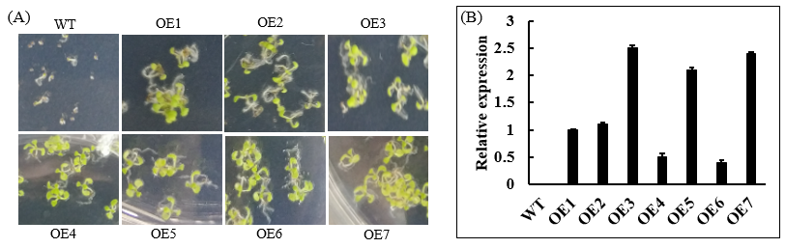
Fig. S1 Screening of positive HcMDH1 plants and analysis of HcMDH1 expression. (A) HcMDH1-overexpressing Arabidopsis were obtained by adding antibiotics (kanamycin) to 1/2 MS medium for growth screening; (B) Relative expression of the overexpressed lines using qRT-PCR analysis in three technical and biological replications at T2 generation.

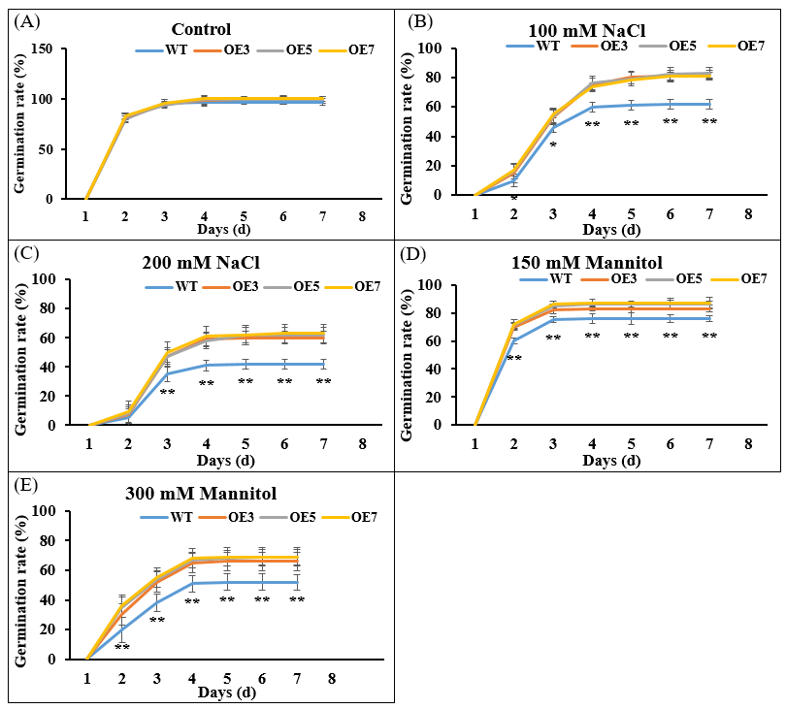
Fig. S2 The germination rate of HcMDH1-OEs and WT seeds under different concentrations of NaCl and mannitol treatment. Statistical analysis was performed using Student's t-test, p < 0.05 (*), p < 0.01 (**).

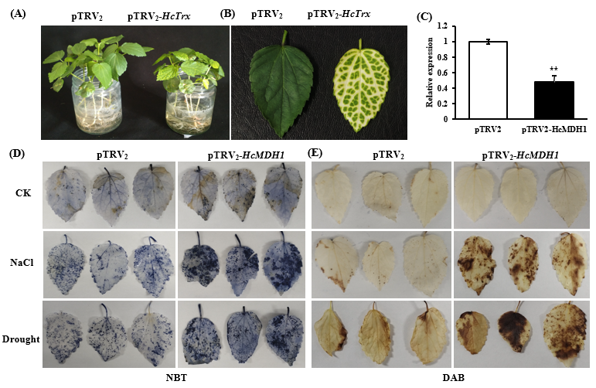
Fig. S3 Silencing HcMDH1 detection of kenaf VIGS. (A-B) Albino phenotype of silencing of HcTrx; (C) The transcript level of the HcMDH1 gene was tested by qRT-PCR; (D-E) NBT and DAB staining, respectively. Statistical analysis was performed using Student's t-test, p < 0.05 (*), p < 0.01 (**).

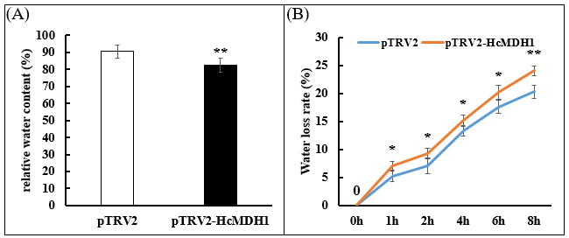
Fig. S4 The relative water content and water loss rate of pTRV₂ and pTRV₂-HcMDH1 plants. (A) The relative water content. (B) Water loss rate. Data were obtained from leaves of each group in three replicates. * and ** represent the significant difference at p < 0.05 and p < 0.01 levels using Student's t test.

Table S1. Primers for qPCR, pGBKT7, pYES2, pBI121 and VIGS vector construction
Primers for PCR
HcActin 3 (reference gene) | 5′-Forward | GTGAGGATATTCAACCCCTTGTCT
HcActin 3 (reference gene) | 3′-Reverse | CATCTTTCTGTCCCATACCAACC
HcGADPH | 5′-Forward | AGGACAAGGCTGCTGCTCAC
HcGADPH | 3′-Reverse | ACGACGAACATAGGGGCA
HcGLYK | 5′-Forward | CGGGTATTTTTCACGAACTCTG
HcGLYK | 3′-Reverse | TGTTGACAGGTGAGAGATTTGA
HcMDH1 | 5′-Forward | GAATAGGTCAGCCTCTGGCACTT
HcMDH1 | 3′-Reverse | GGAACACCAGCAGGAATAACCACT
HcFBA | 5′-Forward | TCCTCTTCACTGCTCCTGG
HcFBA | 3′-Reverse | TTCAAGACATCAACAAAGGGCT
HcFBPase | 5′-Forward | ATCCCACGCTAACATCCTTACATT
HcFBPase | 3′-Reverse | GGAAAGGGTTAGGCTATGGTG
HcPGA | 5′-Forward | AAAACCCTTGTAGTCTTAGCCG
HcPGA | 3′-Reverse | TCACAATCAACGCATCACAAAG
HcLSD | 5′-Forward | CGAGGCTATCCAGAAAGGCGATTC
HcLSD | 3′-Reverse | TTGATATGACCTCCGCCGTTGAAC
Primers for pGBKT7 vector construction
HcMDH1 | 5′-Forward | ATATGGCCATGGAGGCCGAATTC ATGGCAACAACATCAGC
HcMDH1 | 3′-Reverse | GTCGACGGATCCCCGGGAATTC TGCAGTAACTGGCTGCT
pGBKT7 vector primer | 5′-Forward | TAATACGACTCACTATAGGG
pGBKT7 vector primer | 3′-Reverse | TAAGAGTCACTTTAAAATTTGTAT
Primers for pYES2 vector construction
HcMDH1 | 5′-Forward | AACGGCCGCCAGTGTGCTGGAATTC ATGGCAACAACATCAGC
HcMDH1 | 3′-Reverse | AGTGTGATGGATATCTGCAGAATTC TGCAGTAACTGGCTGCT
Primers for pBI121 vector construction
HcMDH1 | 5′-Forward | CCGCTCGAGCGG ATGGCAACAACATCAGC
HcMDH1 | 3′-Reverse | CCGGTCGACCGG TGCAGTAACTGGCTGCT
pBI121 vector primer | 5′-Forward | GACGCACAATCCCACTATCC
pBI121 vector primer | 3′-Reverse | TGCGGTTCACCAGGGTGTCG
Primers for VIGS vector construction
pTRV2 vector primer | 5′-Forward | AGCAGTTTCCAGATAAGAAGGTGTA
pTRV2 vector primer | 3′-Reverse | CCCTATGGTAAGACAATGAGTCG
HcMDH1 | 5′-Forward | ATTCTGTGAGTAAGGTTACC GAATTC TGGTGTTCCAAGAAAGCCC
HcMDH1 | 3′-Reverse | CCCCATGGAGGCCTTCTAGA GAATTCGCACCTGCCTTTGCCTCTAC
Note: The underline represents the homologous arm, and the italics represent the EcoR I cleavage site.

