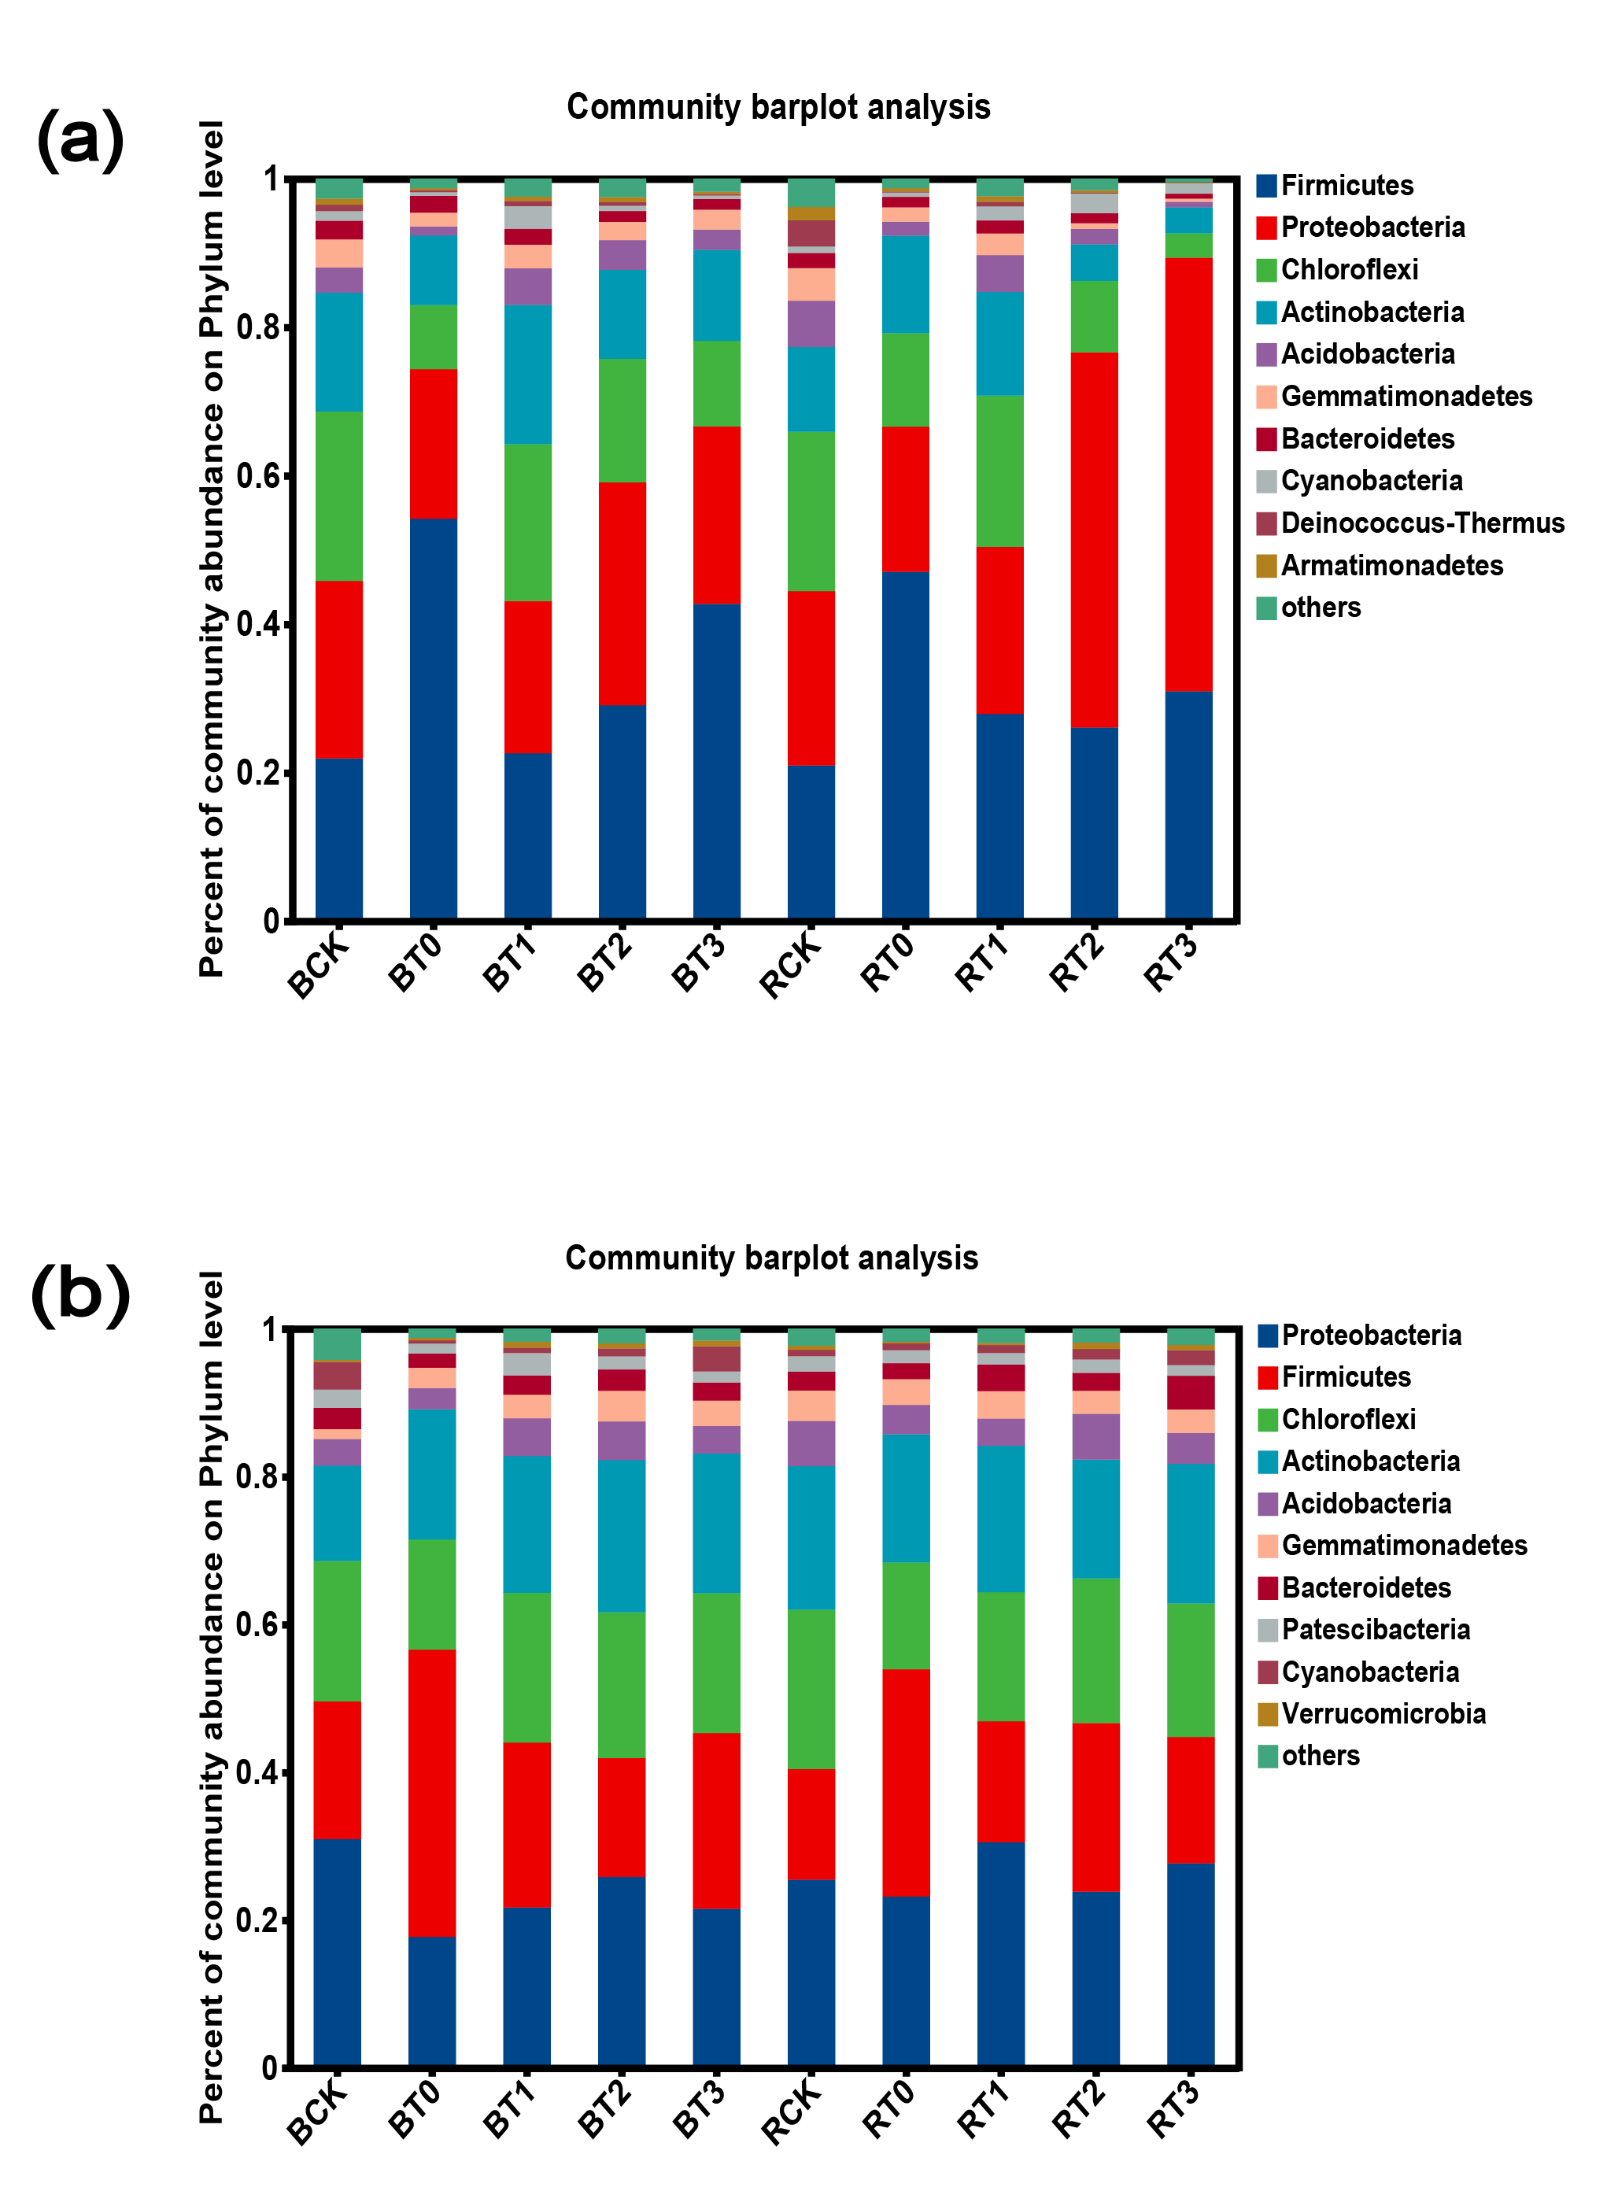
Supplementary Fig. 4 The Relative abundance of bacterial groups in sugarcane rhizosphere soils with different treatments at the phylum level. (a) rhizosphere soil at seedling stage, (b) rhizosphere soil at elongation stage. BCK, control (sterile water) for sugarcane variety B8; BT0, Gluconacetobacter diazotrophicus PAL5 for sugarcane variety B8; BT1, Streptomyces chartreusis WZS021 for sugarcane variety B8; BT2, Bacillus spp. CA1 + Pseudomonas mosselii CN11 for sugarcane variety B8; BT3, Pseudomonas mosselii CN11 + Streptomyces chartreusis WZS021 for sugarcane variety B8. RCK, control (sterile water) for sugarcane variety ROC22; RT0, Gluconacetobacter diazotrophicus PAL5 for sugarcane variety ROC22; RT1, Streptomyces chartreusis WZS021 for sugarcane variety ROC22; RT2, Bacillus spp. CA1 + Pseudomonas mosselii CN11 for sugarcane variety ROC22; RT3, Pseudomonas mosselii CN11 + Streptomyces chartreusis WZS021 for sugarcane variety ROC22.

