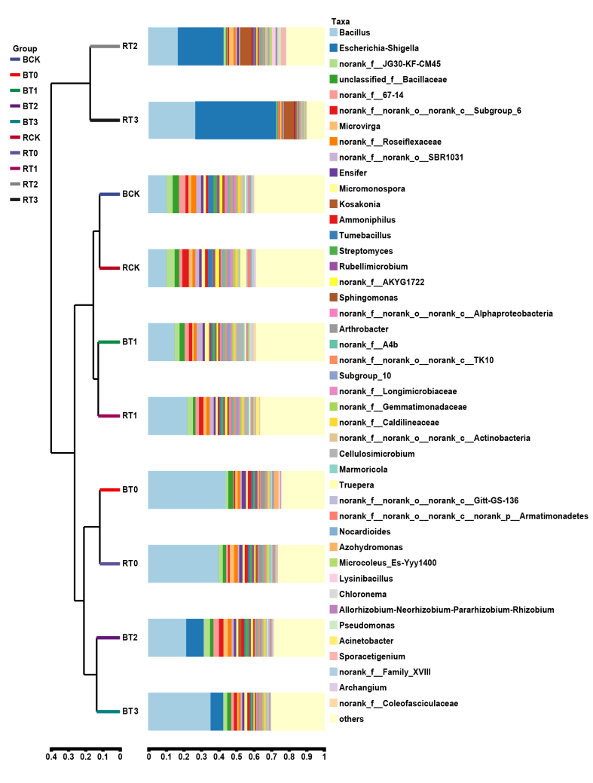
Supplementary Fig. 7 A combination of horizontal multi-sample similarity trees and histograms in sugarcane rhizosphere soil at seedling stage. The left is hierarchical clustering between samples based on community composition (Bray-Curtis algorithm), and the right is a column chart of the sample’s community structure. BCK, control (sterile water) for sugarcane variety B8; BT0, Gluconacetobacter diazotrophicus PAL5 for sugarcane variety B8; BT1, Streptomyces chartreusis WZS021 for sugarcane variety B8; BT2, Bacillus spp. CA1 + Pseudomonas mosselii CN11 for sugarcane variety B8; BT3, Pseudomonas mosselii CN11 + Streptomyces chartreusis WZS021 for sugarcane variety B8. RCK, control (sterile water) for sugarcane variety ROC22; RT0, Gluconacetobacter diazotrophicus PAL5 for sugarcane variety ROC22; RT1, Streptomyces chartreusis WZS021 for sugarcane variety ROC22; RT2, Bacillus spp. CA1 + Pseudomonas mosselii CN11 for sugarcane variety ROC22; RT3, Pseudomonas mosselii CN11 + Streptomyces chartreusis WZS021 for sugarcane variety ROC22.

