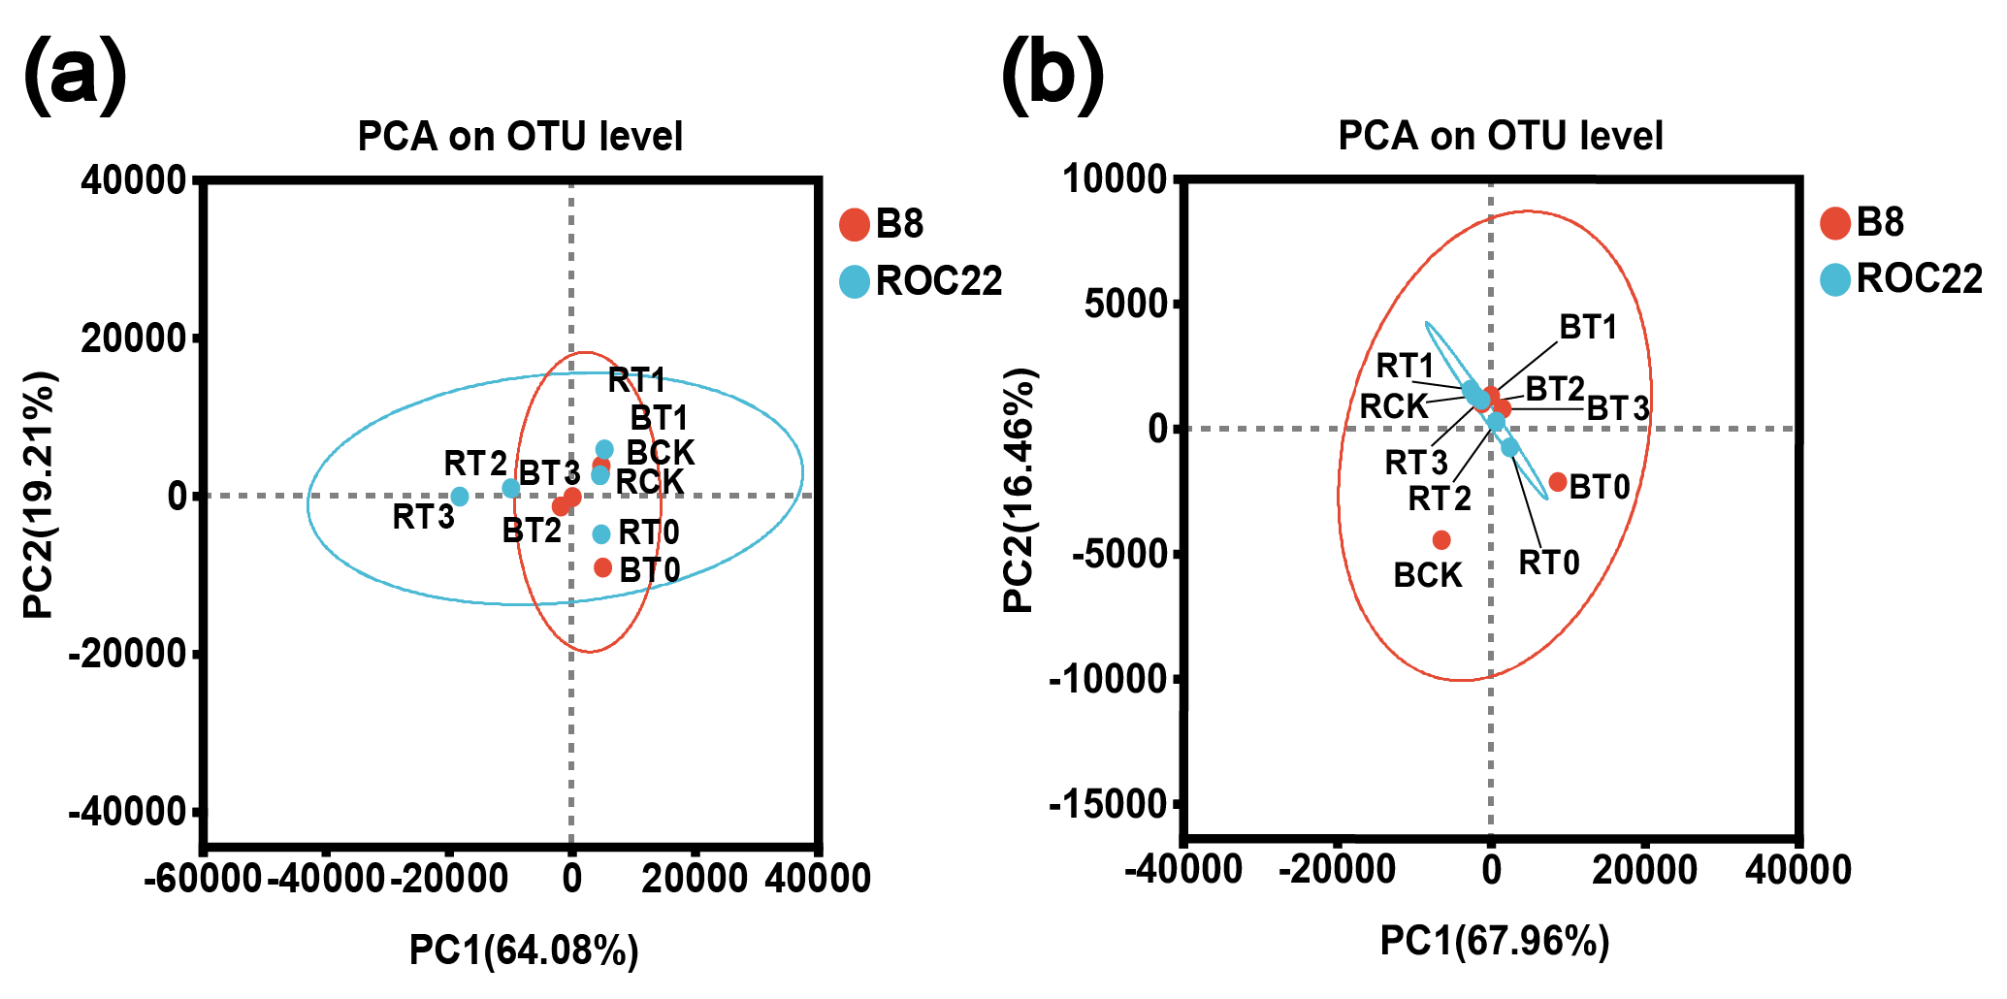
Supplementary Fig. 2 Principal component analysis (PCA) of bacteria community in sugarcane rhizospher soil. (a) rhizosphere soil at seedling stage, (b) rhizosphere soil at elongation stage. Different points of color or shape represent groups of samples under different environmental conditions, and the scale of horizontal and vertical axes is relative distance. BCK, control (sterile water) for sugarcane variety B8; BT0, Gluconacetobacter diazotrophicus PAL5 for sugarcane variety B8; BT1, Streptomyces chartreusis WZS021 for sugarcane variety B8; BT2, Bacillus spp. CA1 + Pseudomonas mosselii CN11 for sugarcane variety B8; BT3, Pseudomonas mosselii CN11 + Streptomyces chartreusis WZS021 for sugarcane variety B8. RCK, control (sterile water) for sugarcane variety ROC22; RT0, Gluconacetobacter diazotrophicus PAL5 for sugarcane variety ROC22; RT1, Streptomyces chartreusis WZS021 for sugarcane variety ROC22; RT2, Bacillus spp. CA1 + Pseudomonas mosselii CN11 for sugarcane variety ROC22; RT3, Pseudomonas mosselii CN11 + Streptomyces chartreusis WZS021 for sugarcane variety ROC22.

