SUPPLEMENTARY INFORMATION

U.S. Flood Risk in the Anthropocene
Wing, Lehman, Bates, Sampson, Quinn, Smith, Neal, Porter, & Kousky

Risk model validation
With previous literature comprehensively evidencing the validity of the hazard model (see Hazard model in Methods), an evaluation of its use in risk quantification remains. Ensuring that the estimates of risk output by a model are valid and reliable is a convoluted and complex endeavour. Indeed, the very reason models of flooding are required is because observations are too sparsely available to meaningfully understand risk. Understanding risk requires large samples of extreme, infrequent floods events, which thus requires a long observational record of flood losses to capture. Paradoxically, to ensure loss observations are relevant to today’s risk, only the most recent observations collected in today’s environmental and socio-economic contexts should be captured. This diametric opposition means we either question whether an observational record contains extreme enough flood events to understand risk, or whether historical building stock, their susceptibility to damage, and contemporary hydrologic conditions are relevant to the present-day. This insoluble challenge, however, does not diminish the need to evidence the validity of modelled losses, but it does require creativity to execute. Further, realistic expectations for how close a match between benchmark and model is desirable should be set, given the limited information content and likely error of observations in this context.

As such, we look to the recent release of OpenFEMA National Flood Insurance Program (NFIP) datasets to forge a meaningful comparison between the risk purported by the model presented here and a benchmark database of historical U.S. flood risk. The underlying population of NFIP policyholders has not only changed in line with U.S. development patterns, it is also a subset of contemporary populations (owing to low insurance penetration). As such, NFIP claims are not the only flood losses to have occurred historically; they are simply those filed under this particular insurance programme. In fact, in recent testimony to the U.S. Congress, the FEMA Assistant Administrator for Risk Management estimated that flood risk has grown from an average annual damage total of ~$4 billion in the 1980s to ~$17 billion in the 2010s.⁵² Those numbers, undoubtedly low relative to actual risk, can be further compared to the ~$2.8 billion paid out by the NFIP over that same period. To address the imbalance between the exposure and population of the NFIP compared to that which we have modelled (every present-day building), we compute the reported damages for each NFIP claim as a proportion of its full replacement value. This yields the average relative damage to buildings which have ever been flooded according to the NFIP. The analogous quantity from our model is the relative AAL (loss as a proportion of replacement cost) for any residential building that incurs non-zero loss. The NFIP-based value is 0.34% of replacement value, while that of our model is 0.40%. This demonstrates that there is some agreement between the model and observations in the general building-level damageability of floods.

The above comparison does not illustrate that the correct number (or proportion) of buildings are flooded; only, for those that are flooded, their damage response is generally in line with what observations suggest. To get an idea of whether the rate at which our model inundates U.S. buildings is sensible, we compare the modelled average annual number of flooded buildings to the average annual number of claims filed under the NFIP. To, again, normalise the differing underlying populations these two quantities are drawn from, they are divided by the total number of buildings and the total number of NFIP policies in force, respectively. The modelled relative average annual building exposure is 0.93%, while that purported by the NFIP is 1.18%. Intriguingly, 1.18% is also the proportion of the U.S. population that our model suggests is exposed to flooding annually, though these population data are more coarse than the analogous building data.

We also sum the replacement value of building structure and contents for every NFIP policy in each year. Policy records with no entries for replacement value (~10-15% of the data used) were assigned the average value from the given year. With average annual damage as a proportion of total exposure (as opposed to just the value of flooded buildings, calculated above), the NFIP-derived figure comes to 0.037%. While this is eerily close to the model’s relative AAL of 0.038%, when we restrict the model to only residential buildings (since the NFIP only covers these) the relative AAL is slightly lower at 0.030%.

The validity of these comparisons is partly predicated on the population of NFIP policies having the same distribution of flood risk as the wider U.S. population. Given flood insurance is only mandatory in the high-hazard SFHAs delineated by FEMA, it may be that policies are concentrated in more risky areas and thus, generally, have a higher flood risk than the whole population. This may explain the slightly higher rate of inundation (1.18%) and loss (0.037%) in the NFIP data than our model’s comparable rate of inundation (0.93%) and loss (0.030%). Equally, we note that over half of modelled U.S. flood damages occur outside of the FEMA SFHA, meaning that there are large numbers of high-risk buildings for which insurance is not mandatory. Where insurance is not obtained voluntarily, this may rebalance the presumed risk disparities between NFIP policies and the full population to some extent. While the above relates to the normalisation of exposure differences as much as is possible, the comparison also assumes that flood frequencies and building vulnerability have remained static across the period of the NFIP (1968–present). Embedded amongst these assumptions employed to control for the temporal and spatial discrepancies between model and observations is the unknown accuracy of the assessed damages and replacement costs in the OpenFEMA claims and policies databases. Considering these limitations, the comparison outlined here has exhausted the utility of the validation data available; finding a largely indistinguishable view of national-scale flood risk between model and observations. We are thus unable to source any evidence contradicting the view that the model presented here provides a reliable estimate of national-scale flood risk. Supplementary Table 1 summarises the results of this exercise.

Comparison scenario | NFIP (%) | Model (%)
NFIP: Average relative damage to all flooded buildings in the NFIP.  Model: Average annual relative damage to all residential buildings that ever incur damage. | 0.34 | 0.40
NFIP: Average annual number of NFIP claims per policy in force.  Model: Average annual number of U.S. residential buildings inundated as a proportion of all buildings. | 1.18 | 0.93
NFIP: Average recorded yearly damages as a proportion of the yearly total value of NFIP policies.  Model: Average annual relative damage to all residential buildings inclusive of non-flooded buildings. | 0.037 | 0.030
Supplementary Table 1. Summary of the key metrics in the comparison of observed and modelled U.S. flood risk.

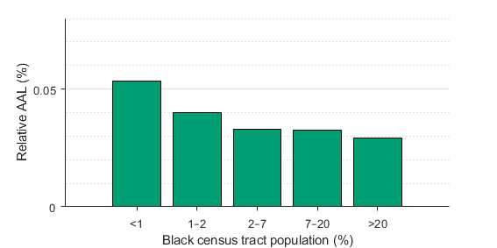
Supplementary Figure 1. Relative average annual loss in 2020 by census tract quintile of Black population proportion.

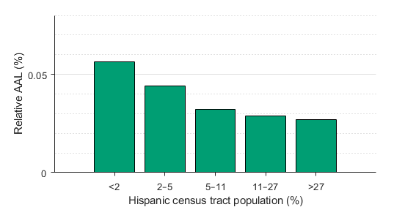
Supplementary Figure 2. Relative average annual loss in 2020 by census tract quintile of Hispanic population proportion.

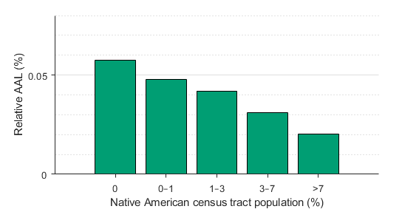
Supplementary Figure 3. Relative average annual loss in 2020 by census tract quintile of Native American population proportion.

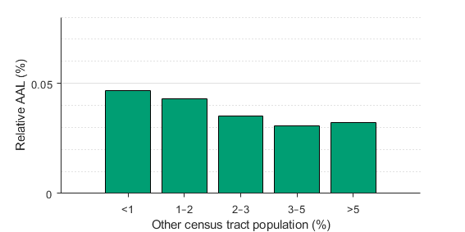
Supplementary Figure 4. Relative average annual loss in 2020 by census tract quintile of other racial groups (not White, Black, Hispanic, or Native American) population proportion.

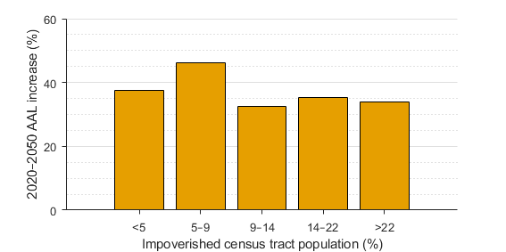
Supplementary Figure 5. Average annual loss increase from 2020 to 2050 for census tract quintile bins of proportion of population in poverty.

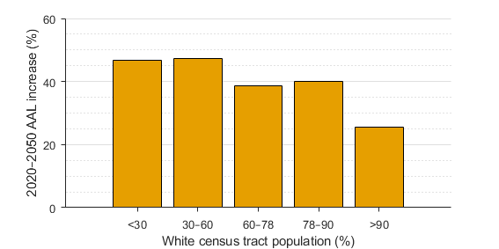
Supplementary Figure 6. Average annual loss increase from 2020 to 2050 for census tract quintile bins of White population proportion.

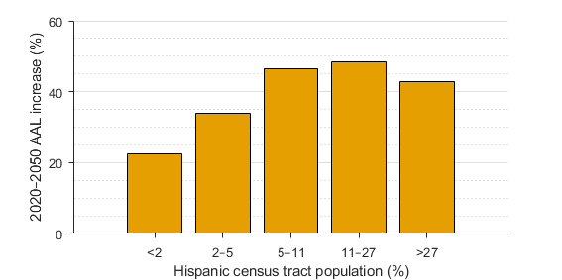
Supplementary Figure 7. Average annual loss increase from 2020 to 2050 for census tract quintile bins of Hispanic population proportion.

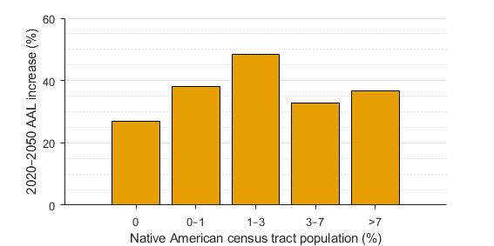
Supplementary Figure 8. Average annual loss increase from 2020 to 2050 for census tract quintile bins of Native American population proportion.

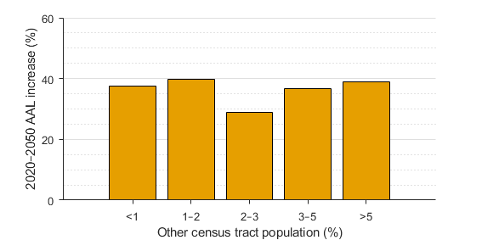
Supplementary Figure 9. Average annual loss increase from 2020 to 2050 for census tract quintile bins of other racial groups (not White, Black, Hispanic, or Native American) population proportion.

Supplementary References
- FEMA. Testimony of Michael Grimm before the Committee on Science Space, and Technology (available from: https://science.house.gov/imo/media/doc/Grimm%20Testimony.pdf, 2020)

