Additional file 2:
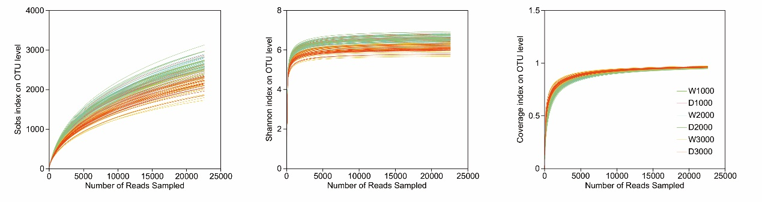

Supplementary Figure S1. Rarefaction curves of community richness (Sobs index), diversity (Shannon index), and coverage (Good’s coverage index) on OTU level across all soil bacterial communities. W1000 (D1000), W2000 (D2000), and W3000 (D3000) represent samples collected from DHVs, transition, and alpine zones during the wet (dry) season, respectively.

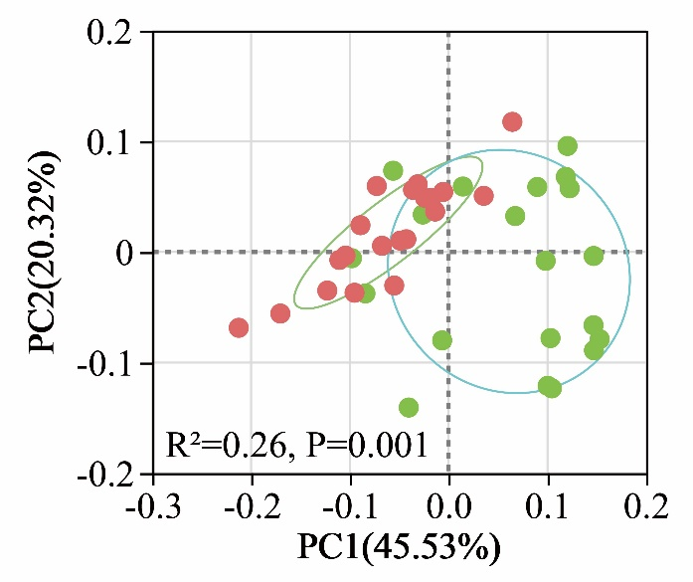

Supplementary Figure S2. Principal component analysis (PCoA) was performed at the phylum level, suggesting the clear distinction between soil bacterial communities in the alpine zones during the wet (green) and dry (red) seasons.

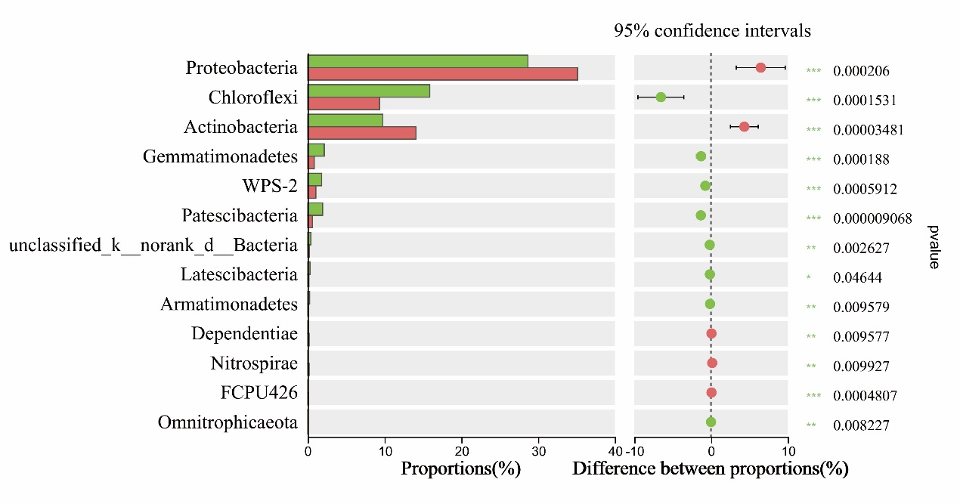

Supplementary Figure S3. An extended error bar plot identifying significant differences between the mean proportions of bacterial taxa from the wet (green) and dry (red) seasons in the alpine zones.

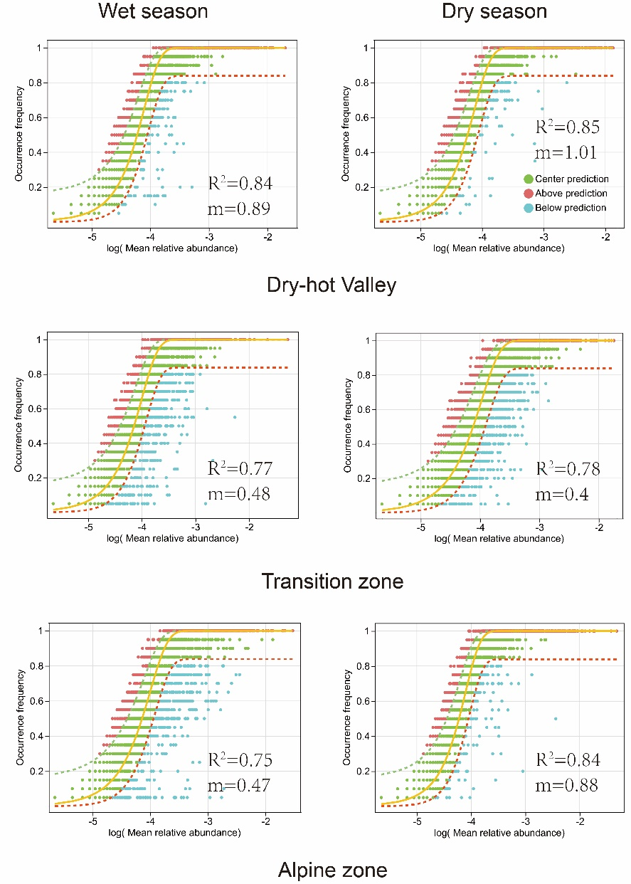
Supplementary Figure S4. Fit of the neutral community model (NCM) of bacterial community assembly. The solid yellow line represents the best fit to the model, with dashed red and green lines indicating the 95% confidence intervals. OTUs deviate from the model’s predictions, either occurring more or less frequently, are highlighting in distinct colors. The R² indicates the goodness of fit to the model, with a higher value denoting a better fit. The migration rate (m) represents the dispersal ability of species within the community. A smaller m-value suggests restricted dispersal and a more localized community, while a higher m-value indicates less restricted dispersal and a more interconnected community.

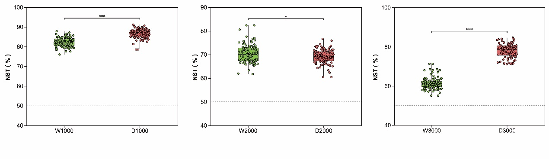

Supplementary Figure S5. Comparison of the normalized stochasticity ratio (NST) between soil bacterial communities at different elevations during the wet (green) and dry (red) seasons. The NST was calculated based on Jaccard using the null model algorithm PF. In this study, 50% was used as the boundary between deterministic (<50%) and stochastic (>50%) processes. W1000 (D1000), W2000 (D2000), and W3000 (D3000) represent samples collected from DHVs, transition, and alpine zones during the wet (dry) season, respectively. *, P<0.05; **, P<0.01; ***, P<0.001.

